Three integrated elements compromise the heart of every organisation and its culture, its:
1. Mission/primary purpose.
2. Vision/desired future.
3. Core beliefs.
Discuss these three elements through an organisation scenario of your choice and through the use of cultural models and principles. Highlight how your selected organisations culture and structures are having an impact on continued success or potential failure in today’s competitive marketplace.
In January 2006 the MOD commissioned the ‘Enabling Acquisition Change Report’, (EAC) to investigate where improvements and savings could be made by the Defence Logistic Organisation (DLO) and Defence Procurement Agency (DPA).
Upon completion, in July 2006, the report recommended the organisations merge. The report highlighted the changing environment in which they were operating: ‘The focus of previous studies has tended to be on the front end of the acquisition process…Today, in an environment in which there is increasing emphasis on agility… and is both affordable to operate through life and readily adaptable.’
Prior to the merger, a HM Parliament Defence Committee (2006) noted ‘DPA will reduce from 4,600…to 4,150 staff’ and ‘DLO will reduce from 27,000 to 21,600 staff’. The organisations had 35,750 staff between them!
The report also highlighted a lack of technical expertise within the organisations: ‘…invest more in training…project management…finance, commercial skills and certain deep technical specialist skills where we're lacking strength in depth and living on the fruits of a former era…’ Training had also been neglected as ‘CDP acknowledged that there had not been enough training in the DPA.’
The DLO and DPA Corporate Plans both seem wordy and hazy - giving the impression of stodgy organisations lacking agility e.g. the DPA’s mission ran to 170 words; the aim, was not clearly highlighted:
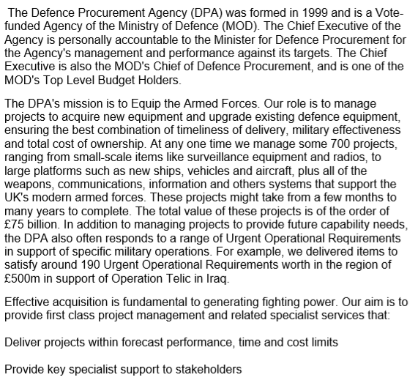
Figure 1: Defence Procurement Agency Mission (2005)
The EAC also stated ‘Previous reforms have focused on changes to organisation and process but lacked sufficient sustained commitment to produce the desired culture and behaviours.’ Culture is mentioned 25 times in the EAC and discussions ‘with a number of leading non-defence sector industrialists…’ highlighted ‘the importance of developing a single and focused high performing cultural identity within the company or organisation.’
The DPA Corporate Plan did not mention ‘its people’, ‘culture’ or ‘diversity’ at all. It concentrated on process and targets. The DLO Business Plan very vaguely mentions ‘its people:
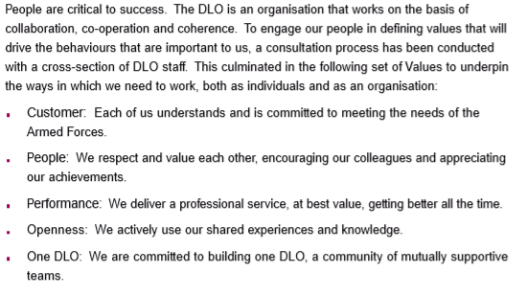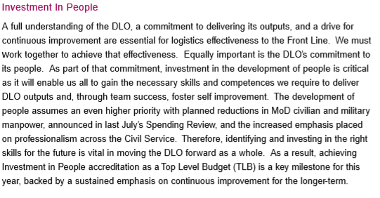
Figure 2: DLO ‘People Policy’ (2005)
The policy mentioned investing in people, but slanted towards outputs - rather than improving them. It also mentioned respecting and valuing each other – but not diversity. Indeed, MOD Armed Forces Homosexuality Policy stated ‘…the policy to bar homosexuals from the Armed Forces was not legally sustainable.’ (MOD Apr 2006). This sounds like a begrudging acceptance of law – and ignores the advantages of a diverse organisation. The culture needed to change…
Acting upon the recommendations of the EAC, the MOD Permanent-under-Secretary ordered the merger, ‘The aim is to improve financial planning by ensuring that new equipment and its in-service support costs are planned more coherently. The merged organisation will be known as Defence Equipment & Support (DE&S).’ (HM Parliament 2006)
The merger would require strategic change, of which there are four types:
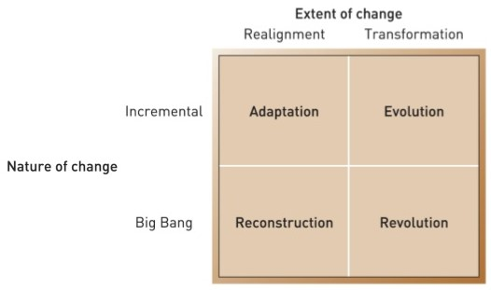
Figure 3: Balogun and Hailey’s Types of Change (1999)
The EAC report and MOD direction acted as internal stimulus to trigger the transformation of defence logistics; this change needed to happen within a year (a short timescale) - meaning this was ‘big bang change’. Therefore, it was a revolution.
Before change can commence, leaders must assess the organisation’s culture. Handy (1976) classified organisations depending on their relationship with individual workers i.e. the power and hierarchy structures determine how people behave. Handy identified four types of culture: role, task, power and person.
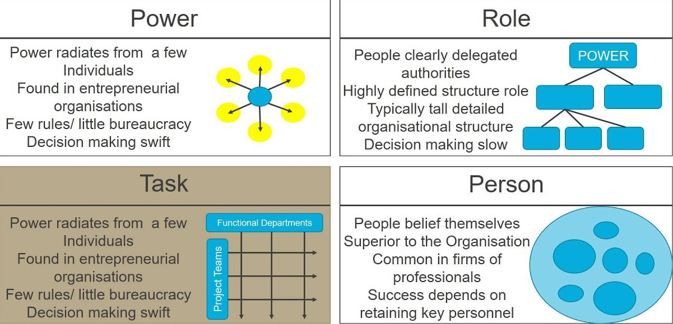
Figure 4: Handy’s 4 Classes of Culture (2016)
DLO and DPA displayed elements of role, task and power cultures. There were some project teams (task) which reported to committees (role). The slow decision making of role cultures was highlighted in the EAC as ‘…the approvals process continues to be a source of dissatisfaction…We have heard complaints that the process is cumbersome and slow.’ Whilst there were leaders to give command (power), the lack of training and investment in workers suggests little ‘person’ culture.
Whilst role cultures are best for delivering repetition, task cultures deliver projects and innovation – power culture delivers rapid responses. Rapid change was needed and was therefore driven by a leader - General O’Donoghue, supported by the head of DPO.
The merger was conducted in four phases:
- Define how the organisation would look and operate.
- Define strategic managers deliverables and changes needed in their areas.
- Engage the workforce and explain what changes meant for them.
- First year of operation – and post project evaluation.
Conducted against the backdrop of two ongoing operations, ‘…industry was apprehensive about the magnitude of internal reorganisation required, the merger did not appear to distract MoD officials from ongoing business.’ (HoC 2008)
However, the same report stated: ‘The Defence Procurement Agency met all its Key Targets in 2005-06 and 2006-07. DE&S took over these targets for 2007-08, but does not expect to meet the Key Target relating to programme slippage.’
It appears fault lay in the change programme, its focus on the wrong areas – and that ‘culture’ was not addressed in Stage 3. I have superimposed changes undertaken next to ‘Kotter’s 8 Step Change Model’ (Kotter 1995), to highlight where the process may have failed:
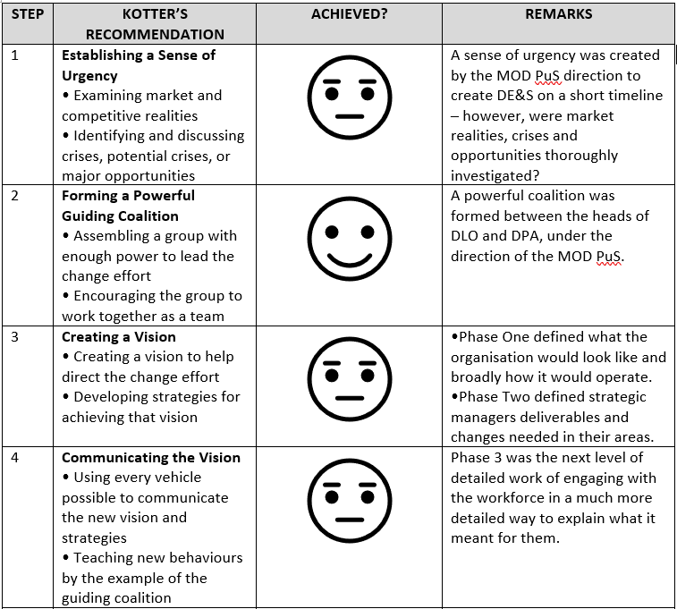
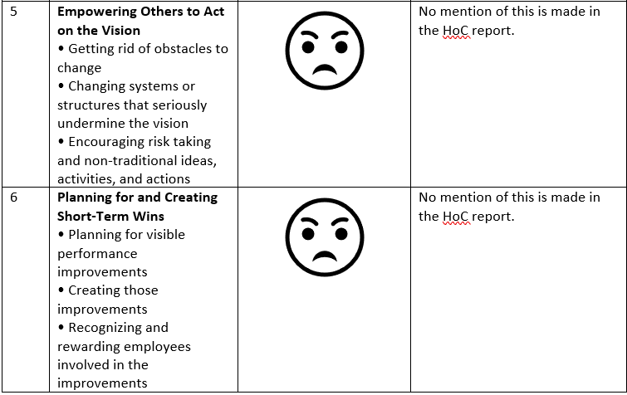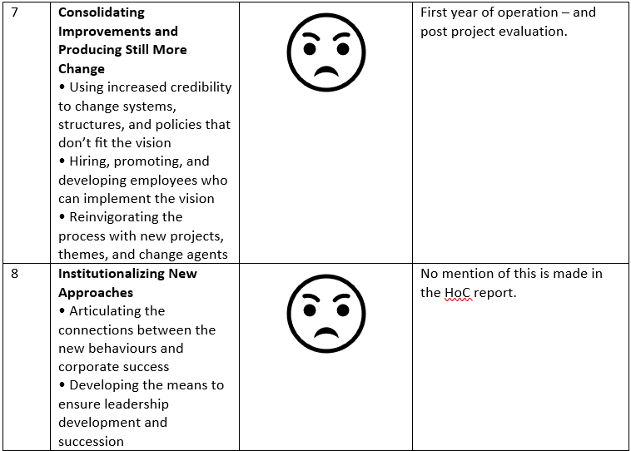
Figure 5: Adapted Kotter 8 Step Change Model v DE&S Change
Planning appears to have focussed more on new organisational structure and senior management roles. It is difficult to find evidence of ‘Step 5’ actions, but the culture of neglecting staff training continued: ‘We find it inexplicable that the number of DE&S staff is to be substantially reduced when staff are currently so busy that they have insufficient time to attend the training and upskilling courses they need.’ (HoC 2008)
Again Step 6 short term win plans are hard to evidence – and so Step 7 (consolidating improvements) is difficult to judge. It appears just merging the organisations was deemed a success and a point to re-evaluate at in ‘Phase 4’. Step 8 possibly seemed too far away to consider.
Gen O’Donoghue retired in 2010 after ‘…. humiliating rebuke…over the MoD’s appalling spending history… the department had over-ordered equipment by more than £36 billion for the next decade.’ (Harding, 2010)
The transformation continued over several years under four civilian Chief Executive Officers.
In 2018 DE&S, a bespoke trading entity, operates ‘at arm’s length from the MOD’ and is a Top-Level Budget, sitting alongside PJHQ and the Front Line Commands (FLC’s).
With an annual budget of £11.1 billion and a workforce of ‘…11,400 - both civilian and military…organised into…11 professional functions’ (DE&S, 2018), it has reduced by 25,000 personnel since merging!
The DE&S primary purpose is ‘to equip and support the UK’s armed forces for operations now and in the future.’ (DE&S, 2018)
To enable this, the following strategic objectives have been set for 2018 - 2021:
- Continuously improve delivery.
- Understand the supply chain.
- Continue to transform.
- Support its people.
- Focus on its customers.
The DE&S vision, ‘DE&S @21’, is a ‘vision of a confident commercial organisation in 2021 that is:
- Customer and performance focused.
- Tech-enabled supporting us to be agile in delivery.
- Forward-looking and results-orientated.
- Offering an employee value proposition that attracts, builds and develops a skills base to underpin better performance.’ (DE&S, 2018)
The verbs contained within the strategic objectives – improve, understand, transform and focus – all describe a progressive organisation trying to get ‘onto the front foot’, so that it can confidently deal with technical, commercial suppliers. This is mirrored in the vision, which also uses positive verbs ‘focussed, results-orientated’ and similarly modern, punchy adjectives: ‘tech-enabled, agile and forward-looking’.
Studies have shown that a diverse workforce ‘…adds creativity and improved decision making as well as better economic outcomes for organizations (sic)’ (Harley, 2010). The workplace therefore needs to be a comfortable, accepting environment for a diverse workforce; to create this DE&S has outlined its core beliefs and standards, that all employees are expected to adhere to. These are laid out in a framework of documents:
- The DE&S Way 2016/17.
- The DE&S Professional 2016/17.
- Code of Business Ethics 2018.
- DE&S Behaviours.
- Inclusion, Diversity and Outreach Policy.
All employees must familiarise themselves with these and conduct an introductory training programme. This is all underpinned by further professional training and annual training.
The organisation adopts ‘function skills’, which are an overview of its core beliefs:
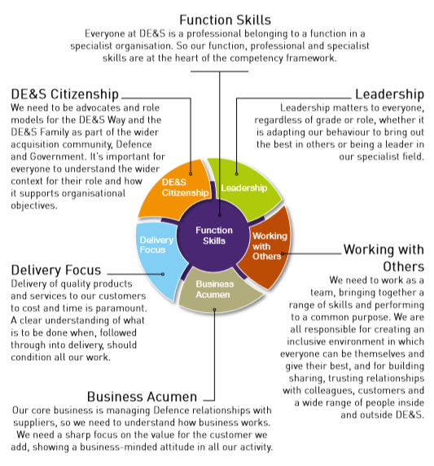
Figure 6: DE&S Function Skills (2016/17).
Each functional skill is broken down into sub-skillsets, with standards that each employee is expected to aspire to. Each behaviour has 5 levels of standard, ranging from basic level of attainment to the excellent practitioner.
DE&S also adopts a common set of behaviours:
- ‘We work as one team with our customer.’
- ‘We support one another.’
- ‘We are professional in everything we do.’
- ‘We are committed to getting better.’
- ‘We deliver on promises. No excuses.’
The belief is that ‘…a common set of behaviours across the organisation to ensure we can meet our objectives, support our people and deliver to our customers. These five behaviours and their supporting statements describe how we should all go about our work – no matter what level we’re at. They help us to work towards our purpose and our vision in a sustainable, cohesive way.’ (DE&S Behaviours)
DE&S leaders have thought carefully about culture and considered Schein (1993), who stated that organisational culture is ‘A pattern of shared basic assumptions that the group learned as it solved its problems of external adaptation and internal integration, that has worked well enough to be considered valid and therefore, to be taught to new members as the correct way to perceive, think, and feel in relation to those problems.’
DE&S leaders also consider the Johnson and Scholes Cultural Web:
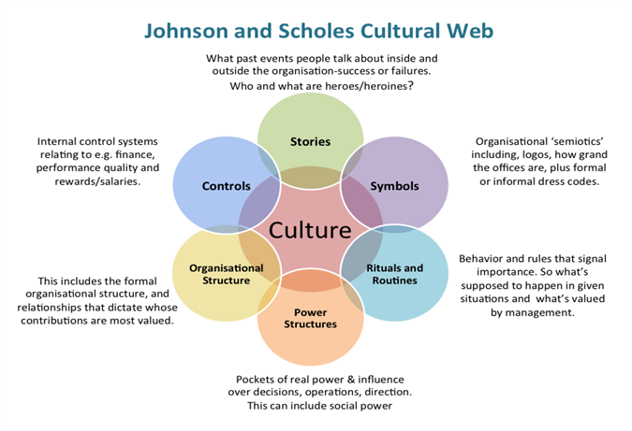
Figure 7: Johnson and Scholes Cultural Web (2013)
DE&S culture lacks heroes and stories upon which to base its culture – but can draw upon success stories of equipment provided to front line troops. These are highlighted in its publication ‘DE&Sider’. The DE&S brand is prominent throughout the workplace. Routines and rituals are given are framed by the DE&S Professional documents – and leaders encourage functions such as ‘Team Breakfasts’ and ‘Dress-down Fridays’.
Organisation leaders are well known through use of blogs, informal coffee mornings etc. Meanwhile, there is heavy emphasis on Project teams, specialist consultants and the employment/training of Project Managers. The organisation has finance, contract management, assurance and compliance departments – as well as pay scale and rewards independent of other government departments.
The training process to introduce new arrivals to DE&S culture is no accident either. It closely follows the Saks and Ashforth (1997) organisational socialisation model:
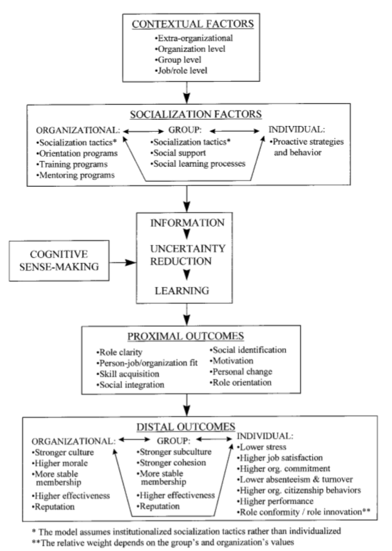
Figure 8: Multi-level process model of organizational socialization. (1997)
DE&S imparts its values and standards upon new employees through training programmes and socialisation with co-workers. This information allows new employees to make sense of their environment, reduce uncertainty and make it easier to learn their role. These ‘proximal outcomes’ have knock on benefits for the organisation, teams and individuals as per Figure 8. The model can be simplified as:
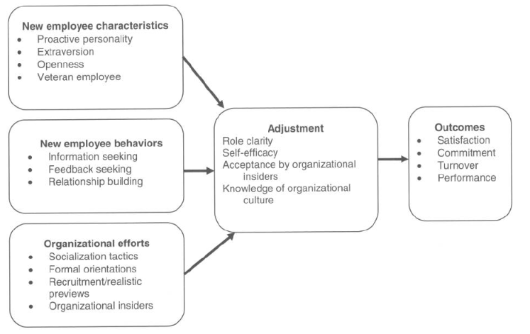
Figure 9: “A Summary Process Model of Socialization” (2011).
Bauer and Erdogan (2011) stated the adjustment period ‘indicates how well a new employee is doing as he or she transitions from being an organisational outsider to organisational insider’. Bauer et al also highlight how ‘…organisational socialisation tactics were directly related to satisfaction…’, which positively resulted in ‘…job satisfaction, organisational commitment, turnover and performance emerged in a large number of studies…’
DE&S has many strategic relationships such as Boeing, BAE Systems, Rolls-Royce, Airbus, Lockheed Martin, Thales, QinetiQ, Babcock, Serco, and Leidos.
Slack (2004) defines Partnership as ‘a type of relationship in supply chains that encourages relatively enduring co-operative agreements for the joint accomplishment of business goals.’
The partnerships look to share skills and resources to achieve joint benefits. Slack (2004) highlights the potential benefits as:
- Sharing success.
- Expected long term commitment and trust.
- Multiple points of contact through both formal and informal channels.
- Joint learning and problem solving.
- Joint co-ordination of activities.
- Information transparency.
The DE&S programme of work is defined by the ‘Command Acquisition & Support Plans’ (CASP), which are agreed with customers and outline the agencies outputs to include:
- Strategic direction, key risks and opportunities.
- Specific customer requirements.
- Accountability, responsibility and delegated authority.
- Specific performance metrics.
DE&S employs ‘APM Methodology’ throughout all of its projects; use a ‘Work Breakdown Structure’ to monitor scope, cost and schedule of all tasks broken down into finer detail. ‘This structure ensures our performance measurement process, Earned Value Management (EVM), can be applied effectively.’ (DE&S, 2016)
DE&S aims to ‘deliver flexible and agile commercial solutions through a simplified “five by six” procurement route model.’ (DE&S, 2018).
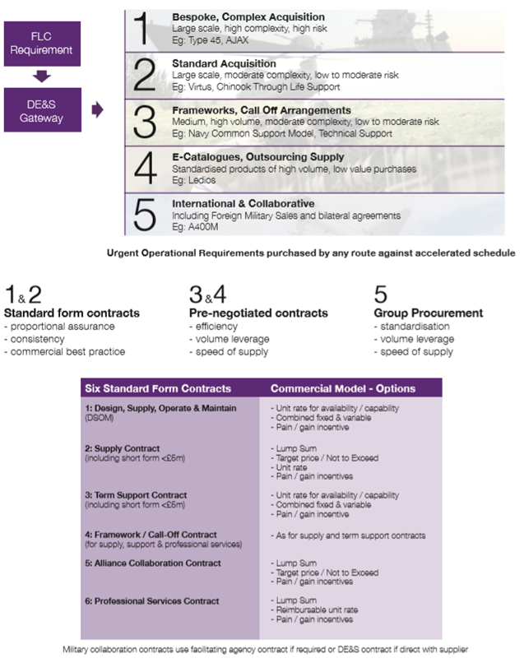
Figure 10: Five by Six Procurement Model (DE&S, 2018)
DE&S choose one of five procurement methods dependant on project scale, complexity and risk. It then uses one of six types of contract best suited to the project by matching requirements to resources.
The Logistic Commodities & Services Transformation programme was awarded to Leidos Europe. The need to find a commercial partner to overhaul and manage the defence supply chain was identified as:
- Deteriorating infrastructure – fragile strategic logistic base.
- Buildings.
- Base Log IT.
- MOD supply chain…in need of modernisation.
- MOD paying too much for commodities and logistic services.
- MOD holding too much stock or the wrong stock
DE&S Strategy (2018)
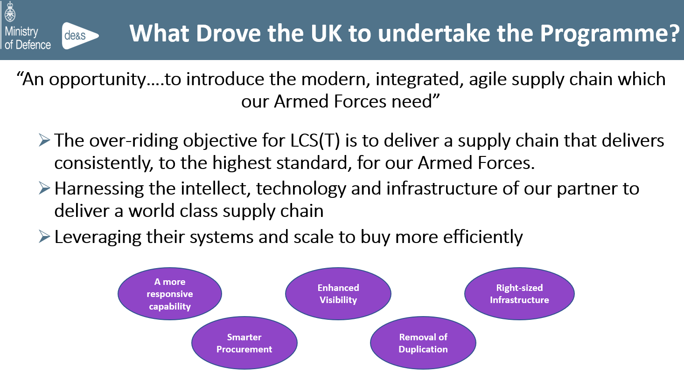
Figure 11: What drove the UK to undertake the LCS(T) Programme? (DE&S Strategy 2018)
Figure 11 shows DE&S was seeking to utilise LEIDOS’ intellect, technology and infrastructure to deliver a modern, integrated, agile, world class supply chain. To do this, the MOD and LEIDOS will invest in:
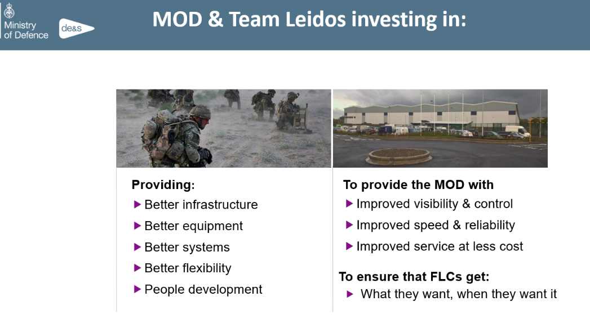
Figure 12: MOD & Team LEIDOS Investments. (DE&S Strategy 2018)
These investments closely reflect the primary purpose, mission and vision of DE&S – and it’s notable that ‘people development’ is a provision, not an afterthought.
The key points of the contract:
a. 13 Year contract worth up to £13 billion.
b. Contract began on 01 August 2015.
c. First 3 years is the Transformation phase. This includes the building of the Defence Fulfilment Centre and introduction of all new IS systems and processes.
d. Following 10 years are for Continuous Improvement.
Leidos (2018)
In deciding whether to undertake this partnership, DE&S will have used some form of Cost Benefit Analysis:
Figure 13: Cost Benefit Analysis (Peregrine 2013)
As an example, the cost of the LEIDOS contract is £6.7bn. I reverse engineered maths to calculate that the existing costs to the MOD were £7.33bn; therefore ‘User benefits’ equals £630m. Construction costs including ‘Defence Fulfilment Centre’ (£90m) and new IT (£40m) are £130m. Net Present Value is User Benefits minus Construction Costs, which is £500m over a 13-year period.
Leidos is a partnership of defence and logistics specialist subcontractors - Kuehne & Nagel, TVS, Agility and Thales.
The contract was awarded by using (another commercial partner) Commerce Decision’s ‘AWARD’ software, to ‘support the management of the interaction with bidders and the evaluation of tenders’ (Commerce Decisions 2018).
It is understood the software incorporates:
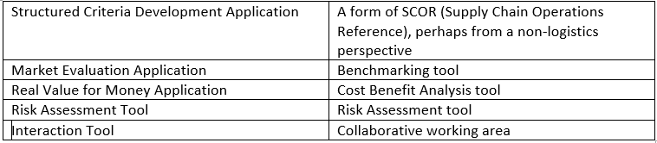
Figure 14. AWARD Software Functions.
The author is blind to AWARD software’s workings, but it is difficult to understand how it benchmarks – and not all DE&S projects utilise AWARD. Benchmarking is to evaluate position within an industry, by measuring an organisation’s processes and performance against industry leaders. Due to the secretive nature of defence, it is extremely difficult to benchmark versus other nation’s armed forces. Furthermore, DE&S does not operate for profit – but looks for cost efficiencies. In time of emergencies, even these can be disregarded – as inevitably money can be thrown at a problem. Where possible, DE&S looks to industries for ‘best practice’ and makes adaptations to fit requirements. ‘DE&S does not currently undertake a traditional benchmarking process, instead we look to ‘Learn From Evidence’ by ensuring thorough Post Project Evaluations are conducted.’ (Lowrie, 2019)
DE&S manages and measures performance using the ‘Performance Measurement Baseline’, which assesses scope, schedule and cost:
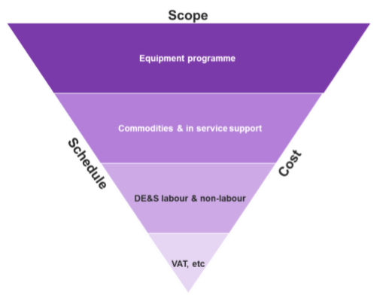
Figure 15: DE&S Performance Measurement Baseline. (DE&S Way 2016)
To evaluate if the LCS(T) contract meets its objectives we can use SMART:
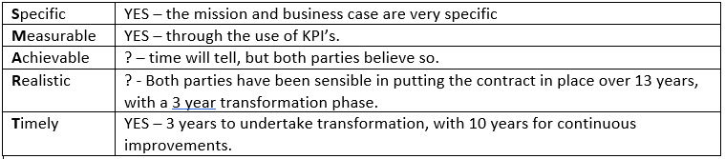
Figure 16: Is LCS(T) SMART?
To understand contract risks, we can undertake SWOT analysis:
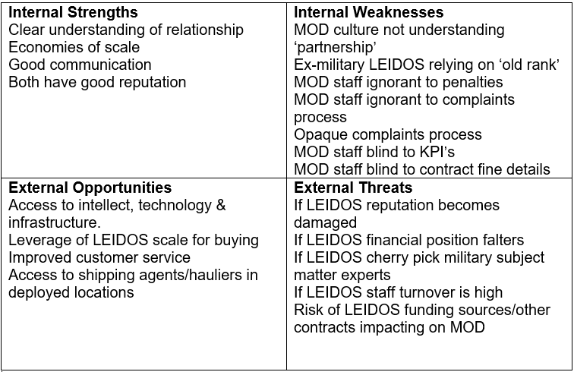
Figure 17: LCS(T) SWOT Analysis.
Whilst the internal weaknesses can be addressed ‘in-house’, external threats need assessing by DE&S management using a Risk Impact Grid:
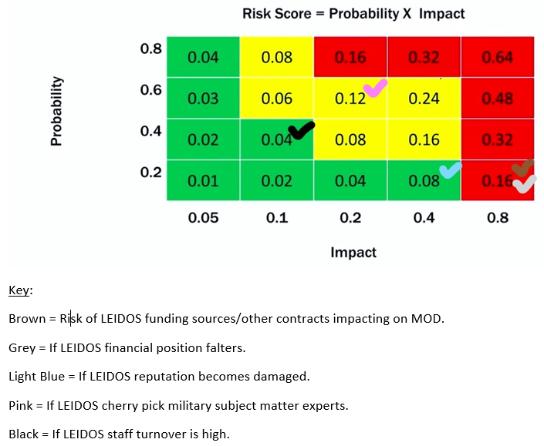
Figure 18: LCS(T) Risk Impact Grid
It seems the greatest risk to the partnership is presented by LEIDOS’ financial position, funding sources and external contracts. This risk is held by the Cabinet Office, who approve all contracts over £10m (MOD, 2018). The MOD Supplier Management and Analytics team routinely produce ‘Supplier Intelligence Briefs’ to give early warning of these issues. DE&S Project Managers defer to Risk Managers, who manage the ‘Active Risk Manager’ system.
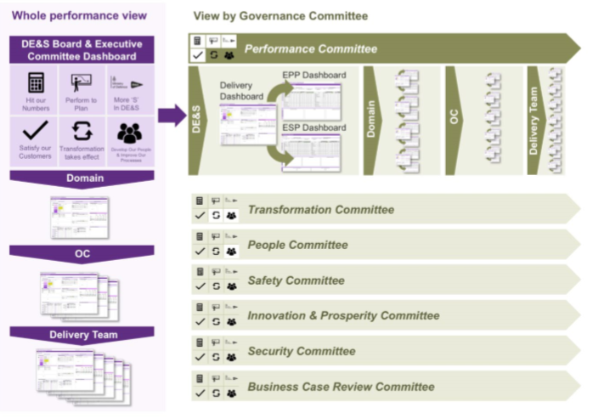
Figure 19: DE&S Performance Reporting Architecture (DE&S, 2016)
‘Performance reporting enables us to make the right decisions at the right time.’ (DE&S,2016)
Executive committees are fed data, on all projects on a monthly basis, via dashboards outlining performance against key business metrics including:
- Key Performance Indicators.
- CASP milestones.
- Safety statistics.
- Strategic risks.
- Transformation.
- Financial Performance.
In summary, DE&S is almost a ‘textbook’ organisation in its implementation of management structures, tools and theories. It appears to be making progress in it’s bid to become ‘a confident commercial organisation’ ready to compete in today’s marketplace.

Word Count: 2731 (not including Figure headings)

List of Figures:
Figure 1. DPA (2005). Defence Procurement Agency Mission. https://webarchive.nationalarchives.gov.uk/20060424202318/http://www.mod.uk/DefenceInternet/MicroSite/DPA/OurPublications/CorporateBusinessPlan2005.htm Retrieved 26 Jan 2019.
Figure 2. DLO (2005). DLO People Policy. https://webarchive.nationalarchives.gov.uk/20060424202148/http://www.mod.uk/DefenceInternet/MicroSite/DLO/OurPublications/DefenceLogisticsOrganisationPlan2005.htm
Retrieved 26 Jan 2019.
Figure 3. Adapted from Balogun and Hailey (1999). Balogun and Hailey’s Types of Change. https://www.slideshare.net/StratMgtAdvisor/sm-lecture-eleven-leadership-and-strategic-change-17434218 Retrieved 28 Jan 2019.
Figure 4. Accounting College (2016). Handy’s 4 Classes of Culture (2016). https://www.youtube.com/watch?v=E1NrJqYudPw Retrieved 28 Jan 2019.
Figure 5. Adapted Kotter 8 Step Change Model v DE&S Change. Adapted from: https://wdhb.org.nz/contented/clientfiles/whanganui-district-health-board/files/rttc_leading-change-by-j-kotter-harvard-business-review.pdf Retrieved 28 Jan 2019.
Figure 6. DE&S (2016). The DE&S Function Skills. “The DE&S Professional” https://des.mod.uk/wp-content/uploads/2018/08/The_DES_Professional_V3_Interactive.pdf Retrieved 22 Jan 2019.
Figure 7: Johnson and Scholes Cultural Web (2013) https://www.managementcentre.co.uk/culture-eats-strategy-for-breakfast/ Retrieved 28 Jan 2019.
Figure 8. Saks, A.M; Ashforth B.E. (1997). Multi-level process model of organizational socialization. https://www.uv.es/=gonzalev/PSI%20ORG%2006-07/ARTICULOS%20SOCIALIZACION%20ORG/ARTICULO%203%20REVISION-ORG%20SOCIALIZATION.pdf Retrieved 26 Jan 2019.
Figure 9. Bauer, T.E; Erdogan, B (2011). A Summary Process Model of Socialization. https://www.researchgate.net/publication/285000696_Organizational_socialization_The_effective_onboarding_of_new_employees Retrieved 26 Jan 2019.
Figure 10. DE&S (2018). Five by Six Procurement Model. “DE&S Corporate Plan 2018-2021”
Figure 11. DE&S Strategy (2018). What drove the UK to undertake the LCS(T) Programme? “Logistics, Commodities & Services Transformation” Powerpoint provided by Contract Management Organisation dated 29 May 2018. Retrieved 2 Feb 2019.
Figure 12. DE&S Strategy (2018). MOD & Team LEIDOS Investments. “Logistics, Commodities & Services Transformation” Powerpoint provided by Contract Management Organisation dated 29 May 2018. Retrieved 2 Feb 2019.
Figure 13. Peregrine, B (2013). Cost Benefit Analysis. Powerpoint delivered by Mr G. Edwards at University of Wales Trinity Saint David on 24 June 2018. https://moodle.uwtsd.ac.uk/pluginfile.php/149729/mod_folder/content/0/Collaboration.ppt?forcedownload=1 Retrieved 27 Jan 2019.
Figure 14. Mulligan, L (2019). AWARD Software Functions. Information extracted from https://www.commercedecisions.com/award Retrieved 2 Feb 2019.
Figure 15. DE&S (2016). DE&S Performance Measurement Baseline. “The DE&S Way”. https://des.mod.uk/wp-content/uploads/2018/01/The_DES_Way.pdf Retrieved 3 Feb 2019.
Figure 16. Mulligan, L (2019). Is LCS(T) SMART?
Figure 17. Mulligan, L (2019). LCS(T) SWOT Analysis.
Figure 18. Mulligan, L (2019). LCS(T) Risk Impact Grid.
Figure 19. DE&S (2016). DE&S Performance Reporting Architecture. “The DE&S Way”. https://des.mod.uk/wp-content/uploads/2018/01/The_DES_Way.pdf Retrieved 3 Feb 2019.

List of References:
MOD (Jul 2006). “Enabling Acquisition Change Report.” Ministry of Defence, London. https://webarchive.nationalarchives.gov.uk/20121109102933/http://www.mod.uk/NR/rdonlyres/10D1F054-A940-4EC6-AA21-D295FFEB6E8A/0/mod_brochure_hr.pdf Retrieved 26 Jan 2019.
HM Parliament (2006). “Parliament Defence Committee First Report.” https://publications.parliament.uk/pa/cm200607/cmselect/cmdfence/56/5606.htm Retrieved 26 Jan 2019.
MOD (Apr 2006). “Homosexuality and the Armed Forces.” https://webarchive.nationalarchives.gov.uk/20060424194326/http://www.mod.uk/DefenceInternet/AboutDefence/Issues/DiversityAndEquality/HomosexualityAndTheArmedForces.htm Retrieved 27 Jan 2019.
Handy, C (1976). “Understanding Organisations.” Penguin, London.
HoC (2008). “House of Commons Defence Committee: Defence Equipment 2008.” https://publications.parliament.uk/pa/cm200708/cmselect/cmdfence/295/295.pdf Retrieved 28 Jan 2019.
Kotter, J (1995). “Leading Change.” Harvard Business Review January 2007. https://wdhb.org.nz/contented/clientfiles/whanganui-district-health-board/files/rttc_leading-change-by-j-kotter-harvard-business-review.pdf Retrieved 28 Jan 2019.
Harding, T (2010). “Critic of defence buying appointed to top MoD procurement job.” The Telegraph, 17 Dec 2010. https://www.telegraph.co.uk/news/uknews/defence/8207267/Critic-of-defence-buying-appointed-to-top-MoD-procurement-job.html Retrieved 28 Jan 2019.
DE&S (2018). “DE&S Corporate Plan 2018 – 2021.” DE&S Creative, Abbey Wood. https://assets.publishing.service.gov.uk/government/uploads/system/uploads/attachment_data/file/707889/DES-Corporate-Plan-2018-HighRes.pdf Retrieved 21 Jan 2019
Harley, P (2010). “Planning strategically for a diverse talent pool: A case study.” Capella University, ProQuest Dissertations Publishing. https://search-proquest-com.ezproxy.uwtsd.ac.uk/central/docview/219931898/91E65E8E6627408CPQ/1?accountid=130472 Retrieved 26 Jan 2019
DE&S (2016). “DE&S Behaviours.” DE&S, Abbey Wood. https://des.mod.uk/wp-content/uploads/2018/02/BehavioursIntro.pdf Retrieved 22 Jan 2019
Schein, E (1992). “Organizational Culture and Leadership.” Jossey-Bass, San Francisco.
Saks, A.M; Ashforth B.E. (1997). “Organizational Socialization: Making Sense of the Past and Present as a Prologue for the Future.” https://www.uv.es/=gonzalev/PSI%20ORG%2006-07/ARTICULOS%20SOCIALIZACION%20ORG/ARTICULO%203%20REVISION-ORG%20SOCIALIZATION.pdf Retrieved 26 Jan 2019.
Bauer, T.E; Erdogan, B (2011). “A Summary Process Model of Socialization” https://www.researchgate.net/publication/285000696_Organizational_socialization_The_effective_onboarding_of_new_employees Retrieved 26 Jan 2019. Retrieved 26 Jan 2019.
Slack, N; Chambers, S; Johnston, R. (2004). “Operations Management.” Prentice Hall, London.
Lowrie, D. (2019). Notes made from discussion with DE&S VST Project Manager at 1116 hrs, 30 Jan 2019.
DE&S (2016). “The DE&S Way”. https://des.mod.uk/wp-content/uploads/2018/01/The_DES_Way.pdf Retrieved 22 Jan 2019.
DE&S Strategy (2018). “Logistics, Commodities & Services Transformation” Powerpoint provided by Contract Management Organisation dated 29 May 2018. Retrieved 2 Feb 2019.
Team Leidos (2018). “LCS(T) An Overview”. https://www.teamleidos.co.uk/about/lcst Retrieved 29 Jan 2018.
Commerce Decisions (2018) “Crucial MOD supplies transformation programme delivered on time and to cost using AWARD®” https://www.commercedecisions.com/assets/uploads/case-studies/MOD%20LCS(T).pdf Retrieved 29 Jan 2019.
MOD (2018) “Cross Government Strategic Suppliers and Cabinet Office Commercial Controls Commercial Policy Statement” MOD Internal Policy Retrieved 3 Feb 2019.

