Llywodraeth Cymru
Welsh Government

The Building Regulations 2025
XY#
Approved Document
Dwellings: Installation of Solar Thermal Heating

December 2025
Student number 2316860
Jocasta Napier

Contents
1.Introduction 3
1.1 Application 3
New Dwellings 3
Exemption for historical and traditional buildings 3
1.2 Scope 3
Solar Thermal 3
1.3 Purpose 4
Net zero 5
Whole life Carbon (WLC) 5
1.4 Interactions with other Approved Documents 5
Approved Document L 5
Approved Document F 6
Approved Document O 6
2. Application Requirements 6
2.1 Scope of Application 6
3. Related Frameworks 7
3.1 BREEAM 7
3.2 Passivhaus 7
3.3 LETI 7
4. Orientation 9
4.1 Building Orientation 9
4.2 Daylight and Sunlight Assessment 11
References 12
Bibliography 14

1.Introduction
This approved document is discussing Approved Document X, Dwellings, using solar thermal heating sources, give guidance on how to comply with Part X of the building regulations and the energy efficiency requirements, while trying to achieve Net - Zero.

1.1 Application
The guidance in this Approved Document X applies to dwellings, it also includes, and how outside space can also be used for solar thermal heating units to be installed.

New Dwellings
Guidance for newly constructed dwellings is provided in Sections (2. Application requirements) of this approved document.

Exemption for historical and traditional buildings
The above types of dwellings do not need to fully comply with the energy efficiency requirements, it would be deemed unacceptable to alter the dwelling appearance or character.
These includes anything listed in section 1 and section 69 of the planning (listed buildings and conservation Areas) Act 1990.

1.2 Scope

Solar Thermal
To start using solar thermal systems within residential homes,
Solar thermal is the ‘Using daylight, solar thermal systems are a means of generating hot water. Two principal types are available: evacuated tube or flat plate. Both systems can be contained within a panel.’ (Hunt, R. and Suhr, M, 2013, p. 158)
When looking at the two different types of design, the tubing and the flat plate design, when looking at the overall maintenance, durability and over all appearance it has been decided to go with a more discreet design and to allow less chance of damage to the system and allowing it to be less costly for the homeowner, after the system has been installed, the decision has been made to go with the flat plate. The panels can be either be integrated into the roof, or if needed on an outbuilding or at ground level. By having the option to be able to install the panels around the house rather than the roof it can preserve any historic roof coverings but allow already existing properties to still benefit from having thermal systems.
Once the panels have been installed in conjunction with and as the properties domestic hot water storage which must be without alteration via a correctly sized Unvented domestic hot water cylinder with twin coil design to enable a primary heating source to coil one and the supplementary and renewable heat source via the solar thermal system supplying heating via coil two thus greatly increasing the efficiency of the domestic hot water system, reducing the dependency on a single heating source such as Gas fired central heating boilers and Air source heat pumps. This in turn reduces fossil/carbon-based fuel consumption and increased demand on electricity supplies which has a major reduction of carbon produced to the environment and a reduction in fuel supplier costs to the end user. This store will be a large unvented thermal hot water cylinder, with adequate capacity to provide adequate space available for the tank itself, expansion vessels, manifolds and pumps observing minimum manufactures clearances for ease of cyclical maintenance and unscheduled repairs if required. If needed due to insufficient space to assign the cylinder it’s dedicated compartment the tank can be stored remotely from the building and pipes will need to be laid linking the system to the house. Note: when installing the heavily constructed insulation the weight needs to be taken into consideration, including if the hot water cylinder is to be sited on an upper floor the weight will also need to be factored into the building. (Hunt, R. and Suhr, M, 2013, p. 158)

1.3 Purpose
There are multiple benefits to using renewable heating systems, which has a positive effect for the residence by lowering for the running costs and energy/fuel consumption whilst adequately providing heating and stored hot water of the property. Along with having a small environmental impact in both the installation and life span as it burns less fossil fuel and carbon has been removed.
The aim of incorporating solar thermal system in properties rather than traditional methods, is to help reduce the impact of the amount of carbon being produced. By doing this it will work towards achieving Net Zero.

Net zero
Net zero’s aim is to balance the amount of green houses gases, produced by human activities compared to the amount being removed by the atmosphere. As there are so many still in the atmosphere, it is important that we are no longer producing more.
The aim for achieving Net Zero is by 2050, in order to do this with in the construction industry it is important that the amount of carbon emissions being produced. (HM Government, 2021)

Whole life Carbon (WLC)
Whole life carbon refers to all carbon produced by built asset. This covers the raw extraction of the materials to the manufacturing, the construction, during the operation and then the need to either recycle or demolish. This also includes any transport of goods and electricity used to construct and run the building.
By having and understanding WLC, it will make it more achievable for achieving Net Zero emissions in the built environment as it shows clearly the buildings carbons footprint.
As the construction industry is a major contributor to the amount of carbon being released, it is essential that these assessments are carried out to try and reduce the number of emissions produced and get closer to achieving Net Zero by 2050.
A standard has been created by the Royal Institution of charted Surveyors (RICS) fro assessing WLC, this framework by managing and measuring carbon environment. The assessment helps identify any opportunities for reducing the operational carbon as well as the embodied carbon as well the embodied carbon. By utililiesing this process it will help work towards any sustainable goals and Net Zero targets. This assessment be a requirement to use on any future developments. (UK GBC, N/A)

1.4 Interactions with other Approved Documents

Approved Document L
This approved document provides guidance and examples of conservation of fuel and power; it provides information on the energy efficiency requirements and gives technical guidance to ensure there is compliance with other regulations. (GOV.UK, 2014)

Approved Document F
This approved document with legal requirements and will focus on the ventilation in buildings which is critical for maintaining the air quality indoor, as well as preventing Mold growth and condensation within a building.

Approved Document O
Approved document O looks at the risk of over heating in any new dwelling, aiming to ensure the design provided doesn’t allow excessive temperatures to occur during the summer months.

2. Application Requirements

2.1 Scope of Application
For new dwelling and developments – a site visit is required to confirm and finalise all specification and design options discussed and agreed with the building architect, designer and planner to establish the most efficient positioning for the required solar thermal collectors (taking into consideration the installation of the collectors, efficiency and highest sunlight hours for optimal performance, minimise any potential for damage accidental or 3rd party interference and aesthetics of the building design). Additional consideration to be taken regarding potential installation options of the flat plated solar thermal collectors positioning during the installation for each property type, whilst the system design is approved and observing all above aspects whether final positioning is more suitable to roof or gable (pine) end or any suitable surface that meets all design and operation requirements.
Heating engineer will need to be trained in the following qualification -
- ‘UHW10 - Vented and Unvented Hot Water Storage Systems (The requirements G3)’
- BPEC Solar Thermal Hot Water Systems NOS Mapped Level 3 (Microgeneration Certification Scheme (MCS)
- All relevant MCS Commissioning documentation.
When considering where to purchase the insulation kits, we would recommend Secon – Solar Thermal Kits (Secon, 2025)
Once fitted the engineer will need to complete a G3 Domestic unvented hot water commissioning certificate.

3. Related Frameworks

3.1 BREEAM
Building Research Establishment Environmental Assessment Method (BREEAM) is used to sustainability performance of a building using science led metric, the goal of using BREEAM is to allow analyse project to be able to protect and or create asset values and allow the risk of the project to be managed (BREEAM, 2025)

3.2 Passivhaus
According to Passivhaus, buildings are responsible for 35% of the total global energy consumption, they have backed with over 30 years of international evidence. Passivhaus have provided proven approaches to deliver Net Zero ready structures for both existing and new builds, to help with decarbonisation while keeping in mind continuing comfort and wellbeing, while converting minimal energy for both cooling and heating. (Passivhaus, 2025)

3.3 LETI
The London Energy Transformation Initiative (LETI) is a volunteering network who are looking to help transition the UK’s built environment to be able to meet the Net Zero target. The network at made up of people with lots of different backgrounds within the construction industry and are trying to spread the word of what changes can be made to allow us to reach the Net Zero Target, one way in which they set to achieve this is through a document they had published in 2020, called the ‘Climate Emergency Design Guide’ this has outlined requirements needed for a new buildings including schools, commercial offices and residential in small, medium and large properties. An example for medium and large-scale houses, is shown below in figure 1.
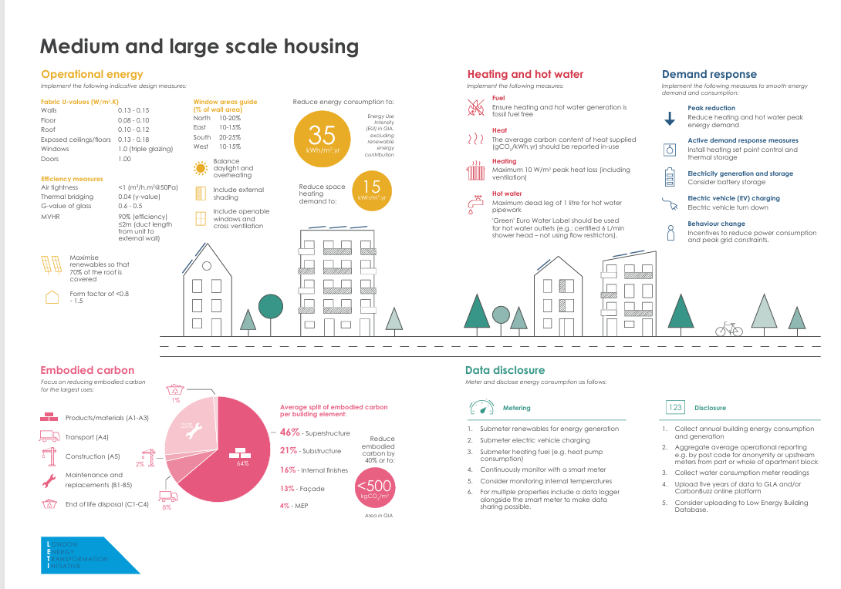
Figure 1 - LETI's Medium and Large Scale Housing Guide

The guide covers 5 key areas –
- Embodied Carbon
- The Future of Heat
- Operational Energy
- Data Disclosure
- Demand Response
By following the information in these key areas LETI is hoping by 2025 that these requirements will become a standard practice within the building design process. When looking at the design process LETI, are already focused on trying to eliminate the use of fossil fuels for heating and hot water within the household, therefore it would be essential to incorporate the LETI framework in to Approved Building Regulation X and that their targets are also met. (LETI, 2025)

4. Orientation

4.1 Building Orientation
When looking at the building orientation on a site it is important that the landscape in and around the development is taken into consideration. An example of the landscape would be a view, in order to sell the properties, it will be more desirable for the contractors to make the view from the houses a selling point of the building.
One of the main natural elements which is considered within the building design is sunlight. This is due to it having a major impact on the future residence of the properties, from the energy performance, comfort and quality of the living space, having a lot of natural light within a home can make someone more productive and have a better wellbeing overall. Therefore how the sun moves across the sky throughout the year, needs to be considered by the designer to make the most out of the sunlight to maximise the daylight, control any glare and manage the solar gains as the building will be using flat plates to collect the thermal heating it is essential they are located in the optimal position to have maximum exposure throughout the year.
Due to the earths axis, there is different exposures to the amount of sunlight as the earth goes around the sun, there is a difference in exposures between the Northen and Southern hemispheres and how close the they are to the sun during the year can effect the duration which the hemispheres is exposed to the amount of sunlight and can increase or decrease through the year.
A sun path calculator should be used to gather data on any specific site. This can then provide details of desired times of day at the site, as well as time the sunrises and sets.
This information can be used to predict the dates of each season which can be made into separate diagrams or can be merged into one, to show where the sun will fall throughout the year as shown below.
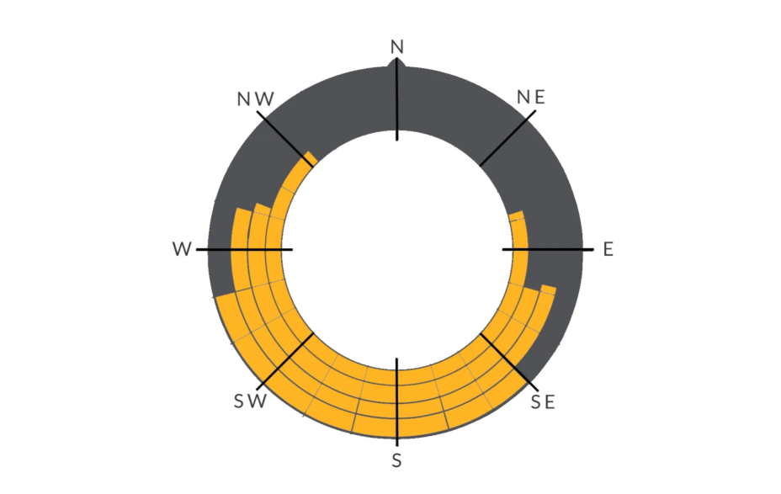
Spring
Summer
Winter
Autumn

Figure 2 - Merged sun path Diagram (Walshaw, E. / First Architecture, 2025)
By using this it can clearly show which position a house needs to be placed to have maximum exposure, depending on the type of building and where the designer wants to maximise the exposure, within the home usually the communal living spaces will be exposed to more sunlight throughout the day and which will make the rooms warmer also, whereas any bedrooms will be placed toward the more shaded areas of the house so that they are cooler environment throughout the year. (Walshaw, E. / First Architecture, 2025)
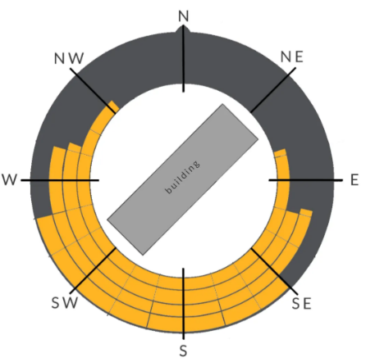
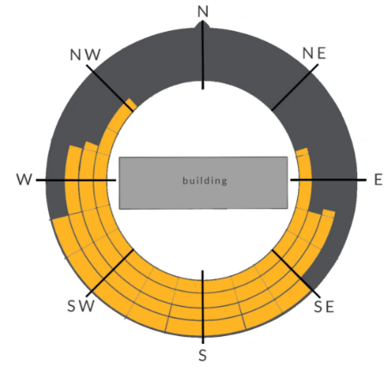
The below diagram shows 3 different orientations of how a building can be placed and the exposure it will have to the sun –

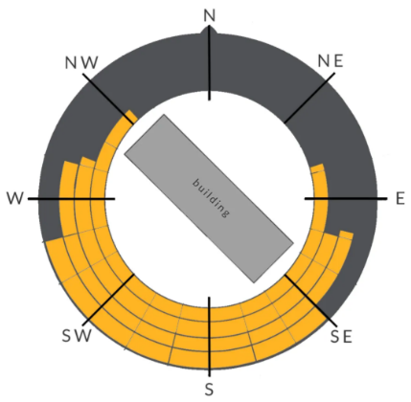
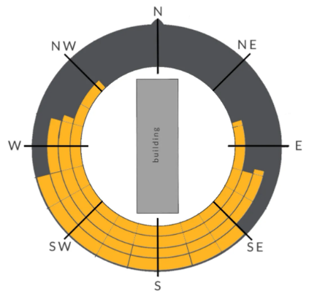
Figure 3 - Different Building Orientation (Walshaw, E. / First Architecture, 2025)

4.2 Daylight and Sunlight Assessment
It is important to consider the exposure of light when plans are being considered in construction, especially with urban and new developments, as it can impact the residences, either with excessive over shadowing from properties being to close together or being placed next to hillsides. It can also harm the amenities which could lead to residential objections.
To avoid this assessment will need to be carried out at the location at the start of the planning process, so the land and location or the buildings can be taken into consideration.
A report and model will then be produced explaining where the houses should be placed within the development, with the aim for all the houses to have maximum exposure to the sunlight with enough space in between them to avoid shadowing.
There will be a detailed breakdown which will include details of –
Sunlight Availability – where applicable, for outdoor space available and any living spaces.
Daylight Availability – for the internal design of the rooms in the proposed development.
Overshadowing analysis – on open spaces in the development as well as neighbouring properties.
Comparisons – with the local building requirements and BREEAM Standards.
Clear report with visualizations, this assessment will be made with what the planner had in mind for the number of properties on the development and how this would be achieved while keeping to the new standards. (Pager Power, 2025)

References
Hunt, R. and Suhr, M. (2013) Old House Eco Handbook, A Practical Guide to Retrofitting for Energy-Efficiency & Sustainability. UK. Frances Lincoln Limited
Water, J.R. (2003) Energy Conservation in Buildings, A Guide to Part L of the Building Regulations. Oxford: Blackwell Publishing USA.
Designing Buildings (2023) Solar Thermal Systems. Available at: https://www.designingbuildings.co.uk/Solar_thermal_systems (Accessed 05/12/2025)
BREEAM (2025) Benefits of BREEAM UK New Construction: Residential Available at: https://breeam.com/breeam-uk-new-construction-residential/benefits (Accessed 02/12/2025)
BBC (2021) What is net zero and is the UK on track to achieve it? Available at: https://www.bbc.co.uk/news/articles/cx238yyr40qo (Accessed 02/12/2025)
Passivhaus Trust (2025) Passivehaus: the route to Zero Carbon?, Available at: https://www.passivhaustrust.org.uk/competitions_and_campaigns/passivhaus-and-zero-carbon/ (Accessed: 01/12/2025)
Palmer, J / Passivehaus Trust (2021) Avoiding summer overheating, Guidelines for summer comfort in Passivhaus buildings and the PHT Summer overheating tool , Available at: https://passivhaus.uk/keeping-cool-avoiding-overheating-risks/ (accessed: 01/12/2025)
Godber,S. Clarke, A. and Still, G./ Passivhaus Trust (2024) Air to Water Heat Pumps, Avaiable at: https://passivhaus.uk/air-to-water-heat-pumps-guidance/ (accessed: 01/12/2025)
Passivehaus Trust (2025) What is Passivhaus? Available at: https://www.passivhaustrust.org.uk/what_is_passivhaus.php#2 (accessed 01/12/2025)
Passivhaus Trust (2025) Hampshire Passivhaus Available at: https://www.passivhaustrust.org.uk/projects/detail/?cId=79 (accessed 01/12/2025)
Walshaw, E. / First Architcture (2025) Building Fabric 03 – Sunlight and Solar Gain. Available at: https://www.firstinarchitecture.co.uk/building-fabric-03-sunlight-and-solar-gain/ (accessed 03/12/2025)
GOV.UK (2014) Conservation of Fuel and Power: Approved Document L. Available at: https://www.gov.uk/government/publications/conservation-of-fuel-and-power-approved-document-l (Accessed - 05/12/2025)
ADVECO (2024) High-efficiency Commercial Solar Thermal Systems for Sustain Hot Water, Available at: https://adveco.co/products/solar-thermal/?utm_term=solar+thermal+heating+system&msclkid=2070d37f4f37124b8449ba5ad404edb6&utm_source=bing&utm_medium=cpc&utm_campaign=Low+Carbon+%7C+Commercial+%7C+Water+Heating&utm_content=Solar+Thermal (Accessed 08/12/2025)
Team (2025) Energy Management Software, Available at: Energy Management Software - TEAM's Sigma Software Solution (Accessed 07/12/2025)
HM Government (2021) Net Zero Strategy: Build Back Greener. Available at: https://assets.publishing.service.gov.uk/media/6194dfa4d3bf7f0555071b1b/net-zero-strategy-beis.pdf (Accessed 08/12/2025)
The UK's plans and progress to reach net zero by 2050 - House of Commons Library
Secon (2025) Solar Thermal Kits. Available at: https://www.seconrenewables.com/solar-thermal-kits-390-c.asp (Accessed 08/12/2025)
Venture Well (2025) Building Orientation. Available at: https://sustainabilityworkshop.venturewell.org/buildings/building-orientation.html (Accessed 08/12/2025)
UK GBC (N/A) Whole Life Carbon, Explainer Guide, Available at: Whole-Life-Carbon-Final.pdf (Accessed 03/12/2025)
Pager Power (2025) Daylight Sunlight Assessment, Available at: Daylight Sunlight Assessment - Pager Power (Accessed 05/12/2025)

Figure 1 - LETI's Medium and Large Scale Housing Guide 8
Figure 2 - Merged sun path Diagram (Walshaw, E. / First Architecture, 2025) 10
Figure 3 - Different Building Orientation (Walshaw, E. / First Architecture, 2025) 10

Bibliography
Blewitt, J. (2015) Understanding Sustainable Development. 2nd edn. Oxon: Routledge.
Borer, P and Harries, C. (2005) The Whole House Book, Ecological Building Design and Materials. 2nd edn. Aberystwyth: Cambrian Printers.
Chief Scientist Group Report / Environment Agency (2025) Net Zero Technologies: environment impact. Available at: https://assets.publishing.service.gov.uk/media/678f79ecc9c786c1eb788679/Net_Zero_technologies_-_report.pdf (Accessed 03/12/2025)
GOV.UK (2000) The Building Regulations 2000, Available at https://www.legislation.gov.uk/uksi/2000/2531/part/I/made (Accessed: 03/12/2025)
GOV.UK (2010) Combustion appliances and fuel storage systems, Available at: https://www.gov.wales/sites/default/files/publications/2024-10/approved-document-j-combustion-appliances-and-fuel-storage-systems.pdf (Accessed 03/12/2025)
GOV.UK (2015) Sanitation, hot water safety and water efficiency, Available at: https://assets.publishing.service.gov.uk/media/66f6c6ce3b919067bb4828cc/ADG_with_2024_amendments.pdf (Accessed 03/12/2025)
Climate Action Wales (2025) Renewable energy systems, Available at: Renewable Energy Systems: Home Heating - Climate Action Wales (Accessed 07/12/2025)

