Analysis of Business Environment of UWTSD
Program: BA (Hons) Business Management
Module: Global Business Management
Module code: LCBB4005_BIRM
Name of Lecture:Dr.Eric Osei
Student Name:Andreea Pislariu
Student ID:2215593

Table of Contents
Introduction 2
Overview of the higher education sector in UK 3
PESTEL Analysis 4
Porter five forces 6
Showcase how “the University of Wales Trinity Saint David (UWTSD)” is affected by global factors 8
Conclusion 11
References 12

Introduction

The business environment is the total of the aspects a business is connected to, affecting a business organization and its operation. Environmental factors both positively and negatively impact a business. Business factors usually affect company decisions, strategies, processes, and performance. These factors are uncontrollable, and in the case of global operation, it provides opportunities or poses threats to an organization. The report is going t conducted to enlighten the business environmental factors from the perspective of the higher education sector. Besides evaluating it, the impact of the business environment on the University of Wales Trinity Saint David (UWTSD) will also be delineated in this report. The report will be accomplished decently with the proper application of models or frameworks.

Overview of the higher education sector in UK

In the case of the UK, higher education incepts after the age of 18. Higher education is the third level of education for a student after leaving school. Higher education takes place at universities and further education colleges, typically including undergraduate and postgraduate study. In the UK, higher graduation is valued worldwide because of the substantial goodwill, standards, and quality of education (Goedegebuure and Hayden, 2021). People from several countries come here to study. Several eminent people from several areas whose work has reached global recognition from several UK universities. Also, for the standard examination and evaluation system, the UK's higher education has a whopping name worldwide. Anyway, several external business environmental factors affect the higher education sector. For a thorough analysis of this impact, the application of the “PESTEL” and “Porter Five Forces” frameworks is going to be used. In higher education qualifications, university students can pursue their desired degree. Like diplomas, bachelor degrees, foundation degrees, post graduate degrees and doctoral degrees are available (Ahmed et al., 2019). Higher education courses come in a module structure, and an individual can make a personalized course by choosing modules or units of study from different subject areas. Besides, an individual can opt for more than one subject as part of an individual course. The student also has the freedom in universities to take two courses, one of their primary and the other as their minor.

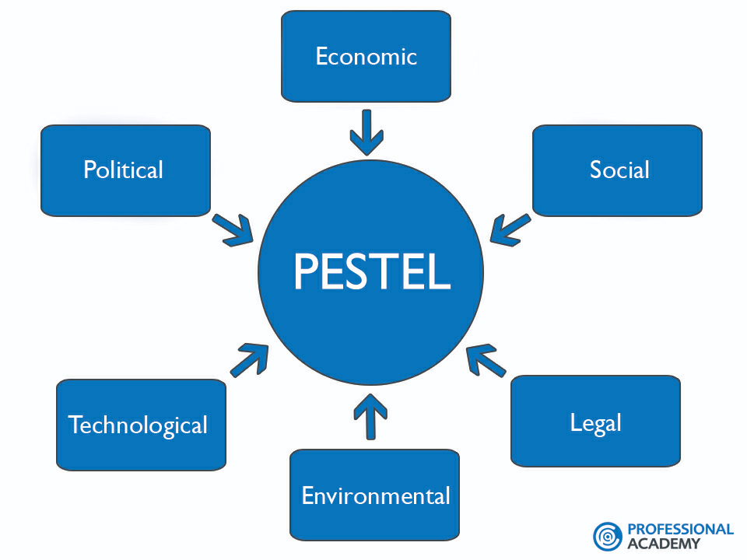
PESTEL Analysis

Fig 1: PESTEL Analysis
Source: (Pan et al., 2019)
Political factors
As the UK wanted to get rid of the “European Union bloc” and, therefore, they were equipped with “Brexit” Brexit” issues have created a lot of uncertainties. Moreover, in the case of universities, this issue causes problems regarding exchange programs such as ERASMUS (Pan et al., 2019). Additionally, this has made ambiguity regarding academics regarding whether the EU bloc will continue practicing in the UK or not. On the contrary, there is an optimistic scenario where higher education institutions get public funding. In this way, the government can partially subsidize the cost of education for the end student (Pan et al., 2019). But nowadays, the UK government is gradually cutting down its education budget, and as a result, it could create severe problems in the future of higher education in the UK.
Economic factors
In the UK, students are forced to take on large amounts of student debt to pay for their degrees. Because of this issue, several graduates have started their careers, including a severe financial setback. Besides, it has also been analysed that graduates are in a considerable number of people are suffering in case of paying off their loans. Similarly, the weak job market in the UK compared to the United States or Australia puts students in a ground where they couldn’t make adequate money after completing their degree (Zhang et al., 2021). But an increase in taxes would help reduce funding for the EMS, which will be helpful for universities.
Social factors
People nowadays acknowledge the value of education along with higher education. Therefore, higher education helps a lot to succeed in the modern world. Time is not like the ancient days; therefore, people know the importance of higher education. Many international students come across to study in UK universities every year to get a quality education along with a reputed degree that is renowned or acceptable across the globe (Zhang et al., 2021). Students are now got familiar with student debt. Students now have accepted the large amounts of debt, and they look forward to carrying out their higher education in the UK. New students are also receiving this debt issue, but seriously it is dwindling the number of students in English universities in the UK.
Technological factors
After the pandemic, most universities look forward to brewing online educational processes and resources. In the UK, more than 180+ universities are there, and most of them have essential online educational materials and facilities. But pursuing online learning can immensely affect the traditional higher education industry of the UK. New technologies, such as augmented learning, practical learning, VR experience, and so others, are improving the educational experience in several ways (Zhang et al., 2021). These are the way which is giving the students a realistic view of learning and problem-solving.
Environmental factors
The atmosphere of universities or higher educational institutes is mostly calm and quiet. By evaluating the study environment, most universities are embedded in the UK; therefore, less noise, adequate spaces, etc., are ensured in the UK higher educational institutions (Spruin, 2021). But several institutors are equipped with air conditioners and other equipment causing climate change. Besides, several wastages and specks of dust damage the ecosystem.
Legal factors
New legislation regarding fees within higher education can drag the risk of prosecution for non-compliance. Besides, the cost associated with tax, levies, and fines are decreasing the number of international students pursuing their degrees from the universities of the UK. But for enabling new rules and legislation for students, dragging them under the discipline of student discipline (Spruin, 2021). Also, teachers must come under professional training, under the law, before incepting their teaching, making learning more effective and intensive for students.

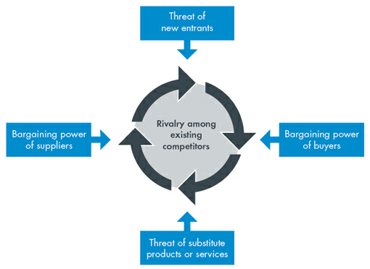
Porter five forces

Fig 2: Porter five forces
Source: (Pringle and Huisman, 2019)

Competitive rivalry
The competition among the universities of the UK is in a high position. The world’s high-ranking universities are established in the UK. Therefore, it is also challenging for the University of Wales Trinity Saint David (UWTSD) to compete with other universities like the University of Oxford, the University of Cambridge, and London’s Global University. The UCAS data shows that several universities offer places to over 90%, particularly those who apply for admission but around a fifth of oxford applicants get an offer (Pringle and Huisman, 2019). Also, some universities give exceptional service; therefore, they want outstanding students, and students witness a complex to getting into universities (Pringle and Huisman, 2019). Renowned and established universities make the structure more complex, and sometimes it’s challenging for students to reach their desired subject to study for outrageous applicants' applications.
The threat of new entry
The threat of new entry is high, particularly for new educational institutions. Cause there existence of several reputed universities and people prefer those institutes to others. Also, overseas students come so far away to get a degree from a reputable university standing in a good position in the world ranking. Several reputed universities are here in the UK, such as the University of Oxford, the University of Cambridge, etc. Also, the current universities are developing their particular degree subjects and quality (Mahat, 2019). To match up with those, a new institution will suffer a lot. Also, services like experienced teachers and new ones cannot be managed during the inception. Also, campus facilities, more comprehensive options to study, accommodation, and so on are hindrances for new ones in higher education.
Threat of substitutes
In the UK, there is little threat of subscribes as the maximum number of students choose to study in the UK. As said before, overseas students must carry higher costs than local students. Also, the competitors on the European mainland enable offers with a lower quality of provision. The scenario shows that fewer private suppliers are available, and their market position is weak. It occurred because of the high prices of study (Mahat, 2019). Also, the four-year degree courses have gap years and two-year programs, including online courses, summer courses, and life experience. These all the competitive options have enhanced the standard tuition fees too, and students are in the buffer zone towards debt and suffer with the pressures on universities in case of adapting to accommodate an ever-widening variance in student needs.
Bargaining power of suppliers
In higher education sectors, suppliers are not only teachers and infrastructure. For example, an individual is assuming to emphasize STEM courses to grow demand and be prepared to witness an enhancement in salary costs. Through a survey, it has been evaluated that the average post-secondary STEM teaching salary is €88116.86, and the average humanities salary will be around €80218.62. Without the suppliers, the STEP per position becomes a cheaper rate (Mahat, 2019). By establishing new lab sciences, business faculties won’t only ensure long-term facilities but also get paid for those. Therefore, physical plant demands can dwindle suppliers' salary budgets and weaken their ability to attract and keep top teaching talent in higher education.
Bargaining power of buyers
Students are the buyers of higher education, including local students of the UK. International students also come to study for their higher education. International students are required to much high tuition fees to get an education in UK higher educational institutes. The bargaining power of students is low here as they are bound to pay and get quality education. Maximum quality educational institutions are embedded in the UK (Mahat, 2019). The scholarship is a limited offer to a limited number of students with some requirements and a portion of the scholarship is made available where international students can be attracted. In the case of scholarships, the students also have less buying power.

Showcase how “the University of Wales Trinity Saint David (UWTSD)” is affected by global factors

Global factors are cultural and social influences, legal issues, demographics, political changes, etc. These are some essential factors that sometimes positively or negatively impact an organization (ul, 2020). The “University of Wales Trinity Saint David (UWTSD)” is amongst the three oldest universities in England and Wales. It was established in 1822 under the Royal Charter, and the intuition is accredited as a public British University. The university is focused on employment and dedicated to ensuring students can witness development in academic and practical knowledge. This instruction is also affected by several global factors, positively or negatively.
Cultural and social aspects influence the University of Wales Trinity Saint David (UWTSD). Britain has a different culture, influenced by the combined nation’s history, religious life, etc. UK universities are surrounded by various cultural and social aspects regarding teaching and learning (Faizan et al., 2019). Besides, the culture is covered by research, knowledge exchange, and improving lives. As a result, students can get a comprehensive view besides knowing several aspects clearly and perfectly. Also, this society and culture help the university to maintain a diverse community and learn to maintain these decently (Faizan et al., 2019). Also, this strong and diverse culture of teaching is helping to improve the learning of the students along with improving the quality of life for people across the UK.
In case of legal issues, the UK is very restricted, and the University of Wales Trinity Saint David (UWTSD) is also required to follow the legal aspects strictly. Common legal issues needed by the “University of Wales Trinity Saint David (UWTSD)” are employment, single-sex education discipline, financial assistance, athletics, etc. In the case of teaching profession, the UK has law for teachers where a teacher must go through several processes before teaching students (Faizan et al., 2019). This legal aspect positively impacts the university; by this process, appropriate teachers are getting into the job, and the university can ensure quality education for their students.
Because of the Brexit issue, the university’s relationship with the European Union will not be strengthened just like prior. Cause, now the other universities are going to change their approach to global relations with an enhancement focus on regionalisation and the benefits of curriculum activates that the university was before to get from European Union universities, now they are going to deprive of those (Faizan et al., 2019). Now “the University of Wales Trinity Saint David (UWTSD)” is required to refresh its international strategies and strengthen its path to follow the UK’s government policy rather than European Union. New immigration requirements and the complex legal framework of the global partnership will make the university suffer a lot (Faizan et al., 2019). Overseas students will witness more complexities, and the process will not be flexible for so many.
For the outbreak of COVID-19, several restrictions are there, which the University of Wales Trinity Saint David (UWTSD) is required to follow. But because of COVID-19, the university, the teachers, and the students are equipped with online learning sessions and tools (Ng, 2022). Therefore, when it’s difficult to take classes or any future disease appears, the university won’t be in a dilemma regarding their teaching. Flexible tools and technologies are used by teachers and students, such as Zoom, Google Meet, Google Drive, and so others. Now with these technologies, the university can ensure more quality education, and it also provides that students can get enough resources and study materials quickly (Ng, 2022). Now, easies technologies and methods are also there to take exams.
After the break out of COVID-19 and this horrible phase, university students still suffer from financial pressures. The university is also facing not going adequate funds to operate its operations effectively and smoothly (Ng, 2022). It is much more complex for that aspect where income relies on overseas students. Also, several overseas students have gone to their homes, and after COVID-19 issues, they didn’t come to join the university once again.
The enhancement in the competition is changing the demographic realities at “the University of Wales Trinity Saint David (UWTSD)”. Dramatic changes are affecting the university’s academic institutions (Ng, 2022). The students are dropping out of university, and currently, along with “the University of Wales Trinity Saint David (UWTSD)”, others are also in a competition for the declining number of potential students.
Now in the UK, the cost of everything is increasing. Inflation is one of the reasons, and Brexit is another one. For universities, it becomes tough to remain competitive. By witnessing high costs in the UK, the university’s fund is deducting and losing the option to invest in personnel, infrastructure, and the necessary student facilities. For the oversee students, the university is suffering to offer adequate scholarship services too. With the cost enhancement, the students are becoming demotivated to continue their studies. But this global factor is also positively attached to the higher education sector, as intuitions can manage to cut costs, saving more money than before (Ng, 2022). It has also been evaluated that the university and other institutions are surrounded with strategies that assist in mitigating the effects posed by these so-called challenges.

Conclusion

The report has evaluated the higher education sector situation by applying appropriate models. Lastly, global factors' positive and negative impacts on the University of Wales Trinity Saint David (UWTSD) have been showcased. The PESTEL analysis comprehensively acknowledges the external environmental factors' positive and negative effects and the competitive analysis and knowledge of power and higher education sector scenarios. Lastly, the significance of global factors on “the University of Wales Trinity Saint David (UWTSD)” is showcased by enlightening different factors such as political, social and cultural, economic, and so on. Both positive and negative sides are delineated in a way that gives an insightful view of the University of Wales Trinity Saint David (UWTSD).

References

Goedegebuure, L. and Hayden, M., 2021. Overview: Governance in higher education—concepts and issues. Higher Education Research & Development, 26(1), pp.1-11.
Ahmed, J.U., Ahmed, K.U., Shimul, M.A.S. and Zuñiga, R., 2019. Managing strategies for higher education institutions in the UK: an overview. Higher Education for the Future, 2(1), pp.32-48.
Pan, W., Chen, L. and Zhan, W., 2019. PESTEL analysis of construction productivity enhancement strategies: A case study of three economies. Journal of Management in Engineering, 35(1), p.05018013.
Zhang, N., Williams, I.D., Kemp, S. and Smith, N.F., 2021. Greening academia: Developing sustainable waste management at Higher Education Institutions. Waste management, 31(7), pp.1606-1616.
Spruin, E., 2021. Creating a Competitive Advantage in the UK Higher Education Sector through Mirrored Course Delivery: A case example.
Pringle, J. and Huisman, J., 2019. Understanding Universities in Ontario, Canada: An Industry Analysis Using Porter's Five Forces Framework. Canadian Journal of Higher Education, 41(3), pp.36-58.
Mahat, M., 2019. The competitive forces that shape Australian medical education: An industry analysis using Porter’s five forces framework. International Journal of Educational Management.
ul Haque, A., 2020. Varying Occupational Stress and Organisational Commitment Within the University Staff of Contrasting Economies (Cross-Sectional Comparative Study of Middle Range Public Universities in Pakistan and the UK). University of Wales Trinity Saint David (United Kingdom).
Faizan, R., Haque, A., Cockrill, A. and Aston, J., 2019, March. Females at strategic level affecting logistics firms’ competitiveness: Qualitative comparative analysis of contrasting gender in Pakistan and Canada. In Forum Scientiae Oeconomia (Vol. 7, No. 1, pp. 57-71).
Ng, K.C., 2022. The factors that influence the state of readiness for entrepreneurial opportunities: a case study of late-career professionals, managers, executives and technicians (PMETs) in Singapore (Doctoral dissertation, University of Wales Trinity Saint David).

