A Comparative Analysis of Financial and Strategic Approaches in Shangri-La Hotels and Travelodge Hotels
Word count: 2100
Student ID number: 1815431
Module: Financial Management for the Hotel Industry

Table of Contents
Introduction 1
Revenue Analysis 1
Market Position 2
Growth Potential 3
Financial Commitment to CSR 4
Conclusions and Recommendations 5
Reference List 7
APPENDICES 9
Revenue Highlights for Shangri-La 9
Revenue Growth for Travelodge 9
Overview of Shangri-La and Travelodge Hotels 10

Introduction
The global hospitality industry is continually changing and developing. To stay on top of the competition, sustain growth, and maintain profitability, hotel chains must learn to adapt and navigate complex challenges. This business report will analyse and compare two of the biggest players in the sector: Shangri-La Hotels and Travelodge Hotels. There entities function in a different segment of the market – Shangri-La offers luxury accommodation, while Travelodge caters for budget-friendly options. However, they both maintain a competitive advantage in the market by implementing strategic financial management decisions.
As such, the primary goal of this essay is to critically analyse the financial management strategies and practices of the Shangri-La Hotel Group and Travelodge Hotels. The essay will focus on key aspects that influence their financial performance and sustainability. The first part will compare revenues, their sources, and relevant trends. The second part of essay will present the market position of the two hotel chains, focusing on market share, demographics, and brand image. The third part will evaluate growth potential and what strategies the two entities can implement to sustain it. Finally, the essay will assess the commitment Corporate Social Responsibility (CSR) initiatives, which play a vital role in contemporary business strategies. Based on this analysis, the final section will provide recommendation for growth and market positions for each company.

Revenue Analysis
As mentioned above, Shangri-La Hotels and Travelodge Hotels operate within different market segments, which influences their revenue generation strategies and results. Revenue is the amount of money a company receives from its customers in exchange for products or services (Hayes, 2022).
Shangri-La Hotels is known for its luxury accommodation and services. Shangri-La was founded in 1971 in China. It grew from a family business to a multinational organisation with over one hundred hotels. Throughout the years, the company has extended its product and services. The company focuses on major cities and exotic destinations, which attracts wealthy tourists and business travellers. In terms of revenue streams, the biggest source was hotel operations followed by investment properties and property development for sale (Shangri-La Group, 2024). In 2023, the total revenue was USD 2.1 billion, which was 46.5% higher than in the previous year (Shangri-La Group, 2024). As such, the revenue trend for Shangri-La has been significantly positive. The growth in revenue was mainly driven by Hong Kong and China (Oh, 2024). Expansion to North America and Europe also contributed to revenue growth. The interest and ability to travel has picked-up in the last two years after pandemic restrictions have eased across the globe (Oh, 2024). Additionally, the growing middle- and upper-class in Asia has increased the demand in luxury accommodation (Stellar Market Research, 2023). Finally, their revenue was augmented by loyalty programmes and partnerships with luxury and lifestyle brands, which has enhanced customer spending (Shangri-La, 2024). The company has also faced challenges from increasing geopolitical tensions in some areas across the globe, which dampened spending on luxury accommodation (Lowman, 2023).
In contrast, Travelodge is predominantly a budget hotel chain. It is a British company that started operating in the mid-1980s. Like Shangri-La, most of Travelodge’s revenue comes from hotel operations of its vast network of properties across UK, Ireland, and Spain. In 2023, the company’s revenue was around GBP 1 billion, which was almost 14% higher than in 2022 (Travelodge, 2024a). Travelodge’s revenue was influenced by economic downturns. Although, during these periods spending on travelling decreases due to reduce disposable income, Travelodge has performed well compared to other hotels because travellers seek more affordable options. Revenue has also increased due to marketing campaigns emphasising value for money (Travelodge, 2024a). Additionally, the company has extended its offerings to business-class rooms, which brought further revenues from people travelling for work purposes (Travelodge, 2024a). Nonetheless, the company has also faced challenges such as, keeping prices low in a period of economic turmoil (Travelodge, 2024a).
The future revenue trends for both will likely be shaped by their ability to adapt to changing consumer behaviours and economic conditions. Shangri-La may need to explore new luxury markets or innovate in luxury travel experiences to sustain growth. On the other hand, Travelodge could benefit from expanding its digital presence and exploring new cost-efficient operational models to enhance its value proposition in a volatile market.

Market Position
Shangri-La Hotels and Travelodge Hotels have different market positions due to their unique business strategies, customer demographics, and brand perceptions.
Shangri-La has established itself in the luxury segment of the hospitality market. The brand is synonymous with high-end services and facilities such as, gourmet dining, luxurious spas, and business amenities (Bhasin, 2018). The brand image also emphasises quality of services and experiences. This positioning allows Shangri-La to charge higher rates and maintain a strong market share in the luxury sector. It is particularly strong in Asia-Pacific. Shangri-La’s customer demographics include wealthier individuals and corporate clients who prioritise comfort and exclusivity over cost (Bhasin, 2018).
Conversely, Travelodge Hotels positions itself in the budget hotel sector and is primarily aimed at cost-conscious travellers. Customer demographics include families, groups, business travellers, and younger tourists on a limited budget (Hoang, 2023). Travelodge has a significant market share in the hotel industry in the UK, being one of the largest players. In the UK, 27% of hotel customers use Travelodge (Statista, 2023). The brand perception of Travelodge is that of a reliable and accessible option for budget-friendly accommodations (Hoang, 2023). Compared to Shangri-La, the company appeals to a broader audience.
When comparing the two companies, it is evident Shangri-La focuses on luxury and premium services. This enables the company to leverage higher profit margins per customer. On the less positive side, this may limit its market reach as many individuals cannot afford its services. On the other hand, Travelodge prioritise volume sales at lower profit margins per room. Travelodge’s model appeals to a wider range of customers. Each group’s market position reflects a tailored approach to their target audiences, which highlights the diversity of strategies within the hospitality industry (Aladag et al., 2020).

Growth Potential
Shangri-La Hotels is positioned in the luxury segment, which presents specific growth opportunities and challenges. The group's expansion strategy involves entering high-value markets with strong demand for luxury accommodations, such as major global cities and popular tourist destinations in Europe, North America, and Asia (Stellar Market Research, 2023; Shangri-La, 2024). Shangri-La has also been increasing its number of hotels in China (Shangri-La Group, 2024). The country has a growing upper-class that can afford spending on luxury services. This represents an opportunity of growth for Shangri-La. Furthermore, Shangri-La continues to explore mixed-use developments, combining residential, retail, and hotel operations (Shangri-La Group, 2024). However, the company also faces challenges such as, high cost of entry in the luxury market, significant investments needed for property and service quality, and the cyclic nature of the luxury market (Jain et al., 2023). Moreover, the company faces competition from other luxury hotel chains and boutiques that offer unique services (Jain et al., 2023).
Travelodge Hotels has a different set of opportunities and challenges. Its growth strategy focuses on expanding its network across the UK in strategic locations such as, near airports, in city centres, and alongside major highways (Travelodge, 2024a). Travelodge also aims to enhance its appeal by refurbishing existing hotels and offering more competitive services, like business-class rooms, to attract a broader range of customers (Travelodge, 2024a). Additionally, in 2023, the company has opened six new hotels in Spain, leveraging the growing trends towards international and budget travel (Gill, 2023).
Potential barriers for Travelodge's growth include the competitive nature of the budget accommodation sector, where price volatility can erode profitability (Chen, Kuo and Tsaur, 2022). Additionally, economic downturns can also decrease sales due to limited spending budgets. The brand’s challenge is to maintain quality and customer satisfaction, while keeping low prices (Chen, Kuo and Tsaur, 2022). Poor services can have a detrimental effect on the company’s image and therefore, growth opportunities.
In summary, Shangri-La's growth potential is driven by its brand image, affluent customer segment, and diversified real estate ventures. The company’s challenges are the high costs and economic sensitivity of the luxury sector. Travelodge can capitalise on growing trend for budget travelling, but it needs to balance affordability and quality of services. Both companies need to find appropriate strategies to successfully navigate these challenges.

Financial Commitment to CSR
According to Cech, Jindrichovska and Neubauer (2018), corporate social responsibility (CSR) is the voluntary integration of social and environmental consideration into business activities. As such, companies that integrate CSR do not only care about profit-maximisation, but they also want to bring positive outcomes in society. In the hotel industry, there is a growing demand for CSR as consumers increasingly prefer brands that demonstrate awareness of pressing social and environmental issues. Hotels responding to this trend enhance their brand reputation and customer loyalty, but also increase operational efficiencies and innovation (Cech, Jindrichovska and Neubauer, 2018).
Shangri-La Hotels has a robust CSR strategy that integrates social and environmental considerations into its business operations. The group's CSR approach focuses on sustainability, community engagement, and employee welfare (Shangri-La group, 2022). Shangri-La has been actively involved in environmental conservation efforts, such as reducing carbon emissions, implementing energy-saving technologies, and waste reduction programs across its properties (Shangri-La Group, 2022, pp. 28-35). Additionally, the hotel chain has committed significant financial resources to community welfare projects, including education programmes, health and safety initiatives, and disaster relief efforts (Shangri-La Group, 2022). For instance, Shangri-La has led the "Sanctuary, Shangri-La Cares for Nature" project aimed at protecting biodiversity in regions where the group operates. The company allocates a portion of the revenue for community projects and sustainable practices to ensure commitment to CSR goals. The company has received many sustainability-related awards such as, CDP China “Guardian of Nature Award” 2022, St James Settlement “Save and Share Gold Partnership” Award 2022, and Hong Kong Council of Social Services (HKCSS) “Caring Company” Label 2022-2023 (Shangri-La Group, 2022, p.7). The company’s extensive efforts and awards truly emphasise its commitment to CSR goals.
Travelodge Hotels also engages in CSR activities, but its activities are more focus on its specific business model. In 2023, Travelodge has established three main goals related to CSR (Travelodge, 2023). Firstly, the company is committed to employment inclusivity. The company wants to achieve a 50/50 ratio between men and women in management roles by 2025. Additionally, the company wants to focus on the well-being of its employees by offering numerous benefits and opportunities for trainings. Finally, Travelodge want to tack climate-change threats and align with the net-zero emission goal. The company aims to achieve this by reducing water consumption per guest by 100 litters and review waste production processes (Travelodge, 2023, p. 6).
Therefore, both hotel groups recognise the importance of CSR in building brand reputation and ensuring long-term sustainability. Each organisation’s CSR financial commitments are indicative of their respective branding strategies and the specific demands of their target customer demographics. The approaches of both companies contribute positively to their communities, environment, and market competitiveness.

Conclusions and Recommendations
Throughout this report, the financial management strategies of Shangri-La Hotels and Travelodge Hotels have been analysed. The revenues of both companies have been growing in the recent years. It has been mostly driven by the ease of travel restrictions and growing interest in travelling. In 2023, Shangri-La’s revenue was twice as large as Travelodge’s revenue. In terms of market positioning, the companies are established in opposite segments. Shangri-La offer luxury accommodation and targets wealthy customers seeking premium services while, Travelodge provides budget accommodations for middle-class families and tourists. Both companies have a strong commitment towards CSR goals. They focus on reducing environmental problems, create an inclusive workforce, and offering benefits for their employees. Due to their distinct business models, each company presents different challenges and opportunities for growth.
For Shangri-La Hotels, the recommendation is to invest in exclusive experiences and partnerships that enhance its luxury appeal. They should continue their strategy of expanding in emerging markets in East and South-East Asia, where luxury travel is growing. By doing so, the company can differentiate itself from competitors and attract a new demographic of affluent travellers.
For Travelodge Hotels, the recommendation is to expand its digital marketing efforts and online booking convenience. Their marketing strategy should focus on emphasising both affordability and quality of services. By doing so, Travelodge can attract and retain customers.

Reference List
Aladag, O.F., Köseoglu, M.A., King, B. and Mehraliyev, F. (2020). Strategy implementation research in hospitality and tourism: Current status and future potential. International Journal of Hospitality Management, 88(3), p.102556. doi:https://doi.org/10.1016/j.ijhm.2020.102556.
Bhasin, H. (2018). Marketing mix of Shangri-la Hotels and Resorts - Shangri-la Marketing. [online] Marketing91. Available at: https://www.marketing91.com/marketing-mix-of-shangri-la-hotels-and-resorts/.
Cech, P., Jindrichovska, I. and Neubauer, J. (2018). Corporate Social Responsibility in Hotel Industry: Empirical Analysis of Transitional Market. International Journal of Economics and Business Administration, VI(Issue 1), pp.61–89. doi:https://doi.org/10.35808/ijeba/152.
Chen, I-Fei., Kuo, P.-Y. and Tsaur, R.-C. (2022). Price Risk Strategy Analysis for Budget Hotels in the Post-Pandemic Era. Axioms, [online] 11(10), p.550. doi:https://doi.org/10.3390/axioms11100550.
Gill, R. (2023). Travelodge gears up for major expansion in Spain. [online] www.businesstravelnewseurope.com. Available at: https://www.businesstravelnewseurope.com/.
Hayes, A. (2022). Understanding Revenue. [online] Investopedia. Available at: https://www.investopedia.com/terms/r/revenue.asp.
Hoang, N. (2023). UK - Evaluating 3 budget hotel brands’ journey through the purchase funnel. [online] business.yougov.com. Available at: https://business.yougov.com/content/46910-uk-hotel-purchase-funnel-analysis-premier-inn-travelodge-holiday-inn.
Jain, V., Wirtz, J., Salunke, P., Nunkoo, R. and Sharma, A. (2023). Luxury hospitality: A systematic literature review and research agenda. International Journal of Hospitality Management, [online] 115, p.103597. doi:https://doi.org/10.1016/j.ijhm.2023.103597.
Lowman, P. (2023). Geopolitical Tensions Persist . [online] Geopolitical Tensions Persist | Investment Quorum. Available at: https://investmentquorum.com/news/the-lowdown-geopolitical-tensions-persist [Accessed 9 May 2024].
Oh, T. (2024). Shangri-La Asia returns to black in FY2023 with US$184.1 million net profit. [online] The Business Times. Available at: https://www.businesstimes.com.sg/companies-markets/shangri-la-asia-returns-black-fy2023-us-184.1-million-net-profit.
Shangri-La Group (2022). Sustainability Report 2022. Available at: https://sitecore-cd.shangri-la.com/-/media/Project/Shangri-La-Group/Investor/Files/Corporate-Governance-and-CSR/Sustainability-Reports/2022_SLA_Sustainability-Report_EN.pdf. [Accessed 8 May 2024].
Shangri-La Group (2024). 2023 Final Results Announcement. Available at https://www1.hkexnews.hk/listedco/listconews/sehk/2024/0322/2024032200585.pdf. [Accessed 4 May 2024].
Statista (2023). Travelodge brand profile UK 2022. [online] Statista. Available at: https://www.statista.com/forecasts/1335657/travelodge-hotels-brand-profile-in-the-uk#:~:text=What%20is%20the%20usage%20share.
Stellar Market Research (2023). Asia-Pacific Luxury Hotel Market: Industry Analysis and Forecast (2024-2030). [online] Stellar Market Research. Available at: https://www.stellarmr.com/report/Asia-Pacific-Luxury-Hotel-Market/1250.
Travelodge (2023). Better Future−Our Sustainability Plan 2023. Available at: https://www.travelodgesustainability.co.uk/wp-content/uploads/sites/2/2023/05/Better-Future-Report-2023.pdf. [Accessed 8 May 2024].
Travelodge (2024a). Record full year performance with Travelodge well positioned for long-term growth. [online] Travelodge Corporate Website. Available at: https://travelodge.co.uk/our-business/blog/press_release/record-full-year-performance-with-travelodge-well-positioned-for-long-term-growth/#:~:text=Jo%20Boydell%2C%20Travelodge%20Chief%20Executive.
Travelodge (2024b). Results for the Year Ended 31 December 2023. Available at https://www.travelodge.co.uk/nw/sites/default/files/2023_Q4_Financial_Results_Presentation_FINAL.pdf. [Accessed 9 May 2024].

APPENDICES
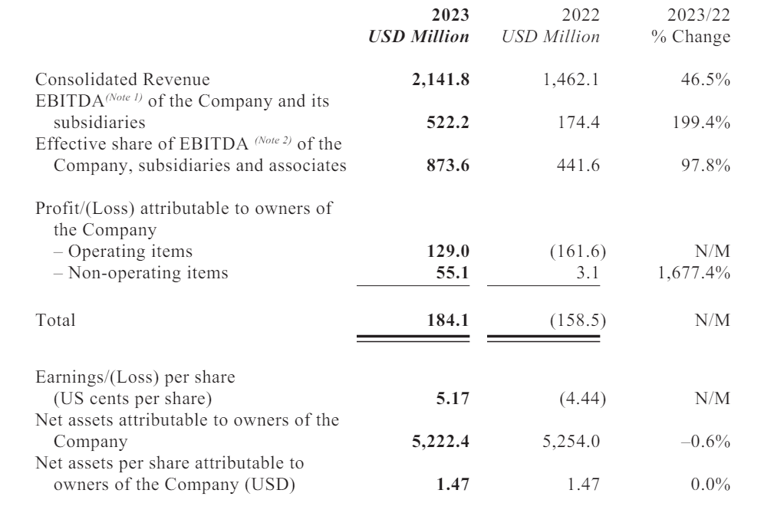
Revenue Highlights for Shangri-La. (Source: Shangri-La Group, 2024).
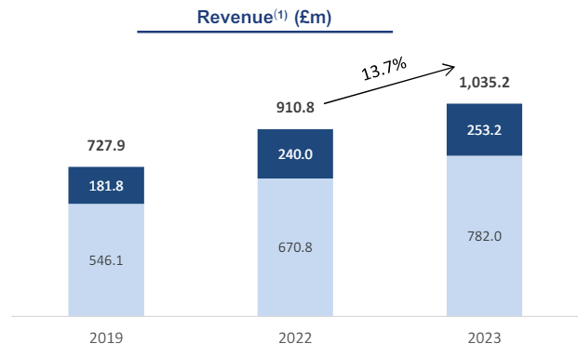
Revenue Growth for Travelodge. (Source: Travelodge, 2024b).

 | Shangri-La Group | Travelodge
Founding Year | 1971 | 1985
Headquarters | China | UK
Number of employees | 40,000+ | 13,000+
Number of hotels and bedrooms | 104; 40,000 | 600; 46,000
Locations | 76 destinations across Asia, Oceania, Europe, North America, and Africa | UK, Ireland, Spain
Segment | Luxury | Budget
Customer Demographic | Wealthy individuals, business partners | Middle-class individuals, business partners with reduced budget
Market Position | One of Asia’s largest players | One of UK’s largest players
Competitors | Hilton, Marriott, Taj Hotels, Starwood Hotels, Hyatt, Radisson Hotels. | Ibis, Sleep Inn, Days Inn, easyHotel, Premier Inn
Revenue (2023) | USD 2,141.8 million | GBP 1,035.2 million (approx. USD 1290.3 million)
CSR | Waste-reduction, technology-saving, education, welfare conversation programmes | Waste-reduction programmes, water-saving initiatives, inclusive employment, employee benefits
Overview of Shangri-La and Travelodge Hotels. (Source: Shangri-La Group, 2024; Travelodge 2024a, 2024b).

This means during periods of economic downturn, the luxury market is more affected as customers have less disposable income.

