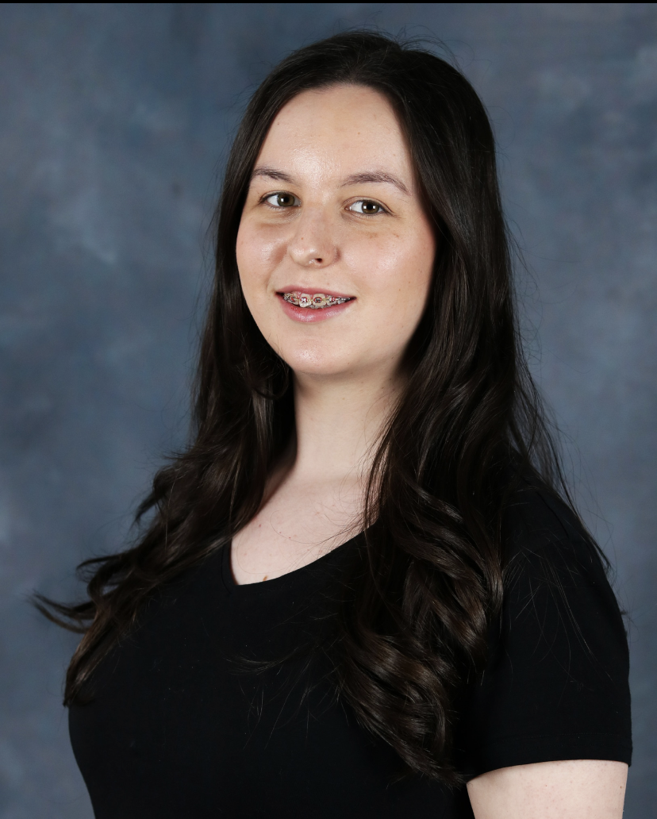
Freya Elizabeth
Email: freyataylorevans@icloud.com
Phone: 07864381288
Playing age: 17-25
Height: 5'7”
Hair: Brown
Eye: Hazel
Gender: Female
Build: Pear shape
Nationality: Welsh

Training

BA (Hons) Musical Theatre – Wales Academy Of Voice and Dramatic Arts – Present
A-Level, Level 3 BTEC and GCSE - Treorchy Comprehensive School – Graduated 2024
Credits Include

Production | Roles | Venue/Company | Director
Waiting The Dating Game | Multirole | WAVDA Studio Theatre | Holly Robert’s
Dŵr | Still Waters | Extra | S4C and Channel 4 | Angharad Lee
Everybody’s Talking About Jamie | Ray | Park and Dare Theatre – Treorchy Comprehensive School | Laura Williams
New Beginnings | Featured actor | It’s My Shout Ltd | Tonya Smith
Made in Dagenham | Cass | Park and Dare Theatre – Treorchy Comprehensive School | Laura Williams
Oklahoma | Featured ensemble | Park and Dare Theatre – Treorchy Comprehensive School | Laura Williams
Children in Need | Choir member | BBC | N/A

Skills

Accents: Welsh | RP | Northern | Northern Irish | Southern & standard American
Singing: Mezzo
Dance: Jazz, Tap, Commercial, Heels
Languages: English, basic Welsh
Stage Combat: ACTT Unarmed (Distinction)
Other: Driving | Cycling | Horse riding | Swimming | Range of accents | Improvisation | Singing

