
Module Title - Operating Hotel Facilities
BMIH4006
Assignment Title – Student Journal, Assessment of Practical Tasks, Presentation (Component 1,2&3)
Student Name – Andreea Gama
Student ID – 2219781
Tutor Name: Scott James

Table of Contents
Component 1: Learning Log 3
Introduction 3
Reflection 4
Conclusion 6
Component 2: Assessment of practical task 7
Component 3: Presentation 10
Introduction 10
Effective training strategies for the housekeeping staff 11
Monitoring the effectiveness of the developed training sessions 13
Employee engagement model to improve the collaborative working effort 14
Conclusion 17
References 18

Component 1: Learning Log

Introduction
Many vital factors are associated with the lodging division and this sector depends on the expertise of the working staff of that sector consists of expertise. The working staff of the lodging sector needed to be out of restrictions regarding time, administration, interpersonal and communication-related capabilities. This particular report will provide a self-reflection on the essential capabilities and expertise of the working staff that are required during the performance within the housekeeping sector. Therefore, a detailed description of the capacities and capabilities of Primer INN Hotel in the UK will be discussed in the report. After that, reflection on the required development of selected skills and their developing process will be highlighted in the report with the help of Gibbs’ reflection model.

Reflection
During my professional journey as a housekeep-related staff within the Premier Inn hotel in the UK some difficulties and uneasiness have been faced by me at the initial times. While working cooperatively with the housekeeping team I was not that efficient and expert to compete with the other experienced employees (Jones, 2010). Extreme competition in the hotel industry of the UK requires skilled, trained, and expert employees and a managing team to compete effectively. The housekeeping team has also a vital role in enhancing the business of the organisations. Premier Inn maintained an enhanced and capable team of housekeeping in maintaining their services at a high level. Therefore, the requirements of the skills and expertise were unignorable regarding the high-class service provision. During my duty days, I have felt the necessity and vitality of certain required skills such as communication skills, leadership skills, resource management skills, analysis and evaluation skills, motivation skills and time management skills. Therefore, I realised that effective and efficient housekeeping staff have to be experts in these skills to perform with full potential so that desired outcomes can be gained. I have also realised some of my skills were not developed at their best level. Subsequently, I was under pressure that caused me to decrease my self-confidence and below of dignity. The lack of some essential skills and their effectiveness was the reason behind my poor service provision during my journey within the Premier Inn hotel. According to my evaluation, unskilled and inefficient housekeeping employees cannot perform effectively within a competitive market (Tesone, 2010). Customers are valuable assets for the hospitality industry and their satisfaction and expenditure ensures the company's profit and popularity. Housekeeping teams in the hospitality industry play a vital role in regarding the customers’ satisfaction. Therefore, the housekeeping team of the Premier Inn is required to develop and enhance their communication skills, management skills, time management skills and others (Casado, 2012). As per my analysis, I also had some of the skill gaps that restricted me from performing within the hotel industry to my full potential. My lack of communication skills caused me some difficulties in performing cooperatively. Other hand the lack of time management skills was the reason behind being late for my given task accomplishment. Leadership management skills were another important factor that required me to develop so that I could motivate and inspire my entire team to work dedicatedly and efficiently (Wood, 2013). Later initiating and implementing some effective and beneficial approaches I succeeded in developing all of the required skills within the housekeeping team of the Premier Inn hotel. I started regular basis meetings and conferences with the authorities and coworkers that helped me enhance my communication skills (McFarlin, 2023). Attending various effective training sessions and management courses was beneficial to me in improving my management skills. Following the properly planned schedule and gathering real-life experiences facilitate me in enhancing my time management skills (Chron Contributor, 2021).

Conclusion
This specific report has described the importance of different developed skills of the housekeeping staff of the Primer Inn to compete within the competitive hospitality industry of the UK. A detailed reflective statement has been presented in the report section with the help of Gibbs' model to show the related aspects and factors that can enhance the business and services of the Premier Inn hotel through the effective housekeeping staff. Individual's personal experience during the performance within the particular hotel as Housekeeping staff has been elaborated in the report with the help of Gibbs' model. The importance of various skills that are required to be obtained by the housekeeping staff of the Premier Inn that has been mentioned earlier has been discussed as a reflective form. Along with the effective process of developing and improving the skills also has been highlighted in the report.

Component 2: Assessment of practical task
Problem | Why did it happen? | What are you going to do? | How will you prevent this from happening in the future? | What measures would you introduce to improve team effectiveness?
Dirty curtains and bedsheets | The problem with dirty curtains and bedsheets may mainly occur due to the housekeeping staff's negligence. It is their duty to clean the curtains and bedsheets on a daily basis and collect laundry regularly (Alcalde-González et al., 2021). | As soon as the problem gets identified I should order the housekeeping staff to get the curtains and bedsheets cleaned as soon as possible. Therefore I should seek the guests who got affected due to this problem and compensate them in another way for instance by providing them discounts or offers. | I should initiate monitoring and tracking activity to ensure the cleanliness in the hotel rooms of Premier Inn, Bridgend. This can greatly help in preventing the same or similar situation from happening in the future. I should also pay a significant amount of attention to guest feedback and act according to it to ensure an optimum level of guest satisfaction Knezevic (Cvelbar et al., 2021). | Firstly I should increase awareness among the staff of Premier Inn, Bridgend Hotel to make them understand the importance of cleanliness and hygiene in the hotel. Therefore proper training should be provided to them to equip them with the necessary skills for maintaining cleanliness in the hotel.
Strained toilets | The complaints of the customers about lack of cleanliness in the hotels of Premier Inn, Bridgend may occur due to the yellow strain in the room toilets. The bacterial growth, use of hard water and overuse of cleaning materials might be the reason behind the occurrence of this issue. | I should first act toward cleaning the affected toilets and track the other toilets in different rooms to identify the same kind of problem. Therefore I will identify the particular housekeeping staff that are responsible for cleaning toilets in Premier Inn, Bridgend inform the management and ask them to take the required steps against those staff (Park et al., 2019). | The main factors are responsible for the uncleaned or yellow strained toilets in Premier Inn, Bridgend should be eliminated to prevent this kind of situation from happening in the future. Apart from that I will also restrict the use of hard water and excessive chemicals for toilet cleaning and encourage the use of certified materials. | I should introduce some learning sessions to increase the knowledge of the housekeeping staff about the use of chemicals and proper toilet cleaning procedures. This can help in increasing the overall effectiveness of the housekeeping staff.
Dirt on floor

Dirty laundry left uncollected | During the cleaning process within the Premier INN, some of the uncleaned cloth of the laundry was not collected according to the client’s complaint. This specific incident may occurred due to the high pressure on the housekeeping staff and their unintentional negligence (PARSIPPANY, N.J, 2023)  . | At that very moment, I would get notified I would instruct my efficient coworkers to collect those dirty uncleaned clothes without any delays. Also, I will apologise to the client personally and provide them with some extra complimentary services. | High alert and immediate conferences will be conducted by me with my coworkers related to housekeeping. Then the specific matter will discussed importantly even the specific housekeeping staff will be warned significantly and a special training session will be arranged by me for that staff. | Certain effective measures will be taken such as arranging new skill development programs, and effective approaches to make the employee efficient in working within a high-pressure situation (Sandlin, 2023)  .

Component 3: Presentation

Introduction
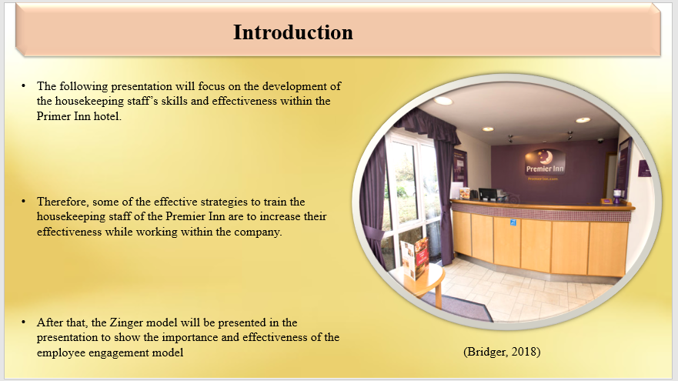
The following presentation will focus on the development of the housekeeping staff’s skills and effectiveness within the Primer Inn hotel. Therefore, some of the effective strategies to train the housekeeping staff of the Premier Inn to increase their effectiveness while working within the company will be provided. During the training season monitoring the overall process was important and the process of monitoring and its importance will be highlighted in the presentation. After that, the Zinger model will be presented in the presentation to show the importance and effectiveness of the employee engagement model in enabling a collaborative working environment.

Effective training strategies for the housekeeping staff
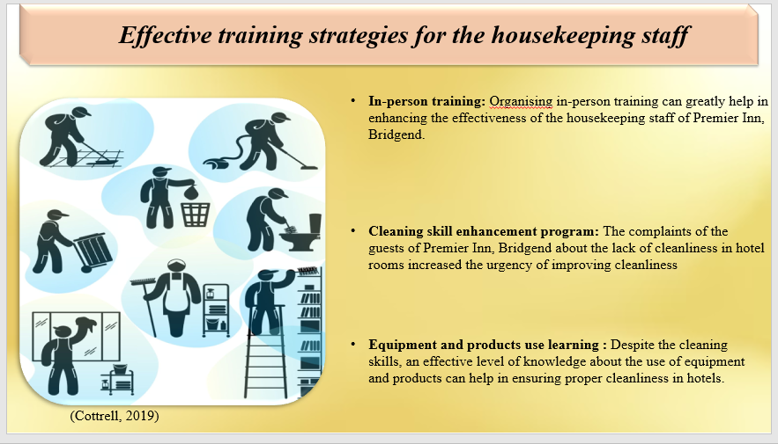
In-person training: Organising in-person training can greatly help in enhancing the effectiveness of the housekeeping staff of Premier Inn, Bridgend. This training strategy is highly applicable for the new arrivals in Premier Inn, Bridgend as housekeeping staff. This can greatly help in making them feel welcomed and comfortable in the team. Through this strategy, the key principles and values of housekeeping should be taught to the housekeeping staff making them aware of the needed skills and areas to be focused on more.
Cleaning skill enhancement program: The complaints of the guests of Premier Inn, Bridgend about the lack of cleanliness in hotel rooms increased the urgency of improving cleanliness in the rooms. The different activities carried out by the housekeeping staff require different kinds of skills to perform effectively (Bridger, 2018). Therefore, implementing a cleaning skill enhancement program can help in equipping the housekeeping staff with the necessary skills needed to maintain cleanliness in hotels.
Equipment and products use learning : Despite the cleaning skills, an effective level of knowledge about the use of equipment and products can help in ensuring proper cleanliness in hotels. Due to the availability of different cleaning chemicals and products, some of the housekeeping staff may not be familiar with the right use of products and chemical usage. Apart from the use of technical equipment usage for instance industrial vacuum cleaners may not be known properly by some particular housekeeping staff. Therefore, providing them with this knowledge can help in ensuring cleanliness in the Premier Inn, Bridgend.
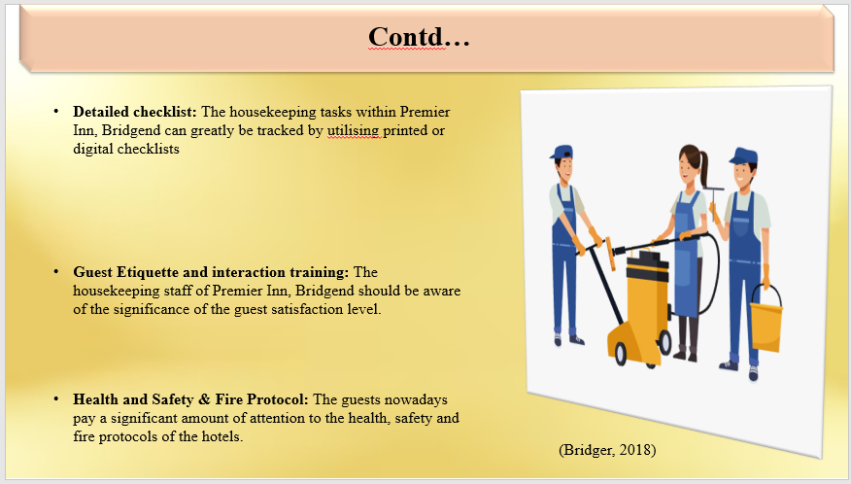
Detailed checklist: The housekeeping tasks within Premier Inn, Bridgend can greatly be tracked by utilising printed or digital checklists and by establishing proper housekeeping standards. Therefore, using a printed or digital checklist can help ensure effective competition and smooth running of the housekeeping tasks (Cottrell, 2019). These checklists should include clearly defined goals regarding work to demonstrate the ways for the housekeeping staff to achieve them.
Guest Etiquette and interaction training: The housekeeping staff of Premier Inn, Bridgend should be aware of the significance of the guest satisfaction level. Thus, providing them with guest etiquette and interaction training can greatly help in improving their treatment and interaction procedures with the guests. The decreased guest satisfaction level reported by Premier Inn, Bridgend’s guests can be due to poor interactions and lack of etiquette of housekeeping staff. Therefore, providing them with proper training can help increase their knowledge about cultural differences and make them capable of delivering an effective first impression.
Health and Safety & Fire Protocol: The guests nowadays pay a significant amount of attention to the health, safety and fire protocols of the hotels. Therefore, engaging the housekeeping staff of the Premier Inn, Bridgend in training sessions regarding health, safety and fire protocols can greatly help in ensuring the proper maintenance of health, safety and fire protocols within the hotels (Leiter and Bakker, 2010). Apart from maintaining the guest satisfaction level through this training it also can help in saving the lives of people. However, the protocols must have to be updated and refreshed on a regular basis.

Monitoring the effectiveness of the developed training sessions
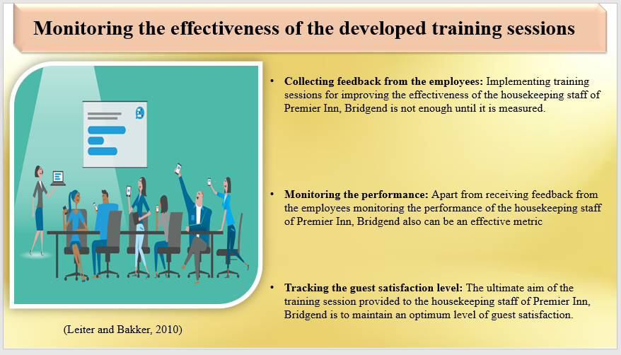
Collecting feedback from the employees: Implementing training sessions for improving the effectiveness of the housekeeping staff of Premier Inn, Bridgend is not enough until it is measured. Collecting feedback from the housekeeping of Premier Inn, Bridgend can greatly help in determining the effectiveness of the training sessions (Mullins and Dossor, 2013). It also can help the organisation to identify the challenges faced by the employees due to the training that further can help in developing more effective training sessions.
Monitoring the performance: Apart from receiving feedback from the employees monitoring the performance of the housekeeping staff of Premier Inn, Bridgend also can be an effective metric for determining the effectiveness of the training sessions. The overall aim of the training session is to improve the overall performance of the employees and ensure an optimum level of guest satisfaction (Quick, 2020). Therefore, monitoring their performance can help in determining the effectiveness of the training sessions as poor performance can indicate low effectiveness of the training session.
Tracking the guest satisfaction level: The ultimate aim of the training session provided to the housekeeping staff of Premier Inn, Bridgend is to maintain an optimum level of guest satisfaction. Therefore, tracking the satisfaction level of the guests can help in determining the effectiveness of the training session of the housekeeping staff (Raghubalan and Raghubalan, 2016). Despite receiving the training session, the housekeeping employees still fail to deliver an optimum level of guest satisfaction.

Employee engagement model to improve the collaborative working effort
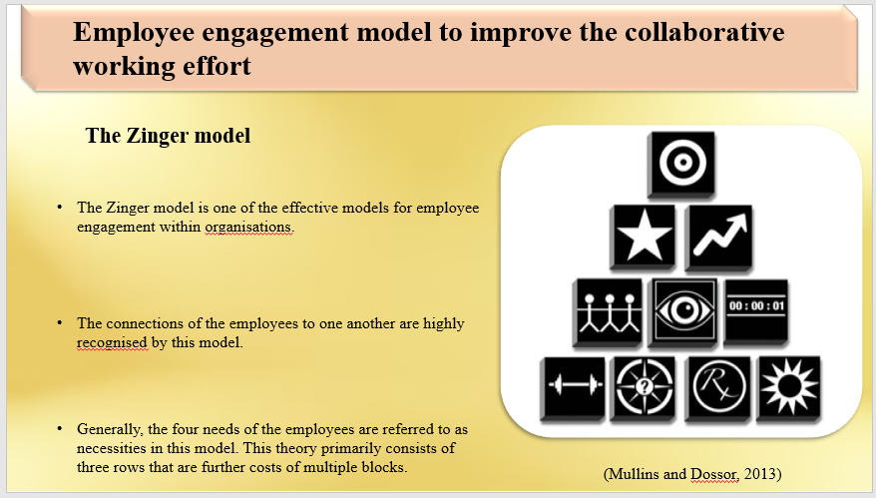
The Zinger model
The Zinger model is one of the effective models for employee engagement within organisations. The overall basis of this model is the psychological, assistance and burnout-related aspects of these employees. The connections of the employees to one another are highly recognised by this model. Therefore, applying this theory within the workplace of Premier Inn, Bridgend may be useful in making the housekeeping staff more engaged with their work and ensuring a smooth work delivery from them (Pellikaan, 2023). Generally, the four needs of the employees are referred to as necessities in this model. This theory primarily consists of three rows that are further costs of multiple blocks.
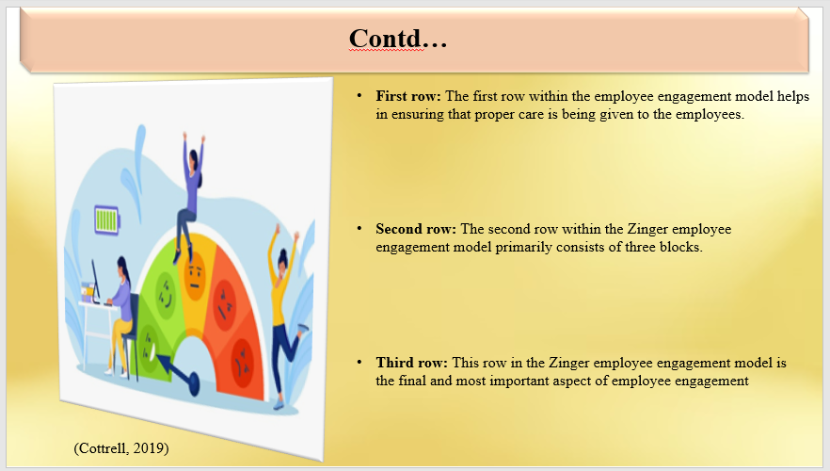
First row: The first row within the employee engagement model helps in ensuring that proper care is being given to the employees. Apart from that within this row the managers also should ensure that proper and meaningful work is provided to the employees that provides them with opportunities to demonstrate their strengths (Protopapas, 2022). While improving the engagement level of the housekeeping staff within Premier Inn, Bridgend the first row plays a crucial role in ensuring the job satisfaction level of the employees.
Second row: The second row within the Zinger employee engagement model primarily consists of three blocks. This row should greatly be considered by Premier Inn, Bridgend as within this row the relationships are built and recognition fostered (MacLennan, 2021). By paying attention to this row the organisation can make their housekeeping staff more engaged with their work by forming bonds and creating space for them.
Third row: This row in the Zinger employee engagement model is the final and most important aspect of employee engagement as increasing the overall productivity of the employees is the prime focus of this row (Raudys, 2023). Two different blocks for instance increasing performance and career progress are priotised in this row. Focusing on this block can greatly help Premier Inn, Bridgend to make their housekeeping staff more effective in their work and ensure a high guest satisfaction level.

Conclusion
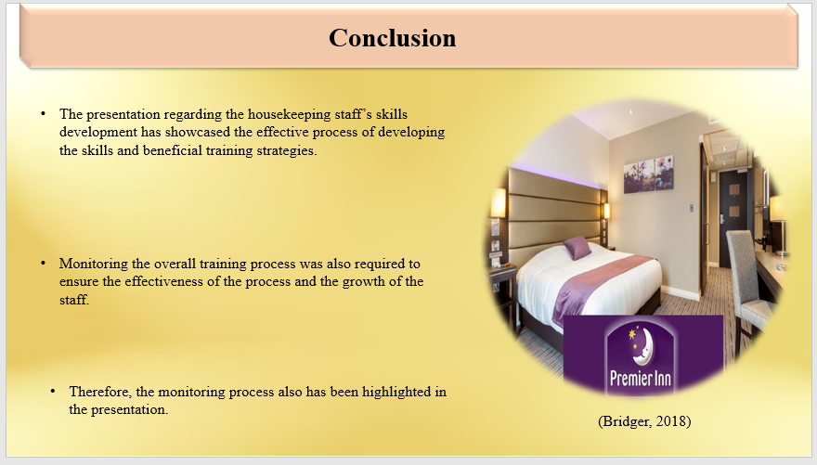
The presentation regarding the housekeeping staff’s skills development has showcased the effective process of developing the skills and beneficial training strategies. Monitoring the overall training process was also required to ensure the effectiveness of the process and the growth of the staff. Therefore, the monitoring process also has been highlighted in the presentation. The end section of the presentation portrayed the effectiveness of the Zinger employee engagement model in developing the cooperative performance of the employees within Premier Inn.

References
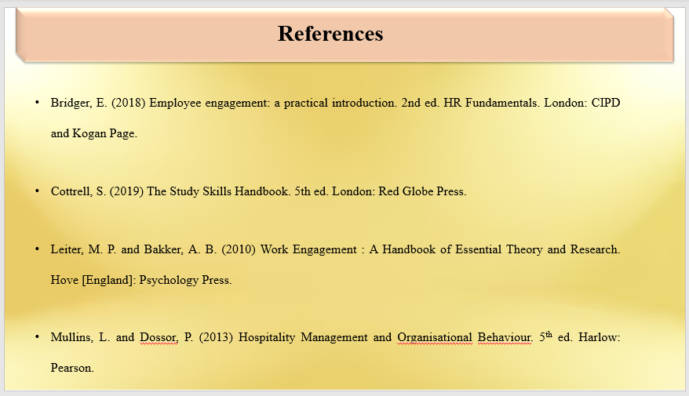
Alcalde-González, V., Mozo, A.G. and Bustos, A.V., (2021). No clean rooms, no hotel business: Subversion tactics in Las Kellys’ struggle for dignity in hotel housekeeping. Annals of Tourism Research, 91, p.103315.
Bridger, E. (2018) Employee engagement: a practical introduction. 2nd ed. HR Fundamentals. London: CIPD and Kogan Page.
Casado, M. (2012) Housekeeping Management. London: Wiley.
Chron Contributor, (2021). Organizational & Time Management Skills. [Online] Available at: https://smallbusiness.chron.com/organizational-time-management-skills-2889.html [Accessed 13 October 2023].
Cottrell, S. (2019) The Study Skills Handbook. 5th ed. London: Red Globe Press.
Johnston, R., Clark, G. & Shulver, M. (2012) Service Operations Management. London: Pearson.
Jones, T. (2010) Professional Management Housekeeping Operations. London: Wiley.
Leiter, M. P. and Bakker, A. B. (2010) Work Engagement: A Handbook of Essential Theory and Research. Hove [England]: Psychology Press.
MacLennan, C., (2021). 6 Employee Engagement Models. [Online] Available at: https://www.motivosity.com/blog/employee-engagement-models/ [Accessed 12 10 2023].
McFarlin, K., (2023). How to Possess Good Communication Skills in the Workplace. [Online] Available at: https://smallbusiness.chron.com/possess-good-communication-skills-workplace-10522.html [Accessed 13 October 2023].
Mullins, L. and Dossor, P. (2013) Hospitality Management and Organisational Behaviour. 5th ed. Harlow: Pearson.
Park, H., Kline, S.F., Kim, J., Almanza, B. and Ma, J., (2019). Does hotel cleanliness correlate with surfaces guests contact?. International Journal of Contemporary Hospitality Management, 31(7), pp.2933-2950.
PARSIPPANY, N.J, (2023). Wyndham Board of Directors Rejects Unsolicited Proposal from Choice. [Online] Available at: https://www.hospitalitynet.org/news/4118673.html [Accessed 13 October 2023].
Pellikaan, M., (2023). Five employee engagement models every HR professional need to know. [Online] Available at: https://www.effectory.com/knowledge/five-employee-engagement-models/#:~:text=The%20Zinger%20model&text=The%20Zinger%20employee%20engagement%20theory,enlivened%20energy%2C%20and%20leveraged%20strengths. [Accessed 12 10 2023].
Protopapas, C., (2022). Top 5 employee engagement models & theories to follow. [Online] Available at: https://www.seenit.io/blog/top-5-employee-engagement-models-theories-to-follow/ [Accessed 12 10 2023].
Quick, L. (2020) Managing Events. Real Challenges, Real Outcomes. London: SAGE Publications Ltd.
Raghubalan, G. and Raghubalan, S. (2016) Hotel Housekeeping - Operations And Management. 3rd ed. India: Oxford University Press.
Raudys, J., (2023). 3 Employee Engagement Models, Theories And Frameworks. [Online] Available at: https://www.contactmonkey.com/blog/employee-engagement-models [Accessed 12 10 2023].
Sandlin, H., (2023). Luxury hotel sector reports record room rates over summer. [Online] Available at: https://www.hotelowner.co.uk/171531-luxury-hotel-sector-reports-record-room-rates-over-summer/ [Accessed 17 October 2023].
Tesone, D. (2010) Principles Of Management For The Hospitality Industry. 1st ed. London: Routledge.
Wood, R. (2013) Key Concepts in Hospitality Management. London: Sage.

