Amanda Da Costa Maia (1802925)

Coexistent perspectives essay

MA Illustration

How did the makers of Jennifer’s Body and Ginger Snaps use these films to advance or reflect feminist societal critiques?

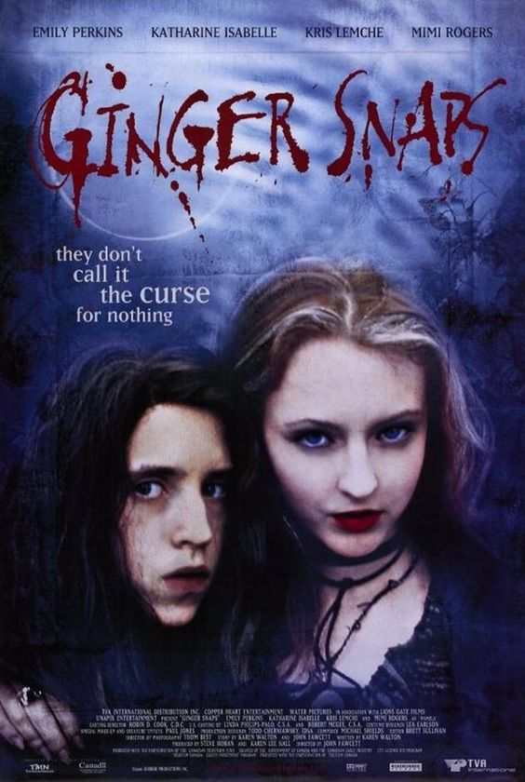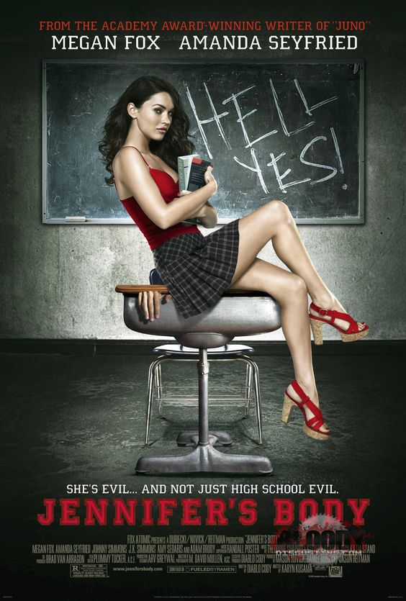

Summary

This essay is an examination of the role of the director and writer in film, with a specific interest in how film can be used to reflect or advance feminist critiques, and the impact on society more broadly. Through an examination of abjection and the monstrous feminine, as advanced by Julia Kristeva and Barbara Creed respectively, it will aim to demonstrate how two specific movies realise this impact by comparing and contrasting Jennifer's Body (2009) and Ginger Snaps (2000). Both depict the monstrous feminine, but depict different sources of the abjection: from external intervention or via interaction with internalised patriarchal standards. Understood this way, the filmmakers can be understood as trying to either reflect on the lived experience of womanhood (especially for young women), or to contribute to a societal conversation about the ways in which women are subjugated by patriarchy. The essay will consider a key limitation of both films, as far as they reproduce certain tropes we might understand to be patriarchal themselves, and end with a brief discussion of the role of film more broadly.

Introduction

This essay will examine the ways in which movies can, as subjects under patriarchy, challenge the oppressive structures within which we live. Firstly, establishing the kind of impact that films specifically - rather than other forms of art - have on us psychologically, in order to ground the responsibility that filmmakers have. That they depict realities that shape our opinions, worldviews and biases gives them a responsibility to the viewer and the society more generally. More than that, though, it also allows for movies that viscerally challenge the established order, even if in a limited way. In order to examine this further, this essay will consider two examples: Jennifer’s Body (2009) and Ginger Snaps (2000). Jennifer’s Body serves as a powerful reflection of the rage and abject horror that stems from being objectified and subjected to patriarchal violence, while Ginger Snaps looks inward and considers the ways in which young women are alienated from themselves.
Central to both readings will be Julia Kristeva’s theory of abjection, understood as the breakdown between self object and subject within the self (Kristeva, 1982). Whether as a result of external patriarchal intervention, or the internalised self-directed horror at the maturing female form, the protagonists of both movies experience this kind of breakdown - of abjection. Specifically, however, this essay focuses on how this happens to them as women, and thus Barbara Creed’s work on the monstrous feminine will be crucial to understanding how these films operate on a societal level. Importantly, they offer depictions of femininity that are not defined by strictly patriarchal archetypes. Instead, they subvert expectations and, by making the feminine monstrous, they put them into competition with the typical patriarchal male role. The main contention of the essay is that this kind of work holds up a mirror for both men and women to see themselves under patriarchy in a new light. They are not perfect, and in places may reinforce some negative stereotypes, but their use of the monstrous feminine should offer insight into techniques we might use to advance feminist causes in film, but also art more generally.

Feminism and Film
As the film industry developed through the late 20th century, interest continued to grow in the phenomenon of movies, and the psychological experience of being a viewer of film. Research considered whether the physiological function of the eye influenced the viewer’s perception, and how a person could be influenced emotionally by film, and through what cognitive process this took place (Gibson, 2014) James Gibson suggests that the experience of watching film represents the structure and ambience of the real world, and the viewer therefore is psychologically involved in the film as an observer in real life. This explains why experiencing film can elicit true experience of emotion (Gibson, 2014). Gibson also states that if the representation within the film deviates from what the viewer considers to be real life, these representations are accepted by the viewer as being a “non-representative exception”.
Dr Vikal Shah builds on this concept (Shah, 2023), describing the “synergistic impact of moving image”, which leads to “a powerful sense of emotion and engagement”. This is supported by Beasley and Brooke (Beasley and Brooke, 2019) who argue that movies, while enjoyable, are also powerful influences on viewers and therefore have wide ranging impacts on our society and lives as part of our cultural landscape. Given the above, it seems reasonable to argue that film makers have a role in how femininity is perceived by viewers. Films can influence people to reflect, transform their view of the world, and challenge their personal bias (Hannuch and Roussow, 2023).
Bearing in mind, therefore, that filmmakers have power with regard to influencing culture and individuals, can we conclude that they have a responsibility for doing so ethically? In a report for Congress in Washington, it was stated that:
“The media's deleterious role models, when internalized, prevent and impede female accomplishments. They also encourage both women and men to define women in terms of men (as sex objects) or in the context of the family (as wives and mothers).”
Gayle Tuchman expands on this, stating that the depiction of women’s lives in fiction focuses on women in terms of male specific terms, such as being a wife, a lover or existing in the “chasm of the male absence” (Tuchman, 1979). The monstrous feminine, when depicted in film, offers a different way of examining the role of women.
The monstrous feminine is a concept developed by Barbara Creed (Creed, 1986) expanding on the theory of abjection put forth by Julia Kristeva (Kristeva, 1982). Kristeva posits in her essay Power of Horror (Kristeva, 1982) that abjection can be considered to be a concept that does not “respect borders, positions, rules” and that “disturbs identity, system, order”. Abjection exists at the point at which anything “falls outside the boundary” that we set between ourselves and “the other”, therefore posing a threat to the identity that we each create for ourselves. (Kristeva, 1982)
Creed examines the role of women monsters in movies by viewing them through a lens of seven archetypes. Women, when monsters, not only act as transgressions to the expectations women hold of themselves, and are therefore at that point abject, but act as symbols of castration in a phallocentric society (Moi, 2024). Creed posits that when women are monsters, they are not only ‘female monsters’ as they exist within unequal societies, therefore a more accurate name is monstrous feminine (Creed, 1986). When a woman is a monstrous feminine she embodies abjection. She is monstrous not only because she is a monster, but because she is embodying the ideals that oppose patriarchy (Peters, 1994). She does this by being strong, fast, ruthless, and violent. This is in direct opposition to the stereotypical expectations of women (Lyndsey, 1991).
Central to Julia Kristeva’s theory of abjection is the removal of the barrier between the object (one’s body) and the subject (one’s inner-self) (Kristeva, 1982). Creed applies this to women’s bodies and expands the concept to include and focus on representations of the body in horror. When a woman is monstrous she is abject. She not only serves to remind the audience that the body and mind can be separated but also intertwined through the tropes of transformation and lycanthropy. She reminds the audience one is not in control of the vessel they inhabit, and to be a woman is to lack control - seen especially through tropes of possession and vampirism. (Kristeva 1982).
Sigmund Freud suggested that femininity is, at its basest, the absence of masculinity and therefore the lack of the control, strength and influence integral to being a man. He went so far as to state that: all “fetishism can be traced back to the lack in the female parent of a proper phallus” (Frost, 2003). This view of femininity as the absence of power or influence, whilst also being abject (since the act of birthing is tied to both femininity and a violent, bloody process which inherently challenges boundaries of the self) - is legitimised and supported by filmmakers if they continue to construct women as of lower value than men (Yang, 2020).

Jennifer’s Body
Jennifer’s Body (2009) is an American horror film directed by Karyn Kusama. The plot revolves around Jennifer Check and her best friend Anita ‘Needy’ Lesnicki and how they navigate Jennifer becoming possessed by a demon after a ritual sacrifice. In the first act we are introduced to the two characters: Jennifer is a popular cheerleader while Needy is unpopular and not as desirable. Jennifer is immediately more dominant, controlling the activities the two engage with while Needy is submissive, agreeing to what Jennifer wants despite her own discomfort. It is Jennifer’s dominance and confidence that sees her attract the group that would eventually attempt to kill her.

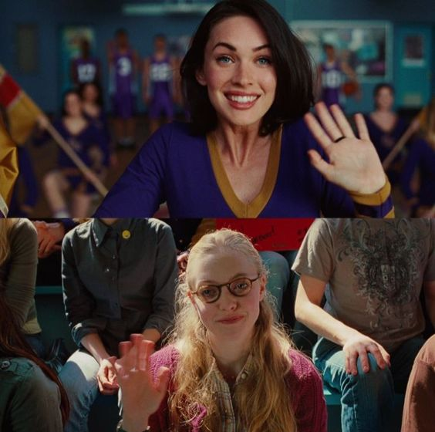
Figure 1: Jennifer Check and Anita 'Needy' Lesnicki.
Throughout this second act we see the filmmakers use abjection, obsession and sexuality to emphasise the horror of the feminine experience. During a scene in which Jennifer goes to Needy’s house intending to kill her, she vomits a black substance after eating a chicken. This use of black vomit invokes the feeling of abjection and alienation in the viewer, intensifying the horror of the scene. This encourages us as the audience to view the experience Jennifer has been subjected to as a horrific act. It is not simply positive, as it adds to her personal power, or negative because she is a victim. It is, in fact, horrific, abject and - at the same time, tied explicitly tied to the feminine. This sequence specifically conjures an image of a disordered eater.
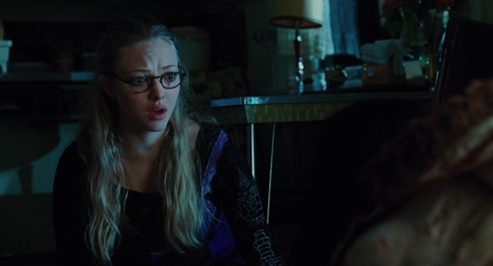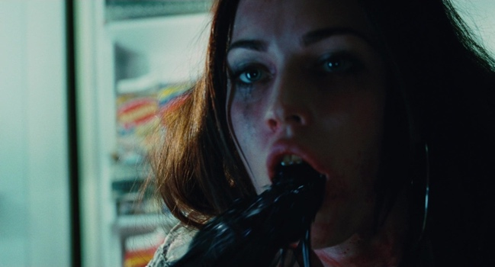
Figure 1: Jennifer and Needy’s first encounter post possession.

The specific use of consuming food and then dispelling it after an experience that ‘changes’ Jennifer echoes ideas of diet and the social pressure to conform to standards, and in turn society creates monsters. We can read this act of consumption as a metaphor for the love and friendship between the two. Jennifer’s first instinct is to consume, and the person she intends to consume is Needy. The choice to allow Jennifer to resist the initial urge to cannibalise her friend, consume a more acceptable food, and then immediately expel said food shows the rejection, obsession and intensity of the friendship.
A feminist reading of the movie might posit that Jennifer’s possession can be interpreted as a metaphor for the experience of girlhood and the increased lack of control arising from coming of age, or becoming sexually viable, as well as becoming aware of the societal expectations laid on women due to their lack of masculine power (Moi, 2004). It shows the experience of entering adolescence, where there is a complete lack of autonomy over the natural changes to your own body. Jennifer, experiences a lack of autonomy and demonstrates the visceral emotional experience of entering womanhood while in a patriarchal society (Medium, 2019). By depicting her as having diminished bodily autonomy (owing to her possession), it mirrors the experience of transformation that occurs within a girl’s body during puberty. Importantly, this possession does not happen as part of a natural process, instead it is directly triggered by violent male intervention in a religious and social context in which she is deemed impure.
By characterising Jennifer as an object of desire that is simultaneously rejected for having realised her own desires, the filmmakers are depicting the societal demonisation of women deemed too chaste or too promiscuous. Jennifer is at once desired, and then violently imposed upon, because of her sexuality. This mirrors the way women’s bodies are viewed within patriarchal systems. The choice to have the protagonist be a teenager is important for two reasons: firstly, it depicts the monstrous feminine as occurring at the cusp of womanhood and secondly, it increases the ideological impact when the film subverts the expectations and structures of gendered violence.
Jennifer’s possession is out of her control, stemming directly from the actions of a group of men who intend to use her specifically for her body and for their own gain who then leave her for dead. This mirrors that way women’s bodies are culturally viewed (Hentschel, 2019). Women can be seen as used and expired in a way that men’s bodies typically are not. Women have less social and cultural capital as they age, being viewed as less fertile and thus, less valuable (Silverstein, 1986).
The choice to adhere to and then subvert gendered violence norms adds emotional weight to the story. The transformation of Jennifer was violatory in nature and further depicts her lack of bodily autonomy at the hands of men. Post-possession, Jennifer is the dominant force, violently and freely killing boys. Not only is the act of killing of boys subversive, but the explicit desire to kill only boys and the objectification of the victims amplifies the effect. The subversion of gendered violence allows the audience to explore the power Jennifer has through her possession and the power she may lack in her girlhood (Coultard, 2007) Completion of her rise to power coincides with the completion of the subject-object order reversing - boys are now objects, she is a person. Under patriarchy, those with power are compelled to be violent or dominant, those without are dominated and violated (Fraser, 2007). When Jennifer explains ‘I’m not killing people, I’m killing boys’, she is emphasising the subversion of the objectification experienced by women. The subversion allows the creators to highlight the gendered implication of the movie and the ways in which the femininity of the character is important. “Nothing can bring up the discussion of proper womanly traits like a violent woman” (Neroni, 2005). Without the femininity Jennifer has, and the larger social connotations, the horror of gendered violence and in turn the terror of becoming a victim because of your gender would be less impactful. The fear is, for men, in being treated as if they were women. The weaponization of female violence by the film makers can show an intent for men to see themselves mirrored as monsters, or potentially simply catharsis. Importantly, this mode of being feminine is not rooted in traditional gendered roles, nor is it defined by the absence of the male - instead, it is the feminine competing within masculine structures.
The creators go to great lengths to demonstrate the complicated relationship with power Jennifer has. The lack of consent and autonomy that Jennifer is able to exercise throughout the film is very important to this reading, but it is especially significant that her rise to power does not necessitate increased autonomy. She experiences the power as power, becoming literally more capable. Despite the fact she is now herself ordered by a system of violence she is not in control of, she feels able to assert herself and victimise boys. This new ability does not negate the circumstances of obtaining the power and the lack of consent implicit in the story. The filmmakers demonstrate visually and narratively that Jennifer feels powerful, but the power itself is, in part, an illusion. She is not truly in control of her body or herself, she is at the behest of an uncontrollable desire to tear flesh and eat people. This mirrors the power experienced by girls and women as objects of desire. A girl may feel powerful when fulfilling her role within patriarchal society by being desired by men, but the power is an illusion. She is still living in a phallocentric society controlled by patriarchy. No matter how powerful you are within the confines of your role as woman, you are still a woman to be controlled. (Hunnicutt, 2009).
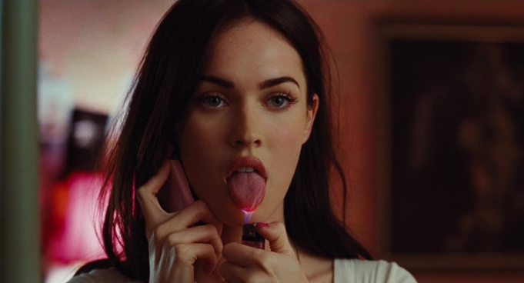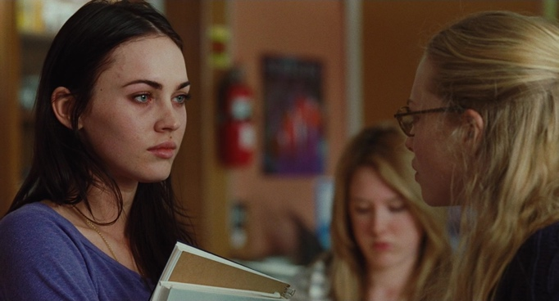
Figure 3: Jennifer shows her power by burning herself. Jennifer seems to appear sickly.

At its core, the power that Jennifer comes to possess in non-consensual in nature – she does not consent to her possession nor the uncontrollable desires that follow. She is possessed but not in possession of herself. The choice for Jennifer to be able to commit multiple acts of violence (using the ways she is perceived as harmless to lure the boys to their deaths) shows the continued objectification she suffers under patriarchy. Jennifer, when no longer terrifying, returns to being an object. She is as powerless as other girls because she continues to be sexualised. Jennifer had no control over her possession and attempted murder, though it may seem like it (she agrees to spend time with the men, an illustration of consent being falsely offered) she did not consent to her body being used as a vessel and did not consent to becoming a monster and most of all could not as she was not informed. This mirrors the experiences of entering teen years, of a girl’s body being sexualised and seen as an object or a vessel for men’s desires and patriarchal expectations. When a girl becomes a teenager she is also forced to engage with power she didn’t ask for and cannot control. She has sexual currency and she is viewed in a new way, but unlike Jennifer she does not have power to change this (Tolman, 2002). She has no physical way to stop being leered at or seen as an object, no violent act to commit to grab the attention of a culture and change it.

Ginger Snaps
Another example of a monstrous feminine movie is Ginger Snaps (2000). Ginger Snaps is a story about two sisters, Brigitte and Ginger in which the latter is bitten by a werewolf. The movie surrounds the sisters as Brigitte tries to cure Ginger of the lycanthropy she views as a curse and the almost-rivalry that develops as Ginger becomes a werewolf. The movie is a direct metaphor for menstruation and the transformation from childhood or here, girlhood to womanhood.
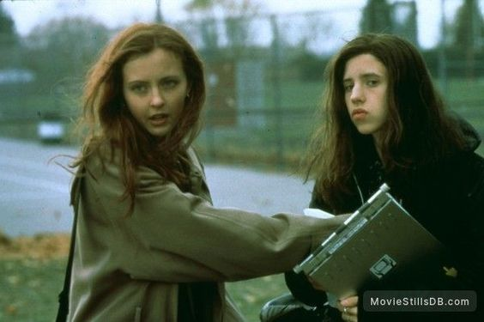
Figure 4: Ginger and Brigitte
The metaphor for menstruation explores how a period is viewed societally (Nielsen, 2004). Looking at stereotypes it is something painful, visceral and abject. It is something to be hidden, not openly discussed lest it force someone to be confronted with the realities of the body or the object of which they are the subject. When Ginger starts her period, it is the period itself that lures the wretched creature from the shadows. The specific choice to have Ginger become a werewolf almost immediately after her body displays clear signs of womanhood shows us the way women are consumed for men’s pleasure and desire. (Vaes, et at. 2011)
Ginger’s immediate transformation beyond her control representing puberty, and her emotional reaction to these changes show the complicated ways girls feel as they mature. By demonstrating them as monstrous we are exploring the ways in which despite the encouragement of maturity, those very signs of adulthood are also discouraged and seen as disgusting. When a girl us young she may try on make up, and older clothes in order to feel more mature, but when she reaches maturity, she is encouraged to look younger. Ginger Snaps portrays the abjection of the feminine body itself, encountering herself as abject. It focuses on the sexualisation and demonisation of a woman’s body
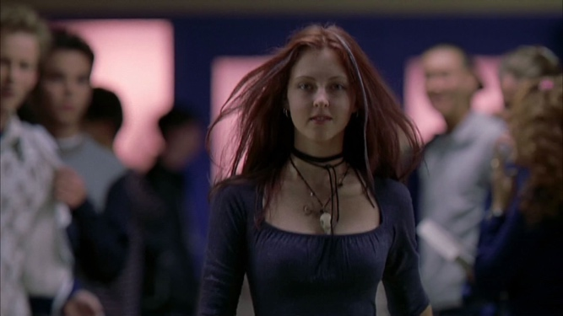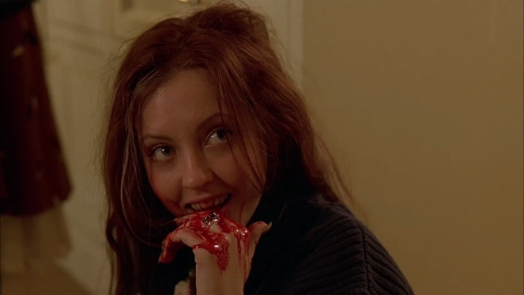
Figure 5: Ginger’s power after being bitten.

In both Jennifer’s Body and Ginger Snaps we see a power arc. We see a young woman become transformed through a supernatural entity beyond their control, we see her become powerful through engaging with this new body, we see her devour people and use viscera as a symbol of adolescence. These are examples of abjection as when these girls are tearing flesh and eating people there is a breakdown of body, society and self. By using abjection the monsters become horrifying in a way that reminds us of our own places and bodies. Through engaging with patriarchal metaphors the girls become more powerful, symbolising that when one conforms to the standards and instructions set forth by patriarchy gains some power.
However, in these monstrous feminine movies we see a downfall, a decay, a decrease. We see Jennifer become more unhinged, we see her stare at her reflection with tears in her eyes, she finds herself abhorrent, she has become a monster. We see Ginger lack control, she kills a classmate and attempts to kill her own sister, the person she valued most. We see this decline as they have embodied patriarchal expectations, they became attractive, more confident, had more interactions and relations with boys, for a time, before enduring a downfall.
Ginger Snaps is about transformation of girlhood to womanhood while Jennifer’s Body focuses more on the rage that comes with being a young woman, and the issues with coming of age within the patriarchy, stereotypes and body image. (Zdancewicz, 2019). By making the main characters female we can emphasise the unique perspective that comes from being an adolescent girl and the abjection inherent in that experience. The tropes the filmmakers decided to use show the demonisation of teenage girls and their bodies, and how it feels to have a body that changes beyond your control for the first time.
Film theorist Carol J. Clover developed the Final Girl Theory (Almwaka, 2021), Framing these young girls as monsters to break these stereotypes is a choice with social connotations. Jennifer and Ginger transgress expectations as they become neither the victim nor the final girl, the two options open to most female characters in the genre. They are not virginal and therefore do not fit the typical final girl trope nor do they fit the typical victim, as they commit violence themselves. They are vessels for the weaponization of violence and female experience in a way that does not conform to expectations.
Despite the implicit and explicit feminist ideals expressed in these movies, they still play into stereotypes especially around the demonisation of sexual promiscuity in young women. These characters are both seen in the story to be sexually active; Jennifer tells Needy “I’m not even a back door virgin.” and Ginger has sex with her classmate after being bitten. While Jennifer and Ginger are exploring their sexuality, Brigitte and Needy are playing the Virgin to their Whore. Brigitte expresses no desire for sex and Needy loses her virginity during the course of the movie. Needy after this point begins to become more dominant and by the end of the movie argues with Jennifer more assertively. Needy ends the movie killing the men who victimised Jennifer after gaining power from Jennifer’s bite. This plays into the trope of sexual corruption.
When we consider femininity, we can consider Sylvia Plath’s Fig Tree. When a woman engages with the patriarchal expectations placed upon her and acts as the maiden and mother, she gains an illusionary power much like Jennifer and Ginger. After she has married, and settled, and reared children, she loses power. What fertility can she bargain with when she is older? Does her beauty hold the same value? Does her value socially decrease with an increased focus on the house she is deemed to be in charge of? Patriarchal standards dictate that she is worth less (Hofmeier, 2016).
When we see the mirrored arcs depicted by the film makers, we can see that whether you are in your girlhood or adulthood, you are at the whims of patriarchal ideals and expectations. When you are an oppressed gender living under the power of another you will not experience true liberation as the structures you exist within are working against your interests. We see that one will be encouraged through social pressure and norms to conform, bend to the standards decided by others and despite all will not become self actualised.
These tropes used in horror movies act as wretched mirrors one must gaze upon to feel the same conflict these women do. One can be in control as one is deciding to engage or not engage with these expectations. One is not in control because one has not set these expectations oneself. While the characters created in these movies can help process the emotional experience inherent to womanhood, we can see the ways in which the patriarchal expectations and societal norms can also be upheld by women. The viewer must consider their own reflection in these movies not only the reflection of men.
The role of a filmmaker is to educate, inspire, challenge and entertain. It is clear that these films achieve these aims, as they have stood the test of time, and continue to attract viewers even now (Leone, 2023) possibly because they challenged the patriarchal pattern of script writing and filmmaking. Films have such powerful influence to engage audiences and there is a question about whether this brings a social responsibility to do so ethically, or in line with societal values. However this would be an unfeasibly complicated quest. Which of society’s values should be paramount? Which culture? Depictions which are perfectly acceptable in some cultures would be repugnant in others. (Miller, 2013)
However, recognising that the depiction of woman in films has been so lacking, both in terms of scope of character but also indeed in terms of screen time (Flowingdata, 2016) perhaps filmmakers should be focusing on a more equitable approach to portraying characters of any gender. This would open up the possibility of exploring women as characters in a more rounded way instead of a simple pastiche ranging from virgin to mother to whore.
Conclusion
To conclude, this essay has examined how movies can challenge and inform our relationship with the self, as a subject under patriarchy, specifically through the use of the abject and the monstrous feminine. We have good reason to believe that movies can help shape social attitudes, and that this is the same for beliefs around gender and gendered roles.

The question might then be: how can films explore these concepts in such a way as to be liberating? One answer might be found in the monstrous feminine - a subject as woman who is not defined by typically feminine roles nor as the absence of masculinity, she instead competes within masculine structures. In Jennifer’s Body, the protagonist is struck by the abject horror of the feminine self after falling victim to masculine violence, stylised as a ritual sacrifice. The subsequent power arc (and inevitable downfall) serve as a powerful metaphor for the ways in which women gain some semblance of power by conforming to patriarchal norms, and the heavy cost that women pay for said power.

Similarly, Ginger Snaps explores the abject horror of the self in the throes of puberty, mirrored by the text as a transformation to werewolf, not just feminine. Whilst Jennifer’s Body is more outward (the source of the abjection is direct male intervention and societal standards), Ginger Snaps looks inward: Ginger is changing (into a woman, as well as wolf) and she has to confront this, too. Part of the value of films like these lies in the fact that a) women can see themselves represented in some way and that b) men might better understand their role in the transgressed patriarchal systems they represent.

These films aren’t perfect, however: both conform in some ways to tropes we might consider harmful, but specifically their use of the monstrous feminine and abject horror seem effective to the stated end. Future work might look at how to better balance the demands of representing patriarchal systems without reproducing them harmfully, and how to balance the demand for socially progressive works without the apparatus of state censorship. Given the power that directors and writers have to sway opinion, and to direct action, these questions are very important whilst we exist under oppressive, patriarchal systems.
BIBLIOGRPAHY

BOOKS

Anderson, P (2009) The Oxford Handbook of English Literature and Theology 1st edn. Oxfrod: University Press

Beasley, C., Brook, H. (2019). The cultural politics of contemporary Hollywood film: Power, culture, and society 1st edn. Manchester: University Press.

Clover, C. J. (1992) Men Women and Chain Saws: Gender in the Modern Horror Film 2nd edn. Princeton University Press.

Coulthard, L. (2007) ‘Rethinking Feminism and Film Violence’ in Tasker, Y. and Negra, D. Interrogating Post-Feminism 1st edn. Duke University Press
Creed, B. (2005) ‘Beauty/The Monstrous-Feminine’ in O’Bryan, J. (eds) Carnal Art: Orlan’s Refacing 1st edn. Minnesota: University Press

Creed, B. (2020) ‘Horror and The Monstrous-Feminine An Imaginary Abjection’ in Weinstock, J. (eds) The Monster Theory Reader 1st edn. Minnesota: University Press.

Creed, B (1993) The Monstrous Feminine: Film Feminism and Psychoanalysis. 2nd edn. London: Routledge.

Gibson, J.J., 2014. The ecological approach to visual perception: classic edition. New Haven: Yale University Press.

Kristeva, J. (1982) Powers of Horror: An Essay on Abection. 2nd edn. New York: Columbia University Press.

Miller, Jacqui (2013) Film and Ethics: What would you have done? 1st edn. Cambridge: Scholars Publishing

Neroni, H. (2005) The Violent Woman: Femininity, Narrative, and Violence in Contemporary American Cinema. 2nd edn. New York: Sunny Press

Tolman, D. L. (2002). VOICES OF DESIRE. In Dilemmas of Desire: Teenage Girls Talk about Sexuality 1st edn. Boston: Harvard University Press

JOURNALS

Almwaka, M. (2021) "Complex Female Agency, the “Final Girl” trope, and the Subversion and Reaffirmation of Patriarchy: The Cases of Western & MENA Horror Films," Journal of International Women's Studies, 24(3) Article 5. Available at: https://vc.bridgew.edu/jiws/vol24/iss3/5

Creed, B. (1986) Horror and the Monstrous-Feminine: An Imaginary Abjection, Screen, 27(1), pp. 44–71, https://doi.org/10.1093/screen/27.1.44

Fraser, N. (2007
) ‘Feminist Politics in the age of Recognition: A Two Dimensional Approach to Gender Justice’ Studies in Social Justice, 1(1), pp. 23-35. Available at https://journals.library.brocku.ca/index.php/SSJ/article/view/979

Frost, G. (2003). [Review of Fantasies of Fetishism: From Decadence to the Post-Human, by A. Fernbach]. Journal of the Fantastic in the Arts, 14(1 (53)), 116–119. Available at http://www.jstor.org/stable/43321462

Hentschel, T, Heilman, M, Peus, C (2019) The Multiple Dimensions of Gender Stereotypes Frontiers in Psychology, 10 Available at:
https://doi.org/10.3389/fpsyg.2019.00011

Hunnicutt, G (2009) ‘Varieties od Patriarchy and Violence Against Women: Resurrecting “Patriarchy” as a Theoretical Tool’ Violence Against Women 15(5) Available at https://doi.org/10.1177/1077801208331246

James, J. (2020) ‘Refusing Abjection: Transphobia and Trans Youth Survinance’ Feminist Theory 22(1) Available at: https://doi.org/10.1177/1464700120974896

Kilker, R. (2006) ‘All Roads Lead to the Abject: The Monstrous Feminine and Gender Boundaries in Stanley Kubrick’s “The Shining”’, Literature/Film Quarterly, 34(1), pp. 54-63

Lindsey, S. (1991) ‘Horror, Femininity, And Carrie’s Monstrous Puberty.’ Journal of Film and Video, 43(4), 33–44. Available at http://www.jstor.org/stable/20687952

Yang, L., Xu, Z., Luo, J. (2020) ‘Measuring Female Representation and Impact in Films over Time.’ ACM/IMS Trans. Data Sci. 1(4) Available at: https://doi.org/10.1145/3411213

Moi, T. (2004). From Femininity to Finitude: Freud, Lacan, and Feminism, Again. Signs, 29(3), 841–878. https://doi.org/10.1086/380630 (Accessed 17 December 2023)

Nielsen, B. (2004) ‘”Something’s Wrong, Like More Than You Being Female”: Transgressive Sexuality and Discourses of Reproduction in Ginger Snaps’, Thirdspace 3(2). Available at https://web.archive.org/web/20060821111909/http://www.thirdspace.ca/articles/3_2_nielsen.htm

Peters, G. (1994) [Review of The Monstrous-Feminine: Film, Feminism, Psychoanalysis, by B. Creed]. Revue Canadienne d’Études Cinématographiques / Canadian Journal of Film Studies, 3(2), pp. 108–113. Available at: http://www.jstor.org/stable/24402392

Tuchman, G. (1979) ‘Women’s Depiction by the Mass Media’ Signs, 4(3), pp. 528–542. Available at: http://www.jstor.org/stable/3173399

Vaes, J., Paladino, P., Puvia, E. (2011) ‘Are Sexualised Women Complete Human Beings? Why Men and Women Dehumanise Sexually Objectified Women’ European Journal of Social Psychology 41(6) pp. 774-785 Available at: https://doi.org/10.1002/ejsp.824

Winter, B. (2014) ‘Horror Movies and the Cognitive Ecology of Primary Metaphors’ Metaphor and Symbol 29(3) Available At: https://doi.org/10.1080/10926488.2014.924280

ARTICLES
Flowdata (2016) ‘Computed Screen Time for Men and Woman’ https://flowingdata.com/2016/09/19/computed-screen-time-for-men-and-women/
(Accessed: 19 November 2023)

Holtz, J (2019) ‘How “Jennifer’s Body” Subverts Horror Narratives and Speaks to the Power of Women’ The Wrangler 2019. Available at: https://thewrangler.org/2019/09/23/jennifers-body-subverts-horror-narratives/ (Accessed: 6 December 2023)

Kehr, D. (2001)’She Was a Teenage Werewolf’ The New York Times, 26 October. Available at: https://web.archive.org/web/20160306091406/https://www.nytimes.com/2001/10/26/movies/26GING.html (Accessed: 7 November 2023)

Leone, Z (2023) ‘Why do we still care about Jennifer’s Body?’ Quinnipiac Chronical 19 September https://quchronicle.com/83050/arts-and-life/why-do-we-still-care-about-jennifers-body/ (Accessed: 6 December 2023)

Medium, (2019) ‘How “Jennifer’s Body” Subverts Horror Narratives and Speaks to the Power of Women’ Medium Available at: https://medium.com/@lila_t/the-boy-run-media-makes-us-seem-crazy-an-ode-to-jennifers-body-5acc51e4abaf (Accessed 7 November 2023)

Orlow Ng, M. (2020) ‘How Film Brings Attention to Major Social, Ethical or Political Issues’ The Medium https://matias-ng.medium.com/how-film-brings-attention-to-major-social-ethical-or-political-issues-672704c898ae (Accessed: 7 November 2023)

Shah, V, (2023) ‘The Role of Film in Society’ Thought Economics – A Journal of Intellectual Capital Available at https://thoughteconomics.com/the-role-of-film-in-society/ (Accessed 4 December 2023)

Zdancewicz, T. (2019) ‘Jennifer’s Body – Full Fledged Feminism or Simply Infuriating’ Brattle Theatre Film Notes Available at: https://www.brattleblog.brattlefilm.org/2019/01/09/jennifers-body-full-fledged-feminism-or-simply-infuriating-14107/

GOVERNMENT DOCUMENTS

Committee of Congress, Washington DC Government Printing Office, 1977 "The Impact of Mass Media Stereotypes upon the Employment of Women," in Women in a Full Employment Economy: A Compendium Prepared for the Use of the Joint Economic Committee of Congress

FILMS

Jennifer’s Body (2009) Directed by K. Kusama [DVD]

Ginger Snaps (2000) Directed by J. Fawcett [DVD]

FIGURES

Figure 1: Kusama, K, Director. Jennifer’s Body (2009) [DVD]

Figure 2: Kusama, K, Director. Jennifer’s Body (2009) [DVD]

Figure 3: Kusama, K, Director. Jennifer’s Body (2009) [DVD]

Figure 4: Fawcett, J, Director. Ginger Snaps (2000) [DVD]

Figure 5: Fawcett, J, Director. Ginger Snaps (2000) [DVD]

