March 13, 2021
Simion Diana
UNIVERSITY OF WALES TRINITY SAINT DAVID
STUDENT NUMBER: 1908799
UNDERSTANDING AND ENGAGING IN THE CUSTOMER EXPERIENCE
MODULE CODE: BMSW5103
PLAN A AT MARKS AND SPENCER- DOES IT DELIVER ON CRM?

Abstract

Customer experience is described as the journey of the business and services. It is directly linked with the customer relationship management which focuses on positive and affective experience with the respective organisation. This helps to improve a strong relationship and imported directly on the profit of the organisation. The study has highlighted the importance of customer relationship management of Marks and Spencer. The assignment has also focused on the ethical and sustainability of Marks and Spencer understanding the theory and citation of the organisation.
Contents

Introduction 3
Meaning of the term ‘Customer Relationship Management’ 4
CRM as per Marks and Spencer 5
Ways for CRM to breed loyalty or trust or satisfaction 5
Customer relationship experience of Marks and Spencer 6
a) Ethical 6
b) Sustainability 8
Critical discussion of a variety of quality models and theories . 9
Benefits of CRM at M&S: 13
a) Segmentation 13
b) Targeting Customers 14
c) A Loyalty Ladder 15
d) Marketing Mix 16
Strengths and weaknesses of Marks and Spencers’ CRM system 18
Options/Recommendations 19
Conclusion……………………………………………………………………………………….20
References list: 21

Introduction
Marks and Spencer is one of the biggest multinational retailers which is headquartered in London that focus on spelling home products, clothes and food products. M&S currently has 959 stores in the UK which has contributed over £1 billion and the revenue of the organisation is £10,181.9 million. The study has also introduced the quality theory of the organisation to improve the relationship manager with different examples and explain about segmentation, customer target, loyalty and marketing mix of Marks and Spencer. Strength and weakness has been reported efficiently of the organisation. The different understanding with respect to Mark and Spencer will focus on improving and increasing the customer experience and meeting the desired expectation of the customers.

Meaning of the term ‘Customer Relationship Management’

CRM which is also known as customer relationship management is a type of technology which manages all types of company's relationships as well as the interactions with the customers as well as potential customers (Liu, 2019). It is also categorized as an integrated data driven software solutions which helps to improve how to interact with the customers along with the business. With the help of CRM, implementers cover each and every aspect of their business cycle which also helps them to increase in marketing returns as well as in sales (Zhao et al. 2019). The CRM solution also helps to focus on the organization's relationships with individual people.
Pros of CRM | Cons of CRM
The system of CRM has provided different advantages in terms of strategic changes which is one of the best examples of increasing the probability in a personal touch. This can also grow the existing relationship with business and with the customers around the world. (Anshari et al. 2019). This system allows each employee to understand the specific needs of their customers as well as their transaction file.CRM systems are useful in identifying potential customers. They keep track of the profiles of the existing clientele and can use them to determine the people to target for maximum clientage returns.CRM data ensures effective coordination of marketing campaigns (Lu and Miller, 2019). Businesses can utilize the data of CRM to focus on the loyalty programs which will help to facilitate the higher customer retention. | As CRM is growing in the market and have several advantages so it can help me to save a huge time by operating it in a functional way. However, adopting a CRM system and software requires a huge cost and the operation has to invest in it. There are varieties of CRM software available in the market so the price of the software ranges in different packages which are actually made according to the needs of the clients. It is also time taking software for which an employee needs to get trained and then can perform. The employees need to learn and information about the CRM software and thus take a prolonged time to complete the necessary work. (Valmohammadi, 2017). Another major con of CRM is the data insecurity which can be stored by any people (Zhenget al. 2019)..

CRM as per Marks and Spencer
M&S is one of the famous departmental stores which is located in London. Over the years they have been successful while in the past decades they had experienced trouble. In present situation, the relationship of the organisation with other organisation has become an important aspect which can help to ensure the sustainability in terms of customer service and long term satisfaction. CRM which is known as Customer relationship management the relationship of the organisation with other organisations has become an important aspect which can help to ensure sustainability in terms of customer service and long term satisfaction. It also focuses on a strong respect between more than two businesses which also raise the importance of the stakeholder. This helps to improve the customer base In the best and improve in the business with more efficient ways which helps to increase the sales. (Valmohammadi, 2017). Market and Spencer runs its store without having the facility of manufacturing and increase the competitive advantage with its high growth that depends on the relationship of the business with different stakeholders in every level. M&S has become a market leader in semi-prepared, own-brand dishes that have been supported through high-profile.Moreover, all retailers have direct contact with their customers, by which they can have the facility to access the management information systems, using data from loyalty cards as well as from direct feedback, to match their new product development to consumer needs (Lu, and Miller, 2019).

Ways for CRM to breed loyalty or trust or satisfaction

CRM is a business philosophy towards customers. It includes different types of technology which is employed for streamlining the customer interactions to find, acquire as well as retain the customer. Due to the involvement of new technology as well as increasing the demand in the digital transformation has created a valuable part with customer revolution. In the past few years, M&S has focused on choice of customer and has evolved in almost every business sector and industry. The organisation has also created feedback secession to understand about their satisfaction level (Nasır, 2017). The focus of M&S’s clothing and household business is to thrive through building long-lasting relationships with customers and a well implemented CRM system. The relationship of the organisation with other organisations has become an important aspect which can help to ensure sustainability in terms of customer service and long term satisfaction. It also focuses on a strong respect between more than two businesses which also raise the importance of the stakeholder. This helps to improve the customer base In the best and improve in the business with more efficient ways which helps to increase the sales.
M&S has been benefited by CRM which has increased the revenue by 6.2% in the UK since 2018 (Goremîchina, 2017). It has allowed M&S to be more efficient in the process of automation in respect to different areas where the business can be more streamline with different forms of processes. The different advantages of CRM will allow the company to become stable in the business and will lead to more practices to better serve their customers (Taylor, 2019). Along with this CRM has personalized the communications of M&S with the customers and employees through digitally as well as offline.

Customer relationship experience of Marks and Spencer

According to the annual award of Loyalty magazine, Marks and Spencer has been recognised as one of the best customer experiences. According to the operation of M&S, program of the organisation has evaluated since 2016 and has created its strategy that has enhanced the way of connection with the customers. It has been noted that a premium customer experience has always been important for Marks and Spencer (Wilshaw et al. 2021). The customer relationship experience of M&S has built a healthy and hard sense of trust and mutual respect between the organisational business, customers and stakeholders. This has increased sales by retaining the customers which also improve in the market over and over again.

Ethical

The retail brand M&S has achieved a good ethical consumer service that received best rating in the logistic part of supply chain management. M&S has focused on Consequentiality and Non-consequentiality ethics to improve the ethical standard of organisation. Consequentiality is based on the mortality of the action with the outcome to focus on right things and vomiting the wrong bad outcomes (Rahman, 2017). The consequences are the effect in the organisation and are defined by Utilitarianism theory. This theory focuses on right action which needs to be led in the organisation for the happiness of a number of people. It also focuses on hedonism and egoism which represent and import humankind to maximize total pleasure and action off license for one individual with others. On the other hand, Non-consequentialist focus on the right and wrong action and consequence in the organisation. There are different variances which have focused on divine command theory, natural rights theory etc (Leite, 2020). The Divine theory has highlighted the actions which need to be sanctioned in the organisation. The moral obligation always commands According to the absolute and natural rights with and human action in the organisation. Consequentialism is sometimes criticized as it is quite difficult and even impossible at some point of time about the result of an action. M&S has critically used this ethics to understand certain situations that can lead to a healthy future (Rahman, 2017).
The consequentialism ethics have helped the management of the organisation to take few correct decisions that are objectionable and have been placed correctly even though the consequences are arguably better. Most of the economists have proved that the world economy would be stronger. M&H has adopted it so that it can be happier, healthier, and wealthier. According to the ethical research of the consumer, M&S had already spread its operation in a number of countries considered by focusing on Consequentialist ethics which is governed by oppressive regimes. On the other hand, M&S has also focused on Non-Consequentialist (Nyame-Asiamah and Ghulam, 2019). Theories which focus on the evaluations of something other than sum total or net aggregate of the consequences of choices. This has helped M&S to promote their services directly with good consequences and minimizing bad ones.

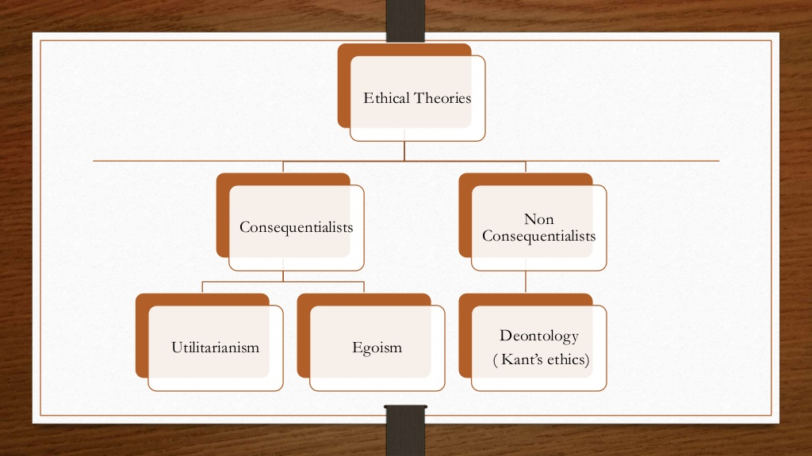
Figure 1: Ethical theories adopted by M&S.
(Source: Leite, 2020)

Sustainability

M&S has focused on plan A where the corporate social responsibility of organisation helps in restructuring the operation and become one of the best retailers in the world. Sustainability is the core concept of M&S brand which helps improve strategies and share program. This improves engaging the customer and enabling the report on the performance at group level. The sustainability strategy has focused on profitable growth and delivering long-term value for the stakeholders and creating new opportunity models to enhance the program with core strategy. It also focuses on parallel operations which help to maintain the business unit and program that can be helpful for the sustainability of organisation (Scott and Walker, 2017).
M&S has committed to the environment and the organisation with emphasis on high quality and long lasting products by maintaining ethics. M&S has also focused on the Global Sourcing principles with collaboration of sustainability and Consequentialist and Non-consequentialist ethics. M&S has continuously exercised social responsibility which has involved different forms in different level of the company. In this way, it has minimised the damages or social impacts to the environment (Lee et al. 2018). M&S has committed high-quality and long-lasting products by focusing on the green environment. Also it has linked with the two ethical values that has helped to focus on recycling programs for shoppers as on the famed Greenpeace Detox Catwalk.
In contrast to Zara, the sustainability of M&S has been more prominent as they use eco-friendly materials like nylons, recycled polyesters and organic cotton. In context to the competitor Zara, M&S have resorted to development firms that can affect positively on communities and on the environments. The organisation has also supported the redundant workers to search for alternative services which has increased the social responsibility and involved careful consideration of any effect on the environment (Purcell et al. 2019). This has not only maintained the ethics but also minimised negative impacts which improves in public relations. This benefited the actions and provided some gain for those affected.

Critical discussion of a variety of quality models and theories .

Quality management can be defined as the act of overseeing different actions and tasks that can be accomplished to cultivate a desired level of excellence quality. This will include the assurance of a quality policy by creating and focusing on quality planning and assurance (Cugurulloet al. 2020). This will also develop the quality control and quality improvement for better performance in the organisation. This is considered as one of the main frame of total quality management (TQM). M&S along with quality management focus on a review plan to control and monitor the business. The plan basically focuses on a given target. The management and operation of M&S focus on weekly review of the plan to understand the progress. This is called scan rate operation targets (Marteket al. 2018).
Target of the markets is set by multiple departments of the organisation and if it is not up to the mark then, Marks and Spencer take a valid action to understand and solve the problem by giving the workers more training and overtime if required. The organisation has also focused on motivation theory which has enhanced job satisfaction and improved the quality of the work (Scott and Walker, 2017). The motivation theory is adopted to motivate the staff according to the level of needs. Another theory which M&S uses is Douglas McGregor Theory X and Y. It focuses on different kinds of employees who are lazy and not enthusiastic about taking responsibilities. This theory develops the people who have no interest in the success of the company (Cugurulloet al. 2020). It also focuses on the extra responsibility and work which is able to take into other categories. The employees prepare themselves to accept the changes because they appreciate changes.
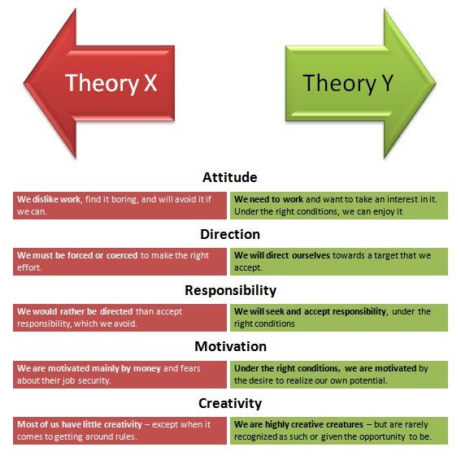
Figure 2: M&S adopted Douglas Mcgregor theory X and Y
(Source: Martek et al. 2018)
Marks and Spencer continuously focus on updating the policy and create innovative solutions for the customers and staff. The company has focused on the checkout process, producing fresh products, connecting with different merchandise, stock controllers and administration personnel. Marks and Spencer has given a lot of importance to total quality management for integrating the quality development, quality improvement and has enabled the production and services with the most economical level with full customer satisfaction (Scott and Walker, 2017). This process has encompassed everyone across the company with cent percent commitment on the top level management and thus implemented three basic things which are total involvement, customer focus and continuous process improvement.
In terms of customer focus, the internal and external customers of the organisation focus on the different production services which help to maintain the relationship from the internal to final consumer of the product. In M&S, output from internal suppliers has become one of the major parts of the development of organisation and input has been a final consumer improving the customer relationship and quality needs (Bolonet al. 2018). Continuous process improvement has helped the organisation to reduce and eliminate the variability from quality process. It has an outcome line and progress which is predictable and difficult for meeting the customers’ expectation. The continuous process improvement of Marks and Spencer has been very low with all availability and variability. The continuous improvement focuses on “Plan A” which is one of the beneficial strategies of the organisation and the organisation reviews it’s efficiently comprehensive set of objectives that governs the business (Volzet al. 2021).
Plan A is considered as a real change in terms of the employees, environment, people working in the supply chain and customers of Mark and Spencer. The plan has introduced different products and services for the customers with a sustainability way which has also contributed to the local communities and focus on additional profits generated back into the business. On the other hand total involvement has also benefited Plan A of the organisation which has contributed in implementing the objective among the employees (Inget al. 2020). This has improved the level of confidence of quality assurance and the managers’ act according to the standard and insured continuous measured and monitored section. Six Sigma approach is termed as one of the disciplined statistics oriented data driven theoretical approach which generates continuous improvement techniques and methodology which helps to eliminate the defects in a proper way in terms of product, process and service.
The view of Six Sigma in M&S is to reduce variability and underline the concept of the approach of statistical terms to maintain the standard deviation and quality assurance. It has determined the best products within a process and improves the manufacturing process of the organisation in the retail sector (Omoikhudu, 2017). The organisation has implemented Six Sigma quality improving the master gland bill and monetary part of Six sigma. This has actually increased 65% increase in the collection hour of the organisation. The different section of Six Sigma has ensured the quality decision which has described the department with greater efficiency and improved customer relationship management. The organisation has also benefited by addressing the collection efforts of the customers with upstream values (Frost et al. 2020). The Six Sigma has reduced the longer term solution and had a direct impact on resolving the debt problem, delivering the product without any issue by approaching DMADV approach and improving in the potential recovery of reducing the cost in operation.
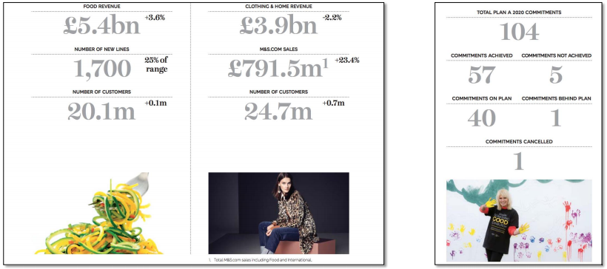
Figure 3: Plan A approach in respect to TQM
(Source: Spencer et al. 2018)
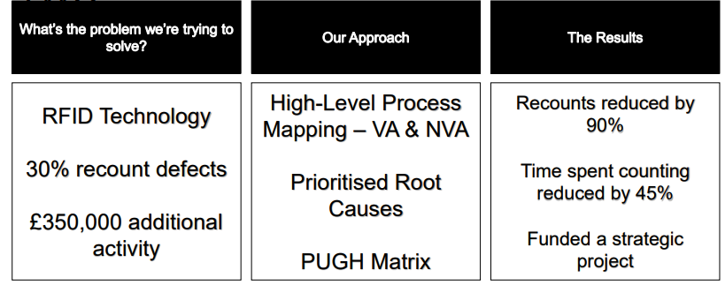
Figure 4: M&S aim by applying TQM and Sig sigma in recent years
(Source: Shaari and Hong, 2018)
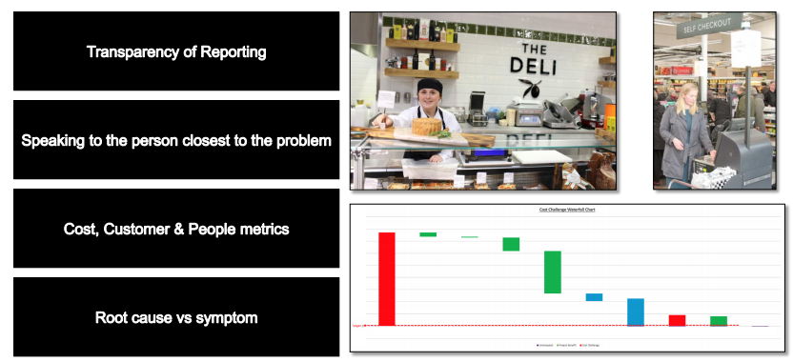
Figure 5: Approach to maintain the CRM and improve in quality
(Source: Spencer, 2021)

Benefits of CRM at M&S:

Segmentation

Segmentation can be defined as a division in the marketplace into different parts according to segments which have a growth potential. M&S have utilised it efficiently to target the entire market, because of time, cost and effort restrictions. In today’s culture and marketplace, segmentation is very important to make the organisation successful and increase the profit with value and usage (Shaari and Hong, 2018). In the UK, M&S stores have derived 70% of the population for clothes and households etc. This has helped M&S with an idea to raise the count of “Simply Food” stores across the UK. By achieving this according to segmentation, these are tailored to fulfil the customers’ needs in their local area (Frost et al. 2020).
Segmentation is considered as the difference segment of the different people which involves in the purchasing power or buying decision. The company has segmented their products and services according to the Geographic, psychographic, demographic and behavioural segments. M&S has segmented the market geographically according to the building stores within the territories which is one of the easiest ways for the customers to shop. The main geographic segment has been derived with 500+ stores operating in 41 International territories (Inget al. 2020). This has also helped to keep an equivalent store environment and is following the constant packaging structure such that the customers find it easier to do shopping.
M&S has also segmented the markets demographic according to age, social class, ethnic groups and different gender. One of the key rivals of the organisation is Tesco. The organisation has also segmented their products into democracy, geography, psychographic and behaviour (Omoikhudu, 2017). Tesco has allowed them to differentiate their products into more than 51 countries according to their personality and lifestyle and is more sensible in the environmental issues and health of the customers. M&S connects with the touch points to grow revenue. The company has Limited the interaction channel and focused on omnichannel model to improve the digital channels with 1253 retail outlets in the UK. This has overhauled the different order management and e-commerce system which has improved the retail transformation not only in the UK but also in different parts of Europe (Bolonet al. 2018).
M&S has focused on improving customer relationship management and business profit by creating a turn around them into the digital first business. The organisation is focusing on maintaining the culture by improving green environment in the environment and has widened the driving style and credentials of clothing by making them more contemporary and digital. This has boosted the organisation to increase market share and trailing new formats which also improved the fastest-growing part of the food market (Banetet al. 2018).

Targeting Customers

M&S has often focused on recognising a retailer for middle-aged shoppers in respect to clothes. The organisation has launched Goodmoves offering 150 different pieces of clothing and accessories to maintain its sustainability and competition in the environment. In respect to the wide variation of price and trend the products range accordingly (Zhao et al. 2019). One of the basic target points of the organization is to clear the stocks with the latest trend for every customer and not focus on any specific target market. The most crucial point of the organisation is to value the loyalty and confidence of the customers. Their main values and target always incorporate much inspiration, innovation, integrity, and in touch underpin the consent of the customer by promising the style statement of the customers. This has helped to demonstrate the commitment which the organisation has towards their products and customer satisfaction (Zhenget al. 2019).
As M&S do not have any specific targets so the organisation focuses on targeting wide range of individuals with their products. With respect to the geographical factor, the fashion product line of M&S seems to manufacture clothing ranges for the middle aged women as well as for the middle class families. By maintaining such set values, the company’s target segmentation is mainly based on the annual report (Leite, 2020). The organization recognizes the changes that need to be adopted as per the changing market. Marks and Spencer have not only operated in the UK but also have targeted its customer in the entire world. So it has announced that they will be partnering with Star count to maintain its five years transformation plan. This will deliver a better customer understanding and will be able to help for maintaining a balance in CRM through personalization of loyalty and CRM programmes by M&S like Sparks Card (Purcell et al. 2019).

A Loyalty Ladder

The loyalty ladder can be defined as the relationship of marketing concepts which focus on values of customers that gradually move up through relationship levels. This basically starts from the bottom as prospects. In this type, it mainly focuses on the intent to purchase but has not yet completed. After this, it ends up at the top as advocates which intensely mention loyal brand champions. In today’s world, loyalty schemes are effortlessly growing as an experience across the channels (MELESE, 2018). However, it is considered as one of the difficult part for the large retailers which help to deliver and provide legacy systems and structures. To its focus, the company has taken this into the heart, and focused on integration with full dot com and enabled in the android and IOS applications and in the cloud store. The storing of data can be one of the benefited parts for the future. Recently, M&S has launched a game platform for the customers rather than focusing on a transactional route. The company has focused on the scheme which has made shoppers to level up into the next reward (Mwangi, 2020).

Marketing Mix

Marketing mix indicates the set of actions as well as tactics which are used by the company to develop the promotion of a specific product in the market. It is now mainly known as the dominant framework for marketing management decisions. The different elements of a marketing mix work in conjunction with one another. The 7P’s of marketing are the basic key factors which are involved in the marketing of a good as well as services.
Product: M&S sell its products and services Under different categories which help the organisation to fulfil its targets in one roof. The company connects with the international market with a wide range of clothing, food, and households etc to increase the competitive position positioning.
Price: M&S follows competitive prices which can be helped to improve the supply chain by reducing the cost (Banet et al. 2018). Also the organisation is focusing on affordable prices for entering the needs market and reducing the cost of unsold goods.
Place: The headquarters of the organisation is operating in more than 500 countries through which the organisation has created its intensive marketing strategy. It has gained a close working relationship with the supplier that has allowed diversifying different products and bringing innovation into the organisation (Mwangi, 2020).
Promotion: The retail has focused on social media platforms like YouTube, Facebook and twitter which have increased high sales of the products globally. Along with this, the retail also gives discount coupons to the customers and also loyalty program points which can be redeemed in the next shopping (Spencer et al. 2018).
People: M&S has taken initiatives for CSR of every employee which can let them to achieve skills of their own and also can increase the organisational efficiency. The marketing department also focuses on sustainability practices of the people which can develop the organisational values.
Process: The process of the stores is very fast and it has achieved sustainability with the different customers. This is mostly done in the sub urban areas and rural areas. The company has its own recycle methods which help to save a lot of cost and deliver a better quality product to the customers (Lichtenthal et al. 2018).
Physical evidence: Most of the customers and employers are encouraged to shop and work due to CSR facilities and values in the organisation. This is done through different campaigns, business statements and promotions which attracted many investors, suppliers and consumers (Ghazi Moghaddam et al. 2020).

Strengths and weaknesses of Marks and Spencers’ CRM system

Strength and weakness will evaluate the realistic goal and objective and strategies of the organisation. This will improve in the information based activity which will improve in the political exercise according to the individual basis and for conception. It has focused on the strengths and weaknesses of the organisation strategy, resources etc that has increased overall organisational effectiveness (Chaudhari et al. 2020). It has focused on the underlying reason for Marks and Spencer which has efficiently responded to the change in environment operation and improved in the strategic position. This has also created an important part in the opportunities according to the competitive and environmental factors that have improved the future direction of the organisation (Chaudhari et al. 2020).
Strength | Weakness
The difference of CRM helps the project manager of every department to meet the KPI allocation efficiently and progress the assessment with reporting and forecasting data  Marks and Spencer have benefited from the advance CRM like Salesforce to improve the professional service automation which has improved and became user friendly with sound quality knowledge (Eisenberg, 2019).  The analytical methods of CRM have also improved in the productivity and performance monitoring of the team mates. This has improved in the Inside performance of the team and has generated multiple models and roles to improve the performance of the organisation (Corejova et al. 2020). | Due to covid 19, the existing CRM strategy has failed to meet the productivity target and could not make the legal system with a large number of enquiries.  It has affected productivity levels with the old system of CRM which has failed to reach the expected level.  The organisation has tried to tweak the software and alternate the business process for improving productivity for the caller's however failed due to old technology (Jin et al. 2018).

Options/Recommendations

Recommendations are required which are based on improving the areas identified within the conclusion as weaknesses.
Few recommendations can be drawn to increase the customer relationship manager which will increase the overall percentage of the satisfaction and global customer service listing the program internationally.
- It is important to invest in the fresh voice of customer approach and software to understand business faster and in a comprehensive way (Hazzan et al. 2017).
- The organisation should focus on more new programs and involvement of measurement tools internal systems that can help to deliver a clear satisfaction of the customers.
- Weekly reports should be a key touchpoint, action plans and recommendations can be generated and can be measured efficiently (Oki, 2019).
- The organisation should focus on closing the outlook on feedback to ensure the store contact and result in sight in a weekly manner which can increase the customer relationship management.
- Organisation should focus on expanding the business more in offline as well as physical stores. Also it can collaborate with Amazon Prime delivering in the world (Ausloos, 2020).

Conclusion

The study has concluded about the different initiatives to improve CRM and the importance of CRM in an organisation. The cross functional analysis with different models and theories has been included in the study to understand the primary objective of CRM in Marks and Spencer. Different marketing strategies have also reflected in the study to understand the measurement indicators and attributes. The tools have influenced the customer values by evaluating the concept and will support to improve the customer requirements according to the quality process. In the last, recommendations have been drawn for developing a better customer relationship which will in return profit the organisation.

References list:

Anshari, M., Almunawar, M.N., Lim, S.A. and Al-Mudimigh, A., 2019. Customer relationship management and big data enabled: Personalization & customization of services. Applied Computing and Informatics, 15(2), pp.94-101.
Ausloos, M., 2020. Valuation Models Applied to Value-Based Management—Application to the Case of UK Companies with Problems. Forecasting, 2(4), pp.549-565.
Banet, M.T., Spencer, M.F. and Raynor, R.A., 2018. Digital-holographic detection in the off-axis pupil plane recording geometry for deep-turbulence wavefront sensing.Applied optics, 57(3), pp.465-475.
Bolon, B., Krinke, G., Butt, M.T., Rao, D.B., Pardo, I.D., Jortner, B.S., Garman, R.H., Jensen, K., Andrews-Jones, L., Morrison, J.P. and Sharma, A.K., 2018. STP position paper: recommended best practices for sampling, processing, and analysis of the peripheral nervous system (nerves and somatic and autonomic ganglia) during nonclinical toxicity studies. Toxicologic pathology, 46(4), pp.372-402.
Chaffey, D. and Smith, P.R., 2017. Digital marketing excellence: planning, optimizing and integrating online marketing. Taylor & Francis.
Chaudhari, H.G., Penterman, J., Whitton, H.J., Spencer, S.J., Flanagan, N., Lei Zhang, M.C., Huang, E., Khedkar, A.S., Toomey, J.M., Shearer, C.A. and Needham, A.W., 2020. Evaluation of homology-independent CRISPR-Cas9 off-target assessment methods.The CRISPR journal, 3(6), pp.440-453.
Chaudhari, H.G., Penterman, J., Whitton, H.J., Spencer, S.J., Flanagan, N., Lei Zhang, M.C., Huang, E., Khedkar, A.S., Toomey, J.M., Shearer, C.A. and Needham, A.W., 2020. Evaluation of homology-independent CRISPR-Cas9 off-target assessment methods.The CRISPR journal, 3(6), pp.440-453.
Corejova, T., Rostasova, M. and Valicova, A., 2020.REMARKS ON THE EVALUATION OF THE STRATEGIC FOCUS OF THE SOCIAL NETWORK. Economic and Social Development: Book of Proceedings, pp.304-311.
Cugurullo, F., Acheampong, R.A., Gueriau, M. and Dusparic, I., 2020.The transition to autonomous cars, the redesign of cities and the future of urban sustainability.Urban Geography, pp.1-27.
Eisenberg, P., 2019. Financial Analysis of Primark Stores Ltd. with regard to a Stock Exchange Floatation (IPO).International Journal of Management, 7(1), pp.91-112.
Frost, K., Jin, H., Olson, W., Schaffer, M., Spencer, G. and Handwerker, C., 2020. The use of decision support tools to accelerate the development of circular economic business models for hard disk drives and rare-earth magnets. MRS Energy & Sustainability, 7.
Ghazi Moghaddam, H., Nasehi Far, V., DehdashtiShahrokh, Z. and Taghavifard, S.M.T., 2020. Developing an integrated distribution channel model for fast moving consumer goods manufacturing and importing companies in Iran. International Journal of Industrial Engineering and Management Science, 7(1), pp.1-19.
Goremîchina, O., 2017. CRM as advanced approach in management: analysis of market and trends. In Paradigmemoderne ale economieişiantreprenoriatuluiinovativ (pp. 339-345).
Hayat, K., Jan, S., Ali, F., Nadeem, A. and Raza, W., 2019. Impact of Green Marketing Mix (4Ps) on Firm Performance: Insights from Industrial Sector Peshawar, Pakistan. Sarhad Journal of Management Sciences, 5(1), pp.143-156.
Hazzan, O., Heyd-Metzuyanim, E., Even-Zahav, A., Tal, T. and Dori, Y.J., 2017. Application of Management Theories for STEM Education: The Case of SWOT Analysis. Springer.
Ing, P., Osman, Z. and Tze-Yin, L., 2020. Marketing Mix and STP Strategies: An Exploratory Study into Grocery Retailers in Malaysia. Asian Journal of Entrepreneurship, 1(4), pp.129-143.
Jin, H., Miao, Y. and Park, S.T., 2018. A Case Study of Marks and Spencer lost China. Journal of Industrial Convergence, 16(2), pp.15-23.
Lee, S.H.N., Zhou, Y., Lo, C.K. and Ha-Brookshire, J., 2018. Luxury fashion brands versus mass fashion brands: Data mining analysis of social media responses toward corporate sustainability. In Sustainability in luxury fashion business (pp. 51-73).Springer, Singapore.
Leite, B.T.D.S., 2020. Marks & spencer out of fashion the case of an outdated brick and mortar (Doctoral dissertation).
Leite, B.T.D.S., 2020. Marks & spencer out of fashion the case of an outdated brick and mortar (Doctoral dissertation).
Lichtenthal, J.D., Tzempelikos, N. and Tellefsen, T., 2018. Journal positioning meta-issues as evolving contexts: Organizational marketing at the crossroads. Industrial Marketing Management, 69, pp.40-52.
Liu, Y.Y., 2019. EXPLORING THE IMPORTANCE OF BEHAVIOR DURING PERSONAL INTERACTIONS AND CUSTOMER RELATIONSHIP MANAGEMENT: CASE INTERVIEWS.International Journal of Organizational Innovation, 11(4).
Lu, Q.S. and Miller, R., 2019. How social media communications combine with customer loyalty management to boost green retail sales. Journal of Interactive Marketing, 46, pp.87-100.
Martek, I., Hosseini, M.R., Shrestha, A., Zavadskas, E.K. and Seaton, S., 2018. The sustainability narrative in contemporary architecture: falling short of building a sustainable future. Sustainability, 10(4), p.981.
MELESE, M., 2018. EFFECT OF MARKETING MIX ON CUSTOMER SATISACTION IN THE CASES OF EAST AFRICA BOTTLING SC (Doctoral dissertation, St. Mary's University).
Mwangi, C.W., 2020. Effects of Customer Loyalty on Customer Retention: A Case of Jade Collection Clothing Retail Store in Nairobi (Doctoral dissertation, United States International University-Africa).
Nasır, S., 2017.Customer Retention Strategies and Customer Loyalty. In Advertising and Branding: Concepts, Methodologies, Tools, and Applications (pp. 1178-1201). IGI Global.
Nyame-Asiamah, F. and Ghulam, S., 2019.The relationship between CSR activity and sales growth in the UK retailing sector.Social Responsibility Journal.
Oki, K.K., 2019. Strategy of Community Economic Development in Border Area with Timor Leste through Cross Border Trade.International Journal of Business and Manajement Invention, 8(3), pp.24-30.
Omoikhudu, J., 2017. The Impact of Training and Development on Employee Retention in the Retail Sector, an Examination of the Role of Coaching in a Leading Retailer in Dublin, Republic of Ireland.A Case Study of Mark and Spencer’s Store Dublin (Doctoral dissertation, Dublin, National College of Ireland).
Ozanne, L.K., Stornelli, J., Luchs, M., Mick, D., Bayuk, J., Birau, M., Chugani-Marquez, S., Fransen, M., Herziger, A., Komarova, Y. and Minton, E., 2020. EXPRESS: Enabling and Cultivating Wiser Consumption: The Roles of Marketing and Public Policy. Journal of Public Policy & Marketing, p.0743915620975407.
Pellizzari, C.J., Spencer, M.F. and Bouman, C.A., 2018, May. Optically coherent image reconstruction in the presence of phase errors using advanced-prior models. In Long-Range Imaging III (Vol. 10650, p. 106500B).International Society for Optics and Photonics.
Purcell, W.M., Henriksen, H. and Spengler, J.D., 2019. Universities as the engine of transformational sustainability toward delivering the sustainable development goals:“Living labs” for sustainability. International Journal of Sustainability in Higher Education.
Rahman, A., 2017. Customer relationship management: a case study on Mother Horlicks (Doctoral dissertation, BRAC Univeristy).
Scott, P. and Walker, J.T., 2017. Barriers to ‘industrialisation’for interwar British retailing?The case of Marks & Spencer Ltd. Business History, 59(2), pp.179-201.
Shaari, A. and Hong, T.T., 2018. Evolution in fashion retail: Comparing fashion specialty store and department store in Malaysia. International Journal of Academic Research in Business and Social Sciences, 8(9), pp.1910-1918.
Spencer, A., 2021. Leadership and Technology: Understanding Adoption Practices. In Technology Adoption in the Caribbean Tourism Industry (pp. 27-86). Palgrave Macmillan, Cham.
Spencer, T., Colombier, M., Sartor, O., Garg, A., Tiwari, V., Burton, J., Caetano, T., Green, F., Teng, F. and Wiseman, J., 2018. The 1.5 C target and coal sector transition: at the limits of societal feasibility. Climate Policy, 18(3), pp.335-351.
Taylor, A., 2019. An exploratory study of the relationship between job insecurity and employee engagement focusing on temporary employees in the retailing industry in the United Kingdom| Case study: Marks and Spencer Group plc.
Valmohammadi, C., 2017. Customer relationship management: Innovation and performance. International Journal of Innovation Science.
Volz, E., Mishra, S., Chand, M., Barrett, J.C., Johnson, R., Geidelberg, L., Hinsley, W.R., Laydon, D.J., Dabrera, G., O’Toole, Á. and Amato, R., 2021.Transmission of SARS-CoV-2 Lineage B. 1.1. 7 in England: Insights from linking epidemiological and genetic data. medRxiv, pp.2020-12.
Wilshaw, R., Fowler, P. and Wallace, B., 2021. Working in Marks and Spencer's Food and Footwear Supply Chains.
Zhao, Z., Zhang, C., Liu, J. and Xin, L., 2019, July. Information Oriented Architecture of M&S Ecosystem. In 2019 Chinese Control Conference (CCC) (pp. 6891-6895).IEEE.
Zheng, Z., Chao, Z., Jiaqi, L. and Shengjun, Z., 2019, June.Research of M&S ecosystem based on Data Driven. In 2019 Chinese Control And Decision Conference (CCDC) (pp. 3046-3051). IEEE.

