Business plan “Dracula Palace Restaurant”

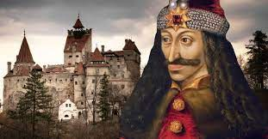
Student details and contribution
GABRIEL DIDEI 2123767
• Cover letter
• Executive summary
• Table of contents
• Business description and history
FLORINA BUCUR 2120194
• Business structure
• Product or service description
• Market analysis and trends
FLORIN LUPU 2120094
•Operations
•Technology plan
•Management and organization

ATTILA KELEMEN 2123680
•Social responsibility and sustainability
•Development, milestones and exit plan
• Financial data

Group 4
Managing Enterprise in the 21st Century
BMSW4006
Lecturer Alfred Mensah

Cover Letter

Dear Sir/Madam
I am very happy to introduce a new business plan to establish a restaurant “Dracula Palace Restaurant” in the market of London. You will get detailed information about the new business plan which is based on innovative ideas and themes which is useful to draw the eyes of customers on a large scale. Also, in this business plan, a complete analysis of the marketing, operations, and financial planning is included which is essential to execute the new business plan in the market.
I am waiting for your response and comment you may have related to this business plan. You can contact us.
Thank you
Yours Faithfully
Dracula Palace Restaurant Team

Executive summary
This study paper deals with the new business plan to open a restaurant in the market in London. The selected name for this business plan is "Dracula Palace Restaurant". This business plan is introduced to establish a technology-based restaurant to provide contactless and paperless services to customers. Also, high-quality products are going to be manufactured by this business organization using organic materials. Also, this business organization will use theme-based organizational culture and environment to boost the customer experience. This study paper also includes a detailed analysis of marketing and operation management to effectively establish and run the business organization in the market in London. To analyze the market trends and competition this business organization uses porter's five forces, pestle analysis, and market segmentation to get appropriate information. Also, an effective management system for this new business plan is included by the executives to manage and operate the business as per the rules and regulations of the business organization and government. A financial statement is also included by the executives to support the organization.

Table of Contents
Introduction 5
Business history and description 6
Vision 7
Mission 8
Values 8
Current strategy 8
Business structure 9
Products and service description 10
Market analysis and segmentation 11
PESTLE Analysis 11
Porter’s five forces 12
Segmentation 13
Market trend 14
Operations 14
Technological plan 15
Organization and Management 17
Social Responsibility and sustainability 22
Development, milestones, and exit plan 22
Financial data 22
Cash flow statement 22
Income statement 27
Balance sheet 30
Conclusion and recommendation 34
Reference List 35
Appendix 38

Introduction
A new business plan is going to be introduced in this paper to open a unique restaurant in London and provide a better customer experience. The suitable name for this business plan of the restaurant is “Dracula Palace Restaurant” which is based on the horror theme. This innovative idea is new to the market and it is effective to attract a large customer base in a short time. It is also found that in the market of London, there are too many business organizations operating business restaurants but they are following the traditional system for business management and older themes. Therefore, this theme of the restaurant is helpful to get a competitive advantage, a large customer base, and high profit to manage and operate the small business in the market (Henriques, et al., 2022). Also, this business organization is focusing on the current needs and wants of customers along with marketing trends to provide unique and effective products and services to consumers. Also, they are going to focus on the pricing strategy which is essential to get a competitive advantage as well as profit. However, this business plan is used to provide high-quality food items and beverages to the customers at affordable prices. Also, the premises are going to be decorated with the theme of Dracula's house.
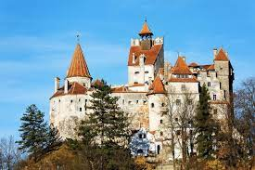
Picture: Dracula Castle (Google)

This study paper is going to include a business description which will contain a vision, mission, values, and current strategy along with a brief history of launching the new business plan in the market of London. The next section will focus on the structure of the business organization and management system to effectively execute the business plan and operate the business. However, this study paper will also outline the description of the product and services which are going to be delivered to the potential customers and get a competitive advantage. To open a new business, a business organization needs information about market trends, needs and expectations of customers, and a proper plan for operations and financial arrangements. Therefore, this business organization will contain a proper analysis of marketing trends and segmentation using the marketing mix analysis and competition analysis to cooperate with the new business organization in the market. This paper will also include a description of industrial operations and technological implementation plan which is also important for the establishment of the new business plan in the market. A financial statement is going to be provided by the executive for the benefit of the Dracula Palace Restaurant” business plan.

Business history and description
In the market of the United Kingdom, there are too many business organizations running restaurants and they are managing the process of business according to their ease. They are also using a traditional system and also they are focusing on the advancement of the business process to stay in the market and create a competitive edge for other business organizations. It is also found that they are also using innovative ideas to provide better experiences to customers. Also, they are trying to establish high-quality products and services for guests and regular customers. However, existing business organizations are also providing cuisine-based food products to customers on a large scale but the number of theme-based restaurants is few in the market. However, from the analysis of the marketing trends, it is found that customers are moving toward the digital world and they are trying to use online services for home delivery of food products and services and also focusing on takeaway services for their good health and safety. Also, the government of the United Kingdom is implementing strict rules and regulations for the reduction of pollution levels by avoiding the use of plastics and waste products management systems for the restaurant business.
It is also identified that existing business organizations are facing problems in the integration of the latest tools and technology within the organization due to a lack of technical knowledge and experienced staff. Also, the existing technology is based on the traditional business management system which is not effective to operate the business in the current situation of the marketing trends. It is also found that consumers are not using dine-in services in the restaurant according to the expectation of the business firm which is creating problems for the restaurant business organization. Also, it is identified that consumers are using an online payment strategy and contactless services to utilize and enjoy the products and services of the restaurant but the existing business enterprises are not getting an appropriate result from this type of service and their business is going downwards. However, they are also providing training and motivation to employees about the new technology and online business management system to operate their business properly. Also, the living style of the population and their needs are changing according to the digital world which is creating too many business opportunities for the establishment of the new business plan.
This business plan is designed on the gothic theme which is new to the market and no other business organization is focusing on such type of theme (Isler, 2022). Also, this business plan is used to focus on the requirement of the digital era to fulfill the market gap. However, the selected gothic theme is based on the Dracula concept which is going to be used for this business plan. A dark-shaded din-in environment is going to be created by the business organization using natural items. They are going to use dim lighting and a Dracula-based ambiance to provide products and services of the Dracula Place Restaurant. However, this business organization is also using high-tech technology and an upgraded system to operate the business and provide a paperless menu, contact-less services, and an online ordering system according to the needs and wants of customers. Also, this business organization is going to provide an ethical workplace for employees to increase engagement and loyalty. Also, they are using the online system to provide proper training and motivation to the employees to operate the online business of Dracula Place restaurant and effective din-in services for customers. Also, they are using the online system to analyze the performance of employees and manage business activity.
Dracula place restaurant is also going to use high-quality products to manufacture tasty food items according to the demand of customers. They are going to use organic materials to provide health-conscious food items to customers. Also, this business organization is going to use the Dracula dress-up to serve the food items and increase the customer experience. Also, they are using a sound system to provide a gothic environment at the workplace to enjoy dine-in services and spend time with family, friends, and dear ones. Also, this business plan is used to focus on environment-friendly products and services to contribute to their presence in a green environment.

Vision
The vision of this business plan is to focus on high-quality products and services for customers in order to provide better experiences to customers. Also, this business organization is using organic food products to deliver delicious and healthy food items. Also, they are focusing on waste food management for the effectiveness of the environment. This business plan is also focusing on the increment of sales and productivity within the organization to get a high profit and competitive advantage. This business organization is also using advanced technology and upgraded tools and technology to manufacture high-quality products. Apart from this, they are also focusing on the development of an ethical and positive environment for employees to motivate them and adopt the latest technology for their personal and professional growth. Also, Dracula Place Restaurant is going to use the theme-based organizational culture and workplace to attract new customers for their business growth and development.

Mission
The mission of Dracula Place Restaurant is to integrate high-tech technology to develop the business organization and services which are not present in the market in London. Also, they are moving towards digitalization to provide home delivery services and execute the contactless business approach in the market of the United Kingdom. However, they are also including dresses and ambiances according to Dracula's styles and dim lights in the development of the dine-in workplace (de Brito, 2019). However, this mission is also necessary to get high-profit and financial and increase awareness among customers about the environment. Also, they are using informative quotations and images in the poster of this business organization to increase brand awareness and recognition among the community. opportunities for the sustainable growth of the new business organization. Apart from this, Dracula Place Restaurant is going to use natural things for the decoration of the restaurant and create a gothic environment which is effective to focus on the sustainable environmental plan.

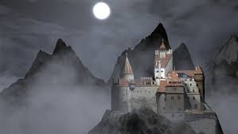
Picture : Dracula Castle (Google)

Values
Values of the business organization are also an important step for the growth of the new business plan in the market. Therefore, Dracula Place Restaurant is going to deliver and proceed with the food products and services for all age groups and communities. Also, they are manufacturing health-conscious food items for customers according to their demands and choices to boost their experiences. Also, they are developing an ethical environment to please customers as well as employees to establish a long-lasting relationship. However, the use of natural products for the decoration of the organization is effective to enhance awareness among customers and help the government of the United Kingdom. They are also following the rules and regulations of the government to operate and manage the business of Dracula Place Restaurant.

Current strategy
The current strategy which is going to be used by Dracula Place Restaurant is to adopt the latest tools and technology for the operation and management of the business plan. This business organization will use artificial intelligence and the internet of things to execute the business activity and analyze the performances of the business organization and employees. Also, they are going to use cloud-based technology to keep a large amount of data and personal information of customers and the workforce safe. They will also analyze the current market trends and needs of customers to provide products and services. This business organization will also focus on advertisement and online marketing campaigns to draw the eyes of customers.

Business structure
The business would be based on sole proprietorship. The owner of the restaurant would be one who would be the one responsible for all the functioning of the restaurant along with bearing the risk that is associated with the restaurant. The skills and knowledge possessed by the owner would be helpful for the smooth functioning of the business. The structure of the business would contain the owner at the top of the business who would possess all the authority and power to take decisions in the business. Then below the owner is the general manager under whom the kitchen owner, as well as the assistant leader, would function (MAKUDZA, et al., 2020). The kitchen owner would be responsible for handling all the tasks that are associated with the preparation of food. The assistant leader would be responsible for other functioning of the restaurant like finances, pantry, dishwasher, etc. hence, the work would be divided as per the structure of the business.

The owner of "The Dracula Palace" would not hold all the shares of the business. 51 percent of the shares would belong to the owner of the restaurant making them the owner and giving authority to the business. However, the rest 49 percent would be owned by the investors along for being used for different tie-ups that the restaurant owner would do so that the business flourishes and they could receive more profit through this process. There are certain gaps in the skills that are possessed by the owner like they lack the knowledge regarding the business functioning which is a significant aspect required for the smooth working of "The Dracula Palace" (Larue., 2020). For filling this gap in the skill, a strategic alliance would be formed with the business consultant. The business consultant would facilitate the owner with knowledge regarding the functioning of the business and the methods by which its expansion would take place. In return, the owner would offer the business consultant a profit share of 8 percent (Wunsch, 2022). The next assistance that the owner would take is the provision of raw materials for the restaurant. Since the restaurant would make use of organic raw materials, therefore they require to choose their suppliers from the local farmers that grow organic food. The restaurant can also form a strategic alliance with the organic farm owner for the management of the supply chain. The farmer would facilitate the restaurant with organic raw materials that would be required by the same and in return, they would receive benefit through the method of profit sharing. This signifies that the owner of the restaurant would facilitate the owner of the farm with a profit of 10-12 percent of the profile. This way the owner, as well as the farm owner, would be benefitted from this exchange (Wunsch, 2022). The restaurant would then tie up with form delivery services like Delivery, Just eat, etc which will work to the mutual advantage for both the delivery services as well as the restaurant.

Products and service description
The restaurant would serve people healthy yet tasty food. People long for flavourful and tasty food however, the growing health issues have made them eat healthy food. The restaurant has profoundly studied and analyzed this demand of the people which has then decided to make food that is the amalgamation of taste and health. The restaurant aims to provide healthy food which does not let them compromise on their taste buds. The restaurant would serve people their favorite food however those would have lesser calories. The menu would include a range of foods that are popular like sandwiches, lasagna, pizza, pasta, burger, burritos, fried chicken, etc. the food that would be prepared by the restaurant would make use of healthy raw materials like organic, use items possessing low calories, and lessen the use of oil and other products that are harmful. The Dracula Palace would not restrict these implementations to just food but it would also incorporate desserts as well as beverages. Both of them would also be prepared to keep in mind the prime focus of the restaurant. The beverages and desserts would be made using the replacement of sugar so that it does not become unhealthy.

The services provided by the restaurant would be unique. The restaurant would be gothic-themed depending on the concept of Dracula. The structure of the restaurant would be made by taking inspiration from the hotel Transylvania which is supposed to be the home of Count Dracula. The ambiance of the hotel would be set according to the hotel which would be dimly lit to give the feel of the gothic palace. In order to create a spooky environment, the restaurant would hang pictures of Dracula. The waiters would be dressed up in the get-up of Dracula. The walls of the restaurant would have stains of red paint to give the resemblance to spilled blood. The restaurant would provide the service of dine-in, takeaway, and home delivery. The restaurant would be paperless so the customers can get the menu through scanning, the payment would also be done through online mode. It would use crockery made from recycled material for keeping in mind the environment.

Market analysis and segmentation

PESTLE Analysis

Political - The United Kingdom’s sustainable politics together with the policies of the government amplifies the food sector of the country which has made way for the establishment of restaurants in the UK (Seyitoğlu, and Ivanov, 2020). The legislative efforts taken by the government have been the prime judging aspects for the growth of the market of “Dracula Palace Restaurant” in the United Kingdom.

Economic - The United Kingdom’s steady economic development together with the huge inflow of citizens from abroad as well as the nation raises the client rate in the restaurants of the country. But, a reduction in the rating parity results in lesser pricing of branded food products might demonstrate challenges for the growth of the restaurant sector. Preservation of a balance of the rate would prove for “The Dracula Palace” in terms of offering more productivity as well as bringing more traffic to the restaurant.

Social - The social atmosphere of the United Kingdom states the presence of people that are health conscious and prefer eating healthy food (Matovic, 2020). The desire for eating organic food is rising in the nation. The steady change in the behavior of projecting an enhancing trend of dining outside is an additional aspect that enhances the business.

Technological - The advancement in the technology of the United Kingdom followed by a revolution in the technology has the capacity of offering innovation and growth to "The Dracula Palace" which would amplify the productivity. It would also be beneficial for the marketing of the company (Seyitoğlu and Ivanov, 2020).

Legal - Legal aspects like continuous assistance from the government would enable the restaurant to amplify its productivity in the market in the UK. Along with this, it would also abide by the laws that are implemented by the government of the nation including Employee law and Food and security law.
Environmental - Environmental aspects like the growing concern on the industry depending on the environmental issues. However, this aspect acts as a favor to the restaurant as the restaurant would implement measures and steps that would be environment friendly. They would make use of organic materials for making their food and the restaurant would be paperless.

Porter’s five forces

The threat of new entrants- this element in the case of "The Dracula Palace" is comparatively less owning to the fewer number of theme-based restaurants that are operating in the markets of the UK at present. In addition to this, the restaurant would serve organic food which is both tasty and healthy which will help in the generation of a favorable base for the growth and flourishing of the business of "The Dracula Palace".

Bargaining authority of the customers- the power of bargaining of the customer is a threat to the growth and development of the business of “The Dracula Palace” (Genoveva, and Siam, 2017). But, this threat could be eliminated through the implementation of an effective strategy for facilitating customer services along with providing organic food and maintaining a balance of rates.

Bargaining authority of the suppliers- The authority of the suppliers could pose a grave threat to the profitability of “The Dracula Palace” (Pezzutto, et al., 2020). The company would have to tie up with farmers for the provision of organic raw materials in which they would have no say as the restaurant does not have many options. Maintenance of a healthy relationship with suppliers, distributors, and stakeholders would amplify the productivity of the business of "The Dracula Palace".

The threat of substitute- The threat of substitute goods in the case of “The Dracula Palace” is comparatively lesser as compared to other restaurants operating in the UK. this is because the restaurant enjoys a competitive advantage in many aspects. The first is, that it would be a gothic restaurant and the next advantage is that it would provide healthy and organic food.

Competitive rivalry- this aspect in the case of “The Dracula Palace” is also less owing to the presence of fewer gothic-style theme-based restaurants in the UK that provides organic and healthy yet tasty food (Pezzutto et al., 2020).

Segmentation
For researching the market segment and target customers, “The Dracula Palace” would conduct the following segmentations.
- Demographic segmentation- The Dracula Palace will search for target customers from different age groups, especially from 18 to 45 years of age which would be both males and females (Camilleri, 2018). They would gain customers by providing them with a good ambiance and healthy food which would be flavourful along with being healthy.
- Geographic segmentation- The restaurant to lure customers from places located near the restaurant as well as far-off places in the UK. For targeting customers from far-off places, the restaurant would make use of takeaways and home delivery systems. The gothic ambiance would also lure tourists visiting from different nations.
- Behavioral segmentation- this aspect would help the restaurant in the decision of the behavior of the customers such as their needs, demands, and ways to earn their loyalty. They would request the customers visiting the place to give them a review on the quality of food on social media along with their feedback which would be useful for luring more customers. The behavior of healthy eating habits of the customer along with those who prefer to have organic food to keep themselves healthy would also be the target of the company.
- Psychographic segmentation- The Dracula Palace would get its target customers from the people who desire to eat healthy yet tasty food along with enjoy gothic-themed places. The menu would consist of food that is healthy with a twist of flavors in this which makes them good for taste buds (Paruchuri, 2019). The unique gothic-themed restaurant would welcome the people who like such kind of ambiance.
- Economic Segmentation- The Dracula Palace would target people belonging to the upper middle class and upper-class people (Musa et al., 2019). Since the restaurant would provide food made from organic raw materials, therefore, the pricing would be slightly higher than the normal restaurant.

Market trend
The people of the United Kingdom are getting health conscious but at the same time, they are not ready to compromise their taste as well. To fulfill this market trend the company would provide its customers with organic and healthy food that would be tasty. Owing to the pandemic people prefer home delivery or take away which would also be facilitated by the restaurant. The prime concern these days are environmental associated issues which have also been highlighted by the government. "The Dracula Palace" would use organic raw materials along with eco-friendly products in the restaurant. The crockery used would be environmentally friendly and they would provide paperless menu and payment options.

Operations
Staffing: This business plan is new and the business organization needs experienced and qualified employees to operate and manage the business operations effectively. Therefore, Dracula Place restaurant is going to hire 15 employees in the starting days with the help of a recruitment plan. They will conduct an online ability test for the employees who are interested in joining this business organization (Roy, et al., 2022). According to the result of the ability test, this organization will conduct a face-to-face interview to select the employees. Also, they will provide a list of rules and regulations to the selected employees before joining. Also, they will provide training to them to enhance their ability according to the requirement.
Premises: Dracula Palace Restaurant will focus on the safety and security of the workforce as well as customers on the premises. Therefore, this business firm will include high-tech technology and effective tools to establish contactless services. Also, they will implement friendly rules and regulations for the employees who are working in this restaurant to motivate them and increase collaboration in the workplace. They will also hire diverse employees to integrate cross-culture and for the reduction of language barriers within premises. Also, they will use an effective system for waste product management which is effective for good health.
Suppliers: Suppliers are also an important entity of the business plan who are contributing their role in the supply of raw materials and effective services to operate the new business plan in the market of London. They will purchase fresh vegetables, and fruits from the local suppliers as well as regional suppliers. Also, they will purchase organic food materials from national and international suppliers with the help of online shopping platforms by comparing the price. Also, they will establish strong relationships with the suppliers to get the products and services at an affordable price and also on time.
Equipment: This business organization is going to use upgraded equipment to operate the business of this restaurant. Also, they will use the automated oven to cook organic food items and provide high-quality products to valuable customers. Also, they will regularly check up and maintain the equipment for the effectiveness of the business process. Also, they will develop personal software to keep the record of organizations and customers confidentially and operate online services to increase customer experiences.
Management of risk: In the execution of the new business plan, this restaurant may face problems in the management of business operations and arrangement of financial balance. However, this business organization will use the automated system to get feedback and analyze the performances of the business organization as well as employees to reduce the risk of customer loss. Also, this business enterprise provides a clean and healthy workplace for the safety and security of the employees (McAdams et al., 2018). Apart from this, they will also use the auto-cut power switches and fuses to prevent accidents and electric shocks within premises. Also, they will follow the rules and regulations of the government to get financial support in a crisis.

Technological plan

The Dracula Palace would leverage its business on technology. With the use of advanced technology, the business functioning of the restaurant would be carried out. For marketing and advertisement the restaurant for relying on technology. It would have its website where the content would be generated based on SEO. The Dracula Palace would have its online presence on different platforms and social media as well. The platforms such as YouTube, Instagram, Twitter, Facebook, etc. would be used for the promotion of the restaurant. People spend a huge amount of time on these sites and the restaurant would take advantage of this technological aspect to lure the attention of its targeted customers. Online marketing has become the best advertising mode which would give a competitive advantage to the restaurant. These platforms along with the website would give people the provision of giving their feedback and writing reviews regarding the company. These reviews, ratings, and feedback would help the restaurant gain access to more audiences as it would help in word-of-mouth publicity (Breckova, and Karas, 2020). The potential customers would read about the restaurant and would know about it which would help the same to get more audience to the restaurant (Park, et al., 2018). The Dracula Palace would also give luring offers on their online platforms like price reduction, buy two get one free, weekend relief offers, discounts, happy hours, etc. these offers and discounts would be promoted online which would reach the masses of the UK easily and help the restaurant to get more traffic.

Technological assistance would also be taken in the restaurant. It would help the same to carry out its functioning (Li, et al., 2019). It would be a paperless restaurant. Therefore, the paper would be replaced by technology. Instead of getting a menu card, the customers could scan the menu from the QR code that would be placed on each of the tables. The payment would also be accepted online by the restaurant.

Apart from the provision of service in the restaurant and marketing assistance, a technological plan would also help in taking orders (Park, et al., 2018). The restaurant would take online orders. The customers even from sitting in the restaurant could order online from the website of the restaurant. People can do online orders from their house as well. The restaurant would provide the facility of home delivery and takeaway. Therefore, the customers can order online through the website of the company or from their delivery partners, do online payment and the food would be delivered to their door. The restaurant would also launch its application which would make ordering easier.

Organization and Management
Organization and management are the backbones of any restaurant industry. It plays a very important role daily, connecting supervising the operation with building a strong bottom line for long-term development. The management team will also play a critical role in specifying and counterbalancing labor expenditures and food expenditures, creating property commodities, balancing restaurant trade, and so on. In the year 2020, almost 6,267 restaurants and cafes have opened all over London (Pont and Harding, 2019). London is the most suitable place to start the business of Dracula Palace Restaurant, along with various advantages to serve a huge number of customers and also fulfilling their requirements. To make the initiative successful of Dracula Palace Restaurant in London, the organization and management need to be done in a relevant way.
Board of directors:
The board of directors' role is the most all-encompassing role in restaurant management that can be played. A board of directors has the responsibility to ensure the proper establishment of accountability for the restaurant's management as well as another role is to ensure reasonable interior control with the help of an autonomous third-party appraisal of the business (Zarotis, 2021). In the initiative of Dracula Palace Restaurant in London, the board of directors will take the initiative which is mentioned below.
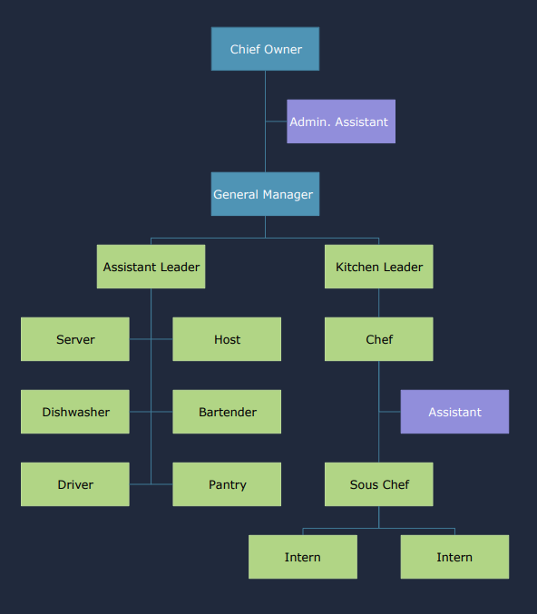
Figure 1: Organizational chart of Dracula Palace Restaurant (Source: self-created)

- Recruit, manage, control, estimate, and pay the manager
The board of directors of Dracula Palace Restaurant will play a very important role in recruiting the proper employees, supervising the managers, maintaining, considering, and providing the proper equilibrium for the CEO. It is the most crucial responsibility of the board of directors of Dracula Palace Restaurant to make a division policy and create various options in the policy. The other major role of the board of directors in this restaurant will be the hiring and dismissal of the senior executive as per the work basis and establishing the payment for the administrator (Trzeciak et al. 2022).
- Furnish supervisor for the restaurant
Another crucial responsibility of the Dracula Palace Restaurant's board of directors will be to ensure the proper strategic position so that it can clearly articulate the concept, task, and objective of the restaurant. The board of directors is sometimes determined in conjunction with the role of a chief administrative officer or general leader in the industry.

- Set proper approach of the restaurant
The board of directors will be responsible for assuming all of the responsibilities of this restaurant, including developing a management system in the business. With the help of various frameworks, it will enable the board of supervisors to make a policy that can surely help Dracula Palace restaurant among many competitors in London.

- Governance and observe all the movement in the restaurant
Another important commitment of the board of directors of Dracula Palace restaurant in London will be to control and scrutinize all functions in the restaurant. The major rules can be stated as auditing the process, engaging the auditors, and so on.

Management team
The management team is the highest level of association that helps the business, typically by hiring appropriate candidates for adequate work. The management team will play a very important role in making the initiative of the Dracula Palace restaurant successful at the higher level of management. The majority of the work to ensure proper management in the restaurant will be done by the management team, such as computation, commerce, attracting customers by offering a deal, and developing and implementing a business-beneficial operational process. The responsibility of the management does not only increase the business of this restaurant; however, it can also provide each and everyone's responsibility in the business by giving proper strategy (Wood, 2021). Almost 70% of the managerial work of Dracula Palace restaurant will be done by the management team.
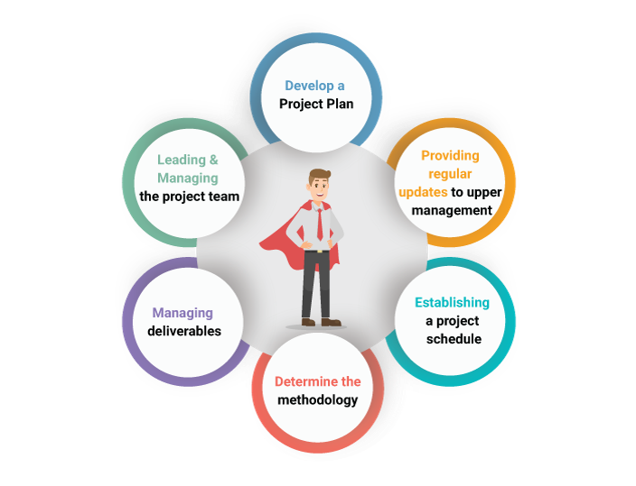
Figure 2: Role of the Management team
(Source: Mhlanga, 2018)
Financial team
The financial team will play another vital role in the Dracula Palace restaurant business. The financial teams will be accountable for providing the appropriate information by making decisions that affect the future implementation of the business, which involves the analysis of various types of data in the restaurant. The financial department is always in a state of scrutiny on any kind of decision that is taken by the senior manager. It is the responsibility of the financial team to make a proper analysis of the efficiency as well as access the financial data that will be involved in the finances of the restaurant of Dracula Palace. As a result, the financial team's importance in this business is compulsory; it is the managers' responsibility to create various balance sheets, monetary accounts, the statement of cash flow reports, day-to-day records, and reports, including payroll calculations, and so on (Mhlanga, 2018).
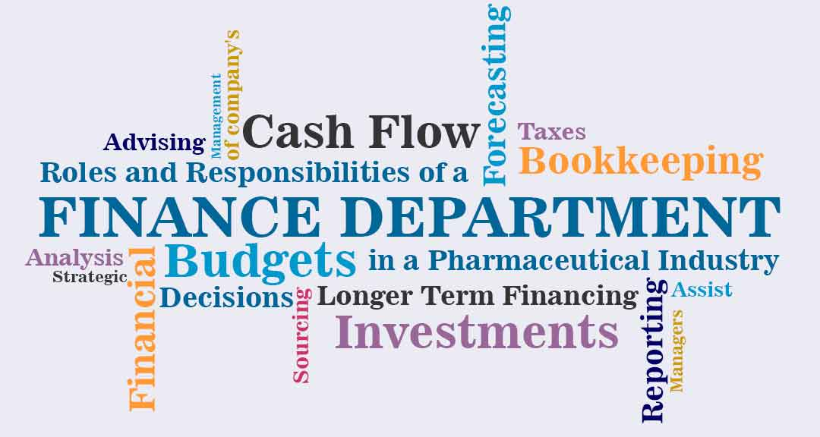
Figure 3: Role of the financial team
(Source: Spivakovskyy et al. 2021)
Marketing team
The marketing team plays the most important role in Dracula Palace restaurant by making the business essential by promoting the food items and ambiance. The marketing team will also be responsible for providing information and updates on various kinds of social media as well as online platforms on the restaurant's application. With the help of providing the promotion as well as an overview of the application, this business can give an adequate sponsorship by delivering the food with adequate quality. The major responsibility of the marketing team of the Dracula Palace restaurant will be to research the appropriate segment of the customer or market where the promotion is essential, as well as to have in hand a proper overview of the customer's behavior and practices. Another major vital responsibility of the marketing team of this restaurant will be to give reasonable food to its customers at inexpensive prices (Spivakovskyy et al. 2021).
The discounts, as well as the deals of the day, can attract the customers and make the management team strong so that they can easily identify any kind of mistake in the business. Another vital role of the Dracula Palace restaurant marketing team is to manage the service appropriately and give the proper marketing information to the management. Another vital responsibility of the marketing team will be to analyze the proper price strategy by analyzing the data of all competitors' pricing strategies in London and give its customers the most accurate cost of food.

Figure 3: Role of the marketing team
(Source: Mhlanga, 2018)

Social Responsibility and sustainability
Dracula Palace Restaurant is also focusing on social responsibility and sustainability to operate the business ethically and for the creation of a positive workplace. This business organization is going to use effective and customer-oriented products and services to deliver health-conscious products and services. Also, they will implement ethical labor policies for the well-being of employees and enhance their experiences (Ashrafi et al., 2020). However, this business organization is going to use an effective waste product material management system for the effectiveness of the environment. They are also going to use fresh and healthy organic food products for the benefit of customers.

Development, milestones, and exit plan
Dracula Place restaurant is going to develop a long-term and short-term business plan to establish and operate the business organization. The short-term business plan of this business organization is to establish a restaurant in the market in London. The long-term business plan of this business organization is to focus on the expansion strategy to expand their business in different geographical regions. The key milestone to improving the profitability and productivity of this business organization is 3-4 years. However, this business organization will focus on the current and upgraded tools and technology to achieve its target. The exit plan of Dracula Place Restaurant is to utilize innovative ideas and strategies to fulfill the long-term goal and accomplish the aim and objectives effectively (de Bloeme et al., 2021).

Financial data
Financial data is also necessary for the establishment of new business because it is the central part of the business organization (Osadchy, et al., 2018). In this section, a cash flow statement is going to include the different areas of investment, an analysis of the expenses along with a description of bank loans and assets of the business organization.

Cash flow statement
Starting date | Sep-22
Cash balance alert minimum | 3,000 | 3,000 | 3,000 | 3,000 | 3,000 | 3,000 | 3,000 | 3,000 | 3,000 | 3,000 | 3,000 | 3,000 | 3,000
 | Beginning | Sept ( £'0) | Oct | Nov | Dec | Jan | Feb | Mar | Apr | May | Jun | Jul | Aug | Total
Cash on hand (beginning of the month) | 8,000 | 8,000 | 8,030 | 9,030 | 10,120 | 11,570 | 12,670 | 14,300 | 15,790 | 17,440 | 19,160 | 21,150 | 23,180
CASH RECEIPTS
Cash sales |  | 300 | 350 | 400 | 450 | 460 | 480 | 500 | 530 | 580 | 600 | 650 | 700 | 6000
Returns and allowances |  | 100 | 120 | 200 | 300 | 250 | 400 | 450 | 400 | 500 | 520 | 500 | 600 | 4340
Collections on accounts receivable |  | 120 | 120 | 150 | 180 | 200 | 230 | 250 | 280 | 300 | 320 | 350 | 450 | 2950
Interest, other income |  | 120 | 120 | 120 | 120 | 120 | 120 | 120 | 120 | 120 | 120 | 120 | 120 | 1440
Loan proceeds |  | 300 | 300 | 300 | 300 | 300 | 300 | 300 | 300 | 300 | 300 | 300 | 300 | 3600
Owner contributions |  | 60 | 60 | 60 | 60 | 60 | 60 | 60 | 60 | 60 | 60 | 60 | 60 | 720
TOTAL CASH RECEIPTS |  | 1,000 | 1,070 | 1,230 | 1,410 | 1,390 | 1,590 | 1,680 | 1,690 | 1,860 | 1,920 | 1,980 | 2,230 | 19050
Total cash available | 8,000 | 9,000 | 10,070 | 11,300 | 12,710 | 14,100 | 15,690 | 17,370 | 19,060 | 20,920 | 22,840 | 24,820 | 27,050
 |  |  |  |  |  |  |  |  |  |  |  |  |  | 0
CASH PAID OUT |  |  |  |  |  |  |  |  |  |  |  |  |  | 0
Advertising |  | 200 | 200 | 200 | 200 | 200 | 200 | 200 | 200 | 200 | 200 | 200 | 200 | 2400
Contract labor |  | 150 | 150 | 150 | 150 | 150 | 150 | 150 | 150 | 150 | 150 | 150 | 150 | 1800
Employee benefit programs |  | 150 | 150 | 150 | 150 | 150 | 150 | 150 | 150 | 150 | 150 | 150 | 150 | 1800
Insurance (other than health) |  | 140 | 140 | 140 | 140 | 140 | 140 | 140 | 140 | 140 | 140 | 140 | 140 | 1680
Interest expense |  | 60 | 60 | 60 | 60 | 60 | 60 | 60 | 60 | 60 | 60 | 60 | 60 | 720
Materials and supplies |  | 200 | 250 | 300 | 400 | 450 | 500 | 550 | 600 | 650 | 650 | 700 | 800 | 6050
Meals and entertainment |  | 100 | 100 | 100 | 100 | 100 | 100 | 100 | 100 | 100 | 100 | 100 | 100 | 1200
Office expense |  | 120 | 100 | 150 | 100 | 160 | 100 | 120 | 100 | 150 | 100 | 100 | 100 | 1400
Other interest expense |  | 100 | 100 | 100 | 100 | 100 | 100 | 100 | 100 | 100 | 100 | 100 | 100 | 1200
Pension and profit-sharing plan |  | 100 | 100 | 100 | 100 | 100 | 100 | 100 | 100 | 100 | 100 | 100 | 100 | 1200
Purchases for resale |  | 100 | 110 | 150 | 180 | 200 | 230 | 280 | 300 | 340 | 380 | 400 | 450 | 3120
Rent or lease |  | 40 | 50 | 60 | 50 | 80 | 50 | 100 | 50 | 120 | 50 | 50 | 50 | 750
Rent or lease: vehicles, equipment |  | 130 | 130 | 130 | 130 | 130 | 130 | 130 | 130 | 130 | 130 | 130 | 130 | 1560
Repairs and maintenance |  | 90 | 90 | 90 | 90 | 90 | 90 | 90 | 90 | 90 | 90 | 90 | 90 | 1080
Supplies (not in COGS) |  | 200 | 250 | 300 | 400 | 450 | 500 | 550 | 600 | 650 | 650 | 700 | 750 | 6000
Taxes and licenses |  | 40 | 40 | 40 | 40 | 40 | 40 | 40 | 40 | 40 | 40 | 40 | 40 | 480
Travel |  | 50 | 50 | 50 | 50 | 50 | 50 | 50 | 50 | 50 | 50 | 50 | 50 | 600
Utilities |  | 70 | 70 | 70 | 70 | 70 | 70 | 70 | 70 | 70 | 70 | 70 | 70 | 840
Wages (less emp. credits) |  | 160 | 180 | 220 | 240 | 270 | 300 | 330 | 360 | 390 | 420 | 450 | 480 | 3800
Other factorial expenses |  | 20 | 20 | 20 | 20 | 20 | 20 | 20 | 20 | 20 | 20 | 20 | 20 | 240
Other expenses |  | 50 | 50 | 50 | 50 | 50 | 50 | 50 | 50 | 50 | 50 | 50 | 50 | 600
Other expenses |  | 40 | 30 | 30 | 30 | 30 | 30 | 30 | 30 | 30 | 30 | 30 | 30 | 370
Miscellaneous |  | 30 | 50 | 70 | 50 | 50 | 50 | 50 | 50 | 50 | 50 | 50 | 50 | 600
SUBTOTAL |  | 2,340 | 2,470 | 2,730 | 2,900 | 3,140 | 3,210 | 3,460 | 3,540 | 3,830 | 3,780 | 3,930 | 4,160 | 39,490
Loan principal payment |  | 400 | 400 | 400 | 400 | 500 | 500 | 500 | 500 | 800 | 800 | 800 | 800 | 6800
Capital purchases |  | 420 | 430 | 500 | 560 | 410 | 470 | 480 | 470 | 320 | 290 | 440 | 440 | 5230
Other startup costs |  | 450 | 450 | 450 | 450 | 450 | 450 | 450 | 450 | 450 | 450 | 450 | 450 | 5400
To reserve and/or escrow |  | 100 | 150 | 200 | 350 | 350 | 400 | 450 | 500 | 500 | 550 | 600 | 600 | 4750
Owners' withdrawal |  | 0 | 0 | 0 | 0 | 0 | 0 | 0 | 0 | 0 | 0 | 0 | 0 | 0
TOTAL CASH OUTFLOW |  | 970 | 1040 | 1180 | 1140 | 1430 | 1390 | 1580 | 1620 | 1760 | 1690 | 1640 | 1870 | 17310
Cash on hand (end of the month) | 8,000 | 8,030 | 9,030 | 10,120 | 11,570 | 12,670 | 14,300 | 15,790 | 17,440 | 19,160 | 21,150 | 23,180 | 25,180 | -17,310
 |  |  |  |  |  |  |  |  |  |  |  |  |  | 0
OTHER OPERATING DATA |  |  |  |  |  |  |  |  |  |  |  |  |  | 0
Sales volume (dollars) |  | 420 | 470 | 550 | 630 | 660 | 710 | 750 | 810 | 880 | 920 | 1000 | 1150 | 8950
Accounts receivable balance |  | 600 | 700 | 800 | 900 | 1,000 | 1,100 | 1,200 | 1300 | 1,400 | 1,500 | 1,600 | 1,700 | 13800
Bad debt balance |  | 80 | 100 | 150 | 160 | 170 | 180 | 200 | 220 | 240 | 260 | 280 | 300 | 2340
Inventory on hand |  | 800 | 820 | 860 | 900 | 950 | 960 | 980 | 1000 | 1200 | 1,300 | 1,400 | 1,500 | 12670
Accounts payable balance |  | 300 | 350 | 400 | 480 | 500 | 600 | 500 | 700 | 800 | 850 | 900 | 1000 | 7380
Depreciation |  | 60 | 65 | 62 | 66 | 74 | 76 | 80 | 82 | 84 | 100 | 130 | 150 | 1029

Income statement
Dracula Palace Resturant
2022-2023
Financial Statements in £'0
Revenue
 | Gross Sales |  |  |  | 6000
 | Less: Sales Returns and Allowances |  |  |  | 4340
 | Net Sales |  |  |  |  | 1660
Cost of Goods Sold
 | Beginning Inventory |  |  |  | 800
 | Add: | Purchases |  |  | 1200
 |  | Freight-in |  |  | 0
 |  | Direct Labor |  |  | 0
 |  | Indirect Expenses |  |  | 0
 | Inventory Available |  |  |  | 2000
 | Less: Ending Inventory |  |  |  | 1500
 | Cost of Goods Sold |  |  |  |  | 500
 | Gross Profit |  |  |  |  | 1160
Expenses
 | Advertising |  |  |  | 2400
 |  |  |  |  | 0
 | Bad Debts |  |  |  | 2350
 | Bank Charges |  |  |  | 0
 | Charitable Contributions |  |  |  | 0
 | Commissions |  |  |  | 0
 | Contract Labor |  |  |  | 1800
 | Depreciation |  |  |  | 1029
 | Dues and Subscriptions |  |  |  | 0
 | Employee Benefit Programs |  |  |  | 1800
 | Insurance |  |  |  | 1680
 | Interest |  |  |  | 720
 | Legal and Professional Fees |  |  |  | 0
 | Licenses and Fees |  |  |  | 0
 | Miscellaneous |  |  |  | 600
 | Office Expense |  |  |  | 1400
 | Payroll Taxes |  |  |  | 0
 | Postage |  |  |  | 0
 | Rent |  |  |  | 750
 | Repairs and Maintenance |  |  |  | 1080
 | Supplies |  |  |  | 6050
 | Telephone |  |  |  | 0
 | Travel |  |  |  | 600
 | Utilities |  |  |  | 840
 | Vehicle Expenses |  |  |  | 1560
 | Wages |  |  |  | 3800
 | Total Expenses |  |  |  |  | 28459
 | Net Operating Income (Loss) |  |  |  |  | -26799
Other Income
 | Gain (Loss) on Sale of Assets |  |  |  | 8950
 | Interest Income |  |  |  | 1440
 | Total Other Income |  |  |  |  | 10390
 | Net Income (Loss) |  |  |  |  | -16409

Balance sheet
Balance Sheet for Dracula Place Restaurant
ASSETS |  | % of ASSETS | LIABILITIES & OWNERS' EQUITY |  | % of LIABILITIES
Current assets |  |  | Current liabilities
Cash and cash equivalents [D] | £200.00 | 2.50% | Loans payable and current portion of long-term debt [H] | 400 | 7.50%
Short-term investments | £400.00 | 7.50% | Accounts payable and accrued expenses | 400 | 7.50%
Accounts receivable [I] | £200.00 | 5.00% | Income taxes payable | 100 | 2.50%
Inventories [C] | £600.00 | 12.50% | Accrued retirement and profit-sharing contributions | 200 | 5.00%
Deferred income taxes |  | 0.00%
Prepaid expenses and other current assets | £400.00 | 10.00%
Total current assets [A] | £ 1,500.00 | 37.50% | Total current liabilities [B] | 800 | 20.00%
Fixed assets |  |  | Other liabilities
Property, plant, and equipment at cost | £1000.00 | 25.00% | Long-term debt [G] | £1000.00 | 25.00%
Less accumulated depreciation | £200.00 | 5.00% | Accrued retirement costs | £500.00 | 12.50%
Total fixed assets | £1200.00 | 30.00% | Deferred income taxes | £500.00 | 12.50%
 |  |  | Deferred credits and other liabilities | £0.00 | 0.00%
Other assets |  |  | Total other liabilities | £2000.00 | 50.00%
Long-term cash investments | £1000.00 | 20.00%
Equity investments | £300.00 | 5.00%
Deferred income taxes | £350.00 | 7.50%
Other assets |  | 0.00% | Total liabilities | £2,800.00 | 70.00%
Total other assets | 1500 | 32.50% | Total owners' equity [F] | £1500.00 | 30.00%
Total assets [E] | £6000.00 | 100.00% | Total liabilities + owners' equity | £6,000.00 | 100.00%

Current Ratio
From the analysis of the balance sheet and cash flow statement, it is found that the current ratio of this business organization will be 1.56% which is derived using the formula “Current Ratio = Current Assets / Current Liabilities” (Mulyadi, and Sihabudin, 2020).
Quick Ratio
The quick ratio for this business organization will be 1.30% and the formula used for the calculation of the quick ratio is “Quick Ratio = (Current Assets – Inventory) / Current Liabilities” (Wijaya and Sedana, 2020).

Debt-to-equity Ratio
0.90% is the debt-to-equity ratio for this business plan and important formula for the calculation of the debt-to-equity ratio is mentioned here to help the business organization that is “Debt-to-equity Ratio = (Long-term debt + Loans payable and current portion long-term debt) / Total owners' equity”.
Debt Ratio:
The debt ratio is going to be calculated in this section which is necessary for the calculation of total debt (Levytska, et al., 2018). It is calculated with the help of “Debt Ratio = Total Debt / Total Assets” and the outcome is 0.5%.
Working Capital
The total working capital for Dracula Place Restaurant is 1000 which is sufficient to establish and operate this business in the market in London (Khan, et al., 2020).

Conclusion and recommendation
This study paper is effectively developed for the establishment of new business plans in the market and to focus on innovative ideas and business plans to get a high profit and a large customer base. This business plan is developed to open a restaurant in London and provide organic and healthy food to customers which are not present in the local market. However, from the above analysis, it is concluded that Dracula Place Restaurant is focusing on the current requirement and expectations of customers and developing the product and services according to them. However, It is also concluded that analysis of the marketing trends is helping them in getting knowledge of the running pricing strategy and existing competitors which is also an important aspect of the establishment of the new business plan.
It is also concluded that this business organization is going to use the sole proprietorship to operate their business and they will use the hierarchical business model to effectively operate their business. It is also concluded that financial data is also necessary for the business organization. Therefore, the executives of this study paper have included the cash-flow statement, income chart, and balance sheet to effectively analyze the financial status for the establishment and operation of the business also, this business organization will use the ethical rules and regulations to operate their business, therefore, it is recommended that they have to focus on the business plan and financial data before the establishment of business and get a competitive advantage. It is also recommended that Dracula Place Restaurant has to analyze the data of marketing and existing competitors for decision-making and future planning.

Reference List
Ashrafi, M., Magnan, G.M., Adams, M. and Walker, T.R., 2020. Understanding the conceptual evolutionary path and theoretical underpinnings of corporate social responsibility and corporate sustainability. Sustainability, 12(3), p.760.
Breckova, P. and Karas, M., 2020. Online technology and promotion tools in SMEs. Innovative marketing, 16(3), p.85.
Camilleri, M.A., 2018. Market segmentation, targeting and positioning. In Travel marketing, tourism economics and the airline product (pp. 69-83). Springer, Cham.
de Bloeme, C.M., Jansen, R.W., Krul, M.R. and Geutjes, E.J., 2021. Stepping to the exit. Nature Biotechnology, 39(9), pp.1048-1054.
de Brito, S.R.P.F., 2019. Strategic Plan for a New Restaurant Business (Doctoral dissertation, ISCTE-Instituto Universitario de Lisboa (Portugal)).
Genoveva, G. and Siam, S.T., 2017. Analysis of Marketing Strategy and Competitive Advantage. International Journal of Economic Perspectives, 11(1)
Henriques, P.L., Matos, P.V. and Jerónimo, H.M., 2022. Eager to Develop Sustainable Business Ideas? Assessment through a New Business Plan (BP4S Model). Sustainability, 14(2), p.1030.
Isler, N., 2022. Business plan for a new restaurant concept in London (Doctoral dissertation).
Khan, W., Ahmed, A.A.A., Hossain, M. and Neogy, T.K., 2020. The Interactive Approach to Working Capital Knowledge: Survey Evidence. International Journal of Nonlinear Analysis and Applications, 11(Special Issue), pp.379-393.
Larue, H.H., 2020. Product or Service Description NAICS Description Description of Requirement.
Levytska, S.O., Krynychnay, I.P., Akimova, A.O. and Kuzmin, O.V., 2018. ANALYSIS OF BUSINESS ENTITIES’FINANCIAL AND OPERATIONAL PERFORMANCE UNDER SUSTAINABLE DEVELOPMENT. Financial and credit activity problems of theory and practice, 2(25), pp.122-127.
Li, C., Mirosa, M. and Bremer, P., 2020. Review of online food delivery platforms and their impacts on sustainability. Sustainability, 12(14), p.5528.
MAKUDZA, F., MANDONGWE, L. and MURIDZI, G., 2022. Towards Sustainability of Single-Owner Entities: An Examination of Financial Factors That Influence Growth of Sole Proprietorship. The Journal of Industrial Distribution & Business, 13(5), pp.15-26.
Matovic, I.M., 2020. PESTEL Analysis of External Environment as a Success Factor of Startup Business. ConScienS, p.96.
McAdams, B., Deng, A. and MacLaurin, T., 2018. Food allergy knowledge, attitudes, and resources of restaurant employees. British Food Journal.
Mulyadi, D. and Sihabudin, O.S., 2020. Analysis of Current Ratio, Net Profit Margin, and Good Corporate Governance against Company Value. Systematic Reviews in Pharmacy, 11(1), pp.588-600.
Musa, M.I., Haeruddin, M.I.M., Haeruddin, M.I.W. and Burhan, M.I., 2019. Analysis of Segmentation, Targeting, and Positioning in Hospitality Sector: The Case of Paputo Beach Cafe. African Journal of Hospitality, Tourism, and Leisure, 8(4).
Osadchy, E.A., Akhmetshin, E.M., Amirova, E.F., Bochkareva, T.N., Gazizyanova, Y., and Yumashev, A.V., 2018. Financial statements of a company as an information base for decision-making in a transforming economy.
Palepu, K.G., Healy, P.M., Wright, S., Bradbury, M. and Coulton, J., 2020. Business analysis and valuation: Using financial statements. Cengage AU.
Park, K., Park, N. and Heo, W., 2018. Factors influencing intranet acceptance in restaurant industry: use of technology acceptance model. International Business Research, 11(10), p.1.
Paruchuri, H., 2019. Market segmentation, targeting, and positioning using machine learning. Asian Journal of Applied Science and Engineering, 8, pp.7-14.
Pezzutto, S., Grilli, G., Zambotti, S. and Dunjic, S., 2018. Forecasting electricity market price for end users in EU28 until 2020—Main factors of influence. Energies, 11(6), p.1460.
Roy, D., Spiliotopoulou, E. and de Vries, J., 2022. Restaurant analytics: Emerging practice and research opportunities. Production and Operations Management.
Seyitoğlu, F. and Ivanov, S., 2020. A conceptual framework of the service delivery system design for hospitality firms in the (post-) viral world: The role of service robots. International Journal of Hospitality Management, 91, p.102661
Wijaya, D.P. and Sedana, I.B.P., 2020. Effects of quick ratio, return on assets, and exchange rates on stock returns. Am. J. Humanities Soc. Sci. Res, 4, pp.323-329.
Wunsch, N.-G., 2022, december 22. Statistica. Retrieved from https://www.statista.com/statistics/1085381/healthy-eating-in-the-uk/

Appendix
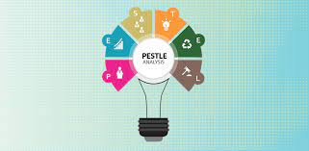
Pestle analysis

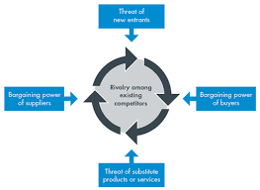
Porter five forces

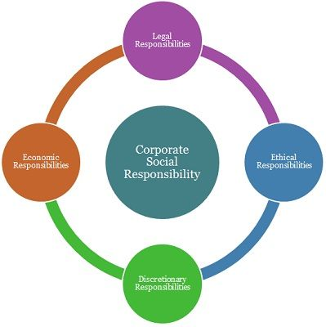
Corporate social Responsibility



