In this essay I will be looking at the similarities and differences in how two different authors portray and explain death within the form of children’s picture books, as well as observing how the authors and author-illustrators convey their messages through their illustrations with the use of colour, composition, and style. Salisbury (2004, p. 6) explains it as a “subtle and complex art form that can communicate on many levels and leave a deep imprint on a child's consciousness”. The most common way young children are taught to read early in life is with picture books. However, it should be noted that within picture books, illustrations are just as important as the text. This is explained in further detail by Salisbury (2012, p. 77), with Salisbury explaining that “learning to look and see through drawing promotes and nurtures vital visual literacy skills, which children begin to do early without prompt”. This essay will also highlight the importance of understanding how children’s minds work when it comes to the topic of death and the psychology behind it to further understand why the authors and author illustrators made the decisions that they made, as the age of the child will greatly affect how they understand and process the subject. A 17-year-old will understand it a lot easier than a younger child would, as younger children have a lot less experience with loss, as explained by Lasher (2008, p. 37). The two books I will be comparing in the pages to follow will be Death, Duck, And The Tulip (Elbruch, 2008) and Cry, Heart, But Never Break (Ringtved, 2016).

Before a child learns to read, picture books are their main tool of learning as explained by Bader (1976, p.2): “Even as a child comes to learn words, he continues for some time to think in images”. So, what makes a picture book so effective? According to Doonan (1993), illustrations consist of a simple concoction of shapes, lines, and colours, which the artist has arranged in a specific way with a medium that conveys their message best. Every line, whether thin or heavy, every small scribble and blob of colour, has been thoughtfully placed to portray a certain experience, whether intentionally or subconsciously. Symbols play a big role within picture books too and can be placed into two categories: denotation and exemplification. Denotation refers to the literal meaning of an object, whereas exemplification refers to an object which is open to interpretation. To quote Doonan (1993, p. 15) “The characteristic of the exemplifying symbol is its open nature; there is no single right answer”. A symbol that is exemplified allows it to stand for something other than itself and brings about a deeper meaning, whether that be metaphorical, cultural, or for societal values.

I will now move on to analysing my first book of choice. Death, Duck, And The Tulip (Erlbruch, 2008) is a children’s picture book that covers the theme of death, however author-illustrator Elbruch (2008) doesn’t tiptoe around the matter. Instead, he addresses it head on, which tells the reader that death as a topic is something which is okay to speak and ask questions about, which is important for young children to learn so that they don’t bottle their feelings up and abstain from learning about the matter. At the age of 5-6, children become a lot more curious of the world around them and begin asking bigger questions and start to slowly accept that the concept of death is something that is inevitable. As Lasher explains;

With this realization, they have come to accept the fact that those things which live, must also die. Herein, school-age children are now beginning to comprehend that death is something which is irreversible. (Lasher, 2008, p. 52).

In Erlbruch’s (2008) book, while Death and Duck eventually become friends, to begin with Duck is afraid of Death which can be noted when the author writes “Duck was scared stiff, and who could blame her?”. The addition of ‘who could blame her?’ validates children’s fears surrounding death. As Lasher explains it, children tend to view death as something to fear and will often draw death as something such as skeletons, monsters, ghosts, or boogeymen. Erlbruch (2008) relates to this in his choice of illustrating death as a skeleton. After spending time together, Duck realises that Death isn’t so bad, and she even goes on to expressing her thoughts about the afterlife, “Some ducks say you become an angel and sit on a cloud, looking over the earth.” and “Some ducks say that deep in the earth there’s a place where you’ll be roasted if you haven’t been good.”, these two lines address many children’s fears of heaven and hell. It’s often taught to children that if they’re not well-behaved they’ll go to hell once they die, which further increases their fears of death and the idea of dying. In the book, Duck is often hesitant to speak about death so forwardly, and Death often finishes her sentence. This appears to be the authors way of portraying that death as a subject isn’t something to be shunned and that it’s okay to talk about it. Erlbruch (2008) even says that “He wasn’t coy about the subject.”, further proving this point. Towards the end of the book, Duck was nearing the end of her life. This isn’t said directly, but rather implied, for example “They sat in the grass, saying little. When a cool wind ruffled her feathers, Duck felt its chill for the first time.”. Death can be portrayed using the phrase ‘as cold as death’, so it’s well known that words like cold, chill, etc are used to describe someone nearing the end of their life.

Duck’s death wasn’t portrayed as a heartbreaking, be all end all event within the book, but rather something natural that happens. Death didn’t make a big fuss over the situation, instead he “stroked a few rumpled feathers back into place” and “carried her to the great river” in what is seen as a peaceful, calm manner. Erlbruch (2008) is not portraying this as a tragic scene. Despite Duck and Death’s friendship, Death isn’t overly upset about it, and this is to teach the children reading this book that even though death can be a sad time, it’s not something that can be helped and is a natural part of life.

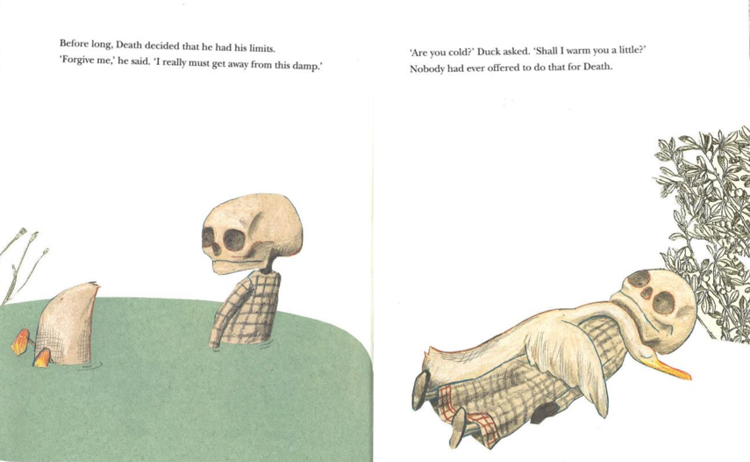
In terms of the style of illustration chosen in this book, there is firstly and notably a lot of negative space. Negative space is used to bring attention to the main subject, in this case Duck and Death, and quite possibly Erlbruch (2008) also used this negative space to not overcomplicate the scene, bringing a sense of simplicity and peace to the subject. Death is a big topic for children to understand, so it would make the story a lot more overwhelming for the child had there been a lot on the page visually as well. Another way Erlbruch (2008) abstained from overcomplicating the illustrations was by using neutral colours, however by combining collage, chalk, pencil, and watercolour (see fig. 1), “…his drawings have a delicacy and a sweet humour that helps us cope with the immensity of the subject.” as explained by Meg Rosoff in her review for the Guardian (Rosoff, paragraph. 3, 2009).
Fig. 1 (Wolf Erlbruch, Death Duck And The Tulip, 2008)

There are a couple instances of semiotics I would also like to address, the first example being the addition of a black crow when Duck and Death are talking about the subject of death. Crows have historically been associated with death due to their common appearance at battlefields and cemeteries and are often thought to circle humans or animals in large groups when they are expected to soon die. This exemplified symbol could have been added as an omen, foreshadowing Duck’s soon-to-be death. Another exemplified symbol I would like to point out is the tulip that Death can be seen holding at the beginning and ending of the book. Tulips are seen to represent rebirth and new beginnings. The personification of Death has always been known to appear at the end of one’s life, to guide them to the afterlife and to new ‘beginnings’, so it seems fitting to illustrate Death to be holding this. In addition to this, Salisbury (2012, p. 123) also describes this tulip as “a rare splash of warm colour on the page”, which brings me to the next thing I’d like to address: the background, Erlbruch (2008) has used white for the background almost all throughout the book. As explained by Bang (2000, p. 68) “White or light backgrounds feel safer to us than dark backgrounds because we can see well during the day and only poorly at night”. Erlbruch (2008) likely used white for the background not only to keep the simplicity that I mentioned earlier, but also to make the topic of death seem much less scary than it already is for a child, as opposed to using a black background which Bang describes as “symbolising the unknown”. In her book, Bang (2000) goes onto say that both black and white both represent death, with metaphors such as ‘dead-white’ coming into play. The only time Erlbruch (2008) doesn’t use white for the background is when Duck has died, where most of the page is then filled with a deep blue. On the surface, this could’ve just been used to represent the blue water in which Duck’s body floats upon, but leaning further into this you would find that dark blue is often used to represent tranquillity, further proving my earlier point that Duck’s death is portrayed as a peaceful and calming end.

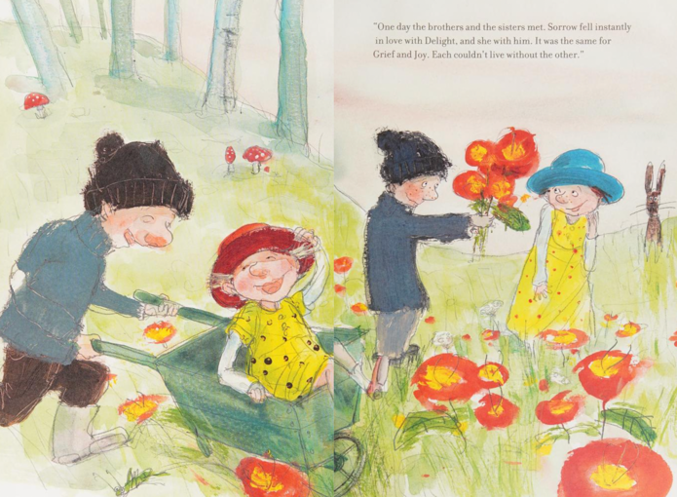
Moving onto my next book Cry, Heart, But Never Break (Ringtved, 2016), there are a lot of notable differences from Erlbruch’s (2008) book. Illustrated by Charlotte Pardi, the first notable difference is the use of full double page illustrations which are beautifully painted with watercolour. As explained by Salisbury (2004, p. 41) watercolour is a popular choice for illustration, boasting a soft transparency which allows the white of the paper to create different tones. Another notable difference is Pardi’s use of bright, vibrant colours compared to Erlbruch’s (2008) softer, desaturated hues. One thing that stood out to me is that red, yellow, and blue are consistently used throughout the illustrations, especially for the children and depiction of the characters’ Joy and Delight (see fig. 2). These are primary colours, which as Snow and Froehlich (1920, p. 25) explain in their book “…are instantly recognized by little children who start with them as the first steps in the acquirement of definite Color knowledge”. The use of these colours therefore provides a sense of familiarity amongst children reading this book, making the topic that it covers a little less scary and unfamiliar. Snow and Froehlich also go on to explain how these three colours all have their own emotional reaction, too. To elaborate, red is associated with warmth and courage, while yellow is known to portray feelings of joy and hope. On the other hand, blue is the opposite of these and is described as “…a balance wheel for yellow and red” (Snow and Froehlich, 1920, p. 42). It is not sunny or warm like red and yellow yet isn’t aggressive either. Blue is mainly used in Ringtved’s (2016) book for Sorrow and Grief, who both are illustrated with dark shades of blue. The choice of this colour therefore represents these two characters as moodier and sadder compared to the vibrancy of Joy and Delight, which children would be able to recognise.
Fig. 2 (Glen Ringtved, Cry, Heart, But Never Break, 2016)

Looking more towards the story now, there is notably a lot more words on the page than in Death, Duck, And The Tulips (Erlbruch, 2008). That isn’t to say that this book is necessarily targeted for older children. As Stewig (1980, p. 120) explains, children need to be exposed to more mature language than theirs if they are to grow their own vocabulary. Even if they don’t fully understand the words, the adult reading it to them will be able to encourage them to notice and comment upon various aspects of the book, such as what the illustrations show, what is happening on the page, how it makes them feel, etc. This will allow the child to further understand the words, thus developing their own language skills. To quote Stewig:

…they allow children to experience an environment unlike their own, to travel to another time, to confront situations different from theirs, or to empathize with a character who shares a common problem (Stewig, 1980, p. 118).

To summarise, even if a child doesn’t fully understand the words on the page, they are still able to relate to and connect the dots from the illustrations, thus understanding.

To further help children understand, when Death is explaining the story about Joy, Delight, Sorrow, and Grief, Ringtved (2016) has personified these characters in a way that children can easily understand. As explained by Male (2007, p. 143) “Imagery that is intrinsic with the story will often convey scenes of dramatic representation using the best practices of image construction”. Rather than leaving the child to try to come up with their own idea of these emotions, Ringtved (2016) has created a base line to build knowledge upon. When the reader thinks of these emotions, they can now imagine them as two couples who cannot live without the other and relate that to their own feelings, thus further understanding that feelings of sorrow and grief are just as natural as feeling joy and delight.

Further along in the book, when Death is about to go upstairs to Grandma, one of the children try to stop him. However he is stopped by his sibling, who says “Life is moving on. This is how it must be” in a calm manner. Similar to Erlbruch’s (2008) book, even though this is an upsetting scene and not something that any child would want to experience, Ringtved (2016) has ensured this isn’t a be all end all event. Despite being sad, the children in the book still allow it to happen, much like when Death allowed Duck’s body to float away in the river in Erlbruch’s (2008) book. This is important for the child to learn that despite being an upsetting moment, it’s still something natural that happens to everyone in life and must be allowed to happen for life to go on. On the next page, Death tells the children “Cry, Heart, but never break. Let your tears of grief and sadness help begin new life” before leaving. This is a beautiful way to tell children that it’s perfectly okay to be upset about this, but don’t let it consume you or life will never move on. It is important for children to understand that this is a normal part of life, and Ringtved (2016) has taught it wonderfully throughout his book.

Upon exploring the topic of death within children’s picture books from the perspective of two different authors and author illustrators, I can confidentially conclude that despite being different in many ways, both authors have conveyed their message in a similar manner. Erlbruch’s (2008) book in terms of illustration was simple, calming, and in a sense more tranquil compared to Pardi’s double page illustrations which included much more vibrant, mainly primary colours, yet the message in both books was that death as a subject isn’t something to be feared. Both books conveyed the message in a calming manner, showing that the death of a loved one, although upsetting, is something natural and a part of life, which is important for children to learn so that they don’t bottle up their feelings surrounding the matter. An important part of both books is that the illustrations and texts go hand in hand, so even if a young child can’t fully understand the words that are being read to them, they can still understand what’s happening from interpreting the pictures. This is an important part of children’s development, as explained by Kiefer (1995, p. 8) “When responding to picture books, children must also discriminate and interpret what they see. This process involves their attention, their recognition, and finally their understanding”. So, to finalise, both books have taught the reader that death isn’t a topic to fear and that it’s okay to be upset about it, and they have both portrayed this message in a calming and peaceful manner despite having different styles of illustration.

Bibliography

- Bader, B. (1976) American Picture Books From Noah’s Ark To The Beast Within. New York: Macmillan.
- Bang, M. (2000) Picture This: How Picture Books Work. New York: SeaStar Books.
- Doonan, J. (1993) Looking At Pictures In Picture Books. Stroud: The Thimble Press.
- Erlbruch, W. (2008) Death, Duck, And The Tulip. Wellington: Gecko Press.
- Kiefer, B Z. (1995) The Potential Of Picture Books: From Visual Literacy To Aesthetic Understanding. Englewood Cliffs: Prentice Hall, Inc.
- Lasher, C L. (2008) Death Is No Stranger. Lima: CSS Publishing.
- Male, A. (2007) Illustration: A Theoretical And Contextual Perspective. Lausanne: AVA Publishing SA.
- Salisbury, M. (2004) Illustrating Children’s Books: Creating Pictures For Publication. Hauppauge: Barron's Educational Series.
- Salisbury, M. (2012) Children's Picture Books: The Art Of Visual Storytelling. London: Laurence King Pub.
- Snow, B E. and Froehlich H B. (1920) The Theory And Practise Of Color. New York: Prang Company.
- Ringtved, G. (2016) Cry, Heart, But Never Break. New York: Enchanted Lion Books.
- Rosoff, M. (2009) ‘Duck, Death and the Tulip by Wolf Erlbruch’. The Guardian, 19 Dec. Available at: https://www.theguardian.com/books/2009/dec/19/wolf-erlbruch-children-picturebook-review
- Stewig, J W. (1980) Children And Literature. Chicago: Houghton Mifflin.

