Research and case scenario in Data Security and Compliance

Submitted By:
Sohaan Sureshkumar
2221048
Module: Data Security and Compliance

Lecturer’s Name:
Carlene Campbell

Table of Contents

ABSTRACT 4

INTRODUCTION 5
2.1 Background 5
2.2 The Need for Comprehensive Security 5
2.3 Purpose of the Report 5

TASK 1 – RESEARCH IN DATA SECURITY AND COMPLIANCE 6
3.1 Security Frameworks: ISO27000 and NIST 6
3.1.1 Overview of Security Frameworks 6
3.1.2 ISO27000 Series 6
3.1.3 NIST Cybersecurity Framework (CSF) 8
3.2 Security Technologies: Firewalls, VPNs, and Access Controls 10
3.2.1 Overview of Security Technologies 10
3.2.2 Firewalls 11
3.2.3 VPNs 12
3.2.4 Access Controls 13
3.2.5 Critical Evaluation 14

TASK 2 – CASE SCENARIO 15
4.1 Organizational Structure/Chart 15
4.1.1 Key Roles and Responsibilities 15
4.1.2 Role Integration and Collaboration 16
4.1.3 Organizational Flow 16
4.2 Policies and Procedures 17
4.2.1 Access Control Policy 17
4.2.2 Incident Response Plan (IRP) 17
4.2.3 Acceptable Use Policy (AUP) 18
4.2.4 Training and Awareness Policy 19
4.3 Compliance (Laws and Ethics) 19
4.3.1 Legal and Regulatory Requirements 19
4.3.2 Ethical Standards 20
4.3.3 Audit Mechanisms 20
4.4 Governance and Strategic Planning for Security 21
4.4.1 Security Governance Framework 21
4.4.2 Strategic Objectives 21
4.4.3 Performance Metrics 22
4.5 Risk Management 23
4.5.1 Risk Identification and Assessment 23
4.5.2 Risk Mitigation Strategies 24
4.6 Contingency Planning 24
4.6.1 Backup and Recovery 24
4.6.2 Business Continuity Plan (BCP) 25
4.7 Protection Mechanisms 25
4.7.1 Firewall Deployment 25
4.7.2 Multi-Factor Authentication (MFA) 25
4.7.3 Data Encryption 26

CONCLUSION 27

REFERENCES 28

Table of Figures

Figure 1 - ISO 27001 Certification Process 7

Figure 2- The functions of the NIST framework 8

Figure 3 - NIST CSF vs. ISO 27001 9

Figure 4 - Types of Firewalls 11

Figure 5 - Comparison between the types of Access Controls 13

Figure 6 - Diagram of ISU of CSS Hierarchy 16

Figure 7 - Incident response cycle with the 4 elements 17

Figure 8 - Information security plan 22

Figure 9 - Risk Management Protocol 23

Figure 10 - Layered Defence Model 25

ABSTRACT

In today’s digital age, where online dangers become increasingly complex with every passing moment, companies are not only facing threat but also, they are under siege. This report presents a roadmap for any business looking to strengthen its defences against the wave of cyber threats.

By delving into respected frameworks like ISO27000 and NIST and exploring state of the art technologies such as firewalls, VPNs and access controls, this report equips you with the tools and strategies to protect your operations and establish unwavering trust with stakeholders.

However, this isn't just theoretical, it's a hands-on manual designed specifically for the information security division at CyStresSolution (CSS) providing solutions that any company can implement in real life scenarios. This document includes defined setups, implementable policies and strategies, proactive risk assessment and a solid backup plan to prepare you not only to endure in the current digital challenges but also to excel.

If you truly value safeguarding your valuables and maintaining compliance while building trust with clients in today’s changing cybersecurity environment, this report is a must read for you! Keep on reading to learn how to fortify your company and make it secure, in the era.

INTRODUCTION

  - 2.1 Background
In today’s digital age, companies are becoming more and more dependent on technology to run their business, boost productivity and provide benefits to all involved. This reliance brings dangers as cyber-attacks have become increasingly advanced and frequent [1]. Prominent breaches in data security such as ransomware assaults and internal threats are no longer just occurrences, they have become a part of life. Such cyber events do not only result in harm but also tarnish a company’s image, disrupt its functions and weaken customer confidence [2].

  - 2.2 The Need for Comprehensive Security
Businesses today need to take a stance in safeguarding their data systems and online resources by going beyond reactive methods for security measures. A solid cybersecurity plan should cover all fronts, from shielding against threats to identifying breaches and reacting swiftly, while also ensuring the safety of their infrastructure and software applications [3]. By adopting this approach to cybersecurity, not only can attacks be thwarted but can also be allowed for quick responses and efficient recovery, in case of any incidents [4]. Failing to establish a security framework and utilizing technologies can expose businesses to risks of severe losses [5].

  - 2.3 Purpose of the Report
This report explores the aspects of securing organizations by focusing on two areas, Security Frameworks and Security Technologies. This task of the report examines how standards such, as ISO27000 and NIST offer approaches to handling cybersecurity risks and delves into how technologies like firewalls, VPNs and access controls play a vital role in enforcing security protocols. The second task applies these insights to create an information security structure, for CyStresSolution (CSS). The report aims to be a guide, for companies looking to enhance their cybersecurity defences and adapt to the evolving landscape of threats by blending knowledge with practical advice [6].

TASK 1 – RESEARCH IN DATA SECURITY AND COMPLIANCE

  - 3.1 Security Frameworks: ISO27000 and NIST

  - 3.1.1 Overview of Security Frameworks
Security frameworks are essential for setting up and maintaining a company’s cybersecurity stance. They offer organized approaches to handling risks and ensuring compliance in IT setups. By providing a plan of action, these frameworks enable organizations to pinpoint weaknesses, safeguard assets and get ready for potential dangers [7]. ISO27000 and NIST are among the frameworks in use today, each offering advantages to contemporary security tactics. ISO27000 prioritizes standards and accreditation while NIST concentrates on adaptability and risk management customized for sectors.
Implementing security frameworks offers not only a method but also empowers companies to measure their cybersecurity readiness against established industry norms [8]. Obtaining ISO27001 certification illustrates a dedication to notch protocols that can facilitate interactions with clients on a worldwide scale [9]. Furthermore, NISTs modular approach enables organizations to expand their security measures in response to evolving risks [10].

  - 3.1.2 ISO27000 Series
The ISO27000 series is widely known around the world for setting out the methods for establishing an Information Security Management System (ISMS) with ISO27001 being a component of it all [11]. It also emphasizes assessing risks to help companies uncover vulnerabilities and put in place the safeguards to address them. Its broad coverage spans across aspects well as physical and technical controls making it a flexible framework suitable for businesses of any scale.

ISO27001 is valuable because it emphasizes enhancements to security measures through evaluations and adjustments to adapt to new dangers and evolving business landscapes. Following ISO27001 also indicates a dedication to safeguard data effectively and comply with regulations like GDPR which helps build trust with stakeholders.

There are hurdles to overcome when putting ISO27001 into practice too, obtaining certification demands plenty of resources in terms of time and effort as well as financial investment in necessary tools and systems [12]. Having all staff members comply with the ISMS policies through training poses a challenge for bigger companies. However, daunting this may seem for organizations working with data, under regulations the advantages of ISO27001 generally surpass the drawbacks [13]. The certification process is illustrated in Figure 1.
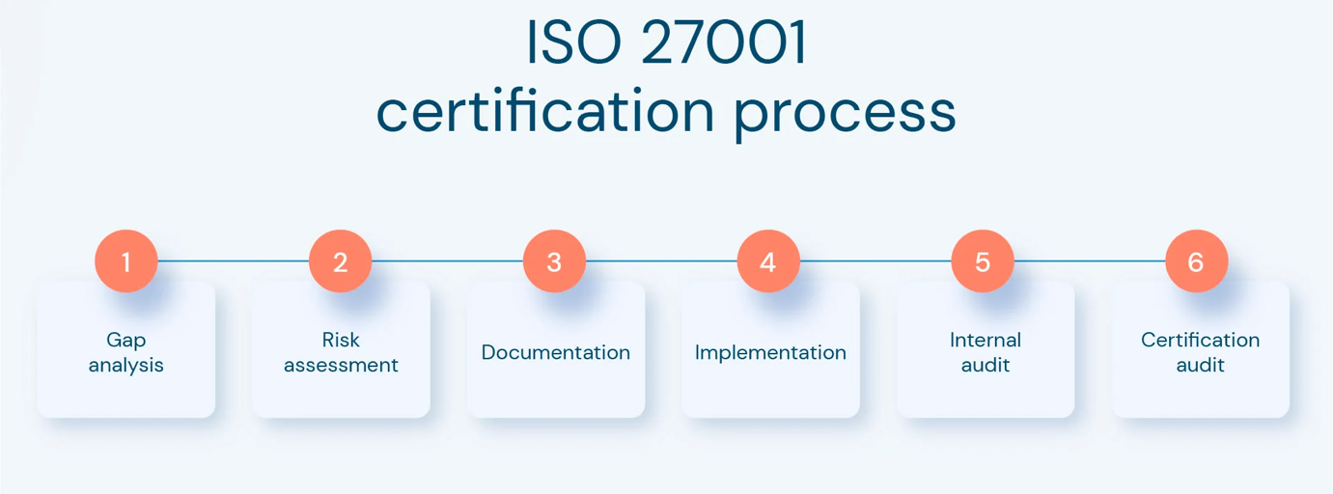
Figure 1 - ISO 27001 Certification Process [14]

ISO27001 not only emphasizes the significance of ISMS but also underscores the importance of the Statement of Applicability (SOA), enabling organizations to outline the controls in place and their reasons for implementation which is a feature that ensures adaptability to specific business requirements [15]. These controls are further elaborated in ISO27002, a standard offering instructions for implementing measures such as access control cryptographic solutions and secure communication protocols.

  - 3.1.3 NIST Cybersecurity Framework (CSF)
The NIST Cybersecurity Framework (CSF) offers a scalable method for handling cybersecurity threats compared to ISO27001, which is not a certifiable standard but serves as guidelines that can be tailored to suit various organizational requirements uniquely [6]. The frameworks possess five fundamental functions—Identification, Safeguarding, Detection, Response and Restoration visualised in Figure 2. These present a cycle for tackling cybersecurity issues [16].

The process of identification entails grasping and addressing risks related to systems and infrastructure as data protection measures, an essential step in establishing a strong security approach that enables organizations to effectively prioritize and allocate resources where needed [17]. On the hand the Protect phase is focused on implementing measures like access controls and encryption to prevent security breaches from occurring. The Detect phase involves recognizing cybersecurity incidents through tools like intrusion detection systems. Lastly the Respond and Recover functions highlight the significance of incident response planning and business continuity strategies in lessening the impact of attacks.

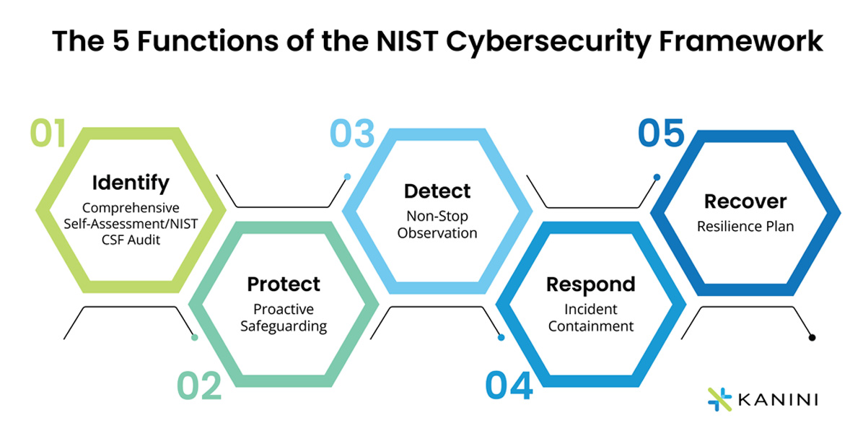
Figure 2- The functions of the NIST framework [18]

The adaptability of NIST makes it a good fit for companies that don't need certification but seek a system to improve their security stance. It is commonly used in sectors like healthcare and finance where rules often require cybersecurity steps. However, the framework heavily depends on knowledge for execution. This could pose a challenge for businesses without cybersecurity experts [19].

NIST goes beyond its functions by using an approach to help organizations evaluate their cybersecurity maturity level effectively. The tiers vary from Partial (Tier 1) to Adaptive (Tier 4) where systems are agile and can promptly address threats. Moreover, NIST offers implementation profiles to assist organizations in tailoring the framework to meet their operational needs [20].

  - 3.1.4 Comparative Analysis
When comparing ISO27000 and NIST briefly distinguished in Figure 3, it becomes clear that each framework is designed to address specific needs within the cybersecurity landscape. ISO27000’s certification process provides a globally recognized standard, making it ideal for organizations that require formal accreditation to meet regulatory or contractual obligations [21]. Its structured approach ensures that all aspects of information security are accounted for, from asset management to incident response [22].

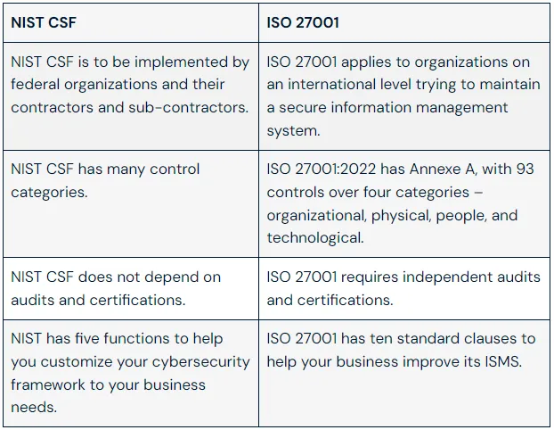
Figure 3 - NIST CSF vs. ISO 27001 [23]

NIST on the other hand, is valued for its adaptability. It allows organizations to tailor their cybersecurity strategies based on specific risks and operational needs, making it highly effective in dynamic industries. Its five core functions align well with the lifecycle of cyber threat management, offering practical guidance for both prevention and response [24].

One other important distinction lies in how regulations are followed. The ISO27001 standard is known worldwide and is frequently mandated in contracts, on the other hand NISTs emphasis on standards makes it better suited for industries such as the federal government and healthcare in the United States [21]. Often the decision hinges on whether a company aims for certification to demonstrate compliance externally or prioritizes adaptability for processes [25].

Despite their differences, these frameworks are not mutually exclusive. Organizations can benefit from combining the structured thoroughness of ISO27000 with the practical flexibility of NIST [21]. For example, an organization may use ISO27000 to establish a strong foundational ISMS while leveraging NIST’s functions to enhance detection and response capabilities. Together, these frameworks provide a all-inclusive approach to managing cybersecurity risks.

  - 3.2 Security Technologies: Firewalls, VPNs, and Access Controls

  - 3.2.1 Overview of Security Technologies
Using security technologies is crucial, for upholding the guidelines set by frameworks like ISO27000 and NIST in the cybersecurity field. These tools are vital for establishing a security posture by defending against risks and managing access to confidential data while also ensuring secure communication channels [1]. Employed technologies include firewalls, VPNs and access controls which work together to build a layered defence system to protect IT systems and data effectively.
Security measures serve not only as defences but also as valuable strategic resources for businesses today. For example, implementing firewalls and VPN systems guarantees business operations while controlling access helps protect property. Moreover, these security tools play a role in upholding standards by enforcing necessary security measures and maintaining detailed audit logs [26].

  - 3.2.2 Firewalls
Firewalls play a role in safeguarding network security by overseeing and regulating outbound network activity according to predetermined security guidelines [27]. They serve as a boundary between networks and suspicious external connections [27]. Traditional firewalls prioritize screening network traffic at the edge by employing techniques, like filtering and stateful inspection to determine the passage or restriction of traffic.

At times there have been developments in Next Generation Firewalls (NGFW) extending their functionalities beyond the features they used to offer initially, the NGFW now provides deep packet inspection capabilities along with intrusion prevention and application monitoring features [28]. These advancements make NGFW highly effective in combating complex threats such as advanced persistent threats (APTs) and zero-day vulnerabilities. For example, NGFW can identify and prevent malicious traffic pretending to be legitimate application data adding an extra level of security protection.

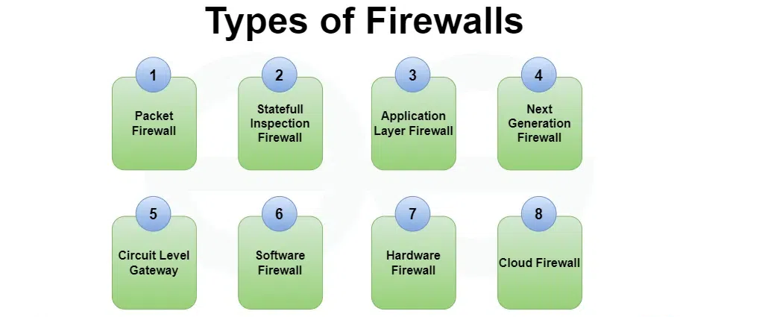
Figure 4 - Types of Firewalls [30]

Firewalls have advanced to incorporate functions, like Geo IP filtering to prevent traffic from areas and sandboxing to isolate and examine suspicious files for harmful actions. This progress has made modern firewalls crucial for identifying cyber-attacks. Furthermore, integrating firewall logs with SIEM tools offers visibility into network activity [27].
Nevertheless, firewalls have their constraints. Although they excel in preventing dangers, their defence against insider threats and attacks at the application layer is restricted. Hence it is advisable to integrate firewalls with other technologies to establish a secure approach [31].

  - 3.2.3 VPNs
In todays interconnected world where remote work is becoming more prevalent than before, Virtual Private Networks (VPNs) play a crucial role in safeguarding the privacy and security of communication between various devices and networks [32]. By encrypting data while it’s in transit, VPNs ensure that confidential information stays private when its being sent over networks. This encryption sets up a protected pathway that blocks intrusion and snooping.
Many companies rely on VPNs to ensure their staff can securely access internal networks and resources remotely which is in fact a crucial need in today’s remote work environment, where employees often connect from insecure places like cafes or airports. By utilizing VPN technology to shield against threats like data snooping and unauthorized access that're common in public Wi Fi hotspots, organizations can enhance their security posture and safeguard sensitive information effectively [33].
Securing work is not only the function of VPN services they can also enable branch offices to establish site to site connections for smooth data transmission between different locations spread across geographies [34]. Zero Trust Network Access (ZTNA), an evolving trend in cybersecurity aims to displace VPN systems by verifying user identity and device status throughout sessions. This approach provides a level of security for businesses.
While VPN services offer advantages, they can pose risks if not set up correctly. For instance, using authentication methods or outdated encryption can expose VPN connections to threats [35]. Moreover, VPNs may slow down network performance when handling huge data loads. To ensure their reliability, it's crucial to update them, employ authentication measures, and adhere to strong encryption protocols [36] [37].

  - 3.2.4 Access Controls
Access controls are tools created to limit access to systems or data depending upon established permissions in place [38]. This is important for safeguarding resources from users and ensuring that individuals can only view information relevant to their responsibilities [39].
There are three main types of Access Controls:
1.Discretionary Access Control (DAC): This type enables resource owners to determine which individuals are granted access to their resources. While flexible, it also may be prone to errors and mismanagement.
2.Role Based Access Control (RBAC): This type of access control simply involves allocating permissions according to roles established within the organization, offering an approach that minimizes the potential for misusing privileges [40].
3.Mandatory Access Control (MAC): This is commonly employed in top security settings to enforce access regulations set by the organization without allowing any user flexibility [38].
Figure 5 compares different types of access controls using several factors.
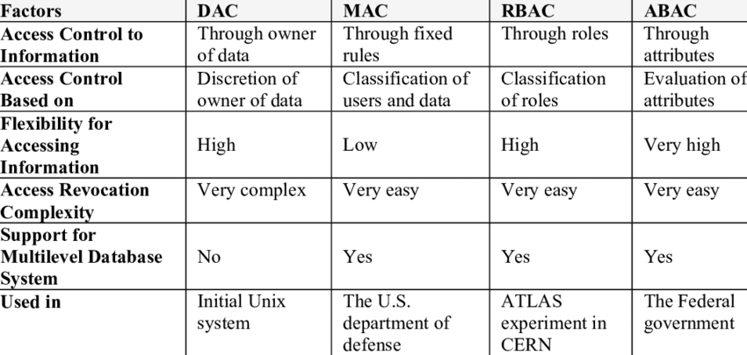
Figure 5 - Comparison between the types of Access Controls [41]
Access control systems nowadays include context-based access features that adapt permissions according to variables such as user location and device type. For instance, an employee who tries to enter systems from a device will either be denied access or asked to complete extra verification procedures [40]. Controlling access is crucial for preventing threats that often result in data breaches being one of the reasons for it occurring in the first place [42]. Keeping track of access controls demands supervision. Providing access can result in unauthorized privilege escalation while giving too little can cause operational disruptions.

  - 3.2.5 Critical Evaluation
In addressing an organizations cybersecurity requirement, individually discussed technologies such as firewalls and VPN and access controls serve purposes. Firewalls act as the defence layer by blocking traffic into the system [42]. VPN secures communication channels for workers whereas access controls protect confidential data by restricting access to unauthorized individuals [36].

Nevertheless, these tools come with their set of drawbacks as well. Firewalls fall short in safeguarding against internal risks. VPN connections can slow down if not set up or managed correctly. Access controls need to be monitored to make sure they are in line with current policies and remain efficient. These tools work best when combined to form a layered defence strategy [43]. This comprehensive approach significantly lowers the chances of cyber-attacks and minimizes their impact, thereby ensuring that business operations run smoothly and securely.

TASK 2 – CASE SCENARIO

  - 4.1 Organizational Structure/Chart

  - 4.1.1 Key Roles and Responsibilities
The effectiveness of the information security division at CyStresSolution (CSS) relies heavily on having a defined framework that outlines roles and responsibilities in detail [44]. The core roles listed below will serve as the cornerstone of the security division:
1. Chief Information Security Officer (CISO): The CISO is responsible for leading the department and guiding its decisions to ensure that security measures support the company’s goals effectively. The CISO oversees ensuring compliance with standards such, as ISO27000 and NIST framework resourcing allocation. Also providing updates to management [45].
2. IT Security Manager: Reporting directly to the CISO, The IT Security Manager is mainly responsible for enforcing security protocols and collaborating with team members to uphold security policies.
3. Risk Manager: The Risk Managers role involves identifying and evaluating risks through risk assessments following the risk management principles of ISO27000 to proactively address any vulnerabilities.
4. Incident Response Team: This team’s role involves identifying security issues and swiftly responding to them to reduce downtime and data loss while adhering to predefined response strategies.
5. Compliance Officer: The compliance officer is responsible for ensuring that CSS complies with regulatory obligations such as GDPR and they also oversee adherence to the company’s policies.
6. Security Analysts: Security analysts serve as the core support for the team by overseeing system monitoring tasks, like threat detection and vulnerability analysis while suggesting ways to address security risks effectively.

  - 4.1.2 Role Integration and Collaboration
Effective security management relies on the cooperation between these roles highlighting the importance of collaboration in safeguarding systems. For example, the Incident Response Team collaborates closely with the Risk Manager following a security breach to assess the consequences and suggest lasting resolutions. Smooth collaboration and knowledge exchange can be achieved through team gatherings and interdisciplinary training sessions [46].

  - 4.1.3 Organizational Flow
The suggested organizational flow is designed in a manner starting with the Chief Information Security Officer (CISO) at the top level and then followed by the IT Security Manager below them, subsequent roles include the Risk Manager, Compliance Officer and Security Analysts, under the IT Security Manager’s supervision to establish clear reporting structures and responsibilities [47]. This can be visualised in Figure 6.

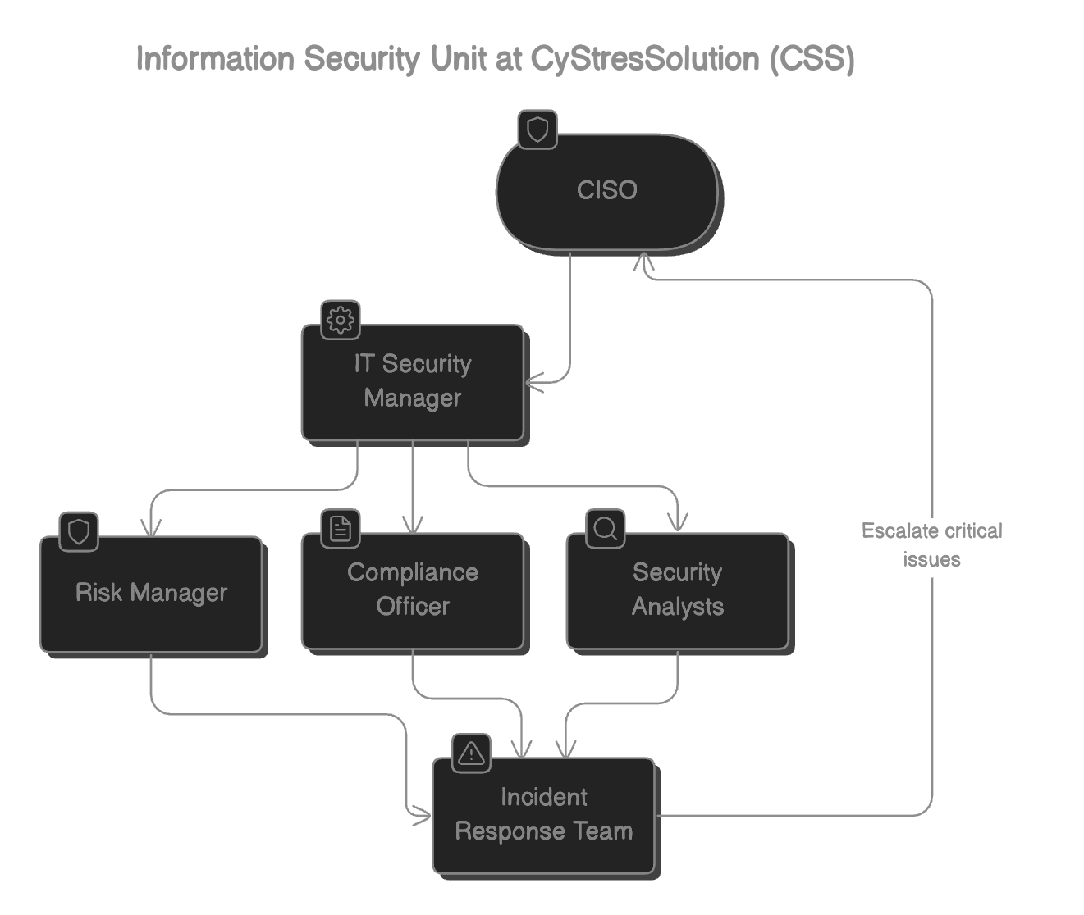
Figure 6 - Diagram of ISU of CSS Hierarchy

  - 4.2 Policies and Procedures

  - 4.2.1 Access Control Policy
The access control policy will follow the principles outlined in ISO27000 by restricting access to systems according to individual roles and duties at CSS [48]. Role Based Access Controls (RBAC) will be put into effect to ensure that the permissions granted align with the job responsibilities of employees [43].
Mandatory Access Control (MAC) on the hand will offer a level of security for critical systems by only permitting verified personnel with authorized credentials to gain access. Enhancing security for systems involves implementing multiple factor authentication (MFA) which mandates that employees must confirm their identity using a combination of various methods like passwords and biometrics [49].

When an employee switches positions or departs from the organization’s staff team, their permissions will be promptly removed for security reasons [50]. This strategy aims to discourage any misuse of privileges and internal risks while still safeguarding business operations.

  - 4.2.2 Incident Response Plan (IRP)
CSS’s Incident Response Plan will adhere to the Respond and Recover functions outlined in the NIST Cybersecurity Framework in Task 1 to guarantee an approach to handling security incidents [51]. The plan shown in Figure 7 will encompass the following elements:
Incident Detection: Monitoring systems such as Intrusion Detection Systems (IDSs ) can quickly pinpoint any activity as it occurs.
Escalation Process: Threat assessments will be categorized into varying levels of severity aiding the Incident Response Team (IRT) in determining the appropriate escalation steps for each incident.
Containment and Mitigation: Taking action by isolating affected systems or updating firewall configurations can help reduce the impact of the situation through containment and mitigation strategies.
Post-Incident Review: Following any incident a thorough review will be conducted to pinpoint the causes and enhance our response procedures [52].

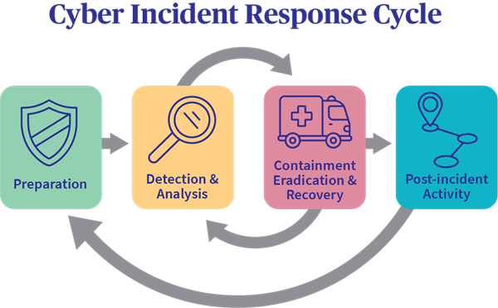
Figure 7 - Incident response cycle with the 4 elements [53]

To make sure everything runs smoothly, CSS will carry out simulations every three months like pretend phishing attempts or ransomware practice sessions. These drills will assess the team’s preparedness and improve the Incident Response Plan according to how they perform.

  - 4.2.3 Acceptable Use Policy (AUP)
The Acceptable Use Policy will detail the use of CSSs information technology systems and resources. Employees being restricted from:
• Trying to get into systems you're not supposed to access without permission.
• Installing software which is unapproved or disclosing login information [54].

To uphold this rule, CSS will keep an eye on network activities and record any breaches. For instance, if an employee tries to bypass the firewall, alerts will be raised resulting in assessment and necessary measures [55]. Moreover, employees will need to undergo training sessions on usage to grasp the significance of the policy.

  - 4.2.4 Training and Awareness Policy
Education and training play a role in ensuring that CSS staff members grasp and comply with the security protocols of the organization properly. Frequent workshops will teach employees how to spot dangers like phishing emails and social engineering tactics. Practical activities, like phishing schemes will aid staff in identifying threats and reacting effectively.

These training initiatives will also highlight the significance of staff members in responding to incidents by outlining procedures for reporting any behaviour and working closely with the Incident Response Team (IRT) [56] [57]. Through stressing the need for precise reporting efforts, CSS can effectively reduce the consequences of security breaches.

To ensure that the training materials stay current and up to date with the threats and technologies in cybersecurity at CSS, regular updates will be made as needed [58]. After training sessions are completed, assessments will be conducted to assess employees understanding levels guaranteeing that the workforce is adequately equipped to uphold CSSs cybersecurity goals [59].

  - 4.3 Compliance (Laws and Ethics)

  - 4.3.1 Legal and Regulatory Requirements
  - Ensuring that CSS’s information security framework adheres to regulatory requirements is crucial. Task 1 emphasizes the importance of the ISO27000 framework in establishing an Information Security Management System (ISMS) which ensures compliance with data protection laws, like the General Data Protection Regulation (GDPR) and the Health Insurance Portability and Accountability Act (HIPAA) [60].

  - To comply with GDPR regulations and protect the information of EU clients adequately and transparently, CSS will handle the data collected with care, storing it securely and retaining it for the required period only [61].

  - 4.3.2 Ethical Standards
To establish trust with CSSs clients and stakeholders it is crucial to follow guidelines. CSS is committed to transparency and accountability while handling data. Employees will receive training on data management to ensure that personal and confidential information is accessed only for authorized reasons [62]. Employees must sign confidentiality agreements to solidify the company’s dedication to standards.

CSS will implement a whistleblower policy to enable staff to report conduct or security breaches without revealing their identity. This is consistent with the focus on integrity and governance in ISO27000 standards [63].

  - 4.3.3 Audit Mechanisms
It's important to conduct checks to ensure compliance and spot any security weaknesses in CSSs framework effectively. These audits will be carried out within the ISO27001s Plan–Do–Check–Act (PDCA) guarantee that operations are consistently monitored and enhanced over time [64].

The audit will concentrate on areas of importance:
1. Checking access controls by reviewing permissions to make sure they adhere to the principle of least privilege.
2.Assessing the efficiency of technology by checking if firewalls and VPN setups as encryption methods comply with the necessary criteria.
3.Ensuring that incident response procedures are in line with the Respond and Recover functions outlined by NIST for compliance purposes [65].

These audits will also consider information gathered through monitoring tools such, as Intrusion Detection Systems (IDS).
  - 4.4 Governance and Strategic Planning for Security

  - 4.4.1 Security Governance Framework
Ensuring security governance means making sure that CSS’s cybersecurity objectives are in line with its business objectives. CSS will set up a governance framework using the ISO27000 ISMS framework to define roles and responsibilities as decision making processes for the information security department [66].

The governance structure will integrate NIST’s “Identify” function focusing on asset identification and risk assessment. CSS will manage an asset register detailing all IT systems and assigning responsibility to designated teams.

We will set up a Security Steering Committee to supervise the execution of security tactics guided by the Chief Information Security Officer (CISO). This group will consist of executives from departments to promote teamwork across functions and enhance coordination efforts [67]. Periodic meetings will be held to assess the effectiveness of the security team and analyse security events to extract insights for improvement.

  - 4.4.2 Strategic Objectives
CSS will prioritize short term and long-term goals to strengthen its cybersecurity defences aiming to enhance its security strategy. These goals encompass a range of objectives:
Short-Term Goals (1 Year):
  - To install firewalls to safeguard the network boundaries and spot sophisticated security risks effectively.
  - To set up VPN connections and use factor authentication, for securing remote entry for staff members in hybrid work settings to safeguard against possible security risks.
  - To ensure to create an Incident Response Plan (IRB) and practice simulations to evaluate its efficiency.

Long-Term Goals (3-5 Years):
  - To Obtain ISO27001 certification to showcase a security stance to clients and stakeholders.
  - To incorporate threat detection systems powered by AI to spot irregularities in real time.
  - To broaden the range of risk evaluations to encompass third party suppliers for security within the supply chain.

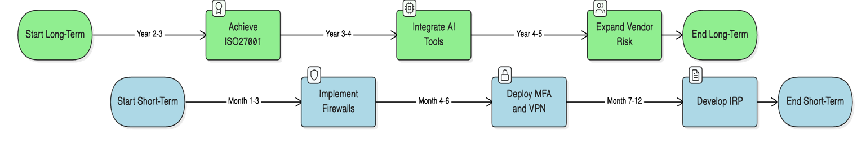
Figure 8 - Information security plan

Every year we will review our goals to make sure they still match up with the changing landscape of cyber risks and regulatory requirements [68].

  - 4.4.3 Performance Metrics
To evaluate the efficiency of CSS’s governance and security tactics effectively, precise performance Metrics will be defined [69].

Incident Response Metrics:
The effectiveness of the Incident Response Plan (IRP) will be evaluated by measuring how fast incidents are identified and handled from start to finish. From detection to containment and resolution stages [69]. For instance, CSS will keep tabs of the time it takes to isolate a compromised system or recover operations after a ransomware attack swiftly.
Compliance Metrics:
CSS will assess its compliance with obligations like GDPR and ISO27001 by monitoring audit outcomes and adherence rates. For example, internal audits will verify the functioning of all access controls, and it would ensure that data management practices comply with GDPR regulations.
Training Metrics:
The efficiency of employee training will be evaluated by monitoring the proportion of employees who finish training sessions and excel in simulated tasks such, as phishing exercises where we assess how many can spot and report phishing attempts [70] [69].

  - 4.5 Risk Management

  - 4.5.1 Risk Identification and Assessment
Risk management is crucial, it starts by recognizing and evaluating risks related to CSS’s systems and data as well as its applications. The ISO27000 framework approach will be taken to list vulnerabilities systematically, these may come from sources like employees or external threats such as hackers or environmental elements.

Methods like vulnerability scanners and penetration tests will be used to discover network weaknesses such as configured firewalls or outdated software systems and will be ranked according to probability and potential impact using a risk assessment tool. This information allows the Risk Manager to focus on addressing high priority risks [72]. An instance would be mitigating a threat with a high chance of occurrence and severe consequences like an attempt to steal client login details before dealing with less urgent risks.

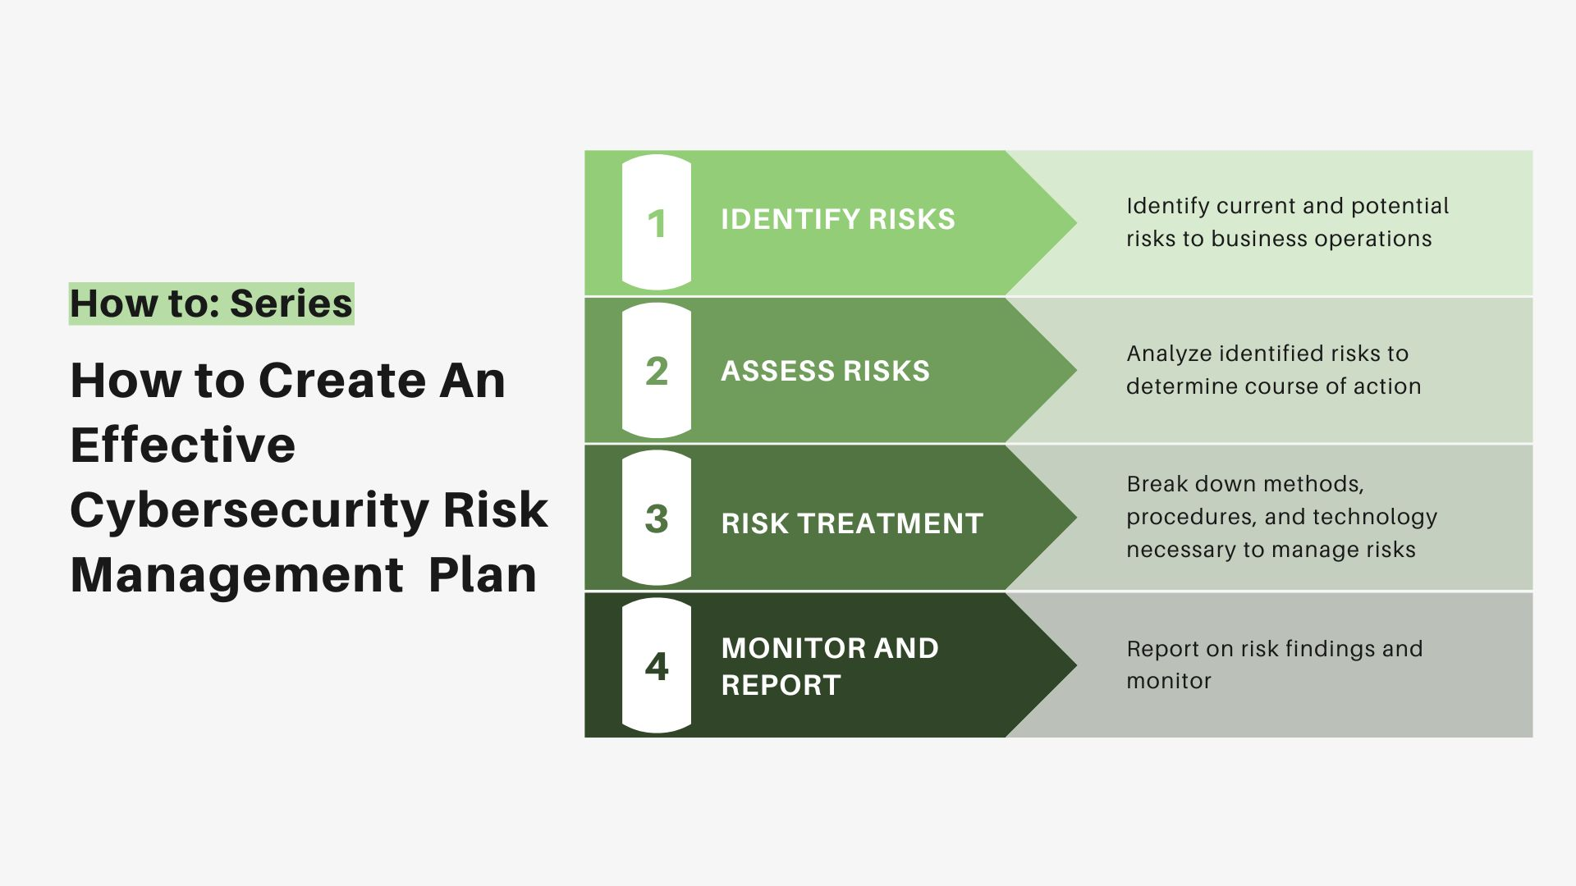
Figure 9 - Risk Management Protocol

  - 4.5.2 Risk Mitigation Strategies

To address identified risks, CSS will implement a variety of mitigation measures, many of which were discussed in Task 1. These include:
1. Firewalls and IDS: Advanced firewalls will block unauthorized access, while intrusion detection systems will monitor for anomalies and alert the team in real-time [29].
2. Access Controls: Role-Based Access Control (RBAC) will ensure that only authorized users can access critical systems [38].

3. Data Encryption: Sensitive data will be encrypted both at rest and in transit, reducing the risk of exposure during breaches [74].
Mitigation will also ensure that all software vulnerabilities are promptly resolved. For example, if a vulnerability is discovered in CSS’s VPN system, patches will be deployed immediately to prevent exploitation.

  - 4.6 Contingency Planning

  - 4.6.1 Backup and Recovery
Ensuring a backup and recovery system is crucial to reduce the effects of data loss or corruption incidents at CSS. Cloud based backups will be secured using encryption methods compliant with ISO27000s data protection guidelines ensuring confidentiality, throughout storage and transfer processes.
To confirm the reliability of these backups in place for CSS system security measures, the organization will carry out recovery exercises to assess how quickly and successfully operations can be restored if needed [75]. As an illustration, the Incident Response Team plans to practice recovering a database that has been encrypted and compromised during an attack to ensure preparedness for real life incidents.

  - 4.6.2 Business Continuity Plan (BCP)
CSSs Business Continuity Plan (BCP) will guarantee that crucial functions can proceed throughout and following a crisis situation. This involves guaranteeing access for staff members through VPN connections so they can work smoothly even if main systems encounter disturbances. For instance, in the event of a data centre failure, staff will transition to cloud based infrastructure to sustain service continuity [76].

  - 4.7 Protection Mechanisms

  - 4.7.1 Firewall Deployment
CSS’s network defence relies on firewalls as its defence mechanism against cyber threats. Advanced firewalls like next generation firewalls (NGFW) are responsible for monitoring network traffic to block access and inspect data packets for signs of malicious activities [29][30]. For instance, CSS will set up firewalls to proactively thwart attack strategies like malware infections.

  - 4.7.2 Multi-Factor Authentication (MFA)
Implementing Multi Factor Authentication (known as MFA) enhances the security of access controls by necessitating users to confirm their identity through two or more means, like passwords and biometric scans [38]. This measure lowers the chance of entry and complies with the access control norms set by ISO27000.
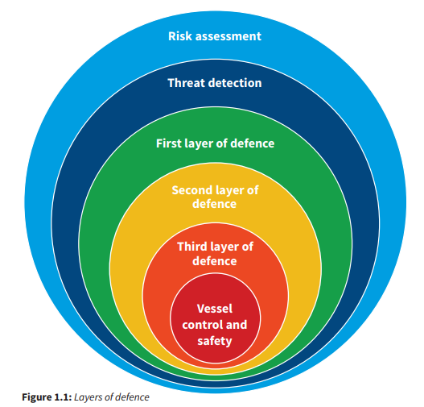
Figure 10 - Layered Defence Model [77]

  - 4.7.3 Data Encryption
We use encryption to keep information safe both when its stored and when its sent over networks or the internet. By following NIST guidelines for encryption algorithms, CSS will make sure that client data is encrypted when its stored and while its being moved between locations [73] .

CONCLUSION

In today’s world, where cyber risks are becoming more advanced and widespread, businesses need to focus on building and upkeeping a cybersecurity system. This document shows how blending ISO27000 and NIST methods offers approaches for handling risks, ensuring adherence to regulations and matching security strategies with business goals. Establishing an information security unit at CyStresSolution (CSS) highlights the significance of defined roles within the organization and proactive risk management strategies with established policies in place.

Organizations leverage the combination of frameworks and technologies not only to identify and thwart threats but also to react promptly and bounce back swiftly from incidents. Sustained monitoring along with audits and ongoing enhancements boost this security stance.

As organizations heavily depend on systems and technologies for their operations and functions, this report can guide them towards enhancing operational security measures and meeting regulatory requirements to gain trust from stakeholders effectively ensuring the longevity and sustainability of their operations in this technology driven era.

REFERENCES

[1]
CISA, “Cybersecurity Best Practices | Cybersecurity and Infrastructure Security Agency CISA,” www.cisa.gov, 2023. https://www.cisa.gov/topics/cybersecurity-best-practices
[2]
R. von Solms and J. van Niekerk, “From Information Security to Cyber Security,” Computers & Security, vol. 38, no. 38, pp. 97–102, Oct. 2013, doi: https://doi.org/10.1016/j.cose.2013.04.004.
[3]
“Cyber Threats,” ENISA. https://www.enisa.europa.eu/topics/cyber-threats
[4]
T. Herath and H. R. Rao, “Encouraging information security behaviors in organizations: Role of penalties, pressures and perceived effectiveness,” Decision Support Systems, vol. 47, no. 2, pp. 154–165, May 2009, doi: https://doi.org/10.1016/j.dss.2009.02.005.
[5]
P. A. Pavlou and O. A. El Sawy, “The ‘Third Hand’: IT-Enabled Competitive Advantage in Turbulence Through Improvisational Capabilities,” Information Systems Research, vol. 21, no. 3, pp. 443–471, Sep. 2010, doi: https://doi.org/10.1287/isre.1100.0280.
[6]
National Institute of Standards and Technology, “The NIST Cybersecurity Framework (CSF) 2.0,” The NIST Cybersecurity Framework (CSF) 2.0, vol. 2.0, no. 29, Feb. 2024, doi: https://doi.org/10.6028/nist.cswp.29.
[7]
ISO, “ISO/IEC 27001 Information security management,” ISO, 2013. https://www.iso.org/isoiec-27001-information-security.html
[8]
M. Alshaikh, “Developing cybersecurity culture to influence employee behavior: A practice perspective,” Computers & Security, vol. 98, no. 98, p. 102003, Nov. 2020, doi: https://doi.org/10.1016/j.cose.2020.102003.
[9]
M. J. Sanchez-Franco, A. F. V. Ramos, and F. A. M. Velicia, “The moderating effect of gender on relationship quality and loyalty toward Internet service providers,” Information & Management, vol. 46, no. 3, pp. 196–202, Apr. 2009, doi: https://doi.org/10.1016/j.im.2009.02.001.
[10]
NIST, “Cybersecurity Framework,” National Institute of Standards and Technology, 2024. https://www.nist.gov/cyberframework
[11]
ISO27001security.com, “ISO/IEC 27001 certification standard,” Iso27001security.com, 2013. https://www.iso27001security.com/html/27001.html
[12]
S. S. Rao, “Social development in Indian rural communities: Adoption of telecentres,” International Journal of Information Management, vol. 28, no. 6, pp. 474–482, Dec. 2008, doi: https://doi.org/10.1016/j.ijinfomgt.2008.01.001.
[13]
E. Humphreys, “Information security management standards: Compliance, governance and risk management,” Information Security Technical Report, vol. 13, no. 4, pp. 247–255, Nov. 2018, doi: https://doi.org/10.1016/j.istr.2008.10.010.
[14]
S. Danby, “ISO 27001: How to Implement the Information Security Standard in Your Organization,” blog.invgate.com. https://blog.invgate.com/iso-27001
[15]
V. Goyal, V. Kumar, M. Singh, A. Abraham, and S. Sanyal, “A new protocol to counter online dictionary attacks,” Computers & Security, vol. 25, no. 2, pp. 114–120, Mar. 2006, doi: https://doi.org/10.1016/j.cose.2005.09.003.
[16]
NCSC, “The National Cyber Security Centre,” Ncsc.gov.uk, 2019. https://www.ncsc.gov.uk/
[17]
K. Stouffer, V. Pillitteri, S. Lightman, M. Abrams, and A. Hahn, “NIST Special Publication 800-82 Revision 2 Guide to Industrial Control Systems (ICS) Security Supervisory Control and Data Acquisition (SCADA) Systems, Distributed Control Systems (DCS), and Other Control System Configurations such as Programmable Logic Controllers (PLC),” NIST, May 2015, doi: https://doi.org/10.6028/NIST.SP.800-82r2.
[18]
J. Smith, “NIST Cybersecurity Framework - The Guide to Building a Mature Cybersecurity Program,” KANINI, Sep. 13, 2022. https://kanini.com/blog/5-functions-of-nist-cybersecurity-csf-framework/
[19]
M. Barrett et al., “Approaches for federal agencies to use the cybersecurity framework,” Mar. 2020, doi: https://doi.org/10.6028/nist.ir.8170.
[20]
“Unpacking the NIST cybersecurity framework 2.0,” Security Intelligence. https://securityintelligence.com/articles/nist-cybersecurity-framework-2/
[21]
P. P. Roy, “A High-Level Comparison between the NIST Cyber Security Framework and the ISO 27001 Information Security Standard,” 2020 National Conference on Emerging Trends on Sustainable Technology and Engineering Applications (NCETSTEA), Feb. 2020, doi: https://doi.org/10.1109/ncetstea48365.2020.9119914.
[22]
C. Krauß, M. Schneider, and C. Eckert, “On handling insider attacks in wireless sensor networks,” Information Security Technical Report, vol. 13, no. 3, pp. 165–172, Aug. 2008, doi: https://doi.org/10.1016/j.istr.2008.10.011.
[23]
Akitra, “NIST CSF vs. ISO 27001: Which Compliance Standard Should You Choose?,” Medium, Aug. 06, 2023. https://medium.com/@akitrablog/nist-csf-vs-iso-27001-which-compliance-standard-should-you-choose-806f6c3e1292
[24]
S. Posthumus and R. von Solms, “A framework for the governance of information security,” Computers & Security, vol. 23, no. 8, pp. 638–646, Dec. 2004, doi: https://doi.org/10.1016/j.cose.2004.10.006.
[25]
M. Alshar’e, “CYBER SECURITY FRAMEWORK SELECTION: COMPARISION OF NIST AND ISO27001,” Applied computing Journal, vol. 3, no. 1, pp. 245–255, Feb. 2023, doi: https://doi.org/10.52098/acj.202364.
[26]
B. von Solms and R. von Solms, “The 10 deadly sins of information security management,” Computers & Security, vol. 23, no. 5, pp. 371–376, Jul. 2004, doi: https://doi.org/10.1016/j.cose.2004.05.002.
[27]
Cisco, “Cisco Secure Firewall: First Line of Defense,” Cisco, Aug. 2024. https://www.cisco.com/site/us/en/learn/topics/security/what-is-a-firewall.html
[28]
S. Rajasoundaran, S. A. Sivakumar, S. Devaraju, M. Jahir Pasha, and J. Lloret, “A deep experimental analysis of energy‐proficient firewall policies and security practices for resource limited wireless networks,” Security and Privacy, Aug. 2024, doi: https://doi.org/10.1002/spy2.450.
[29]
“What is a Firewall? Types, history, methods & importance,” nordlayer.com. https://nordlayer.com/learn/firewall/what-is-firewall/
[30]
“Types of Network Firewall,” GeeksforGeeks, Oct. 10, 2021. https://www.geeksforgeeks.org/types-of-network-firewall/
[31]
A. Khoumsi, M. Erradi, and W. Krombi, “A formal basis for the design and analysis of firewall security policies,” Journal of King Saud University - Computer and Information Sciences, vol. 30, no. 1, pp. 51–66, Jan. 2018, doi: https://doi.org/10.1016/j.jksuci.2016.11.008.
[32]
Cloudflare, “VPN security: How VPNs help secure data and control access,” Cloudflare.com, 2024. https://www.cloudflare.com/learning/access-management/vpn-security/
[33]
S. Dawson, “VPN vs Firewall,” TechRadar, Jun. 07, 2024. https://www.techradar.com/pro/vpn/vpn-vs-firewall
[34]
D. Perdices, J. E. López de Vergara, I. González, and L. de Pedro, “Web browsing privacy in the deep learning era: Beyond VPNs and encryption,” Computer Networks, vol. 220, p. 109471, Jan. 2023, doi: https://doi.org/10.1016/j.comnet.2022.109471.
[35]
S. Jingyao, S. Chandel, Y. Yunnan, Z. Jingji, and Z. Zhipeng, “Securing a Network: How Effective Using Firewalls and VPNs Are?,” Lecture Notes in Networks and Systems, vol. 70, pp. 1050–1068, Feb. 2019, doi: https://doi.org/10.1007/978-3-030-12385-7_71.
[36]
“VPN (Virtual Private Network) Explained,” www.youtube.com. https://www.youtube.com/watch?v=R-JUOpCgTZc
[37]
R. Bansode and A. Girdhar, “Common Vulnerabilities Exposed in VPN – A Survey,” Journal of Physics: Conference Series, vol. 1714, p. 012045, Jan. 2021, doi: https://doi.org/10.1088/1742-6596/1714/1/012045.
[38]
chiradeep-basumallick, “Access Control Lists: Working, Importance, and Best Practices,” Spiceworks Inc, Jul. 29, 2024. https://www.spiceworks.com/tech/networking/articles/access-control-lists/
[39]
CISCO, “What Is Network Security?,” Cisco. https://www.cisco.com/c/en/us/products/security/what-is-network-security.html#~types
[40]
R. S. Sandhu, E. J. Coyne, H. L. Feinstein, and C. E. Youman, “Role-based access control models,” Computer, vol. 29, no. 2, pp. 38–47, 2021, doi: https://doi.org/10.1109/2.485845.
[41]
E. F. K. Emad F. Khalaf, “A Survey of Access Control and Data Encryption for Database Security,” journal of King Abdulaziz University Engineering Sciences, vol. 28, no. 1, pp. 19–30, Jan. 2017, doi: https://doi.org/10.4197/eng.28-1.2.
[42]
TerryLanfear, “Azure security features that help with identity management,” learn.microsoft.com. https://learn.microsoft.com/en-us/azure/security/fundamentals/identity-management-overview
[43]
Y. M. Gajmal and U. R, “Analysis of Authentication based Data Access Control Systems in Cloud,” Journal of Advanced Research in Dynamical and Control Systems, vol. 12, no. 07-SPECIAL ISSUE, pp. 2961–2967, Jun. 2020, doi: https://doi.org/10.5373/jardcs/v12sp7/20202441.
[44]
A. Book, “Understanding Cyber Security Team Roles and Responsibilities,” Tufin, Oct. 11, 2023. https://www.tufin.com/blog/understanding-cyber-security-team-roles-and-responsibilities
[45]
PECB, “A Guide to the CISO Role in Information Security,” pecb.com, 2023. https://pecb.com/article/a-guide-to-the-ciso-role-in-information-security
[46]
T. Seals-Dormer, “How to organize your security team: The evolution of cybersecurity roles and responsibilities,” Microsoft Security Blog, Aug. 06, 2020. https://www.microsoft.com/en-us/security/blog/2020/08/06/organize-security-team-evolution-cybersecurity-roles-responsibilities/

[47]
D. Tangney, “Cybersecurity Organizational Structure,” Compyl, Aug. 10, 2023. https://compyl.com/blog/cybersecurity-organizational-structure/
[48]
KirkpatrickPrice, “What is an Access Control Cybersecurity Policy?,” YouTube, May 05, 2023. https://www.youtube.com/watch?v=X09Ty5FVjrA (accessed Nov. 28, 2024).
[49]
Isms.online, “Annex A.9 – Access control,” ISMS.online, Jun. 27, 2018. https://www.isms.online/iso-27001/annex-a-9-access-control/
[50]
V. C. Hu, D. F. Ferraiolo, and D. R. Kuhn, “Assessment of access control systems,” 2006, doi: https://doi.org/10.6028/nist.ir.7316.
[51]
J. Zhao, “How to Create a Cybersecurity Incident Response Plan,” Hyperproof, Mar. 27, 2020. https://hyperproof.io/resource/cybersecurity-incident-response-plan/
[52]
S. Pagnotta, “5 Steps to Creating an Incident Response Plan,” Bitsight, Oct. 17, 2023. https://www.bitsight.com/blog/5-steps-creating-incident-response-plan
[53]
“The Cyber Incident Response Lifecycle,” axaxl.com. https://axaxl.com/fast-fast-forward/articles/the-cyber-incident-response-lifecycle
[54]
A. Pantelakis, “Acceptable use policy template,” Recruiting Resources: How to Recruit and Hire Better, Aug. 14, 2023. https://resources.workable.com/acceptable-use-policy-template (accessed Oct. 13, 2023).
[55]
“Creating an Acceptable Use Policy | Checklist & Templates,” www.genieai.co. https://www.genieai.co/blog/creating-an-acceptable-use-policy
[56]
A. Qureshi, “Data Retention Policy 101: Best Practices, Examples & More,” Intradyn, Sep. 25, 2020. https://www.intradyn.com/data-retention-policy/
[57]
“How To Create A Security Awareness Training Policy (Template Included),” caniphish.com. https://caniphish.com/free-templates/security-awareness-training-policy
[58]
P. Puhakainen and M. Siponen, “Improving Employees’ Compliance Through Information Systems Security Training: An Action Research Study,” MIS Quarterly, vol. 34, no. 4, p. 757, 2010, doi: https://doi.org/10.2307/25750704.
[59]
Workable, “Employee Training and Development Policy Template | Workable,” Recruiting Resources: How to Recruit and Hire Better, Nov. 28, 2017. https://resources.workable.com/employee-development-company-policy
[60]
“ISO 27001 and the GDPR | IT Governance UK,” Itgovernance.co.uk, 2018. https://www.itgovernance.co.uk/gdpr-and-iso-27001? (accessed Nov. 28, 2024).
[61]
M. Sharron, “DutySheet talks to ISMS.online about information security, GDPR and assurances,” ISMS.online, Jul. 27, 2023. https://www.isms.online/general-data-protection-regulation-gdpr/the-ultimate-guide-to-gdpr-compliance-with-iso-27001-and-iso-27701/
[62]
K. Chin, “Cybersecurity and Social Responsibility: Ethical Considerations | UpGuard,” www.upguard.com, Aug. 21, 2023. https://www.upguard.com/blog/cybersecurity-ethics
[63]
14:00-17:00, “ISO 37002:2021,” ISO. https://www.iso.org/standard/65035.html
[64]
“Get Stronger IT Security with the Plan Do Check Act Cycle (PDCA),” www.cyberpilot.io. https://www.cyberpilot.io/cyberpilot-blog/maintain-your-information-security-with-the-plan-do-check-act-cycle
[65]
CyberTalents, “Cybersecurity Audit: Everything You Need to Know,” CyberTalents Blog. https://cybertalents.com/blog/cyber-security-audit
[66]
“Navigating Cybersecurity Governance: How to Build an Effective Strategy,” Secureframe. https://secureframe.com/hub/grc/cybersecurity-governance
[67]
“Cyber security governance,” www.ncsc.gov.uk. https://www.ncsc.gov.uk/collection/risk-management/cyber-security-governance
[68]
Adam, “Cybersecurity Strategy – Strategic Plan,” Your IT Department, Dec. 18, 2023. https://www.your-itdepartment.co.uk/cybersecurity-strategy/
[69]
“Top 10 Cybersecurity Metrics and KPIs for Businesses to Track,” www.linkedin.com. https://www.linkedin.com/pulse/top-10-cybersecurity-metrics-kpis-businesses-track-eran-lahav-hlpef/
[70]
“A Guide To Cybersecurity Metrics And KPIs | RiskXchange,” Apr. 06, 2023. https://riskxchange.co/1006911/a-guide-to-cybersecurity-metrics-and-kpis/
[71]
“Cybersecurity Risk Assessments: Your Shield Against Threats,” Samurai security, Oct. 28, 2024. https://samuraisecurity.co.uk/security-assessments/risk-assessment/ (accessed Nov. 28, 2024).
[72]
D. Kosutic, “ISO 27001 Risk Assessment & Risk Treatment: The Complete Guide,” advisera.com, 2023. https://advisera.com/27001academy/iso-27001-risk-assessment-treatment-management/
[73]
J. Rodrigues, “How to Create an Effective Cybersecurity Risk Management Plan,” TitanFile, Jul. 29, 2022. https://www.titanfile.com/blog/how-to-create-an-effective-cybersecurity-risk-management-plan/
[74]
P. C. Docs, “The Importance of Encryption in Cybersecurity,” PC Docs, Aug. 06, 2021. https://www.pc-docs.co.uk/the-importance-of-encryption-in-cybersecurity/ (accessed May 03, 2023).
[75]
Z. Amos, “Do You Have a Cybersecurity Contingency Plan?,” gca.isa.org. https://gca.isa.org/blog/do-you-have-a-cybersecurity-contingency-plan
[76]
“What Is Business Continuity Planning in Cyber Security | Institute of Data,” Jan. 11, 2024. https://www.institutedata.com/blog/business-continuity-planning-in-cyber-security/
[77]
SAFETY4SEA Editor, “OCIMF: 6 defence layers against unauthorized boarding,” SAFETY4SEA, Jul. 27, 2018. https://safety4sea.com/ocimf-6-defence-layers-against-unauthorized-boarding/ (accessed Nov. 27, 2024).

