Criminal Law – Emily Prothero (2204285)
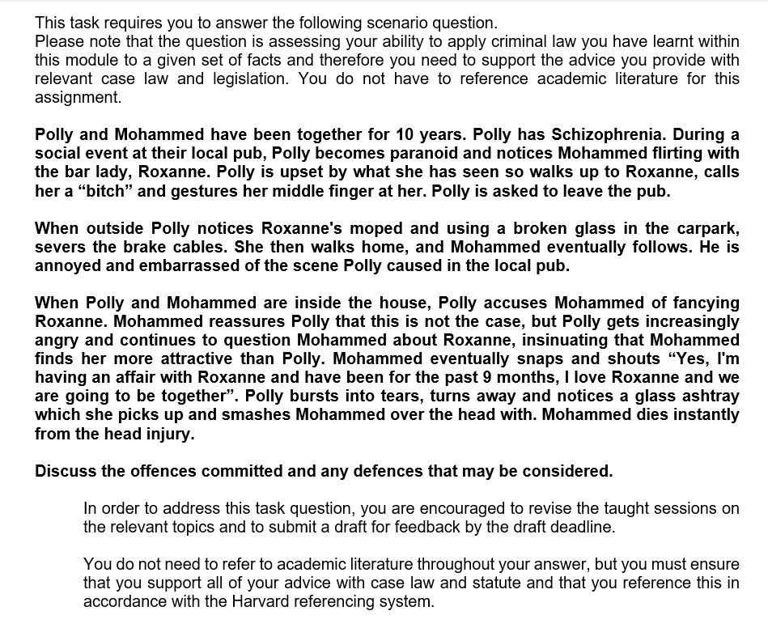

To thoroughly discuss the given scenario, one must be competent enough to consider all criminal liabilities present. It is evident that there are three significant individuals entwined within the given circumstance, and so each offence shall be discussed in chronological order.

The first of the criminal liabilities demonstrated within the given scenario may be deemed as common assault. Some may argue that Polly’s hand gesture and comment she condemned towards Roxanne were indeed verbal abuse. After thoroughly analysing Common Assault which is located within Section 39 of the Criminal Justice Act 1988, Polly did not commit this offence (The Crown Prosecution Service, 2022). An assault is defined as any act (rather than an omission to act) in which a person intentionally or recklessly causes another person to suffer or be apprehended by imminent unlawful violence. Yes, one may contend with the fact that being called a ‘bitch’ is rather humiliating, however, it is not classed as terroristic or an assault in any shape or form.
In the second instance, it must be recognised that Polly does indeed suffer from a serious mental disorder; Schizophrenia. According to NHS (2023), Schizophrenia affects the mind psychologically and can result in hallucinations and delusions.
Within the scenario, as the result of Mohammad acting flirtatiously towards bar-lady, Roxanne, Polly utilises and proceeds to use a broken piece of glass to sever the brake cables of Roxanne’s moped. This is indeed Criminal Damage.
A person who destroys or damages property belonging to another without legitimate cause, with the intent to destroy or damage such property, or who is reckless as to whether such property will be destroyed or damaged, commits an offence (Criminal Damage Act, 1971). Severing brake cables is considered an act of criminal damage; Polly did indeed commit this offence recklessly and with the intention to destroy or damage the property.
It is evident that the statute mentions the term, ‘destroy or damage’. The phrase 'destruction' signifies that the said object no longer exists as a result of the defendant's actions. The term 'damage' implies that the acts harmed the property but did not destroy it.
In criminal law, the term ‘actus reus’ is used frequently. Within the Criminal Damage Act of 1971, this expression is condemned within section 1 (1) of the legislation. A person is deemed guilty if they purposely, recklessly harm or damage another person’s property without any lawful excuse. Within the given scenario, Polly severed Roxanne’s brake cables without lawful justification and so actus reus was indeed established.
Furthermore, under review of mens rea for the unlawful act of criminal damage, it may be easily satisfied within the given scenario. In essence, mens rea is otherwise pursued as the ‘guilty mind’ of the offender.
Based on criminal damage, the mens rea is the intention whilst being reckless to either destroy or damage the said property that isn’t their own (GOV.UK, 2021). The moped is the property of Roxanne and not Polly; similar to the case of R v Steer (1988). The defendant (D) was convicted of criminal damage contrary to section 1 (1) of the Criminal Damage Act (1971). Following an argument with his business partner, the appellant advanced his way to their house, armed with a gun. D proceeded to ring the doorbell before firing shots through both the windows and doors.
The scenario proceeds to mention that after the conversation, Mohammad establishes the fact that he and Roxanne have been seeing each other for the past nine months. Polly bursts into tears, and out of anger, notices a glass ashtray. Polly proceeds to smash it over Mohammad’s head causing him to die instantly as a result.
As mentioned previously, Polly suffers from schizophrenia, an abnormality of the mind; that affects the way one thinks, feels and behaves.
Whilst Polly has killed Mohammad; due to her mental abnormality, she committed a partial offence of Diminished Responsibility under Section 52 of the Coroners and Justice Act (2009). The term ‘partial’ means less culpable.
Diminished Responsibility can be located within the Homicide Act (1957) yet modified by the Coroners and Justice Act (2009). Diminished Responsibility acts as a stepping-stone in the fact that if one is successful, diminished responsibility creates an effect in the sense that it reduces a murder conviction to manslaughter.
Similar to the case of R v Byrne (1960), where a man raped, killed and mutilated a young girl. He then went on to plead diminished responsibility causing him to be found guilty of manslaughter and not murder. The Judge recognised that he was indeed a sexual psychopath, so bad that his behaviour became impossible to control when driven by sexual desires.
Polly must provide evidence on the ‘balance of probabilities’ that she was indeed suffering from an ‘abnormality of mental functioning’ (R v Byrne) which has arisen from a ‘recognised medical condition’.
Polly could also plead a defence called Loss of Control; a defence that has three components within Section 54 (1) (a) (b) and (c) of the Coroners and Justice Act (2009). These are categorically viewed as; a loss of control, a qualifying trigger and an objective test (where an individual of the defendant's age and gender with a typical level of tolerance and self-control would have reacted similarly).
The defendant must lose self-control for this defence to be liable. If the evidence demonstrates that the attack was pre-thought-out, then Polly is unlikely to rely on this argument. Section 54 of the Coroners and Justice Act (2009) mentions that if the act was executed through revenge, then one cannot use the defence of loss of control.
It is evident that Polly perhaps lost her temper as a result of Mohammad confessing his love for Roxanne. This is similar to the case of R v Woollin (1998). The defendant, here, lost his temper with his three-month-old child and threw him against a hard surface. When charged with murder, the defendant progressed to argue that he had not intended to cause his child any harm.

Reference List
Offences against the person, incorporating the charging standard (no date) Offences against the Person, incorporating the Charging Standard | The Crown Prosecution Service. Available at: https://www.cps.gov.uk/legal-guidance/offences-against-person-incorporating-charging-standard (Accessed: May 5, 2023).
Participation, E. (1978) Criminal damage act 1971, Legislation.gov.uk. Statute Law Database. Available at: https://www.legislation.gov.uk/ukpga/1971/48 (Accessed: May 5, 2023).

