Programme – Built environment portfolio
Assignment title – portfolio
Lecturer – Juan A. Ferriz Papi
Submission 2 (70% of total coursework)
BY Aidan Swan

Introduction

In this assignment I will be solving different questions for the execution of works needed for the development proposed. The development proposed in this case study is the construction of a bridge that will cross the river Lougher, there are many considerations that need to be taken into account when building a bridge because there are many different routes to choose from in its construction but also many different problems that can occur with each one.
The design for each bridge is made specifically for that individual bridge as every location is unique and can come with its own problems. The design should take into account various factors such as water currents, local topography, wind patterns, possible earthquakes, soil conditions, cost limits, aesthetics and traffic volume, these aspects all have a major part to play in the construction of the Lougher Bridge.

The construction of the bridge
In the process below, I will go through the main steps in constructing this bridge across the river Lougher.
The first part of this project is to build the cofferdam around each column location in the riverbed, next the water will be pumped out from the inside of the cofferdam. The setting of the foundations is the next stage, in this project the middle two foundations will be pedestal piles and the outside ones will be drilled piles. An excavation machine will be used to drill shafts through the riverbed all the way down to the solid bedrock as it is fitted with an auger drill which as it drills will brings the soil up from the hole, with a clay slurry in turn being pumped into the shaft to substitute for the soil and stop the hole from collapsing (Mishra, A 2018).
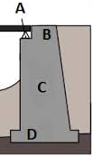
Once the required depths are reached (shown in sketch), a cylindrical cage of reinforced steel rebar will be lowered in to the shaft and then concrete is pumped in from the bottom, by pumping the concrete in at the bottom this will force the slurry out, so It can be collected, cleaned and reused. Then the aboveground portion of each column will be formed and cast in place as well.

Abutment
The abutments on either end of the bridge are the next step, they will all be mounted simultaneously on both sides of the shores. A gravity abutment will be used which includes the backwall, footings, bridge seat and wing walls which will hold up the bridges deck while including a retaining wall for the embankment this is shown in figure 1.
The abutment is prepared on the riverbank where the bridge end rests, a concrete back wall will be moulded and poured between river bed and top of the ban, this is a retaining wall for the soil beyond the end of the bridge. A ledge/seat is formed for the bridge to rest on top of the backwall. There will also be wingwalls included which will extend out from the back wall across the riverbank to retain fill dirt for the bridge approaches.
Figure 1. Gravity abutment (2018 study.com)

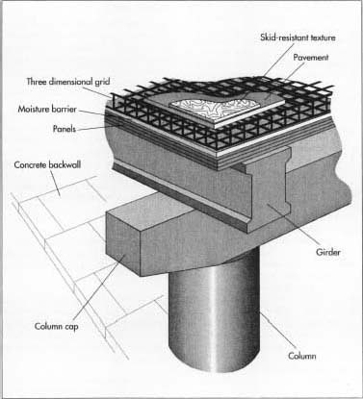
There is a crane used on each shore that will install the beam elements which are then reconstituted by welding on site (welded I beams). The deck will be equipped with a launching nose and a ballast at the rear to prevent any possibility of tipping. This will be pushed onto the piles using winches, pulleys and cables, with the deck advancing at about 9m/h for safety it is kept to a low speed but there will also be other restraint systems in place to stop any chance of runaway with the decks.
Next is the pouring of the slab, the beams are equipped with connectors that will allow the steel structure to be bonded with the concrete slab of the latter. Then once these beams are on their final supports a lost formwork will be added and a reinforcement before pouring the layer of concrete with a thickness of around 25cm which will be the solid slab on concrete on the structure (Cai, Z.-K., 2018)
Figure 2. Bridge beam design (How products are made 2018)
The very last step to finish of this structure is to lay asphalt on the road. Asphalt is a very special type of bitumen that has the characteristics that allow it to perfectly endure the deck expansions. This bitumen will not crack even if the steel deforms it will always keep its high quality and accommodate the traffic on the road.

Conclusion
This assignment has covered every aspect of what it would take to construct a bridge over the lougher river but only in a short version, given a higher word limit I would be able to explain each step in far more detail. The detailed sketch shows the measurements of what my bridge would consist of and how the foundations, cofferdam, abutment and deck all go into place and work simultaneously to create the bridge in its final form.

sketch of bridge construction
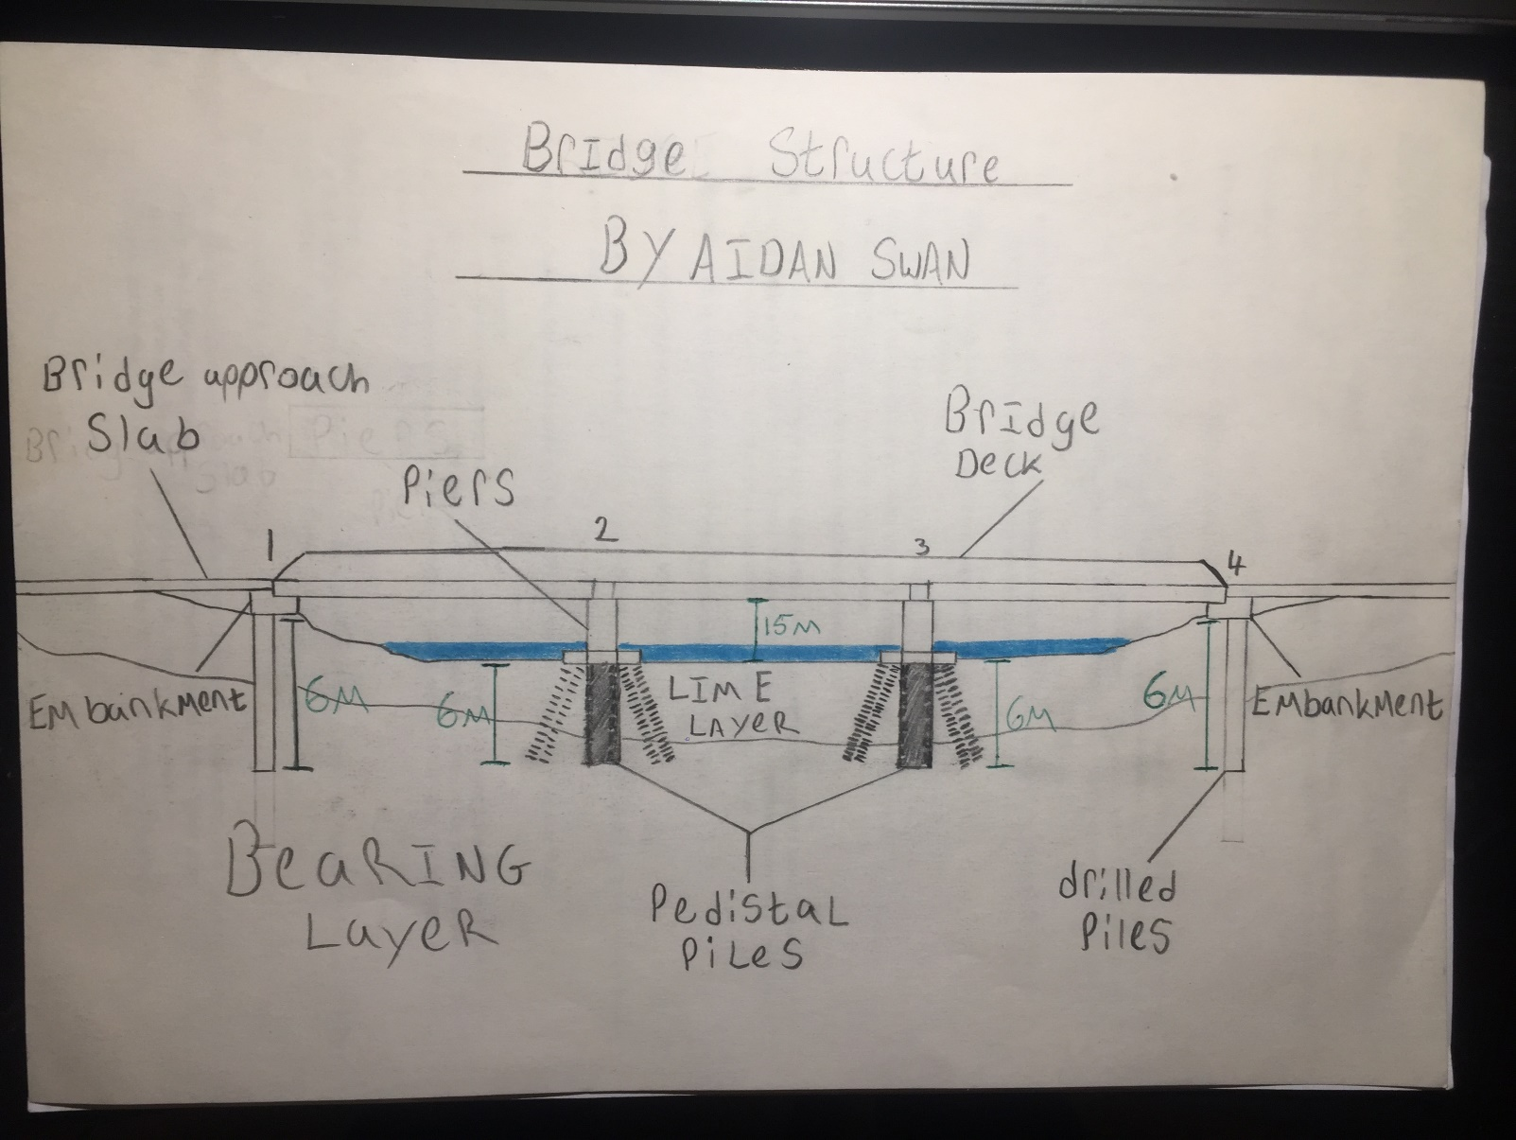

References
Cai, Z.-K., Wang, Z., Yang, T.Y. 2018 construction and building materials volume 945 pp 166
Mishra, A., Patra, N.R. 2018 settlement of pile foundations using five-parameter viscoelastic soil models volume 18
How products are made (2018) available at: http://www.madehow.com/Volume-4/Concrete-Beam-Bridge.html Accessed on: 22/02/2018
Study.com (2018) available at: https://study.com/academy/lesson/bridge-abutment-design-types-examples.html Accessed on : 22/02/2108

