Drew McClennon (2312801)
2312801@student.uwtsd.ac.uk
Research, build, and deploy a virtualised enterprise network
Network Operating Systems and Services – ACCA5023

Table of Contents
Task 1 1
Hypervisor 1
IP Addressing 2
Routing 2
Network Services 3
Task 2 3
2.1 Choosing my Hypervisor 3
2.2 Download and Setup 4
Task 3 14
3.1 Reflection 14

Task 1

Hypervisor
A hypervisor is virtualization software that enables multiple virtual machines to be simultaneously ran on a single physical machine. It works by distributing the physical machines hardware into virtual components such as the CPU, RAM, storage, and also networking. There are two main types of Hypervisors, Type 1 (bare-metal), and Type 2 (hosted).

Type 1 Hypervisors are typically ran directly on the physical components without a host operating system. The main benefit of using type 1 Hypervisors would predominantly be the increased performance over using a type 2 Hypervisor. However, it also provides better efficiency, and security due to there being no intermediate software layer. Examples of type 1 Hypervisors include Microsoft Hyper-V, VMware vSphere, and Citrix Hypervisor. Due to the type 1 Hypervisor being exclusively for running multiple VMs on a single physical system, this approach would be best suited for a professional enterprise environment.

Type 2 Hypervisors operate on top of a pre existing operating system. While this approach does come with the downsides less efficiency and not being able to allocate each virtual system as much virtual resources as type 1 Hypervisors, it is a much easier approach and more suited to the everyday user. Examples of a type 2 Hypervisor include Oracle VirtualBox, VMware Workstation, or Parallels Desktop.

Whilst in a real enterprise environment, using a type 1 Hypervisor would be the best option due to the increased efficiency, performance, and security, for this assignment I will be using the type 2 Hypervisor VirtualBox from Oracle as the workstations in the computer lab we used for this project came pre equipped with that software and I personally find it easiest to use due to prior experience.

IP Addressing
Data travels across the internet using packet switching. When a computer sends data, it is broken into small packets, each packet containing a source and destination IP address. These addresses uniquely identify devices on a network and ensure the packets reach their designated destination. The internet protocol (IP) operates at the network layer of the OSI model, and its job is to assign logical addressing and routing.
Routers examine the destination IP address in each packet and will forward it towards the correct network, while switches operate mainly at the Data Link layer using MAC addresses to deliver frames within a local network.
IPv4 addresses are 32 bit numbers written in dotted decimal format (for example 192.168.10.1) divided into network and host portions. However, due to IPv4 exhaustion, IPv6 has been introduced. IPv6 uses 128 bit hexadecimal addresses (for example 2001:0db8::1) which provides a vastly larger address space while also improving efficiency.
Subnetting divides a large network into smaller sub networks in order to improve performance, security, and address management.

Routing
Routing is the process of forwarding data packets between different networks using routers. Routing protocols determine the best path for data packets to travel based on metrics such as hop count, bandwidth, delay, and cost. Their primary purpose is to ensure reliable and efficient delivery of packets across networks. Routing operates at Layer 3 (the network layer) of the OSI model, where routers examine destination IP address and consult routing tables to forward traffic accordingly.
There are two main routing approaches, Static routing and Dynamic routing. Static routing requires administrators to manually configure routes in the router’s routing table. It is simple, secure, and uses minimal system resources however, it lacks scalability and automatic adaption to network changes. If a link fails, manual reconfiguration is required.
Dynamic routing on the other hand uses routing protocols such as RIP, OSPF, or BGP to automatically exchange routing information between routers. These protocols allow routers to learn new routes, detect failures, and adjust paths automatically. While dynamic routing is more scalable and resilient, it introduces additional configuration complexity and resource usage.
For our use case, I will be using static routing as this should prove sufficient for the small network size in the topology given between the Debian and Windows servers.

Network Services
A Virtual Private Network (VPN) creates a secure and encrypted tunnel over a public network allowing for remote users to access internal resources safely. The main key features of using a VPN include data encryption, authentication, and data integrity. Examples include NordVPN, TunnelBear, ExpressVPN, and SurfShark.
Dynamic Host Configuration protocol (DHCP) automatically assigns IP addresses and network configuration settings (such as subnet mask, gateway, and DNS) to devices. This reduces manual configuration errors and improves scalability.
Active Directory Domain Services (AD DS) provides centralized authentication, authorization, and management of users, computers, and resources within a Windows domain environment. Key features include Group Policy Management, domain controllers, and Kerbos-based authentication.
A Certificate Authority (CA) issues and manages digital certificates used for encryption, authentication, and secure communications (for example HTTPS, VPN, email security).

Task 2

2.1 Choosing my Hypervisor
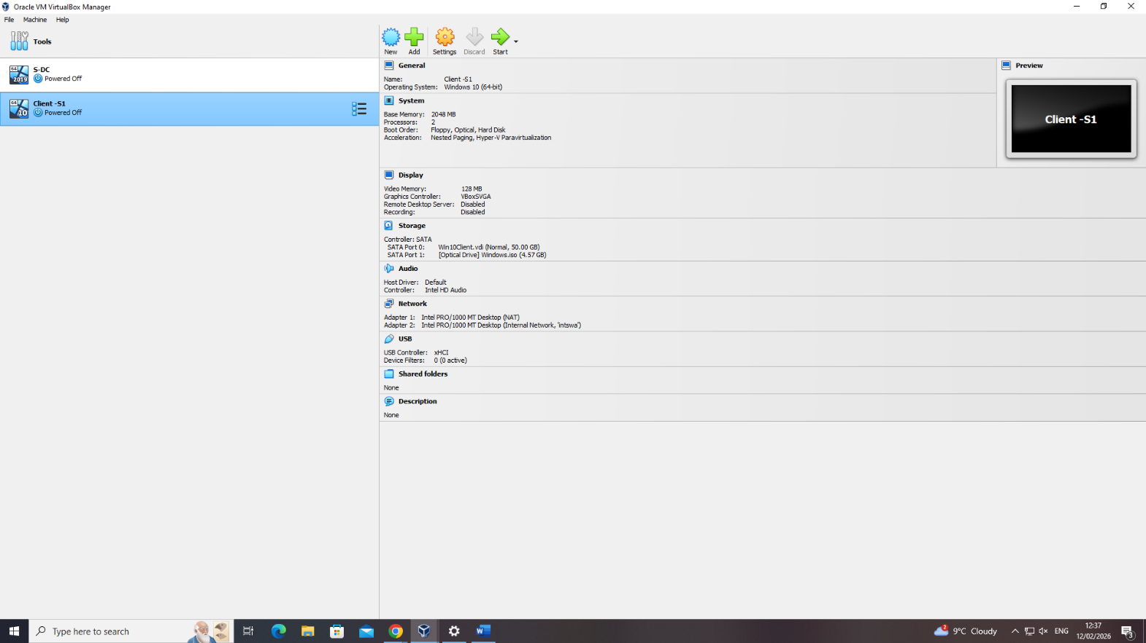
As mentioned above, I decided to use Oracles VirtualBox type 2 Hypervisor for a multitude of reasons, firstly I have used VirtualBox numerous times before so I was very familiar with how it works. Next, it was already installed onto the computers in the computer lab that we were using. Using a type 2 bare metal Hypervisor was also advantageous as if id have decided to use a type 1 hypervisor, it would have required removing the operating system off of the machine which is not feasible in my usecase. (See screenshot below of me using VirtualBox).

2.2 Download and Setup
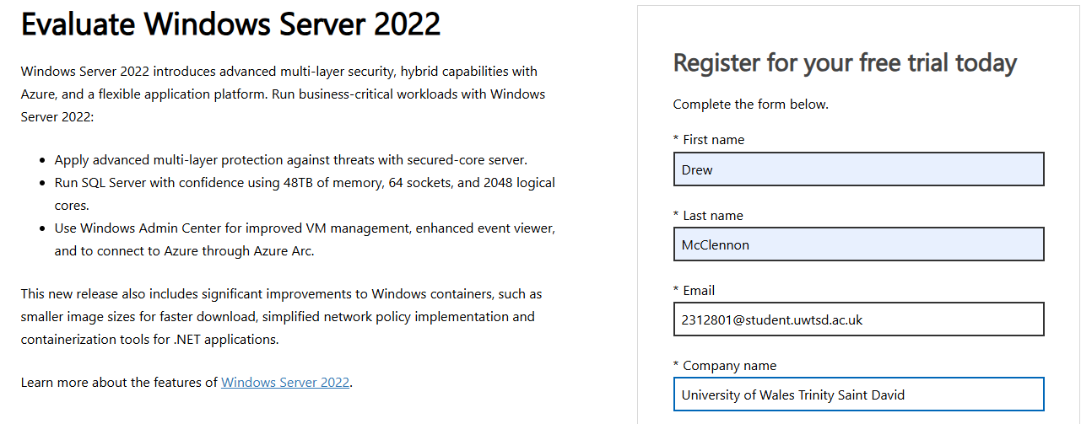
Next I have to download the appropriate operating systems that I will be using for my servers and clients. For this, I am using Windows Server 2022 Evaluation Edition, and a Debian Server. For the two respective clients, I will be using Windows 10 and Debian Desktop.

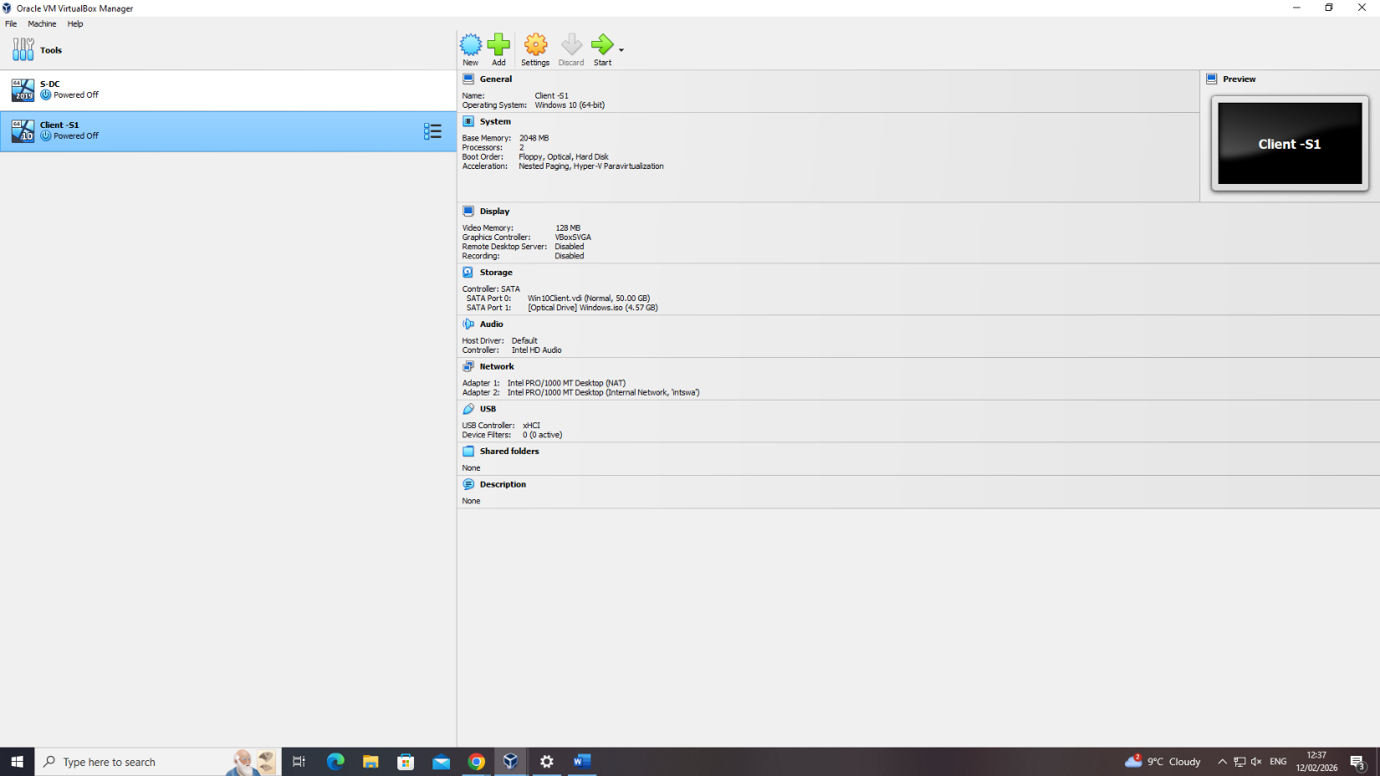
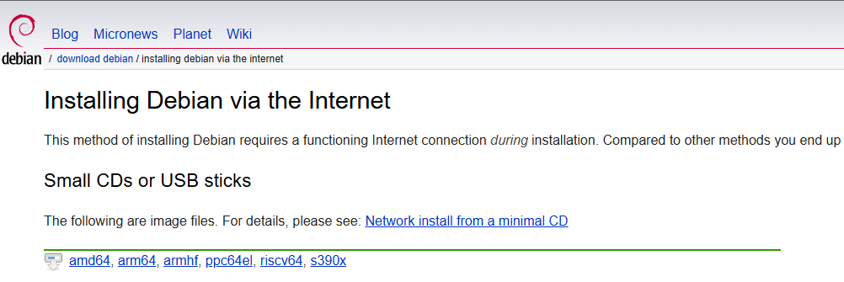
Here you can see both the Windows Server (S-DC) and the Windows Client (Client-S1).
For the Windows Server I assigned 40gb of hard disk space, 4 CPU processors and 4GB of memory (RAM) to run as the Windows Server is the most resource intensive machine of the 4 that I will be using. For the Windows client I allocated 50gb of hard disk space, 2gb of memory, and 2 CPU processor cores as while more intensive than the Debian systems, it is not as power hungry as the Windows server.

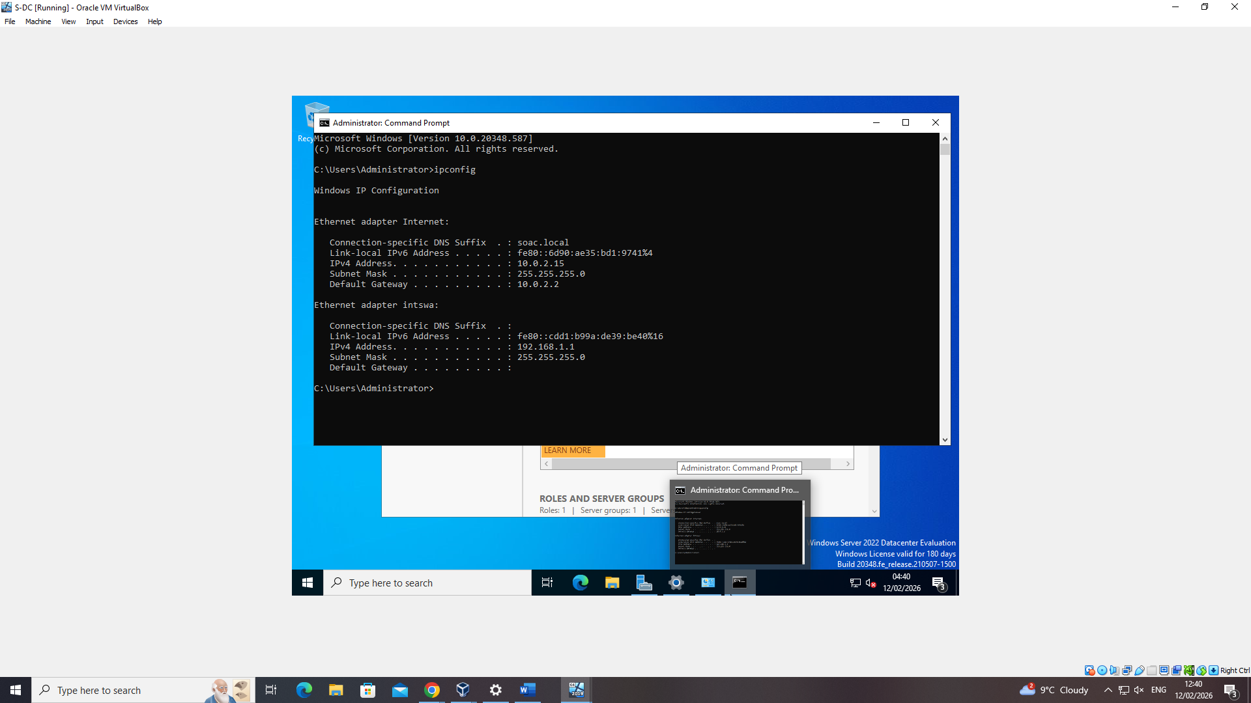
Above you can see the IP config set up on the Windows Server after id assigned both its IP address and default gateway.
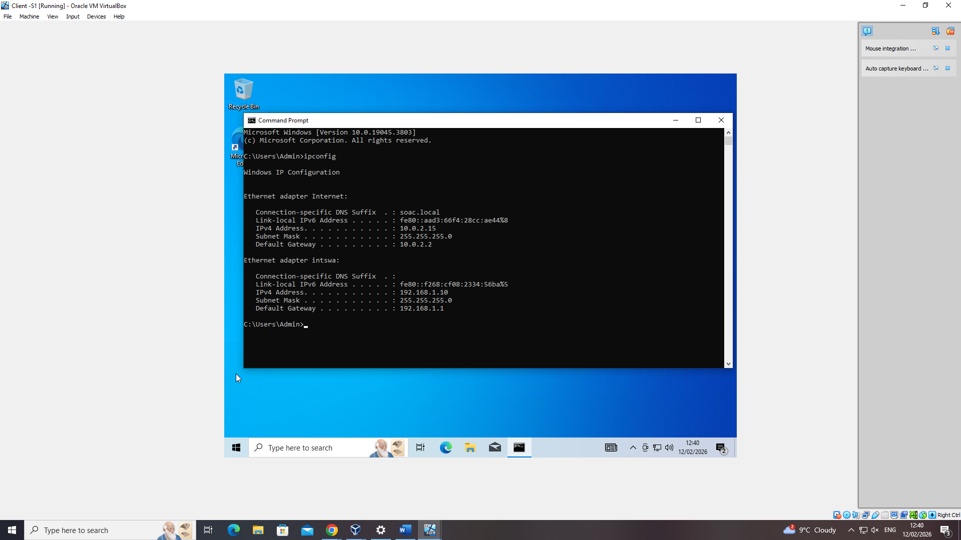
Above you can see the IP config setup on the Windows client after id assigned both its IP address and set the default gateway to route through the Windows server.
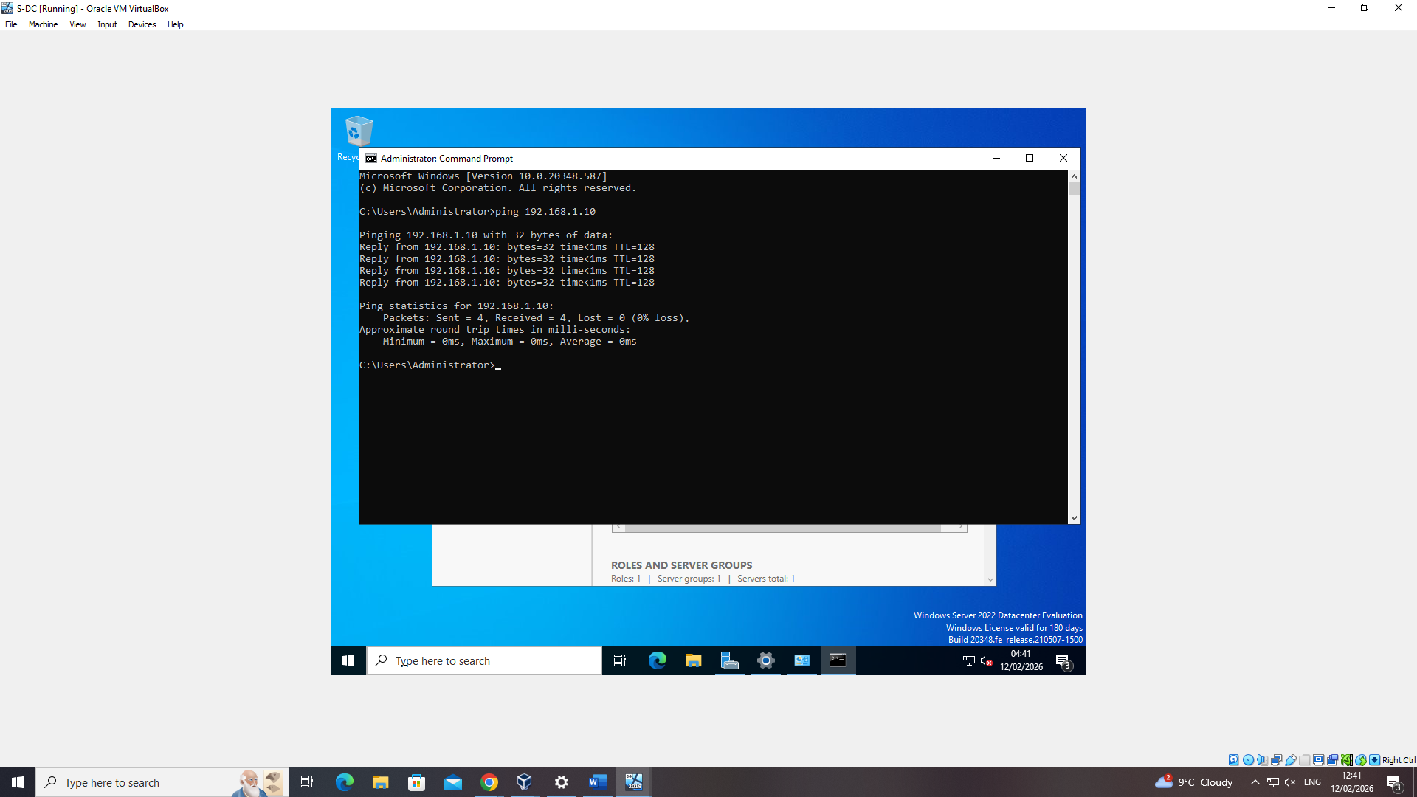
Once I’d set up both the Windows server and client, it was time to test the two and ensure that they were connected. Above you can see a successful ping from the server to the client.
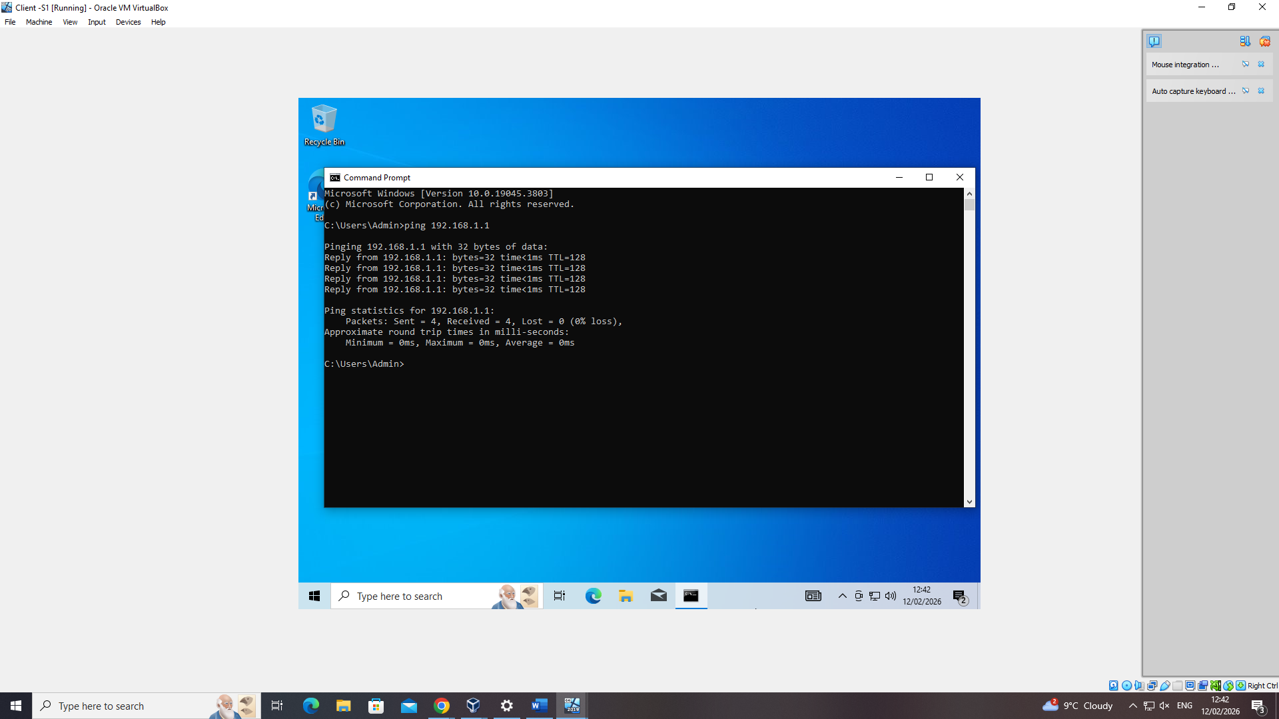
And vice versa here, the client successfully pinged the server confirming their connection.
Once both the Windows server and client were confirmed to be working correctly and communicating to each other, it was time to move on to setting up both the Debian server and client.
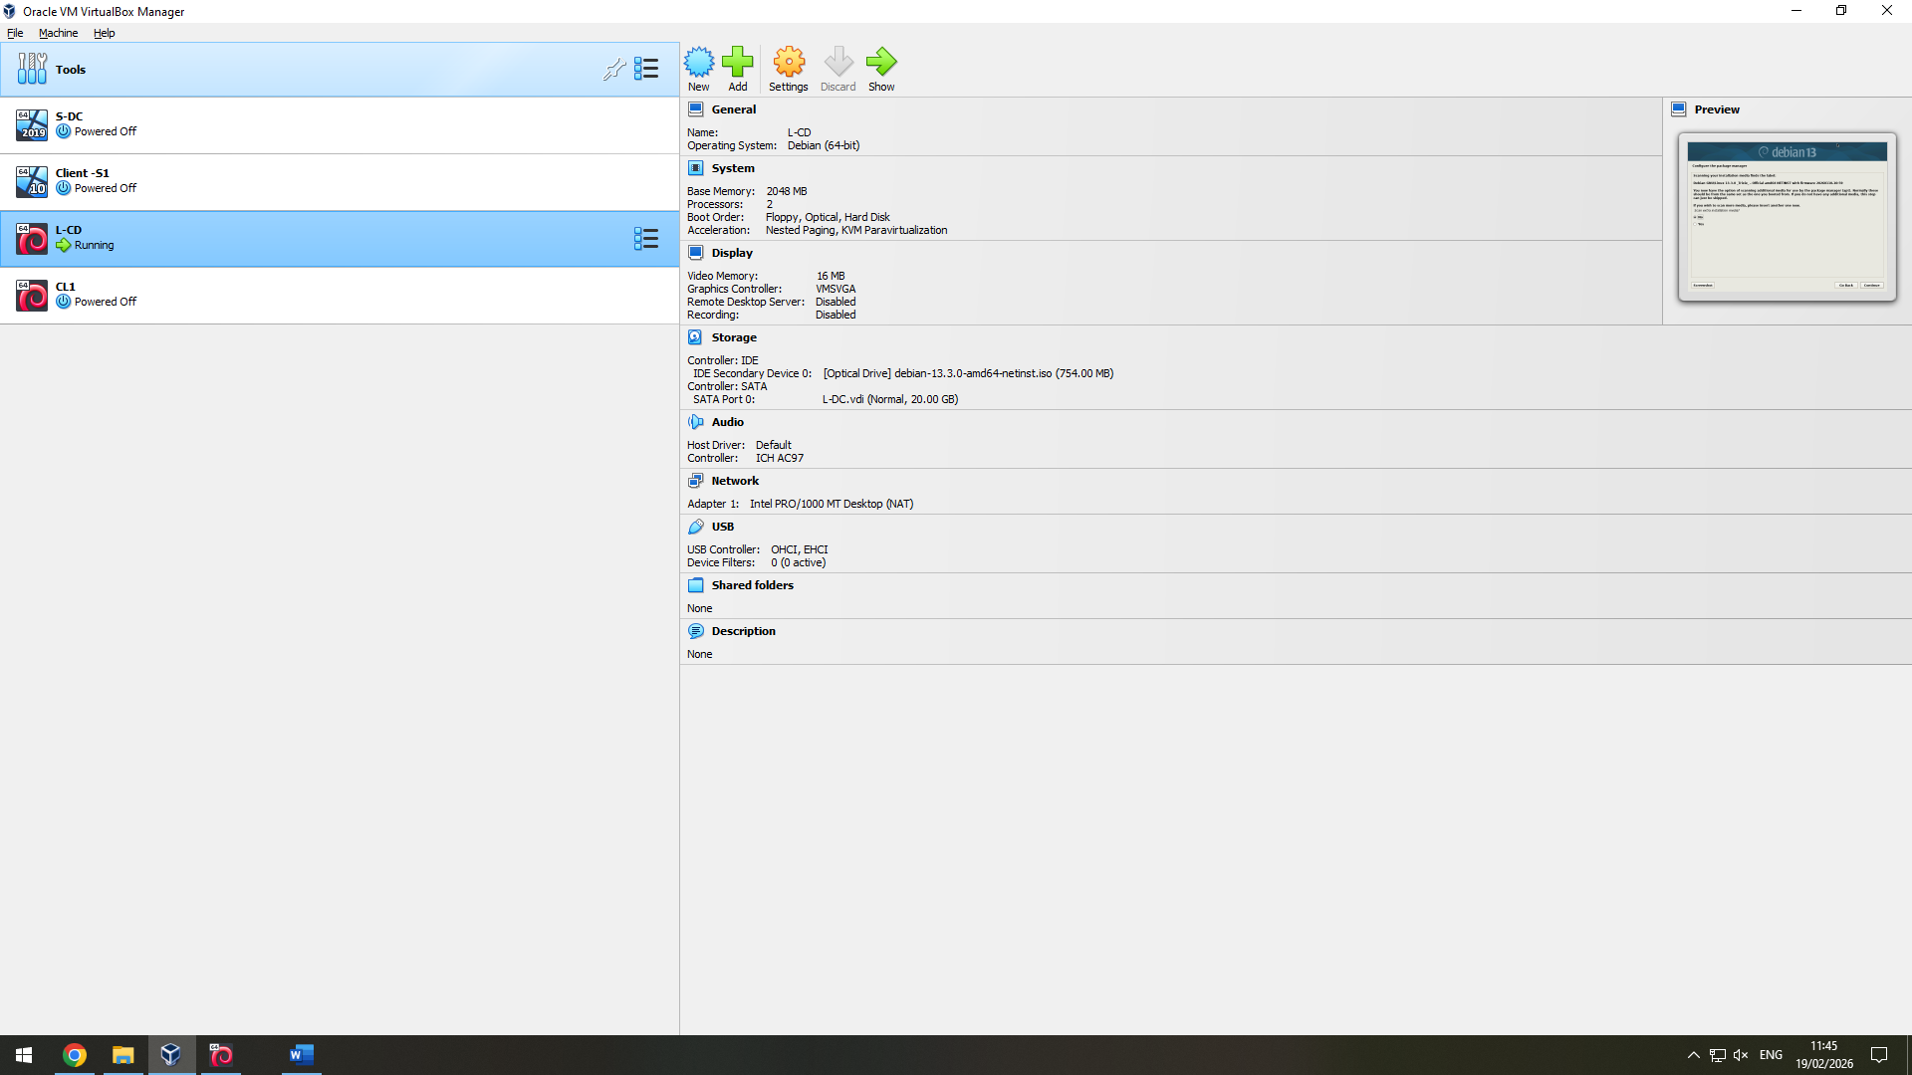
Shown above you can see for the Debian server, I have allocated 20gb of hard disk space, 2gb of memory, and 2 CPU processors. The Debian server will be ran in a command line interface so is much less resource hungry that the Windows server.
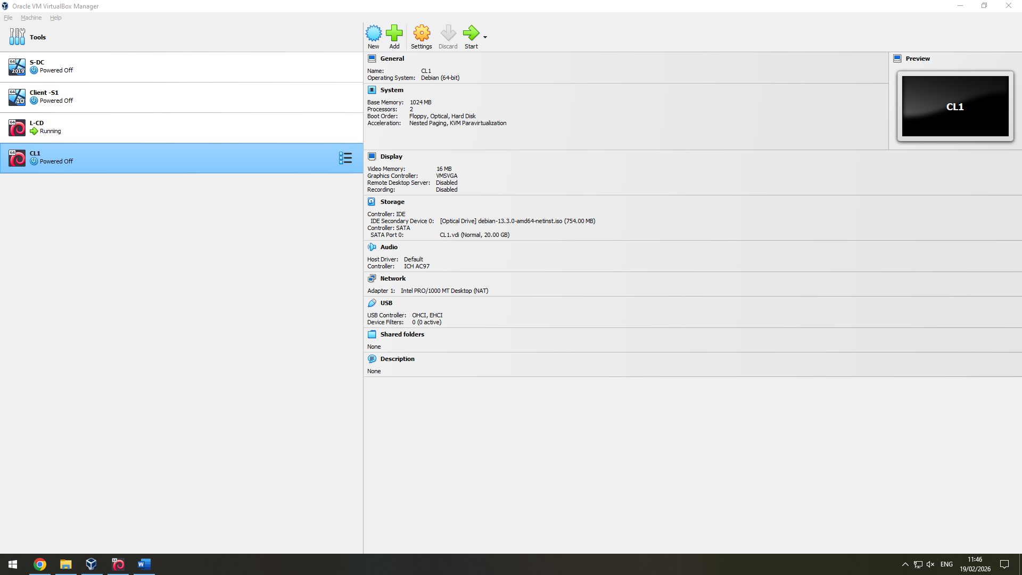
Above you can see the resources that I have allocated to the Debian client, 20gb of hard disk space, 1gb of memory and 2 CPU processors.
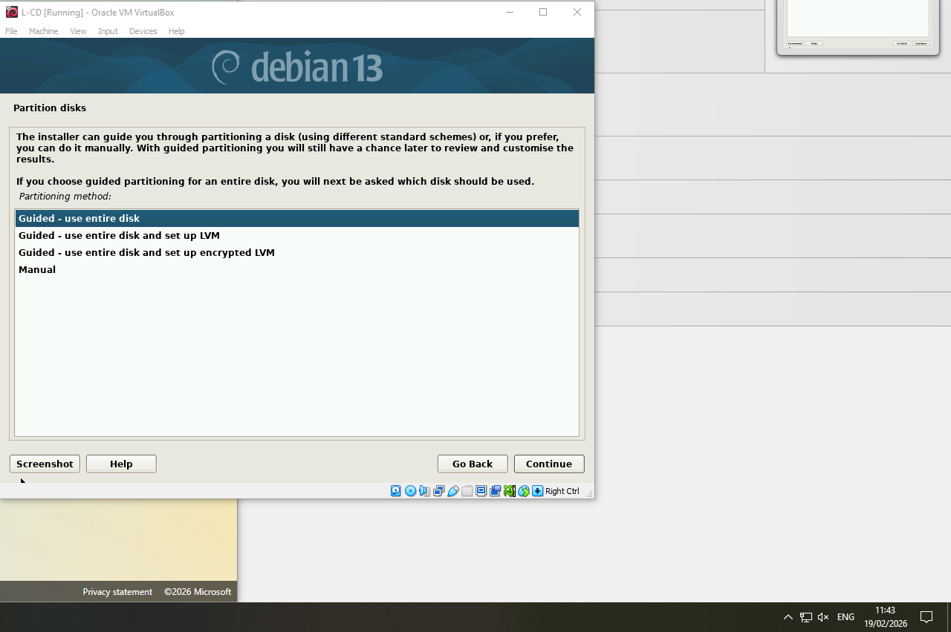
Shown above is part of the install process for the Debian Server.
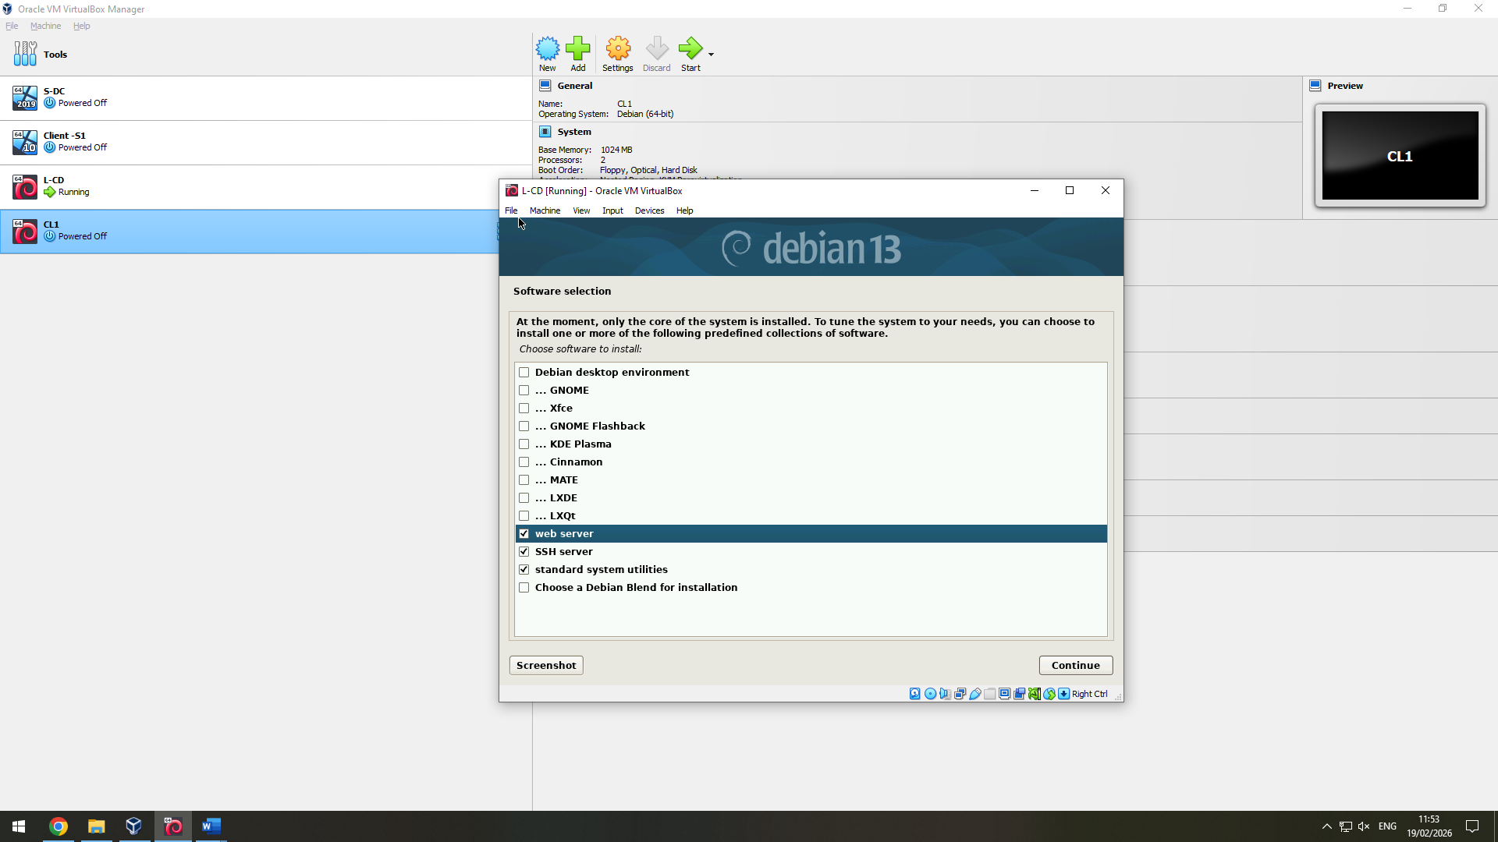
To create the servers CLI environment I had to tell the Debian installer that rather than having the standard packages for the client (Desktop environment, gnome, and standard system utilities) I selected SSH server, Web Server, and standard system utilities.
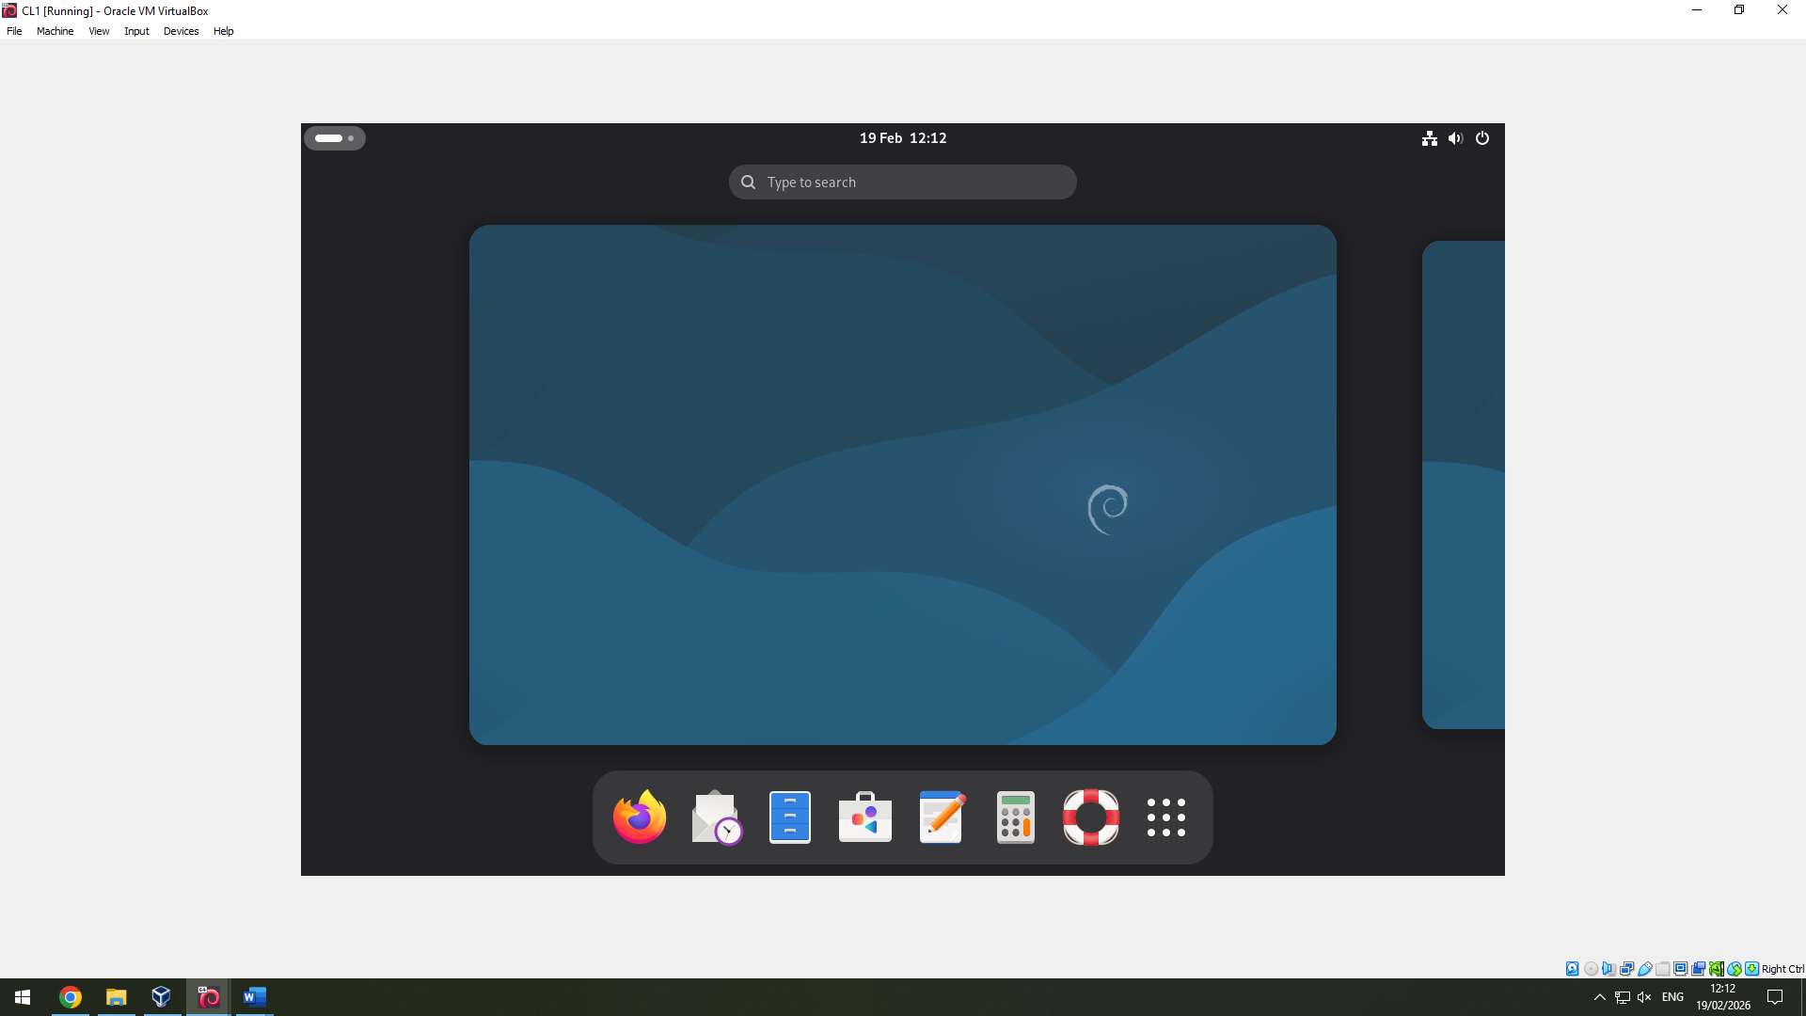
Above you can see the Debian client desktop working.
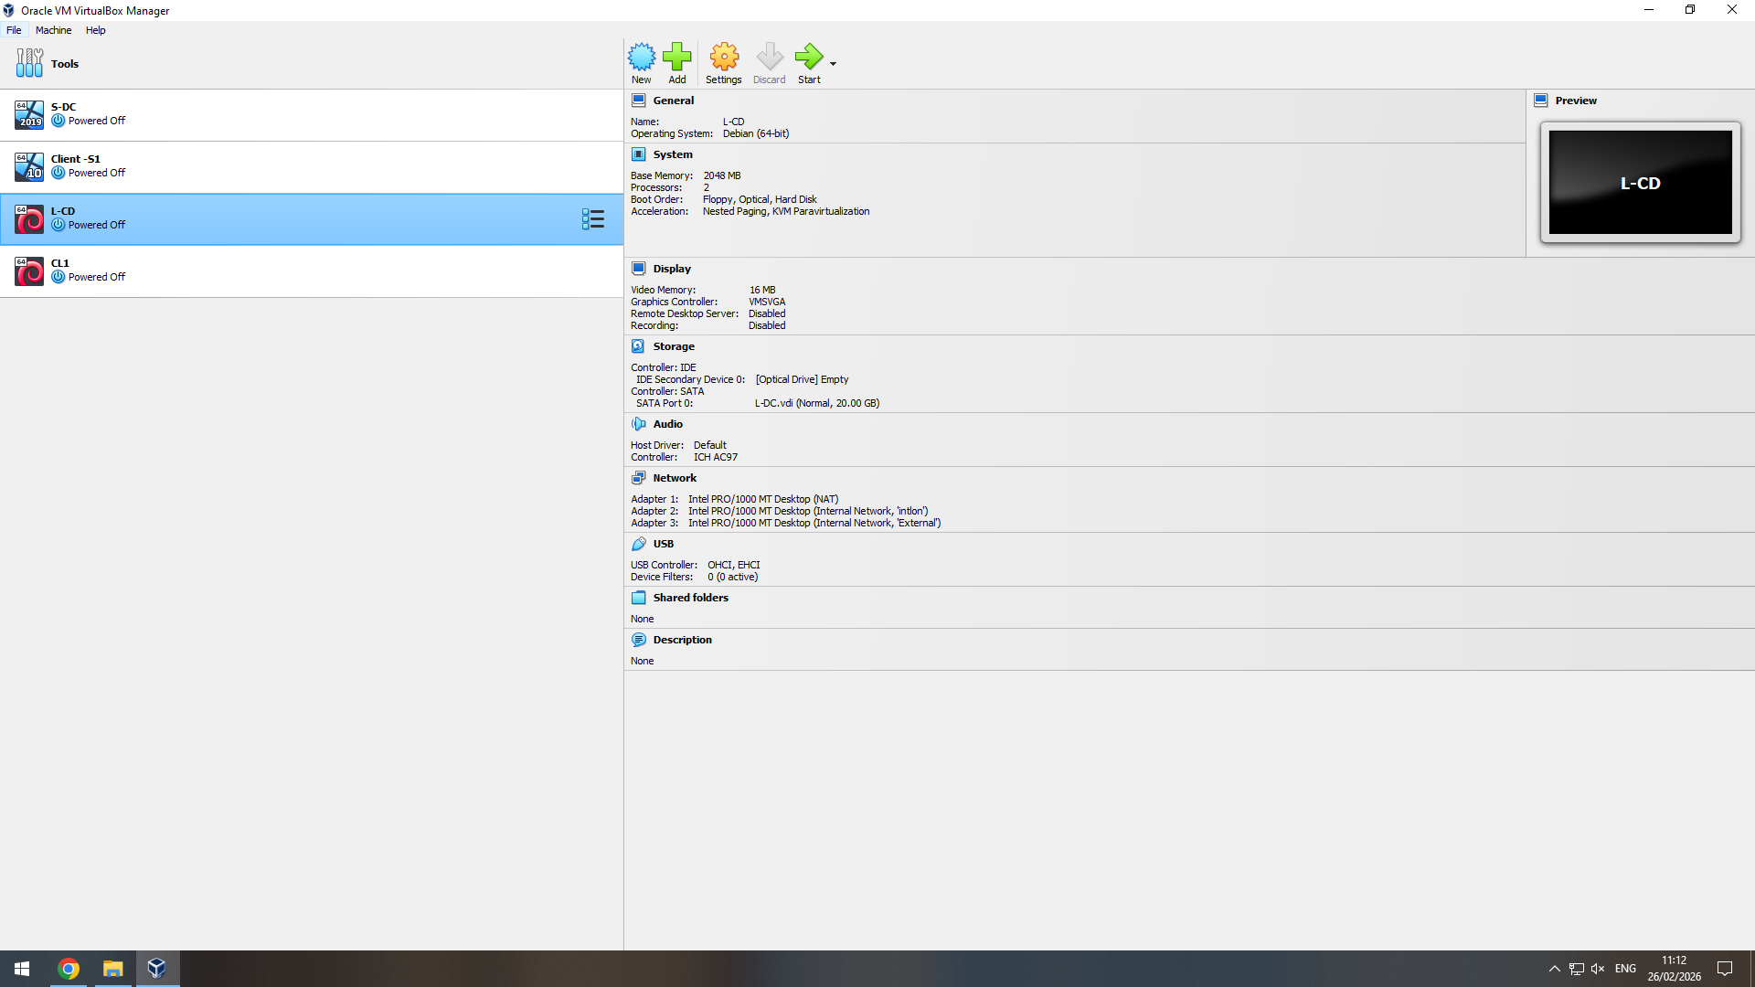
Above you can see the third network adapter enabled for us to create an external network to connect the two servers together despite being in different geographical locations.
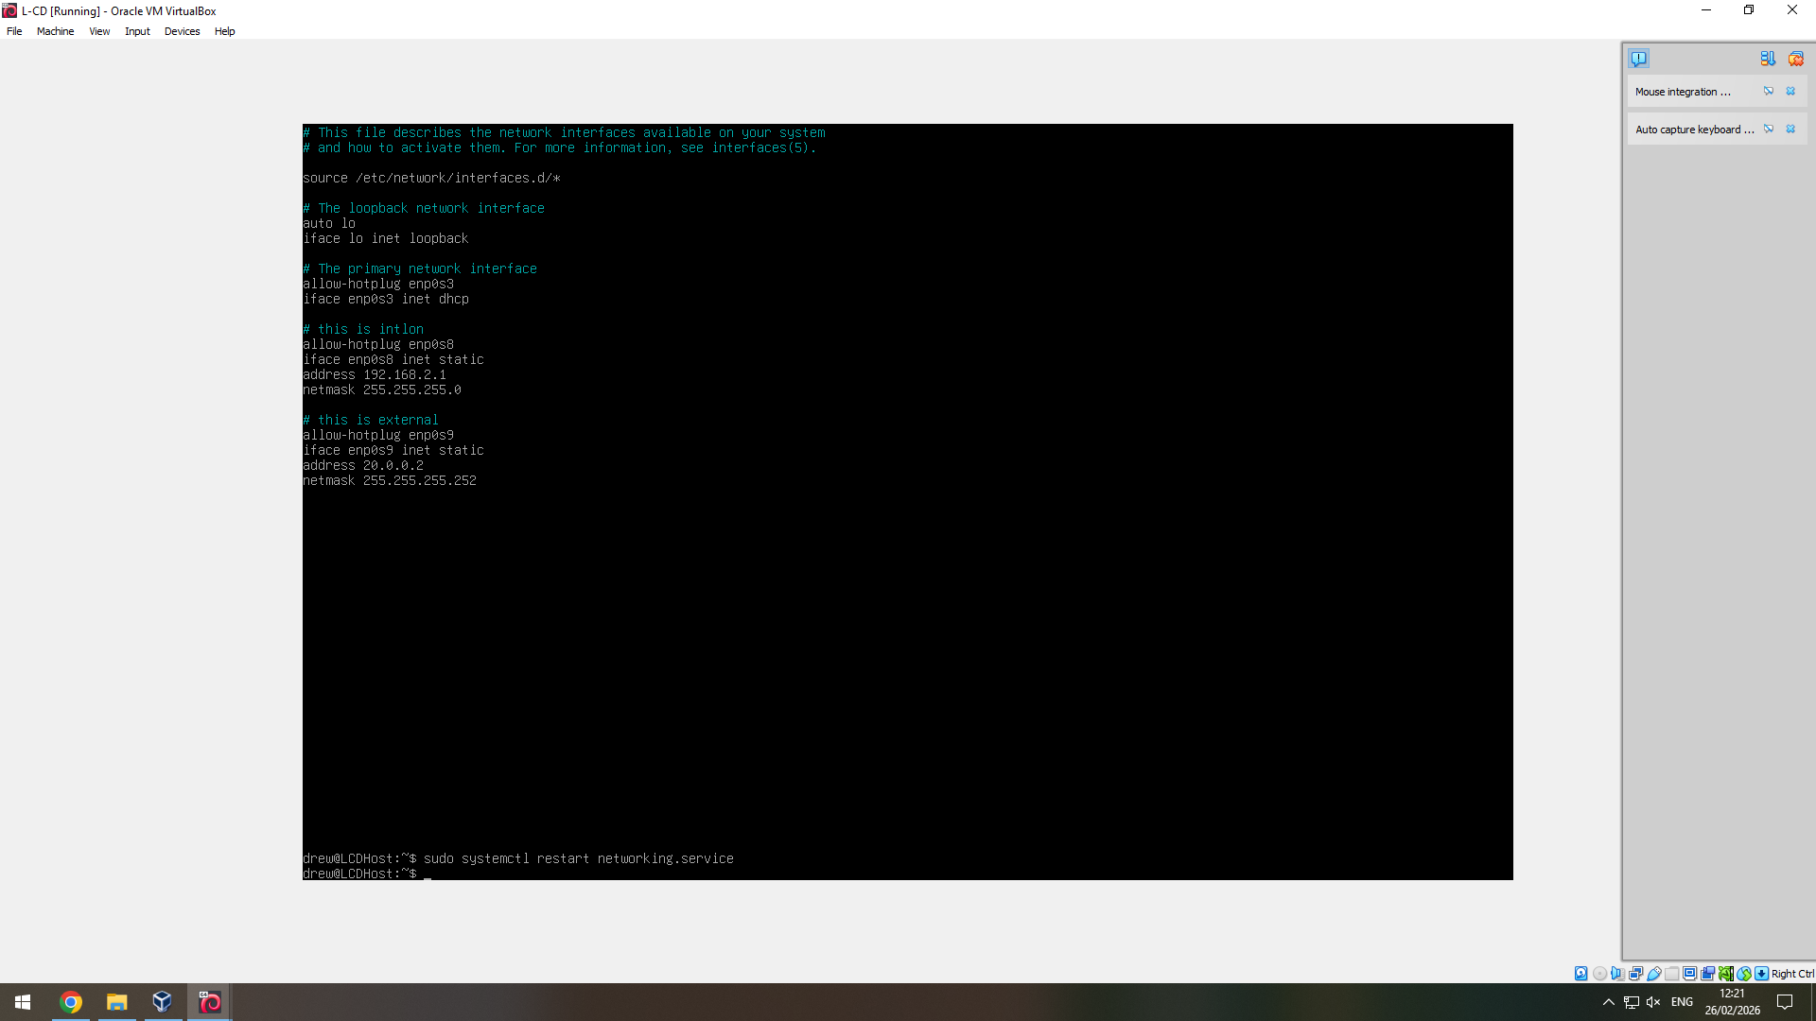
Shown in the screenshot above, you can see both the internal (Debian server to client) network set up (intlon) and the external network setup (Debian – Windows server connection).
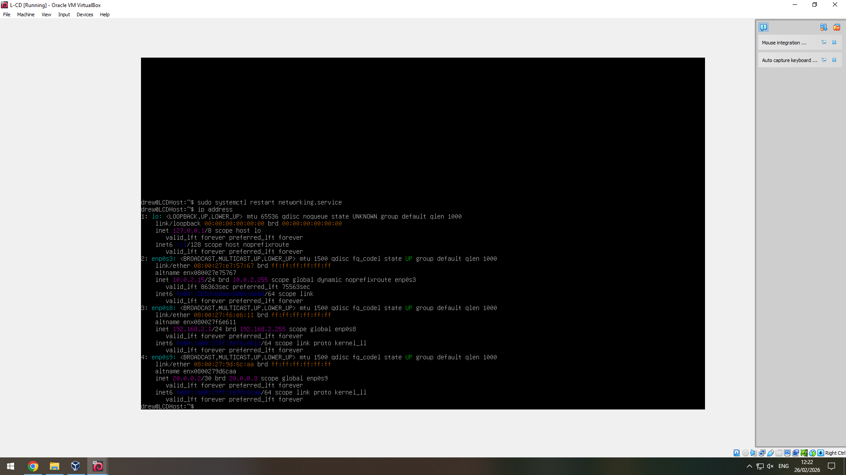
In the screenshot above you can see that both the network adapters set up for the Debian server are showing as UP and working.

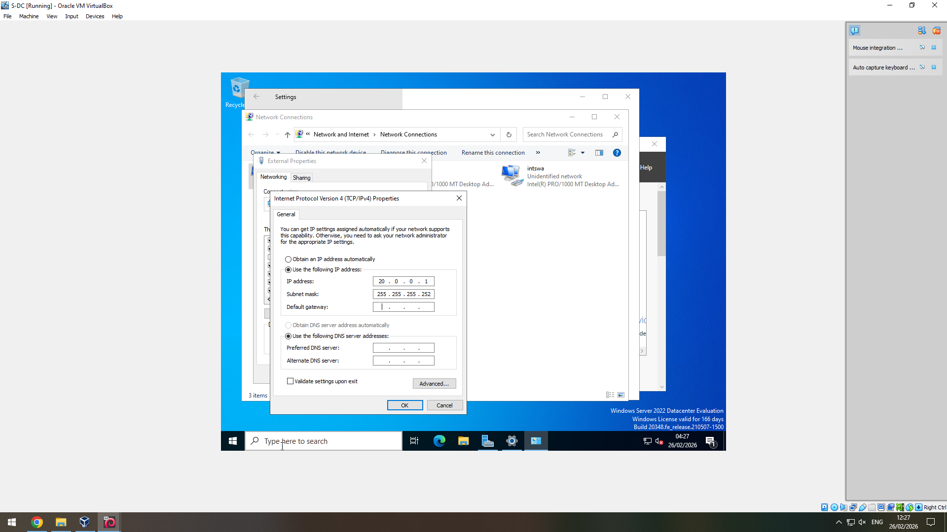
In the screenshot above you can see me setting up the external connection on the Windows server.
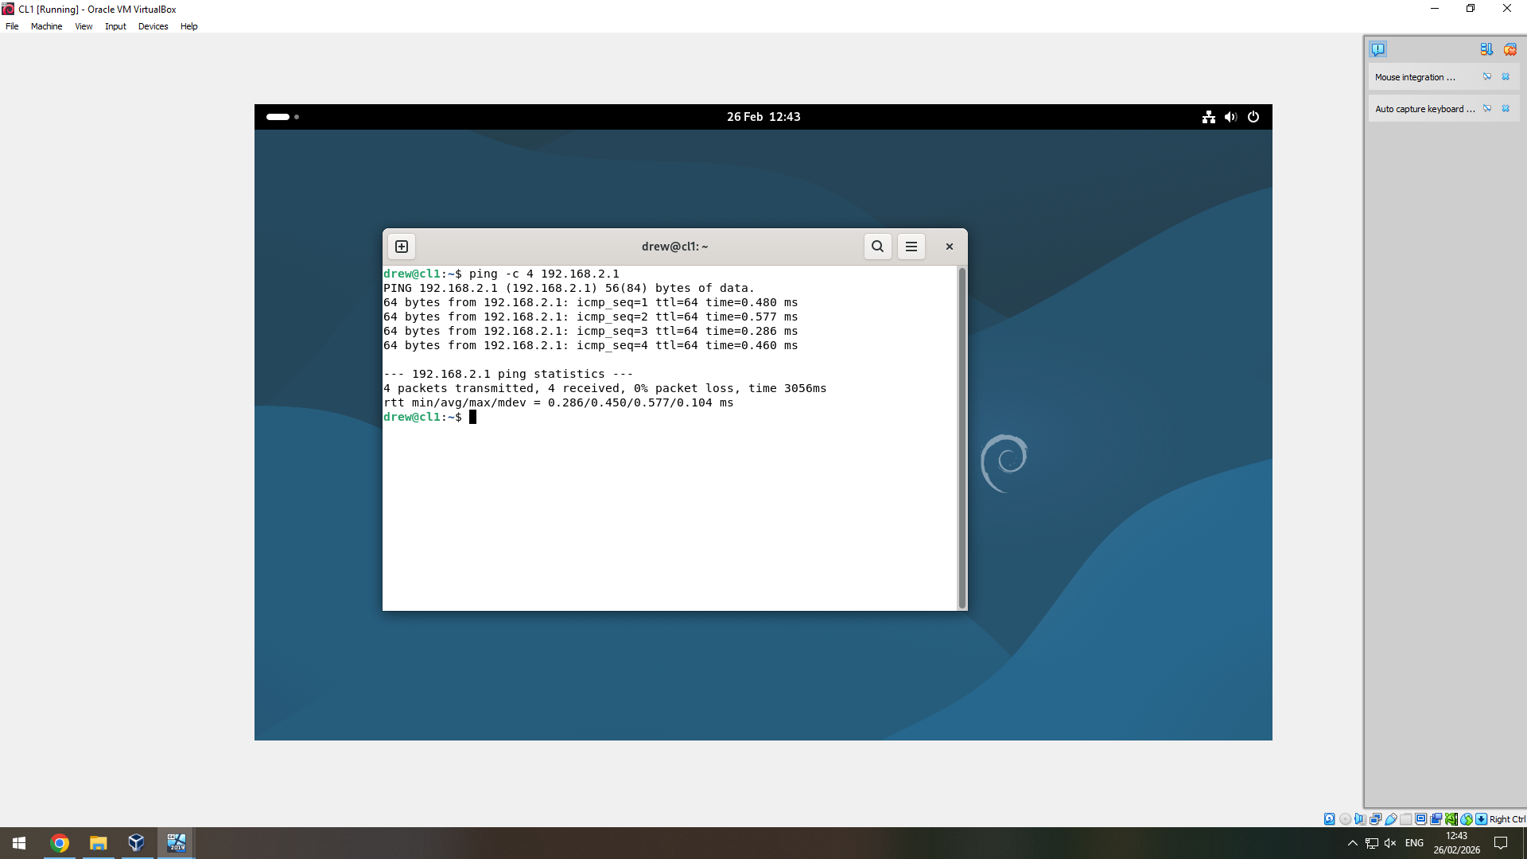
Once I’d got the network set up on the Debian side, I sent 4 pings from the Debian client to the server to verify the connection was set up correctly.
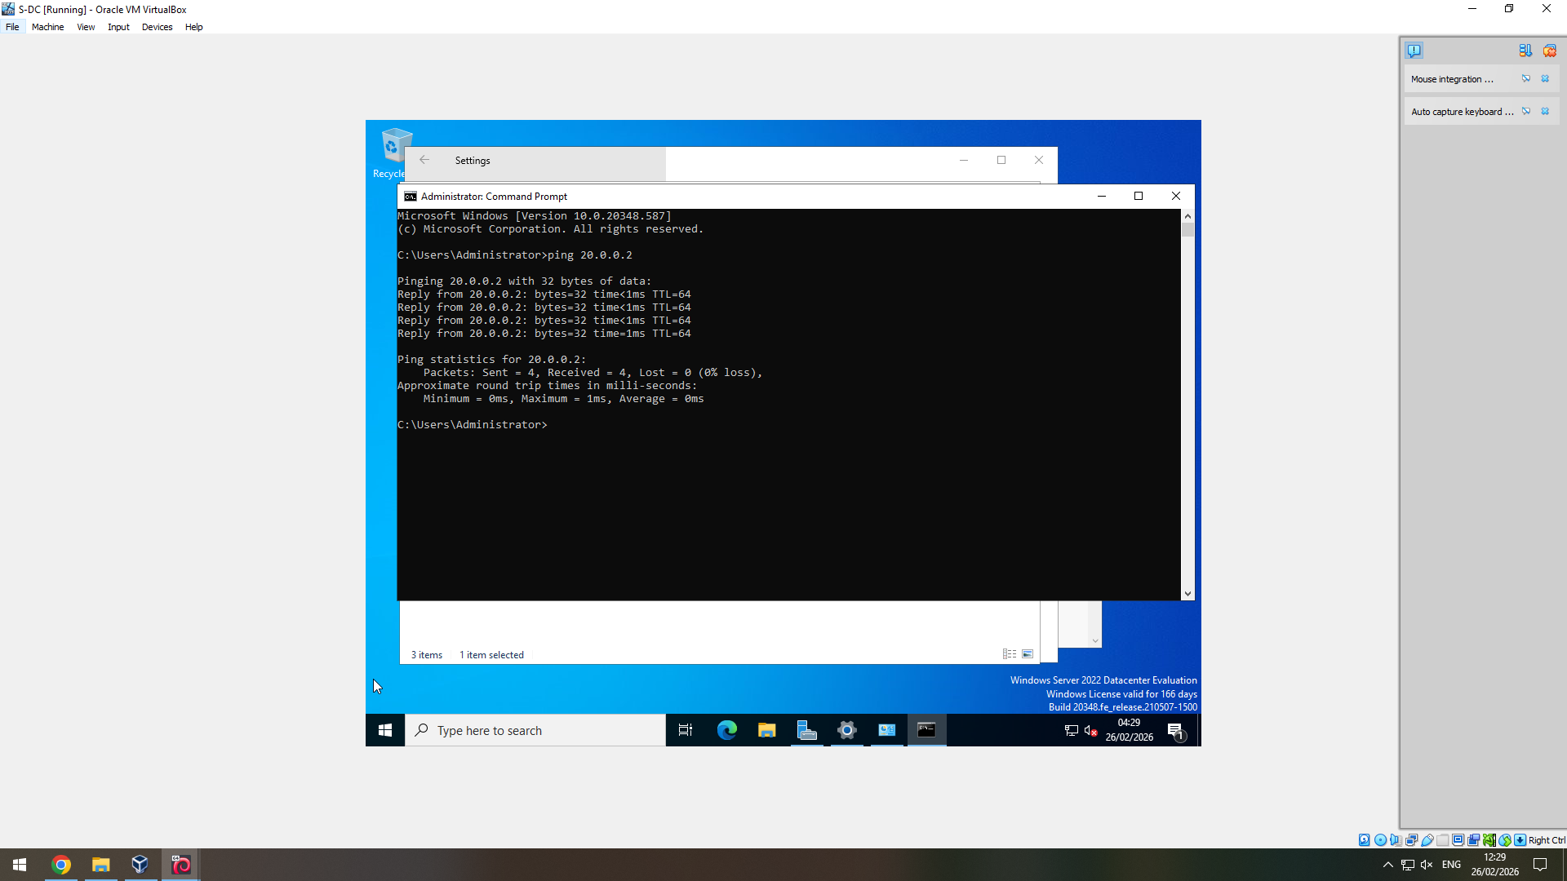
Once the Debian server and client could talk to each other, I moved to testing that the Windows server, and Debian server could ping each other over the external network that I had set up.
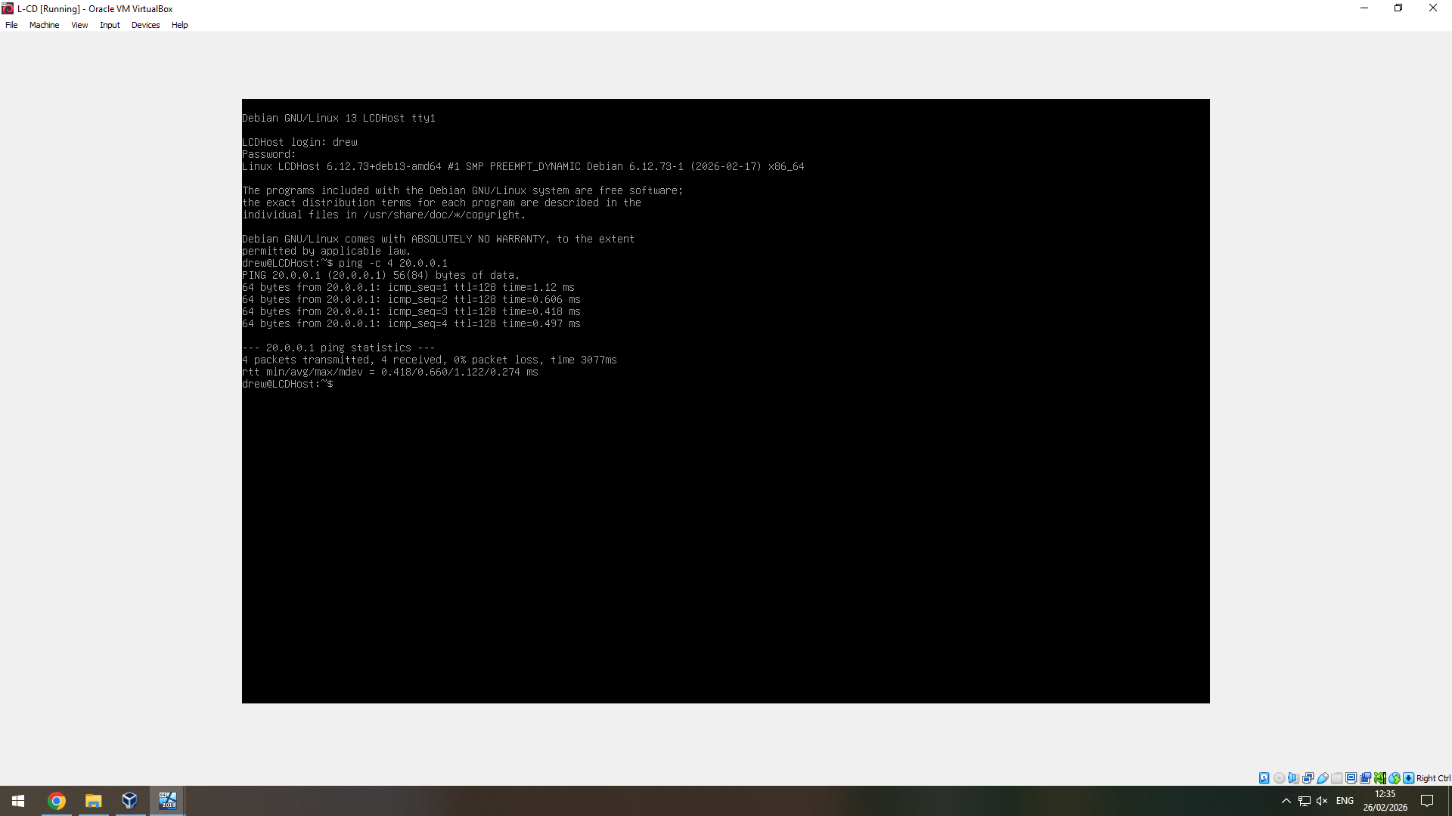
Pings sent from both servers were received by each other flawlessly verifying that the external network was set up correctly.

Task 3

3.1 Reflection
Overall, task 2 was completed with minimal issues. Each network was set up successfully and was able to communicate to each other (with the exception of pinging the Windows client and the Debian client to one another as our network was not set up for this). The only major issue that I’d encountered throughout creating and testing this network came along when I tried pinging from the Debian server and client. This was due to using the (for example) ‘ping 192.168.2.1’ rather than using ‘ping -c 4 192.168.2.1’. Without the ‘-c 4’ Debian will infinitely ping the address until it is forcibly stopped.
If I were to do this again, I would make sure to include screenshots of absolutely everything. Upon writing this assignment I have come to the realisation that I am missing core screenshots of both the Windows server and client configuration, and the ping tests between both the Debian server and client.

