Financial Comparison of Marriott International and Intercontinental Hotels Group (IHG)

Name- Ferdous Rahman
Student Id- 2120267
Module Title- Financial Management for The Hotel Industry
Module Number – (BMIH5007)
Lecturer’s name – Christopher Wilkin
Table of Contents
Introduction 3
Selection of Organisations 3
Total Revenue 4
Market Position 5
Growth Potential 6
Financial Commitment to CSR 8
Recommendations 9
Recommendation for Marriott International; Specific area for improvement or strategic focus 9
Recommendation for Intercontinental Hotels Group (IHG); Specific area for improvement or strategic focus: 9
Conclusion 10
References……………………………………………………………………………...11

Introduction
The hospitality industry plays a significant role in the global economy, encircling many sectors in hotels, resorts, restaurants, and tourism services. It is a dynamic and highly competitive industry that caters to travelers’ and consumers’ versatile needs and preferences globally. The following report compares the commercial organisation tactics of Marriott International and Intercontinental Hotels Group (IHG), two protuberant players in the generosity sector. Financial management is of the most significant status in the hospitality industry (Ren, 2020). Effective financial management guarantees the utilization and allocation of resources to increase or improve profitability, sustainability, and long-term growth. It incorporates strategic planning, budgeting, financial analysis, and control mechanisms to enhance revenue generation, manage costs, and mitigate financial risks (Ren, 2020).

Selection of Organisations
Marriott International is an internationally renowned hospitality company for its widespread collection of hotel brands. With its headquarters in Bethesda, Maryland, USA, Marriott operates in more or less 140 countries and territories. The company’s diverse brand portfolio comprises luxury, premium, select-service, and extended-stay hotels, supplying a broad range of customer preferences and travel needs. Marriott International is well-known for its commitment to extraordinary guest experiences, ground-breaking services, and high-quality accommodations (Jones et al. 2019). The company’s strong market presence and brand reputation have made it a leader in the hospitality industry.
Intercontinental Hotels Group (IHG) is a leading global hotel headquartered in Denham, United Kingdom. IHG activates in nearly 100 countries, with a portfolio of well-known brands encompassing luxury, upscale, and mid-scale segments. IHG’s iconic brands comprise InterContinental Hotels & Resorts, Crowne Plaza, Holiday Inn, and Holiday Inn Express (Jones et al. 2019). The company articulates on ensuring outstanding guest experiences, dignifying quality standards, and offering customized services to broad traveler preferences (Jones et al. 2019). IHG’s wide geographical footprint and strong brand recognition have subsidized its success in the hospitality market (Voegeli, 2021). Marriott International and IHG have been chosen for this comparison due to their

significant presence and influence within the hospitality industry. Both organizations own extensive portfolios of brands that target different market segments, from luxury to budget travelers. In addition, they have dependably demonstrated financial strength, innovative approaches to guest satisfaction, and a commitment to corporate social responsibility.

Total Revenue
Marriott International has consistently illustrated solid financial performance. Their operating income in the 2020 fiscal year amounted to $84. As illustrated in Table 1, the company experienced steady revenue growth till 2019 (Darsin et al. 2019). However, the pandemic significantly reduced the operating income of the hotel. Marriott International generates revenue from various streams, containing room bookings, food and beverage sales, conference and event services, and loyalty programs. Most of their revenue is from room bookings, with ancillary services and food and beverage contributing significantly to their overall revenue (Darsin et al. 2019).
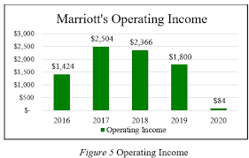
(Table 1: Marriott International)
Similarly, Intercontinental Hotels Group (IHG) has also exhibited robust financial performance. According to Table 2, their total revenue reached $5.3 billion. Like Marriott International, IHG has qualified unswerving revenue growth over the years, driven by amplified global occupancy rates and expansion into emerging markets (Wang et al. 2020). Likewise, IHG also produces revenue through multiple channels, principally from room bookings, food and beverage sales, and conference and event services. Room bookings account for a significant portion of their total revenue, with ancillary services and food and beverage also causative to their overall revenue (Wang et al. 2020).
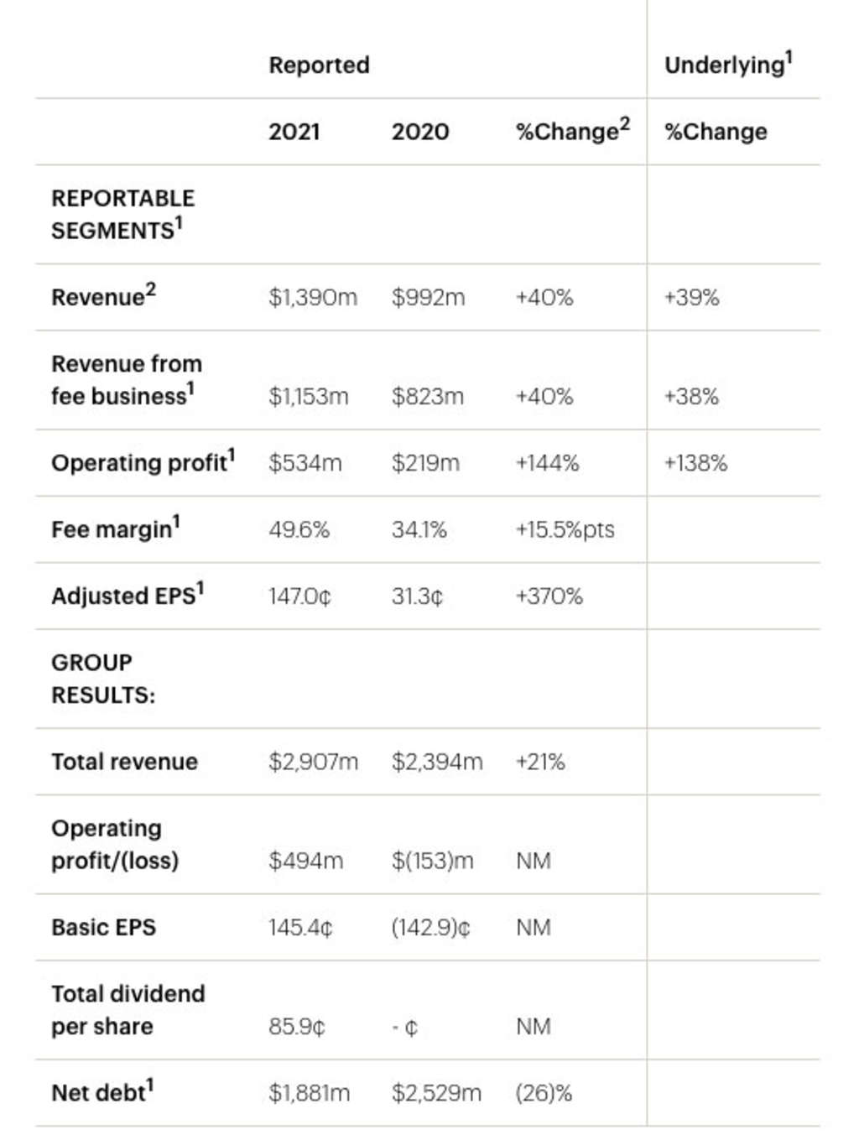
(Table 2: Intercontinental Hotels Group)
With its more considerable total revenue of $12.74 billion compared to IHG’s $5.3 billion, Marriott International has a stronger financial position in revenue generation. Both companies have demonstrated consistent revenue growth, albeit at different rates (Jiang, 2023). However, it’s essential to deliberate that Marriott International functions a more significant number of properties globally, subsidizing its higher revenue figures (Jiang, 2023).

Market Position
With its global reach and extensive brand portfolio, Marriott International has recognized a strong market locus in the hospitality industry (Wickham et al. 2020). The company functions in more than 140 countries, making it one of the largest hotel chains globally. With more or less 7,800 properties under its umbrella, Marriott International has a well-defined and augmented presence in crucial travel destinations worldwide. Marriott’s diverse brand portfolio is a key strength, catering to different customer segments and preferences (Wickham et al. 2020). From luxury properties like The Ritz-Carlton and JW Marriott to select-service brands like Courtyard by Marriott and Residence Inn, Marriott International covers a broad range of market segments. It allows the company to capture a broader customer base and meet the needs of various travelers (Wu, 2021).
Similarly, Intercontinental Hotels Group (IHG) also grips a strong market position with its worldwide presence and well-known brands. It functions in more or less 100 countries and manages approximately 6,000 properties worldwide (Khare et al. 2019). While IHG’s impression is slightly lesser than Marriott International’s, it still has considerable topographical coverage. IHG’s brand portfolio comprises renowned names: InterContinental Hotels & Resorts, Crowne Plaza, Holiday Inn, and Holiday Inn Express (Khare et al. 2019). Each brand within the IHG portfolio is deliberately situated to target specific market segments and deliver unique experiences. The given strategy allows IHG to cater to broad and versatile travelers and capture market share in different segments, from luxury to mid-scale and budget (POPȘA, 2021).
In addition, regarding market reach and brand recognition, Marriott International possesses a better competitive edge over IHG, and its presence in more countries and properties is one of the interlinked reasons behind it (Nishat, 2021). The widespread global presence of Marriott International empowers it to tap into a broader customer base and leverage economies of scale. As a result, Marriott International and IHG have applied different strategies to differentiate themselves and maintain their market positions (Nishat, 2021).
Likewise, Marriott International influences its strong brand reputation and articulates on offering exceptional guest experiences across its brands. Similarly, the company has also recognized a vigorous loyalty program, Marriott Bonvoy, which incentivizes customer loyalty and drives repeat business (POPȘA, 2021).

Growth Potential
Marriott International has recognized significant growth opportunities through strategic development plans and new market entry. The company articulates on increasing its presence in emerging markets with rapidly growing economies like China and India. In addition, by leveraging its strong brand portfolio, Marriott International aims to capture market share in these high-potential regions (Tošić et al. 2021). Additionally, the company dignifies new market entries by studying market demand and classifying good locations for property development in key cities and popular tourist destinations. These expansion efforts allow Marriott International to tap into new customer bases and drive revenue growth (Singh et al. 2021). In addition, Marriott International vigorously appraises potential acquisitions as part of its growth strategy. As a result, the company has successfully performed distinguished acquisitions, like the acquisition of Starwood Hotels & Resorts Worldwide (Nhamo et al. 2020). These strategic acquisitions have long drawn-out Marriott International’s brand portfolio and global footprint, subsidizing its growth and market presence (Singh et al. 2021).
Intercontinental Hotels Group (IHG) illustrates full growth potential through its well-defined growth strategies and market expansion efforts. The company dignifies its presence in crafting markets and high-growth regions like the Asia-Pacific and the Middle East. IHG identifies market gaps and develops tailored brand offerings to meet these markets’ specific needs and preferences. By intentionally intensifying into key cities and tourist destinations within these regions, IHG takes advantage of increasing travel and tourism activities and positions itself for growth (Bourke et al. 2020). In addition, IHG is familiar with the probable of emerging markets and target segments for its growth strategy. The company classifies realms with unexploited potential and strategically positions its brands to capture market share. IHG’s prominence in developing segments like extended-stay and midscale accommodations allows it to cater to the changing preferences of business and leisure travelers (Genc et al. 2020). Furthermore, IHG emphasizes the luxury and lifestyle segments, proposing unique experiences to cater to the preferences of discerning travelers seeking premium accommodations. As a result, IHG expands its market reach and drives growth by targeting these emerging markets and segments (Genc et al. 2020).
On the other hand, Marriott International’s growth potential depends on its expansion plans, new market entries, and successful acquisitions. The company’s focus on developing markets and strategic property development in crucial locations subsidizes its growth trajectory. Marriott International’s strong brand portfolio and successful partnerships further improve its growth potential (Lee, 2019). IHG’s growth potential stalks from its strategic growth strategies and focus on market expansion. The company’s presence in established markets and its emphasis on emerging markets and target segments position it well for growth. In addition, IHG’s focus on extended-stay and luxury accommodations allows it to capture evolving customer preferences and capitalize on market trends.

Financial Commitment to CSR
Marriott International is devoted to sustainability and social responsibility across its operations. The company dignifies four key areas: environmental sustainability, human rights, diversity and inclusion, and community engagement. Marriott’s sustainability programs include initiatives to limit or control carbon emissions, conserve water, reduce waste, and enhance sustainable sourcing (Ertuna et al. 2022). The company also lists human rights by obeying responsible labor practices and endorsing employee well-being. Regarding diversity and inclusion, Marriott endorses a broad workforce and inclusive workplace practices. Moreover, the company actively engages with local communities through workforce development, disaster relief, and supporting education programs. Marriott International illustrates a solid financial commitment to CSR. The company capitalizes on community engagement programs and initiatives, ultimately bestowing resources to impact society (Bourke et al. 2020). Marriott’s financial support encompasses programs concentrating on environmental conservation, education, and local community development. The company also reassures employee volunteerism and offers resources for acquaintances to participate in community service projects (Ertuna et al. 2022). Through these efforts, Marriott International actively contributes to the well-being of communities where it operates.
Intercontinental Hotels Group (IHG) significantly accentuates sustainability practices and corporate citizenship. The company has recognized a detailed and multi-faceted sustainability framework called IHG Green Engage, which offers and ensures its environmental efforts. IHG focuses on limiting carbon emissions, conserving water, and reducing waste. The company also assimilates sustainability considerations into its supply chain and procurement processes. In terms of corporate citizenship, IHG actively provisions local communities through initiatives related to education, disaster relief, and social welfare (Wang et al. 2020). In addition, IHG illustrates a solid financial commitment to CSR and environmental stewardship. Furthermore, IHG engages in community-focused initiatives, such as youth employability programs and charitable partnerships, to make a positive difference in society (Surya et al. 2020).
Marriott International and IHG have robust CSR strategies and demonstrate a solid financial commitment to CSR. While specific financial figures are readily available, both organizations allocate resources to support their sustainability and community engagement initiatives (Bourke et al. 2020).

Recommendations

Recommendation for Marriott International; Specific area for improvement or strategic focus
Marriott International is advised to improve its sustainability efforts and set ambitious environmental targets across its global operations (Wickham et al. 2020). While Marriott International has ended major progress in sustainability initiatives, there is still much capacity for further development. Hence, with the effective implementation of ambitious environmental targets, like reducing carbon emissions and water consumption, the company can demonstrate its commitment to mitigating environmental impact (Wickham et al. 2020). Furthermore, the proposed strategic focus aligns with growing customer expectations for eco-friendly practices in the hospitality industry. In addition, by applying innovative technologies and sustainable practices throughout its properties, Marriott International will control its environmental footprint and inspire positive change within the industry.
Recommendation for Intercontinental Hotels Group (IHG); Specific area for improvement or strategic focus:
IHG should strengthen its efforts to encourage diversity and inclusion within its workforce and leadership positions. While IHG concedes the significance of diversity and inclusion, further emphasis on these areas will yield substantial benefits. By actively encouraging diversity and inclusion within its workforce, IHG will tap into a broader talent pool, nurture a more inclusive work environment, and improve employee engagement and satisfaction (Bourke et al. 2020). Additionally, focusing on diversity in leadership positions will bring fresh perspectives, improve decision-making processes, and contribute to a more comprehensive understanding of diverse customer needs.

Conclusion
The report compared Marriott International and Intercontinental Hotels Group (IHG) based on their economic management approaches. The report has studied total revenue, market standing, growth prospective, and financial liability to corporate social liability (CSR). The analysis shows that Marriott International is more considerate towards the total revenue, global reach, and diverse brand portfolio. At the same time, IHG illustrates strong growth potential through strategic market expansion and sustainability practices. In addition, both organizations showcase a solid financial commitment to CSR and community engagement. The findings highlight the importance of effective financial management in the hospitality industry.

References
Bourke, J.G., Izadi, J. and Olya, H.G., (2020). Failure of play on asset disposals and share buybacks: application of game theory in the international hotel market. Tourism Management, 77, p.103984.
Darsin, J., Rosner, J., Urdaneta, C. and Yepes, M., (2019). Marriott International: Exploring and Understanding Disruption in the Hospitality Industry in South Florida. Journal of Multidisciplinary Research, 11(1), pp.99-119.
Ertuna, B., Gu, H. and Yu, L., (2022). “A thread connects all beads”: Aligning global CSR strategy by hotel MNCs. Tourism Management, 91, p.104520.
Genc, V., Genc, S.G. and Aytekin, E., (2020). The Role of Mergers and Acquisitions as Growth Strategies in the International Hospitality Industry. In The Routledge Companion To International Hospitality Management (pp. 219-230). Routledge.
Jiang, B., (2023). Analysis of Marriott's Financial Position under the Epidemic. Highlights in Business, Economics and Management, 10, pp.122-126.
Jones, P. and Comfort, D., (2019). Sustainable development goals and the world’s leading hotel groups. Athens Journal of Tourism, 6(1), pp.1-14.
Khare, A. and Bhagwat, J., (2019). The relevance and utility of market segmentation for the international hospitality industry. Atithya: A Journal of Hospitality, 5(1), pp.4-7.
Lee, I., (2019). The Internet of Things for Enterprises: An Ecosystem, architecture, and IoT service business model. Internet of Things, 7, p.100078.
Nishat, R.I., (2021). Effectiveness of marketing strategies for renaissance Dhaka Gulshan Hotel.
Nhamo, G., Dube, K., Chikodzi, D., Nhamo, G., Dube, K. and Chikodzi, D., (2020). Impacts and implications of COVID-19 on the global hotel industry and Airbnb. Counting the Cost of COVID-19 on the global tourism industry, pp.183-204.
POPȘA, R.E., (2021). CONCEPTUALIZING BUSINESS MODELS OF INTERNATIONAL HOTEL CHAINS. Revista Economica, 73(2).
Ren, L., (2020). The Development of Hotel Management Contracts in China. In The Routledge Companion To International Hospitality Management (pp. 271-278). Routledge.
Singh, V.B. and Goel, S.K., (2021). Growth of the Indian Tourism and Hospitality Industry. Turkish Online Journal of Qualitative Inquiry, 12(7).
Surya, P.R.A., Budarma, I.K. and Mudana, I.G., (2020). Three-cluster policy in the implementation of corporate social responsibility at Intercontinental Bali Resort. International Journal of Green Tourism Research and Applications, 2(1), pp.11-21.
Tošić, V., Tucović, M. and Tošić, T., (2021). Loyalty programs in hospitality on the example of the hotel Holiday Inn Suschevsky. Turističko poslovanje, (28), pp.39-46.
Voegeli, C., (2021). A Case Study of Knowledge Management Practices at the Intercontinental Hotels Group. Available at SSRN 3819409.
Wang, C., Hu, R. and Zhang, T.C., (2020). Corporate social responsibility in international hotel chains and its effects on local employees: Scale development and empirical testing in China. International Journal of Hospitality Management, 90, p.102598.
Wang, C., Hu, R. and Zhang, T.C., (2020). Corporate social responsibility in international hotel chains and its effects on local employees: Scale development and empirical testing in China. International Journal of Hospitality Management, 90, p.102598.
Wickham, M., French, L. and Wong, T., (2020). Marriott's strategic sustainability priorities in the Chinese hotel industry. International Journal of Sustainable Strategic Management, 8(1), pp.77-97.
Wu, H., (2021), March. Comparison of Marketing Strategies Between Emerging and Legacy Companies. In 6th International Conference on Financial Innovation and Economic Development (ICFIED 2021) (pp. 195-198). Atlantis Press.

