Learning outcome 2: Understand the range of HR roles and behavioural requirements of HR professionals
Executive summary
According to HR magazine “92% of employees of a recent survey said that employee experience was the most important thing to get them motivated at work” (www.HRmagazine.co.uk). Therefore, a focus should be made on rewarding performance, creating positive morale and working environments (www.humanresourcesedu.org). All tasks which HR can provide help support and be involved in to ‘add value’.
With this statement in mind it brings to light the need for competent HR Practitioners to deliver changing demands if the workforce and increase employee retention rates. This report looks at the requirements of professional and competent HR staff, identifying that HR should focus on ‘added value’ tasks not providing a basic admin function.
Introduction
HR was previously seen as a basic admin function, providing written contracts, policy’s, absence management and simple job advertisement.
In a changing and technically advancing 21st century workplace it is important for HR practitioners to adapt, keep up to date with knowledge, work trends and changing demands to provide best practice advice (bersinacademy.com).
A recent study concluded that “82% of HR leaders believe that HR will be unrecognisable in 10 years’ time” (hrmagazine.co.uk). Each day is different from the next making human resources a challenging work environment, and with constant change this is set to continue. This highlights the need for Continued Professional Development as a CIPD requirement and why flexibility is a required trait for any successful HR professional (www.managerskills.org).
Main body
Today’s HR is much more than administrative tasks. The focus should now be on adding value to the strategic plans of the organisations and any employee initiatives should impact the business in positive ways (www.humanresourcesedu.org).
Johns & Perkins (2016) state the role of HR is to ‘add value’ to organisations, with a focus on encouraging staff to reach their full potential and training line managers to lead by example.
An August 2014 Forbes article explored the goals of today’s HR., The article found that HR teams tend to be focused on things that don’t add value by being a basic admin function with no real purpose. Conclusions from an independent study of Senior HR Managers found that as high as ”65% of HR professionals at mid-tier firms are struggling to spend any time working on value-add initiatives” (www.humanresourcesedu.org).
Adding value activities may include employee engagement, wellness programmes and talent development instead of the admin demands such as annual leave queries, basic monitoring attendance, payroll admin and health and safety (www.humanresourcesedu.org).
With the role of HR continually changing; the qualities of a successful HR practitioner are integral to deal with the demands of the role.
Ethical values focus on the ‘right thing to do’ and ensuring not to make decisions based on monetary or personal gain. The decisions and hoses made in organisations will have great effects, especially incorrect decisions. These can affect an organisation financially, ruin reputation and cause low mood amongst employees. Making decisions ethically can therefor have the alternative effect – improving the organisation, employee morale and satisfaction. (ethics at work: an employer’s guide, CIPD October 2019)
A key attribute of a HR practitioner is always to be professional whilst at work, showing guidance, support, clear communication skills along with excellent time management. A professional uses specialist knowledge to provide guidance without judgement, whilst being guided by a set of principles. A professional does not need to be a member of a professional association to be professional (Lester, 2010). Although Johns & Perkins (2016) mention that different definitions of the term ‘professional’ may contradict this.
John & Perkins (2016) state an alternative definition of a professional is ‘to occupations that are controlled to a considerable extent by governing body which has a formal membership structure with admission barriers as performance criteria that must be met”. Membership to the CIPD is not mandatory so even though it is a professional body you do not have to be part of the CIPD to work within the HR function, therefore puts question to if HR practice is a profession. With the wealth of knowledge and continued personal development that is required to be a competent HR practitioner it seems inappropriate that HR practitioner can be called anything other than part of a profession.
The CIPD’s From Best to Good Practice: Developing principles for the profession report (2015a) identified the following core elements of what it means to be a HR Professional; social and ethical responsibility, commitment, a body of expert knowledge and skills, continuing professional development (CPD) and situational judgement. The report highlighted the importance of professionals maintaining ethical values so that a trust relationship can be built (Baczor & Zheltoukhova, January 2017).
In 2015 a professional map was developed to help identify strength and weakness and ensure continued professional growth (CIPD, 2015).
The CIPD Professional Map 2015 (www.cipd.co.uk)
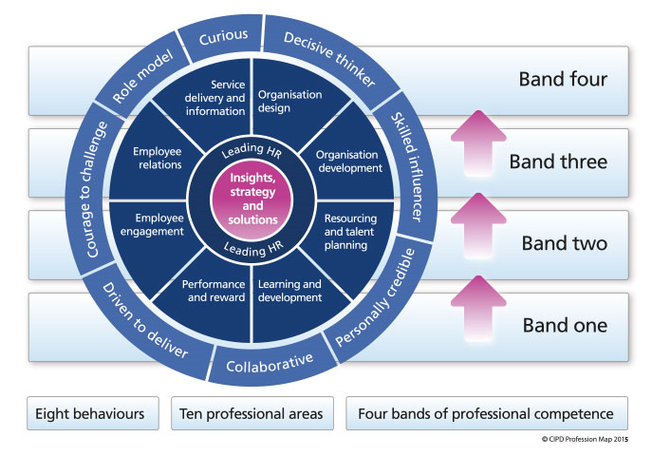
To ensure clear guidance of best practice HR the CIPD HR professional map (CIPD, 2015) sets out key behaviours and skills to provide universal guidance to all HR practitioners. The map consists of two core areas, ten professional specialisms, 8 key behaviours and 4 bands. Each band represents the level of HR practitioner, from administrator to strategic HR manager. Via the CIPD website you can access the map and discover through a questionnaire what your strengths and weakness may be, the outcome gives guidance on recommended study to further develop skills.
‘Strategy, Insights, and Solutions’ is at the core of the map, this is important for an HR Professional at any level of competence. It is essential that HR Practitioners have an understanding of the organisation, to enable them to tailor strategy and solutions to meet the needs of the organisation.
‘Leading HR’ is also the core of the map. As a leader it’s essential to act as a role model, supporting and developing others in your team.
All 8 behaviours give HR practitioner the tools to deal with the variety day of a HR practitioner.
Curiosity ensures that the practitioner is looking to add value to an organisation by seeking continuous improvement. This could involve looking at outside organisation process to gain ideas to make improvements within own organisations.
A Decisive Thinker can analyse data quickly and provide realistic recommendations. For example, a raise in absence rates will need further analysis to establish why, how and what can be done to try and minimis any further rise.
The Skilled Influencer with develop relationship with stakeholders to gain support to make change within organisations. This will ensure that HR incentives are taken on board and promoted by the senior leaders of the organisation which will encourage change amongst the workforce. Recently we have driven a project to make the organisation carbon neutral by 2025, this has resulted in massive change throughout the organisation. Without the support of senior management this may have not been so well received.
To be Personally Creditable the HR practitioner will provide relevant and up to date HR expertise and knowledge.
Working Collaboratively will include a range of individuals to ensure positive outcomes for the organisation.
To be Driven to Deliver the HR practitioner shows determination and focus to deliver positive outcomes.
Having the Courage to challenge successfully is key in any organisation, with ranging opinions of different stakeholders to be diplomatic and confident to raise a point shows courage. Senior management may have a personal belief that clouds judgment on a decision, the HR practitioner will give sound legislative advice and knowledge as to why something can or cannot be done within the law, often disagreeing with senior management and influencers withing the organisation. This needs to be handled with confidence but respectively.
Being a Role Model ultimately always involves continually acting with integrity, being clear, transparent and ensuring to work within the policies, procedures of the organisation and always within the law.
A recent study by ?? concluded that “51% of HR leaders said a lack of vision and leadership in their organisation is preventing change” (hrmagazine.co.uk). This shows the challenge faced by many HR practitioners, behaviours of the HR Profession map such as having courage, showing drive to deliver and skilled influencer will all encourage working collaboratively to encourage positive vison and leadership.
Belbin reiterates this with the statement “In employment, the ability to handle people and behave appropriately becomes crucial to career progress at every turn” (Belbin, 2013).
In November 2018 a new professional map was devised to continue to keep up to date with the changing HR profession, at the centre of the map it states the “fundamental purpose of the people professional is to champion better work and working lives” (CIPD, 2018).
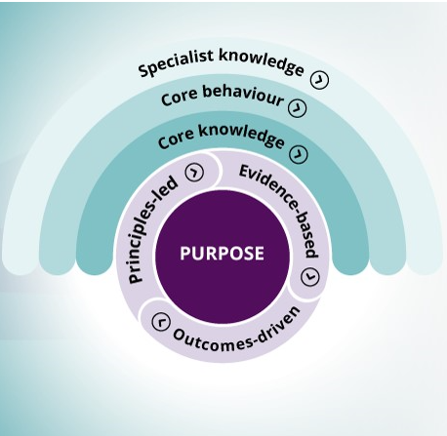

CIPD recognises the importance the traits of a ‘thinking partner’ to be a competent HR practitioner.
Johns & Perkins (2016) state that a “thinking partner is the person who not only performs operationally, but the person who also thinks about what they are doing”. A thinking partner will seek to find out and contribute to an organisations strategic goals, will challenge to provide solutions which result in higher standards of working, which may improve service, lower financial costs and increase productivity. Whilst continue to promote compliance and add value. A thinking partner will develop relationships with customers, seeking feedback and look outside their organisations for new ideas and practice to improve their organisation. These skills can provide a valued asset to any organisation. Providing realistic and worthwhile change to improve the organisation (Johns & Perkins, 2016).

Conclusion
Increasing demands on HR, such as the importance of developing relationships with key stakeholders, being at the forefront of delivering priority strategy and goals are all part of the varied role for the HR practitioner. It is evident that a practitioner will need the varied skill set to match the expectations of the role in order to achieve success.

Recommendations
To be a professional HR practitioner can be achieved by ensuring to continue professional development via CIPD guidance to maintain the qualities mentioned and identified throughout this report.

