

Student Name – Vrunda Natvarbhai Parmar
Student Number - 2418330
Module Name: - International Marketing
Module Code: - LCMB7026
Lecture Name: - Muhammad Tariq
Assignment Title: Report
Company: - BMW
Term 2

Table of Contents
Introduction 3
Brand overview 3
Comparison of the socio-cultural context of Country A and Country B 4
Comparison of Brand’s STP strategies in Country A and Country B 6
Comparison of Marketing Mix Strategies in Country A and Country B 9
Evaluation of the performance of marketing strategies 12
Evaluation of marketing ethics practice 14
Recommendation 17
Conclusion 18
References 20
Appendix 23

Introduction
International marketing can be referred to as a process of planning, promotion, pricing, and distribution of products and services across national and international borders to satisfy the objectives of individuals and organisations. It also involves the process of adapting marketing strategies to different cultural, political, economic, and legal environments within foreign markets to reach global consumers (Kumar, 2024). There are various principles involved in international marketing, such as universal marketing concepts, adaptation, localisation vs. standardisation, principles of marketing mix, and more. Some of the important marketing practices include market entry modes, environmental analysis, tailored strategies, global branding and more. In this report, BMW is taken as an organisation which is one of the most influential premium automotive brands in the world.
The present report critically analyses the marketing strategies of BMW (Bayerische Motoren Werke AG) in the USA and Germany by comparing their social-cultural environments, marketing mix strategies, segmentation, targeting, and positioning (STP) strategies by applying marketing frameworks. This report also effectively assesses the performance of BMW's strategies in both selected markets and evaluates critical considerations associated with the marketing strategies of the company. The present report also offers strategic recommendations which can help BMW to effectively improve its international marketing approach to deal with high competition, sustainability expectations, and digital transformation.

Brand overview
BMW is a globally recognised German automotive manufacturer offering its vehicles across different parts of the world. The company was founded in 1916 and has been able to build a strong reputation for design excellence, innovative engineering, and advanced technologies (BMW Group, 2025). The company's product portfolio includes SUVs, sedans, electric vehicles (EVs), sports cars, and high-performance models that come under the BMW M brand. In addition to that, BMW also owns Rolls-Royce and Mini, further extending its reach within the luxury segment. Germany remains the centre of the operation of BMW, hosting major manufacturing plants in Munich, Regensburg, and Leipzig.
The company sold approximately 2.45 million cars in 2024, and the total revenue generated by the company in 2024 was 142.4 billion Euros (BMW Group, 2025). However, the US is the second-largest global market as well as home to BMW’s largest manufacturing facility in South Carolina, producing primarily SUVs for worldwide distribution. The US market favours advanced infotainment features, larger vehicles, and lifestyle-oriented marketing appeals. Furthermore, BMW has positioned its brand as a premium, dynamic, and performance-driven brand, adapting its model lineup, communication tone, and pricing strategies accordingly. Thus, these operational differences make the USA and Germany ideal markets for comparative analysis.

Comparison of the socio-cultural context of Country A and Country B
Understanding BMW's marketing strategies in both countries requires the proper analysis of socio-cultural environmental factors that effectively shape the behaviours of consumers in the USA and Germany. Socio-cultural factors have a strong influence on consumer attitudes towards technology, sustainability, luxury, purchase decisions, and product attributes. This can be done by understanding the macro-environmental conditions of both countries by using the PESTLE framework as discussed below.
Political factors: Considering the political environment of Germany, it is quite stable, strongly supportive, and predictable for manufacturing industries, especially for automotive manufacturing. The country effectively adheres to coordinated EU-level regulations related to emissions, competition, and trade (Krzywdzinski, 2021). In addition to that, German government policies strongly prioritise renewable energy, electrification, and sustainability, reinforced by incentives for EV adoption as well as strict emission targets. Thus, the company benefits from political support for innovation but also faces strong pressure to accelerate EV production and reduce emissions.
On the other hand, the USA’s political environment is also stable but is much more fragmented due to state-level autonomy. The political approach towards environmental regulations significantly varies across different states. In addition to that, federal polices of the US also fluctuate frequently based on trade tariffs, tax incentives for EVs, and administrations. The manufacturing plant of BMW in the USA helps it to mitigate reliance on imports and also effectively aligns with the political expectations of the country. However, unpredictable regulations pose a serious challenge to the company for long-term planning when compared to Germany.
Economic factors: Germany has a strong and export-driven economy with low unemployment, robust consumer confidence within the premium automotive sector, and high purchasing power. The automotive industry of Germany is the cornerstone of its economy as it significantly contributes to 5% of GDP and 7-9% of employment, innovative driver 30% of R&D, and being a top exporter 70% of its revenue in 2024 (ZEW, 2025). Thus, it can be said that rational purchasing behaviour and economic stability of the country strongly support the premium positioning of BMW; however, the rising competition from numerous domestic brands like Audi and Mercedes-Benz affects its market share.
On the other hand, the US economy is the world's largest, and it has been characterised by higher disposable income and high consumer spending. The demand for luxury vehicles remains strong, especially for SUVs, which dominate the automotive market in the country. Larger road networks, suburban lifestyle, and lower petrol prices drive greater demand for big vehicles when compared to Germany. Moreover, the USA's economic environment offers opportunities for high profit margins, especially through the popularity of high-priced models such as the BMW X7 and X5. However, the economic fluctuations, such as changes in consumer credit and recession risks, can negatively impact sales.
Social factors: The social environment of Germany is highly influenced by the preference for high-quality engineering, environmental consciousness, and long-term value orientation. Consumers in the country tend to conduct extensive research before buying and highly prioritise sustainability, safety, reliability, and technical sophistication. Environmental awareness and urbanisation have effectively contributed to an increase in interest in EVs as well as hybrid models. So, this can be a huge opportunity for BMW to offer EVs and hybrid models to customers.
The USA has a highly diverse social environment, which is shaped by individualism, strong brand consciousness, and lifestyle-focused consumption. Moreover, US citizens generally perceive cars as an expression of personal success and identity. Thus, has fueled the demand for luxury and performance vehicles (Aalbers and Whelan, 2021). The car culture of the country is deeply rooted in mobility, social status, and freedom, which foster strong emotional branding opportunities.
Technological factors: Germany is considered one of the leaders in automotive and engineering technology. Besides, its industrial ecosystem effectively supports automation, research, advanced manufacturing, and electric mobility innovation. Thus, BMW benefited from strong national collaboration with German universities, R&D support, tech clusters, and suppliers. However, the digital transformation of Germany, especially digital services and online retail progress, is slower when compared to the US, impacting its digital marketing strategies.
The USA is a highly technologically advanced country with a strong digital economy, widespread consumer adoption of digital platforms, and world-leading tech firms. Besides, the country also plays a vital role in shaping the global mobility technologies which include AI, connectivity systems, and autonomous driving (Pavlínek, 2022). Thus, this technological environment has highly benefited BMW’s over-the-air updates and ConnectedDevice Services.
Legal factors: The legal environment of Germany is highly regulated which has got strict laws that govern product safety, emissions, data protection, and labour rights (Pichler et.al 2021). Automotive laws effectively emphasise consumer safety and environmental sustainability. Thus, BMW complies with transparent marketing practices and stringent testing standards. On the other hand, legal regulations in the US vary between state and federal levels, which creates a more complex compliance landscape. Moreover, emission laws in the country differ widely from those in states like California, thus imposing stricter standards. Product liability laws in the country are stricter, which impacts warranty, communication strategies, and the safety of BMW.
Environmental factors: Germany is a major environmental sustainability leader with ambitious climate policies, strict emission controls, and carbon-neutrality goals. So, this macro-environment requires the company to prioritise hybrid technologies, eco-friendly manufacturing, and transparent sustainability (Germann, 2023). On the other hand, the US shows increasing but less consistent environmental engagement, but some states like California lead in environmental regulations and EV adoption. Thus, in such states, BMW need to adopt by promoting both sustainability and performance.

Comparison of Brand’s STP strategies in Country A and Country B
Segmenting, Targeting, and Positioning (STP) is a core marketing framework where a company segments the market into distinct group, targets the most attractive segments to focus on, and then finally positions it product to create a unique and appealing message within the minds of those targeted customers to ensure that the message resonates and stands out from competitors (Madić et.al 2021). STP is considered a core strategic marketing approach of BMW. As the company maintains a unified global identity, the STP strategies of the company differ across different markets based on competition, socio-economic factors, and consumer behaviour.
SEGMENTATION STRATEGIES
Considering the segmentation strategy of BMW, it segments its market by using psychographic, demographic, behavioural, and geographic variables.
Germany
In Germany, segmentation is influenced by different factors such as high environmental awareness, urbanisation, and structured mobility needs (Rahman, 2021). So, the key segments include.
- Executives and professionals seeking engineering safety, quality, and advanced functionality.
- Families seeking safe, efficient, and reliable SUVs.
- Environmental-conscious customers who are attracted to hybrid models and EVs.
- Performance enthusiasts interested in the BMW M-series.
Thus, the segment preferences of the company reflect Germany’s sustainability-oriented and rational consumption behaviour.
United States
Within the US, the segmentation is more diversified and broader due to varying lifestyles as well as income levels. Some of the major segments include.
- Luxury seekers who value design aesthetics and brand prestige.
- Affluent middle-class households prefer SUVs like the X5 and X3.
- Performance-driven consumers who are dedicated to the M-series
- Young professionals who are attracted to digital features and sporty sedans.
Thus, American segmentation shows greater focus on personalisation, aspirational value, and lifestyle.
TARGETING STRATEGIES
Germany
Within Germany, the company follows a differentiated and premium targeting approach aimed at consumers who value sustainability, reliability, and engineering precision. Moreover, German targeting is shaped by higher expectation of quality consistency and environmental compliance (Hong, 2024). The company in Germany targets middle-to-high-income professionals, tech-savvy early adopters of EVs, and families seeking premium vehicles.
United States
In the US, BMW targets affluent professionals aged 30-50, lifestyle-driven consumers, and families with higher disposable incomes (Karthikeyan and Bajj, 2025). Moreover, the targeting heavily relies on emotional appeals, freedom, luxury, and performance. In addition to that, SUVs play a critical role within the US targeting strategy of BMW due to their strong cultural resonance.
POSITIONING STRATEGIES
Germany
Within Germany, BMW is considered a symbol of German engineering excellence, sustainable mobility, and technological leadership. The positioning strategy of BMW focuses on innovation, safety, efficiency, and precision. Marketing materials of the company also highlight eco-friendly technologies, engineering sophistication, and intelligent mobility.
United States
BMW’s long-standing position within the US is built on performance, luxury, and excitement. The Ultimate Driving Machine continues to shape American perceptions, emphasising emotional connection and freedom. The company also positions itself as a premium performance brand that enhances confidence, personal identity, and lifestyle.
Differences and Similarities
One of the major similarities is that in both markets, such as Germany and the US, BMW has effectively maintained a premium identity and has also emphasised innovation, technology, performance, and design as core brand pillars. In addition to that, the company in both markets has also focused on sustainability as a prime focus and has been able to attract environmentally conscious customers. So, focusing on these strategies can play an effective role in targeting and position a brand successfully within the market and can also allow a company to gain a competitive advantage as well (Anne et.al 2023). However, the difference is that BMW in Germany adopts rational and technology-driven positioning, and in the US, it has emphasised emotional, lifestyle, and emotion-based appeals. In addition to that, German segmentation is much narrower and more rational than US segmentation. Furthermore, the company's segmentation strategies in the UK focus more on versatility and aspiration. Thus, it can be said that the STP strategies of BMW reflect the socio-economic and cultural contexts of each market. The company also maintains consistent global branding while adopting its positioning message and targeting logic to reflect local values and preferences.

Comparison of Marketing Mix Strategies in Country A and Country B
7Ps of Marketing Mix | Germany | USA
Product | Within Germany, BMW emphasises fuel efficiency, sustainability, and advanced engineering. It can be analysed that the German market has high demand for hybrid-models and EVs (Kassab, 2023). Cars such as the BMW i4, iX variants and plug-in hybrid variants of the 3-series and 5-series have gained popularity. In addition to that, German consumers expect technology integration, high reliability, and precision. The product development process of the company in the country involves a strong focus on dynamic driving, luxury, and core engineering. Also, models of the company often highlight performance heritage and innovation. | Within the USA, the company focuses on SUVs due to stronger cultural preferences for larger vehicles. BMW’s X-Series, such as X7, X5, and X3, have dominated the US sales. Customers in America value larger interiors, comfort, infotainment upgrades, and high-performance vehicles. The product design of the company thus focuses on entertainment, driving dynamics, and spaciousness (CHIBATAMOTO, 2025). The product development process of BMW in the US emphasises cutting-edge technology, safety ratings, luxury features like comfort and ambient lighting, and more customisation options.
Price | Within the German market, the company has adopted a premium pricing strategy; however, the price may differ across markets. Consumers in Germany evaluate prices rationally and also compare value, long-term benefits, and engineering quality as well. The company also uses value-based pricing and offers environmentally friendly incentives on EVs. Moreover, leasing is more popular in Germany due to cost predictability. | Within the USA, premium pricing effectively aligns with aspirational consumption. Within the country, leasing is also common, but people are more open to financing luxury purchases. BMW leverages dynamic pricing strategies and also offers flexible payment options, dealer incentives, and competitive financing plans to attract lifestyle-driven customers.
Place | The country uses a highly structured dealership-based distribution system with a strong focus on after-sales services. The domestic market of the company has benefited from dense dealership networks and modern service centres. In addition to that, online sales are also growing, but they remain supplementary due to German consumer preferences for physical interactions. | Within the US, BMW has a more geographically dispersed dealership network. The company leverages online digital purchasing processes and online vehicle configurators more heavily. Experience centres such as BMW Performance Centre in South Caroline have effectively enhanced their brand loyalty and offer test-driving attractions as well (Mills, 2025).
Promotion | In Germany, the company’s promotional tone focuses on sustainability, rational appeals, and engineering excellence. The process of advertisement highlights efficiency, innovation, and minimalistic visuals. The company also emphasises its environmental commitments in Germany due to strict regulatory expectations (Worku, 2022). | Within the US, the company uses aspirational, emotional, and performance-centred messages. Celebrity partnerships, television commercials, sports sponsorships, and lifestyle imagery play a significant role. Moreover, the company also invests heavily in social media campaigns, experimental marketing activities, and digital content to attract affluent and younger audiences.
People | BMW in Germany focuses on technical knowledge, professionalism, and a consultative sales approach. Moreover, consumers expect transparent information as well as long-term service reliability. | In the USA, service culture is more relationship-driven, and sales interactions are more friendly, personalised, and lifestyle-oriented (Bhagat, 2021). In addition to that, a more flexible negotiation culture also impacts the sales behaviour.
Process | Within the country, people generally value an efficient, transparent, and structured purchasing procedure. So, the business process of the company mostly focuses on providing accurate information, predictable delivery times, and consultations. This has proved to be one of the effective strategies for the company to attract customers and keep the engaged (Allaudi, 2025). In addition to that, the business process of BMW in Germany is efficient and streamlined with high-quality control procedures. | In the US, BMW focuses on customisation, negotiation flexibility, convenience, and experimental engagement. The company also fosters flexible financing and digital documentation to enhance customer satisfaction. The business process of BMW in the US focuses on a seamless customer journey from online browsing to purchase and fast tech-enabled services.
Physical Evidence | One of the major physical evidence offered by the company is its showrooms within Germany. In addition to that, German showrooms emphasise technological displays, efficiency, and minimalism. Moreover, spaces also reflect the engineering-oriented identity of BMW. Another proof of physical evidence in Germany is cars with high-quality materials reflecting heritage and German design. | BMW showrooms in the USA effectively prioritise luxury aesthetics, personalised lounges, and spacious displays, which allowed the company to reinforce lifestyle and aspirational positioning. The showrooms in the US are luxurious, high-tech displays, premium branding, and experimental spaces.
So, it can be said that BMW leverages its German roots across the globe; however, the American market demands more explicit emphasis on safety, technology, and value. Germany focuses on heritage more directly and German engineering within its core messaging process.

Evaluation of the performance of marketing strategies
To measure the effectiveness of the marketing strategies used by BMW in Germany and the USA, it is vital to examine the dynamics of market shares, sales performance, the effectiveness of brand positioning, and the results of consumer engagement.
Germany
The advertising campaign used by BMW in Germany is very effective, as the company is leading in sales in the segment of premium cars. ET BrandEquity, (2024) reports that BMW has sold 152,012 units in the first half of 2024 and beats Mercedes-Benz and Audi in the German premium car market. This positioned BMW on the top of the segment, which suggests that consumers were fairly responsive to the value propositions of the brand engineering excellence, technological innovation, and sustainability. This excellent sales performance is a direct result of the success of its marketing communications, which focuses on German engineering quality and the expanding electrified vehicle (EV) portfolio.
Its overall European performance also shows the success of the BMW EV-oriented marketing strategy. According to BMW Group (2025), the number of fully electric vehicles (BEVs) deliveries grows by about 34 percent annually in early 2025, with the European markets in Germany and other countries being especially active. This expansion indicates that BMW positioning concerning sustainability and technological innovation are appealing to German consumers, who generally focus on energy usage and environment. The BMW i4, iX1, and iX are some of the main models that have been a core of this success and are commonly used in the German marketing campaigns which emphasise innovation and lower carbon footprints (Statista, 2025).
Financial indicators also prove the power of the strategy of BMW on the home market. BMW Group (2025) reiterated its profitability forecast over the year in the wake of strong sales in Europe. The effectiveness of premium pricing strategy and the capacity of BMW to sustain high demand even under competitive pressure is closely related to this stability. The use of marketing messages which emphasise reliability, craftsmanship, and driving performance has contributed to maintaining a high level of brand loyalty at the BMW brand in Germany where customers emphasise domestic automotive heritage and product durability.
Overall, BMW is performing well in Germany, with leading positions in the market, increasing sales of EVs, and stable profitability indicates that the marketing strategies are in accordance with consumer demands and trends in the country.
United States
The marketing plan of BMW in the US has also been successful but its success is due to the variation in the taste of consumers and the market forces. The American market is more focused on lifestyle branding, performance characteristics, and large cars-topics where BMW has already positioned itself strategically.
As per Statista (2025), the United States was one of the largest international markets of BMW Group in 2023 with the number of vehicles sold by the German company reaching to 395,741. The brand was also one of the leading premium car manufacturers in the country with high demand on its X-series SUVs. Specifically, the BMW X5 and X7 are still among the most successful BMW models in the U.S. and correspond to the domestic bias toward spacious, luxury utility cars. This means that the product and promotional strategies of BMW, which focus on performance, versatility, and high-end lifestyle, fulfil consumer expectations well.
The localisation strategy of BMW has also contributed greatly to performance in the market. Its manufacturing plant in Spartanburg, South Carolina, manufactures more than 400,000 vehicles in a year, with a majority of them being SUVs, many of which are sold directly in the domestic market (Statista, 2025). This reinforces marketing messages about American job creation and domestic presence, which will enable the brand to establish even more emotional and financial connexions with U.S. consumers. The localisation storey also boosts consumer confidence and also caters to a cultural bias towards favouring locally produced products (Labaronne, 2024).
BMW has made digital and experiential marketing the focus of its strategy in the U.S., which has resulted in a high brand engagement. The BMW association with motorsport, influencer campaigns, and immersive digital campaigns contribute to preserving the aspirational brand image with younger audiences. Statista (2025) data indicates that BMW has a global brand value of about EUR55.8 billion, which is largely supported by its high visibility and presence in critical global markets including the United States. These engagement rates indicate that marketing campaigns based in the U.S. and focused on lifestyle and emotional appeal keep on building brand equity.
Furthermore, BMW is slowly expanding its electric cars performance in the United States, though not as quick as in Germany. However, further sales of the BMW i4 and iX, along with government EV incentives in the US, suggest a strategic move to position BMW as a competitor in the American EV market (BMW Group, 2025). Although Tesla and other luxury brands still compete with BMW, the localised manufacturing, targeting lifestyle-oriented marketing, robust SUV line, and digital branding have seen the company maintain high sales volumes and a high market share position.

Evaluation of marketing ethics practice
To assess the marketing ethics of the company in Germany and the United States, it is necessary to evaluate the way the company handles transparency, sustainability communication, consumer safety messages, digital data practises, and promotional strategy fairness.
Key Ethical Issues in BMW’s Marketing:
Ethical Area | Germany | United States
Sustainability Claims | High scrutiny; avoid overstated environmental claims. | Mixed messaging due to strong SUV promotion.
Performance Advertising | Need to balance performance with safety expectations. | Higher safety risk; performance messaging more ethically sensitive.
Data & Privacy | Strict GDPR standards; high transparency required. | Looser regulations; risk of unclear data use.
Pricing Communication | More regulated; clearer cost disclosures. | Leasing ads may hide full costs if not detailed.
Cultural Representation | Generally neutral and factual. | More aspirational; risk of reinforcing stereotypes.
One of the main ethical concerns that arise in both countries is related to the issue of sustainability claims. BMW often markets its innovation in the electric mobility, carbon-reduced production, and long-term climate initiatives. In Germany, where the environmental factor is highly regulated and the consumer is much concerned about the ecological responsibility, the advertising message of BMW concerning sustainability is a significant strategic factor (Chen, 2025). But there is ethical danger in this when marketing messages are too ambitious about the environmental advancement of the company. To illustrate, despite the fact that BMW is actively increasing the number of electric vehicles (EV) and has already demonstrated a significant increase in BEV sales, the company still relies on conventional combustion engines to make a significant portion of sales worldwide (O’Riordan and Hampden-Turner, 2021). By focusing on ideal future results instead of quantifiable successes in environmental marketing, there is a risk that it can be taken as misleading or as part of the perceptions of greenwashing. Ethical standard in Germany demands a high level of transparency where promotional claims are to be based on verifiable indicators of performance.
Sustainability messaging is also available in the United States, but its ethical value is different because of the weaker environmental regulation pressure and the variations in consumer value. As BMW sells its EV lineup, particularly in the states with robust climate policies such as California, the promotion focus remains largely concentrated around the large luxury SUVs which are more emitting (Labaronne, 2024). As long as sustainability demands co-exist with active marketing of models which are inconsistent with environmental objectives, there will be ethical tensions.
Another ethical aspect is associated with performance-oriented advertising. BMW has traditionally positioned itself using images of dynamic handling, speed, and high-performance driving (Hussain, Dawood and Soundarapandiyan, 2023). In Germany, the ethical dilemma is less because high-speed driving on the autobahn is culturally accepted, although there is still the danger of promoting practises that lead to the development of unsafe behaviours. Ethical marketing would demand that BMW does not glorify unsafe driving or that excessive speed is suitable in normal situations. Although the brand has become more amenable to including safety messages and support technology features in marketing content, it is critical to balance ensuring the safety of the population and encouraging performance in marketing (Disch, 2024).
In the United States, this moral dilemma is intensified because the rates of traffic fatality are much higher, and the population is more vigilant regarding road safety. The U.S. campaigns are highly focused on power, speed, or sporty driving dynamics can indirectly support unsafe attitudes. Ethical advertisement in such a market need to encompass that the appeal to performance is not overridden by the responsible driving appeals and the technological contributions of the brand to safety.
Another significant area which should be evaluated is digital marketing and data ethics. In both countries, BMW uses advanced personalised advertising technologies, such as online tracking, behavioural analytics, and targeted campaigns. Adherence to the General Data Protection Regulation (GDPR) of the EU is legally binding and morally important in Germany (Liu and Liu, 2021). The consumers desire open data practises, definite consent, and the explanation of the usage of personal information. There is also the ethical issue when personalised marketing is offensive or when users do not know the scope of information gathering.
The U.S. market is associated with other ethical issues, with the regulations being less consistent and the standards of consumer protection differing between states. The extensive application of digital targeting and behavioural advertising in BMW is typical of the U.S. automotive industry, yet there is an ethical need to present transparent disclosures and avoid misappropriation of consumer data (Chen, 2025). Ethical digital marketing needs to put the autonomy of the user at the forefront and not rely on manipulative design to reduce the ability to make informed decisions.
In the US, BMW often advertises competitive leasing, low monthly payments, and special financing rates. The ethical issue which emerges is where the advertised payment sums fail to convey full ownership expenses such as the extra charges or long-term financial obligations (O’Riordan and Hampden-Turner, 2021). Conversely, Germany has a more regulated advertising environment which tends to decrease the ambiguity of pricing communication, but ethical responsibility demands clarity and avoid making false claims about costs.
Another ethical consideration is cultural representation and inclusiveness. U.S. adverts tend to focus on the dream lives and exclusivity, which are at times reinforcing socio-economic stereotypes or unrealistic standards of achievement. Respectful, diverse, and evolving social expectations should be the foundation of ethical marketing as it should be represented (Labaronne, 2024). The advertising environment in Germany is typically more conservative, but there are ethical expectations of sensitivity to diversity and avoiding the reductive cultural symbolism.

Recommendation
According to the analysis of BMW marketing practices, recommendations are made which will help the company to enhance its global marketing performance and remain ethically responsible in the multiple markets.
- Improve Sustainability Communication Transparency and Consistency: BMW needs to be stricter and more standardised in terms of sustainability messaging in both countries. Although sustainability campaigns are effective in Germany, the same care and transparency need to be placed to the U.S. market to prevent discrepancies. Evidence-based communication, including lifecycle emission information, EV supply chain reporting, and verifiable progress indicators, can be used by BMW to escape greenwashing and enhance consumer confidence all over the world (Hussain, Dawood and Soundarapandiyan, 2023).
- Enhance Ethical Online Marketing and Customer Data privacy: As the use of personalised digital advertising becomes more and more popular, BMW needs to increase its ethical data handling by ensuring that the collection, usage and storage of consumer information is explained in a clear and accessible way. Even though the GDPR framework in Germany already implements high standards, BMW need to voluntarily implement similar transparency principles in the United States, where regulations are very different (Disch, 2024). The adoption of international internal standards of data ethics will guarantee uniformity and reduce the threat associated with excessive surveillance, specific manipulation, or ambiguous consent procedures.
- Strike a balance between Performance-based messages and Road safety accountability: The long-standing focus on performance in BMW needs to be accompanied with the communication being more safety-oriented. The autobahn culture in Germany and the higher accident rates in the United States both pose some ethical dilemmas in encouraging speed and power (Schindler and Schmihing, 2023). BMW should incorporate safety technology messaging in all of its promotional efforts and ensure that advertisements based on performance do not accidentally promote unsafe driving behaviours.
- Enhance transparency of pricing, especially in the U.S market: BMW needs to embrace more transparent and elaborate disclosure of leasing and financing promotions in the U.S. where the consumer is well aware of financial obligations over time. Open cost communication eliminates ethical risk, builds trust, and satisfies the increasing consumer demands of responsible financial marketing. Although German laws already provide clarity, globalisation of these practises would enhance uniformity of brands.
- Become More Culturally Sensitive and Representative: BMW need to ensure its marketing content is more inclusive of various identities and is not perpetuating aspirational stereotypes (particularly in the U.S. market) to better match the changing consumer expectations. Brand relatability can be improved with more inclusive imagery and messaging, which can also help improve ethical communication norms (Liu and Liu, 2021).
Overall, these recommendations will enable BMW to improve ethical marketing and increase strategic effectiveness, which will contribute to long-term brand resilience both in Germany and in the United States.

Conclusion
It can be concluded from the report that BMW is one of the major automotive companies in both countries, and it has adopted both different and similar marketing strategies in Germany and the USA. Based on the socio-cultural contexts, it can be concluded that political conditions in both countries are different; however, German political conditions are more favourable to the company as compared to the US. Germany's market emphasises sustainability, rational decision-making, and engineering quality, while the US prioritises performance, comfort, and lifestyle appeal. It can also be concluded that BMW adapts its strategies according to focusing on rational positioning and eco-friendly technologies in Germany and uses performance-driven, SUV dominance, and emotional connection in the US.
Based on the performance evaluation, it can be concluded that the company has a strong business presence in both countries, but the strengths may differ. In Germany, it benefits from brand heritage and growth in EVs and in the US, it leads in SUV sales as well as digital engagement. Ethical concerns, especially transparency, subscription models, and environmental messaging, present a huge challenge for BMW and need to be addressed effectively. Some of the major strategic recommendations include investing in sustainable business models, product adoption, transparency, ethical communication, enhanced after-sales strategies and improved digital experiences. It can also be concluded that by addressing these factors, the company can effectively strengthen its international marketing performance and also maintain a strong position as a global premium automotive brand.

References
Aalbers, R., and Whelan, E. (2021). Implementing digitally enabled collaborative innovation: A case study of online and offline interaction in the German automotive industry. Creativity and innovation management, 30(2), 368-383.
Allaudi, I. A. H. (2025). AUTO SERVICE MARKETING COMMUNICATION THROUGH INSTAGRAM ACCOUNT@ gontorautoservice BASE ON 4C MARKETING THEORY (Doctoral dissertation, Universitas Darussalam Gontor).
Anne, N. A. W., and Windasari, N. A. (2023). Proposed Relationship Marketing Strategy for Used Car Dealer. International Journal of Current Science Research and Review, 6(07), 5082-5101.
Bhagat, Y. (2021). Analyzing the Effectiveness of Internet Marketing in Growing Sales. Czech University of Life Sciences Prague.
BMW Group, (2025). BMW Group confirms adjusted full year guidance. [Online]. Available Through: <https://www.press.bmwgroup.com/global/article/detail/T0446175EN/bmw-group-confirms-adjusted-full-year-guidance?language=en> [Accessed on: 9th December 2025].
BMW Group., (2025). BMW Group History. [Online]. Available through: <https://www.bmwgroup.com/en/company/history.html>. [Accessed on: 8 December 2025].
BMW Group., (2025). Introducing the BMW Group. [Online]. Available through: <https://www.bmwgroup.com/en/company.html>. [Accessed on: 8 December 2025].
Chen, I., (2025). From Carbon Emissions, Data Privacy, to Self-Driving: How Transnational Corporations Shape Global Technical Standards and Governance. Ind. Int'l & Compar. L. Rev., 35, p.295.
CHIBATAMOTO, F. (2025). Effectiveness of the 7Ps of Marketing on Student Enrolment in Zimbabwean Polytechnics. The ATUPA Journal, 1(01).
Disch, H., (2024). Exploring business ethics and responsibility: a case study in the automobile industry (Doctoral dissertation, Middle Georgia State University).
ET BrandEquity, (2024). BMW leads German premium car brands in first-half sales. [Online]. Available Through: <https://brandequity.economictimes.indiatimes.com/news/business-of-brands/bmw-leads-german-premium-car-brands-in-first-half-sales/111651475> [Accessed on: 9th December 2025].
Germann, J. (2023). Global rivalries, corporate interests and Germany’s ‘National Industrial Strategy 2030’. Review of international political economy, 30(5), 1749-1775.
Hong, J. (2024). Competitive Strategies and Market Positions of Global Automotive Giants: Toyota, Tesla, and BMW. In International Conference on Educational Information Technology (Vol. 6, No. 2).
Hussain, N.R., Dawood, D.A.K. and Soundarapandiyan, K. eds., (2023). Role of Management and Business Practices for Sustainable Development. Alborear (OPC) Pvt. Ltd..
Karthikeyan, A and Bajj, A., (2025). BMW Marketing Strategy: How the Iconic Brand Reaches Its Target Market. [Online]. Available through: <https://startuptalky.com/bmw-marketing-strategies/>. [Accessed on: 9 December 2025].
Kassab, A. (2023). Emerging Trends in Marketing Strategy: A Comprehensive Analysis Of 4ps.
Krzywdzinski, M. (2021). Automation, digitalization, and changes in occupational structures in the automobile industry in Germany, Japan, and the United States: a brief history from the early 1990s until 2018. Industrial and Corporate Change, 30(3), 499-535.
Kumar, V. (2024). International Marketing Research: A Transformative Approach. Springer Nature.
Labaronne, L., (2024). Corporate Engagement and Cultural Leadership: Thomas Girst, Global Head of Cultural Engagement, BMW Group: In Conversation (Germany). In Cultural Leadership in Practice (pp. 128-146). Routledge.
Liu, Y. and Liu, Y.L., (2021). A critical analysis of how BMW designs a collaborative and value-adding supply chain. International Journal of Business Performance and Supply Chain Modelling, 12(4), pp.414-429.
Madić, V., Marković, D., and Mijušković, V. (2021). Competitive strategies in premium automotive segment. Teme, 639-659.
Mills, I., (2025). BMW Performance Center: A 50-Year Journey Of Driving Excellence And Customer Engagement. [Online]. Available through: <https://www.drivespark.com/four-wheelers/2025/bmw-performance-center-50-years-anniversary-011-72121.html>. [Accessed on: 9 December 2025].
O’Riordan, L. and Hampden-Turner, C., (2021). Corporate social responsibility in Germany. Current global practices of corporate social responsibility: In the era of sustainable development goals, pp.149-192.
Pavlínek, P. (2022). Relative positions of countries in the core-periphery structure of the European automotive industry. European Urban and Regional Studies, 29(1), 59-84.
Pichler, M., Krenmayr, N., Schneider, E., and Brand, U. (2021). EU industrial policy: Between modernization and transformation of the automotive industry. Environmental innovation and societal transitions, 38, 140-152.
Rahman, M. (2021). An Assignment on Strategic Brand Management: Concepts and Practices in BMW (Doctoral dissertation, Comilla University).
Schindler, M. and Schmihing, F., (2023). Technology Serves People: Democratising Analytics and AI in the BMW Production System. In Responsible Artificial Intelligence: Challenges for Sustainable Management (pp. 159-182). Cham: Springer International Publishing.
Statista, (2025). BMW Group - Statistics & Facts. [Online]. Available Through: <https://www.statista.com/topics/5551/bmw/?srsltid=AfmBOoqUcMSjY2yvg6wyjEimOhYmTqlZU4xCuxoh7mPCh68HnvK9OOvj#topicOverview> [Accessed on: 9th December 2025].
Worku, E. (2022). Analyzing the Influence of Marketing Mix Elements on Customers’ Passenger Car Brand Preference; The Case of Car Dealers in Addis Ababa (Doctoral dissertation, ST. MARY’S UNIVERSITY).
ZEW., (2025). The Role of the Automotive Industry for the German Economy and from a European Perspective. [Online]. Available through: <https://www.zew.de/en/research-at-zew/projects/the-role-of-the-automotive-industry-for-the-german-economy-and-from-a-european-perspective#:~:text=The%20Automotive%20Industry%20is%20a,demand%20on%20cutting%20environmental%20impacts.>. [Accessed on: 9 December 2025].

Appendix
BMW Marketing Mix
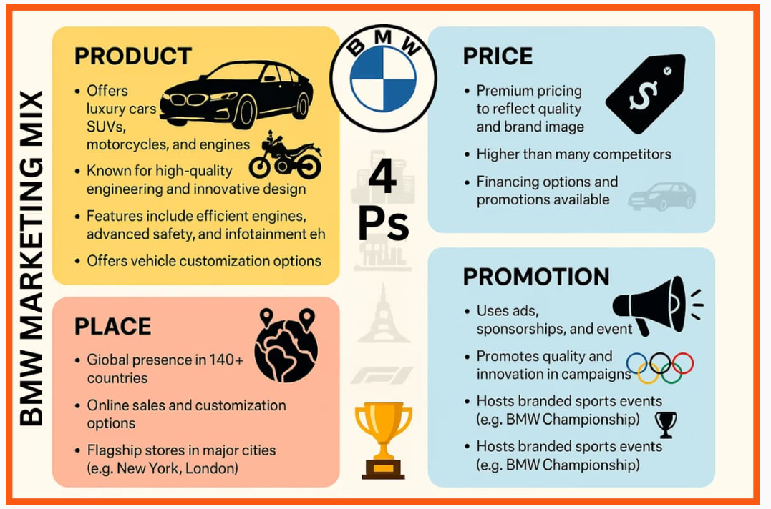

BMW Group Largest Automobile Markets
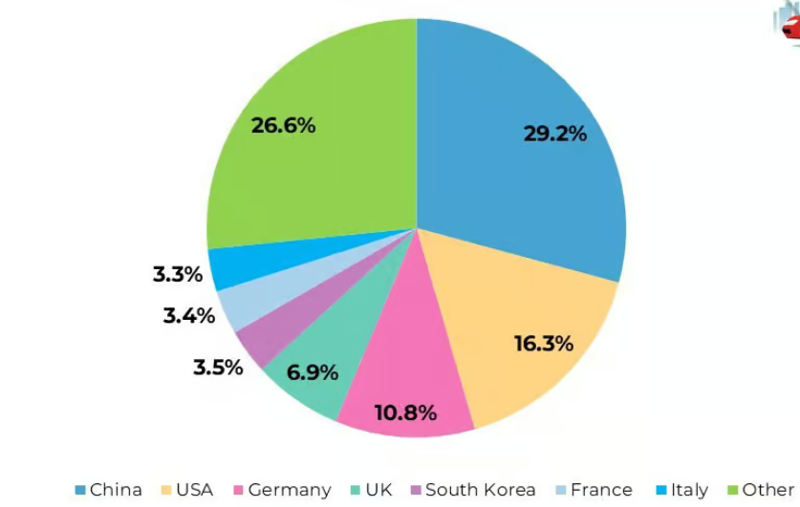

Breakdown of BMW Group's worldwide automobile sales in FY 2024, by region
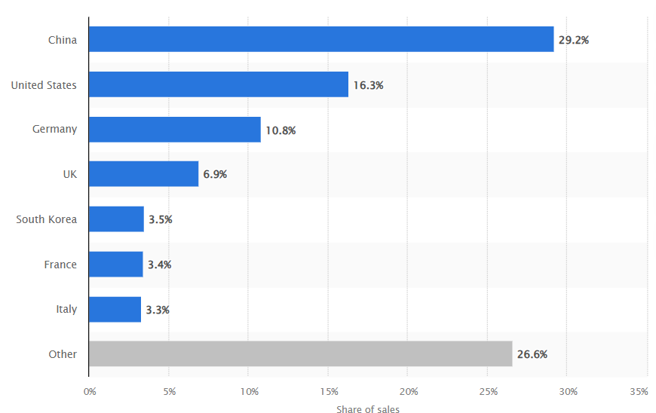

BMW Clings To Luxury-Sales Crown As Mercedes Narrows Gap


