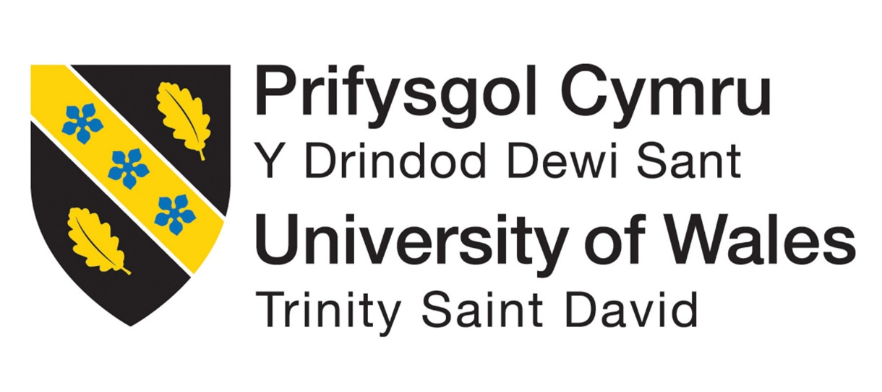


Academic Writing
M4X01498
Assignment
on

Software Project Management

Agile Vs Waterfall Method

Submitted to:
John Rees

Submitted by:
Anthony Smith
1704559

Second Semester: Foundation

Contents

Introduction Page 3

Waterfall Method Page 3/4
Agile Method Page 4/5

Conclusion Page 5

References Page 6

Introduction
Since the very beginning of project management, businesses had failed to conquer projects with satisfactory results, either failing completion on budget or on schedule. With many competing software management methods, utilising the right philosophies had become important, due to the increasing failures to fully implement customers’ expectations.
According to Pankaj Jalote , head of quality for Infosys, a million projects are executed each year, producing software worth $600 billion, but the vast majority of these ventures have an unsuccessful hit target rate, and suggests that about one-third of missions have cost and schedule overruns of more than 125%. [1]
To combat these imperfections, which are mainly down to bad planning or unclear objectives, a decision to choose an ideology with its effective techniques, needs to be put in place to make the organisation reach its goal. Such an approach are Agile and Traditional (Waterfall) methods.

Waterfall (Traditional) Method
Being the classical archetypal system model for development, the waterfall method uses a “top to Bottom” work ethic, and is structured to run through a sequence of activities, and advances on to the next stage, once a specific part of the project has been completed. Much like a real waterfall that flows from the top to the bottom, sometimes a little splash back can occur, a re-visit to a previous stage may be needed if any extra work or attention is required, but this would be a rare occurrence and not to expected throughout the project (see fig 1.1).
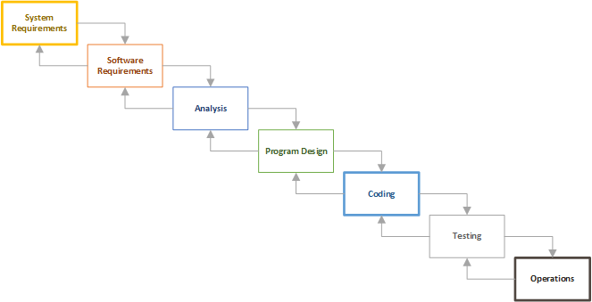

Fig 1.1 Shows the Waterfall Method and its linear construction. [2]

Modifying tasks that have previously been completed, can in fact be a disadvantage while working on large projects and the need to avoid reworks is essential if completion dates are to be met. Due to this limited scope for change, it is one of the core strengths for using this type of process model and one to be favoured by some managements. At each stage a review can be made to see if the project is still valid, cost effective and keeping to time frames, constant communication with the employer can also be implemented, while maintaining confidence in the set completion forecast. This approach is ideal for projects that have defined requirements and an end goal that’s well clarified. [3]

Agile Method
Although this method is seen as recent revelation, it has been circulating for over 20 years. Agile was an adopted form of project management seen to right the wrongs of previous mistakes made from out dated methodology and seen to be the “holy grail” that will change the failings of its predecessors.
Agile received its name, due to this method being agile and responsive, and embraces many challenges that the others do not conform to. The objective of this type of project is to create a rough version of the final goal and improve on it over the duration of the planned project. The main intention of the Agile process is to give you something that can be used in a short period of time, and that can also be evaluated after each step [4]
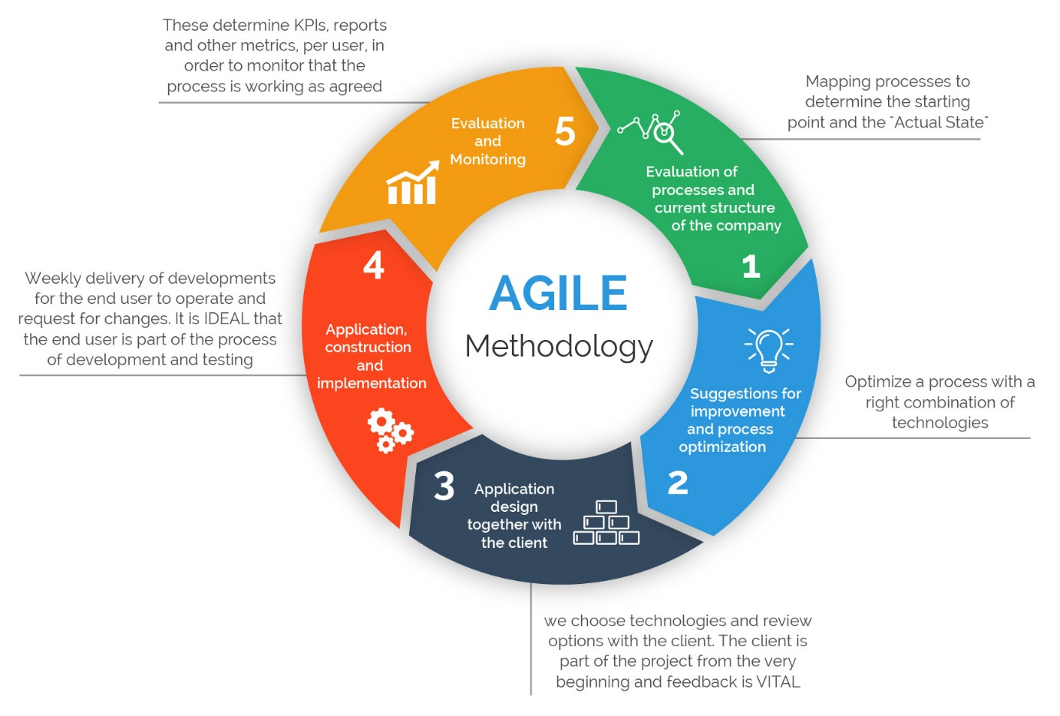

Fig 1.2 Agile Framework [5]

One main factor that differentiates Agile from other methods, is the absence of any form of Wishlist and starts by identifying the minimum requirements needed to get the work started. This stops the project from overspending and allows a natural build up, which lowers the chance of any unexpected surprises further down the line.
The Agile Manifesto principles, which were created by 17 practitioners in 2001, revolve around 4 key issues which were agreed upon to make the Agile movement a success:
- Individuals and interactions -over processes and tools
- Working Software – over comprehensive documentation
- Customer collaboration – over contract negotiation
- Responding to change – over following a plan
Change is not the enemy when implementing Agile, it is seen as an evolution of any good idea and goes as far as embracing it. The handling of uncertainty or unclear requirements is handled effectively and due to constantly iterating means you can quickly adapt [6]

Conclusion
Taking in to account the principles that both these methodologies are based upon, coming to a defined answer to which would be a better implemented form of management is difficult. Circumstances and needs of the individual champions the right method applied to the project and both Waterfall and Agile have there for and against.
Waterfall can identify problems which potentially could have been found in the development stage early and solved in the design venture. More details and documentation are made giving an organisation confidence in the reliability of the project and as Waterfall uses a straight framework that is more or less a step by step, makes it easier to understand for the employee and investors. As long as the project has a short duration and well-defined instructions, with no option of change, the Waterfall method can receive great success.
But certain drawbacks can be discovered while executing this framework, such as labour-intensive changes that were not foreseen at the beginning of the project, brought on by new technology or different ideals placed on the project by the company. Working with the unknown is not handled well with Waterfall and what seems to be viable design at the beginning, can result in problems stemming from implementation of that design.
Agile accepts change, and a fundamental human trait is alter and build on to an original idea and using this framework does not encumber invention or progression. Change can be made at any stage of development. Constant involvement between the developers and the organisation can improve the final product while giving the opportunity of constructive criticism.
If the Agile method is applied badly, it can introduce more inefficiencies in large projects and as Agile relies on the importance of working software, documentation and planning can sometimes be neglected. Due to the unsystematic structure of Agile, it can be more difficult to understand and execute.
Although the Agile method is employed by most software development companies and is deemed a more reliable and workable framework, denying Waterfall can be just as successful would be inaccurate, and both can bring benefits depending on the project at hand.

References

[1] | P. Jalote, Software Project Management in Practise, Addison-Wesley, 2002.
[2] | BAwiki, "www.bawiki.com," [Online]. Available: http://bawiki.com/wiki/concepts/sdlc-process-models/waterfall/.
[3] | B. Hughes and M. Cotterell, Software Project Management, fifth ed., McGraw-Hill, 2009.
[4] | J. Mills, "www.smartsheet.com," 7 June 2016. [Online]. Available: https://www.smartsheet.com/blog/agile-vs-waterfall-which-best-your-business. [Accessed 12 April 2018].
[5] | "www.360logica.com," [Online]. Available: https://www.360logica.com/blog/the-importance-of-different-agile-methodologies-included-in-agile-manifesto/. [Accessed 12 april 2018].
[6] | E. Scotcher and R. Cole , Brilliant Agile Project Management, Pearson, 2015.

