Student Name: Virgiliu Bahvalov
Student ID: 2123038
Module: Effective Team Working and Communication
Module Code: BMSW4002

Models of communication, the communication skills and the advantages and disadvantages of technology in Communication

Introduction

Communication is a process of exchanging messages and information with others. In the work environment it is very important to have effective communication in both written and verbal way. It improves team collaboration, productivity, increase loyalty and reduces conflicts between stuff. Every person at work have to communicate in one way or other. It is crucial to acknowledge what impact communication have on work progress and career development.

Models of Communication

Shannon and Weaver
The Shannon Weaver model of communication was developed in 1948 when Warren Weaver and Claude Elwood Shannon co-authored the Bell System Technical Journal paper "A Mathematical Theory of Communication." Shannon and Weaver Model of communication is a linear form which include a one-way message transmitted from sender to receiver.

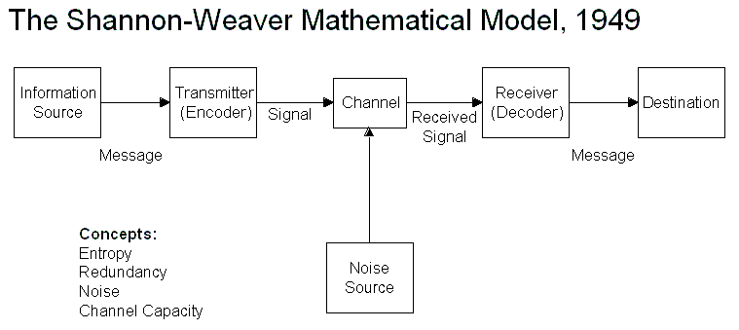
Maria and Pedro is an example of the Shannon and Weaver model were Maria is information source and her message is send by voice (Transmitter) through the phone (channel) and gets on Pedro’s phone (Receiver) a to the final destination which is Pedro. In this case study the Noise source is the loud construction works that made Pedro to hear “Kitchen” instead of “Chicken”. The way this misunderstanding could be avoided is if Pedro would confirm that he understands the Maria’s request or would find a place where is less noise.
At my workplace is very common to face same confusions as in Maria and Pedro case study. Usually misunderstanding take place when two persons are on a distance apart from each other and do not have possibility to get closer because of barriers or working plants on the way, so when they are communicating, they need to shout or speak very loudly. This makes the message unclear, and some people may pretend they understand the message when they actually do not. The best way to avoid later conflicts is to make sure both persons understood clearly each other by giving a feedback or repeat the message.

Schramm (1954)
Schramm Communication model is based on Shannon and Weaver model. It was first suggested in 1954 and is defined as a cyclical model of communication in which a message or information and its feedback or acknowledgment pass in between a sender and receiver.
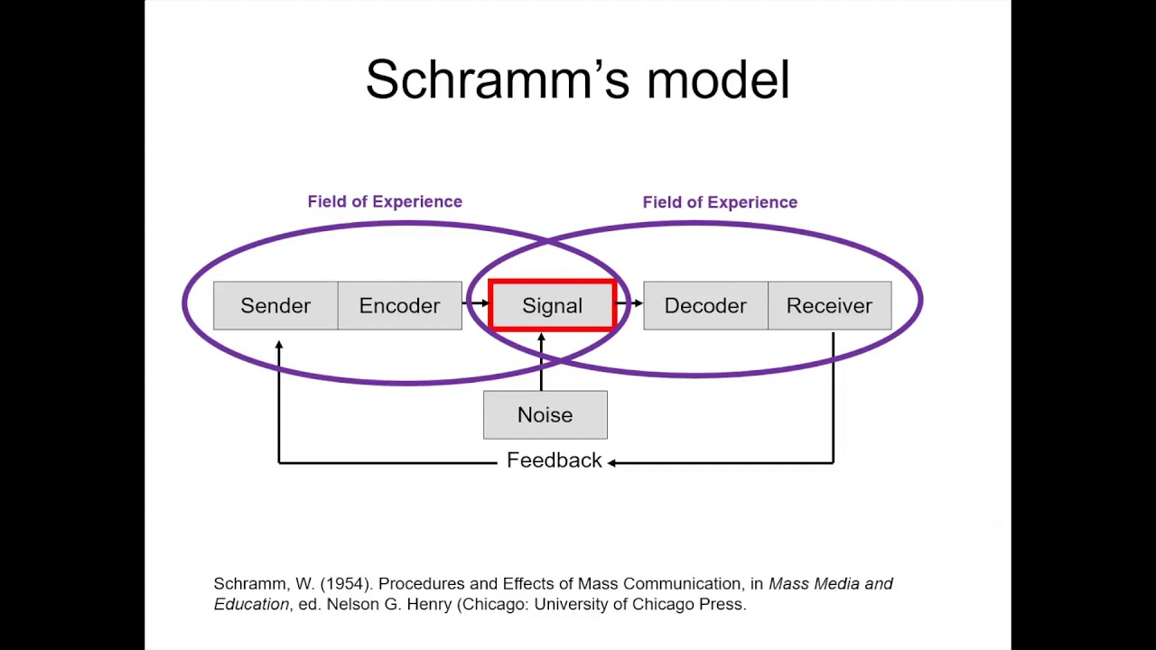

Using the Schramm’s model of communication, the misunderstanding between Maria and Pedro could be avoided. The difference in this models is that Schramm interpret communication as a two-way process between sender and receiver where the feedback is given. If Pedro would repeat the Maria’s message or called her later to ask again because the construction works where to loud, this confusion would not happen. Schramm believed that in any communication where sender does not receive the feedback, is not complete and ineffective.
In my workplace are used various methods of communication, and phone calls are very common. Because of carried work which can be very loud and make big noises or bad reception during the phone call, we often face confusions. When this happens, the best way to avoid misunderstanding is to make sure you can clearly hear the person and at the end of conversation to repeat the task, so both sender and receiver know they have been understood. Or in some cases to send a text message later to confirm the assignment.

Berlo (1964)
In 1964 David Berlo developed a model of communication that include four elements - Source-Message-Channel-Receiver, also known as Berlo’s SMCR model of communication. This model is based on Shannon and Weaver model and focuses on both verbal and non-verbal communication elements to convey information. The main difference between Berlo’s and other models of communication is the David Berlo believed that the message can be influenced not only by noises but also because of the differences between sender and receiver, such as communication skills, attitudes, knowledge, social system and culture.
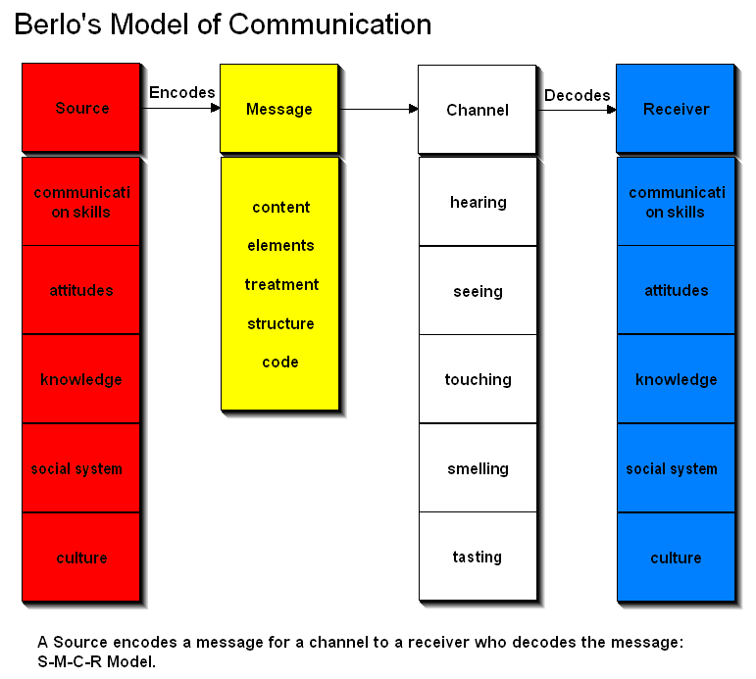
A good example was the case study that was showed on one of the classes where the professor who is living in the village and because of his communication skills and lack of knowledge of the peoples living in the village he was never able to make a conversation with them. In one night, he founded his house on fire and because he couldn’t handle the flame himself, professor tried to ask the villagers for help. He used an elevated vocabulary to send the message, but nobody could understand what he is trying to say so his house wasn’t saved form the fire.
When I first arrived in UK I have experienced many times the misunderstanding based upon communication skills and knowledge. My language was poor, at my workplace was very hard have a conversation particularly with British peoples because of fast speech and their accent. Also the knowledge in various of works taken because of the difference between how it is being done in other countries.

Communication Skills
Having good communication skills means being able to share, understand, and express information, ideas, and feelings effectively. Having excellent communication skills will allow you to interact with people in a variety of situations, such as during personal interactions, public speaking, or workplace communication. No matter where you work or what you do, you need to be able to communicate effectively. By having good communication skills, misunderstandings can be avoided early on, and if they do occur, they can be resolved promptly.
In order to lead a successful life, it is essential to be able to convey information effectively, clearly, and as intended. Poor communication can even turn a favourable situation into an unfavourable one, while improving your communication skills can make a difference in your quality of life. There is few type of communication skills such as verbal (oral or written), non-verbal (body language, facial expressions, gestures) and listening.

Verbal communication
It is essential to have effective verbal communication skills to succeed in any work environment (or non-work environment). Being able to present your ideas in the most articulate manner is an acquired skill that needs to be developed. The receiver should be able to understand your message clearly and concisely if you want to get your message across. In the absence of such communication, conflicts and misunderstandings can arise.
Verbal communication is the most common way people to send the message. When talking to others the message should always pe interpreted respectfully, need to use the language the receiver can understand, and it should be age and culturally appropriate. To make the message understandable the sender should speak slowly and clearly, also to choose the right words and to make sure that the body interpret the same message as the words. Understanding to which person the message is send is crucial, both in spoken and written, the slangs and street language should never be used with the persons who are not known, only formal form of communication.

Non-verbal Communication
When people communicate nonverbally, they do not use any words, either oral or written. For expressing feelings, attitudes, or information, it relies on non-verbal cues such as physical movements, tasks, colours, signs, symbols, and signals charts. While non-verbal communication does not use words, it can effectively communicate many human feelings more accurately than verbal communication. Body language, eye contact, facial expressions, gestures, and body language are the most common types of nonverbal communication.
Faces play an important role in communication. People often say that the face is the index of the mind. There is an emotional expression for almost every kind of feeling or emotion, such as joy, love, interest, sorrow, anger, annoyance, confusion, enthusiasm, fear, hatred, surprise, and uncertainty.
You may appear boring, stiff, and unanimated if you don't gesture while speaking. It is important to use an engaging and animated style to capture the attention of audience, make the material more interesting, facilitate the process, and provide a bit of entertainment for them. Gestures are very important in our communication, and we should pay attention to them.
Non-verbal communication also includes body language. Messages and meanings can be conveyed through body movements. Movements of the body can be unconscious or controlled consciously.
In “A Day with a chief” case study we can see how verbal and non-verbal communication can effectively deliver messages. The chief used the verbal language to make accommodate the Mark, she successfully makes him feel comfortable and for a moment to forget who he is talking with. Mark being relaxed started to use a non-formal body language loosening his tie and crossing his legs he showed some disrespect and exaggerated when he started complaining on his supervisors and London office after what Chief executive asked her secretary to show him the way out.

Listening – Active listening
Listening actively involves paying full attention to what someone is saying and absorbing it so that the exchange between the listener and speaker is meaningful and productive. It is beneficial to your career and personal life to be more conscious while listening. Whether it is in your daily conversations with colleagues, in networking for future opportunities, or in maintaining genuine connections as a manager, listening makes people feel heard. Building meaningful relationships requires empathy, which is the basis of active listening. The benefits of active listening include managing emotions, retaining data, and resolving conflicts.

Empathetic listening
When listening to someone empathically, you pay attention and respond appropriately. Empaths feel what others feel and understand where others are coming from. A compassionate listening style is at the core of empathic or empathetic listening. Your personal and professional lives can both benefit from empathic listening. Listening empathically is about being attentive, compassionate, and kind to others when they speak. By listening empathically, you are showing that you respect the speaker and that you are paying attention to what they have to say.
In the case study which we discussed in class, we can see how important is to pay attention to others and active listen. Max knows very well his job, all his customers are happy of his works, but at the moment when he can’t focus to all the customer because of a lot of oncoming calls he lost one of his loyal customer.
I’m working in the environment where at the same time a lot of people are taking a very different kinds of activities, and every activities have many details. It is often happening that one person who is supervising to many peoples becomes busy and inattentive. They are not paying attention at the managers tasks and not listening the workers which will bring problems in the long run.

Technology in communication
In our time you can have a conversation with others using different technologies and you don’t need to meet face-to-face and seeking for free time and places. You can just use a phone or a computer to make calls and send messages, sharing photos and videos of the moments, also work environment benefits from technology. But the biggest disadvantages is a possible misunderstanding because of lack of emotions that you can get. Some peoples feel more confident when they can express themselves using their body language and facial expressions. Also, pure connection sometimes affect the quality of the conversation and it may end up not as it was planned.

Conclusion
The importance of communication cannot be overstated. In order to live a happy and fulfilling life, one must share their thoughts and feelings. We suffer less and feel better about everything around us when we communicate more. The art of effective communication, however, is all the more important to convey one's message effectively.

References
- iEduNote.com. (2018). Nonverbal Communication: Definition, Types, Importance (Explained). [online] Available at: https://www.iedunote.com/nonverbal-communication.
- Harappa. (2021). Empathetic Listening - Meaning, Definition And Examples. [online] Available at: https://harappa.education/harappa-diaries/empathic-listening/.
- The Classroom | Empowering Students in Their College Journey. (2010). The Advantages & Disadvantages of Communication Technology. [online] Available at: https://www.theclassroom.com/the-advantages-disadvantages-of-communication-technology-12080586.html.
- Quintanilla, K.M. and Wahl, S.T. (2020). Business and professional communication keys for workplace excellence. 4th ed. Los Angeles Sage.

