

Student Name: Rafeen Akram
Student Id: 2407472
Module: Changemakers: Building your personal Brand for Sustainable Employment
Module code: BMHP5015
Lecturer: Olufemi Oluranti
Assignment Title: Component 2: Assignment (Report)
Table of Contents
1. Introduction 3
2. Job Description and Person Specification for the presented vacancy. 3
2.1 Overview of the Selected Vacancy 3
2.2 Main Duties and Responsibilities 3
3. Employability Skills Analysis for the role 4
3.1 Overview of Employability Skills 4
3.2 Communication and Active Listening 4
3.3 Person-Centred Practice 4
3.4 Empathy and Emotional Intelligence 4
3.5 Partnership Working and Community Collaboration 5
3.6 Safeguarding, Digital Records and Resilience 5
4. Evaluation of My Current Skills against the Job Role 5
4.1 Skills Audit and SWOT Analysis 5
4.2 Current Strengths 5
4.3 Areas for Development 6
5. Current Experience, Qualifications and Evidence 6
5.1 Academic Experience 6
5.2 Need for Practical Experience 6
6. Creating your own brand. 6
6.1 Personal Brand Statement 6
6.2 Preparing for the Job Search Process 7
7. Professional identity and USP. 7
7.1 Professional Identity 7
7.2 Unique Selling Point and Value Added 7
8. Establishes a network for successful employment. 7
8.1 Importance of Networking 7
8.2 My Professional Network 8
9. Develop an Action Plan and a Five Year Timeline. 8
9.1 Purpose of the Action Plan 8
9.2 Short-Term Goals: 0–6 Months 8
9.3 Medium-Term Goals: 6–12 Months 8
9.4 Long-Term Goals: 1–5 Years 8
10. Resources Needed to Achieve the Role 9
10.1 Training and Development Resources 9
10.2 Purpose of the Resources 9
11. Communicating My Skills to Employers 9
11.1 CV, Cover Letter and LinkedIn 9
11.2 Interview Evidence 9
12. Conclusion 9
References 10
Appendices 13

A Career Development Report for the role of Social Prescribing Link Worker in the UK Health and Social Care / Adult Social Care Sector

1. Introduction
The aim of this report is to explore the Social Prescribing Link Worker role as a career pathway in the future for health and social care in the UK. It is a blend of person-centred, communication, community support and partnership working. Social prescribing is important because wellbeing may be impacted by factors outside of medical care, including loneliness, poverty, housing, long-term illness, and not being connected to the community. Evidence in the UK has demonstrated that social prescribing is being utilised to tackle health inequalities and is becoming more common (Melam, Dyson and Thomson, 2025). But it is not the whole answer as there are also broader social, economic and political inequalities which contribute to inequalities (Moscrop, 2023). It contains details of a job vacancy, necessary skills, my skills and an action plan.

2. Job Description and Person Specification for the presented vacancy.

2.1 Overview of the Selected Vacancy
The role will be a Social Prescribing Link Worker as detailed in Appendix 1. The job involves assisting the person with non-medical needs to identify what this is, and to engage them in appropriate services and support within the community, voluntary and wellbeing sector. A job description and person specification have been summarised in Appendix 2.

2.2 Main Duties and Responsibilities
Social prescribing connects those to emotional, practical and community-based services and support to mitigate the impact of social issues on wellbeing (Khan and Tierney, 2024). The role is not simply to make signposts but also involves relationship building, needs assessment, referral, follow-up and partnership building. There are variations in the role between settings, so it is important to establish clear duties and boundaries, as explained by Mulholland et al. (2025). Communication, person-centred practice and safeguarding skills are identified as key areas of requirement alongside the need for partnership working and an understanding of the community (James Street Group Practice, 2026).

3. Employability Skills Analysis for the role

3.1 Overview of Employability Skills
Employability skills and care knowledge are essential to a Social Prescribing Link Worker. Link worker programmes may include the need identification, motivational encouragement, referral to services and outcome monitoring, which require interpersonal and practical skills (Sandhu et al., 2022). Professional behaviour, adaptability and readiness for work are found to be associated with employability in the education of health professionals (Leadbeatter et al., 2023).

3.2 Communication and Active Listening
Communication is a key skill as link workers communicate with service users, their GP's, voluntary organisations and other professionals. They need to listen, ask pertinent questions and offer well-reasoned decisions. Communication and interpersonal skills relate to fostering trust, engagement and shared understanding in practice relating to care (Koprowska, 2024). It is particularly important for the worker to listen actively since he or she needs to comprehend the person's own objectives.

3.3 Person-Centred Practice
Social prescribing needs to start with the needs, strengths, choices and circumstances of an individual and this is where person centred practice comes in. The person's preferences, context and wellbeing goals should be considered when planning for care instead of only the professional priorities (Damant et al., 2026). This is important because it must be of benefit to the person.

3.4 Empathy and Emotional Intelligence
Empathy and emotional intelligence are required as many service users may suffer from loneliness, anxiety, low confidence and/or financial stress or long-term health conditions. Emotional intelligence is related to the ability to understand one's own emotions as well as others' emotions, thus aiding in sensitive professional relationships (Heikkinen, Kuha and Kanste, 2026).

3.5 Partnership Working and Community Collaboration
The key aspect of partnership working is that link workers work with GP practices, charities, community groups, libraries, housing services and voluntary organisations. Community partnerships can enhance access to local support and can be a part of health promotion (Lenstra et al., 2026). Hence, having a strong network building and professional relationship- building ability is important for a link worker.

3.6 Safeguarding, Digital Records and Resilience
Ensuring that awareness is maintained is essential as link workers may be working with vulnerable adults. They need to identify risk, adhere to reporting protocols and set and uphold boundaries. The safeguarding of adults is about recognising harm, abuse or neglect and taking appropriate action (Duffy, Browne and Connolly, 2025). Digital skills needed as referrals, support plans and outcomes need to be recorded accurately. Electronic records can be used to provide continuity and quality of care (Adeniyi et al., 2024). In complex social issues and emotional pressure, it is important to be resilient as the role may require that. The research indicates that when healthcare workers are faced with a stressful situation, resilience will enable them to work effectively (Curtin, Richards and Fortune, 2022).

4. Evaluation of My Current Skills against the Job Role

4.1 Skills Audit and SWOT Analysis
A personal employability skills audit, skills gap chart and SWOT analysis were used to assess my employability. The skills audit, the skills gap chart and the SWOT analysis are shown in Appendix 3, Appendix 4 and Appendix 5, respectively. SWOT analysis helps to distinguish the internal strengths and weaknesses from external opportunities and threats (Drastichová, 2024). Reflective practice is also vital as health and social care workers need to become aware of their strengths, weaknesses and learning needs (Čajko Eibicht, Lorenz and Havrdová, 2022).

4.2 Current Strengths
My top 3 strengths are communication, empathy, cultural awareness and open to learning. These are relevant because service users have a need to feel valued, respected and included. Academic study has enabled me to develop discussion, presentation, research and team working skills, which are all aspects of communication and confidence. Cultural awareness is also beneficial as social prescribing is about helping those from different backgrounds.

4.3 Areas for Development
My primary development areas are preserving knowledge, gaining direct contacts in health and social care in the UK, developing a professional network, record keeping and confident for interviews. The gaps in safeguarding and networking are the largest ones as indicated in Appendix 4. So, there's a need to concentrate on practical, professional, confidence and training for my plan. It is also revealed in Appendix 5 that volunteering, career support and networking via LinkedIn are helpful opportunities, while limited experience and job competition are potential threats.

5. Current Experience, Qualifications and Evidence

5.1 Academic Experience
During my studies in BSc Health and Social Care, I have learnt about the values of care, equality, communication, safeguarding, professionalism and health inequalities. Team working, presentations and research activities have also helped the development of team working, confidence and academic communication.

5.2 Need for Practical Experience
Work experience can enhance students’ perception of their employability by providing them with an opportunity to learn about workplace expectations and to practice learning in practice (Bennett, Knight and Li, 2023). Currently, I would like to gain further experience in the health and social care/community support sector in the United Kingdom. So, in my action plan volunteering in a charity/community centre/wellbeing service will be included.

6. Creating your own brand.

6.1 Personal Brand Statement
My personal brand is that I am a future Health and Social Care worker who is compassionate, reliable and culturally aware and will provide person-centred and community-based support. Personal branding helps the individual convey their values, strengths, and career direction to the employers and hence personal branding is an important factor in employability (Deshpande, Shinde and Parasnis, 2023).

6.2 Preparing for the Job Search Process
My brand should demonstrate that I am respectful, trustworthy, motivated and capable of working with a variety of communities for a Social Prescribing Link Worker position. I will do this by the creation of a professional CV, LinkedIn profile, reflective portfolio and training certificates and volunteering evidence. As evidence of my professional online presence, see the following example of a LinkedIn profile (Appendix 9). Social prescribing, wellbeing in the community, communication, mental health, person centred care should be the keywords that come across in my profile.

7. Professional identity and USP.

7.1 Professional Identity
My professional role is as a developing Health and Social Care practitioner, who respects Dignity, Inclusion, Empowerment and wellbeing of the community. Professional identity influences the perception of the role, values and responsibilities that professionals have in interprofessional practice (Cantaert et al., 2022). As a staff member of this school, I should be confidentially, respectful, reliable and accountable.

7.2 Unique Selling Point and Value Added
A combination of empathy, cultural awareness and communication and a genuine desire to assist individuals to gain access to practical support is my unique selling point. I can contribute positively by being non-judgemental, establishing trust, developing a sense of belonging to the community. This is an important factor to consider as social prescribing relies on referral and social connection.

8. Establishes a network for successful employment.

8.1 Importance of Networking
The skills that I need to develop for my career are significant, as social prescribing is reliant on a network of relationships between health services, voluntary organisations and community groups. Weak ties and social networks can have positive effects on employability as they provide access to information, opportunities and professional networks (Özer, 2023). My Network Map can be seen in Appendix 6.

8.2 My Professional Network
My network will involve lecturers, academic tutor, classmates, careers service, LinkedIn professionals, local charities, GP/Primary Care services, volunteering organisations and family/friend network, as well as community groups. This will be created in careers events, CV feedback, contacts online and enquiries about volunteering.

9. Develop an Action Plan and a Five-Year Timeline.

9.1 Purpose of the Action Plan
I have started my 5-year action plan in Appendix 7. Progresses from knowledge building to experiences and career advancement. Competence, confidence and managing work challenges are related to career development, which in turn helps to improve job satisfaction and progression (Seno, Magito and Perkasa, 2023). There is also a need to understand formal services and the lived experiences of people across communities in health and social care practice (Glasby, 2026).

9.2 Short-Term Goals: 0–6 Months
I will spend the first 3-6 months studying the guidance on social prescribing, taking Safeguarding Adults Level 2 training, enhancing my CV and LinkedIn profile. Such actions will contribute to the development of professional readiness.

9.3 Medium-Term Goals: 6–12 Months
I will apply for volunteer opportunities in local charities/community centres or wellbeing services within 6-12 months. This will help develop experience, confidence and awareness of the needs of the service user.

9.4 Long-Term Goals: 1–5 Years
I will be applying for jobs in the next 1-2 years, including support worker, community wellbeing assistant or social prescribing assistant. These will be followed by roles to gain experience before applications for Social Prescribing Link Workers. My goal is to get the target role in 2-5 years and to further develop through supervision, training and reflective practice.

10. Resources Needed to Achieve the Role

10.1 Training and Development Resources
These are my needs for resources in Appendix 8. Training to safeguard, mental health awareness training, social prescribing guidance, volunteering opportunities and careers service support and interview practice are the most important resources.

10.2 Purpose of the Resources
Training will ensure that I can safeguard vulnerable service users; understanding mental health awareness will help to build my awareness of emotional wellbeing. Volunteering will give me invaluable experience and careers support will help me to enhance my CV and LinkedIn profile as well as interview skills.

11. Communicating My Skills to Employers

11.1 CV, Cover Letter and LinkedIn
I will present my skills in a customised CV, cover letter, LinkedIn profile, certificate and via volunteering and interview examples. Communication, empathy, culture awareness, safeguarding development and community interest and willingness to learn will be emphasized in my CV.

11.2 Interview Evidence
The STAR approach will be used in interviews to demonstrate examples from university, volunteering and group work. When available I will also refer to tutors, supervisors or organisations of volunteer work.

12. Conclusion
The Social Prescribing Link Worker role is a good future career pathway role as it links health, social care and community wellbeing. My strengths are my ability to be empathic, communicate and have cultural awareness, and my areas of development are protecting, networking, practical experience and confidence. My action plan is realistic pathway to get into a job.

References
Adeniyi, A.O., Arowoogun, J.O., Chidi, R., Okolo, C.A. and Babawarun, O., 2024. The impact of electronic health records on patient care and outcomes: A comprehensive review. World Journal of Advanced Research and Reviews, 21(2), pp.1446-1455.
Bennett, D., Knight, E. and Li, I., 2023. The impact of pre-entry work experience on university students’ perceived employability. Journal of Further and Higher Education, 47(8), pp.1140-1154.
Čajko Eibicht, M., Lorenz, W. and Havrdová, Z., 2022. Enhancing reflectivity in social, care and health professionals–Identifying students’ abilities and needs. European Journal of Social Work, 25(4), pp.732-744.
Cantaert, G.R., Pype, P., Valcke, M. and Lauwerier, E., 2022. Interprofessional identity in health and social care: analysis and synthesis of the assumptions and conceptions in the literature. International journal of environmental research and public health, 19(22), p.14799.
Curtin, M., Richards, H.L. and Fortune, D.G., 2022. Resilience among health care workers while working during a pandemic: A systematic review and meta synthesis of qualitative studies. Clinical psychology review, 95, p.102173.
Damant, J., Hamashima, Y., Toma, M., Smith, N., Taylor, J., Caprioli, T., Jasim, S., Prato, L., Mcleod, H., Giebel, C. and Peters, M., 2026. Investigating Person‐Centred Care Planning in Care Homes Across England: An Exploratory Study of Practices and Contextual Factors. Journal of Advanced Nursing, 82(1), pp.617-631.
Deshpande, A.M., Shinde, A.G. and Parasnis, P.K., Significance of Personal Branding in Enhancing Employability. Rivista Italiana di Filosofia Analitica Junior, 14(2), p.2023.
Drastichová, M., 2024. SWOT analysis of the sustainable development concept. Problemy Ekorozwoju, 19(1).
Duffy, A., Browne, F. and Connolly, M., 2025. Safeguarding adults: A concept analysis. Journal of Advanced Nursing, 81(1), pp.181-197.
Glasby, J., 2026. Understanding health and social care. In Understanding Health and Social Care. Policy Press.
Heikkinen, H., Kuha, S. and Kanste, O., 2026. Exploring the core of emotional intelligence in healthcare leadership: a concept analysis. Journal of Advanced Nursing, 82(2), pp.1760-1774.
Khan, K. and Tierney, S., 2024. The role of social prescribing in addressing health inequalities. In Social prescribing policy, research and practice: Transforming systems and communities for improved health and wellbeing (pp. 31-45). Cham: Springer International Publishing.
Koprowska, J., 2024. Communication and interpersonal skills in social work.
Leadbeatter, D., Nanayakkara, S., Zhou, X. and Gao, J., 2023. Employability in health professional education: a scoping review. BMC medical education, 23(1), p.33.
Lenstra, N., DeGuzman, P.B., McConnaughy, R. and Weis, M., 2026. How do public library partnerships impact health? A scoping review. Health Promotion Practice, 27(1), pp.173-191.
Melam, C., Dyson, J. and Thomson, K., 2025. The role of social prescribing interventions in addressing health inequalities in the United Kingdom: a narrative review. Health & Social Care in the Community, 2025(1), p.6613809.
Moscrop, A., 2023. Social prescribing is no remedy for health inequalities. bmj, 381.
Mulholland, J., Galway, K., O’Hare, L., Bertotti, M. and Gildea, A., 2025. The social prescribing link Worker—Clarifying the role to Harness potential: A scoping review. Health & Social Care in the Community, 2025(1), p.4394123.
Özer, M., 2023. Impact of human capital and weak ties in social networks on employability. International Journal of Turkish Education Sciences, 2023(21), pp.254-274.
Sandhu, S., Lian, T., Drake, C., Moffatt, S., Wildman, J. and Wildman, J., 2022. Intervention components of link worker social prescribing programmes: a scoping review. Health & social care in the community, 30(6), pp.e3761-e3774.
Seno, S., Magito, M. and Perkasa, D.H., 2023. The influence of career development, competence and work conflict on job satisfaction. Talent: Journal of Economics and Business, 1(01), pp.14-22.

Appendices
Appendix 1: Current Job Vacancy Screenshot
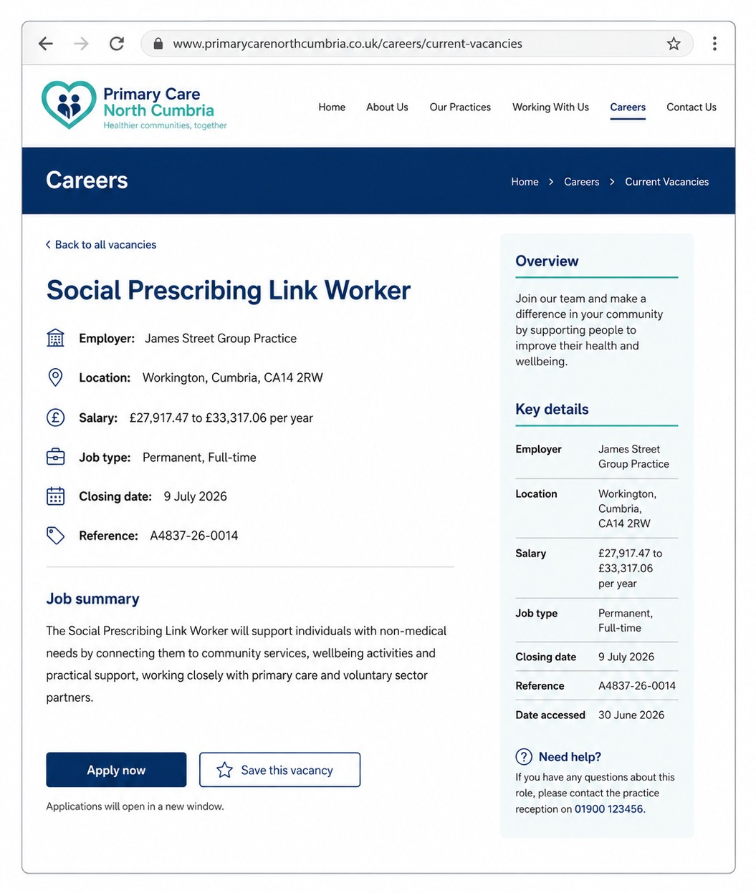

Appendix 2: Job Description and Person Specification Summary
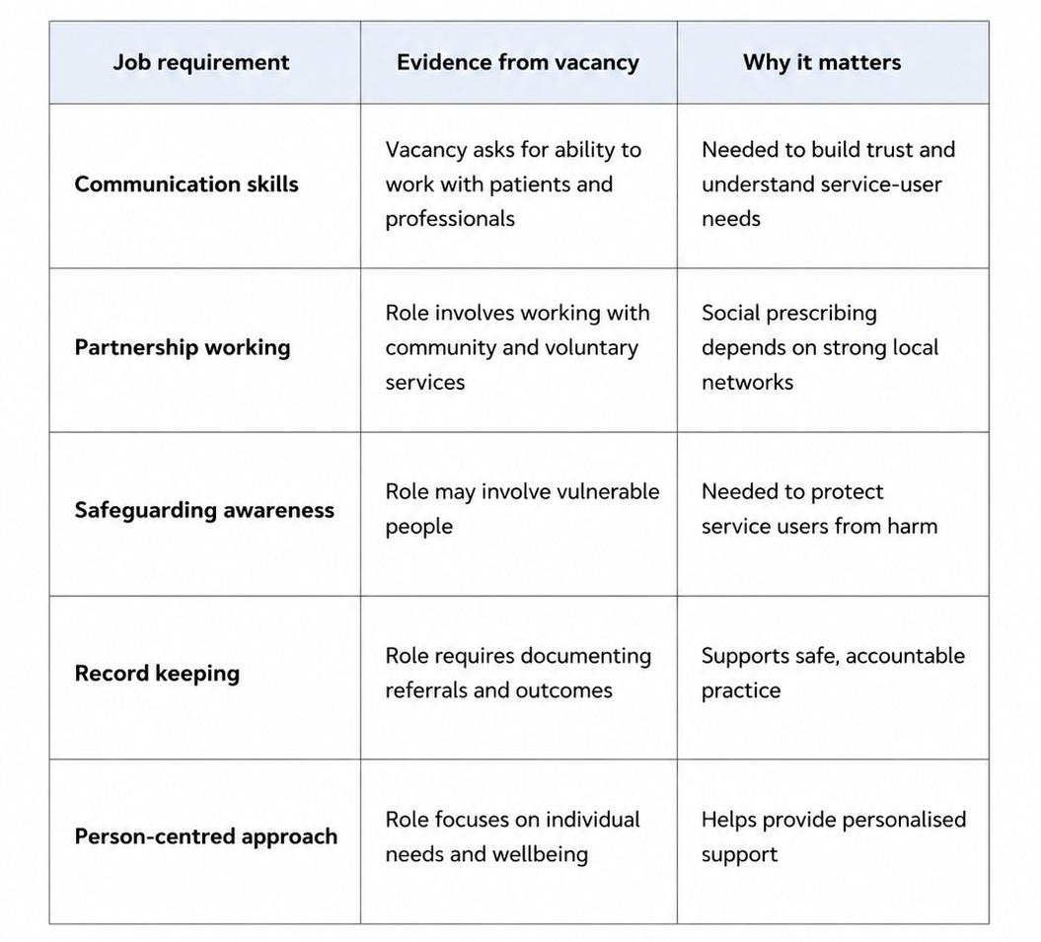

Appendix 3: Personal Skills Audit
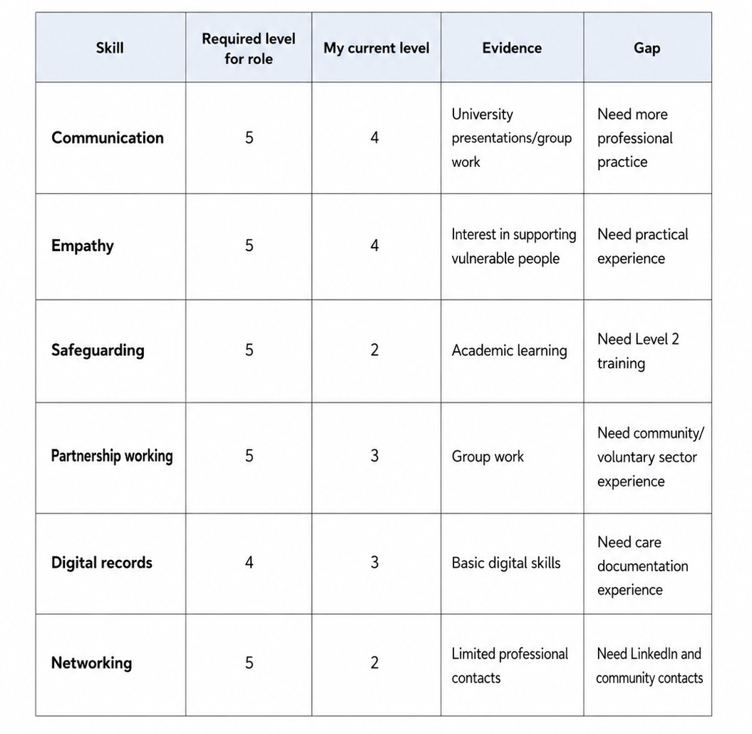

Appendix 4: Skills Gap Chart
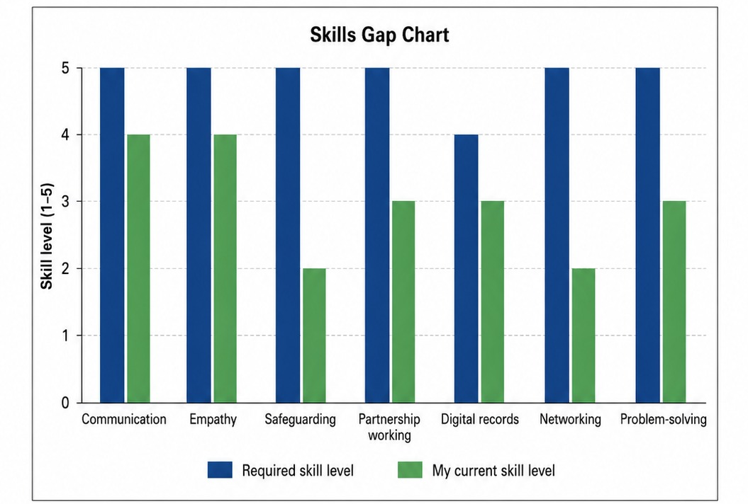
Appendix 5: Personal SWOT Analysis
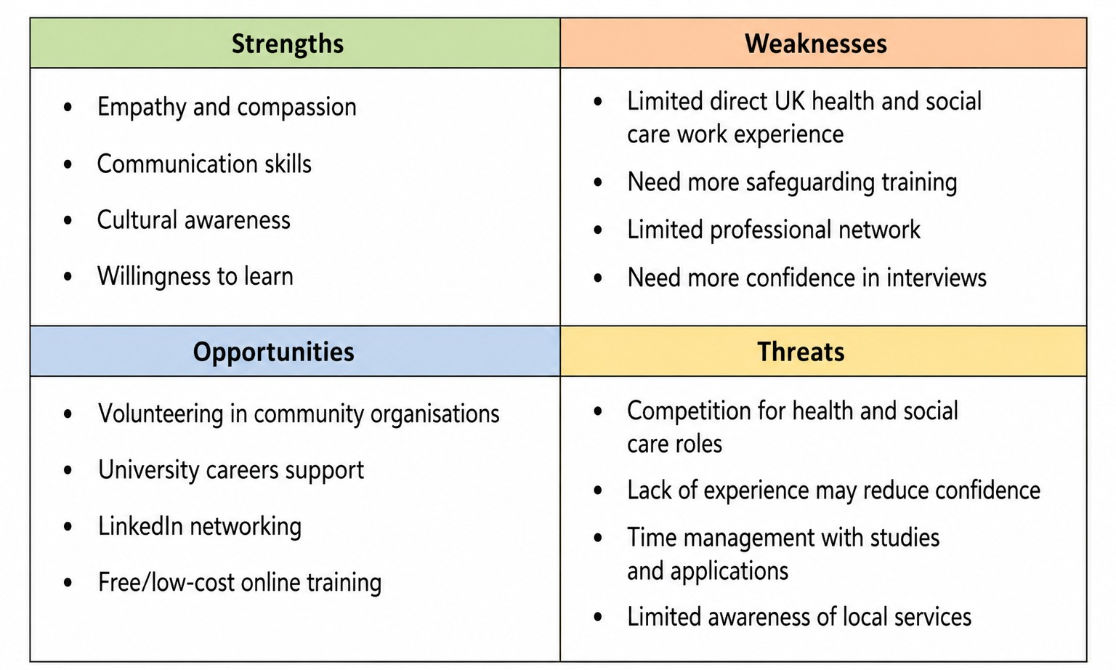

Appendix 6: Personal and Professional Network Map
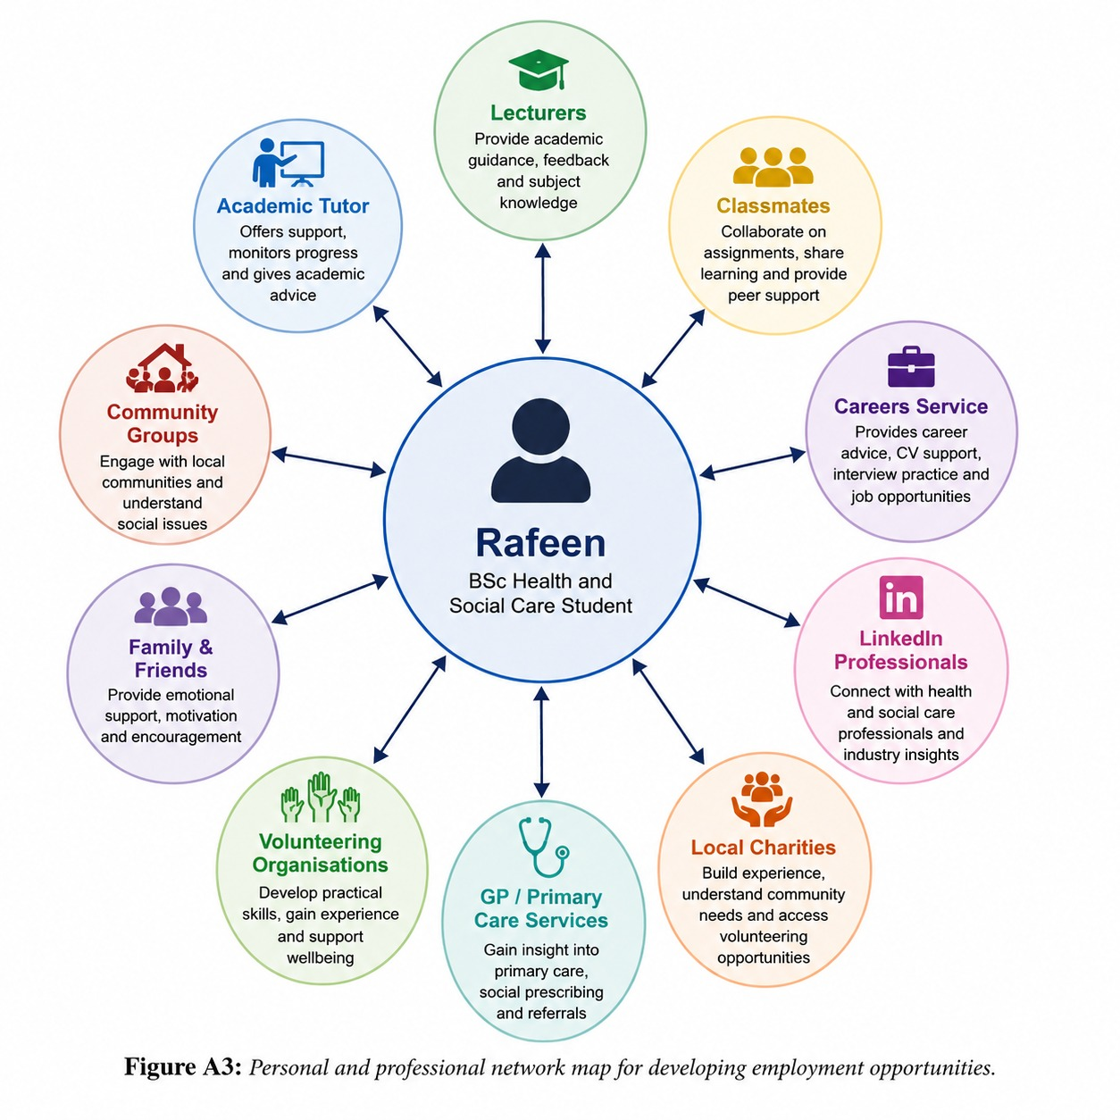

Appendix 7: Five-Year Action Plan and Timeline
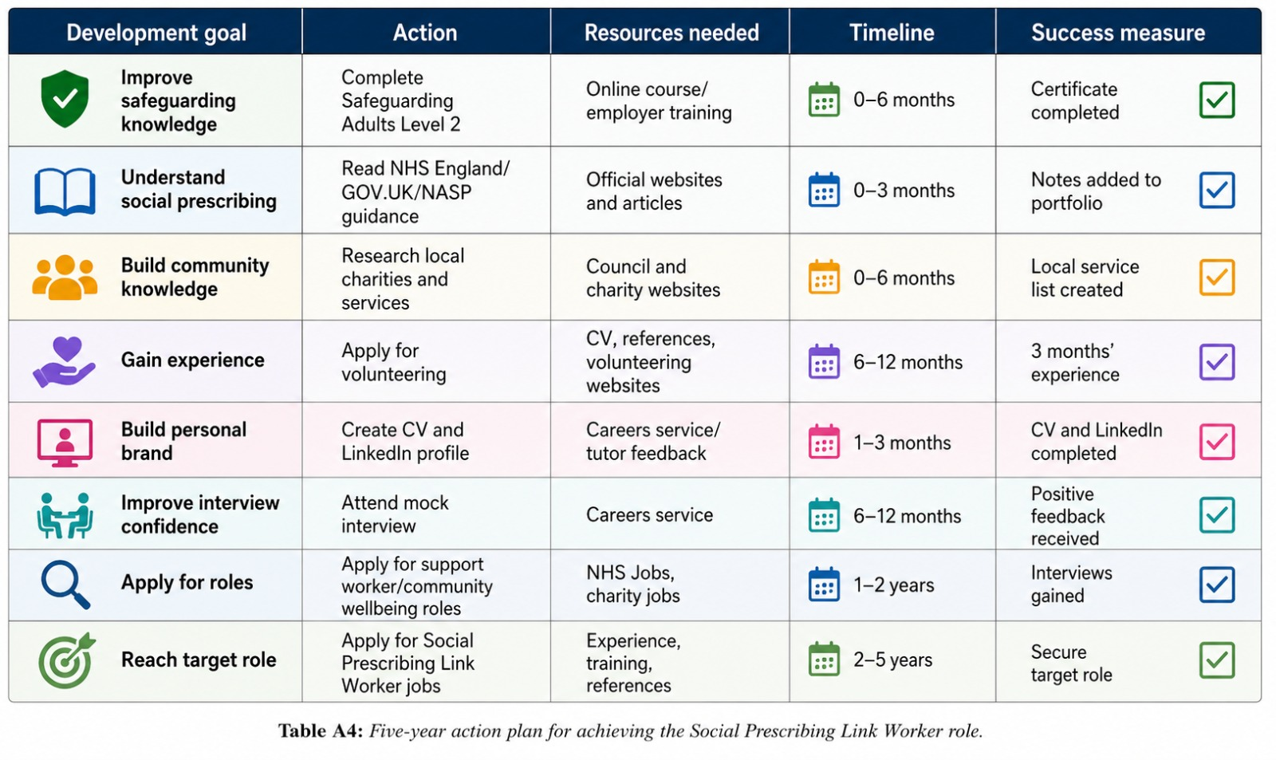
Appendix 8: Training and Resources Needed
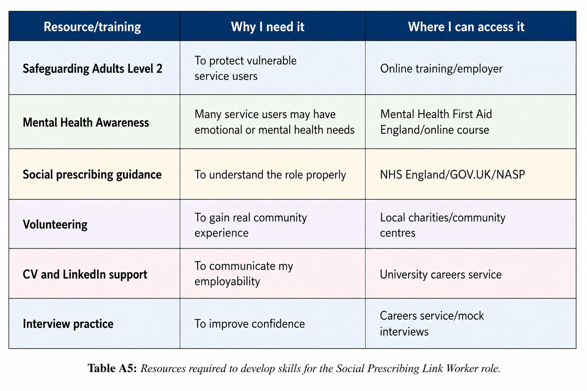

Appendix 9: Personal Brand Evidence / LinkedIn Profile


