Student Self Evaluation Form

This section repeats in brief the common assessment criteria detailed on previous pages. The extent to which these are demonstrated by you determines your mark. Using these criteria, tick the box that best indicates the level of achievement you feel you have achieved with regard to each of them.

Common Assessment Criteria Applied
Common Assessment Criteria Applied | REFER |  | D |  | C |  | B | A
 | OUTRIGHT FAIL | UNSATISFACTORY | SATISFACTORY | GOOD |  | VERY GOOD |  | EXCELLENT
1. Subject Knowledge and Understanding (which includes using research-informed literature and knowledge and understanding of the subject)
2. Intellectual Skills (Analysis)
3. Pedagogic and Professional Applications (Practical Application and Deployment)
4. Key Transferable Skills

PLEASE COMMENT ON AREAS IN WHICH YOU FEEL THAT YOU HAVE PERFORMED WELL | PLEASE COMMENT ON AREAS you feel that you need TO DEVELOP
I believe that my extensive reading has enabled me to make good links to theory throughout. In addition, my organisational skills have helped in writing such a lengthy piece of work in a limited amount of time. | Due to my limited experience in this area, I sometimes found it difficult to recommend next steps for the learner.

‘Supporting pupil progress: a detailed analysis of one child’s holistic development, with justification for the next steps in learning.’

Student Number: 1700926
Group 4
Level 7
Word Count: 4932

Introduction
Learning is considered to be a process whereby a perpetual modification of behaviour occurs through either a variety of experiences or practice (Lachman, 1997: 477). Stages of development are not equal for each child and thus it should be expected that the rates in which pupils make progress will subsequently be varied (Department for Children, Education, Lifelong Learning and Skills, 2008: 4). Likewise, it is imperative that children are able to access the curriculum in a differentiated manner that accounts for their developmental requirements (Department for Children, Education, Lifelong Learning and Skills, 2008: 5). Therefore, as teachers, we need to provide rich learning experiences that account for the differing levels of progress that our pupils make (Department for Children, Education, Lifelong Learning and Skills, 2008: 5). This essay will focus on various intertwining aspects of a child’s development and the impact that such factors have upon their progression in learning.
For my professional teaching experience, I have been placed in a large, urban, English-medium community primary school that consists of over 700 pupils ranging from three to eleven years of age (Estyn, 2015). A lower than average amount of pupils are entitled to free school meals (Estyn, 2015). In addition, a substantially lower than average number of pupils are considered to have Additional Learning Needs (ALN) (Estyn, 2015). I have been placed in a Key Stage Two class where pupils are aged between eight and nine years of age. The class consists of 29 pupils and four of these children are deemed to have ALN.

For the purpose of this assignment, I have focused my attention on a male pupil who is of middle attainment with the desire to develop ways to progress his learning. Before selecting this pupil, I engaged in various conversations with the class teacher to inform my decision and utilised purposive sampling to ensure that I selected a middle attaining pupil (MacNaughton et al, 2001). Due to the importance of anonymity, I will refer to this target pupil as Pupil A throughout this essay. Pupil A is nine years of age and he has attended the school since Nursery. Discussions with the class teacher gave me an insight into the summative assessments that have been made regarding Pupil A’s learning. For example, it is suggested that Pupil A is currently on track to achieve the expected level 4 by the end of Key Stage Two. The class teacher has given Pupil A a general target of attempting to improve his concentration levels and remain focused.

Data collection
The chosen methodology was the Mosaic approach which considers both adults and children to be the ‘co-constructors of meaning’ (Clark & Moss, 2011: 1). This approach involves children and adults working collaboratively to develop a profounder understanding into the lives and education of children (Clark and Moss, 2011; Greenfield, 2011). In addition, children are viewed as being specialists in their own lives within this approach. (Clark & Moss, 2005; 2011). The Mosaic approach can be categorised into three stages which consist of adults and children collaborating to collect information, interpreting the data through discussion and constructing ways for progression and continuity (Clark and Moss, 2011). This approach involves combining various methods of data collection including observations, child conferencing, photography and child-led tours of their educational setting to gain a clearer insight into the child’s own views (Clark and Moss, 2011; Greenfield, 2011).

The combination of these methods has numerous benefits particularly in the way that they provide a rich and varied set of data (Clark and Moss, 2011). Despite this, however, there are also several limitations to utilising such methods of data collection. For example, observations may not be deemed as reliable due to the way in which the observer may unintentionally omit information from their recordings and so may not provide a truthful representation of the event (MacRae, 2011; Palaiologou, 2008). In addition, such observations are likely to be accountable to observer bias in which the observer allows their emotions to influence what is observed during the event (MacNaughton et al, 2001; Palaiologou, 2008). Moreover, the vast amount of data required for the Mosaic approach means that the process of data collection and interpreting the data are extremely time consuming (Clark and Moss, 2011). A further drawback of the Mosaic approach is considered by Clark and Moss (2011) who claim that although the approach allows children to give their perspectives in various forms, there is a risk that listening to the children in such a thorough manner may mean that these children may be more susceptible to being controlled.

Although there are clear drawbacks of using such methods of data collection, the qualitative approaches used within the Mosaic approach contribute to collecting data that is more natural and spontaneous and allows for a better interaction between the researcher and the child (Mack et al, 2005). Likewise, the Mosaic approach involves the use of both verbal and visual tools to collect information which helps children to express their views in various ways (Clark and Moss, 2011). In addition, such qualitative data provides a method to gain a variety of perspectives whilst also offering information that is rich in detail (Grigg, 2015). An additional benefit is the fact that, in line with Donaldson’s (2015) recommendations about pupil voice, the Mosaic approach upholds the child’s participation as a central feature and offers a multi-method approach to gain a better understanding of the child (Clark and Moss, 2011). Despite the limitations of using these methods, I feel that the combination of such innovative methods provides an effective way to gain the child’s perspectives (Clark and Moss, 2011; Greenfield, 2011). Moreover, the Mosaic approach is certainly advantageous as a form of data collection with the way it involves the child in the whole process from the onset (Clark and Moss, 2011). Thus, it is evident that the benefits in terms of gaining a deeper understanding of the child far outweigh the drawbacks of the Mosaic approach.

Ethical considerations
Throughout the research process, I conducted myself in accordance with BERA’S (2011) ethical guidelines to ensure any potential ethical risks were reduced. For example, I made Pupil A aware of his right to consent for participating in the research and allowing his work to be used to discuss his learning (Appendix 1). Likewise, I also gained informed consent from the class teacher by asking them to sign a written consent form (Appendix 1) (Hogg and Vaughan, 2008; Mack et al, 2005). In addition, after gaining informed consent, I confirmed that Pupil A was aware of his right to withdraw from the research at any time if he so wished (BERA, 2011). Moreover, all of the collected data will remain confidential as it will be stored in line with the legal requirements of data storage using password-protected cloud storage (BERA, 2011). Similarly, all data will remain anonymous as it will not contain information that could reveal the identity of either the target child or the school (BERA, 2011). Furthermore, Pupil A did not receive any incentive for agreeing to participate in this research.

Analysis of the learner
It is proposed that there are three key aspects of learning which consist of attitudes, skills and knowledge (A.S.K) (Nottingham, 2013). It is imperative that, as teachers, we recognise how these three aspects impact upon a child’s learning and ensure that their education accounts for the development of all three components of learning (Nottingham, 2013). With this in mind, I will utilise Nottingham’s (2013) A.S.K model as a tool to analyse Pupil A’s attitudes, skills and knowledge with regard to his learning. Although a wide variety of areas will be discussed, there will be a particular focus on Literacy, Numeracy and Wellbeing due to the high regard that Donaldson (2015) places on these elements.

Attitudes
Pupil A led me on a tour of the whole school, yet he ignored a large proportion of areas and instead photographed various outdoor areas such as the playground and the field (Appendix 2). During our child conferencing, I asked him to explain why he had taken such photographs and he expressed his desire to have the majority of his lessons outside as he believes that the fresh air and large amount of space will enable him to learn better. This highlights that pupil A certainly has the desire to succeed in his learning. Moreover, the underlying theme of his love for the outdoors can be supported by Piaget’s theory of Constructivism (1967, cited by Lamanauskas, 2010) which suggests that the child is active in the process of learning and that they acquire knowledge through their interaction with the environment (Macblain, 2014). In addition, Pupil A appears to foster a mature attitude to his learning which was highlighted by a discussion during the child conferencing. When asked about the factors that he considered to be effective in ensuring his learning is successful, Pupil A noted that he likes the room to be quiet when he is set a task as he finds it distracting when other children are talking. Adding to this is the fact that although he considers displays to be beneficial in the information that they provide within in the classroom, he thinks at times the colourful backgrounds can be somewhat distracting. Likewise, he stated that he needs to concentrate during lessons and if the room isn’t free from distractions, he finds it difficult to uphold high levels of concentration. This can be supported by the perspective of the class teacher who highlighted how Pupil A’s lack of concentration leads him to make silly errors of judgement within his learning (Appendix 3). Furthermore, Pupil A articulated his love of the school’s methods of positive reinforcement especially with the use of Class Dojo, a popular method of token economy to increase the rates of favourable behaviours within the classroom environment (Robacker et al, 2016). Pupil A’s desire to gain Dojo Points can be explained by Behaviourism which proposes that learning occurs when a child associates a stimulus with a specific response (Macblain, 2014) and the use of positive reinforcement motivates the learner to exhibit the desired behaviour (Arthur & Cremin, 2010).

Pupil A is a well-liked member of the class and even at times of adversity, he appears to be particularly resilient. For example, at the end of English lessons we often play games to consolidate the pupils’ literacy skills. I observed Pupil A on one particular occasion in which he gave an incorrect answer which resulted in him being the first member to be disqualified from the game. He accepted this with ease and even laughed it off which can be contrasted to other pupils in the class who have become upset at this prospect. Adding to this, when he is made aware of mistakes within his work, he acknowledges his mistakes and tries his best to rectify them. This high level of resilience can perhaps be attributed to his high levels of self-esteem (Daniel and Wassell, 2002: 13). Likewise, Pupil A appears to be particularly open-minded which can be demonstrated with the way he treats all members of the school with kindness. Likewise, during a Mathematics lesson, I utilised a carousel of learning activities which is unfamiliar to the school’s typical lesson structure. Some pupils immediately felt uncomfortable with trying something new whereas Pupil A was eager to try a new approach. This also signifies his curious nature particularly regarding his own learning. Perhaps this open-mindedness and curiosity can be attributed to the fact that the children currently partake in Philosophy for Children (P4C) sessions which aim to help children to become more reflective and respectful towards others (Nottingham, 2013). Overall, Pupil A possesses a positive attitude towards his peers yet also applies this positivity to most areas of learning. Despite this, however, the child conferencing did highlight that Pupil A dislikes Mathematics and English and justified this by saying, “They make my brain hurt!”.

Skills
Pupil A has sound literacy skills and he is currently working at a best fit judgement of a level 3B in English. Regarding the various strands, Pupil A is considered to be working at the following levels: Oracy – 3B, Reading: 3A, and Writing – 3C. In line with this, at present he is working at a level 3B in Mathematics. He utilises both literacy and numeracy skills well throughout all areas of the curriculum. In particular, his oracy skills have proven beneficial in communicating with his peers within the classroom environment. For example, Pupil A is always very keen to participate in class discussions and uses his oracy skills in a cross-curricular manner to make contributions to a variety of lessons (Department for Education and Skills, 2016). For example, during one particular Mathematics lesson focusing on Pictograms, he shared with the class his opinion that “It’s easy to tell which one is a pictogram because it uses pictures”. His clear expression of his opinion enabled him to share his insights with the rest of the class to inform their learning. Although Pupil A has good oracy and reading skills, his writing skills appear to hold him back slightly. Pupil A often forgets to use punctuation accurately and the presentation of his work combined with his handwriting needs to improve to ensure that his writing is decipherable (Department for Education and Skills, 2016) (Appendix 4). He is also competent in utilising his numeracy skills although whilst practicing for the National Tests, it became apparent that he needs to refine his numerical reasoning skills (Department for Education and Skills, 2015).

During a variety of lessons, we have utilised iPads and laptops to ensure that children are having regular opportunities to use technology. Through observing Pupil A conducting various tasks on these devices, it is evident that he is confident in applying his digital skills to a variety of contexts. When Pupil A led me on the tour of the school, he was eager to photograph the computer suite (Appendix 5). This led to a discussion in which Pupil A expressed his love for using technology. When I probed him further, he stated that he loves using the iPads to complete his work and enjoys doing his homework on his computer at home. I then used the opportunity to ask him what his favourite subject is to which he replied, “ICT because it’s fun and we do lots of different things”. In addition, Pupil A has well developed gross skills and fine motor skills which help him to carry out a range of cross-curricular activities (Department for Children, Education, Lifelong Learning and Skills, 2008).
Pupil A is considered to have well-developing social skills. Although he comments on who his best friends are during the child conferencing, I have observed him playing with many different members of the class on various occasions which highlights his ability to utilise these social skills to communicate with children he is not as familiar with. In addition, Pupil A was able to show empathy when one of his peers was upset because they had lost their toy during breaktime. Pupil A immediately tried to comfort his friend and offered to help him look for the toy. Friendship appears to be an important theme for Pupil A and this was indicated through his photographs and the child conferencing. For example, Pupil A took photographs of the ‘Adventure trail’ that is situated outside on the playground (Appendix 6). The child conferencing allowed Pupil A to highlight that these areas are where he likes to have fun with his friends and would like this element of fun to be applied to his lessons and the activities that he undertakes. Likewise, Pupil A stated that he enjoys working as a group within lessons because he gets to hear a wide range of ideas to progress his learning. These aspects can be reinforced by Vygotsky’s Social Constructivism theory of learning (1978, cited by Macblain, 2014; Nottingham, 2013) which proposes that children learn best through their interactions with other individuals.

Knowledge
Pupil A certainly exhibits some solid levels of knowledge regarding a wide range of subject areas. For example, as part of our topic of ‘Wild Wood’, we had numerous Science lessons learning about a woodland habitat. Pupil A was able to share a number of facts about woodland animals and subsequently applied this knowledge using concepts such as food chains. In addition, Pupil A utilised his knowledge in this area to complete an Art activity in which the children created their own diorama of a woodland habitat (Appendix 7). Although he is competent in his numeracy skills, Pupil A struggled with one particular element of a symmetry activity (Appendix 8). Upon discussing this with Pupil A during the lesson, it became apparent that his lack of knowledge of shapes added a further difficulty in completing the required task. Such confusion in Mathematics is common because of the concepts that children are required to understand (Nottingham, 2013). Moreover, during an English lesson, Pupil A was able to apply his existing knowledge to answer the following question: ‘Is exaggerating the same as lying?’ Pupil A was able to think in a logical and structured manner (Department for Children, Education, Lifelong Learning and Skills, 2008) and presented his ideas to deliver a well-balanced argument. Despite this, although it is often evident that Pupil A has the required levels of knowledge, he sometimes struggles to organise his ideas and write these down in a well presented, structured manner. Likewise, although he has the knowledge on the purpose of punctuation, he often fails to use it, seemingly through a lack of focus.
Upon careful analysis of Pupil A, it is apparent that his learning needs to be progressed in all areas but especially Literacy and Numeracy to ensure that he achieves the Predicted level 4 at the end of Key Stage 2. Similarly, a particular focus needs to be placed on improving his writing skills throughout all areas of the curriculum. In addition, Pupil A has expressed his desire to take part in group learning in a variety of contexts other than the classroom to deepen his learning repertoire. Moreover, the analysis has highlighted the need to eliminate distractions to ensure that Pupil A’s concentration levels are not affected. Furthermore, it is imperative that Pupil A’s negative attitude towards English and Mathematics is addressed to guarantee that his attitude does not hinder his progress.

Next Steps
Given the crucial role that the combination of attitudes, skills and knowledge play in the process of learning, it is certainly apparent that lessons and goals need to be planned with these factors in mind (Nottingham, 2013). Thus, by ensuring that these elements are accounted for throughout Pupil A’s education, he will certainly develop to become holistically ‘outstanding’ in his learning (Nottingham, 2013: 5). Determining the next steps to move the learning forward is vital in widening Pupil A’s learning repertoire (Department for Children, Education, Lifelong Learning and Skills, 2010). In order to help Pupil A progress in his holistic development, a culture of learning should be created in which a variety of strategies can be used to ensure this progression (Clarke, 2014).
Although Pupil A upholds a generally positive attitude, his negative attitudes towards subjects such as English and Mathematics may become detrimental to his progress if they are not altered. In order to address his attitude, determining why he holds such a negative view of these subjects is fundamental. Likewise, it is imperative for Pupil A to comprehend the impact that his attitudes have upon his likelihood to succeed and hopefully he will recognise that he can be an active participant in his learning and determine his own success (Nottingham, 2013). Moreover, I would like to create a classroom culture in which a growth mindset is fostered (Clarke, 2014). It is proposed that a growth mindset enables individuals to believe that traits such as intelligence are not secure and can be altered with a positive approach (Schroder et al, 2017; Clarke, 2014). Such a growth mindset can be developed through the use of praise and can be applied to all areas of development to advance learning rates and successes (Nottingham, 2013). In addition, it is essential that as teachers, we utilise praise for effort instead of achievement which will shape children into more resilient learners (Clarke, 2014). By adopting a growth mindset, Pupil A will be more confident when confronted with challenges and he will be able to use a variety of strategies to problem solve and move forward in his learning (Donaldson, 2015; Nottingham; 2013). The research process highlighted that Pupil A has lots of support from his parents and so it would be beneficial to involve parents in this culture to ensure that this learning philosophy can be used at home through the use of praise and effective modelling (Clarke, 2014). For example, a learning journal could be used in which parents are able to give feedback regarding their child’s efforts (Clarke, 2014). Moreover, this approach should help Pupil A in recognising that success and improvements in his learning can be attributed to persevering and working hard (Elish-Piper, 2014).
An additional element required in creating a positive learning culture is that of collaborative learning (Clarke, 2014). The research process highlighted that Pupil A feels that his learning is at its best when he is collaborating with his peers which is in line with Vygotsky’s Social Constructivism (1978, cited by Macblain, 2014). Donaldson (2015) suggests that working cooperatively with peers helps children to gain a deeper understanding and aids in progressing their learning. Collaborative learning involves children working with those of differing abilities which aims to create an element of challenge whilst also protecting their self-esteem (Clarke, 2014). During lessons, we already adopt some elements of collaborative learning in the form of talk partners, but Pupil A has expressed his desire to work within bigger groups. This could be conducted in the form of a carousel of activities for all areas of the curriculum whereby pupils work together to solve various problems. Moreover, given Pupil A’s love of the outdoor environment, it may prove to be beneficial to conduct a variety of these lessons outside which is in accordance with the principles of the Constructivist approach (Macblain, 2014; Lamanauskas, 2010). In support of this is the Department for Children, Education, Lifelong Learning and Skills (2009: 2) who denote that the outdoors is beneficial to learning with the way it allows children to engage in ‘experiential learning’ whilst also augmenting their holistic development. The combination of such approaches to learning will hopefully contribute to an increase in Pupil A’s engagement levels and particularly his rates of participation and interest (Philp and Duchesne, 2016). However, to ensure that Pupil A remains engaged, it is important not to overuse such methods of co-operative learning and instead ensure that he is exposed to various opportunities in which he is able to work independently, with a partner and also with a larger group of learners (Nottingham, 2013).
In order to ensure Pupil A continues to develop holistically, there are additional factors that are necessary to create a positive learning culture in which he can thrive. Formative assessment is an essential component of learning and it is crucial that children are made aware of the expectations in terms of how we expect them to learn (Clarke, 2003). Likewise, formative assessment is used to gain an understanding of what children have learned and how their learning can be accelerated (Department for Education and Skills, 2013; Overall and Sangster; 2006). Assessment for learning (AfL) strategies such as feedback, questioning and peer and self-assessment are effective tools in ensuring pupils are successful in their learning (Department for Education and Skills, 2010; 2013). During the child conferencing, I was able to ask Pupil A whether the feedback that he is given is valuable to his learning. Pupil A acknowledged that written feedback is beneficial to his learning, yet he doesn’t always have time to read the comments so is unable to make use of this feedback. Adding to this, he likes the school’s method of self-assessment whereby pupils highlight how they have reached the objective of the lesson. Given the fact that pupils are not given enough opportunities to acknowledge their feedback, I will utilise the ‘Feedback Friday’ approach whereby pupils will be given time to read through their comments and make improvements to their work in addition to having the opportunity to assess their peers’ work (Estyn, 2016). Adding to this, verbal feedback will remain as a constant to ensure that Pupil A gains a good understanding (Nottingham and Nottingham, 2017). This will allow Pupil A to gain clarity of what is expected of him and the improvements needed to ensure that he achieves success (Estyn, 2016). Moreover, this culture of feedback will enable Pupil A to adopt the principles of Metacognition in which he can take greater control of his own learning (Nottingham and Nottingham, 2017: 2).
In addition to this, I aim to adjust my questioning techniques through Bloom’s Taxonomy (1956, cited by Freahat and Smadi, 2014) to create an environment in which pupils can experience greater rates of interaction (Harris, 2000). This will enable Pupil A to uphold higher levels of concentration whilst also generating his use of thinking skills to deepen his understanding (Dean, 1986). By utilising higher levels of questioning within my lessons, Pupil A will enhance his learning through the teacher-pupil interactions he will experience which is in support of the Social Constructivist viewpoint (Gilson et al, 2014). Moreover, to ensure that Pupil A can concentrate on his learning, I will promote a learning culture whereby pupils will work quietly during the completion of tasks. Likewise, to further minimise distractions, future displays will be in the form of a learning wall with a focus on the essential information rather than the appearance (Clarke, 2014).

Although the suggested steps are applicable to all areas of development, I am also conscious of the need to implement specific strategies to improve Pupil A’s literacy and numeracy skills to ensure that he can use these skills in a cross-curricular manner. The research process demonstrated that Pupil A responds well to positive reinforcement and so this Behaviourist principle can be used to motivate him in these learning areas (Arthur and Cremin, 2010). For example, Pupil A could be rewarded with Class Dojo points each time he actively participates within Mathematics and English lessons and subsequent rewards can be awarded for his efforts in attempting to make improvements with respect to his numeracy and literacy targets. Additionally, given Pupil A’s love of technology, I will provide regular opportunities to use iPads during lessons so that he can utilise his literacy, numeracy and digital skills whilst also being engaged in the activities.

Given the adverse outcomes of having poor literacy skills, it is imperative that Pupil A’s writing skills are drastically improved (Estyn, 2008). In addition, the school currently utilises a scheme for their English lessons which is somewhat prescriptive and does not always account for pupils to apply their writing skills meaningfully (Estyn, 2018). Donaldson (2015) suggests that learning needs to be relevant to children’s interests and so using cross-curricular topic lessons, I will incorporate Pupil A’s interests within lessons with the hope that this will provide engaging stimuli to develop his writing skills. Likewise, in order for Pupil A to have a positive outlook on Mathematics, effective and engaging activities are crucial (Boaler, 2015). With this in mind, I will adopt daily sessions whereby pupils will attempt to solve reasoning questions. Additionally, I will also utilise elements of the Maths Mastery approach within my lessons to ensure that Pupil A gains deeper levels of understanding with a particular focus on reasoning skills (Jerrim and Vignoles, 2016). Moreover, the research process highlighted that Pupil A has developed skills that have contributed to his positive wellbeing. Despite this, it is crucial that he continues to develop these skills throughout his education. During the child conferencing, we engaged in a conversation regarding extracurricular clubs and Pupil A revealed that he does not attend any clubs. Thus, to further develop his communication skills and confidence, Pupil A should be encouraged to partake in extracurricular activities (Zhang, 2001). By combining all of these next steps, Pupil A should experience a greater level of challenge in all areas of learning which will deepen his understanding so that he can celebrate greater levels of success (Donaldson, 2015).

Conclusion
Through adopting the Mosaic approach, I have gained a greater insight into a child’s perspectives and recognised that pupils can experience greater rates of learning when they are given responsibility to lead their own learning (Wiburg and Brown, 2007). As a prospective teacher, I have realised the vast importance of utilising formative assessment to identify the necessary steps to accelerate pupils in their learning (Nottingham and Nottingham, 2017). Moreover, it is certainly apparent that for formative assessment to be effective, it is vital that pupils become active in the learning process (Clarke, 2014). Likewise, it is evident that learning refers to more than a child’s progress in various areas of the curriculum and thus, the holistic development of a child always needs to be considered (Donaldson, 2015). Furthermore, I will ensure that I utilise a variety of approaches to ensure that my pupils experience a learning culture whereby pupils’ efforts are celebrated and children are actively involved in the entire process of learning (Clarke, 2014). This will hopefully aid in fostering a generation of learners that are ‘ambitious, capable learners’, ‘enterprising, creative contributors’, ‘ethical, informed citizens’ and ‘healthy, confident, individuals’ (Donaldson, 2015: 29).

References

Arthur, J. and Cremin, T. (2010). Learning to Teach in the Primary School. Abingdon: Routledge.

Boaler, J. (2015). The Elephant in the Classroom: Helping Children Learn and Love Maths. London: Souvenir Press.

British Educational Research Association. (2011). ‘Ethical Guidelines for Educational Research’. London: BERA.

Clark, A. and Moss, P. (2011). Listening to Young Children. The Mosaic Approach. London: National Children’s Bureau.
Clark, A. and Moss, P. (2005). Spaces to Play. More Listening to Children using the Mosaic Approach. London: National Children’s Bureau.

Clarke, S. (2003). Enriching feedback in the primary classroom. Abingdon: Hodder & Stoughton.

Clarke, S. (2014). Outstanding Formative Assessment. London: Hodder Education.

Daniel, B. and Wassell, S. (2002). The Early Years: Assessing and Promoting Resilience in Vulnerable Chidren 1. London: Jessica Kingsley Publishers.

Dean, D. (1986) ‘Questioning Techniques for Teachers: A Closer Look at the Process’, Contemporary Education, 57, 4, pp.184-185.
Donaldson, G. (2015). Successful Futures. Independent Review of Curriculum and Assessment Arrangements in Wales. Cardiff: Welsh Assembly Government.
Elish-Piper, L. (2014). ‘Parental Involvement in Reading’, Illinois Reading Council Journal, 42, 4, pp.59-64.

Estyn. (2015). ‘A report on Romilly Community Primary school’. Available at https://www.estyn.gov.wales/sites/default/files/documents/Adroddiad%20arolygiad%20Romilly%20Community%20Primary%20School%202015%20%28Saesneg%20yn%20unig%29.pdf.pdf.pdf.pdf.pdf.pdf_0.pdf [Accessed: 27th May 2018]

Estyn. (2008). Best practice in the reading and writing of pupils aged 7 to 14 years. Available at https://www.estyn.gov.wales/sites/default/files/documents/Best%20practice%20in%20the%20reading%20and%20writing%20of%20pupils%20aged%207%20to%2014%20years%20-%20May%202008.pdf [Accessed: 28th May 2018]

Estyn. (2018). Curriculum innovation in primary schools. Available at file:///C:/Users/Owner/AppData/Local/Packages/Microsoft.MicrosoftEdge_8wekyb3d8bbwe/TempState/Downloads/Curriculum%20innovation%20in%20primary%20schools%20-%20en.pdf [Accessed: 28th May 2018]

Estyn. (2016). Effective feedback to support independent learners. Available at https://www.estyn.gov.wales/effective-practice/effective-feedback-support-independent-learners [Accessed: 28th May 2018]
Estyn. (2016). Pupil participation: a best practice guide. Available at https://www.estyn.gov.wales/sites/default/files/documents/Pupil%20participation.pdf [Accessed: 27th May 2018].

Freahat, N. M. and Smadi, O. M. (2014) ‘Lower-order and Higher-order Reading questions in Secondary and University Level EFL Textbooks in Jordan’, Theory and Practice in Language Studies, 4, 9, September, pp.1804-1813.

Gilson, C. M., Little, C. A., Ruegg, A. N. and Bruce-Davis, M. (2014) ‘An Investigation of Elementary Teachers’ use of Follow-up questions for students at Different Reading Levels’, Journal of Advanced Academics, 25, 2, pp.101-128.
Greenfield, C. (2011). ‘Personal reflection on research process and tools: Effectiveness, highlights and challenges in using the Mosaic Approach’. Australasian Journal of Early Childhood, 36, 3, pp.109-116.
Grigg, R. (2015). Becoming an outstanding Primary school teacher. Abingdon: Routledge.

Harris, R. L. (2000) ‘Battling 1,000: Questioning Techniques in Student-Centred classrooms ‘, Clearing House, 74, 1, pp.25-26.
Hogg, M. A and Vaughan, G. M. (2008). Social Psychology. (5th ed) Harlow: Pearson Education Limited.

Jerrim, J. and Vignoles, A. (2016). ‘The link between East Asian ‘mastery’ teaching methods and English children’s mathematical skills’, Economics of Education Review, 50, pp.29-44

Lachman, S. J. (1997). ‘Learning Is A Process: Toward an Improved Definition of Learning’, The Journal of Psychology, 131, 5, pp.477-480.
Lamanauskas, V. (2010). ‘Integrated science education in the context of the Constructivism theory: Some important issues’, Problems of Education in the 21st Century, 25, pp.5-9.
Macblain, S. (2014). How Children Learn. London: Sage Publications.

Mack, N., Woodsong, C., MacQueen, K. M., Guest, B. and Namey, E. (2005). Qualitative Research Methods: A Data Collector’s Field Guide. North Carolina: Family Health International.
MacNaughton, G., Rolfe, S. A. and Siraj-Blatchford, I. (2001). Doing Early Childhood Research. International Perspectives on Theory and Practice. Berkshire: Open University Press.
MacRae, C. (2011) ‘Framing children through observation practices: Using art theory to re-think ways of looking at children’, Reconceptualizing Educational Research Methodology, 2, 1, pp.34-49.

Nottingham, J. (2013). Encouraging Learning: How you can help children learn. Abingdon: Routledge.

Nottingham, J. and Nottingham, J. (2017). Challenging Learning Through Feedback. How to Get the Type, Tone, and Quality of Feedback Right Every Time. London: Sage Publications Limited.
Overall, L. and Sangster, M. (2006). Assessment: a practical guide for primary teachers. London: Continuum.
Palaiologou, I. (2008). Childhood Observation. Exeter: Learning Matters Limited.
Philp, J. and Duchesne, S. (2016). ‘Exploring Engagement in Tasks in the Language Classroom’, Annual Review of Applied Linguistics, 36, March, pp.50-72.

Robacker, C. M., Rivera, C. and Warren, S. H. (2016). ‘A Token Economy Made Easy Through Class Dojo’, Intervention in School and Clinic, 52, 1, pp.39-43.
Schroder, H. S., Yalch, M. M., Dawood, S., Callahan, C. P., Donnellan, M. B. and Moser, J. S. (2017). ‘Growth mindset of anxiety buffers the link between stressful life events and psychological distress and coping strategies’, Personality and Individual Differences, 110, pp.23-26.

Wales: Department for Children, Education, Lifelong Learning and Skills. (2009). Foundation Phase Outdoor Learning Handbook. Cardiff: Welsh Assembly Government.

Wales: Department for Children, Education, Lifelong Learning and Skills. (2008). Framework for Children’s Learning for 3 to 7-year-olds in Wales. Cardiff: Welsh Assembly Government.

Wales: Department for Children, Education, Lifelong Learning and Skills. (2010).
How to develop thinking and assessment for learning in the classroom. Cardiff: Welsh Assembly Government.

Wales: Department for Children, Education, Lifelong Learning and Skills. (2008). Learning and Teaching Pedagogy. Cardiff: Welsh Assembly Government.

Wales: Department for Children, Education, Lifelong Learning and Skills. (2008). Observing Children. Cardiff: Welsh Assembly Government.

Wales: Department for Children, Education, Lifelong Learning and Skills. (2008). Physical Education in the National Curriculum for Wales. Key Stages 2-4. Cardiff: Welsh Assembly Government.

Wales: Department for Children, Education, Lifelong Learning and Skills. (2008). Skills framework for 3 to 19-year-olds in Wales. Cardiff: Welsh Assembly Government.

Wales: Department for Education and Skills. (2013). Assessment for learning and the National Literacy and Numeracy Framework. Cardiff: Welsh Assembly Government.
Wales: Department for Education and Skills. (2016). Programme of Study for English Key Stages 2-4. Cardiff: Welsh Assembly Government.

Wales: Department for Education and Skills. (2015). Programme of Study for Mathematics Key Stages 2-4. Cardiff: Welsh Assembly Government.

Wales: Department for Education and Skills. (2010). Why develop thinking and assessment for learning in the classroom? Cardiff: Welsh Assembly Government.

Wiburg, K. M. and Brown, S. (2007). Lesson Study Communities: Increasing Achievement with Diverse Students. Thousand Oaks: Corwin Press.

Zhang, L. (2001). ‘Thinking styles, self-esteem, and extracurricular experiences’, International Journal of Psychology, 36, 2, pp.100-107.

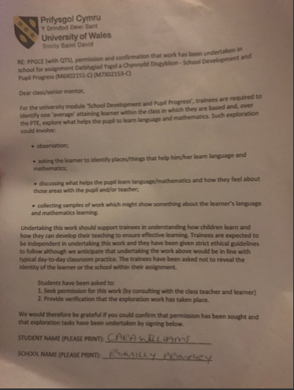
Appendix 1: Written consent form

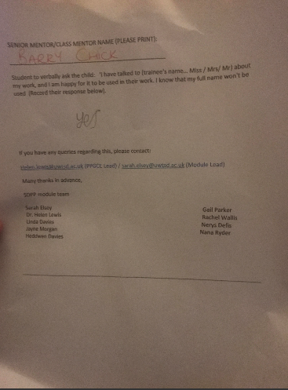

Appendix 2: Photographs of Outdoor areas (playground and field)
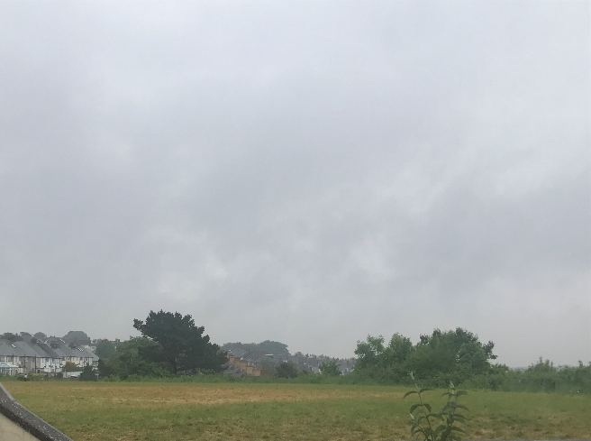

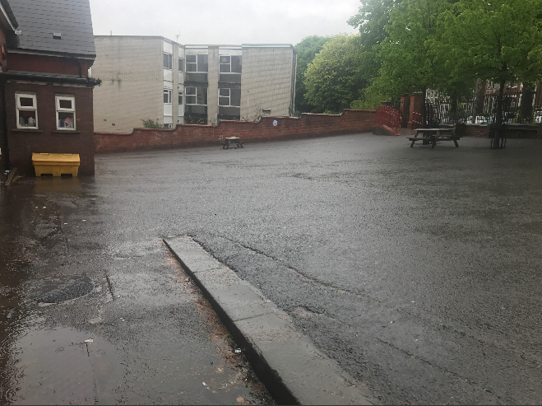

Appendix 3: Pupil A’s mistakes during a Mathematics lesson (Note: His work is stuck in upside down due to lack of concentration)

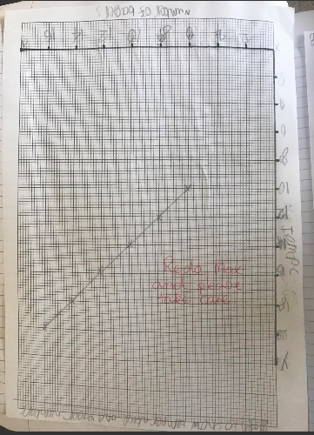

Appendix 4: English work: Lack of presentation and spacing
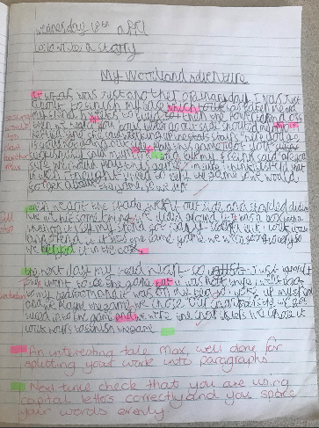

Appendix 5: Photograph of the computer suite

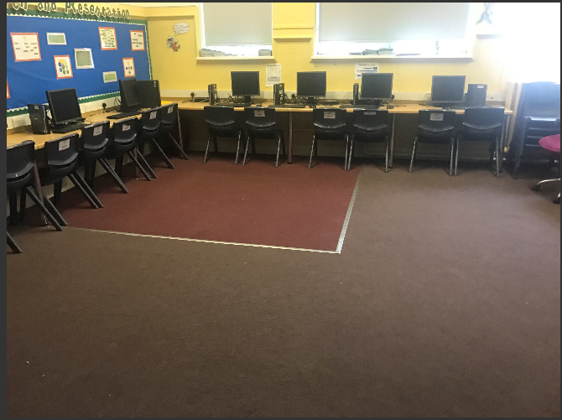

Appendix 6: Photograph of the Adventure Trail
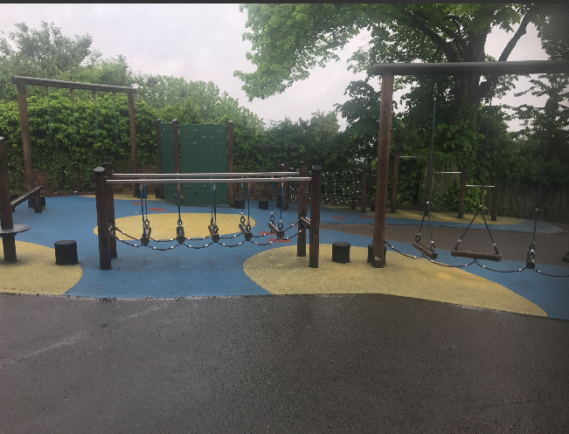

Appendix 7: Photograph of Pupil A’s Woodland habitat diorama

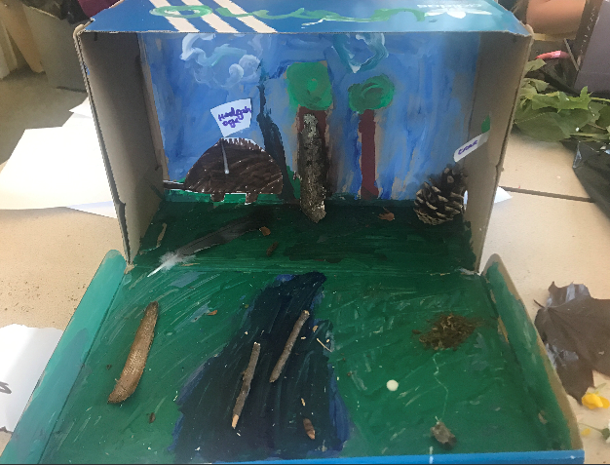

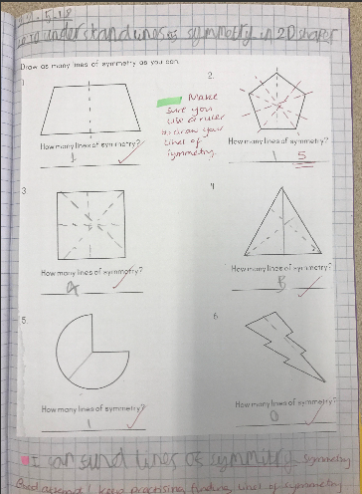
Appendix 8: Pupil A’s Mathematics work - Symmetry

