Marie Pitson

Management report
Romi begum1709527

Executive Summary
On May 2018 Marie Pitson report from Romi Begum, to be submitted on the 20th of July 2018 the report covers problem solving and decision making on Ryanair Airlines.

Contents
Executive Summary 1
Introduction 3
Main Body 4
Current Problems 4
Aging Population 4
Finance 4
Changes in Lifestyle 4
The Fishbone 4
Stakeholder Analysis 4
PESTLE Analysis 4
Conclusion 5
Recommendations 6
Reference List 7
Appendix 8

Introduction

Ryanair DAC is an Irish low cost airline founded during in the 1984, head quartered in swords, Dublin, Ireland, via London stansted airports. The ceo is Michael O’Leary (1st January 1994). Ryanair all started in the 1984 by a group of Irish people named was tony Ryan, founder of aircraft the re-launched in as the Europe’s first low fares airlines. What does the company do is an family booking with Ryanair can save about 50% on children’s seats ,baggage, boarding pass and insurance a low cost fee on infants bag allowance as well for baby changing, bottle feedings and nappies.. Also, do business class same like everyone else but much more expensive tickets, which are called ‘premium seats’.

Airline cancels 2,000 flights, due to CEO admitting issues was badly handled across Europe the budget airline is offering allot to the pilots to come back to work because not enough money pay for they wages. They were forced to cancel of flights between September and end of October. Many pilots were taking annual leave meaning not enough staff covers, according to CEO to help the situation. The pilots was offered a bonus of 12,ooo Euros to work for the extra 10 days but refused the bonus, there was no solution to fix it.
Ryanair passengers were facing problems with over priced payment and their condition of employment. Further due the ryanair pilot was facing two strikes due to take place in Ireland, they was announced this more 24 hour stopping, 20 and 24 July, after 30 plane flights were cancelled .
The budget airline most of the customers affected by the strike that they wanted a refunded they tried to solve the issues but eventually the talks striked down.
Ryanair finance chief lack of progress on rules after brexit they have complained that they still want to run the airline still around the uk and Europe however, unless people actually starts sitting around a table and discussing this, nobody will have this kind of certainly that’s a big problem for all the airlines, from finance issues people complained on how terrible the seating policy is shocking and forcing customers to pay extra to sit near friends, family.

Main Body
Why have ryanair cancelled flights because due to pay and conditions issues, up to 300 flights in response they was in a strike for 48 hours by the cabin crew in belguim,portugual and Spain the staff was very unhappy because of not enough money for wages and how they as treated by the company and customers was also complaining on about the seating policy on how high the price is for better seats to sit near to the friends and family costing them a double the price.
Staff moaning at on how the airline tries to squeeze profit out of everything food, extra blanket, bottle warmer. According to those that walk the galleys, they face disciplinary action if they do not meet certain sales targets, and are often encouraged to coerce passengers into making additional duty free purchases. In a memo, which was issued to staff in March, a supervisor they been warned: “If the same crew member’s names appear to not be reaching their daily targets if they haven’t sold products it’s a big problem for them they are more likely to lose they job leaving them jobless.
No enough staff to cover and low salary compared to other airlines with no security with zero contract, fly attendant are not getting paid for the hard work, putting passengers in the seat, putting luggage’s away, cleaning up mess and boarding people on inside. Many customers complained on why everything is so expensive and how why u have to pay extra for seating.
Cabin crew and pilots have complained that they had to pay for their own training costing them of "£2,000 for flight attendants and £30,000 for pilots. One flight attendant said on the career had to pay for the training, the uniform and the food. The cabin crew complained about the cleanness on how little they clean and how they only clean once a day and the toilets due to not cleaning the flight desk leading to food poisoning which leading to staff members being ill and not having not enough staff to cover them.
Ryan air was the biggest low cost airline in the uk even with all those cancelled fights. They have been The low-cost carrier has suffered a month or so, cancelling the flights of some 700,000 customers before having to fight rumoured that from both its pilots and cabin crew. Some analysts began to question O’Leary’ the CEO.
But now, 99 per cent of the original cancellations (and 90 per cent of the second wave) have been improved upon on and a truce with the staff is seemingly close. What’s more, new figures from Iata, the international airlines association, have confirmed the Irish carrier is now the fifth largest on the planet, and the largest in Europe.
With help from the kind of other branded airlines has been forced to suspend to get its flying schedule back on track, Ryanair carried 112 million passengers in 2016, behind only Southwest Airlines (151.8m), American (144.2m), Delta (143.3m) and China Southern (114.5m).
In short, in time eventually Ryanair became popular in the UK, In Europe, Lufthansa, which carried 110 million passengers in 2016, is its nearest rival, followed by IAG (which includes BA, Aer Lingus and Iberia) on 101 million, Air France-KLM on 93 million and easyJet on 75 million.
As Iata highlighted yet further growth in the global airline market, with a seven per cent increase in passenger numbers on 2015 to 3.8 billion, it also noted the continued rise of budget airlines.

Current Problems
Aging population- A aging population means there are fewer working-age people in the working environment. This leading to a supply shortage of qualified workers, making it more complicated for businesses or companies to fill in-demand roles.
Finance- Ryanair’s half in year results for financial year 2018 have showed that the airline is far from a brace landing. The company posted an 11% increase in profit to €1.29bn, compared to €1.17bn in 2016. Ryanair traffic also grew by 11% to 72.1m, up on 64.8m for the same period in 2016. increases have been attributed to both a strong Easter period and a 5% reduction in airfares, which the airline said has resulted in customer savings of over €160m. Of total of 80 new routes have been added, three new bases created and 35 new B737s delivered in the first half of 2017.
Changing in lifestyle- Ryanair is unable to refund you your money back, only can change your ticket but not cancel your ticket, when you haven’t travelled your also can’t get a refund back due to the travelling policy leaving people unhappy and the company looking bad.

BREXIT
The UK has voted to leave the European Union., It is scheduled to depart at 11pm UK time on Friday 29 March 2019.When the uk decided to own EU and The UK and EU Airline warnings that airplanes may not fly anymore from even to the uk edges closer to EU transition deal,they said that their willing to still sell tickets with the caveats from September, despite hopes a transitional deal for the like departure from the EU was closer, the budget airline chief marketing officer, Kenny Jacobs told bbc ‘everyone is saying it be alright on the night once we get closer to April 2019.

Mismanagement
Ryanair cancelling thousands of flights because of pilot annual leave making bigger problems about the governance they was in crisis, didn’t know how to deliver and by poor reputation and treating the staff horrible and leading customers unhappy and wanting a refunded by the seating policy leaving the company in debt by 38 billion with poor unqualified staff, ryanair is stopping them from their holiday break from nobody to cover them. which means there was staff quitting their jobs because they wasn’t no contract most likely needed to find a new one, they had to pay their training and they uniform which was costing over 300for the uniform and the training was 2,000.

Alternative Transport Methods
- Checking if booking the return flight is cheaper
- Ryanair is stricter than a royal marines major general
- Ryanairs cut fee check in windows two days before you travelling
- If you don’t pay to choose a seat you risk your group being set rows apart
- You must pay a seat if your child is under 12 years old
- Checking other airline is its more affordble

The Fishbone
The fishbone diagram identifies causes for an effect or problems by used to structure a brain storming session using the diagram while identifying big problems.
The fishbone diagram or the cause are the effect is a graphic presentation that shows all the possible causes of a problems or situation it is also called as ishakara diagram it displays the cause, five perspectives ,customer, advertisement, personal competitor and sale channel .
- Shows relationships clearly and logically captures the links and relationships among the protentional causes and good results.
- Showing all causes simulating caused chain featuring on the fishbone diagram could lead to the problem to the stakeholders.
- Brainstorming is a great way to boost and simulate your brain brainstorming about the main points and reasons results.
- Problem solving keeping team focused and discussing what need to done and how to re solve it.
- Maintain team focus and the fishbone can keep you team focus on the cause of the problem.
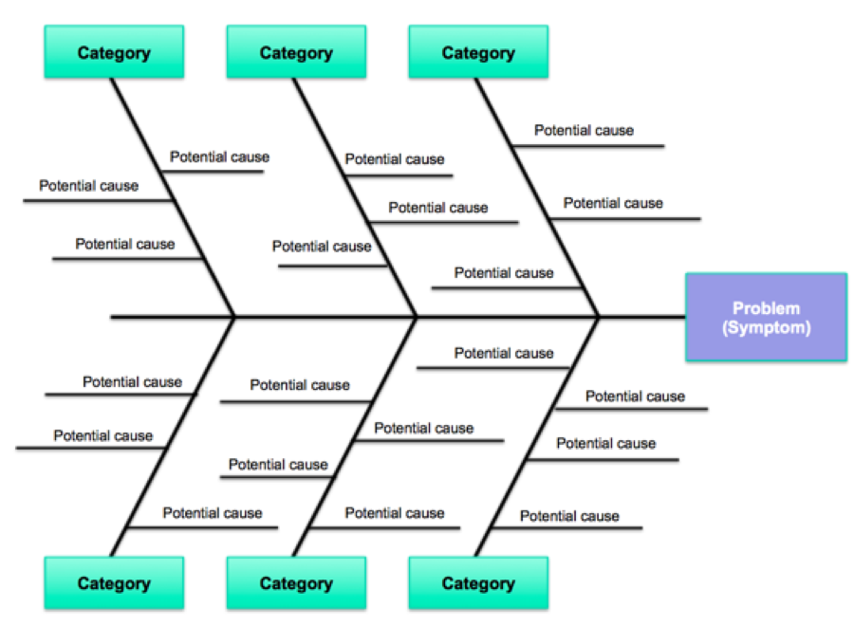

Stakeholder Analysis
Internal | External | Connected
Air host | Other airlines | Customers
Passengers | communities | staff
Air traffic control | security | Cleaners
Pilot | Travel agent | Cabin crew

PESTLE Analysis
Political – airlines liberation, open sky agreement
Economic – uncertainly of fuel cost, economical state of region
Sociological- customer environmental awareness, consumers travel lifestyle and demographics
Technologic – internet adaption, much more energy efficient engine
Legal- corporate lawsuits, allegation on misleading advertisement
Environment- controlling noise pollution

Conclusion
Staff and leaving because due to no having they holiday leave and flights been cancelled leaving them no payments fee the main issue from ryanair was cancelling flights during the Christmas time, people around the UK and Europe complained on how much they have spent on the tickets due to how expensive it was, cabin crew and then strike up to 48 hours due to payments and poor conditions, customers was not happy about paying extra for the seating just o sit near the family or friends. Dealing with low wages and paying for them uniform, training, and not getting paid for the hard work leaving them demands. Leading pilots quitting they jobs and no one qualified to cover them, also overpriced food and selling products on the airplanes for commission. People are paying extra to sit next to a window and good seating areas. People complained about how dirty it was and how minimum they clean by one of the staff member got food poisoned due to unhygienic the food was and how dirty the place was people complained on how minimum the food was and wasn’t any choice but to buy it because they was hungry. Flights was being delayed or there would be cancelled people would complain on how they had to buy another ticket if they miss it. Due to competing to other airlines like Easy, jet and British airline is the biggest airline larger than ryanair.
Recommendation
1)I would recommended on hiring more staff to cover people being absent,
2)cleaning more than once a day and avoiding food poisoning by cleaning the toilets , by issuing the problems and dealing with it by a solution
3) No disrespecting the pilots will not help to solve shared problems or make they come back from the annual leave by giving them bonuses.
4) Permanent local contracts – following national laws and rights
5) Co-ordination between regional pilot teams – recognised as negotiating partners
6) Benchmarking of conditions with regional competitor airlines to stem the exit of pilots
7) New contracts, properly negotiated, by 01 Jan 2018 – with agreed interim arrangements if negotiations are delayed
8) Pilots are pilots – they will therefore have their own professional assistance for any negotiations
9) Pilots want Ryanair to succeed and thrive. They want to minimise cancellations and will support as much as possible every effort to achieve this stability
10 ) Pilots will surrender some of their leave to help resolve the current problems, but only in the context of the changes outlined above
On how to improve your management communication is by having more team meetings, setting a routine for the team members for the absence, more training and addressing the problems straight away by the higher management. Hiring more staff for each cabin crew can get more help and advice from someone who can give more support and replying back even if too busy. Giving credit to team members for them achievements can boost they can be more confident at work and bring brilliant team skills to the table, working in a team can help with your confidence and strengths work on your weaknesses and build up your work career by following the fish bone method.
By setting a routine can help the staff members on the busy schedules so they won’t be under stress during work giving out free training and uniform , share the work between the cabin crew members if stuck and need help it can also cause problems with the team and can give poorly customer service by bad customer service, leaving them confused by that suggesting a good routine with the staff and being organised and sharing ideas when someone or just email the manager if required for any problems Evaluate each other ideas together, be clear when hearing each other while in a team meeting, encourage other staff members to trust each other. Setting ground rules will also help with the staff member by being strict on time and work.Update they website and improving the customer service, making sure to have extra a staff members on the cabin crew and saving oil petrol for the environment .

Reference List
American society for quality,(2018),www.asq.org/team-quality,(19th July 2018)
Gerry Johnson, Kevan Scholes, Richard,(8th editon),exploring corporate:strategy:textandcase,(19th july)
luk gaham,(13th july 2018),www.gurdian.com),(19th july2018)
Marianne Calnan, (22ndsep2017),www.peoplemanagement.co.uk,(19th july)
sally,www,moneysavingexpert.com,(june 2018),(19th 2018)
simon calder,(24th july 2017),www.independet.co.uk),(19th july 2018)
Tony dundon, (October 20th 2014), www.mbs.ac.uk,(19th July 2018)
www.cnbc.com),(13th july 2017),(19th july)
www.corporate.aerlingus.com,(2018),(19th july 2018)
www.edrawsoft.com,(october 20th 2016),(19th July 2018)
www.independent.com,(2018),(19th july 2018)
www.slideshare.net/PauliusBagdanskas/ryanair-industry-analysis-a-case-study-report,(2017),(19th july)
www.theguardian.com,(2018),(19th july 2018)
www.thejornalie/ryanair.com,(2018),19th july 2018)

Appendix
Here are some examples on the weaknesses and strengths:



