Internet Technology and Security

Content

Introduction … Page 3

What is Bring Your Own Device (BYOD) … Page 3

The Pros and Cons of BYOD … Page 3 – 4

Pros of BYOD … Page 3 – 4

Cons of BYOD … Page 4

Threats to Security … Page 5

Protection against Threats … Page 7

Conclusion … Page 8

Reference List … Page 9

Appendices … Page 10

Introduction

Cyber security is a major issue that both online and high-street, large and small businesses face daily. Frequency of cybercrimes has increased and so poses a major concern for organisations, companies and anyone that requires security to be in place. This issue of an increase in cybercrimes and also getting the right level of security set up for the business and processes that will be undertaken in the business, this balance for their performance and safety measures to allow for a comfortable experience for both the employees and the customers is the reason that internet security can cost a lot of money for a business. The level of cybersecurity between different companies, organisations and businesses can vary greatly, depending on the level of information that is being held by them, and how much value that information can have. [1]
However, if viable and sustainable cybersecurity processes are in place and procedures are followed by anyone accesses the network, the ease of access for staff and customers and the savings in costs for the purchase of devices for the company can be of great value to any organisation or business.

What is Bring Your Own Device (BYOD)
In a lot of businesses and organisations it is common to see personal devices being used in order to carry out tasks in the workplace. [1]This creates an environment where bringing your personal device into work, these devices need to be secured to ensure that the network that they are to be used upon is not compromised in anyway. [2]This security can be via several widely used security measures and tools in order to protect the network in question. They can be things such as firewalls and anti-virus software and any other similar software or tool that will provide the desired protection of the personal device on the network. [2]
As it can be imagined, though Bring Your Own Device is extremely productive for many parts of industry, it does come with a lot of possible threats not too dissimilar to any Desktop computers and set ups. Some common and regularly occurring threats to any device on a network are malware, data leakage and distributed denial of service (DDoS) attacks. [2]

The Pros and Cons of BYOD
Bring Your Own Device is a vastly growing practise by many companies and organisations, as mentioned previously, and is growing to become and accepted practise in modern day business.
With many other practises in the workplace, there are obvious pros and cons to this practise.
Pros to BYOD
Convenience
The convenience of being able to bring your own device to the office that an employee will be comfortable using can have an effect of improving the work ethic of individuals. The ease at which an employee can also use their mobile phone instead of a computer to perform their work tasks instead of juggling between a desktop and their mobile device also makes it more convenient for the staff member.

Cost Savings
Implementing a Bring Your Own Device policy and practise into the business, there will be a reduction in costs for hardware such as desktop computers, laptops, and mobile phones from the staff within the business. Very few employees may not have their own device, meaning that the cost for purchasing a suitable device for an employee may never be completely gone, however most employees have access to their own mobile devices, whether that be a laptop or mobile phone, that is capable of performing some or all work tasks that are required of them.

Efficiency
With an employee using their own device in a Bring Your Own Device policy, there will be almost no need for any learning of the equipment and the use of that device. As it is their own device, they will already understand how to use this, and from the start on the policy on day one they can be productive immediately.

Cons of BYOD
Higher Security Risks
Though it is possible to create rules to help with the prevention of security breaches and data being compromised, enforcing the policy can sometimes be harder at times. This is especially seen more when either working from home with their own device or allowing someone else to use their device that they use to work from. Although it is possible to use VPNs to help protect an employee’s connection to the internal network and keep them secure, if the device holds sensitive data it can pose a security risk if anyone is able to freely gain access to that device. This is just one example of a security risk, which mainly looked at data leakage, there is also malware and DDoS attacks that are malicious and cause issues for a business and the sensitive data that is trying to be protected by the business.
IT Support
A business that only owns one brand of hardware or specific software means their IT support teams are able to assist more easily in any issues that may come about with those devices. When more brands and more varied devices are added to the business through a Bring Your Own Device policy the amount that the IT support team must cover to help support the staff of the business increases, so too does the amount of strain on these support teams due to this.

Threats to Security

Distributed Denial of Service (DDoS)
A Distributed Denial of Service attack, or DDoS attack, is an attack on the availability of services of a given target system or network that is commonly launched indirectly through a compromised computing system or many compromised computer systems. [4]These attacks in short, are a malicious way for an attacker to disrupt the normal traffic of data at a targeted service, network or server through the use of overwhelming the target with a flood of internet data traffic. [2]DDoS attacks can deny regular employees and customers from running machines on the network or their own personal devices from that network. Any corporation or business that is subjected to a DDoS attack will have their servers negatively impacted, and this will ultimately deny the availability of the system to the users of said network. [2]This disruption can be costly for the business as network access will be greatly denied for employees and customers a like and therefore causing delays in service.

Data Leakage
Data leakage occurs as a result of access to corporate or business data anytime and anywhere by its employees and potentially its customers This by the misuse of that access by these sources to the network they are attempting to connect to or are connected to. [2]A business or corporation has a reduced amount of control over the data they store and use over the network due to data on that network being stored and accessed by personal mobile devices of employees using the BYOD method of working on the network. [2]If an employee loses the device, the sensitive data that could be stored on that device will be available to any person who finds the device and manages to gain access to it. If the data available in the lost personal device are sensitive and confidential business or customer data, they can be made available publicly by the person in the possession of the device. This will open the company to blackmailing by the person or people that have gained access to the lost device and the data that device has stored upon it. [2]This can cost the business an awful lot of money in ransom and damages caused by this data leak and can also have the effect of impacting how the business or company is viewed by the public, investors and staff members. This negative viewing of the business or company can sometimes be more impactful on the business than the financial loss of the data or the ransom that was being blackmailed. It can prevent further trade with some corporations, make staff, customers and partners feel that their data is not being stored safely within the company’s network. They will therefore not want to have the company hold or store information that they require on their network due to the insecurity of the networking, being able to be broken by poor use of the Bring Your Own Device method of working. [5]

Malware
Malware refers to malicious applications that can affect both mobile devices such as laptops and mobile devices for the use of Bring Your Own Device, and even business machines and applications. [2] Malware that can affect mobile devices that can be used for BYOD include applications with code embedded within them, that compromise the security of these mobile devices or related data that can be obtained from these devices. Additionally, malicious applications can be encountered when a user visits a compromised site. When a device becomes compromised by malware, any company confidential data that the business holds can be obtained and lost. [1]An effect of this can be that identities within the business can be impersonated by the attacker, resulting in further data being obtained by the attackers, and potential reoccurring attacks also. In addition to compromising individual devices that are externally connecting to the network, malware can also affect business applications and devices, thereby rendering them unusable or non-functional. [6] This can be extremely impactful on a business with costs in mind, most likely replacing the effected applications or machines. Malicious applications normally take the appearance of a normal or regularly used business applications that have been injected with malicious code intended to affect the targeted application or device in order to extract any sensitive or confidential data from that application or device. Malicious malware and code can be inserted into an application, which is known as a Trojan app, with the intent of getting past any firewall or security that is already in place to stop any breach. It does this by appearing like an innocent or recognised application that a user would use regularly or would assume was not be of a threat to the user. [4]Malware can also appear embedded within many forms of social media and communication applications. This can be within emails sent to a staff member or user, or SMS messages with malicious links to follow. [2]The intent of these links sent by email or SMS is to direct the user to a website that hosts the malicious code, or directly in the message is the malicious code ready to infiltrate the machine or application they be connected to obtain any data it can.

Protecting against Threats

In order to avoid threats to a network system it is crucial to establish security policies and network securities also.
A network should be developed with adequate security measures – Firewalls, password encryption, and switches to allow from security before the servers. Appendix A is a good simple example of what this security network could potentially look. [4]
A Bring Your Own Device Policy should be created with security guidelines to help protect companywide resources when being accessed from anywhere. This policy should also be made available for all staff and potentially for customers also. [5]
This BYOD policy must include security guidelines that require:

- Minimum security controls on devices, such as password with strong alphanumeric passwords and data encryption.
- Data of confidential nature must be stored on a secure cloud infrastructure and not to be kept locally on any BYOD device.
- A device security application or equivalent that must be installed on any BYOD device before being allowed to connect to the network.
- If not connected through a wired connection to the network, connection to a VPN must be established to create a secure point-to-point connection between device and the target location.
- IT Support must be able to remote access a device via Mobile Device Management (MDM) in order to wipe the contents of the device if any data breach is detected, virus detected or threat to any data or infrastructure is found to be present. This can apply also to a lost device.

Conclusion

A BYOD policy may work extremely well for a smaller company. However, it would be best not to make the decision to implement a BYOD policy when based mainly on the convenience of the policy and saving to cost that could potentially be had by implementing this.
It would be wise to think about how a BYOD policy could have an impact upon the business when mainly looking in terms of the privacy, confidential and general business data safeguarding, security that is required of the network, and IT support that will be required in order to maintain the policy and implement. A though should be made towards what device or devices employees would want to use for work while sticking to a BYOD policy. The future would also need to be thought of when making a decision too, mainly about how to handle the devices or software upon the devices when an employee leaves the organisation.
It seems to be a double-edged sword, but well worth the effort of implementing if done properly.

[1]

References

[1] | J. W. a. K. V. Y. Wang, Bring your own device security issues and challenges, Las Vegas: 11th Consumer Communications and Networkngi Conference , 2014.
[2] | M. T. A. R. M. A. A. Morufu Olalere, A Review of Bring Your Own Device on Security Issues, 2015.
[3] | K. D. a. M. Bhattacharya, BYOD Security: A New Business Challenge, Chengdu, 2015.
[4] | L. Semer, “Auditing the BYOD program: The growing business use of personal smartphones and other devices raises new security risks,” Internal Auditor Vol 70, No. 1 , p. P. 23+, 2013.
[5] | K. Ready, “Issues in Information Systems Volume 14, Issue 2,” BYOD Issues and Strategies, pp. P. 195-201.
[6] | P. Gwalior, “International Conference on Information Security & Privacy,” Legal Issues in Secure Implamentation on Bring Your Own Device, 2015.
[7] | L. Semer, “Auditing the BYOD Program,” The Growing Business use of Personal Smartphones and other devices raises new security risks, 2013.

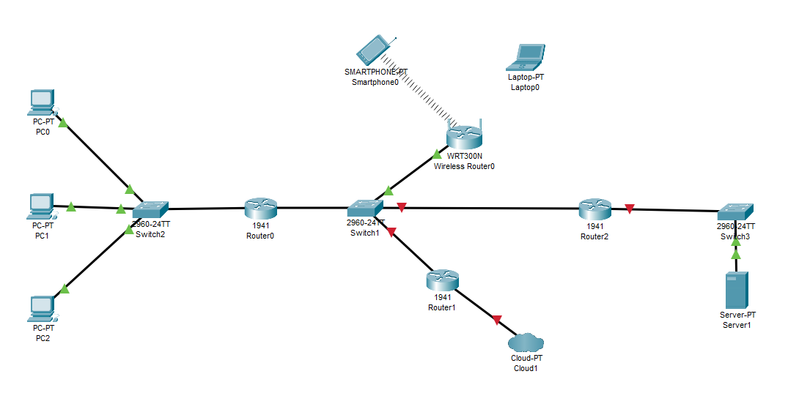
Appendices

Appendix A.
Above is the Network Topology of the example system to implement.
The wired system on the far left, the wireless/BYOD system to the top, Cloud working toward the bottom, and to the far right the core servers of the network.

