DISSERTATION PROJECT
Module code: LCBB6000

THE IMPORTANCE OF DIGITAL MARKETING FOR SME’s FOR HAIRDRESSING INDUSTRY IN THE UK

Student name: Cornelia-Roxana Rad
Student ID: 2023709

Supervisor Name: Tushara Balendran
Table of Contents
Abstract 4
Acknowledgement 5
1. INTRODUCTION 6
1.1 Introduction 6
1.2 Background 8
1.3 Rationale of the study 9
1.4 Research Aim 9
1.5 Research objectives 9
1.5 Research Questions 10
1.6 Dissertation outline 10
2. LITERATURE REVIEW 12
2.1 Introduction 12
2.2 Definition of digital marketing 13
2.3 Brand Loyalty 13
2.4 SME’s and Customers in the hairdressing industry 15
2.5 The current digital marketing strategies utilised by SME’s for hairdressing companies in the UK 17
2.6 How customers perceive and respond to different types of SME’s messages promotional offers, appointment reminders, and other communication efforts 18
2.7 The impact of digital marketing strategies on the brand loyalty of hairdressing customers 19
2.8 Advantages and disadvantage of SEM’s hairdressing companies in implementing digital marketing 19
2.9 Literature gap what is the limitations of the current research 20
2.10 Race Model 21
2.11 The Honeycomb Model 24
2.12 Honeycomb Model versus RACE Model. Differences and Similarities 30
3. RESEARCH METHODOLOGY 31
3.1 Introduction 31
3.2 Research Philosophy 32
3.3 Research approach 32
3.4 Research strategy 33
3.5 Type of investigation 33
3.6 Primary Research 33
3.7 Advantages and Disadvantages of Primary Research 34
3.8 Secondary Research 35
3.9 Advantages and Disadvantages of Secondary Research 35
3.10 Choices 36
3.11 Advantages and Disadvantages of Quantitative Research 37
3.12 Time Horizons 38
3.13 Data collection and analysis 38
3.14 Sample size 38
3.15 Sample type 38
3.16 Sampling method 39
3.18 Data Collection method 40
3.19 Analysis of Data 40
3.20 Research Ethics 41
4 .ANALYSIS OF DATA 42
4.1 Introduction 42
4.2 Questionnaire Analysis 42
5. CONCLUSION AND RECOMANDATIONS 51
5.1 Conclusion 51
5.2 Recommendations 54
5.3 Limitations 56
6. FURTHER RESEARCH 57
7.REFERENCES 58
8. APPENDIX 61

Abstract

The success of small and medium-sized enterprises (SMEs) in the UK hairdressing industry is increasingly dependent on effective digital marketing strategies. This study aims to explore the impact of digital marketing on customer preferences, perceptions, and behaviour in this industry. The research questions investigate customer preferences for SME marketing, their responses to different types of marketing messages, the key factors influencing the success of marketing campaigns, and the impact of digital marketing on brand loyalty. The study employs a mixed-methods approach, combining surveys with hairdressing customers and interviews with industry experts. The findings reveal that SMEs in the hairdressing industry can improve their marketing effectiveness by focusing on customer engagement, personalization, and social media marketing. The study provides insights into how SMEs can optimize their digital marketing strategies to build brand loyalty and drive business growth in this competitive industry.

The study also highlights the role of customer feedback and engagement in shaping effective marketing campaigns. SMEs that actively seek customer feedback and incorporate it into their marketing strategies are more likely to build strong customer relationships and establish a loyal customer base.
Another important finding is the importance of personalization in digital marketing. Customers are more likely to engage with marketing messages that are tailored to their specific needs and preferences. SMEs can leverage customer data and analytics to create personalized marketing campaigns that resonate with their target audience.

Finally, the study underscores the growing importance of social media marketing in the hairdressing industry. SMEs that effectively utilize social media platforms to connect with customers and build brand awareness are more likely to succeed in this highly competitive industry.

Acknowledgement

I would like to express my deepest gratitude to all those who have supported and assisted me in completing this research.

Firstly, I would like to thank my supervisor, Prof. Thushara Balendran for their invaluable guidance, constructive feedback, and unwavering support throughout the research process. Their expertise and experience in the field have been instrumental in shaping the direction and quality of this study.

I would also like to thank the participants in this study, including the customers and industry experts who generously shared their time and insights with me. Their valuable contributions have greatly enriched the research findings.

I would like to extend my sincere appreciation to the University of Wales Trinity Saint David for providing me with the necessary tools and resources to conduct this research. Their support and commitment to academic excellence have been instrumental in the successful completion of this dissertation.

Finally, I would like to acknowledge the support of my friends and family, who have provided me with emotional support, encouragement, and motivation throughout this challenging but rewarding journey.

I am deeply grateful to all of you for your contributions to this research, and I hope that my findings will make a positive impact on the hairdressing industry."

1. INTRODUCTION

1.1 Introduction

Digital marketing is a broad term that refers to various tactics and techniques used to advertise products or services online. This can include developing a website, optimizing it for search engines, leveraging social media platforms, creating engaging content, sending emails to potential customers, and displaying advertisements on the internet. These strategies are particularly beneficial for small and medium-sized enterprises (SMEs) in the hairdressing industry, as they provide an affordable and effective way to reach their target audience, increase brand recognition, and ultimately boost their business success (Ryan & Jones).
Digital marketing enables SMEs in the hairdressing industry to establish a more personal connection with their customers, fostering a sense of community and loyalty. By utilizing social media and email marketing, hairdressing salons can establish direct communication channels with their clientele, allowing them to address concerns promptly, provide personalized recommendations, and offer exclusive deals. This level of personalized engagement not only enhances customer satisfaction but also encourages positive word-of-mouth referrals, which are crucial for the success of SMEs in this industry. Through these channels, hairdressing salons can create a community of loyal customers who not only return for their own hair care needs but also refer their friends and family to the salon, helping to grow the business.
In addition to its targeting capabilities, digital marketing also enables SMEs in the hairdressing industry to analyse and measure the effectiveness of their marketing efforts. Through various analytics tools and metrics, SMEs can gain valuable insights into consumer behaviour, campaign performance, and return on investment. This data-driven approach empowers SMEs to make informed marketing decisions, refine their strategies, and allocate their resources more effectively.
In today's increasingly digital world, businesses across various industries are embracing digital marketing strategies to stay competitive and reach their target audiences effectively. The hairdressing industry in the UK is no exception. With the rapid growth of online platforms and the changing consumer behaviour, it is crucial for hairdressing salons to adopt digital marketing techniques to enhance their brand visibility, attract new customers, and retain existing ones (2021).
Moreover, digital marketing allows SMEs in the hairdressing industry to precisely target their desired audience. Through methods such as social media advertising or search engine marketing, SMEs can tailor their marketing messages and campaigns to reach individuals who are actively seeking hairdressing services or have expressed an interest in related topics. This targeted approach increases the likelihood of attracting qualified leads and converting them into loyal customers.
One of the primary benefits of digital marketing for SMEs in the hairdressing industry is its ability to level the playing field. Unlike traditional marketing methods that often require significant financial resources, digital marketing provides SMEs with affordable and accessible avenues to reach their target market. With the right digital marketing strategies, even small hairdressing salons can compete with larger establishments, effectively reaching potential customers and showcasing their unique services and offerings. This equal opportunity to engage with consumers enables SMEs to establish their brand presence and create a competitive edge.
Small and Medium-sized Enterprises (SMEs) play a crucial role in the hairdressing industry, contributing to its vibrancy and diversity. However, SMEs in the hairdressing sector face numerous challenges, including fierce competition from larger establishments, limited marketing budgets, and the need to reach and engage with their target market effectively. In today's digital age, the importance of digital marketing cannot be overstated. It has become an essential tool for SMEs in the hairdressing industry to establish their brand presence, attract new customers, and foster customer loyalty. This introduction aims to highlight the significance of digital marketing for SMEs in the hairdressing industry (2019).

1.2 Background

The hairdressing industry in the UK has experienced significant growth over the past decade. As a highly competitive market with numerous salons vying for customers, it is essential for hairdressing businesses to differentiate themselves and stand out from the competition. Traditional marketing strategies, such as word-of-mouth referrals and print advertising, are no longer sufficient to reach and engage with the target audience effectively. Thus, digital marketing has emerged as a critical tool to connect with customers and promote hairdressing services in an increasingly digital landscape.
Traditionally, hairdressing salons relied on conventional marketing methods such as print advertisements, flyers, and word-of-mouth referrals to attract customers. While these strategies still hold some value, they are no longer sufficient to reach and engage with the target audience effectively. The advent of digital technologies and the widespread use of the internet have transformed consumer behaviour and expectations, necessitating a shift towards digital marketing in the hairdressing industry (Pearson, 2017).
While digital marketing presents numerous opportunities, it also poses challenges for hairdressing salons. These challenges include staying updated with evolving digital trends, managing multiple online platforms, and effectively utilizing data and analytics for informed decision-making. Despite these hurdles, embracing digital marketing is crucial for hairdressing salons in the UK to remain competitive, reach their target audience, and adapt to the changing consumer landscape.
The hairdressing industry in the UK is undergoing a transformation with the increasing importance of digital marketing. Digital marketing offers hairdressing salons the ability to expand their reach, engage with their target audience, and build strong customer relationships. By embracing digital marketing strategies, hairdressing salons can position themselves for success in a competitive market, attract new customers, and cultivate a loyal customer base (Kotler, et al., 2017).

1.3 Rationale of the study

The purpose of investigating the utilisation of SMS marketing in the hairdressing business is to gain insights into its efficacy and advantages in terms of consumer outreach and engagement. The objective of this study is to analyse the effects of SMS marketing as a digital marketing technique on customer retention, customer satisfaction, and business growth within the hairdressing industry in the UK. By doing this examination, valuable insights regarding the value of SMS marketing will be obtained.
This research has the potential to enhance future strategies in digital marketing or social media marketing. This research offers potential benefits to companies operating within the hairdressing industry, as it provides an opportunity to enhance their comprehension of the influence exerted by social media platforms in terms of client attraction and retention. with measuring the success of their present social media marketing and customer relationship management initiatives.

1.4 Research Aim

The main aim of this research is to analyse the effectiveness and the importance of SME’s marketing in the hairdressing industry in the UK.

1.5 Research objectives

- To determine the current digital marketing strategies utilised by SME’s for hairdressing companies in the UK.
- To analyse how customers perceive and respond to different types of SME’s messages promotional offers, appointment reminders, and other communication efforts.
- To investigate the impact of digital marketing strategies on the brand loyalty of hairdressing customers.
- To analyse the advantages and disadvantage of SEM’s hairdressing companies in implementing digital marketing.

1.5 Research Questions

1.What are the preferences of customers in the hairdressing industry regarding SME’s marketing?

2. How do customers perceive and respond to different types of SME’s messages promotional offers, appointment reminders, and other communication efforts?

3. What are the key factors that influence the success of SME’s marketing campaigns in the hairdressing industry?

4.What is the impact of digital marketing strategies on the brand loyalty of hairdressing customers?

1.6 Dissertation outline

Chapter 1- Introduction

The introductory section provides pertinent background information pertaining to the research topic area, the rationale behind conducting this study, and the unique aspects that set this research apart.
Additionally, it is important to note that this chapter encompasses the research objectives and questions. These elements serve as a compass for the researcher, aiding in the navigation of the study and the fulfilment of the research aims.

Chapter 2- Literature review

This section aims to provide a comprehensive review of relevant literature to contextualise the forthcoming research within existing theoretical frameworks and identify areas that require further investigation. To achieve this, established models in the field of digital marketing (specifically social media marketing) and Customer Relationship Management (with a focus on brand loyalty) will be employed. These models will be used to construct a conceptual framework that highlights the imp The present study will conduct a critical analysis of pre-existing secondary data to gain a deeper understanding of the important issues, advantages, and disadvantages associated with different models.

Chapter 3 – Research methodology

The inclusion of this chapter, which delineates the methodologies and protocols employed for data collection and analysis, is crucial to the overall study. Moreover, this study will offer a comprehensive exposition of the research design, data collection methods, and data analysis strategies implemented in this scholarly article. It will demonstrate the meticulousness and credibility of the processes employed to ensure the precision and dependability of the findings.

Chapter 4 – Analysis of data

This section of the study will consist of a detailed analysis of the survey questionnaire response with a focus on the customers preferences on pick-up the hairdressing salon and the importance of digital marketing for SME’s. Additionally, it will provide valuable insights into impact of digital marketing strategies on brand loyalty.

Chapter 5 – Conclusion

This section will present a comprehensive overview of the research, focusing on the research objectives derived from the primary data gathered and the literature analysis pertaining to the significance of digital marketing for small and medium-sized enterprises (SMEs) operating within the hairdressing industry in the United Kingdom. The recommendation will be formulated based on the research conducted and the subsequent analysis of the data.

2. LITERATURE REVIEW

2.1 Introduction

In today's digital age, the significance of digital marketing for small and medium-sized enterprises (SMEs) in the hairdressing industry in the UK cannot be overstated. With the rapid advancement of technology and the increasing usage of the internet, traditional marketing approaches are no longer sufficient to compete in the highly competitive marketplace. Instead, SMEs need to embrace digital marketing strategies to effectively reach their target audience and enhance their brand visibility (J., 2021).

Digital marketing encompasses various online channels, such as social media platforms, search engine optimization (SEO), content marketing, email marketing, and online advertising. These tools provide SMEs with the ability to engage with potential customers, build brand awareness, and drive sales, all while remaining cost-effective compared to traditional marketing methods. One of the primary reasons why digital marketing is crucial for SMEs in the hairdressing industry is the changing consumer behaviour. Today's consumers are increasingly relying on the internet to search for products and services, including hair salons. A study conducted by Google found that 80% of consumers turn to search engines when looking for local businesses, including hairdressers. Therefore, having a strong online presence is essential for SMEs to be discovered by potential customers (Pedley, 2021).

Moreover, digital marketing allows SMEs to target specific demographics and tailor their marketing efforts accordingly. With the ability to collect and analyse customer data, SMEs can gain valuable insights into their target audience's preferences, behaviours, and needs. This information can then be utilized to create personalized marketing campaigns that resonate with potential customers, ultimately driving higher conversion rates.
Another advantage of digital marketing for SMEs in the hairdressing industry is the opportunity for increased brand visibility and recognition. Through social media platforms and online advertising, SMEs can reach a wider audience and increase their brand exposure. This exposure not only helps in attracting new customers but also builds trust and credibility, as consumers tend to view brands with a strong online presence as more reliable and professional.
Furthermore, digital marketing provides SMEs with measurable results and the ability to track their marketing efforts. Unlike traditional marketing methods, digital marketing allows SMEs to monitor the performance of their campaigns in real-time. This data-driven approach enables businesses to optimize their strategies, identify areas of improvement, and allocate their resources more effectively.

2.2 Definition of digital marketing

Digital marketing refers to the systematic approach of promoting goods, services, or brands via the utilisation of various digital platforms and resources. This encompasses a variety of online marketing techniques and methodologies designed to engage and establish connections with a specific audience using electronic devices such as computers, smartphones, tablets, and other digital platforms (2016) (2017).
Digital marketing encompasses the strategic utilisation of various digital channels, including websites, search engines, social media platforms, email, mobile apps, and online advertising. Through these channels, digital marketing establishes connections with prospective customers, fosters brand recognition, augments website traffic, generates leads, and eventually attains corporate goals (Deiss & Henneberry, 2020).

2.3 Brand Loyalty

Brand loyalty in the hairdressing sector refers to the level of commitment, preference, and repeated patronage that customers have towards a specific hair salon or brand. It is a measure of the customer's willingness to continue engaging with the brand and choosing it over competitors.

Building brand loyalty in the hairdressing sector is crucial for the success and growth of salons and brands. It not only leads to repeat business but also helps in attracting new customers through positive word-of-mouth and recommendations.
There are several factors that contribute to the development of brand loyalty in the hairdressing sector (2015):

- Service Quality: Providing high-quality services that meet or exceed customer expectations is essential for building brand loyalty. This includes factors such as skilled hairstylists, up-to-date knowledge of hair trends and techniques, using quality products, and providing excellent customer service.

- Customer Satisfaction: Ensuring customer satisfaction is a key driver of brand loyalty. Customers should feel valued, listened to, and their needs and preferences should be met. This can be achieved through personalized consultations, attention to detail, and addressing any concerns or issues promptly (S & J., 2019).

- Trust and Reliability: Building trust with customers is crucial for brand loyalty. Customers should feel confident in the salon or brand's ability to deliver consistent results and take care of their hair. This can be achieved through transparent communication, professional conduct, and using reliable and trustworthy hair products (N., et al., 2012).

- Emotional Connection: Creating an emotional connection with customers helps to build brand loyalty. This can be achieved by creating a warm and welcoming environment, establishing a sense of community, and engaging customers through personal interactions and experiences.

- Value for Money: Providing value for money is important in the hairdressing sector. Customers should feel that the services offered are worth the price they pay. This can be achieved through competitive pricing, offering promotions or loyalty programs, and providing additional benefits or perks to loyal customers.

In conclusion, brand loyalty in the hairdressing sector is built through factors such as service quality, customer satisfaction, trust, emotional connection, and value for money. By focusing on these aspects, hair salons and brands can foster strong relationships with customers and enhance their loyalty.

2.4 SME’s and Customers in the hairdressing industry

The marketing efforts of Small and Medium-sized Enterprises (SMEs) are subject to the diverse tastes of customers within the hairdressing sector. While individual tastes may exhibit variability, the following are several prevalent preferences that buyers of hairdressing services may possess:

- Personalized Communication:

Hairdressing small and medium enterprises (SMEs) are valued by customers for their personalised communication. This encompasses many forms of communication, such as personalised emails, text messages, or interactions on social media platforms, which specifically address individuals by their names and make customised suggestions, recommendations, or reminders based on their preferences, previous purchases, or appointment records (2023).

- Mobile-Friendly Experience:

Due to the escalating prevalence of smartphones, clients exhibit a preference for hairdressing small and medium enterprises (SMEs) who provide a user experience optimised for mobile devices. This include the implementation of a website that is designed to be responsive and user-friendly on mobile devices, the development of mobile applications for the purpose of appointment booking or loyalty programmes, and the use of mobile-friendly communication channels.

- Online Booking and Convenience:

The convenience of online booking systems, which enable customers to make appointments effortlessly and expeditiously, is highly valued by consumers. Small and medium-sized enterprises (SMEs) in the hairdressing industry that provide online booking platforms or integrate with widely used salon appointment applications enhance the convenience for customers to schedule appointments at their desired time and minimise waiting periods.

- Social Media Presence:

A significant number of clients within the hairdressing sector exhibit a preference for small and medium-sized enterprises (SMEs) in the field of hairdressing that maintain an active and engaging presence on various social media platforms. The search is conducted for enterprises that exhibit captivating and pertinent information, present their work through visual representations of before-and-after transformations, immediately address consumer inquiries, and furnish regular updates regarding promotional activities or novel offerings.

- Positive Online Reviews and Testimonials:

Customers frequently depend on internet evaluations and comments as a crucial determinant in their decision-making process when selecting a hairdressing small and medium-sized enterprise (SME). Consumers hold a favourable perspective towards enterprises that possess favourable evaluations and testimonials on prominent online platforms such as Google, Yelp, and various social media channels. The provision of exceptional service instils confidence in clients and facilitates their ability to make educated decisions.

- Communication and Transparency:
Effective communication and transparency play a crucial role in meeting the expectations of clients within the hairdressing industry. They value organisations that engage in transparent communication regarding pricing, services, and any possible constraints or prerequisites. Promoting transparency regarding the procedural aspects, utilised items, and any supplementary fees facilitates clients in making well-informed choices and cultivates a sense of confidence.

- Engagement and Interaction:
Customers receive satisfaction from engaging with small and medium-sized enterprises (SMEs) in the hairdressing industry that demonstrate a proactive approach in interacting with them. This encompasses activities like as addressing comments and messages on social media platforms, soliciting feedback or recommendations, and engaging customers in contests or interactive campaigns. The act of engagement fosters a feeling of communal belonging and establishes a link between individuals and the brand.

It is imperative to acknowledge that these preferences may exhibit variability across customers, and it is not necessarily the case that all customers will possess identical preferences. Hence, it is imperative for small and medium-sized enterprises (SMEs) in the hairdressing industry to carefully analyse their target demographic, engage in comprehensive market research, and actively request customer feedback. This approach enables SMEs to gain a deep understanding of their customer base and effectively tailor their services to meet the individual tastes and needs of their clientele.

2.5 The current digital marketing strategies utilised by SME’s for hairdressing companies in the UK

Hairdressers in the UK are using a variety of digital marketing strategies to reach their target audience. Some popular strategies include:

- Social media marketing: Creating engaging content on platforms like Instagram and Facebook to showcase their work and connect with potential customers.
- SEO: Optimizing their website and online presence to improve their ranking in search results for relevant keywords
- Email marketing: Building a database of email subscribers and sending regular updates, promotions, and offers to drive customers to their business.
- Paid advertising: Using platforms like Google Ads and Facebook Ads to target potential customers with relevant ads.
- Online booking systems: Making it easy for customers to book appointments online.
- Content marketing: Create videos showing hairstyling tutorials, product demonstrations, and salon tours. Write blog posts on hair care tips, product reviews, and style inspiration. Develop infographics on hair care routines, hairstyle trends, and product recommendations. Share customer success stories and before-and-after transformations.
- Customer reviews: Encourage reviews on multiple platforms. Respond promptly and positively to al reviews. Highlight and share positive reviews. Use feedback to improve the customers experiences.

2.6 How customers perceive and respond to different types of SME’s messages promotional offers, appointment reminders, and other communication efforts

Here are some factors that can affect how customers perceive and respond to different types of messages:

- Tone: Messaging should be friendly, helpful, and professional. A casual, conversational tone can build a connection with customers.
- Frequency: Customers don't want to be bombarded with messages. A good rule of thumb is to send no more than 1-2 messages per week.
- Personalization: Customers appreciate messages that feel tailored to them. Use their name and reference their previous purchases or appointments.
- Value: Customers are more likely to respond to messages that offer value, such as discounts, special offers, or useful information.
- Timing: Messages should be sent at times when customers are most likely to read them. Avoid sending messages late at night or on weekends.

2.7 The impact of digital marketing strategies on the brand loyalty of hairdressing customers

- Digital marketing strategies can increase brand loyalty among hairdressing customers through regular communication, personalized recommendations, valuable content, and seamless online booking and payment processes.
- A strong digital marketing strategy can build brand loyalty among hairdressing customers by cultivating a sense of community, establishing thought leadership, and creating positive customer experiences.
- The use of social media, email marketing, and other digital channels can enhance the hairdressing customer experience, thereby increasing brand loyalty and customer retention.

2.8 Advantages and disadvantage of SEM’s hairdressing companies in implementing digital marketing

Here are some advantages and disadvantages of digital marketing for hairdressing companies:

Advantages:

- Increased visibility and reach through social media, search engine optimization, and online advertising.
- Ability to target specific audiences based on demographics, interests, and behaviour.
- Cost-effective compared to traditional marketing methods.
- Increased engagement and interaction with customers through social media and online reviews.
- Ability to track and measure the effectiveness of campaigns in real time.

Disadvantages:

- Competition from other businesses in the same niche.
- Cost of hiring digital marketing professionals or agencies.
- Difficulty in keeping up with the constantly changing digital landscape.
- Potential for negative reviews or backlash on social media.
- Potential for data privacy and security concerns.

2.9 Literature gap what is the limitations of the current research

The current literature on digital marketing for hairdressing companies has several limitations:

- Limited focus on small and medium-sized businesses: Most studies focus on large, established brands, which may not be representative of the challenges faced by smaller businesses.
- Limited understanding of the unique challenges and opportunities of digital marketing in the hairdressing industry.
- Limited understanding of the role of social media in building brand loyalty and engagement for hairdressing companies.
- Lack of research on the impact of artificial intelligence and chatbots on customer engagement and retention in the hairdressing industry.
- Lack of information on the use of influencer marketing and other innovative digital strategies in the hairdressing industry.
- Limited information on the hairdressing industry and digital marketing strategies.

2.10 Race Model

The RACE model is a frequently used framework in the field of marketing and communication, serving as a guiding structure for the formulation and implementation of digital marketing initiatives. The acronym RACE delineates distinct phases of the customer experience (Chaffey, 2022):
- Reach
- Act
- Convert
- Engage

The model under consideration was formulated by Smart Insights in the year 2010. Smart Insights is a platform that provides marketing counsel to organisations, aiding them in the identification of their marketing objectives, monitoring their advancement, and evaluating their outcomes (D. & F., 2016).

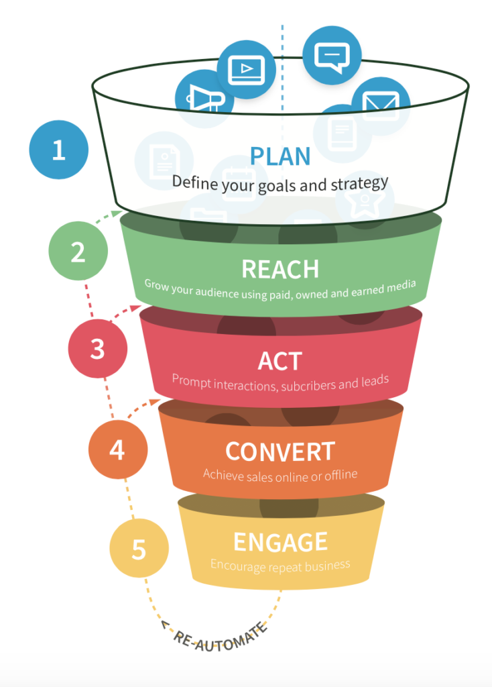Source (internet): (benjamin slap, 2023)
- Reach:
In this stage, the company must build its brand and draw in new clients. The comprehensive strategy encompasses the utilisation of several channels, including as search engine optimisation (SEO), social media marketing, email marketing, content marketing, and online advertising, with the objective of ensuring that the business's intended audience is effectively exposed to its brand and offerings. Hairdressers have the ability to employ several channels and strategies to generate awareness and entice prospective consumers. These methods include using search engine optimisation (SEO) techniques for both branded and non-branded keywords, engaging in content marketing, utilising social media marketing, collaborating with influencers, and employing digital advertising. Many hairdressing salons in the present day prioritise the promotion of exclusivity and distinction, hence necessitating the establishment of a carefully curated web presence and the creation of high-quality content (Oxford College of Marketing, 2023).

- Act:
The subsequent phase entails fostering audience participation and prompting them to act in relation to your brand. Potential actions that individuals may engage in include subscribing to a newsletter, acquiring a whitepaper, engaging in a transaction, or completing a contact form. The objective is to transform individuals who visit a website into potential prospects or paying clientele. Strategies aimed at promoting action may involve the optimisation of landing pages, enhancement of user experience, development of persuasive calls-to-action (CTAs), and integration of lead capturing tools.
- Convert:
The third stage of the process entails the conversion of leads or individuals who visit the website into consumers. The process entails cultivating and establishing connections with prospective clientele, delivering meaningful and informative material, resolving their inquiries and apprehensions, and helping them throughout the progression of the purchasing process. At this juncture, efficacious strategies encompass email marketing, customised messaging, retargeting campaigns, and marketing automation. (F., 2020)
- Engage:
This final stage focuses on developing long-term relationships with clients. This phase entails cultivating customer loyalty and promoting recurring business through customer retention tactics, including tailored email marketing initiatives, provision of exceptional customer care, and establishment of reward programmes. Interacting with clients is a valuable avenue for obtaining feedback, enabling the business to enhance its offerings and customise its marketing strategies to better cater to their requirements (J., 2021).

2.11 The Honeycomb Model

The Kietzmann Honeycomb model, commonly referred to as the Honeycomb model of social media, elucidates the seven fundamental functional components that comprise social media. A model has been developed to analyse the effectiveness of social media by examining the factors that influence user engagement in this context (H., et al., 2011).

Source (internet): (benjamin slap, 2023)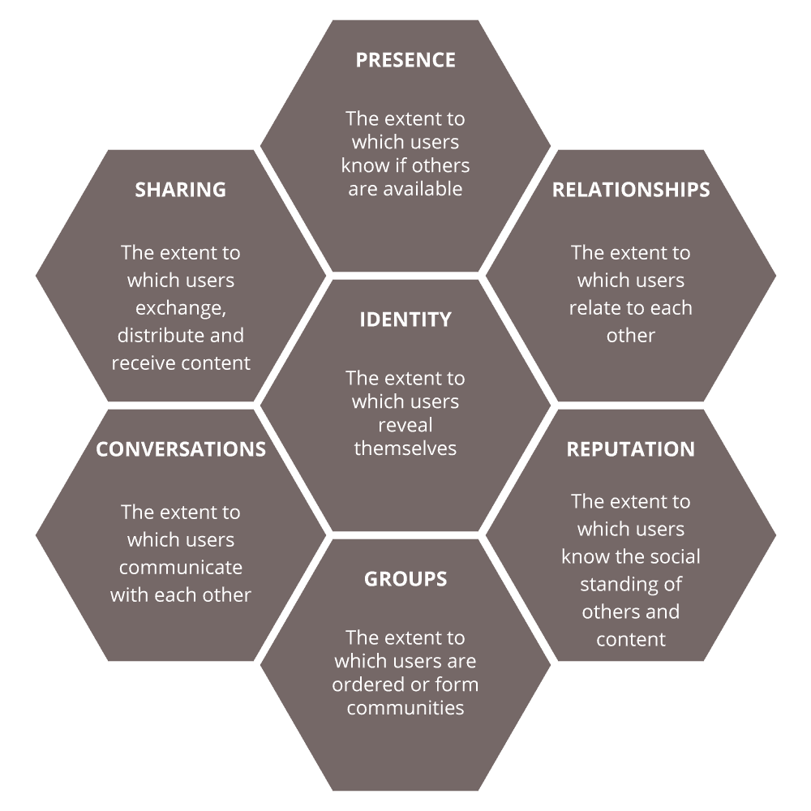

Identity

Identity refers to the online persona or brand image that a hairdressing business presents to its audience. It encompasses the unique qualities, values, and characteristics that differentiate the business from others in the industry. A strong and well-defined identity helps to create a consistent and recognizable brand, which in turn builds trust and loyalty among customers. Elements of identity can include the brand name, logo, colour palette, typography, tone of voice, and overall visual style. It is important for a hairdressing business to establish a cohesive and authentic identity that resonates with its target audience and reflects its values and mission.

Presence

Presence refers to the online platforms and channels that a hairdressing business utilizes to establish its presence and reach its target audience. It encompasses the digital footprint and visibility of the business across various online platforms, including websites, social media profiles, online directories, and review sites. A strong online presence is essential in today's digital age, as it allows potential customers to discover and learn more about the hairdressing business. It also provides an opportunity for the business to showcase its services, share updates and promotions, and engage with its audience. Having a well-designed and user-friendly website, active social media accounts, and consistent branding across all online platforms helps to establish a professional and cohesive online presence. Regularly updating and maintaining these online channels is important to ensure that the business remains visible and relevant to its target audience.

Relationships

Relationships refer to the interactions and connections that a hairdressing business establishes and maintains with its audience. In the context of the honeycomb model for online presence and social media, building and nurturing relationships with clients, influencers, and industry professionals is crucial for the success of the business.

When it comes to clients, a hairdressing business can foster relationships by providing excellent customer service, personalizing the experience, and actively listening to their needs and preferences. This can be done through various online channels, such as responding to comments and messages, addressing customer inquiries and concerns, and proactively reaching out to gather feedback.

Influencers and industry professionals can also play a significant role in building relationships for a hairdressing business. Collaborating with influencers in the beauty and fashion industry can help increase brand visibility and credibility. Engaging with industry professionals through networking events, conferences, and online communities can provide opportunities for knowledge sharing, partnerships, and industry recognition.
By investing in building strong relationships, a hairdressing business can create a loyal customer base, gain valuable word-of-mouth referrals, and establish itself as a trusted and reputable player in the industry.

Reputation

Reputation refers to the overall perception and opinion that clients, industry professionals, and the public have about a hairdressing business. It is an important aspect of a business's identity and can significantly impact its success.

Building a positive reputation involves consistently delivering high-quality services, meeting customer expectations, and maintaining strong ethical standards. It also involves actively managing and responding to customer feedback, whether it is positive or negative.

In the digital age, reputation management also extends to online platforms such as review sites, social media, and online directories. Monitoring and responding to online reviews and comments is crucial in shaping and maintaining a positive reputation. Engaging with customers, addressing their concerns, and seeking resolution can help build trust and demonstrate a commitment to customer satisfaction.

Additionally, a hairdressing business can enhance its reputation through positive word-of-mouth recommendations, collaborations with reputable industry professionals, and participation in community events or charitable initiatives. These activities can contribute to a favourable perception of the business and differentiate it from competitors.

A strong reputation is valuable as it can attract new customers, retain existing ones, and enhance the overall brand image of the hairdressing business. It is important for a business to consistently uphold its values and deliver exceptional service to maintain and enhance its reputation over time.

Groups
In the context of a hairdressing business, "groups" can refer to various audiences or communities that the business interacts with or targets. Here are a few examples of groups relevant to a hairdressing business:

1. Target Audience: This group represents the specific demographic or market segment that the hairdressing business caters to. It may include individuals of different ages, genders, and lifestyles who are interested in haircare, hairstyling, and related services.

2. Existing Clients: This group consists of individuals who have already used the services of the hairdressing business. Maintaining a strong relationship with existing clients is important for customer retention and encouraging repeat business.

3. Prospective Clients: This group includes individuals who have shown interest in the hairdressing business but have not yet become clients. Targeted marketing efforts, such as advertising, promotions, and online engagement, may be directed towards this group to attract them as new clients.

4. Industry Professionals: This group consists of individuals who work in the hairdressing, beauty, and fashion industries. Building relationships and collaborating with industry professionals, such as hairstylists, makeup artists, and fashion designers, can help expand the network and create opportunities for partnerships and referrals.

5. Influencers and Bloggers: This group includes individuals who have a significant following on social media platforms or run popular beauty and fashion blogs. Collaborating with influencers and bloggers can help increase brand visibility, reach a wider audience, and gain credibility among their followers.

6. Community Organizations: This group consists of local community organizations and groups that a hairdressing business can engage with. Participating in community events, sponsoring local initiatives, or offering special discounts for community members can help build a positive brand image and establish a presence within the local community.

Identifying and understanding these different groups can help a hairdressing business tailor its marketing strategies, communication efforts, and services to meet the specific needs and preferences of each group.

Conversations

Conversations are an essential part of communication and interaction within a hairdressing business. They involve exchanging information, ideas, and opinions between hairdressers and clients, as well as among team members. Effective conversations play a crucial role in delivering excellent customer service, understanding client needs and preferences, and ensuring a positive experience.

Sharing

Sharing is an important aspect of a hairdressing business, as it involves distributing and exchanging information, resources, and experiences. Here are a few ways in which sharing is relevant to a hairdressing business:

1. Sharing Expertise: Hairdressers can share their knowledge, skills, and expertise with clients to educate them about haircare, styling techniques, and product recommendations. This helps clients make informed decisions about their hair and empowers them to maintain their hairstyle between salon visits.

2. Sharing Inspiration: Hairdressers often share images, trends, and style ideas with clients to inspire them and help them envision their desired look. Sharing before-and-after photos, celebrity hairstyles, or current trends can spark creativity and assist clients in finding the perfect hairstyle.

3. Sharing Product Information: Hairdressers can share information about the products they use during appointments, such as the benefits, ingredients, and proper usage. This allows clients to understand the products they are using and make informed choices about their haircare routine.

4. Sharing Feedback: Clients can share their feedback and reviews about the hairdressing services they received. This feedback is valuable for the business as it helps identify areas for improvement and maintain high-quality service standards. Positive feedback can also be shared on social media or review platforms to showcase the business's success and attract new clients.

5. Sharing Promotions and Offers: Hairdressing businesses often share special promotions, discounts, or loyalty programs with clients to encourage repeat visits and referrals. Sharing these offers through various channels, such as social media, email newsletters, or in-salon signage, helps spread the word and attract new clients.

6. Sharing Industry Insights: Hairdressers can participate in industry events, workshops, or education programs to stay updated on the latest trends, techniques, and product innovations. Sharing this knowledge with the team and incorporating it into the salon's services keeps the business competitive and ensures clients receive the most current and relevant hairdressing experience.

By embracing the concept of sharing, a hairdressing business can foster strong relationships with clients, build trust, and establish itself as a reliable source of expertise in the industry.

2.12 Honeycomb Model versus RACE Model. Differences and Similarities

Differences

The Honeycomb model is predicated upon the notion that social media may be comprehended by means of seven fundamental components that symbolise distinct facets of social media. In contrast, the RACE model delineates the various phases of the customer journey within the realm of digital marketing, underscoring the significance of effectively identifying the appropriate target audience and effectively conveying tailored messages at each juncture of the customer journey.
The Honeycomb model is primarily designed to address the realm of social media marketing, while the RACE model spans a wider scope of digital marketing activity. The Honeycomb model has been developed as a tool to aid companies in comprehending the complex social media landscape and optimising the effectiveness of their social media strategy. In contrast, the RACE model employs a more complete approach and provides a strategic framework that can be applied across many digital marketing platforms.
Both models provide useful perspectives on the field of digital marketing, but from distinct standpoints. The Honeycomb model places greater emphasis on the various components of social media and their interrelationships. The RACE model places greater emphasis on the customer journey and strategies for effectively engaging customers at each stage.

Similarities

Both models place a significant focus on the significance of effectively communicating and engaging with the intended audience. Moreover, both models place emphasis on the establishment and sustenance of customer relationships, ultimately resulting in enhanced brand reputation. Both Honeycomb and RACE miles prioritise the utilisation of digital media to accomplish marketing goals.

3. RESEARCH METHODOLOGY

3.1 Introduction

The research methodology refers to the framework that guides the process of conducting research, considering the underlying philosophical and theoretical principles upon which the research is built, and the implications of these assumptions for the chosen research method (Saunders, et al., 2019).

Metaphorically speaking, the layers of research technique are represented by the research onion. The framework presented by Melnikovas (2018) , was designed to depict the many stages or degrees of research and their interconnectedness. The implementation of the research onion framework aids researchers in comprehending the intricate nature and advancement of research design, while also offering a systematic methodology for carrying out research (Phair & Warren, 2021).

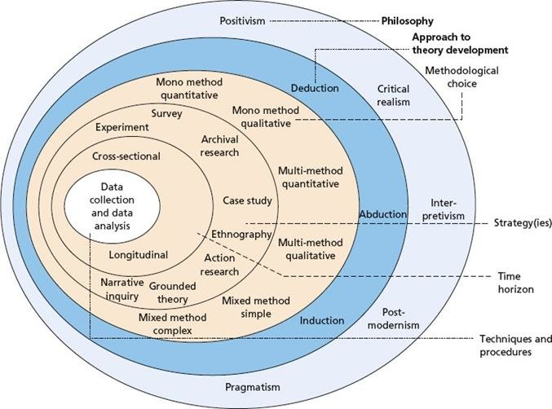
Source(internet), (Tambun, 2023).

3.2 Research Philosophy

The researcher's philosophical viewpoint or worldview, which influences their approach to knowledge and the research process, is symbolised by the outermost layer. This stratum encompasses philosophical frameworks such as positivism, interpretivism, critical theory, and pragmatism. The research philosophy that is selected has a direct impact on the choice of research methods and the subsequent interpretation of research findings. The study will adopt positivism as the overarching philosophical framework to address the research objectives outlined in the introduction. The utilisation of positivism in this study will enable the researcher to gather empirical data and information, subject it to scrutiny in order to validate or invalidate the research hypothesis, and thereafter formulate explanations grounded in the prevailing paradigm (Sahay, 2016).

3.3 Research approach

Saunders (2019) believes that the deductive approach is a research methodology employed to construct theories, wherein the evaluation of a theoretical assertion is conducted through the utilisation of a research plan tailored for this objective. In this study, the researcher will employ a deductive technique to ascertain the significance of digital marketing for small and medium-sized enterprises (SMEs) in the hairdressing industry in the United Kingdom. The research project will employ a deductive approach to examine the significance of digital marketing for small and medium-sized enterprises (SMEs) operating in the hairdressing industry within the United Kingdom. This methodology entails commencing with a broad theory or hypothesis pertaining to the field of digital marketing and its relevance to small and medium-sized firms (SMEs) operating within the hairdressing sector. The theoretical framework can be derived from a synthesis of relevant scholarly literature, prevailing patterns within the sector, or authoritative viewpoints from subject matter experts.
Specific predictions or hypotheses can be drawn from this overarching framework. The forecasts may encompass assertions such as "Small and medium-sized enterprises (SMEs) in the hairdressing industry who successfully use digital marketing strategies are likely to observe enhanced levels of consumer involvement and a subsequent rise in sales." The forecasts will establish the fundamental basis for the forthcoming research investigation (Stainton, 2021).

3.4 Research strategy

The deductive research approach is commonly associated with the survey strategy (Saunders, et al., 2019).The application of this methodology is prevalent in the field of business and management research, mostly aimed at addressing inquiries related to the subject matter. In the context of research inquiry, it is essential to address the fundamental questions of "who," "what," "how much," "where," and "how many." These inquiries serve as the basis for gathering comprehensive and objective information. By systematically examining these aspects, researchers can gain a deeper understanding of the subject matter under investigation. Therefore, it is frequently utilised in descriptive and exploratory research (Saunders, et al., 2015).
A survey is a methodical approach of gathering information from a set of individuals to depict, comprehend, or elucidate the characteristics, perspectives, behaviours, or attitudes of a larger population (FJ., 2013).
In this study, a survey questionnaire approach was utilised to gather comprehensive, trustworthy, and easily understandable data from users of social media sites, including both followers and consumers to analyse the problem.

3.5 Type of investigation

The current study has employed both primary and secondary investigation methods in order analyse and collect data in support of the research aims. These methodologies enabled the researcher to acquire a full comprehension of the research subject matter through several sources, thereby providing a more solid and dependable analysis.

3.6 Primary Research

According to Saunders, primary research refers to the systematic collection of novel and customised data or material that is specifically designed to address the objectives of a particular research endeavour. Primary investigation, also known as field research, allows researchers to investigate specific study questions or objectives using methods such as interviews, surveys, observations, or experiments (Saunders, et al., 2015)
The research "onion" framework offers a systematic approach to primary research by assisting the researcher in selecting the most appropriate methodologies to address their research questions and objectives. This structured approach promotes the coherence and rigor of the research methodology, resulting in a study that is of high quality, valid, and reliable. The framework encompasses research philosophy, approach, strategy, choices, time horizon, and techniques, ensuring a well-rounded and thorough investigation. In summary, the research "onion" provides a
comprehensive approach to primary research that enhances the overall quality of the study.

Survey questionnaires are a frequently used method in primary research, allowing for the collection of standardised data from many respondents (A., 2016) . In this study, the questionnaire was used to gather insights into the significance of digital marketing for small and medium-sized enterprises in the hairdressing industry in the UK (FJ., 2013) . By employing a standardised method of data collection, the researcher can gain a more accurate and comprehensive understanding of the attitudes, opinions, behaviours, and demographic characteristics of the respondents, leading to valuable insights into the research topic.

3.7 Advantages and Disadvantages of Primary Research

Advantages
  - Data collected is specific and relevant to the research question.
  - Allows for flexibility and customization of research methods.
- Provides a deeper level of understanding of the research topic (2016).
- Can yield qualitative data that provides rich insights (2011).
- Increases the credibility and trustworthiness of the research findings (2019).
Disadvantages
- Requires time, resources, and expertise (Prospect & Walker, 2021).
- May be subject to bias, error, and subjectivity.
- Limited to the sample size and research population.
- Results may not be generalizable to a larger population.
- May be difficult to replicate or validate the results.

3.8 Secondary Research

The process of secondary research involves compiling, summarizing, and analysing previously published data and literature from other researchers, including academic journal articles and books. The data may have been originally collected for different purposes but can be re-analysed to draw new insights and conclusions, contributing to the advancement of knowledge (Saunders, et al., 2019). In the context of this research paper, the literature review serves as a way for the author to demonstrate their understanding of the current scholarship in the field and to provide a foundation for the primary research, data analysis, and conclusions (K., 2013).The literature review is a critical component of the research process, providing context and support for the primary research findings and helping to validate the conclusions drawn from the data.

3.9 Advantages and Disadvantages of Secondary Research

Advantages
- Cost savings from not having to collect new data
- Quicker timeline for research, as the data is already available
- Access to large-scale data sets that would be impractical or costly to collect from scratch
- Ability to leverage existing research to build upon prior knowledge and hypotheses
- Easier to replicate existing studies, facilitating the verification and validation of results (George, 2023)
Disadvantages
- Data quality, accuracy, and control concerns, including biases from the original study design or data collection methods
- The existing data may not be representative of the current population or situation being studied
- The original data collection methods and analysis may not align with the researcher's intended objectives
- Data may be outdated or incomplete, limiting the applicability of findings

3.10 Choices

The term "methodology choices" pertains to the decisions made by researchers on the methods and tools they employ to carry out a study and address the research questions, with the aim of ensuring consistency in the research design. The choice of methodology is influenced by various aspects, including the study aims and questions, the intended purpose, the research environment, the availability of resources, and the researcher's skills (Saunders, et al., 2019).
Research philosophy determines the strategy to be taken, which involves theory creation. Based on this, the researcher must select one of three methodological options: qualitative, quantitative, or mixed methodologies.

Qualitative research is a broad notion that includes several interpretive approaches used to clarify and understand. Understanding and grasping the importance of naturally happening events in the social realm, rather than just their occurrence rate (Merriam & EJ., 2016).

Quantitative research entails identifying a research problem by observing patterns in the field or aiming to explain a phenomenon (Creswell, 2013). The researcher thereafter engages in the analysis of the problem by conducting tests on objective hypotheses and investigating the correlation between variables. These variables are evaluated and examined quantitatively using several graphical and statistical techniques (Merriam & Tisdell, 2015).
For the research approach, the researcher has chosen the mono method, specifically quantitative data will be collected.

The use of mixed methods is a research methodology that integrates qualitative as well as quantitative methodologies to yield a more comprehensive comprehension of a research issue .
The author of this study takes an epistemological position, using positivism as the guiding philosophy and adopting a deductive approach that focuses on empirical, quantitative research and collecting primary data to create findings that may be applied more broadly. The mono-method quantitative research methodology has been chosen for this study as it would just collect quantitative data (Azorin & Cameron).

3.11 Advantages and Disadvantages of Quantitative Research

Advantages
- Generalizability: Quantitative research produces statistically significant data that can be generalized to a larger population.
- Reproducibility: Quantitative research is based on standardized procedures and measurements, making it easy to replicate and validate results.
- Reliability: Quantitative research produces objective and reliable data that can be trusted and used to support decision-making.
- Efficiency: Quantitative research is often faster and less costly than qualitative research, as it requires less time and resources to collect and analyse data.
Disadvantages
- Lack of depth: Quantitative research often lacks the depth and context that qualitative research can provide. It may not capture the full picture of an issue or phenomenon.
- Reliance on survey instruments: Quantitative research often relies on survey instruments, which may not be well-suited to all topics or populations.
- Over-reliance on numbers: Quantitative research can lead to an overemphasis on numbers and statistics, which may not fully capture the human experience or the complexity of a situation.

3.12 Time Horizons

In the present study, a cross-sectional time horizon was adopted due to the brief duration of ten weeks during which the research was carried out and data collection occurred exclusively at a single point in time. A cross-sectional study seeks to gain insight into the phenomenon under investigation by collecting data at a specific moment in time. According to Saunders, (et al., 2019), cross-sectional research often employs survey methods (Sahay, 2016).

3.13 Data collection and analysis

3.14 Sample size

This study aims to examine the significance of digital marketing for small and medium-sized enterprises (SMEs) in the hairdressing industry in the United Kingdom. At the outset of this study, a sample size of 50 respondents was deemed enough to address the research inquiries, considering the limited duration of the project. Nevertheless, when doing the data collection process, we obtained 57 replies, slightly surpassing the intended sample size. While a larger sample size could enhance result accuracy, the researcher maintains that the current sample size strikes an acceptable equilibrium between result reliability, data collection feasibility, and the project's limited time period. The researcher acquired access to the sample size by using several social networks where they had an account. They enlisted the support of friends who shared the poll on their own accounts, thus contributing to the sample size.
This approach facilitated rapid data acquisition and a heterogeneous pool of participants.

3.15 Sample type

The online survey targeted UK residents who use social media and are influenced by the role of digital marketing for small and medium-sized enterprises (SMEs) in the hairdressing industry. The study included respondents of all genders and ages 18 and above.

3.16 Sampling method

The people who took part in this study were selected by convenience sampling, a non-probability method. Convenience sampling is a data collection approach that focuses on efficiency by selecting respondents who are easily accessible and willing to get involved in the study (R. & P., 2014)
The adoption of convenience sampling strategy in this study was driven by the convenient accessibility to potential respondents through popular social media platforms including Facebook, Instagram, and TikTok. Through the dissemination of the online survey on these platforms, the researcher effectively reached a heterogeneous set of users who are influenced by luxury brands, thereby accomplishing the desired sample size for the study in a shorter duration than anticipated. Despite its limits, the researcher has deemed the convenience sampling approach adequate for attaining the aim and objectives of this study, owing to its advantages.

3.17 Advantages and Disadvantages of Samling Method

Advantages
- Cost and time efficiency: Sampling methods allow researchers to collect data from a representative subset of the population, which saves time and resources compared to collecting data from the entire population.
- Improved accuracy: Sampling can increase the accuracy of results by reducing bias and ensuring that the sample is representative of the population.
- Increased generalizability: By using a representative sample, researchers can make inferences about the population, making the results more generalizable.
- Flexibility: Sampling allows researchers to tailor their study design to the specific needs of their research question, such as the type of data needed and the target population.
- Disadvantages
- Sampling error: There is always a risk that the sample does not accurately reflect the population, leading to biased results.
- Lack of precision: Sampling methods may not provide precise estimates of population characteristics, especially when the sample size is small.
- Response bias: Participants in a study may provide inaccurate or incomplete information due to social desirability bias, acquiescence bias, or other factors.
- Non-response bias: Some individuals may not participate in the study, which can lead to a sample that is not representative of the population.

3.18 Data Collection method

Data collection for this research has been conducted using a survey questionnaire. The objective was to administer the survey digitally to a cohort of 50 participants. The survey was administered from November 15th to November 22nd, 2023. The survey link was disseminated through popular social media sites such as Instagram, Facebook, and TikTok. Additionally, participants were provided with a printed QR code to scan and complete the questionnaire.
Microsoft Forms was used to create a online survey. The survey will contain 9 closed ended questions with two Multiple-choice, two 5-point Linkert scale., two Rating scale, two demographic. The average completion time for the survey was a swift 2 minutes and 35 seconds.

3.19 Analysis of Data

Microsoft Excel was used for quantitative data analysis, making it simple to create tables, graphs, and charts. There were no challenges during data analysis, as Microsoft Forms allows all responses to be downloaded as a Pivot table within Excel. This streamlined the process of generating visualizations of the data.

3.20 Research Ethics

Research ethics is all about upholding the dignity, rights, and safety of research participants and maintaining honesty, transparency, and integrity in the research process. This includes ensuring informed consent, confidentiality, and data protection, minimizing harm to participants, and ensuring the research results are valid and reliable.
The researchers promise to safeguard participants' data and privacy by not disclosing any information to outside parties and by protecting all data with strict security measures. By doing so, the researchers are demonstrating their commitment to maintaining ethical standards and ensuring participants' trust.

4 .ANALYSIS OF DATA

4.1 Introduction

The data analysis in this section was conducted in a thorough and methodical manner, resulting in meaningful insights that address the study's objectives. The researcher utilized a systematic approach to organize, analyses, and interpret the quantitative data, ensuring a clear and concise presentation of the results, enhanced by the use of tables and graphs. The literature review and introduction chapters provided a strong foundation for the discussion, validating the findings and deepening the understanding of the topic at hand.

4.2 Questionnaire Analysis

Question 1
Age Ranges | Participants
Under 25 | 13
25-34 | 30
35-44 | 9
45-54 | 4
55-64 | 1
64 or older | 0
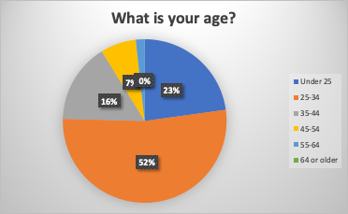

The survey received 57 responses, with the 25-34 age group being the largest demographic with 52% of the respondents. The under 25 age group followed with 23% of the respondents, and the 35-44 age group represented 16% of the total sample. The remaining 9% of respondents were split between the 45-54 age group (7%), the 55-64 age group (2%), and the 65+ age group (0%). This breakdown illustrates that the majority of respondents were within the younger age brackets, with a notable decrease in representation in the older age groups.

Question 2

What is your gender?
Gender group | Participants
Woman | 24
Man | 33
Prefer not to say | 0

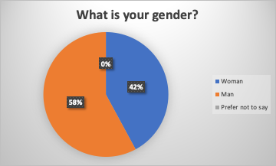

The survey results demonstrated a clear disparity in gender distribution, with no responses recorded in the prefer not to say category. A gender analysis revealed that males made up 58% of the respondents, while females accounted for 42%. This skewed gender distribution suggests that the survey was likely more appealing or accessible to male participants, potentially due to factors such as topic relevance, survey design, or promotional efforts.

Question 3

How frequently do you visit the salon?
Options | Participants: 57
Rarely (less than once a year) | 4
Occasionally (1-4 times a year) | 7
Sometimes (5-10) | 8
Frequently (more than 10 times a year) | 38

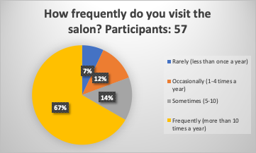

The results of the study showed that the majority of participants (67%) visited the salon frequently (more than 10 times a year), followed by those who visited sometimes (5-10 per year) at 14%, occasionally (1-4 per year) at 12%, and rarely (less than once a year) at 7%. This suggests that most participants were loyal customers, indicating that the salon is likely providing high-quality services and creating a positive customer experience. The frequency of visits can also provide valuable insights into customer preferences and salon operations.

Question 4

Which one of these promotional strategies has help you to increase the brand loyalty with your hairdresser / barber?
Options | Participants
Sales promotion (discount) | 12
Advertising | 8
Direct mail | 0
Public relations (word of mouth) | 37

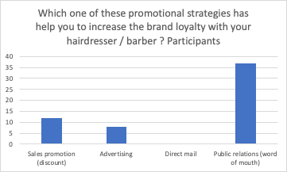

Public relations (word of mouth) were the most popular choice among participants, with 67% of respondents selecting this option. Sales promotions (discounts) came in second place, with 21% of participants selecting this option. Advertising came in third place, with 14% of participants selecting this option. Direct mail was the least popular option, with no participants selecting it. This reveals that customers value personal recommendations and discounts more than traditional advertising methods.

Question 5

Which digital marketing strategy influences your choice of hairdresser/barber?
Options | Participants
Search engine optimization | 2
Influencer | 7
Website | 7
Social media | 39
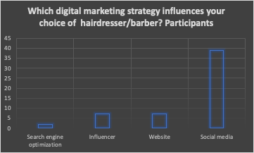

Social media was the most influential factor for 71% of participants in choosing a hairdresser or barber. Websites came in second place, with 13% of participants citing them as a significant influence. Influencers and search engine optimization tied for third place, with 13% and 4% of participants respectively citing them as an important factor in their decision-making process.
This highlights the growing importance of digital marketing in the beauty industry, with social media and influencers becoming increasingly crucial in driving customer acquisition and retention.

Question 6

How likely are you to recommend a friend after viewing digital marketing strategies?
Rating | Participants
One star | 0
Two stars | 0
Three stars | 4
Four stars | 10
Five stars | 43

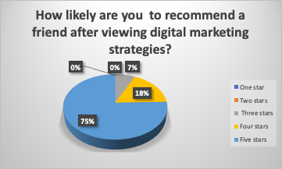

After seeing digital marketing strategies, a whopping 95% of respondents gave a positive rating, with 10 people giving 4 stars, and 43 people giving 5 stars. Only 3 participants gave a rating of 3 stars. This indicates that digital marketing efforts are generally well-received by customers and can effectively influence their recommendations. The data suggests that digital marketing campaigns can greatly impact customers' willingness to recommend a business to their friends, which can be a powerful driver of customer acquisition and loyalty.

Question 7

Options | Strongly agree | Agree | Neutral | Disagree | Strongly disagre
Answers | 63% | 31.6% | 5.3% | 0 | 0
Participants 57 | 35 | 18 | 4 | 0 | 0

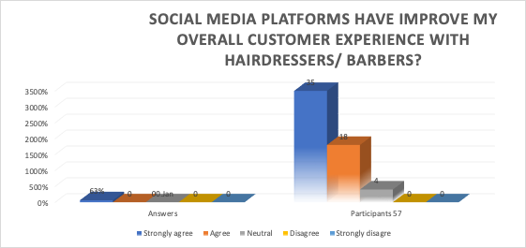

The survey results indicate that a majority of respondents (63%) strongly agree that social media platforms enhance the customer experience with barbers and hairdressers, while a sizable minority (31.6%) simply agree. The remaining participants were neutral on the matter, and no respondents disagreed or strongly disagreed with the statement. In summary, social media appears to have a generally positive impact on customer satisfaction in the hair care industry.

Question 8

Please rate your level of satisfaction with the level of service provide by hairdresser/barber?
Rating | Answers
1 | 0
2 | 0
3 | 0
4 | 0
5 | 0
6 | 0
7 | 3
8 | 3
9 | 1
10 | 50
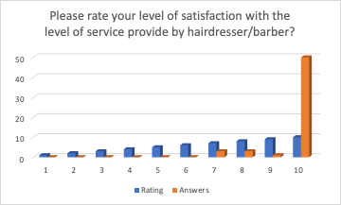

The satisfaction ratings range from 7 to 10, with the majority of respondents (50) giving the highest rating of 10.
- The next highest ratings are 7 and 8, with 3 respondents each.
- The least chosen rating is 9, with only 1 respondent.
In conclusion, this suggests that respondents are overwhelmingly satisfied with the service provided by hairdressers and barbers, with a high percentage of respondents giving the highest possible rating.

5. CONCLUSION AND RECOMANDATIONS

5.1 Conclusion

This research successfully met the established objectives by examining both primary and secondary data sources. The insights gained from the study provide a comprehensive understanding of the current landscape of social media marketing and customer relationship strategies in the hairdressing industry.
The study first examined the existing social media marketing strategies employed in the hair care industry, which revealed a wide variety of approaches being utilized. This analysis revealed several key trends, such as the increasing popularity of visual content and influencer partnerships and identified areas where improvements could be made. Most hairdressing salons extensively depend on social media platforms to establish connections with their clientele and advertise their enterprise. Facebook, Instagram, TikTok, Pinterest, Twitter, and YouTube are popular platforms that enable communication between customers and businesses, while also serving as effective marketing tools for hair salons. it's worth noting that social media platforms provide hair salons with an affordable and accessible way to reach a large audience. In addition to providing a platform for promoting their services, social media also allows salons to engage with their clients, creating a more personalized and interactive experience. This, in turn, can lead to increased customer loyalty and satisfaction, as well as more effective marketing campaigns. By utilizing these platforms effectively, hair salons can build a strong online presence and reach a wider range of potential clients. Noting that social media platforms provide hair salons with an affordable and accessible way to reach a large audience. In addition to providing a platform for promoting their services, social media also allows salons to engage with their clients, creating a more personalized and interactive experience. This, in turn, can lead to increased customer loyalty and satisfaction, as well as more effective marketing campaigns. By utilizing these platforms effectively, hair salons can build a strong online presence and reach a wider range of potential clients.
The benefits of increased engagement and reach, social media platforms also allow hair salons to track and analyses customer behaviour and preferences. This can be invaluable in understanding which services and products are most popular with clients, as well as how to better tailor their offerings to meet their needs. Furthermore, social media provides an effective platform for sharing user-generated content, such as reviews and testimonials, which can help to increase brand credibility and boost sales. By harnessing the power of social media, hair salons can not only increase their visibility but also improve their marketing and sales strategies to better meet the needs of their customers.
In the second phase of the research, the focus shifted to the role of promotional strategies in building brand loyalty in the hair care industry. This analysis considered factors such as the effectiveness of discounts and loyalty programs, the impact of seasonal promotions and special events, and the use of targeted advertising to reach specific audiences. By examining these factors, the research was able to provide valuable insights into the ways in which hair salons can effectively increase customer loyalty and engagement. One important aspect is that brand loyalty can be a critical factor in a salon's success. Customers who are loyal to a particular brand are more likely to return for repeat business, as well as recommend the salon to friends and family. Building a strong brand identity and offering consistent, high-quality service can be key in attracting and retaining loyal customers. Additionally, offering exclusive discounts and loyalty programs to regular clients can help to incentivize repeat visits, further strengthening their relationship with the salon. This, in turn, can lead to increased customer retention and greater profitability.

The research findings ultimately demonstrated that social media platforms are an invaluable tool for building and nurturing relationships with customers in the hair care industry. By providing a platform for two-way communication, social media enables hair salons to engage with customers at every stage of the customer lifecycle, from initial awareness to retention and advocacy.
The survey results further highlighted the critical role that social media plays in promoting businesses within the industry. Most respondents agreed that social media platforms are essential in marketing and brand promotion, allowing hair salons to reach a wider audience and build a strong online presence. This supports the hypothesis that social media can be a powerful tool for increasing a salon's visibility and attracting new customers. It's also worth noting that the impact of social media goes beyond simply attracting new customers. It can also help to create a more personalized and interactive experience for existing clients. For example, hair salons can use social media to share before and after photos of client transformations, offer styling tips and advice, and create a community around the brand. This can foster greater customer loyalty and help to build a sense of connection with the salon, which can be a powerful differentiator in a highly competitive industry.
In conclusion, the research findings have significant implications for small and medium-sized hairdressing businesses in the UK. By leveraging the power of digital marketing and social media, these businesses can better connect with their customers, increase brand loyalty, and ultimately drive profitability. As the hair care industry continues to evolve, it is essential for hairdressers to stay abreast of the latest trends and technologies to remain competitive and thrive in the digital age.

5.2 Recommendations

The significance of digital marketing in the hairdressing sector for small and medium-sized enterprises (SMEs) should not be undervalued. As technology advances and customer behaviour is more influenced by these platforms, it is crucial for hair salons to stay updated on the newest trends and innovations. To develop impactful marketing strategies for social media platforms, it is imperative to comprehend consumer preferences and expectations. Given this fact, the purpose of these recommendations is to enhance the social media presence of hair salons and suggest further ways for improvement.
- Invest in a strong social media presence: Create engaging content, respond to comments and messages, and regularly engage with your followers.
- Use targeted advertising: Utilize social media ads to reach specific audiences and increase your customer base.
- Implement loyalty programs: Offer discounts and exclusive deals to your regular clients to foster brand loyalty and increase retention.
- Track customer behaviour and preferences: Use social media analytics to gain insights into your customers' interests and preferences, and tailor your marketing strategies accordingly.
- Stay updated with the latest trends in the hair care industry by attending industry events and conferences and following influencers and experts on social media.
- Offer a personalized experience by tailoring recommendations and services to individual customers based on their specific needs and preferences.
- Create a referral program to incentivize customers to recommend your business to their friends and family.
- Stay active on review sites to monitor and respond to customer feedback in a timely manner, which can help improve customer satisfaction and your online reputation.
- Collaborate with local businesses and community events to increase your brand awareness and reach a wider audience.
- Invest in building a strong online presence on review sites such as Yelp and Google My Business. Encourage your satisfied customers to leave reviews and respond to both positive and negative feedback in a professional manner. This can help build trust with potential customers and improve your online reputation.
- Monitor and track the performance of your marketing campaigns regularly to identify areas for improvement and optimize your strategies. Use tools such as Google Analytics and social media platform analytics to gather data and make informed decisions.

5.3 Limitations

Notwithstanding the acquired insights, this research is susceptible to many constraints. These constraints encompass, but are not restricted to, the subsequent factors:
- This research was conducted with a small sample of participants, which may not be representative of the entire population of hair care or hairdressing consumers.
- The data collected was limited to responses from survey participants, which may not capture the full range of opinions and perspectives on the subject.
- The research did not look at the impact of social media on other areas of the hair care industries, such as product development or supplier relationships.
- The research was conducted during a specific time frame, which may not reflect the changing dynamics of social media marketing over time.
- The research focused on the UK market, and the findings may not be applicable to other countries with different social media and cultural norms.
- The survey questions may have been subject to bias or misinterpretation, as the responses were based on self-reported data.
- The data collected was primarily qualitative, which may limit the ability to generalize the findings to a broader population.
These limitations should be considered when interpreting the research findings and making decisions based on the recommendations provided. Despite these limitations, the research offered valuable insight into the current state of social media marketing in the hair care industry and provided actionable recommendations to be able to have.

6. FURTHER RESEARCH

To overcome the constraints and enhance comprehension of the significance of digital marketing for small and medium-sized enterprises (SMEs) in the hairdressing industry in the United Kingdom, the subsequent recommendations for additional investigation can be proposed:

- Conducting a longitudinal study to track changes in social media marketing strategies over time and identify emerging trends.
- Expanding the research to include a wider range of participants, including customers from different demographics and locations.
- Investigating the effectiveness of different social media marketing strategies for different types of hair care businesses, such as independent salons vs. franchises, or high-end salons vs. budget-friendly options.
- Conducting case studies of successful social media marketing campaigns in the hair care industry, to better understand what factors contribute to success.
- Exploring the impact of social media on other aspects of the hair care industry, such as product development or industry trends.

7.REFERENCES

Deiss, R. & Henneberry, R., 2020. Digital Marketing for dummies A Wiley Brand. New Jersey: Jhon Wiley & Sons.
Chaffey, D., 2022. RACE marketing model. [Online]
Available at: https://www.davechaffey.com/digital-marketing-glossary/race-marketing-planning-model/
Saunders, M., Lewis, P. & Thornhill, A., 2007. Research Methods for Business Students. Harlow: Pearson.
Saunders, M., Lewis, P. & Thornhill, A., 2019. Research Methods for Business Students. 8th edition Harlow: Pearson.
Phair, D. & Warren, K., 2021. GRADCOACH. [Online]
Available at: https://gradcoach.com/saunders-research-onion/
Melnikovas, A., 2018. Towards an Explicit Research Methodology: Adapting Research Onion Model for Futures Studies. Journal of Futures Studies, pp. 1-16.
Sahay, A., 2016. Peelig Saunder's Research Onion. Research Onion, pp. 1-5.
Stainton, D. H., 2021. The Research Onion Made EASY! Simple Research Methods Template For Your Methodology Chapter. [Online]
Available at: https://www.youtube.com/watch?v=HSPwTdMn6_c
Merriam, S. B. & Tisdell, E. J., 2015. Qualitative Research: A Guide to Design and Implementation, 4th Edition. England: Jossey-Bass.
CONSUMER LOYALTY AND SUPPLIER SWITCH IN SMES: THE HAIRDRESSER CASE (2021).
Jáuregui, Á. L., Partal, M. M. & Labeaga, J. M., 2019. Impact of SMEs strategy on loyalty: the hairdresser case. [Online]
Available at: https://www.emerald.com/insight/content/doi/10.1108/SJME-11-2018-0051/full/html
[Accessed 1 November 2023].
S, G. & J., S., 2019. The influence of customer satisfaction on brand loyalty in haidressing salons. International Journal of Business and Society, 20(2), pp. 660-674.
S., M. & P., Y. P., 2015. Factors influencing brand loyalty in the haidressing industry. Procedia Economics and Finance, Issue 31, pp. 269-277.
N., H., P., W. K. & C., K., 2012. An empirical analysis of haidressers' customer loyalty: A cross-national comparison. Journal of Retailing and Customers Services, 2(19), pp. 228-235.
J., S., 2021. Digital Marketing Strategies for Small and Medium-Sized Enterprises in the hairdessing industry. London: ABC.
Pedley, J., 2021. Beauty salon loyalty program. [Online]
Available at: https://easyweek.io/beauty-salon-best-loyalty-program.html
[Accessed Octomber 25 2023].
Linkedin, 2023. The benefits of personalized communication for customer experience Whelp. [Online]
Available at: https://www.linkedin.com/pulse/benefits-personalized-communication-customer-experience-whelp
[Accessed 28 October 2023].
Pearson, 2017. International-GCSE-Bussiness. [Online]
Available at: https://www.pearson.com/content/dam/one-dot-com/one-dot-com/international-schools/pdfs/secondary-curriculum/international-gcse/business/International-GCSE-Business-Z01-ANS-001-086.pdf
[Accessed 12 November 2023].
Kotler, P., Armstrong, G., Saunders , J. & Wong, V., 2017. PRINCIPLES OF MARKETING. Second ed. London: Prentice Hall Europe.
Ryan, D. & Jones, C., 2012. Understanding Digital Marketing. Second edition ed. London, Philadelhia, New Delhi: Kogan Page Limited.
Tambun, T., 2023. Linkedin. [Online]
Available at: https://www.linkedin.com/pulse/semi-final-stop-saunders-research-onion-toronata-tambun
[Accessed 11 November 2023].
Saunders, M., Lewis, S. P. & Thornhill, A., 2019. Research methods for business students. 7th ed. ed. Harlow: Pearson.
Saunders, M., Lewis, S. P. & Thornhill, A., 2015. Research metods for business students. New York State: Pearson.
FJ., F., 2013. Survey research methods. 5 th edition ed. Ca;SAGE: Thousand Oaks.
Saunders, M. N., Lewis, P. & Thornhill, A., 2019. "Research Metods for Business Students" Chapter 4: Understanding research philosophy and approaches to theory development. Eighth Edition ed. Harlow, England,London: Pearson.
A., B., 2016. Social Research methods. 5th edition ed. Oxford: Oxford University Press..
FJ., F., 2013. Survey research methods. 2 th edition ed. Thousand Oacks: CA:SAGE.
Lewis, S. M. & Thornhill, A. P., 2019. Research metods for business student ( advantages of primary research). 7th edition ed. Harlow: Pearson.
C., R., 2011. Real World Research: A Resorces for Social Scientists and Practitioner-Researchers. 4 TH. EDITION ed. s.l.:SAGE.
D., S., 2016. Doing Qualitative Research: A Practical Handbook. 4th edition ed. s.l.:SAGE .
Prospect, R. & Walker, J., 2021. "Disadvantages of Primary Research". [Online]
Available at: https://www.researchprospect.com/disadvantages-of-primary-research/
[Accessed 23 November 2023].
K., P., 2013. Introduction to cocial media research: Quantitative and Qualitative approches. Los Angeles, California: SAGE.
George, T., 2023. Scribbr: What is Secondary Research? | Definition, Types, & Examples. [Online]
Available at: https://www.scribbr.com/methodology/secondary-research/
[Accessed 25 november 2023].
Merriam, S. B. & EJ., T., 2016. Qualitative Research: a guide to design and implementation.. 4th edition ed. San Francisco: CA:Jossey-Bass.
Azorin, J. M. & Cameron, R., 2010. The Application of Mixed Methods in Organisational Research: A Literature Review. [Online]
Available at: file:///Users/radcornelia-roxana/Downloads/The_Application_of_Mixed_Methods_in_Organisational.pdf
[Accessed 27 november 2023].
R., C. D. & P., S., 2014. Business research metods. 12th Edition ed. New York: MCGraw-Hill Irwin.
benjamin slap, 2023. 5 digital marketing models Digital frameworks to help organise and plan your projects. [Online]
Available at: https://www.benjaminslap.be/5-digital-marketing-models/
[Accessed 27 octomber 2023].
S., B. & A., S., 2016. Digital Marketing: Strategy,Implementation and Practice.. s.l.:John Wiley & Sons.
C., L. K. & G., T. C., 2017. Creating Customer Value and Engagement. In: In Management Information Systems. s.l.:Pearson, pp. 624-637.
Oxford College of Marketing, 2023. Oxford college of Marketing. [Online]
Available at: https://blog.oxfordcollegeofmarketing.com/2018/08/06/using-the-race-framework/
D., C. & F., E. C., 2016. RACE Planning System for Digital marketing Strategy. In: Digital Marketing Strategy, Implementation and Practice. s.l.:s.n., pp. 139-162.
F., C., 2020. RACE Model to Develop a Comprehensive Digital Marketing Strategy. Digital Marketing Research, 1(12), pp. 29-43.
J., B., 2021. A Practical Guide to Implementing the RACE Model in Your Digital Marketing Plan. Journal of Internet Marketing, 3(35), pp. 1-18.
H., K. J., K., H., P., M. I. & S., S. B., 2011. Understanding the Functional Building Blocks of Social Media. Business Horizons, 2(54), pp. 241-251.

8. APPENDIX

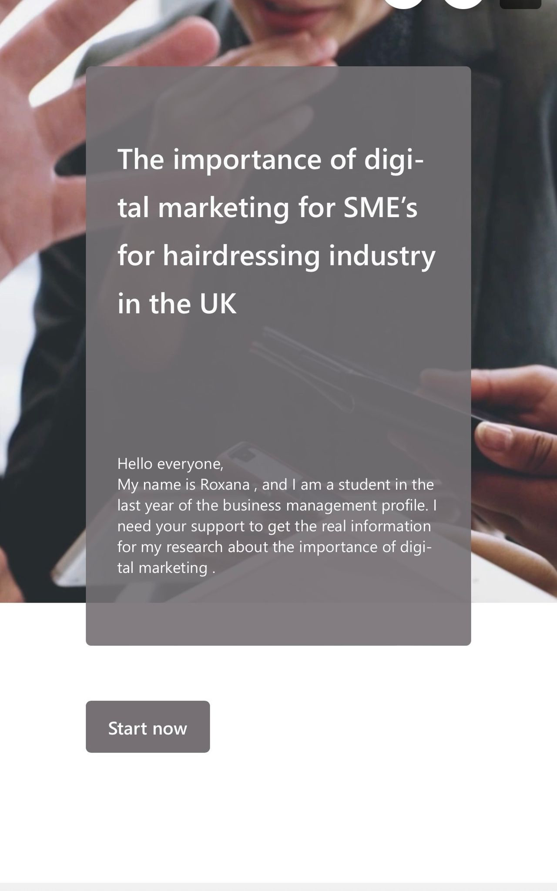
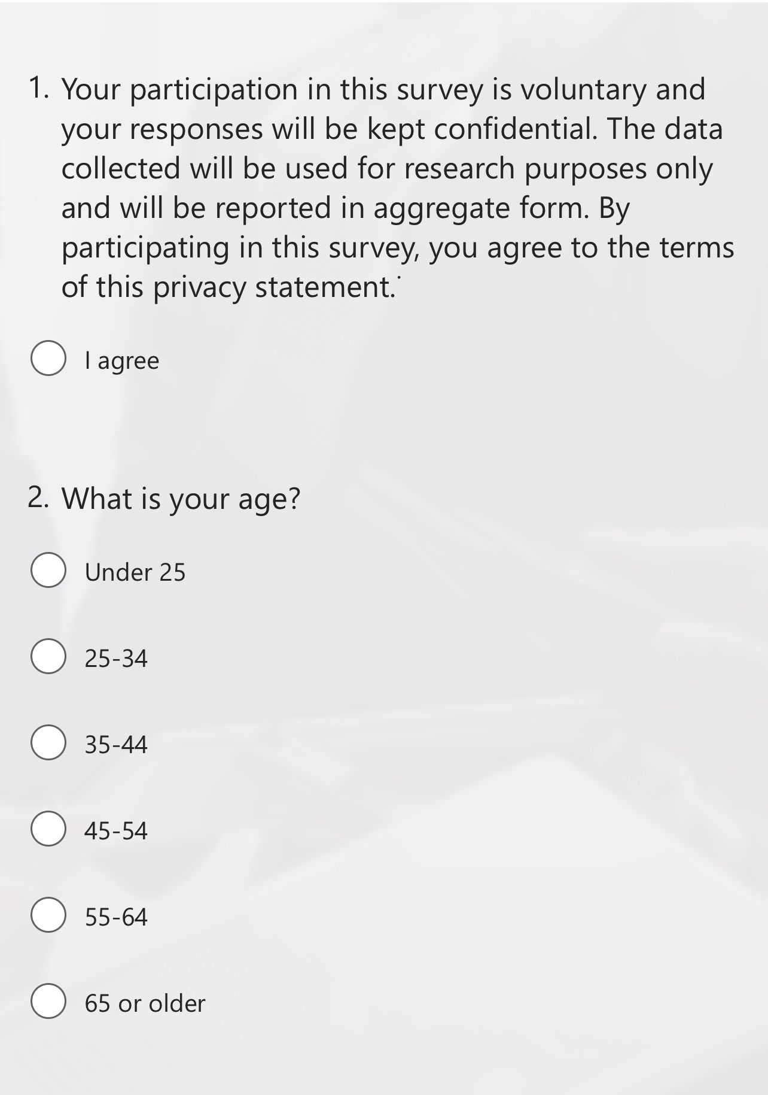
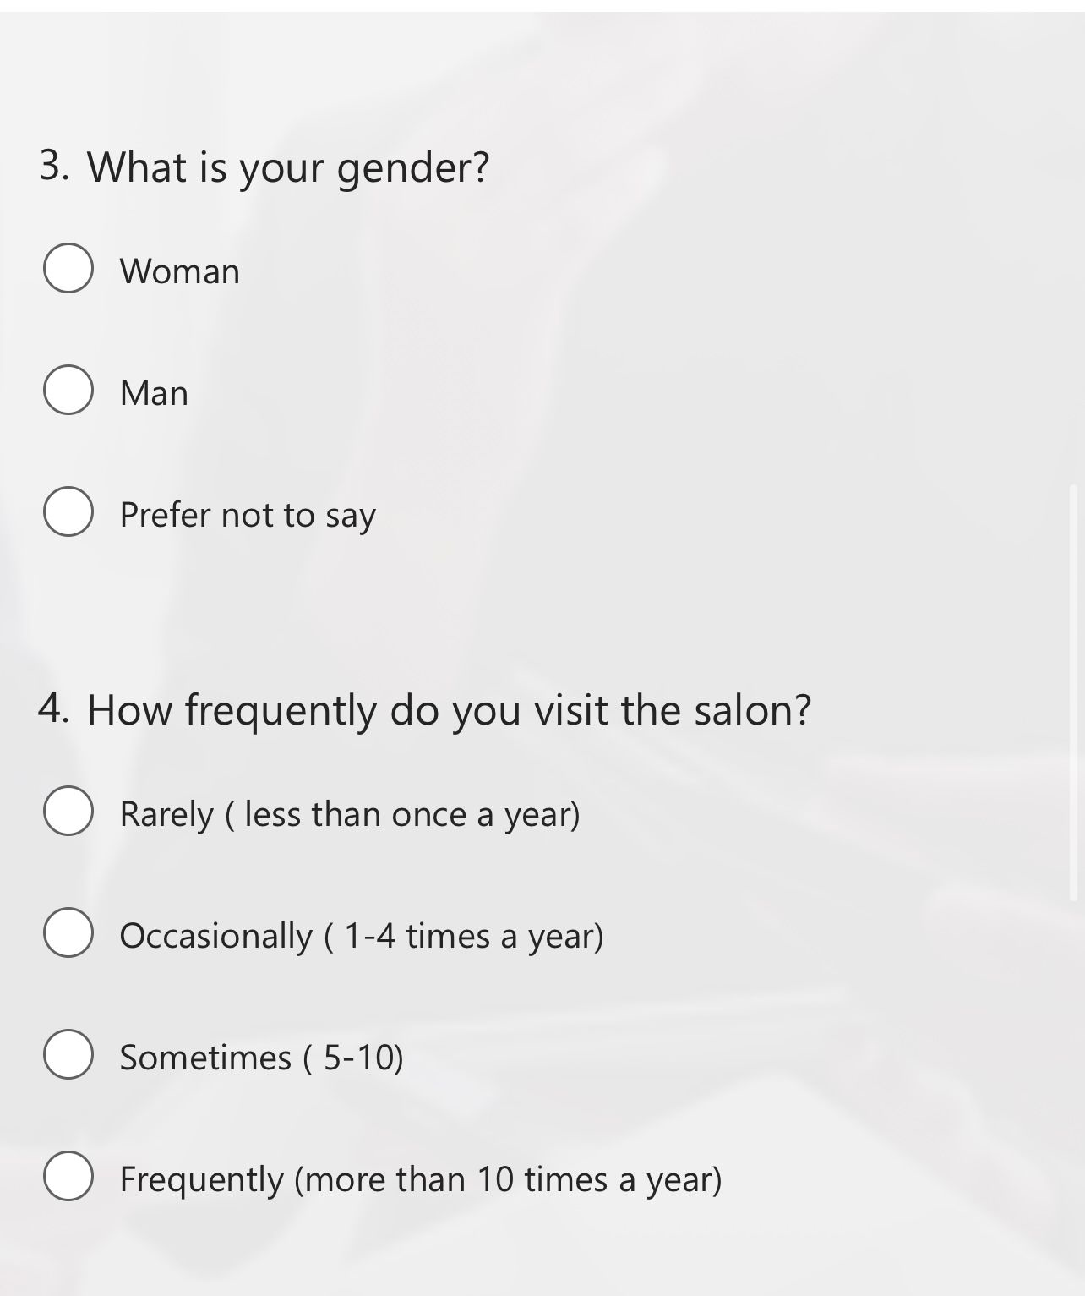

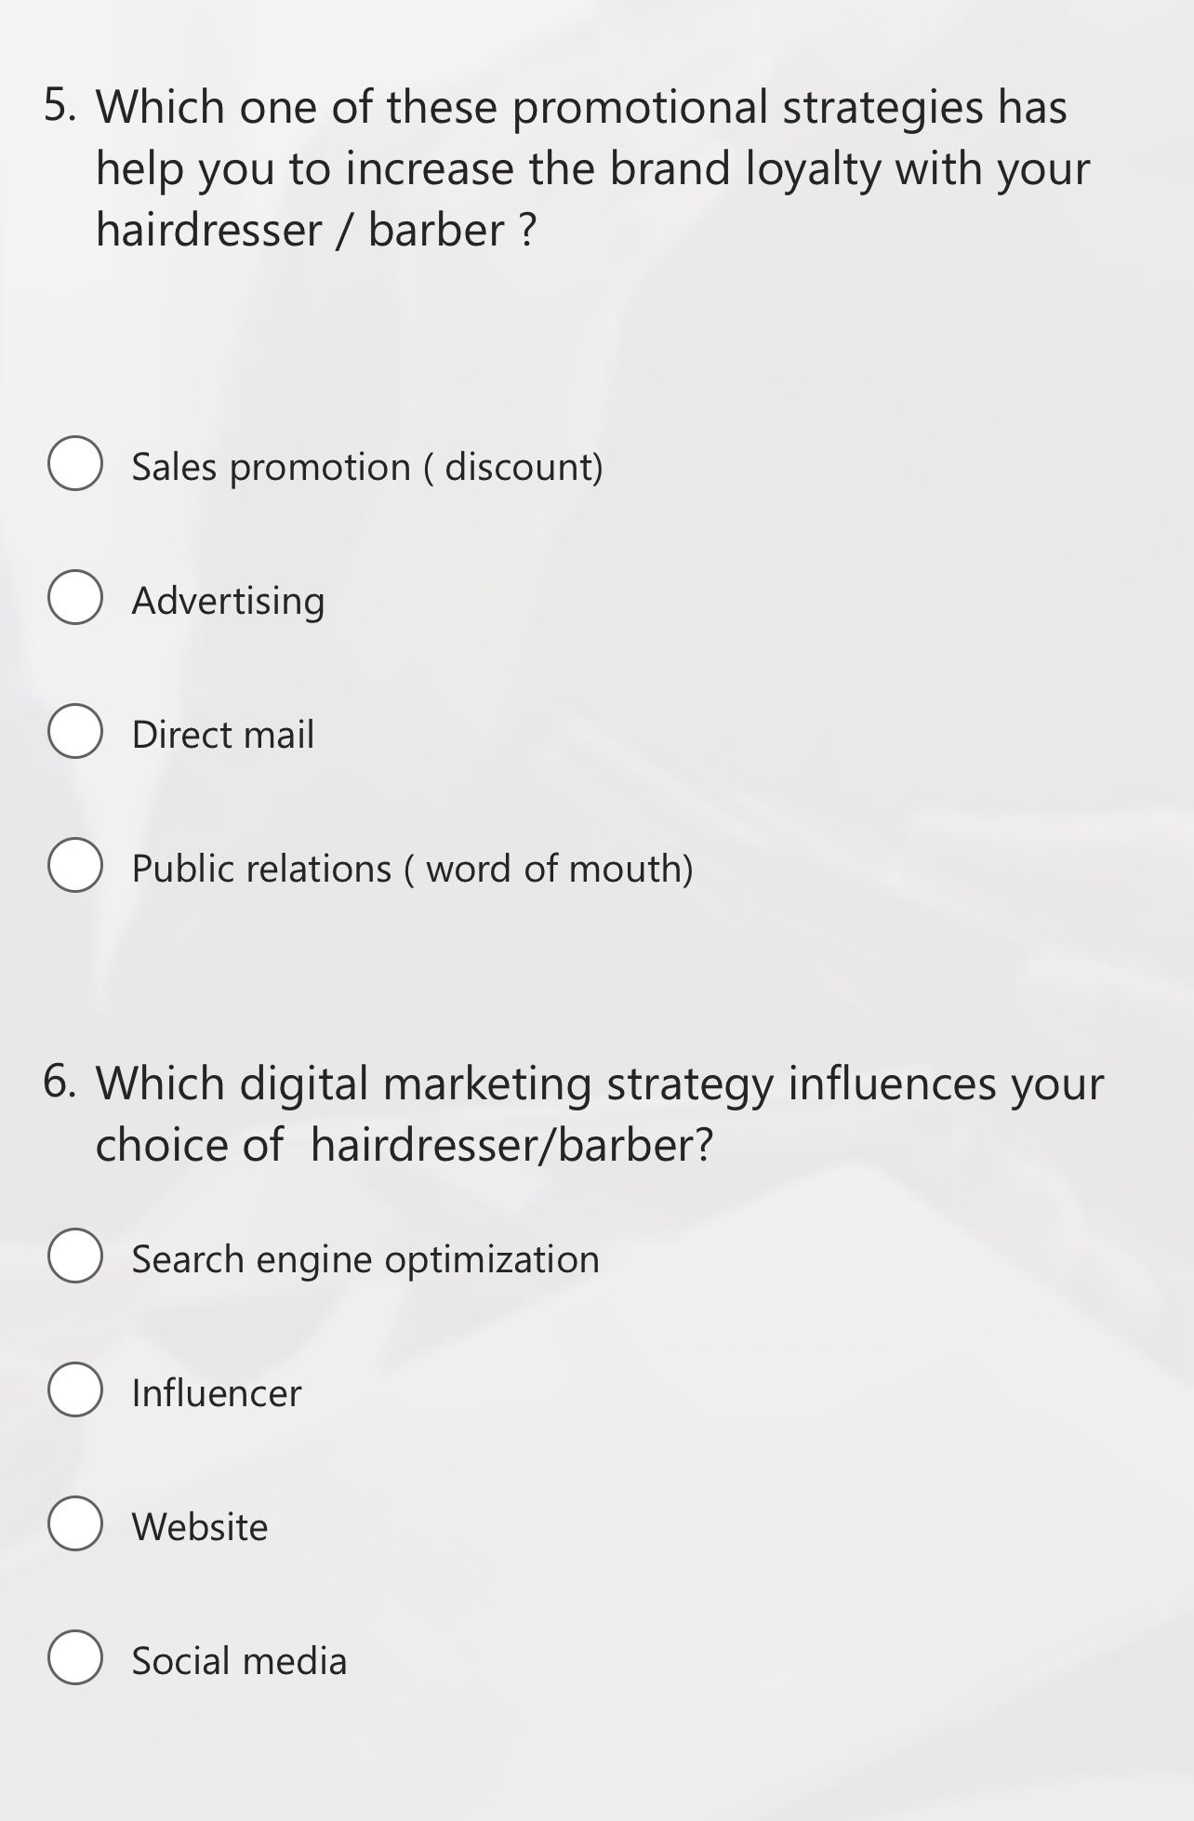
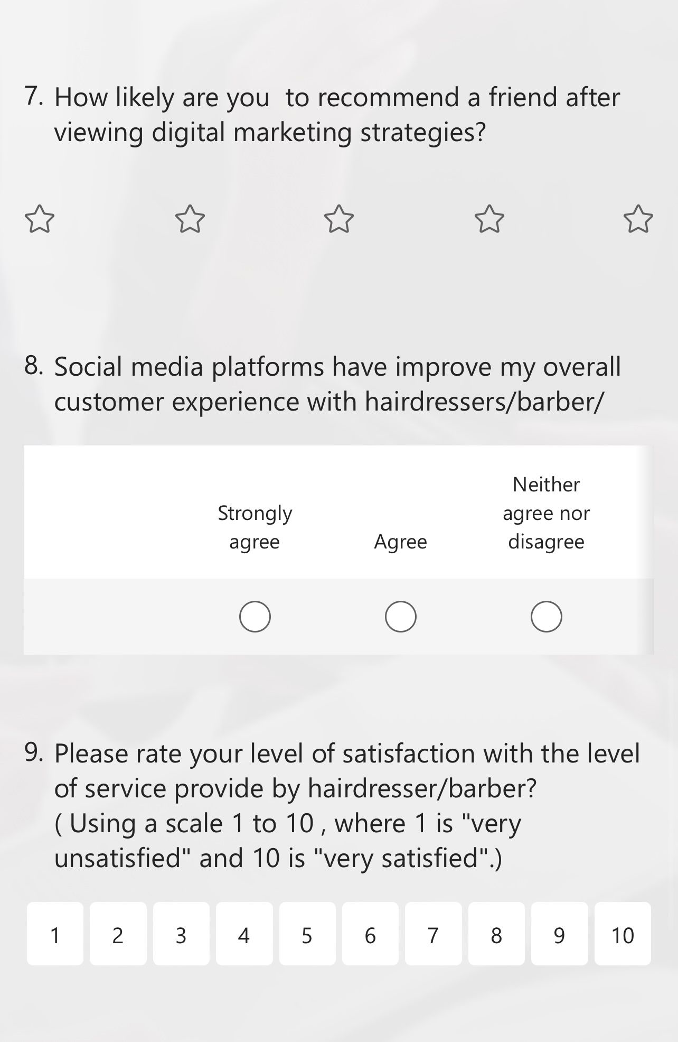

APPLICATION FOR ETHICAL APPROVAL

In order for research to result in benefit and minimise risk of harm, it must be conducted ethically. A researcher may not be covered by the University’s insurance if ethical approval has not been obtained prior to commencement.

The University follows the OECD Frascati manual definition of research activity: “creative work undertaken on a systematic basis in order to increase the stock of knowledge, including knowledge of man, culture and society, and the use of this stock of knowledge to devise new applications”. As such this covers activities undertaken by members of staff, postgraduate research students, and both taught postgraduate and undergraduate students working on dissertations/projects.

The individual undertaking the research activity is known as the “principal researcher”.

Ethical approval is not required for routine audits, performance reviews, quality assurance studies, testing within normal educational requirements, and literary or artistic criticism.

Please read the notes for guidance before completing ALL sections of the form.

This form must be completed and approved prior to undertaking any research activity. Please see Checklist for details of process for different categories of application.

SECTION A: About You (Principal Researcher)
1 | Full Name: |  | Cornelia-Roxana Rad
2 | Tick all boxes that apply: |  | Member of staff: | ☐ | Honorary research fellow: | ☐
 | Undergraduate Student | ​​☒​ | Taught Postgraduate Student | ​​☐​ | Postgraduate Research Student | ​​☐​

3 | Institute/Academic Discipline/Centre: | University of Wales Trinity Saint David
4 | Campus: | London Campus, Winchester House
5 | E-mail address: | 2023709@student.uwtsd.ac.uk
6 | Contact Telephone Number: | 07770809526
 | For students:
7 | Student Number: | 2023709
8 | Programme of Study: | BA(Hons) Business Management
9 | Director of Studies/Supervisor: | Tushara Balendran

SECTION B: Approval for Research Activity
1 | Has the research activity received approval in principle?  (please check the Guidance Notes as to the appropriate approval process for different levels of research by different categories of individual) |  | YES | ​​☒​ | NO | ​​☐​
 |  |  |  |  | Date
2 | If Yes, please indicate source of approval (and date where known): Approval in principle must be obtained from the relevant source prior to seeking ethical approval | Research Degrees Committee |  | ​​☐​
2 |  | Institute Research Committee |  | ​​☐​
2 |  | Other (write in) |  | ​​☐​

SECTION C: Internal and External Ethical Guidance Materials
 | Please list the core ethical guidance documents that have been referred to during the completion of this form (including any discipline-specific codes of research ethics, location-specific codes of research ethics, and also any specific ethical guidance relating to the proposed methodology). Please tick to confirm that your research proposal adheres to these codes and guidelines. You may add rows to this table if needed.
1 | UWTSD Research Ethics & Integrity Code of Practice | ​​☒​
2 | UWTSD Research Data Management Policy | ​​☒​
3 | [List any other relevant documents here] | ​​☐​

SECTION D: External Collaborative Research Activity
If there are external collaborators then you should gain consent from the contact persons to share their personal data with the university. If there are no external collaborators then leave this section blank and continue to section E.
1 | Institution
2 | Contact person name
3 | Contact person e-mail address
4 | Is your research externally funded? |  | YES | ​​☐​ | NO |  | ​​☐​
5 | Are you in receipt of a KESS scholarship? |  | YES | ​​☐​ | NO |  | ​​☐​
6 | Are you specifically employed to undertake this research in either a paid or voluntary capacity? | Voluntary | YES | ​​☐​ | NO | ​​☐​
7 |  | Employed | YES | ​​☐​ | NO | ​​☐​
8 | Is the research being undertaken within an existing UWTSD Athrofa Professional Learning Partnership (APLP)? | If YES then the permission question below does not need to be answered. | YES | ​​☐​ | NO |  | ​​☐​
9 | Has permission to undertake the research has been provided by the partner organisation? | (If YES attach copy)  If NO the application cannot continue | YES | ​​☐​ | NO |  | ​​☐​

Where research activity is carried out in collaboration with an external organisation
10 | Does this organisation have its own ethics approval system? | YES | ​​☐​ | NO | ​​☒​
 | If Yes, please attach a copy of any final approval (or interim approval) from the organisation (this may be a copy of an email if appropriate).

SECTION E: Details of Research Activity
1 | Indicative title: | The importance of digital marketing for SME”s for hairdressing industry in the UK
2 | Proposed start date: | 9th October | Proposed end date: | 31st December-LO
Introduction to the Research (maximum 300 words per section)
Ensure that you write for a Non-Specialist Audience when outlining your response to the points below:
- Purpose of Research Activity
- Proposed Research Question
- Aims of Research Activity
- Objectives of Research Activity
Demonstrate, briefly, how Existing Research has informed the proposed activity and explain
- What the research activity will add to the body of knowledge
- How it addresses an area of importance.
3 | Purpose of Research Activity  The purpose of research is to study the importance of digital marketing for SME”S for hairdressing industry in the UK  (this box should expand as you type)
4 | Research Question  1.What are the preferences of customers in the hairdressing industry regarding SME’s marketing?  2. How do customers perceive and respond to different types of SME’s messages promotional offers, appointment reminders, and other communication efforts?  3. What are the key factors that influence the success of SME’s marketing campaigns in the hairdressing industry?  4.What is the impact of digital marketing strategies on the brand loyalty of hairdressing customers?  (this box should expand as you type)
5 | Aims of Research Activity  The main aim of this research is to analyse the effectiveness and the importance of SME’s marketing in the hairdressing industry in the UK.  (this box should expand as you type)
6 | Objectives of Research Activity  - To determine the current digital marketing strategies utilised by SME’s for hairdressing companies in the UK.  - To analyse how customers perceive and respond to different types of SME’s messages promotional offers, appointment reminders, and other communication efforts.  - To investigate the impact of digital marketing strategies on the brand loyalty of hairdressing customers.  - To analyse the advantages and disadvantage of SEM’s hairdressing companies in implementing digital marketing.  (this box should expand as you type)
Proposed methods (maximum 600 words)
Provide a brief summary of all the methods that may be used in the research activity, making it clear what specific techniques may be used. If methods other than those listed in this section are deemed appropriate later, additional ethical approval for those methods will be needed. You do not need to justify the methods here, but should instead describe how you intend to collect the data necessary for you to complete your project.
7 | (this box should expand as you type)
Location of research activity
Identify all locations where research activity will take place.
8 | -LONDON  (this box should expand as you type)
Research activity outside of the UK
If research activity will take place overseas, you are responsible for ensuring that local ethical considerations are complied with and that the relevant permissions are sought. Specify any local guidelines (e.g. from local professional associations/learned societies/universities) that exist and whether these involve any ethical stipulations beyond those usual in the UK (provide details of any licenses or permissions required). Also specify whether there are any specific ethical issues raised by the local context in which the research activity is taking place, for example, particular cultural and/or legal sensitivities or vulnerabilities of participants. If you live in the country where you will do the research then please state this.
9 | (this box should expand as you type)

10 | Use of documentation not in the public domain: Are any documents NOT publicly available? | NO | ​​☒​
10 |  | YES | ​​☐​
11 | If Yes, please provide details here of how you will gain access to specific documentation that is not in the public domain and that this is in accordance with the current data protection law of the country in question and that of England and Wales.  (this box should expand as you type)

 | Does your research relate to one or more of the seven aims of the Well-being of Future Generations (Wales) Act 2015? | YES | NO
12 | A prosperous Wales | ​​☐​ | ​​☒​
13 | A resilient Wales | ​​☐​ | ​​☒​
14 | A healthier Wales | ​​☐​ | ​​☒​
15 | A more equal Wales | ​​☐​ | ​​☒​
16 | A Wales of cohesive communities | ​​☐​ | ​​☒​
17 | A Wales of vibrant culture and thriving Welsh language | ​​☐​ | ​​☒​
18 | A globally responsible Wales | ​​☐​ | ​​☒​
19 | If YES to any of the above, please give details:
 | (this box should expand as you type)

SECTION F: Scope of Research Activity
 | Will the research activity include: | YES | NO
1 | Use of a questionnaire or similar research instrument? | ​​☒​ | ​​☐​
2 | Use of interviews? | ​​☐​ | ​​☒​
3 | Use of focus groups? | ​​☐​ | ​​☒​
4 | Use of participant diaries? | ​​☐​ | ​​☒​
5 | Use of video or audio recording? | ​​☐​ | ​​☒​
6 | Use of computer-generated log files? | ​​☐​ | ​​☒​
7 | Participant observation with their knowledge? | ​​☐​ | ​​☒​
8 | Participant observation without their knowledge? | ​​☐​ | ​​☒​
9 | Access to personal or confidential information without the participants’ specific consent? | ​​☐​ | ​​☒​
10 | Administration of any questions, test stimuli, presentation that may be experienced as physically, mentally or emotionally harmful / offensive? | ​​☐​ | ​​☒​
11 | Performance of any acts which may cause embarrassment or affect self-esteem? | ​​☐​ | ​​☒​
12 | Investigation of participants involved in illegal activities? | ​​☐​ | ​​☒​
13 | Use of procedures that involve deception? | ​​☐​ | ​​☒​
14 | Administration of any substance, agent or placebo? | ​​☐​ | ​​☒​
15 | Working with live vertebrate animals? | ​​☐​ | ​​☒​
16 | Procedures that may have a negative impact on the environment? | ​​☐​ | ​​☒​
17 | Other primary data collection methods. Please indicate the type of data collection method(s) below. | ​​☐​ | ​​☒​
 | Details of any other primary data collection method:  (this box should expand as you type) | ​​☐​ | ​​☒​
If NO to every question, then the research activity is (ethically) low risk and may be exempt from some of the following sections (please refer to Guidance Notes).

If YES to any question, then no research activity should be undertaken until full ethical approval has been obtained.

SECTION G: Intended Participants
If there are no participants then do not complete this section, but go directly to section H.

 | Who are the intended participants: | YES | NO
1 | Students or staff at the University? | ​​☐​ | ​​☒​
2 | Adults (over the age of 18 and competent to give consent)? | ​​☒​ | ​​☐​
3 | Vulnerable adults? | ​​☐​ | ​​☒​
4 | Children and Young People under the age of 18? (Consent from Parent, Carer or Guardian will be required) | ​​☐​ | ​​☒​
5 | Prisoners? | ​​☐​ | ​​☒​
6 | Young offenders? | ​​☐​ | ​​☒​
7 | Those who could be considered to have a particularly dependent relationship with the investigator or a gatekeeper? | ​​☐​ | ​​☒​
8 | People engaged in illegal activities? | ​​☐​ | ​​☒​
9 | Others. Please indicate the participants below, and specifically any group who may be unable to give consent. | ​​☐​ | ​​☒​
 | Details of any other participant groups:  (this box should expand as you type) | ​​☐​ | ​​☒​

Participant numbers and source
Provide an estimate of the expected number of participants. How will you identify participants and how will they be recruited?
10 | How many participants are expected? | (this box should expand as you type)
11 | Who will the participants be? | (this box should expand as you type)
12 | How will you identify the participants? | (this box should expand as you type)

 | Information for participants: | YES | NO | N/A
13 | Will you describe the main research procedures to participants in advance, so that they are informed about what to expect? | ​​☒​ | ​​☐​ | ​​☐​
14 | Will you tell participants that their participation is voluntary? | ​​☒​ | ​​☐​ | ​​☐​
15 | Will you obtain written consent for participation? | ​​☐​ | ​​☐​ | ​​☒​
16 | Will you explain to participants that refusal to participate in the research will not affect their treatment or education (if relevant)? | ​​☐​ | ​​☐​ | ​​☒​
17 | If the research is observational, will you ask participants for their consent to being observed? | ​​☐​ | ​​☐​ | ​​☒​
18 | Will you tell participants that they may withdraw from the research at any time and for any reason? | ​​☒​ | ​​☐​ | ​​☐​
19 | With questionnaires, will you give participants the option of omitting questions they do not want to answer? | ​​☐​ | ​​☒​ | ​​☐​
20 | Will you tell participants that their data will be treated with full confidentiality and that, if published, it will not be identifiable as theirs? | ​​☒​ | ​​☐​ | ​​☐​
21 | Will you debrief participants at the end of their participation, in a way appropriate to the type of research undertaken? | ​​☐​ | ​​☒​ | ​​☐​
22 | If NO to any of above questions, please give an explanation
 | (this box should expand as you type)

 | Information for participants: | YES | NO | N/A
24 | Will participants be paid? | ​​☐​ | ​​☒​ | ​​☐​
25 | Is specialist electrical or other equipment to be used with participants? | ​​☐​ | ​​☒​ | ​​☐​
26 | Are there any financial or other interests to the investigator or University arising from this study? | ​​☐​ | ​​☒​ | ​​☐​
27 | Will the research activity involve deliberately misleading participants in any way, or the partial or full concealment of the specific study aims? | ​​☐​ | ​​☒​ | ​​☐​
28 | If YES to any question, please provide full details
 | (this box should expand as you type)

SECTION H: Anticipated Risks

Outline any anticipated risks that may adversely affect any of the participants, the researchers and/or the University, and the steps that will be taken to address them.

If you have completed a full risk assessment (for example as required by a laboratory, or external research collaborator) you may append that to this form.
1 | Full risk assessment completed and appended? |  | Yes | ​​☒​
1 |  |  | No | ​​☐​
2 | Risks to participants  For example: sector-specific health & safety, emotional distress, financial disclosure, physical harm, transfer of personal data, sensitive organisational information
 | Risk to participants:  No Risks  (this box should expand as you type) | How you will mitigate the risk to participants:  N/A  (this box should expand as you type)
3 | If research activity may include sensitive, embarrassing or upsetting topics (e.g. sexual activity, drug use) or issues likely to disclose information requiring further action (e.g. criminal activity), give details of the procedures to deal with these issues, including any support/advice (e.g. helpline numbers) to be offered to participants. Note that where applicable, consent procedures should make it clear that if something potentially or actually illegal is discovered in the course of a project, it may need to be disclosed to the proper authorities
The research does not include sensitive, embarrassing, or upsetting topics, and does not include issues with disclosing information to further action.

(this box should expand as you type)
4 | Risks to the investigator  For example: personal health & safety, physical harm, emotional distress, risk of accusation of harm/impropriety, conflict of interest
 | Risk to the investigator:  No Risk  (this box should expand as you type) | How you will mitigate the risk to the investigator:  N/A  (this box should expand as you type)
5 | University/institutional risks  For example: adverse publicity, financial loss, data protection
 | Risk to the University:  No Risk  (this box should expand as you type) | How you will mitigate the risk to the University:  N/A  (this box should expand as you type)
6 | Environmental risks  For example: accidental spillage of pollutants, damage to local ecosystems
 | Risk to the environment:  No Risk  (this box should expand as you type) | How you will mitigate the risk to environment:  N/A  (this box should expand as you type)

 | Disclosure and Barring Service
 | If the research activity involves children or vulnerable adults, a Disclosure and Barring Service (DBS) certificate must be obtained before any contact with such participants. | YES | NO | N/A
7 | Does your research require you to hold a current DBS Certificate? | ​​☐​ | ​​☒​ | ​​☐​
8 | If YES, please give the certificate number. If the certificate number is not available please write “Pending”; in this case any ethical approval will be subject to providing the appropriate certificate number.

SECTION I: Feedback, Consent and Confidentiality

1 | Feedback  What de-briefing and feedback will be provided to participants, how will this be done and when?
No Feedback

(this box should expand as you type)
2 | Informed consent  Describe the arrangements to inform potential participants, before providing consent, of what is involved in participating. Describe the arrangements for participants to provide full consent before data collection begins. If gaining consent in this way is inappropriate, explain how consent will be obtained and recorded in accordance with prevailing data protection legislation.
No personal data was included for participants. No need to provide consent.

(this box should expand as you type)
3 | Confidentiality / Anonymity  Set out how anonymity of participants and confidentiality will be ensured in any outputs. If anonymity is not being offered, explain why this is the case.
No confidential data was included (anonymity of participants) in any outputs.
(this box should expand as you type)

SECTION J: Data Protection and Storage

 | Does the research activity involve personal data (as defined by the General Data Protection Regulation 2016 “GDPR” and the Data Protection Act 2018 “DPA”)? | YES | NO
1 | “Personal data” means any information relating to an identified or identifiable natural person (‘data subject’). An identifiable natural person is one who can be identified, directly or indirectly, in particular by reference to an identifier such as a name, an identification number, location data, an online identifier or to one or more factors specific to the physical, physiological, genetic, mental, economic, cultural or social identity of that natural person. Any video or audio recordings of participants is considered to be personal data. | ☐ | X
 | If YES, provide a description of the data and explain why this data needs to be collected:
2 | (this box should expand as you type)
 | Does it involve special category data (as defined by the GDPR)? | YES | NO
3 | “Special category data” means sensitive personal data consisting of information as to the data subjects’ –  (a) racial or ethnic origin,  (b) political opinions,  (c ) religious beliefs or other beliefs of a similar nature,  (d) membership of a trade union (within the meaning of the Trade Union and Labour Relations (Consolidation) Act 1992),  (e) physical or mental health or condition,  (f) sexual life,  (g) genetics,  (h) biometric data (as used for ID purposes), | ☐ | X
 | If YES, provide a description of the special category data and explain why this data needs to be collected:
4 | (this box should expand as you type)

 | Will data from the research activity (collected data, drafts of the thesis, or materials for publication) be stored in any of the following ways? | YES | NO
5 | Manual files (i.e. in paper form)? | ​​☐​ | ​​☒​
6 | University computers? | ​​☐​ | ​​☒​
7 | Private company computers? | ​​☐​ | ​​☒​
8 | Home or other personal computers? | ​​☒​ | ​​☐​
9 | Laptop computers/ CDs/ Portable disk-drives/ memory sticks? | ​​☐​ | ​​☒​
10 | “Cloud” storage or websites? | ​​☐​ | ​​☒​
11 | Other – specify: | ​​☐​ | ​​☒​
12 | For all stored data, explain the measures in place to ensure the security of the data collected, data confidentiality, including details of backup procedures, password protection, encryption, anonymisation and pseudonymisation:
All research data will be stored on the researcher's personal computer.
There is no data for publication.

(this box should expand as you type)

 | Data Protection
 | Will the research activity involve any of the following activities: | YES | NO
13 | Electronic transfer of data in any form? | ​​☐​ | ​​☒​
14 | Sharing of data with others at the University outside of the immediate research team? | ​​☐​ | ​​☒​
15 | Sharing of data with other organisations? | ​​☐​ | ​​☒​
16 | Export of data outside the UK or importing of data from outside the UK? | ​​☐​ | ​​☒​
17 | Use of personal addresses, postcodes, faxes, emails or telephone numbers? | ​​☐​ | ​​☒​
18 | Publication of data that might allow identification of individuals? | ​​☐​ | ​​☒​
19 | Use of data management system? | ​​☐​ | ​​☒​
20 | Data archiving? | ​​☐​ | ​​☒​
21 | If YES to any question, please provide full details, explaining how this will be conducted in accordance with the GDPR and Data Protection Act (2018) (and any international equivalents, where appropriate):
 | (this box should expand as you type)
22 | List all who will have access to the data generated by the research activity:
 | (this box should expand as you type)
23 | List who will have control of, and act as custodian(s) for, data generated by the research activity:
 | (this box should expand as you type)
24 | Give details of data storage arrangements, including security measures in place to protect the data, where data will be stored, how long for, and in what form. Will data be archived – if so how and if not why not.
 | (this box should expand as you type)
25 | Please indicate if your data will be stored in the UWTSD Research Data Repository (see https://researchdata.uwtsd.ac.uk/ ). If so please explain. (Most relevant to academic staff)
 | (this box should expand as you type)
26 | Confirm that you have read the UWTSD guidance on data management (see https://www.uwtsd.ac.uk/library/research-data-management/) | YES | ​​X​
27 | Confirm that you are aware that you need to keep all data until after your research has completed or the end of your funding | YES | ​​X​

SECTION K: Declaration
The information which I have provided is correct and complete to the best of my knowledge. I have attempted to identify any risks and issues related to the research activity and acknowledge my obligations and the rights of the participants.

In submitting this application I hereby confirm that I undertake to ensure that the above named research activity will meet the University’s Research Ethics and Integrity Code of Practice which is published on the website: https://www.uwtsd.ac.uk/research/research-ethics/
1 | Signature of applicant: | Cornelia-Roxana Rad | Date:  27.12.2023

For STUDENT Submissions:
2 | Director of Studies/Supervisor: | Tushara Balendran | Date:  27.12.2023
3 | Signature: | T.Balendran | Date:  27.12.2023

For STAFF Submissions:
4 | Academic Director/ Assistant Dean: |  | Date:
5 | Signature: |  | Date:

Checklist: Please complete the checklist below to ensure that you have completed the form according to the guidelines and attached any required documentation:
​​☒​ | I have read the guidance notes supplied before completing the form.
​​☒​ | I have completed ALL RELEVANT sections of the form in full.
​​☒​ | I confirm that the research activity has received approval in principle
​​☒​ | I have attached a copy of final/interim approval from external organisation (where appropriate)
​​☒​ | I have attached a full risk assessment (where appropriate) ONLY TICK IF YOU HAVE ATTACHED A FULL RISK ASSESSMENT
​​☒​ | I understand that it is my responsibility to ensure that the above named research activity will meet the University’s Research Ethics and Integrity Code of Practice.
​​☒​ | I understand that before commencing data collection all documents aimed at respondents (including information sheets, consent forms, questionnaires, interview schedules etc.) must be confirmed by the DoS/Supervisor, module tutor or Academic Director.

RESEARCH STUDENTS AND STAFF ONLY
All communications relating to this application during its processing must be in writing and emailed to pgresearch@uwtsd.ac.uk , with the title ‘Ethical Approval’ followed by your name.
You will be informed of the outcome of your claim by email; therefore it is important that you check your University and personal email accounts regularly.
STUDENTS ON UNDERGRADUATE OR TAUGHT MASTERS PROGRAMMES should submit this form (and receive the outcome) via systems explained to you by the supervisor/module leader.

This form is available electronically from the Academic Office web pages: https://www.uwtsd.ac.uk/academic-office/appendices-and-forms/

