

LEVEL 5 ASSESSMENT
BA (Hons) Business Management
Module: Entrepreneurship
Module code: LCBB5001
Student name: Anna Buonocore
ID: 2022563

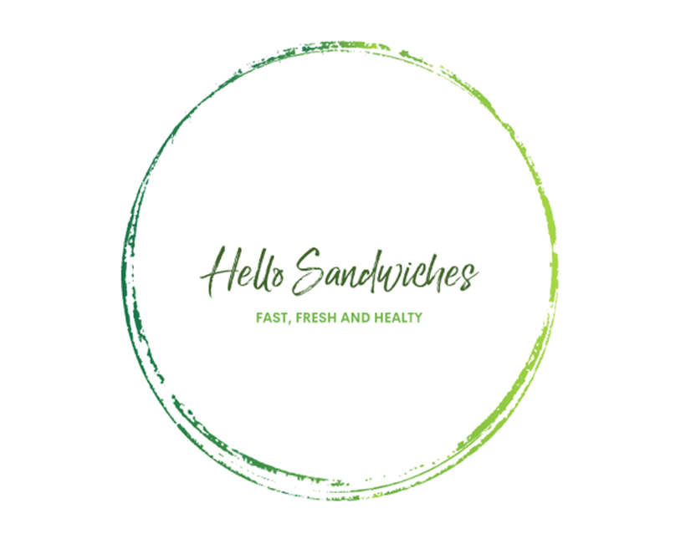

TABLE OF CONTENTS

BUSINESS DESCRIPTION / MARKET OPPORTUNITY 3
INDUSTRY ANALYSIS 5
OPERATIONS AND MANAGEMENT TEAM OPERATIONS 8
MANAGEMENT TEAM 9
MARKETING: The Four P’s must be used to describe your marketing strategy 10
FINANCIALS 12
REFERENCES 14

BUSINESS DESCRIPTION / MARKET OPPORTUNITY

During covid 19 with the shutdown of restaurants and the radical change in human routines, people were forced to spend more time at home and this caused people to start cooking at home, a choice that seems to have been adopted even at the end of the pandemic, preferring packed lunches instead of buying food at the many restaurants on the way.

Hello Sandwiches, is born to serve all those people who due to limited time for lunch break from work, studies or for who are simply looking for a low cost, healthy and fast option for a lunch break. The mission of the company is Eat Healthy Live healthy , therefore the aim of the company is providing healthy lunch options for a healthy life span.

Hello Sandwiches is a private limited company (LTD) With three shareholders my two sisters and myself
The greatest benefit of an LTD corporation is the minimization of personal liability, which means that the shareholders having limited liability in case of economic difficulties of the company the personal benefits of the shareholders cannot be confiscated by the creditors, being finances separate from personal finances, if the company fails, the investor loses only the initial share. Therefore, the company is separate from the people who own it, this separation is called " corporate veil".

In the united kingdom, LTD companies can benefit from more flexibility in tax planning, which currently pay only 19% corporate tax, while sole proprietorships pay 20-45% (Business Advice, 2021)

Hello Sandwiches is my first personal business idea turned into reality, it was born as a LTD but the project is to let people know about it, understand if and how it works in the market and turn it into a franchise to start expanding my business to other cities.

The decision to become a franchise can be an effective way to grow the business, instead of opening new stores is running them yourself, it is a way to get our brand awareness and reach the masses.
A low-risk entrepreneurial opportunity with already established and developed know-how to be able to compete with big brands right away. Using equipment, products and production systems already tested and established in the market by us.

The affiliates will get their own funding to run the business themselves, using my business name and method. As a company, we will offer an operating manual that will explain how to manage and start a new store.

INDUSTRY ANALYSIS

Threat of new entry
One of tool for analyzing the inside of the enterprise is VRIO analysis. This tool was developed by Barney in 1991, according to him there are 4 attributes that a firm must possess to have a lasting competitive advantage. Resources must be rare, inimitable and non-substitutable (Sridharan, 2017).
Valuable: my leadership skill will add valuable to the company, my ability to share clear messages and make ideas easy for everyone to understand, Will create a harmony among all employee.
Rarerity: We have a sustainability mindset because that has always been our way of thinking, in a small way we will collaborate on recycling and growing small businesses like us, we buy raw materials from local farms that will help us keep our products fresh. By buying raw materials from local sellers we will ensure the freshness of the products.
Inimitable: The personality of my company is built by the team and the family, who then provide a kind of seal to the company, which is very difficult to imitate, it will allow running our business in a unique way.
Organisation: since it is a family business the most advantages are the flexibility, stability and trust all important in most successful family -run business.
However, the company is organized to encourage employees to make effective and efficient use of the resources offered by improving their knowledge and skills.

Threat of substitutes is high when rivals, or companies outside the industry, offer more attractive and/or lower cost products.
If the cost of change is high the threat of substitution is low.
We will reduce the threat of substitute products or services by clearly emphasizing how our product is better than those already available in the market.
We will maximize value for money and work on our customer's loyalty, by staying in touch with our customers through various channels and offering loyalty programs, discounts or promotions is one way to ensure that shoppers are incentivized to return to us.

Bargaining power of customers
The most feared factors in Porter’s Five Forces model.
Nowadays it is important to know and analyze the bargaining power of customers, the economic crisis caused by the arrival of covid 19 has had a great impact on people's behaviour, buyers, especially the rational ones, will try to pay less and get more for products and services.
Customers can exert significant influence, particularly if they make purchases repeatedly, prefer to buy from other vendors rather than us, or are knowledgeable about the market and base their requests on that knowledge.

Bargaining power of suppliers when suppliers have bargaining power, they can pressure a company by charging higher prices, since all industries need raw materials as inputs for their process.
Suppliers do not represent a real threat at the moment for Hello Sandwiches; in the market in which we will operate there are often more suppliers than buyers, so suppliers will have less control over prices.
Hello Sandwiches also wants to be a healthy choice for the environment, so all our boxes, containers, cups, and cutlery will be sourced from companies that recycle paper and plastic into new materials, in United Kingdom there are over 85 plastic recycling plants (Enfrecycling.com, 2019).
Bread is the heart of Hello Sandwiches, for this reason it will be produced by us, good raw material is essential for the success of the product, we will import the flour from Italy, from one of the best sellers in southern Italy, Caputo flours will help us to add value to our company, after Brexit, the amount and export of products from the European Union have undergone changes, currently you will need to pay VAT, calculated on the total of price and shipping costs. (GOV.UK, n.d.)
While,fruits and vegetables will be bought from sellers in Uk, keeping as much Km 0 as possible.

Competitive Rivalry: who are your main competitors and how can you differentiate yourself from them

Name of competitor | Differentiation
Pret a manger | Pret a manger offers a wide selection of fresh meal deal sandwiches with activating prices that can put any other seller at a disadvantage. The point to our advantage is the freshness of our products and giving the customer a choice, from bread to toppings and sauces, with prices that remain reasonable.
Subway | Subway often has a cheap and neglected appearance, which becomes unattractive in the eyes of consumers, as well as having a high employee turnover rate, our business differentiates itself by being a relaxing and well-maintained place for lunch break, family management will add a plus that will bring us to the management of the store by creating a unique family business environment.
Itsu | We share with Itsu the goal of offering healthy food in a short time. We differ in the diversification of raw materials by embracing the various diets and needs of customers, they focus on sushi and products that have fish as a base. Their stores are forced to have higher electricity usage because of the refrigerators they need to keep the product at the right temperature, our products can be away from the fridge for hours, and the boxes we offer will be able to preserve their freshness for hours.

OPERATIONS AND MANAGEMENT TEAM OPERATIONS
What is your business process like?

We give the customer the opportunity to choose each part of the sandwich, first thing first, if they prefer a single
sandwiches or the meal deal, this will allow us to choose the appropriate box.
We begin to build the perfect sandwich by first choosing the bread, there are 3 types of bread gluten-free, whole wheat and seeded.
Next, the choice of meat, two types of meat can be added but these can be charged, it will be possible to choose between chicken, ham, turkey, or opt for tuna, eggs or falafel for the vegan option.
Then we move on to the addition of the toppings, the choice of cheese, at this point the customer may request to toast the bread,
we prefer to toast it before adding the vegetables.
The addition of vegetables and fruits are one of the main step, we will offer a wide variety of vegetables, we will include salad, tomatoes, cucumbers, olives, onions, spinach, avocado, peppers, carrots, corn, broccoli sprouts, there will also be seeds.
The last step is the topping based on our client preferred flavour there will be two house-made sauces, accompanied by the classics, ketchup, light mayonnaise and ranch sauches.
The sandwich is ready to be packed and eaten.

How would you generate revenue for your business?

Planning to generate revenue for our business by upselling new healthy ideas to our menu. Britain can get very cold, with low temperatures most of the year, and a quick hot option might be a perfect idea, so we will be adding a selection of soups to the menu for our customers to choose from.

The bread will be our daily production, we would like to expand this business by selling our fresh bread to other concessions such as Marks and Spencer and Waitrose.

To avoid leakage, we continually review key performance indicators (KPI), which will help each area of the company move forward at the strategic level (Kahn, 2013), target new customers per month, and continually review customer demand.

Aiming for sustainability, our ambition will be to opt for packages and boxes made entirely of paper and cardboard, make it 100% recyclable.

MANAGEMENT TEAM

Name | Skills | What do they bring to the firm
Myself – Anna CEO | Clear Communication  Growth mindset  Transparency | Contributing to the strategic planning of the business, focus for the future, setting goal and targets, ensuring profit is achieved.
Sister 1 – Management | Administration | Costumers satisfaction, keeping documents orderly, delegating tasks to other team members, processing timesheets and payroll, recruiting new employees.
Sister 2 - Operation | Supervision | ordering materials and supplies, kitchen supervisor, maintain quality standards

MARKETING: The Four P’s must be used to describe your marketing strategy

Product: Brief description of your product
Hello sandwiches primarily sells sandwiches, salad and beverage
Planning to increase the business by adding 3 kinds of soups to our menu.

Price: How much would you charge for your product and what is the basis for the price chosen?
Raw materials Bread (include salt, flour and yeast), salad, meat, cheese, sauces, overhead expenses, rent, salaries, packaging, transportations = £3 + 100 % Minimum £6 will be the price for single sandwiches.

Promotional Mix: What techniques would be used in promoting your product?
Business communication is the process of sharing information between people within the workplace and outside a company.
The audience who will be the future consumers, needs to be informed about the product, in this case using flyers in places such as the entrance to parks, subway, and large supermarkets. Email marketing and online advertising, which are of paramount importance because it can capture the visibility of so many people in a very short time, which is why Hello Sandwiches, will be present online since the beginning with video and ads posted on major social platforms such as Instagram and tik toc.

Place (Distribution strategy):
Location acts as an anchor point to our idea which helps up to reach a huge range of people, our sandwiches will only be produced for our restaurants, which will be allocated in major crowded spots, such as tubes, and in the proximity of offices and schools.

FINANCIALS

Sources of funds: where would you be getting funds from?

The idea of opening this business was born a few years ago, after assessing the funds I would have to invest to start the business, 60,000 pounds is the money I would have to invest.
Half of the investment came from our savings, I started saving a small amount of money needed to start the business, I invested 25% of the amount, which was £15,000, while my two sisters split the other 25%, £7,500 each.
For the remaining 50%, we took out a loan from the bank, granted for start-ups, which gave us the flexibility to get our new business off the ground.

 | Month 1 | Month 2 | Month 3 | Month 4 | Month 5 | Month 6
Revenue (from your operations and marketing section) | (800 sandwiches x £6) + (450 meal deal x £10) + (£900 beverage)  £10.200 | (800 sandwiches x £6) + (450 meal deal x £10) + (£900beverage)=  £10.200 | (900 sandwiches x £6) + (500 meal deal x £10) + (£1000 beverage) =  £11.400 | (1200 sandwiches x £6) +( 550 meal deal x £10)+ (£1000 beverage)=  £13.700 | (1200 sandwiches x £6) +( 550 meal deal x £10)+ (£1000 beverage)=  £13.700 | (1500 sandwiches x £6)+(570 meal deal x £10) + (£1050 beverage)=  £15.750
Fixed Costs  (List out your fixed costs) | Rent £900  Salary 1.500  Insurance £ 200  Digital Advertising £100  Paper advertisement (fliers)£100 | Rent £900  Salary £ 1.500  Insurance £ 200  Digital Advertising £100  Paper advertisement (fliers)£100 | Rent £900  Salary £ 1.500  Insurance £ 200  Digital Advertising £ 100 | Rent £ 900  Salary £ 1.500  Insurance £ 200  Digital Advertising £ 100 | Rent £ 900  Salary £ 1.500  Insurance £ 200  Digital Advertising £ 100 | Rent £ 900  Salary £ 1.500  Insurance £ 200  Digital Advertising £ 100
Variable Costs  (List out your variable costs) | Electricity £200  Gas £ 50  Petrol £50  Supplies 1.000  Wages (x3) £12h£ x25h x 30 days=1200 x 3 = 3.600 | Electricity £200  Gas £ 50  Petrol £ 50  Supplies 1.000  Wages(x3)  £12h£ x25h x 30 days=1200 x 3 = 3.600 | Electricity £200  Gas £ 50  Petrol £ 50  Supplies 1.000  Wages (x3)  £12h£ x25h x 30 days=1200 x 3 = 3.600 | Electricity £350  Gas £ 70  Petrol £50  Suppliers 1.200  Wages (x4)  £12h£ x25h x 30 days=1200 x 4 = 4.800  (increased opening hours) | Electricity £ 350  Gas £ 70  Petrol £50  Suppliers 1.200  Wages(x4)  £12h£ x25h x 30 days=1200 x 4 = 4.800  (increased opening hours) | Electricity£ 350  Gas £ 70  Petrol £ 50  Suppliers 1.200  Wages (x4)  £12h£ x25h x 30 days=1200 x 4 =  4.800  (increased opening hours)
Profit | £2.500 | £2.500 | £3.700 | £4.530 | £4.530 | £6.580

REFERENCES

Business Advice. (2021). PLC vs LTD: advantages & disadvantages. [online] Available at: https://businessadvice.co.uk/strategy/plc-vs-ltd-advantages-disadvantages/.
Barney, J.B. and Wright, P.M., 1998. On becoming a strategic partner: The role of human resources in gaining competitive advantage. Human Resource Management: Published in Cooperation with the School of Business Administration, The University of Michigan and in alliance with the Society of Human Resources Management, 37(1), pp.31-46.
Enfrecycling.com. (2019). Plastic Recycling Plants In United Kingdom - ENF Recycling Directory. [online] Available at: https://www.enfrecycling.com/directory/plastic-plant/United-Kingdom.

GOV.UK. (n.d.). UK Trade Tariff: export prohibitions and restrictions. [online] Available at: https://www.gov.uk/government/publications/uk-trade-tariff-export-prohibitions-and-restrictions/uk-trade-tariff-export-prohibitions-and-restrictions.

‌
Sridharan, M. (2017). Think Insights | VRIO framework for sustained competitive advantage. [online] Think Insights. Available at: https://thinkinsights.net/strategy/vrio-framework/#:~:text=Organization-

Kahn, S.. (2013) ‘Marr, Bernard. Key performance indicators: the 75 measures every manager needs to know’, CHOICE: Current Reviews for Academic Libraries. American Library Association CHOICE, p. 926–.

