

E-Portfolio
Module: Digital Skills for Personal Development and Business Growth (BMSW4008)
Student: Ana-Maria Codreanu (2332162)
Module lead: Philippa Fitzgerald
Email: p.fitzgerald@uwtsd.ac.uk
Submission Date: 28.03.2025

Word count: 2700

Contents

Task 1: 750 words questionnaire analysis 3
Task 2: 1000 words on the design of the website and marketing materials 7
Task 3: Microsoft Excel 750 words 16
Task 4: Create a short 3-minute video advertising your chosen brand, 200 words. 19
References list 20

Task 1: 750-word questionnaire analysis

Introduction
As part of the initial step in creating a business plan, market research has been conducted among Ana’s homemade Cakes customers. There were 10 questions, of which four key questions were selected to identify trends, patterns and insights that will be utilised to enhance the business. The questions chosen were an effective platform for marketing, including favourite flavour, determinants of selection for a cake or sweet, and suggestions for improvement.
- Effective Platform for marketing
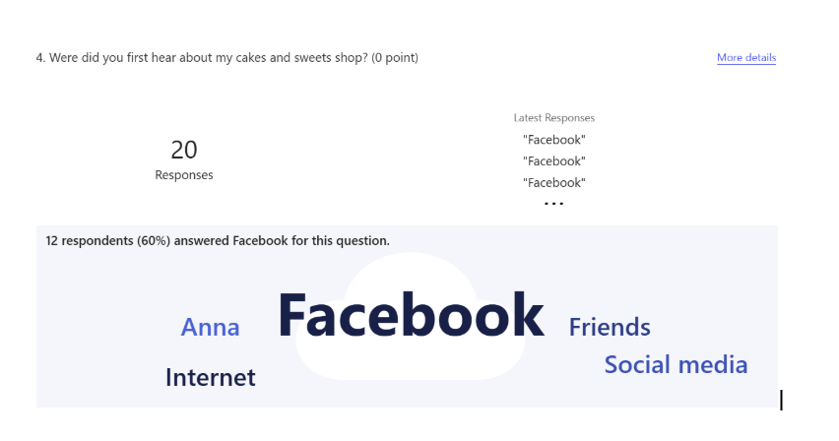
The survey revealed that 60% of the customers found Ana’s homemade Cakes on Facebook. It is evident that Facebook is the leading source of enquiry and acts as the most effective online platform for lead generation and marketing for the current business. This suggests that further feedback collection, such as determining whether potential customers discovered the business through reels, videos, or reviews, is necessary to decide on which method is most effective in capturing their attention. In this era of rapid technological advancement, where people have access to technology across various devices, including smartphones, tablets, and computers, and are in constant communication, the company's marketing department is capitalising on this opportunity to create innovative content that is both suitable and accessible through these mediums, thereby enhancing connectivity and customer engagement (Dadwal, 2020). In a broader sense, Facebook remains an effective platform for advertising businesses due to its vast user base and the ability to target potential customers based on age and location, thereby supporting businesses that are published or advertised on the platform. Other popular platforms are WhatsApp, Instagram, TikTok, LinkedIn, Facebook Messenger, Pinterest, and email marketing. Google My Business and Facebook ads are also popular options (Maxwell, 2022). A study on the effectiveness of Facebook revealed that the presence of an organisation and marketing efficiency have a significant relationship in building customer relationships, motivating purchase decisions, increasing awareness, and enhancing brand recognition. This suggests that maintaining consistency in social media presence is crucial for creating awareness and recognition among customers, thereby building and retaining the customer base. Social media marketing is often done by customers, not businesses. It is through them that brand awareness and brand recognition are enhanced; therefore, sharing motivating, valuable, and engaging content with potential customers, which captivates them to share on social media, would be an effective tool (Islam et al., 2024). It cannot be ignored that online presence across different channels is inevitable, combined with an offline marketing strategy to achieve profit maximisation. However, other popular social media channels and official websites should also focus on expanding the customer base.

- Most favourite flavour
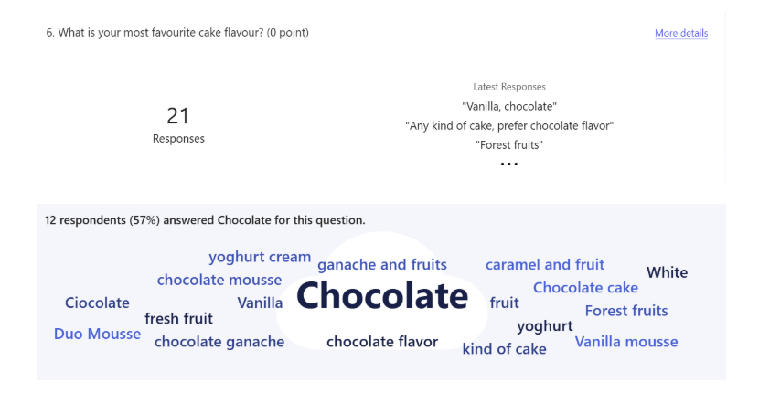

57% consider Chocolate as their popular choice in terms of flavours. In Ana’s homemade Cakes, premium-quality Belgian Chocolate from Callebaut is used, which yields the finest and most delicious chocolate cakes. Vanilla comes as the second choice. This suggests that people are willing to pay more for high-quality goods. The concept of perceived value involves the comparative assessment of customers' perceptions of the benefits of a product and the costs associated with it, such as price, time, and effort. This suggests that people purchase a premium-quality chocolate product because they perceive their effort as balanced with the quality (Femina and Santhi, 2024). From a broader perspective, the UK is the largest consumer of chocolates (CBI, 2022). The country's stricter restrictions on HFSS (High in Fat, Sugar, or Salt) products have reduced the visibility of chocolates in stores, making it inevitable to add more healthy options, as well as expand chocolate-flavoured cakes.

- Determinants of selecting a cake or sweet
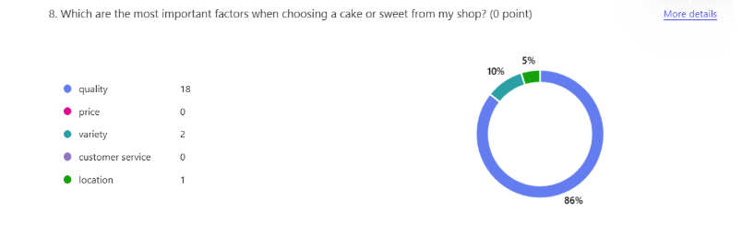
86% of the respondents have shared an opinion that quality is the top factor, while 10% opted for price, and 5% considered location as the most crucial factor when choosing a product. The products from Ana’s homemade Cakes prioritise locally sourced, high-quality ingredients and carefully prepared goods for their customers. The business values customer satisfaction. When a consumer considers product quality in their purchasing decisions, it indicates that they think about the physical condition, function, and nature of a product, which relates to and contributes to consumer satisfaction under the perceived value (Prihartono, 2021). Therefore, to maintain quality in business is not just the product quality, but all of the above.
- Suggestions for Improvement
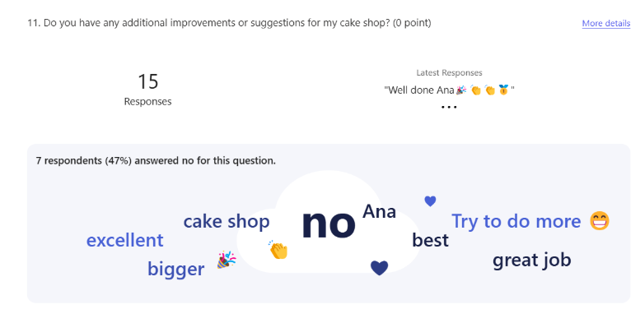
The results indicated that all 15 respondents were fully satisfied with the quality and experience of Ana’s homemade Cakes. Being a brand highly focused on high quality, great taste, significant aspects, good customer service, and timely delivery, the brand enjoys high customer satisfaction and customer loyalty. Kotler defines total customer value as the benefits customers obtain from using a product or service, after subtracting the total customer cost (Croitoru et al., 2024). The brand meets its customer expectations. Efforts shall be made to retain the same.

Task 2: 1000 words on the design of the website and marketing materials

As part of the Business plan to open a physical shop for Ana’s homemade Cakes, market research was conducted among customers using an online questionnaire tool to understand their opinions, preferences, and suggestions regarding products and services. The questionnaire consisted of 10 questions, from which four key questions and their corresponding responses were selected for analysis. The insights shed light on the most effective social media platform, their favourite flavour, the primary determinant of the product, and their opinion about the product and services.

Figure 1.
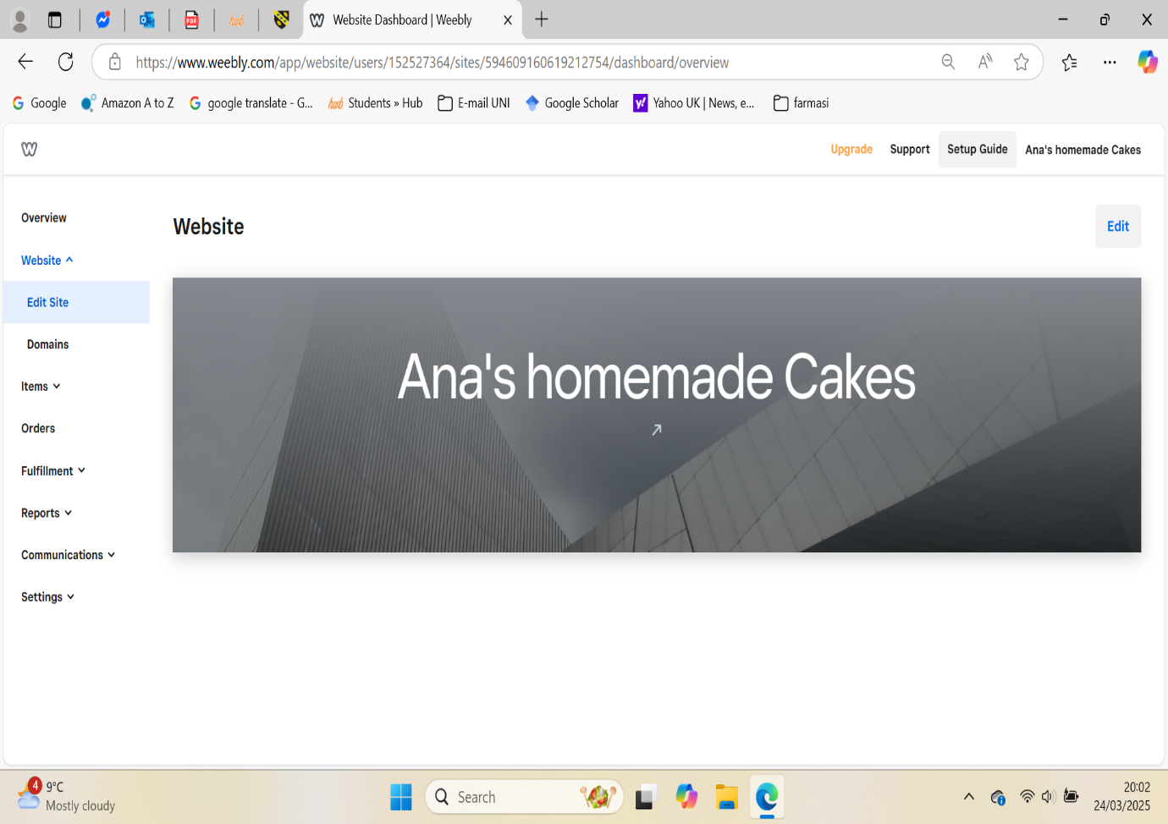

Figure 2.
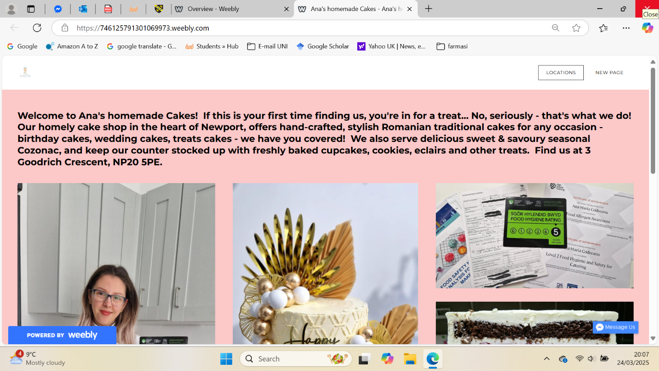

The responses revealed that Facebook is the most effective platform for Ana’s homemade Cakes, where customers are more active and engaged. Chocolate overpowers other flavours, and vanilla comes second in the list. Quality is the most determining factor in purchase decisions. Regarding overall suggestions, customers are delighted, with no significant areas for improvement. This information was essential for core decisions regarding the marketing strategy and design of the web presence. All four of these factors have been carefully integrated during market segmentation, as well as in the design of the website and marketing materials for Ana’s homemade Cakes' physical shop in Newport, Wales, UK. According to Philip Kotler, “Market segmentation is the subdividing of a market into homogeneous sub-sections of customers, where any subsection may conceivably be selected as a market target to be reached with a distinct marketing mix” (Sharma, 2020). There are four types of market segmentation: demographic, where the market is divided based on factors such as age, gender, occupation, and others. While geographic segmentation considers location, country, region and psychographic segmentation considers the customer’s lifestyle, attitude, interests, and values. Behavioural segmentation focuses on customers’ purchasing behaviours, occasions, loyalty, and usage rates (Włodzimierz, 2020).
The marketing strategy of Ana’s homemade Cakes has adopted a hybrid marketing approach, combining multiple segmentation types, which allows for the recognition of the complexity of evolving consumer behaviour and integrates multiple variables for more precise targeting (Cybellium, 2024). This allows the brand to use a more customised and unique segmentation strategy and marketing strategy. Ana’s homemade Cakes combine psychographic and behavioural segmentation, as well as geographical segmentation, variables to divide the market and reach the targeted audience more precisely.
By using psychographic segmentation that focuses on lifestyle, values, interests, and preferences (Kingsnorth, 2022), Ana’s homemade Cakes is keen to ensure that the website and marketing materials align with the interests of the majority of customers. Since the brand offers premium cakes and cookies crafted with high-quality ingredients, customers are luxury seekers who prefer high-quality, tasteful products, and also appreciate luxurious or customised presentations. They often buy gifts for special occasions, such as birthdays and weddings. The website features a premium look, showcasing high-quality images of original works with minimal aesthetic elements in elegant backgrounds, as can be seen in Figures 3, 4, and 5. This approach maintains the brand's image and recognition through the use of the logo, brand colour palette, and words such as 'premium', 'luxury', 'high-quality', and 'customised', which highlight the craftsmanship and premium ingredients in the products. To ensure the best customer service, a “contact me on Messenger” option is also provided on page 2. Ana's homemade Cakes is registered with Newport City Council under the UK Government, a requirement for all food-related businesses, and has obtained all the necessary certifications. (Newport City Council, 2025). The other details, such as Certifications and achievements, include food allergen certification by Highspeed training, and a Level 2 Food Hygiene and Safety for Catering certificate, which highlights the quality and authenticity of the product and services. Quality is the primary determinant of customers’ preference for selecting Ana’s products. The locally sourced, high-quality ingredients and freshly prepared products, all produced under set standards, are the highlights of Ana’s bakes, which cater to the interests of customers, predominantly premium customers. This has also been highlighted on the website.

Figure 3.
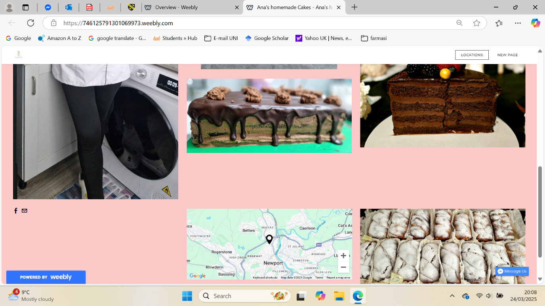

Figure 4.
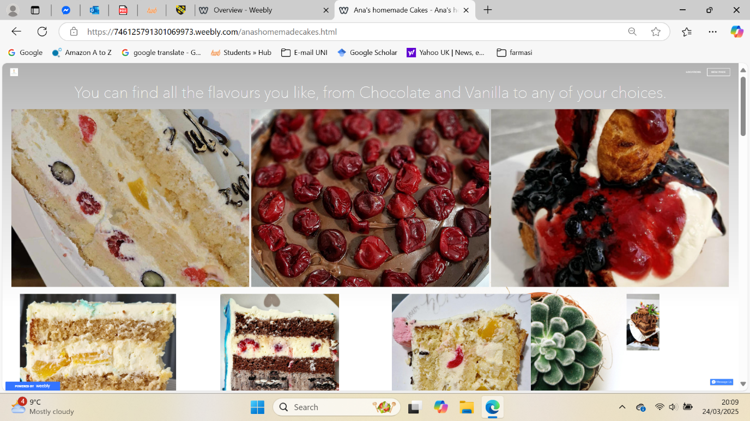
Figure 5.
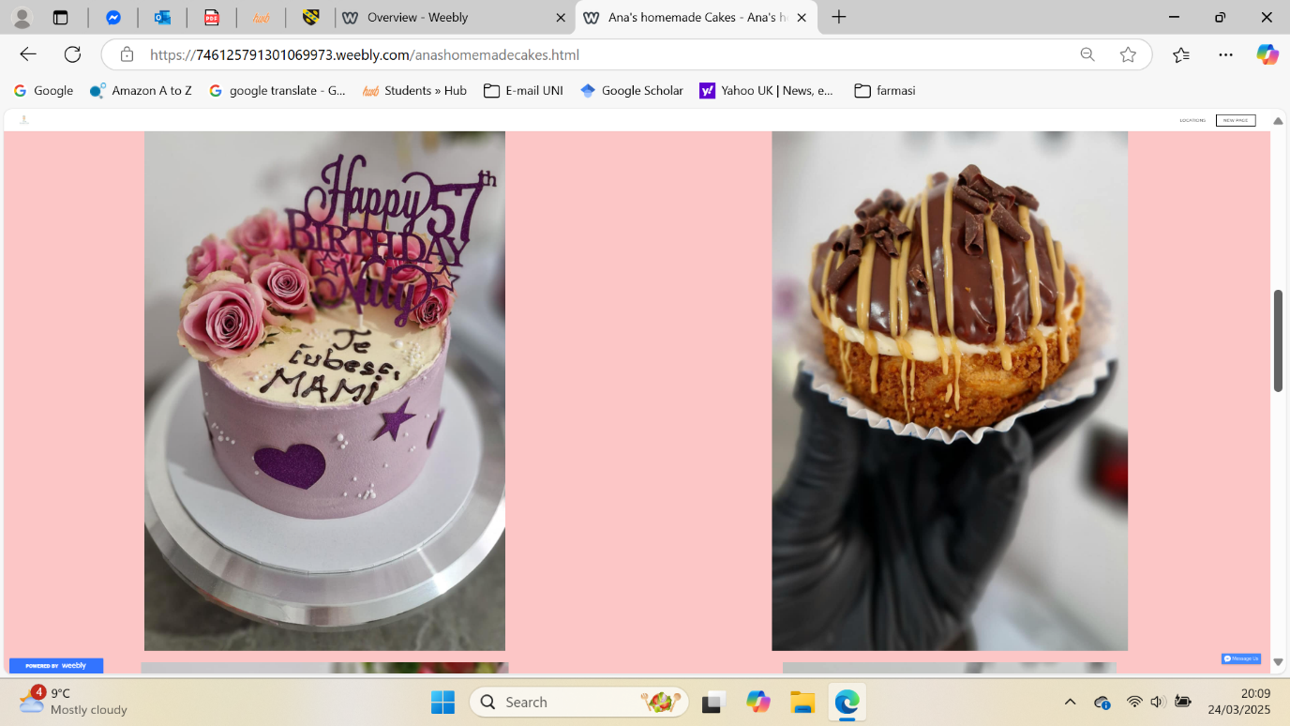

Discussing geographical segmentation, the physical location is Newport, Wales, and Ana targets customers who live within the town area and prefer to place direct orders. Phone numbers, email IDs, and physical shop addresses with location maps have been added on Page 2 to improve accessibility for them. The marketing materials include business cards and flyers (as shown in Figures 8, 9, 10, and 11) to attract local customers and visitors, utilising behavioural segmentation, which considers consumers' purchasing behaviour, occasion, and frequency. The Ana’s customers are mostly occasion- and celebration-based, looking for customised, personalised cakes and other items. A detailed menu with prices is included on page 2, and categories are also displayed, including Christmas and Easter cakes, mini cakes, chocolate, and celebration cakes as shown in Figures 6 and 7.

Figure 6.
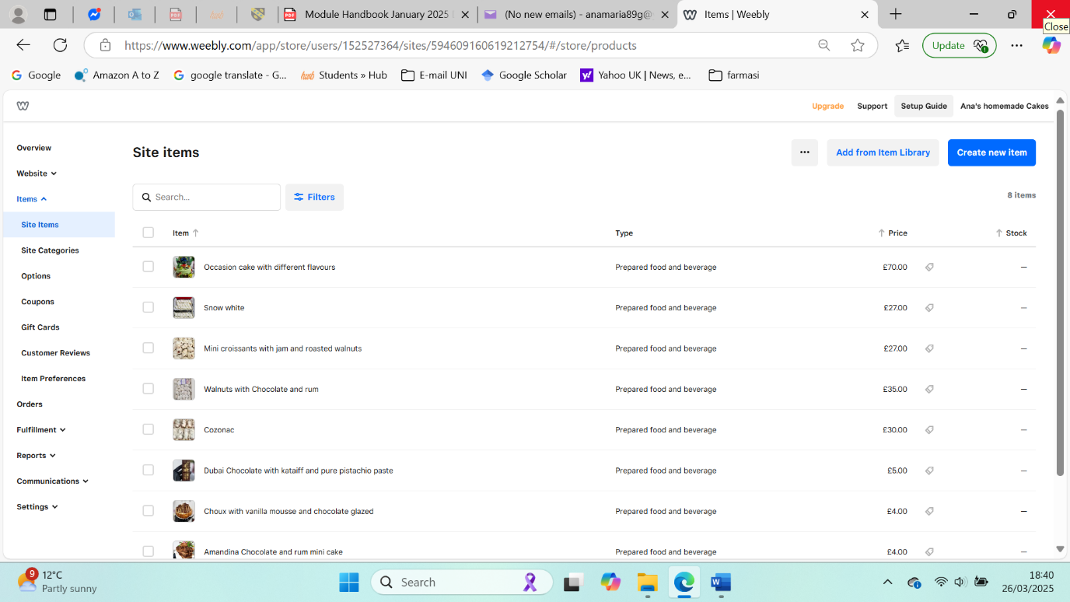

Figure 7.
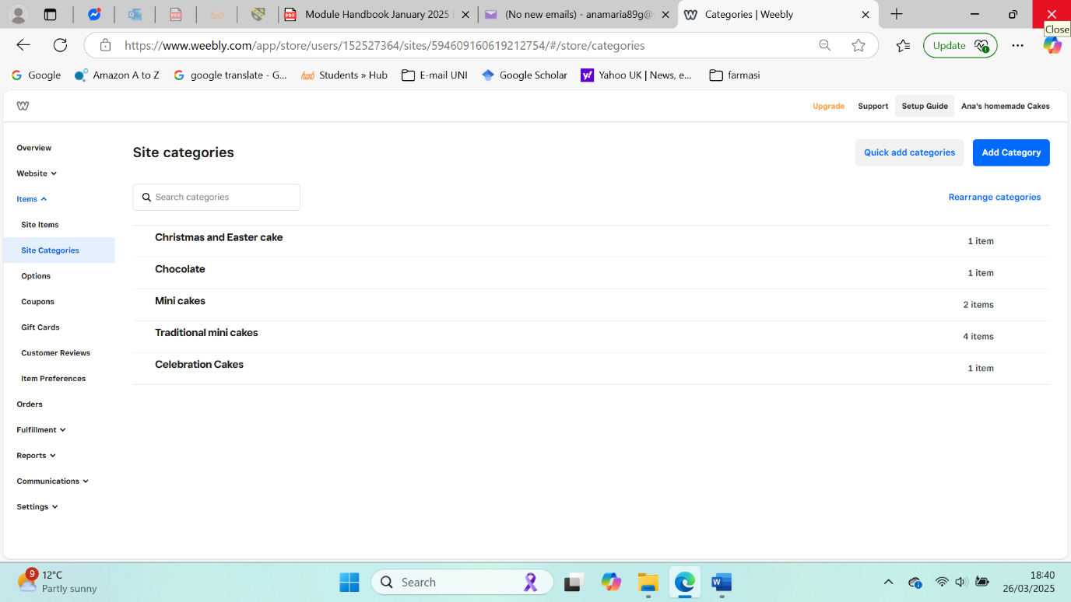
SEO optimisation is inevitable to improve online website visibility. The higher a site appears in search engine results, the more visitors it will receive (Veglis and Giomelakis, 2019). Ana’s homemade Cakes website and marketing materials are search engine optimised and ensure that they align with the insights of marketing research. Since Facebook has been identified as the most effective platform, marketing materials created using Canva specifically for Facebook will serve as a strong marketing tool. Quality is the top priority in purchase decisions, and a quality promise has been consistently maintained throughout the content. Additionally, content such as short videos showcasing craftsmanship has been prepared and shared on Facebook and TikTok, using tag words like #Quality, #Premium, #FreshlyBaked, #Traditional, #Tasteful and #Delicious, to optimise the search. Marketing materials, including flyers, Facebook posts, short videos and Instagram posts, highlighted the high-quality ingredients. In Ana’s homemade Cakes, premium-quality Belgian Chocolate from Callebaut is used, offering the finest and most delicious chocolate cakes. Vanilla became the second choice. To cater to chocolate lovers, the website has highlighted chocolate-flavoured cakes and added a category dedicated to chocolate under the product category, featuring SEO-friendly descriptions that highlight premium ingredients such as Belgian chocolate and Callebaut. The survey revealed that customers are delighted with products and services. To improve SEO, user-generated content, such as cake photos and reviews, is used for content marketing on Facebook. The embedded "Contact me on Messenger" option for instant customer messages can enhance customer satisfaction and loyalty.
In short, a hybrid segmentation approach that offers unique insights for each segment, allowing for the creation of more targeted marketing strategies by clearly considering relevant variables and attributes, can foster deeper connections with customers (Nourijanian, 2024). Based on that, SEO can precisely target the right audiences, leading to a broader customer base with high loyalty.

Figure 8.
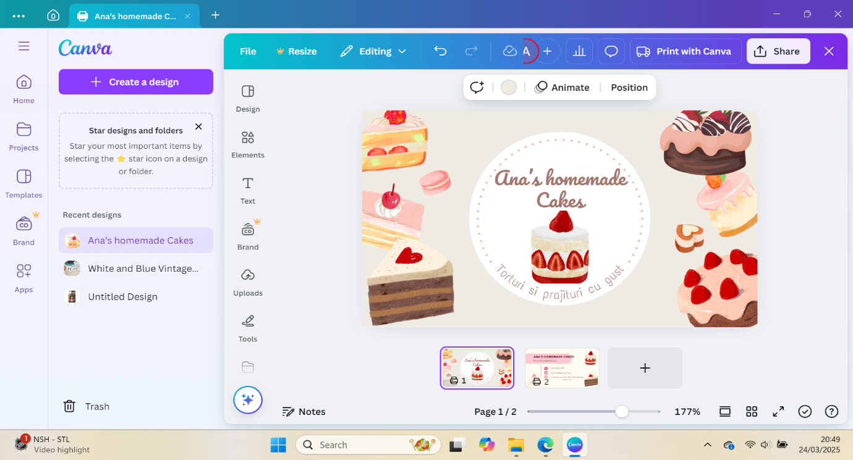

Figure 9.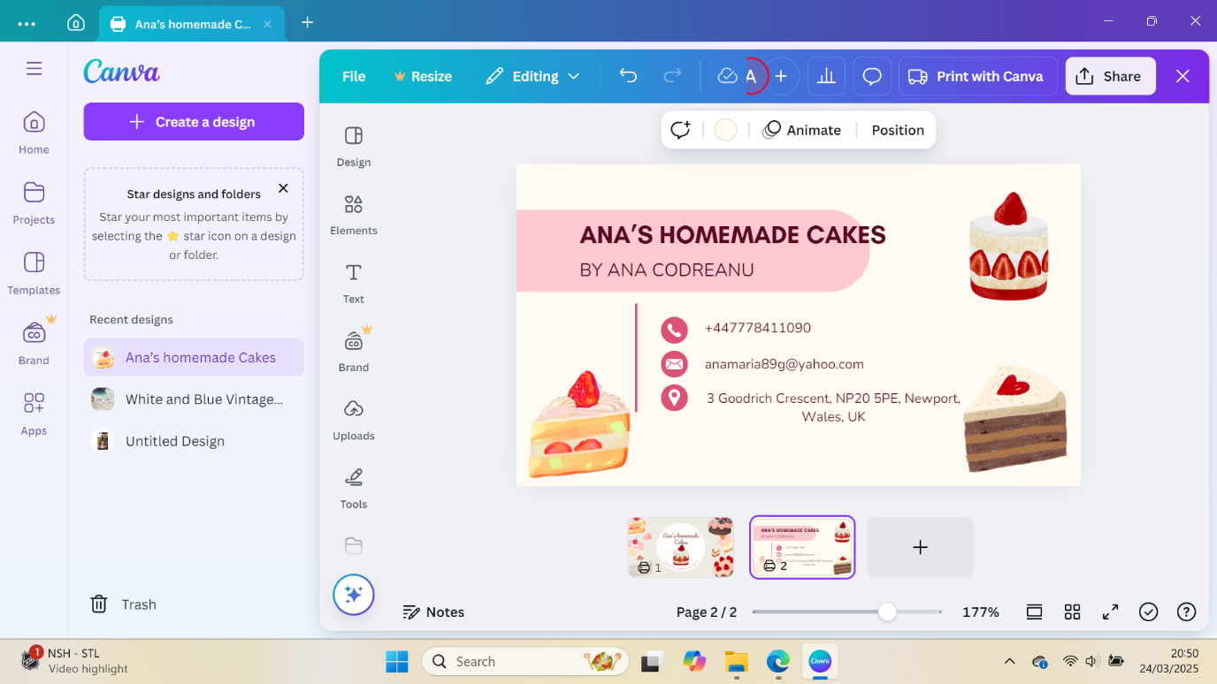
Figure 10.
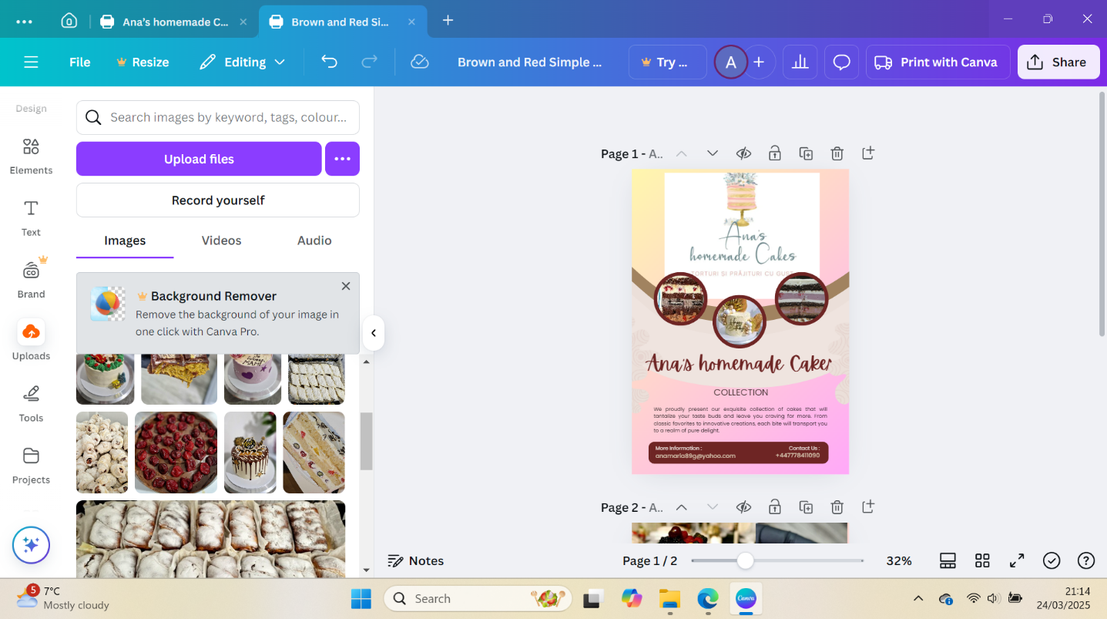

Figure 11.

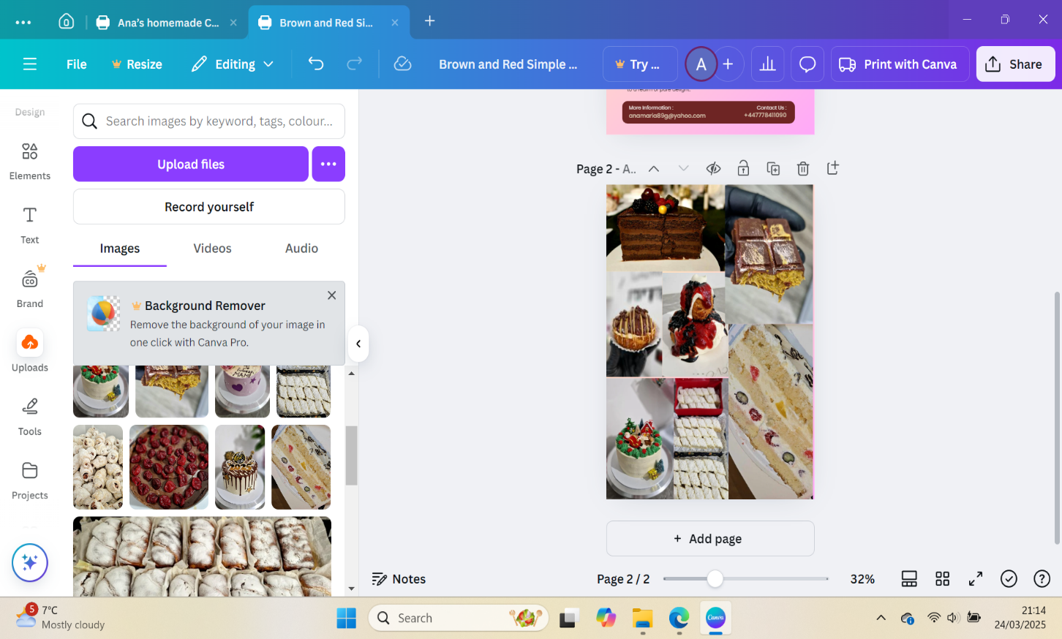

Task 3: Microsoft Excel

Microsoft Excel is a spreadsheet program developed by Microsoft that offers a powerful tool for creating, analysing, and visualising data. The initial release was in 1985, and the latest version is Microsoft 365 and Office, which is available for both Windows and macOS. The software is primarily used for data entry and management, Accounting purposes, Scheduling and task management, planning, creating budgets and invoices, producing high-quality charts, and entering sales numbers and business forecasting (Microsoft, 2025). Initially, the primary objective of MS Excel was to assist users with their financial data, including compiling and managing yearly debit and credit transactions. Surprisingly, Excel has become one of the most widely used software programs, offering numerous features and functions to help users from diverse categories, including schoolchildren and multinational corporations, manage their data effectively (Statanalytica,2024).
In today’s technological era, where the importance of data and data analytics cannot be overstated, the insights from data analysis and visualisation lead to vital decision-making and financial planning. To discuss further, the importance of a programme like Excel in business or daily life is imperative. It is a one-stop solution for people who deal with data, whether they are students, data analysts, or business professionals; it helps everyone update, organise, analyse, and plan their data. It helps with budgeting and financial planning. It helps with personal projects and health goals. It helps students support their studies and projects, and professionals expand their opportunities (McDonald, 2023). The software helps track their daily cash flow, expenses, revenues, and balance sheet, among other things. It also helps to forecast the financial situation by using different conditions, which enable them to forecast figures in various scenarios (Washburn, 2023). For example, the cash flow statement in the business plan was prepared using Excel, which helped create an estimate of the business's financial performance over the first 12 months. This projection helped to prepare a budget and forecast the estimated amount for the start-up.
Excel helps keep data more organised. Usually, businesses deal with millions of data points, and organising them is a herculean task. However, software like Excel can keep the data organised, sorted, filtered, and used to understand current positions, trends, and market research purposes. For example, for the bakery business plan, it helps to organise data for inventory management, daily sales, raw material details, delivery details, resource allocation, miscellaneous expenses, supplier details, or any other required information, which is more precise, optimised, and quickly accessible. Additionally, it helps with cost management.
Excel is a great support tool for project management. Creating a Gantt chart helps to establish timelines and milestones, develop an action plan, and track progress. If the bakery business is handling a large order, the Gantt chart will help mark milestones and deadlines, and the chart can effectively visualise progress (Microsoft, 2024).
The most widely used feature of Excel is its ease of calculation, which allows for innovative arithmetic options for small to large datasets, with a vast range of formulas, including essential functions such as addition and subtraction, as well as advanced calculations (Gillis, 2021). This also aids in business forecasting and trend analysis. The formatting options help to highlight or differentiate important data with colours and italics. This feature enables us to highlight specific information, understand complex scenarios, and perform additional tasks. For instance, the bakery business can utilise this option to calculate total sales for the month, filter the data based on the order of highest turnover to lowest turnover, and calculate the average sales on peak days. This allows for better planning of potential days, which is applicable on a yearly or quarterly basis.
The chart option helps you select specific data, perform analysis, and visually represent the results. For example, it helps to generate a graphical representation of sales and revenue figures in a single click, which can be used in reports or presentations. It also helps to pull data from another file and consolidate everything in a single space, allowing the user to have a comprehensive view of the data. The integrated AI assistant helps the users transform the spreadsheet into a powerful data analytics platform. The option is highly beneficial for business professionals, data analysts, scientists, and marketing professionals. This feature helps generate formulas, automate tasks, ease data analysis, translate text, and streamline processes across various departments or offices. Excel is used for human resource planning and operations, as it facilitates the entry of human resource details, including names, attendance, hours, and payments (Microsoft, 2025).
In conclusion, Excel is a comprehensive solution for various complex tasks that are essential for anyone working with small to large datasets, thereby enhancing operational efficiency and productivity. For individuals, it improves their competitiveness and widens their career opportunities. The software is used by even housewives, indicating that, in the 21st century, Excel is a familiar tool among even everyday people (Bala Excelinsights, 2024).

Task 4: Create a short 3-minute video advertising your chosen brand.

https://youtu.be/9KvSvzMXoNI

To advertise the cake shop, personal stories have been employed. Different storytelling methods were effectively utilised to capture the audience's attention and establish an emotional connection with the product. The video begins with a friendly and relatable opening. Firstly, the use of character development is central to the promotion, with the bakery owner portrayed as passionate and dedicated, building trust and relatability (Nelson, 2020). The video highlights the baker's path, emphasising her dedication to excellence. Another essential technique employed is the use of visual imagery, which triggers sensory experiences, mainly the vibrant textures and hues of the cakes. This not only showcases the product but also taps into the viewer's emotions, associating the cakes with pleasure and indulgence (Smith & Johnson, 2022). These visual elements evoke a longing in the viewer to enjoy freshly baked products made with ingredients from local farms. Finally, the clear call-to-action at the end of the video strengthens the connection, encouraging viewers to visit the cake shop and become part of the story themselves (Smith & Taylor, 2023). This blend of visual, emotional, and narrative components corresponds with modern marketing approaches that emphasise storytelling to foster brand loyalty and awareness.

References list

- Bala_Excel_Insights (2024). Excel in Small Businesses: Simplifying Operations - Bala_Excel_Insights - Medium. [online] Medium. Available at: https://medium.com/@kbala7092/excel-in-small-businesses-simplifying-operations-aa0b58063007 [Accessed 27 Feb. 2025].
- CBI (2022). The United Kingdom market potential for cocoa | CBI. [online] www.cbi.eu. Available at: https://www.cbi.eu/market-information/cocoa/united-kingdom/market-potential [Accessed 22 Feb. 2025].
- Cybellium (2024). Understanding Market Segmentation. [online] Cybellium. Available at: https://www.google.co.in/books/edition/Understanding_Market_Segmentation/4mIsEQAAQBAJ?hl=en&gbpv=1&dq=hybrid+market+segmentation&pg=PA217&printsec=frontcover [Accessed 26 Mar. 2025].
- Croitoru, G., Capatina, A., Florea, N.V., Codignola, F. and Sokolic, D. (2024). A cross-cultural analysis of perceived value and customer loyalty in restaurants. European Research on Management and Business Economics, [online] 30(3), p.100265. doi:https://doi.org/10.1016/j.iedeen.2024.100265.
- E.P. Femina and P. Santhi (2024). Effects of perceived value dimensions on customer brand loyalty towards luxury cars. Rajagiri Management Journal. [online] doi:https://doi.org/10.1108/ramj-01-2024-0006.
- Gillis, A. (2021). What Is Excel? Everything You Need to Know - Definition by WhatIs.com. [online] SearchEnterpriseDesktop. Available at: https://www.techtarget.com/searchenterprisedesktop/definition/Excel [Accessed 21 Mar. 2025].
- Islam, T., Miron, A., Nandy, M., Choudrie, J., Liu, X. and Li, Y. (2024). Transforming Digital Marketing with Generative AI. Computers, [online] 13(7), pp.168–168. doi:https://doi.org/10.3390/computers13070168.
- Jeswani, R. (2023). The Role and Importance of Social Media Marketing in Brand Building. [online] ResearchGate. Available at: https://www.researchgate.net/publication/375731382_The_Role_and_Importance_of_Social_Media_Marketing_in_Brand_Building [Accessed 16 Mar. 2025].
- Kingsnorth, S. (2022). Digital marketing strategy: an integrated approach to online marketing. 3rd ed. [online] New York: Kogan Page Ltd. Available at: https://www.google.co.in/books/edition/Digital_Marketing_Strategy/acdsEAAAQBAJ?hl=en&gbpv=1&dq=psychographic+segmentation+SEO&pg=PA397&printsec=frontcover [Accessed 26 Mar. 2025].
- Maxwell, T. (2022). Council Post: What To Consider Before Advertising On Facebook Today. Forbes. [online] 12 Aug. Available at: https://www.forbes.com/councils/forbesagencycouncil/2022/12/09/what-to-consider-before-advertising-on-facebook-today/ [Accessed 22 Feb. 2025].
- Microsoft (2025a). AI Assistant for Excel. [online] AI Assistant for Excel. Available at: https://appsource.microsoft.com/en-us/product/office/wa200005401?tab=overview [Accessed 28 Feb. 2025].
- Microsoft (2025b). Free Online Spreadsheet Software: Excel | Microsoft 365. [online] Microsoft.com. Available at: https://www.microsoft.com/en-in/microsoft-365/excel#Key-features [Accessed 27 Feb. 2025].
- Nelson, A. (2020). Character-driven marketing: Crafting authentic brand stories. Marketing Review, 34(3), 201-215.
- Newport City Council (2025). Starting a food business | Newport City Council. [online] Newport.gov.uk. Available at: https://www.newport.gov.uk/business/food-standards-and-safety/starting-food-business [Accessed 25 Mar. 2025].
- Nourijanian, E. (2024). Council Post: Using Enhanced Marketing Segmentation To Engage Audiences. Forbes. [online] 12 Aug. Available at: https://www.forbes.com/councils/forbescommunicationscouncil/2024/07/01/using-enhanced-marketing-segmentation-to-engage-audiences/ [Accessed 26 Mar. 2025].
- Prihartono, P. (2021). Determination of Purchase Decision: Product Quality, Price and Place (Literature Review). Dinasti International Journal of Economics, Finance & Accounting, 2(3), pp.357–365. doi:https://doi.org/10.38035/dijefa.v2i3.1365.
- Prof. Michael McDonald (2023). 200+ Excel Formulas and Functions. [online] BPB Publications. Available at: https://www.google.co.in/books/edition/200+_Excel_Formulas_and_Functions/QBbAEAAAQBAJ?hl=en&gbpv=1&dq=why+excel+is+important&printsec=frontcover [Accessed 27 Feb. 2025].
- Sharma, C. (2020). Marketing Management by Dr. F. C. Sharma (eBook). [online] SBPD Publications. Available at: https://www.google.co.in/books/edition/Marketing_Management_by_Dr_F_C_Sharma/I4buDwAAQBAJ?hl=en&gbpv=1&dq=kotler+segmentation+sub+definition&pg=PA49&printsec=frontcover [Accessed 26 Mar. 2025].
- Smith, L., & Johnson, T. (2022). Visual storytelling in digital advertising. International Journal of Advertising, 40(1), 45-59.
- Smith, L., & Taylor, R. (2023). Digital storytelling: Building connections with customers. Business and Media Review, 12(1), 123-137.
- StatAnalytica.com (2020). What are The Uses of Excel in Our Daily Life? [online] Statanalytica. Available at: https://statanalytica.com/blog/uses-of-excel/ [Accessed 27 Feb. 2025].
- Sumesh Dadwal (2020). Handbook of research on innovations in technology and marketing for the connected consumer. Hershey, Pennsylvania: Igi Global.
- Veglis, A. and Giomelakis, D. (2019). Search Engine Optimization. Future Internet, [online] 12(1), p.6. doi:https://doi.org/10.3390/fi12010006.
- Washburn, E. (2023). 5 Ways To Get Started Using Microsoft Excel. Forbes. [online] 5 Apr. Available at: https://www.forbes.com/sites/emilywashburn/2023/04/05/5-ways-to-get-started-using-microsoft-excel/.
- Włodzimierz Sroka (2020). Perspectives on Consumer Behaviour: Theoretical Aspects and Practical Applications. [online] Cham: Springer International Publishing, Imprint Springer. Available at: https://www.google.co.in/books/edition/Perspectives_on_Consumer_Behaviour/h4vtDwAAQBAJ?hl=en&gbpv=1&dq=4+types+of+segmentation+psychographic+demographic&pg=PA182&printsec=frontcover [Accessed 26 Mar. 2025].

