An investigation into body image perception and eating patterns of retired competitive body builders
Valentina Serra
000000526288

An investigation into body image perception and eating patterns of retired competitive body builders.
Research Question
Are there negative body image perceptions, and restrictive eating patterns in retired competitive male bodybuilders?
Introduction
The link between elite sports and increased risk and prevalence of eating disorders is well researched and documented (Li et al., 2024), with high incidence in weight limiting and leanness sports (Mancine et al., 2020) ‘Nutrition and body composition are functions of an athlete’s occupation, sometimes creating a complex relationship with food and body for the individual’ (Buckley et al., 2019). Although some research has been conducted into the prevalence of eating disorders in male body builders (Goldfield et al., 2006), research around eating disorders in sports is predominantly focused on female athletes (Plateau et al., 2017). Restrictive eating patterns associated with body building often give rise to disordered eating behaviours (Efthymiou et al., 2021), precursor for eating disorders. Research has also demonstrated that recovery from an eating disorder is low, with approximately half of patients with anorexia nervosa (AN) not recovering even after following an adequate course of treatment (Eddy et al., 2016). However, restrictive intake patterns are ‘normalised’ in body building (Efthymiou et al., 2021), and few studies have explored the long-term effects of these patterns on body image and eating patterns.
This research proposal will include a rationale for the proposed research, with a clear idea of what the study aims to explore. The proposed method for the research will be presented, with a clear rationale for the choice. The appendix will provide a proposed timeline for the completion of the study, a complete ethics form, information sheet, EAT-26 form, and consent form.

Aims and objectives
The current study aims to explore body image perception, and eating disorder cognitions and behaviours amongst retired competitive bodybuilders.
It aims to ascertain whether energy intake is adequate to meet requirements, to establish whether there is a variety of intake across the food groups, and to establish whether the eating attitude test (EAT-26) indicates negative body image perceptions associated with eating disorder cognitions and behaviours.
Scope and Limitations
It is acknowledged that a gap in the literature exists around disordered eating and eating disorder behaviours in the general retired athlete population. However, the scope of the study, time constraints, and accessibility to retired athletes mean that the study cannot be conducted on a large scale, and therefore unable to explore all sports. The scope of the study is therefore not to establish a link between being a retired athlete and incidence of eating disorder cognitions, but simply to explore whether there is an incidence of negative body image perceptions and restrictive eating amongst a small sample of retired body builders.

Generalisability of findings is therefore going to be limited.

Additionally, the food frequency questionnaire (FFQ) is prone to measurement errors (National Cancer Institute (NIH), 2025). However, this will be used as a way to establish restriction of food groups, rather than accurate intake.
Background
Eating disorders are serious mental illnesses marked by dysfunctional eating behaviours and distorted body image (Feng et al., 2023). Their development is thought to be influenced by biological, psychological, environmental factors, and genetic predisposition (Díaz-Marsá et al., 2017). According to a review of existing literature, risk factors for its incidence include, but are not limited to, genetics, personality traits, gender, body image and social influence, and elite sports (Barakat et al., 2023). Elite athletes are, thus, at greater risk of developing an eating disorder than the non-athlete population (Sundgot-Borgen & Torstveit, 2004, and existing literature demonstrates a higher incidence of disordered eating behaviours amongst athletes than in the general population (Fatt et al., 2024), and an increased incidence amongst male athletes compared to non-athlete males (Karrer et al., 2020). The prevalence of eating disorder behaviours and attitudes amongst athletes is estimated to be between fourteen and forty-five percent (Martinsen et al., 2009, Petrie et al., 2008).
It is well documented that eating disorders are more prevalent in weight-sensitive sports such as ‘gymnastics, figure skating, and synchronized swimming’ (Devrim et al., 2018, Sundgot-Borgen et al., 2013), with greater weight pressures associated with a higher prevalence of disordered eating (Fatt et al., 2024). ‘Nutrition and body composition are functions of an athlete’s occupation, sometimes creating a complex relationship with food and body for the individual’ (Buckley et al., 2019). Additionally, eating disorders may present differently in men, who desire to have a more muscular shape, particularly in body weight-related sports, such as bodybuilding (Devrim et al., 2018), thus making their diagnosis more difficult at an early stage. Body dissatisfaction may present as a desire to be bigger, have more muscles, rather than the desire to be thinner associated with a typical presentation.
In sport, body weight has an effect on performance, leading to preoccupation with weight gain, and increasing the risks for eating disorders (Currie, 2010). Body building is a ‘lean’ sport. Athletes are judged on the aesthetics of their physiques, low subcutaneous fat being one of the primary criteria. Consequently, great emphasis is placed on looks rather than performance for the duration of the athlete’s career. Additionally, eating patterns amongst body builders are very restrictive, with studies reporting only around six percent of body building athletes following their regular diet the week prior to competition (Chappell & Simper, 2018), and engaging in other disordered eating practices during their careers. Pickett et al. (2005) demonstrated that bodybuilders had higher self-reported disordered eating symptoms than control groups.
However, there is a lack of scientific research that explores whether these restrictive practices continue into athlete retirement, and whether preoccupation with appearance and body composition for the duration of the athlete’s career has longer term psychological and dietary implications.

Methodology

Research Design
The current study proposes to employ a non-experimental, cross-sectional, observational research design, using a mixed method approach.

Participants
Participants will be retired male body builders.
Exclusion criteria 1) diagnosed eating disorder

Data Collection
A number of previously conducted studies into eating disorder behaviours and cognitions have used the eating attitude test (EAT-26) (Gleaves et al., 2014), a validated, self-reporting test that measures the presence of abnormal eating attitudes and behaviours.

The present study will provide participants with the EAT-26 test and a food frequency questionnaire. Participants will subsequently be called to a semi-structured interview over Microsoft Teams, where a 24-hour recall of a typical day of dietary intake will be collected and compared with estimated nutritional requirements calculated using the equation by De Lorenzo et al. (1999) [REE= -857+9*BW in kg+11*Height (cm)], and further questions asked about current intake and restriction. The transcripts will be recorded.

Reported anthropometric data (height and weight) will be collected and used to aid the assessment of whether current intake is adequate to meet requirements.

The current study does not aim to compare data gathered with that of non-athletes, it aims only to identify IF there are eating disorder behaviours and cognitions amongst the retired athletes. On this basis, a control group will not be required.

Analysis
Data will be analysed using Nvivo 14 (14.24.3) and IBM SPSS (30.0.0.0).
Statistical significance will be considered as confidence interval of 95% (p-value of 0.05)

Procedures
Participation to the study is voluntary. Participants will be provided with a study information sheet which details the study and its purpose. The information sheet will also contain information for further support for eating disorders.
Participants will be required to complete informed consent forms.

Ethical considerations
A number of ethical considerations are significant in this type of research, and must be considered when conducting this study.

Informed consent: participants should be made aware of what the study entails, and participation should be voluntary. Participants will also be made aware they have the chance to withdraw from the study at any point, ensuring their psychological well-being is prioritised.

Psychological wellbeing: The questionnaires and questions asked may be of a sensitive nature, and could be triggering for the participants. Furthermore, participant answers may indicate eating disorder behaviours or cognitions. It is therefore important that all participants receive information on eating disorders and how to seek support.

Findings: findings of the study will be reported with accuracy and honesty, acknowledging any relevance and being clear about the limitations and implications for further research.

Good practice: In keeping with ethical good practice, the amount of sensitive and re-identifiable data stored will be kept to a minimum, reviewed frequently and disposed of at the earliest opportunity (UK Statistics Authority, 2022). The study will adhere to UWTSD and BDA guidelines.

Word Count 1414

References

Barakat, S. et al. (2023) ‘Risk factors for eating disorders: Findings from a rapid review’,
Journal of Eating Disorders, 11(1). doi:10.1186/s40337-022-00717-4.

Buckley, G. et al. (2019) ‘Retired athletes and the intersection of food and body: A systematic
literature review exploring compensatory behaviours and body change’, Nutrients, 11(6), p.
1395. doi:10.3390/nu11061395.

Chappell, A.J. and Simper, T.N. (2018) ‘Nutritional peak week and competition day strategies
of competitive natural bodybuilders’, Sports, 6(4), p. 126. doi:10.3390/sports6040126.

Currie, A. (2010) ‘Sport and eating disorders - understanding and managing the risks’, Asian
Journal of Sports Medicine, 1(2). doi:10.5812/asjsm.34864.
De Lorenzo, A., Bertini, I., Candeloro, N., Piccinelli, R. & al, e. 1999, "A new predictive equation to calculate resting metabolic rate in athletes", Journal of Sports Medicine and Physical Fitness, vol. 39, no. 3, pp. 213-9.

Devrim, A., Bilgic, P. and Hongu, N. (2018) ‘Is there any relationship between body image perception, eating disorders, and muscle dysmorphic disorders in male bodybuilders?’, American Journal of Men’s Health, 12(5), pp. 1746–1758. doi:10.1177/1557988318786868.

Díaz-Marsá, M., Alberdi-Páramo, Íñigo and Niell-Galmés, L. (2017) “Nutritional supplements in eating disorders”, Actas Españolas de Psiquiatría, 45(Suppl. 1), pp. 26–36. Available at: https://actaspsiquiatria.es/index.php/actas/article/view/1384 (Accessed: 12 March 2026).

Eddy, K.T. et al. (2016) ‘Recovery from anorexia nervosa and bulimia nervosa at 22-year
follow-up’, The Journal of Clinical Psychiatry, 78(02), pp. 184–189.
doi:10.4088/jcp.15m10393.

Efthymiou, D. et al. (2021) ‘Perceived ideal body weight exacerbates bulimia and dieting in
bodybuilding athletes’, Toxicology Reports, 8, pp. 1777–1782.
doi:10.1016/j.toxrep.2021.10.007.

Fatt, S.J., George, E., Hay, P., Jeacocke, N. and Mitchison, D. (2024) ‘Comparing population-
general and sport-specific correlates of disordered eating amongst elite athletes: A cross-
sectional study’, Sports Medicine - Open, 10(1). doi:10.1186/s40798-024-00791-9.

Fatt, S.J., George, E., Hay, P., Jeacocke, N., Gotkiewicz, E., et al. (2024) ‘An umbrella
review of body image concerns, disordered eating, and eating disorders in elite athletes’,
Journal of Clinical Medicine, 13(14), p. 4171. doi:10.3390/jcm13144171.

Feng, B. et al. (2023) ‘Current discoveries and future implications of eating disorders’,
International Journal of Environmental Research and Public Health, 20(14), p. 6325. doi:10.3390/ijerph20146325.

Gleaves, D.H. et al. (2014) ‘Measuring eating disorder attitudes and behaviors: A reliability
generalization study’, Journal of Eating Disorders, 2(1). doi:10.1186/2050-2974-2-6.

Goldfield, G.S., Blouin, A.G. and Woodside, D.B. (2006) ‘Body image, binge eating, and
bulimia nervosa in male bodybuilders’, The Canadian Journal of Psychiatry, 51(3), pp. 160–
168. doi:10.1177/070674370605100306.

Karrer, Y. et al. (2020) ‘Disordered eating and eating disorders in male elite athletes: A
scoping review’, BMJ Open Sport &amp; Exercise Medicine, 6(1). doi:10.1136/bmjsem-
2020-000801.

Li, Q. et al. (2024) ‘Athlete body image and eating disorders: A systematic review of their
association and influencing factors’, Nutrients, 16(16), p. 2686. doi:10.3390/nu16162686.

Mancine, R.P. et al. (2020) ‘Prevalence of disordered eating in athletes categorized by
emphasis on leanness and activity type – A systematic review’, Journal of Eating Disorders,
8(1). doi:10.1186/s40337-020-00323-2.

Martinsen, M. et al. (2009) ‘Dieting to win or to be thin? A study of dieting and disordered
eating among adolescent elite athletes and non-athlete controls’, British Journal of Sports
Medicine, 44(1), pp. 70–76. doi:10.1136/bjsm.2009.068668.

Money-Taylor, E. et al. (2021) ‘Differences in attitudes, behaviours and beliefs towards
eating between female bodybuilding athletes and non-athletes, and the implications for eating
disorders and disordered eating’, Sport Sciences for Health, 18(1), pp. 67–74.
doi:10.1007/s11332-021-00775-2.

National Cancer Institute (NIH) (2025) Food frequency questionnaire at a glance, Food
Frequency Questionnaire at a Glance | EGRP/DCCPS/NCI/NIH. Available at:
https://epi.grants.cancer.gov/dietary-assessment-primer/profiles/questionnaire/ (Accessed: 12
March 2026).

Petrie, T.A. et al. (2008) ‘Prevalence of disordered eating behaviors among male collegiate
athletes’, PsycEXTRA Dataset [Preprint]. doi:10.1037/e505532008-001.

Pickett, T.C., Lewis, R.J. and Cash, T.F. (2005) ‘Men, muscles, and body image:
Comparisons of competitive bodybuilders, weight trainers, and athletically active controls’,
British Journal of Sports Medicine, 39(4), pp. 217–222. doi:10.1136/bjsm.2004.012013.

Plateau, C.R. et al. (2017) ‘Female athlete experiences of seeking and receiving treatment for
an eating disorder’, Eating Disorders, 25(3), pp. 273–277.
doi:10.1080/10640266.2016.1269551.

Quatromoni, P.A. (2017) ‘A tale of two runners: A case report of athletes’ experiences with
eating disorders in college’, Journal of the Academy of Nutrition and Dietetics, 117(1), pp.
21–31. doi:10.1016/j.jand.2016.09.032.

Schlickmann, D. da et al. (2023) ‘The moderating role of macronutrient intake in relation to
body composition and genotoxicity: A study with Gym Users’, Mutation Research/Genetic
Toxicology and Environmental Mutagenesis, 890, p. 503660.
doi:10.1016/j.mrgentox.2023.503660.

Stapleton, P., McIntyre, T. and Bannatyne, A. (2014) ‘Body image avoidance, body
dissatisfaction, and eating pathology’, American Journal of Men’s Health, 10(2), pp. 100–
109. doi:10.1177/1557988314556673.

Sundgot-Borgen, J. and Torstveit, M.K. (2004) ‘Prevalence of eating disorders in elite athletes is higher than in the general population’, Clinical Journal of Sport Medicine, 14(1), pp. 25–32. doi:10.1097/00042752-200401000-00005.

Sundgot-Borgen, J. et al. (2013) ‘How to minimise the health risks to athletes who compete
in weight-sensitive sports review and position statement on behalf of the Ad Hoc Research
Working Group on body composition, health and performance, under the auspices of the IOC
Medical Commission’, British Journal of Sports Medicine, 47(16), pp. 1012–1022.
doi:10.1136/bjsports-2013-092966.

UK Statistics Authority (2022) Ethical considerations associated with Qualitative Research
Methods, UK Statistics Authority. Available at:
https://uksa.statisticsauthority.gov.uk/publication/ethical-considerations-associated-with-
qualitative-research-methods/ (Accessed: 12 March 2026).

Appendices

Appendix A- Timeline

Week Commencing | Responsibilities
9th March | - Complete ethics form and submit for approval  - Produce participant information sheet  - Obtain informed consent form  - Submit Research proposal
23rd March | - Recruit participants
6th April | - Conduct Teams Interviews
13th April | - Analyse collected data
20th April | - Write up data and compare with any previous research
27th April | - Draft poster
8th May | - Submit poster for research project

Appendix B- Ethics Form

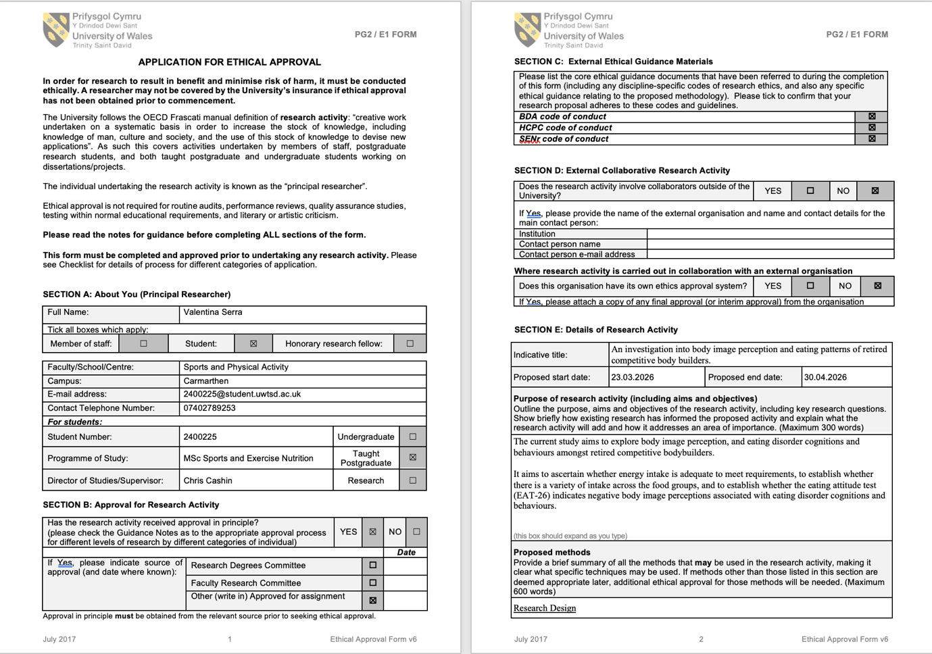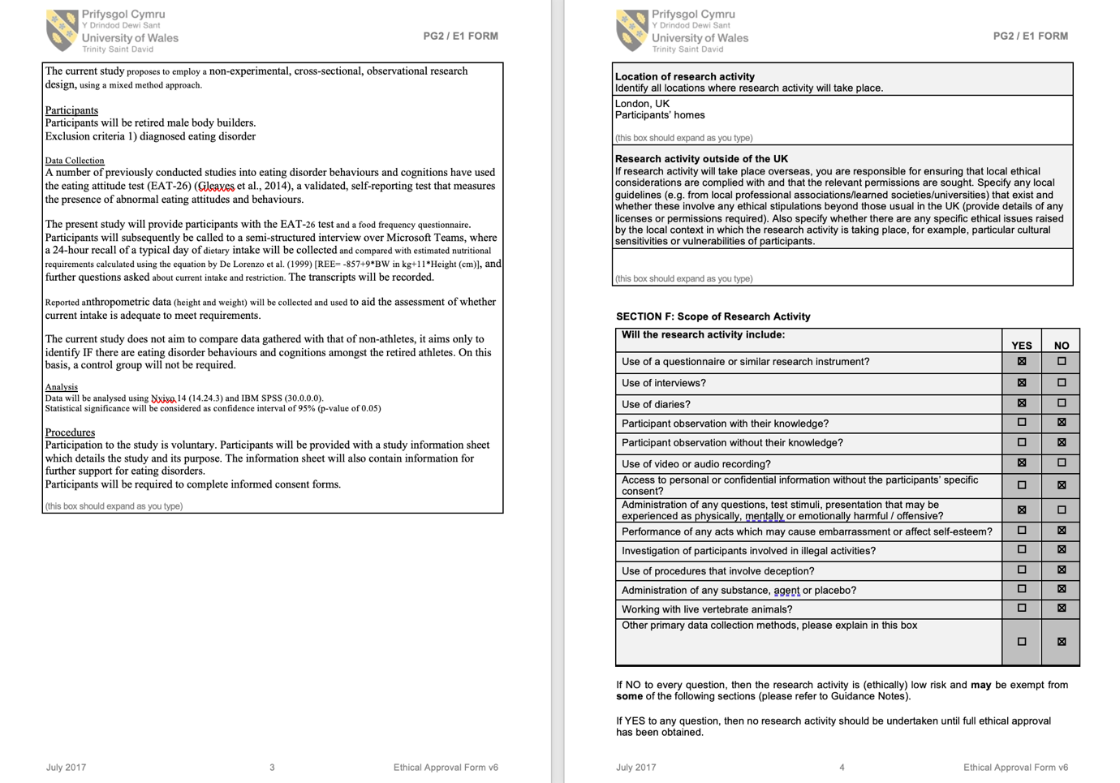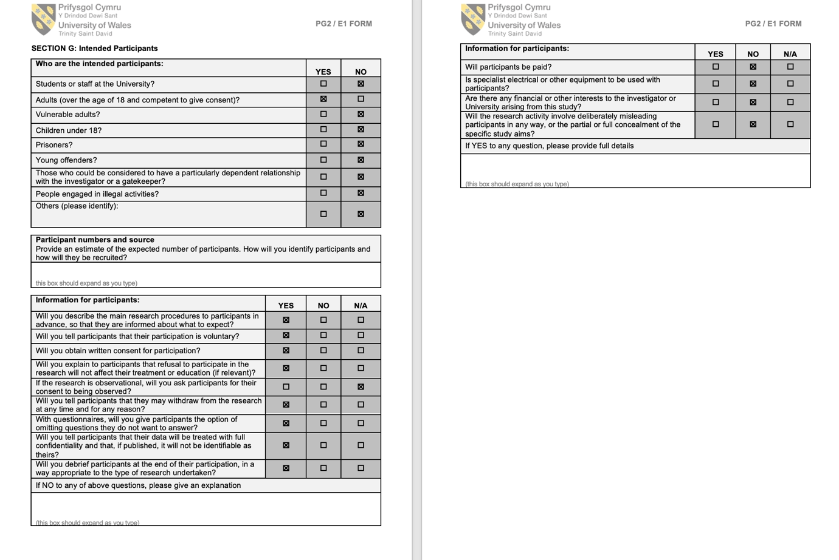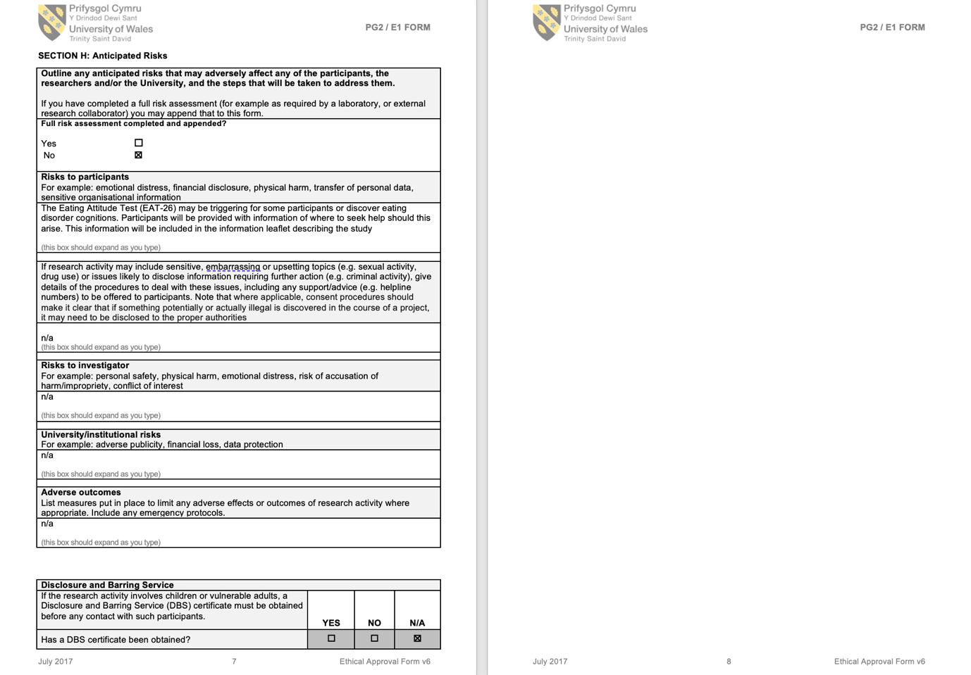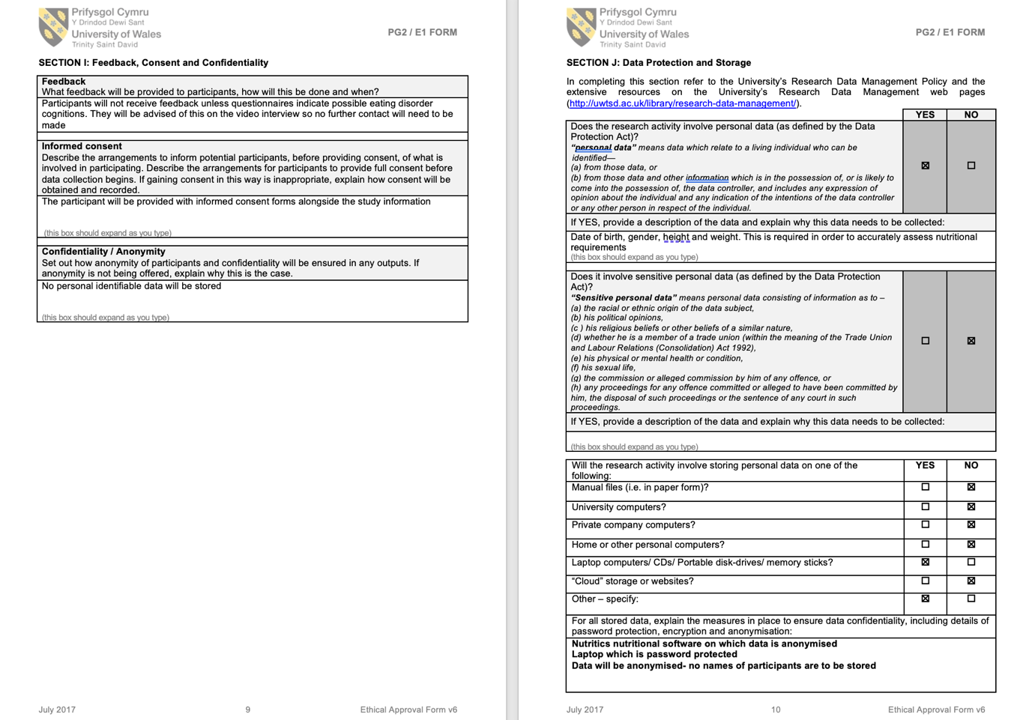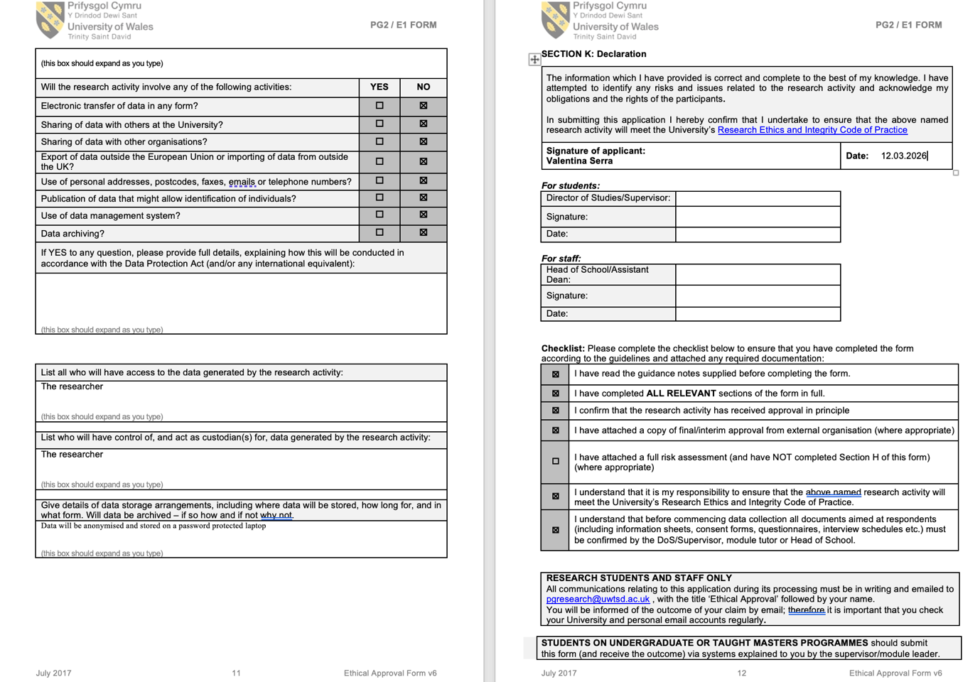

Appendix C- Informed consent form

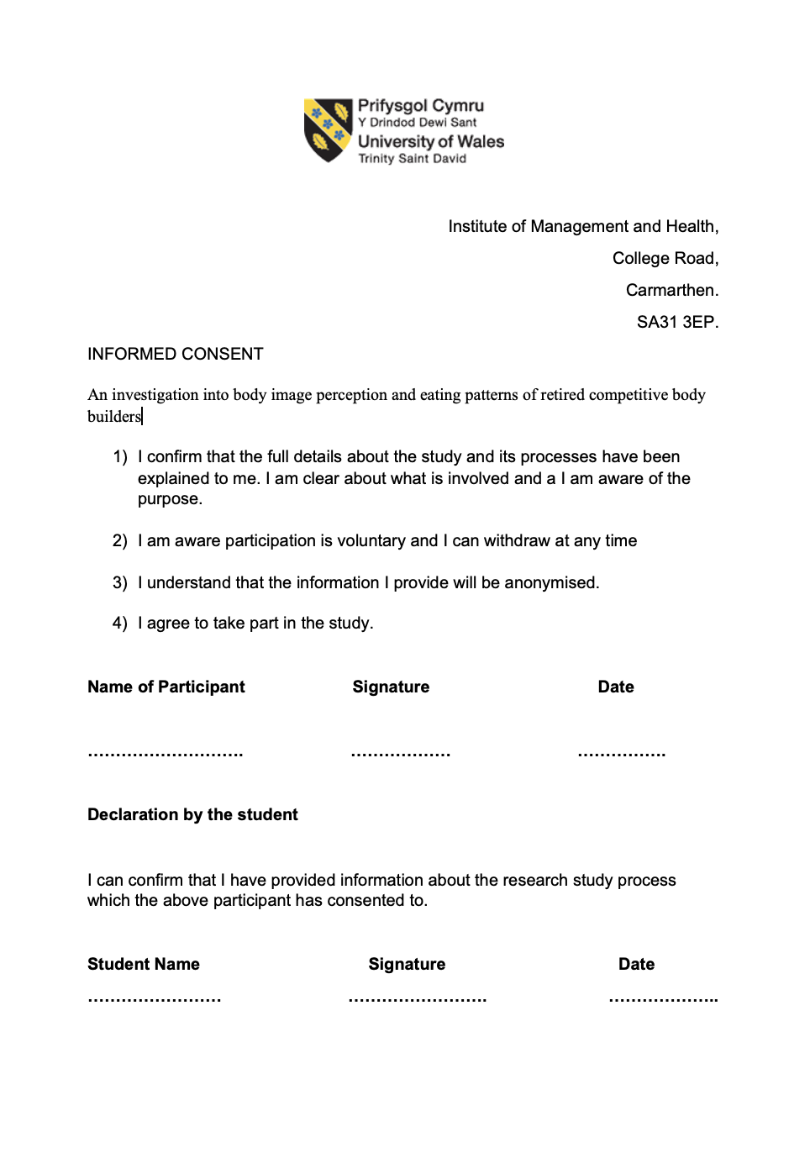
Appendix D- Information leaflet
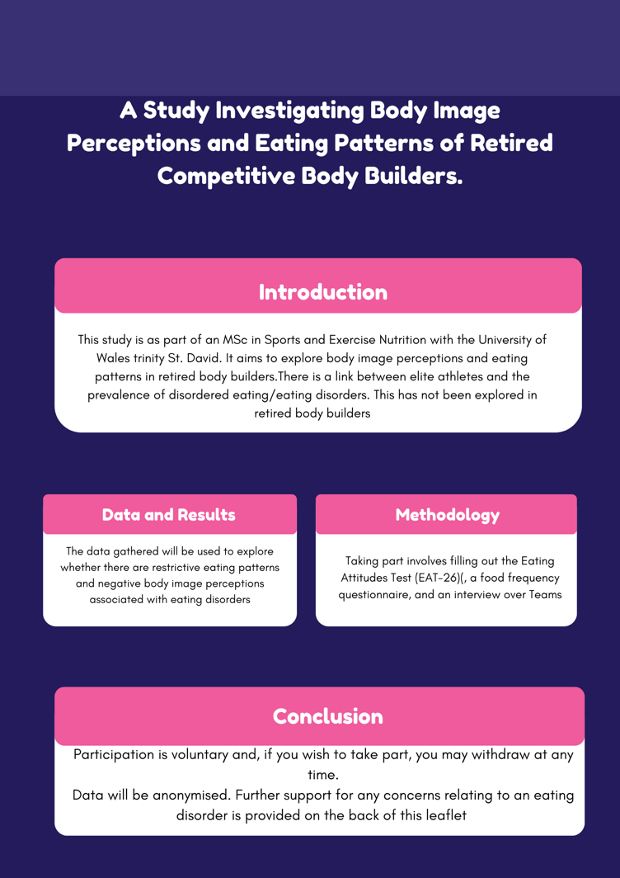
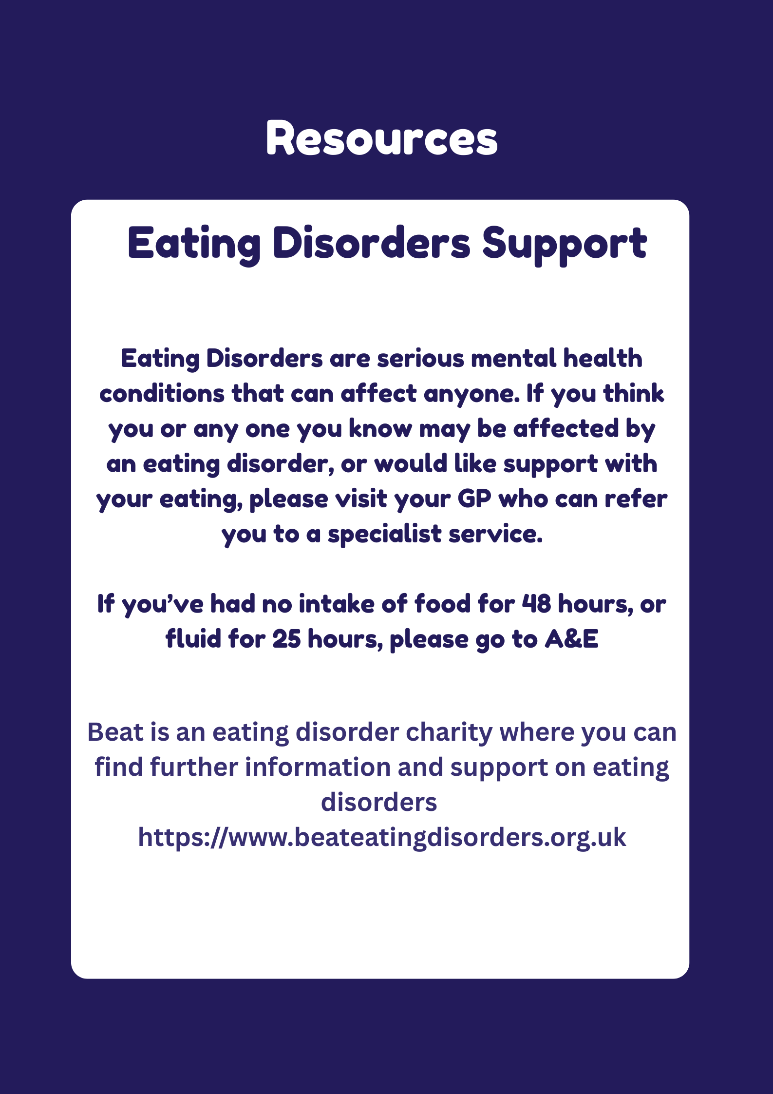

Appendix E- Eating Aptitude Test

Eating Attitudes Test (EAT-26)©
Instructions: This is a screening measure to help you determine whether you might have an eating disorder that needs professional attention. This screening measure is not designed to make a diagnosis of an eating disorder or take the place of a professional consultation. Please fill out the below form as accurately, honestly and completely as possible. There are no right or wrong answers. All of your responses are confidential.
Part A: Complete the following questions:
1) Birth Date |  |  | Month: |  |  | Day: |  | Year: |  |  |  | 2) Gender: |  |  |  |  |  | Male |  |  |  | Female
3) Height Feet : |  |  |  |  | Inches: |  |  |  |  |  |  |  |  |  |  |  |  | □ |  |  |  | □
4) Current Weight (lbs.): |  |  |  |  |  | 5) Highest Weight (excluding pregnancy):
6) Lowest Adult Weight: |  |  |  |  |  | 7: Ideal Weight:
Part B: Check a response for each of the following statements: |  |  |  |  |  |  |  |  |  |  |  |  |  | Always |  |  | Usually |  |  | Often |  |  |  | Some  times |  | Rarely |  |  | Never
1. |  | Am terrified about being overweight. |  |  |  |  |  |  |  |  |  |  |  | □ |  |  | □ |  |  | □ |  |  |  | □ |  | □ |  |  | □
2. |  | Avoid eating when I am hungry. |  |  |  |  |  |  |  |  |  |  |  | □ |  |  | □ |  |  | □ |  |  |  | □ |  | □ |  |  | □
3. |  | Find myself preoccupied with food. |  |  |  |  |  |  |  |  |  |  |  | □ |  |  | □ |  |  | □ |  |  |  | □ |  | □ |  |  | □
4. |  | Have gone on eating binges where I feel that I may not be able to stop. |  |  |  |  |  |  |  |  |  |  |  | □ |  |  | □ |  |  | □ |  |  |  | □ |  | □ |  |  | □
5. |  | Cut my food into small pieces. |  |  |  |  |  |  |  |  |  |  |  | □ |  |  | □ |  |  | □ |  |  |  | □ |  | □ |  |  | □
6. |  | Aware of the calorie content of foods that I eat. |  |  |  |  |  |  |  |  |  |  |  | □ |  |  | □ |  |  | □ |  |  |  | □ |  | □ |  |  | □
7. |  | Particularly avoid food with a high carbohydrate content (i.e. bread, rice, potatoes, etc.) |  |  |  |  |  |  |  |  |  |  |  | □ |  |  | □ |  |  | □ |  |  |  | □ |  | □ |  |  | □
8. |  | Feel that others would prefer if I ate more. |  |  |  |  |  |  |  |  |  |  |  | □ |  |  | □ |  |  | □ |  |  |  | □ |  | □ |  |  | □
9. |  | Vomit after I have eaten. |  |  |  |  |  |  |  |  |  |  |  | □ |  |  | □ |  |  | □ |  |  |  | □ |  | □ |  |  | □
10. |  | Feel extremely guilty after eating. |  |  |  |  |  |  |  |  |  |  |  | □ |  |  | □ |  |  | □ |  |  |  | □ |  | □ |  |  | □
11. |  | Am preoccupied with a desire to be thinner. |  |  |  |  |  |  |  |  |  |  |  | □ |  |  | □ |  |  | □ |  |  |  | □ |  | □ |  |  | □
12. |  | Think about burning up calories when I exercise. |  |  |  |  |  |  |  |  |  |  |  | □ |  |  | □ |  |  | □ |  |  |  | □ |  | □ |  |  | □
13. |  | Other people think that I am too thin. |  |  |  |  |  |  |  |  |  |  |  | □ |  |  | □ |  |  | □ |  |  |  | □ |  | □ |  |  | □
14. |  | Am preoccupied with the thought of having fat on my body. |  |  |  |  |  |  |  |  |  |  |  | □ |  |  | □ |  |  | □ |  |  |  | □ |  | □ |  |  | □
15. |  | Take longer than others to eat my meals. |  |  |  |  |  |  |  |  |  |  |  | □ |  |  | □ |  |  | □ |  |  |  | □ |  | □ |  |  | □
16. |  | Avoid foods with sugar in them. |  |  |  |  |  |  |  |  |  |  |  | □ |  |  | □ |  |  | □ |  |  |  | □ |  | □ |  |  | □
17. |  | Eat diet foods. |  |  |  |  |  |  |  |  |  |  |  | □ |  |  | □ |  |  | □ |  |  |  | □ |  | □ |  |  | □
18. |  | Feel that food controls my life. |  |  |  |  |  |  |  |  |  |  |  | □ |  |  | □ |  |  | □ |  |  |  | □ |  | □ |  |  | □
19. |  | Display self-control around food. |  |  |  |  |  |  |  |  |  |  |  | □ |  |  | □ |  |  | □ |  |  |  | □ |  | □ |  |  | □
20. |  | Feel that others pressure me to eat. |  |  |  |  |  |  |  |  |  |  |  | □ |  |  | □ |  |  | □ |  |  |  | □ |  | □ |  |  | □
21. |  | Give too much time and thought to food. |  |  |  |  |  |  |  |  |  |  |  | □ |  |  | □ |  |  | □ |  |  |  | □ |  | □ |  |  | □
22. |  | Feel uncomfortable after eating sweets. |  |  |  |  |  |  |  |  |  |  |  | □ |  |  | □ |  |  | □ |  |  |  | □ |  | □ |  |  | □
23. |  | Engage in dieting behavior. |  |  |  |  |  |  |  |  |  |  |  | □ |  |  | □ |  |  | □ |  |  |  | □ |  | □ |  |  | □
24. |  | Like my stomach to be empty. |  |  |  |  |  |  |  |  |  |  |  | □ |  |  | □ |  |  | □ |  |  |  | □ |  | □ |  |  | □
25. |  | Have the impulse to vomit after meals. |  |  |  |  |  |  |  |  |  |  |  | □ |  |  | □ |  |  | □ |  |  |  | □ |  | □ |  |  | □
26. |  | Enjoy trying new rich foods. |  |  |  |  |  |  |  |  |  |  |  | □ |  |  | □ |  |  | □ |  |  |  | □ |  | □ |  |  | □
Part C: Behavioral Questions:  In the past 6 months have you: |  |  |  |  |  |  |  |  |  |  |  |  | Never |  |  | Once a month or less |  |  | 2-3 times a month |  |  |  | Once a week |  | 2-6 times a week |  |  | Once a day or more
A | Gone on eating binges where you feel that you may not be able to stop? * |  |  |  |  |  |  |  |  |  |  |  | □ |  |  | □ |  |  | □ |  |  |  | □ |  | □ |  |  | □
B | Ever made yourself sick (vomited) to control your weight or shape? |  |  |  |  |  |  |  |  |  |  |  | □ |  |  | □ |  |  | □ |  |  |  | □ |  | □ |  |  | □
C | Ever used laxatives, diet pills or diuretics (water pills) to control your weight or shape? |  |  |  |  |  |  |  |  |  |  |  | □ |  |  | □ |  |  | □ |  |  |  | □ |  | □ |  |  | □
D | Exercised more than 60 minutes a day to lose or to control your weight? |  |  |  |  |  |  |  |  |  |  |  | □ |  |  | □ |  |  | □ |  |  |  | □ |  | □ |  |  | □
E | Lost 20 pounds or more in the past 6 months |  |  |  |  |  |  |  |  |  |  |  | Yes □ |  |  |  |  |  | No □
* Defined as eating much more than most people would under the same circumstances and feeling that eating is out of control
© Copyright: EAT-26: (Garner et al. 1982, Psychological Medicine, 12, 871-878); adapted by D. Garner with permission.

Appendix F- Food Frequency Questionnaire (FFQ)



