Review of Industry Skills

Roisin Hannon
Academic and Industry Skills
Module: M4X02101
Module Tutor: Marie Pitson



Executive Summary

This report provides an insight into the employability skills and industry skills expected and needed as an events manager doing a content analysis of a position in the Copthorne hotel in Cardiff. It identifies and discusses the main duties that will be required to fulfil this position and it also discusses the attributes and skills wanted from the hotel. Research within this report has highlighted the skills desired from managers and employers in general from within the events industry and provided a summary of the research and findings from within the job advertisement.

Contents
Executive Summary 2
Introduction 4
Main Body 5
Conclusion 6
References 7
Appendix 8
Appendix A 8
Appendix B 8
Appendix C 9
CV 9
Appendix D 10
Cover letter 10
Bibliography 12

Introduction
This report will be discussing employability skills and their importance to employers in the events industry. Employability skills are essential because employers are now looking for the skills that they already want their employees to possess when they hire them. The events industry was worth £40 billion in 2014 and has since then increased providing a huge range of different jobs to its employees (www.rbgroup.co.uk). The writer will be discussing the position of an events coordinator/events manager at Copthorne Hotel located in Cardiff.

Main Body
As Perry et al, inferred, knowledge and skills can be taught through training and experience can be learned and developed. However, personal attributes or employability skills are essential and are what employers are searching for when considering employees for their organisations. Employers from all different types of sectors and industries are searching for people with these skills. As Cottrell (2013) stated ‘’There are now much higher expectations for good interpersonal and communication skills’’. The national association of colleges and employers (an organisation that links college career placements with employers) ran a survey which involved collecting responses from 200 employers/managers. The survey found that the top five most important skills/attributes they wanted their employees to possess were, the ability to work in a team, the ability to solve problems quickly and efficiently, to plan, organize and prioritise work, communication skills and finally the ability to obtain and process information (www.forbes.com). All these skills are relevant to this job due to the fact the writer would need to have all these skills in order to organise and run the event efficiently. The Copthorne Hotel also stated they needed someone who was ‘very organised’ and ‘friendly’.
The position at the Copthorne Hotel requires the writer to have a range of skills, including administration, market planning, diary management, organisational skills, communication skills and the ability to achieve targets. The writer will have to attend weekly operations meetings, schedule and co-ordinate pre-conference meetings with hotels staff and client, host any internal client hospitality events and undertake any requests and projects as assigned by senior management. All of which will require the writer’s organisation skills to come into practice. For the organisational function of the hotel the writer will be required to ensure effective communication with organisers, communicate closely with all relative departments and their managers, be visible to the organiser ad guests during their event and establish good working relationship within the department and other departments. These duties and responsibilities mentioned are all communication skills and will be essential for the writer to succeed in getting this job role.
As Cottrell S (2013) stated people skills are a good combination of good interpersonal skills and intra-personal skills, they are critical to success in a wide range of careers. They are as important to the modern economy as are knowledge, information and technical skills. People skills are vital for this position as the writer will have to create relationships with clients, create relationships with their team and co-workers, liaise with different departments such as sales teams, front office, food and beverage outlets etc. The hotel as specifically said they would want the writer to display ‘excellent telephone skills at all times. All of these require exceptional communication and people skills from the writer.
A content analysis of 105 job advertisements was taken out by The University of Queensland and this found that more than over a quarter of adverts were in the events industry, mainly being events management. The content analysis found that the top five most important general skills were organisation and planning, communication, leadership and decision making, financial management and lastly marketing. These skills are also mentioned within the Copthorne Hotels job advertisement and planning and organisation seems to be most important to the hotel, the same as the other job advertisements. Planning and organisation has its own section within the advert with the hotel stating what would be expected from the writer (see appendix A) which suggests this is a very important aspect for the hotel. Financial budgeting was also an important skill for the writer to have, with that also having its own section. The advert stated a lot of different roles the writer would have to complete using their financial skills (see appendix B).
The top five personal attributes found by Queensland University within the adverts were motivation, positiveness, dynamism and energy, commitment and lastly creativity. The Copthorne hotel stated in their advert that they would need their events coordinator to motivate and encourage on going training and maximise revenue through all meetings and events function rooms. The writer’s motivation and natural leadership would help enable them to complete these tasks and to a better standard. Positivity was also mentioned a lot throughout the Copthorne hotels job advert. The hotel stated, they wanted ‘high levels of enthusiasm’ and someone with a ‘can do attitude’. With the writer’s positive approach and attitude, it will help show other employees at the organisation how to deal with issues in a positive and calm manner and show customers if there are any issues during their event or conference they will be dealt with effectively, which will hopefully create more revenue and repeat custom for the hotel which was also stated throughout the advert.

Conclusion
To conclude this report has discussed the skills needed for the position of an events co-ordinator/events manager at the Copthorne hotel in Cardiff and found that the main skills the writer should possess are communication, organisational and planning skills, timekeeping and enthusiasm. The report has analysed what personal attributes will also be needed to fulfil the job role and what skills the writer already has. It has highlighted why employability skills are essential to employers, what key skills they are mostly looking for in the events industry and which ones are most important.

References
Adams, S. (2013), ‘The 10 skills employers want in 20-something employees’, [Online]. Available: https://www.forbes.com/sites/susanadams/2013/10/11/the-10-skills-employers-most-want-in-20-something-employees/#4d18975a6330, [2018, March, 09].
Cottrell, S. (2015), Skills for Success: Personal Development and Employability, (3rd Edition), Basingstoke: Palgrave Macmillan.
www.indeed.co.uk. (2018), ‘Event coordinator’, [Online]. Available: https://www.indeed.co.uk/jobs?q=Event%20Manager&l=Cardiff&vjk=b2c568534488ec55, [2018, April, 02].
Perry, M., Foley, P. & Rumpf, P. (1996). Events management: an emerging challenge in Australian higher education. Festival Management & Event Tourism, 4(3/4), 85 - 93.
www.rbgroup.co.uk. (2014), ‘Events industry worth £40 billion to UK economy’, [Online]. Available: http://rbgroup.co.uk/index.php/2014/04/events-industry-worth-40-billion/, [2018, April, 09].

Appendix

Appendix A
Copthorne hotel job advert - event planning section.
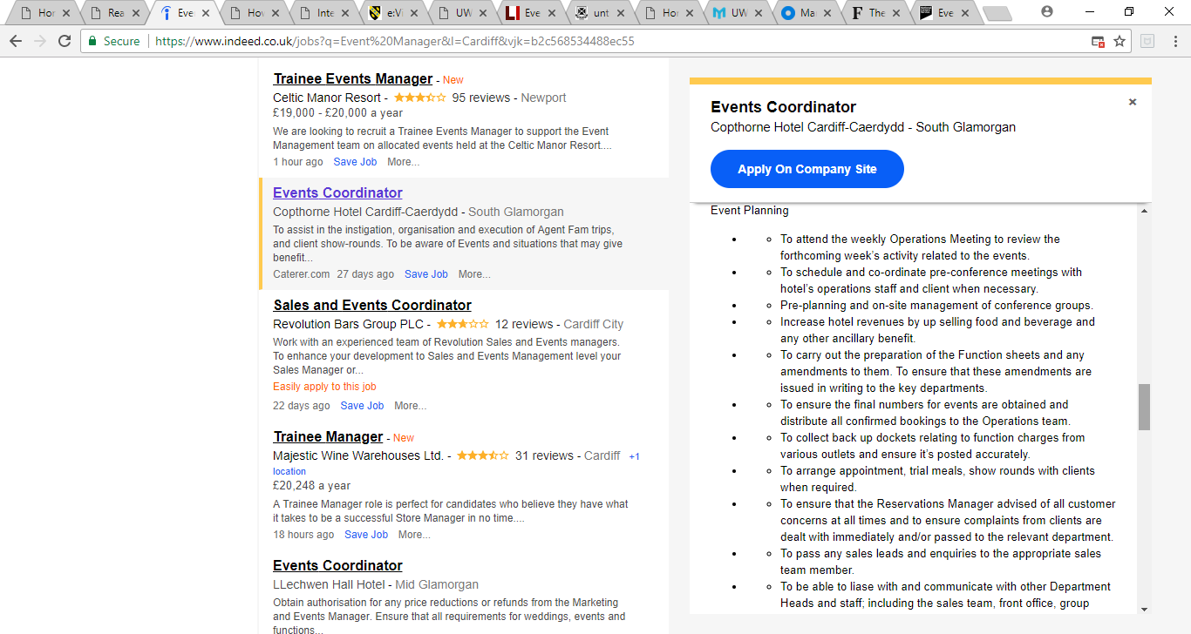

Appendix B
Copthorne hotel advert – financial skills
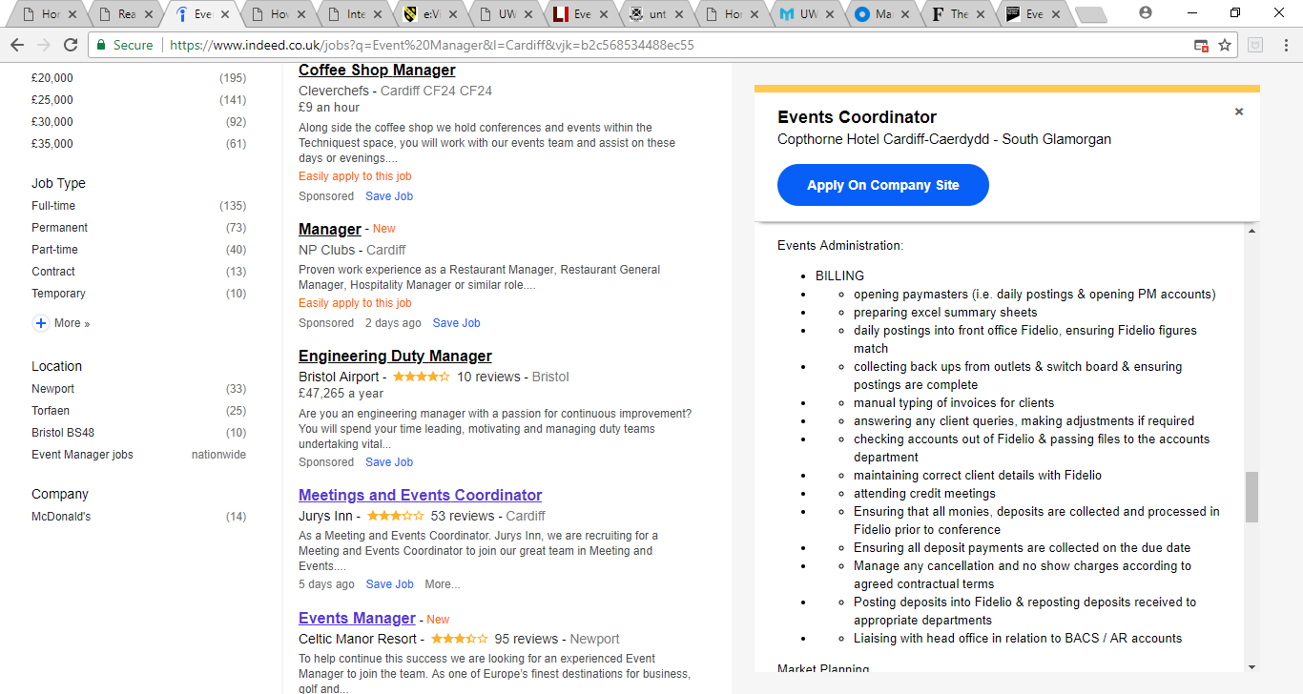

Appendix C

CV
Roisin Hannon
E-mail: roisin_hannon@outlook.com
Phone: 07482318981
Address: 30B Richardson Street
Swansea
SA13JE

Profile
A well-presented events management student currently looking for a managerial position that offers variety and opportunities in the events industry. Strong customer service orientation with experience in working at events and with customer service. Excellent communication skills, time management skills and is keen to start work in a fast paced and hands on environment. Very passionate individual about events and the organisation of them.
Education
Gower College Swansea – BTEC Travel and Tourism – Distinction
Ysgol Y Gwendraeth - 7 GCSES
BTEC Business studies – Pass
BTEC Pubic Services – Pass
Work Experience
JR Catering and Events 2016-Present
Job Role: Hospitality
Duties:
- Waiting tables at various awards, such as the Swansea bay awards and the police awards
- Bar work
- Dealing with customers
- Cashing up tills
- Bar tender at prosecco festivals in Manchester, Leeds, Swansea and Ipswich.
Arc recruitment March ’18-Present
Duties:
Job roles can vary from
- Front and back of house staff (greeting customers, communicating with all other sectors of the event, making sure everything is clean and tidy front and back of house, scanning tickets, directing customers)
- Catering (preparing food, making sure all food is kept to the right temperatures and stocked up always)
- Bar and kiosk (dealing with customers, handling money, using tills, serving drinks, keeping the bar clean and tidy + well stocked)
- Hospitality roles (greeting, serving, and being professional to customers, serving food and beverages, setting up tables etc)
- Cashier (Handling money, cashing up the tills, dealing with customers, knowing all stock)
- Betting staff (explaining odds, welcoming customers, keeping stocked with betting slips, making sure everything is clean, looking for underage gambling)
- Ticket Office (handling cash, communicating with customers and dealing with any problems, scanning tickets, helping with the purchase of tickets).
References available upon request.

Appendix D

Cover letter

Copthorne Way Roisin Hannon
Cardiff 30B Richardson Street
CF5 6DH Swansea
07482318981
Roisin_hannon@outlook.com
Dear Sir/Madam,
I am very interested in the event manager position in your organisation, Copthorne Hotel Cardiff and as requested I have included my CV. This position could enable me to capitalise on my knowledge and widen my experience as an events manager. I am a student currently studying events management at University of Wales Trinity Saint David and am enjoying it thoroughly. The description of this job role parallels my passions and I believe your organisations environment is perfect for me. I have worked in numerous events over the last few years, ranging from major events to minor ones and it has become a passion.
I have a wide experience of dealing with problems quickly and efficiently, communication with customers and helping to organise small events. My energetic, friendly and positive personally allows me to work well with other people while still being professional at all times. I have excellent organisational skills which is proven through all my previous events running smoothly. Any event or birthday party for example, organised by me has become my main priority and I will see that it is a success.
I believe that I am a suitable candidate for this position in view of my passion for events, making them a success and excellent organisational skills. I hope that you will consider me for this position and realise that I could be a huge contribution to your team.
Yours sincerely,
Roisin Hannon

Bibliography

Cottrell, S. (2013), Study Skills Handbook, (4th Edition), Basingstoke: Palgrave Macmillan.
www.nationalcareersservice.direct.gov.uk.com, (2018), ‘Events manager’, [Online]. Available: https://nationalcareersservice.direct.gov.uk/job-profiles/events-manager, [2018, April,09].
Trought, F. (2012), Brilliant employabitlity skills: how to stand out from the crowd in the graduate job market, Harlow : Prentice Hall

