Contents

- PDP

- Briefing Paper

- Written piece
 | What do I want to educate myself on or be? | What do I have to do to get there? | How will I acknowledge I’ve achieved this? | What resources will I retrieve? | What might get in the way of accomplishing this? | What assistance will I have? | Begin date: | Finish date:
1. | Growing more confident will enable me to boost my self-esteem levels. | Book myself a confidence course. | I feel happy with myself and enjoy the flow of things. I stay positive for a long period. | https://www.wea.org.uk/courses/life-skills/confidence-skills  https://www.bbcmaestro.com/courses/evy-poumpouras/the-art-of-influence?utm_source=google&utm_medium=cpc&utm_campaign={campaign}&utm_term=self-help%20course&utm_content=168657143214&gad_source=1&gclid=EAIaIQobChMI0KL-6IfciQMVm45QBh2tQjk8EAAYASAAEgJ7lvD_BwE | I may have low days and that might trigger my anxiety levels, which might make me feel less motivated. | My family is my backbone and rock. They will support and guide me and, give advice on areas for improvement, as they want what is best for me. | October 2024 | July 2025
2. | Build on my communication skills. | Book a communication-enhancing course. | I will improve my communication skills and carry myself well. Also, I received compliments/feedback from family and friends telling me I had improved. | https://www.impactfactory.com/programmes/communication-skills-training/open-courses/communication-skills-course/?ppc_keyword=communications%20course&gad_source=1&gclid=EAIaIQobChMIqsedhonciQMVmqRQBh235zOmEAAYAiAAEgIjpfD_BwE | Communication is part of everyday life. If I practice something important in everyday life, I might feel overwhelmed and lack confidence. | Being in social situations and putting myself out there will enhance my communication with situations better. | November 2024 | June 2024
3. | Broaden my knowledge of Safeguarding policies and procedures. | Download the Wales Safeguarding Procedures app, read, and gain an insight into the policies and procedures. | Test my knowledge of safeguarding by quizzing myself and asking family members to test me as this will let me know how well I know the policies and procedures. | https://www.safeguarding.wales/en/ | Time management issues – Having family commitments, or any other responsibilities. Also, I might easily forget to fit it into my schedule. |  | October 2024 | January 2025
4. | Learn more Welsh | Book me a Welsh language course |  |  | Cost implications – There will be a fee for the course as well as travel expenses, and resources. | I can get help from my peers, the resources available to me, and my teachers.

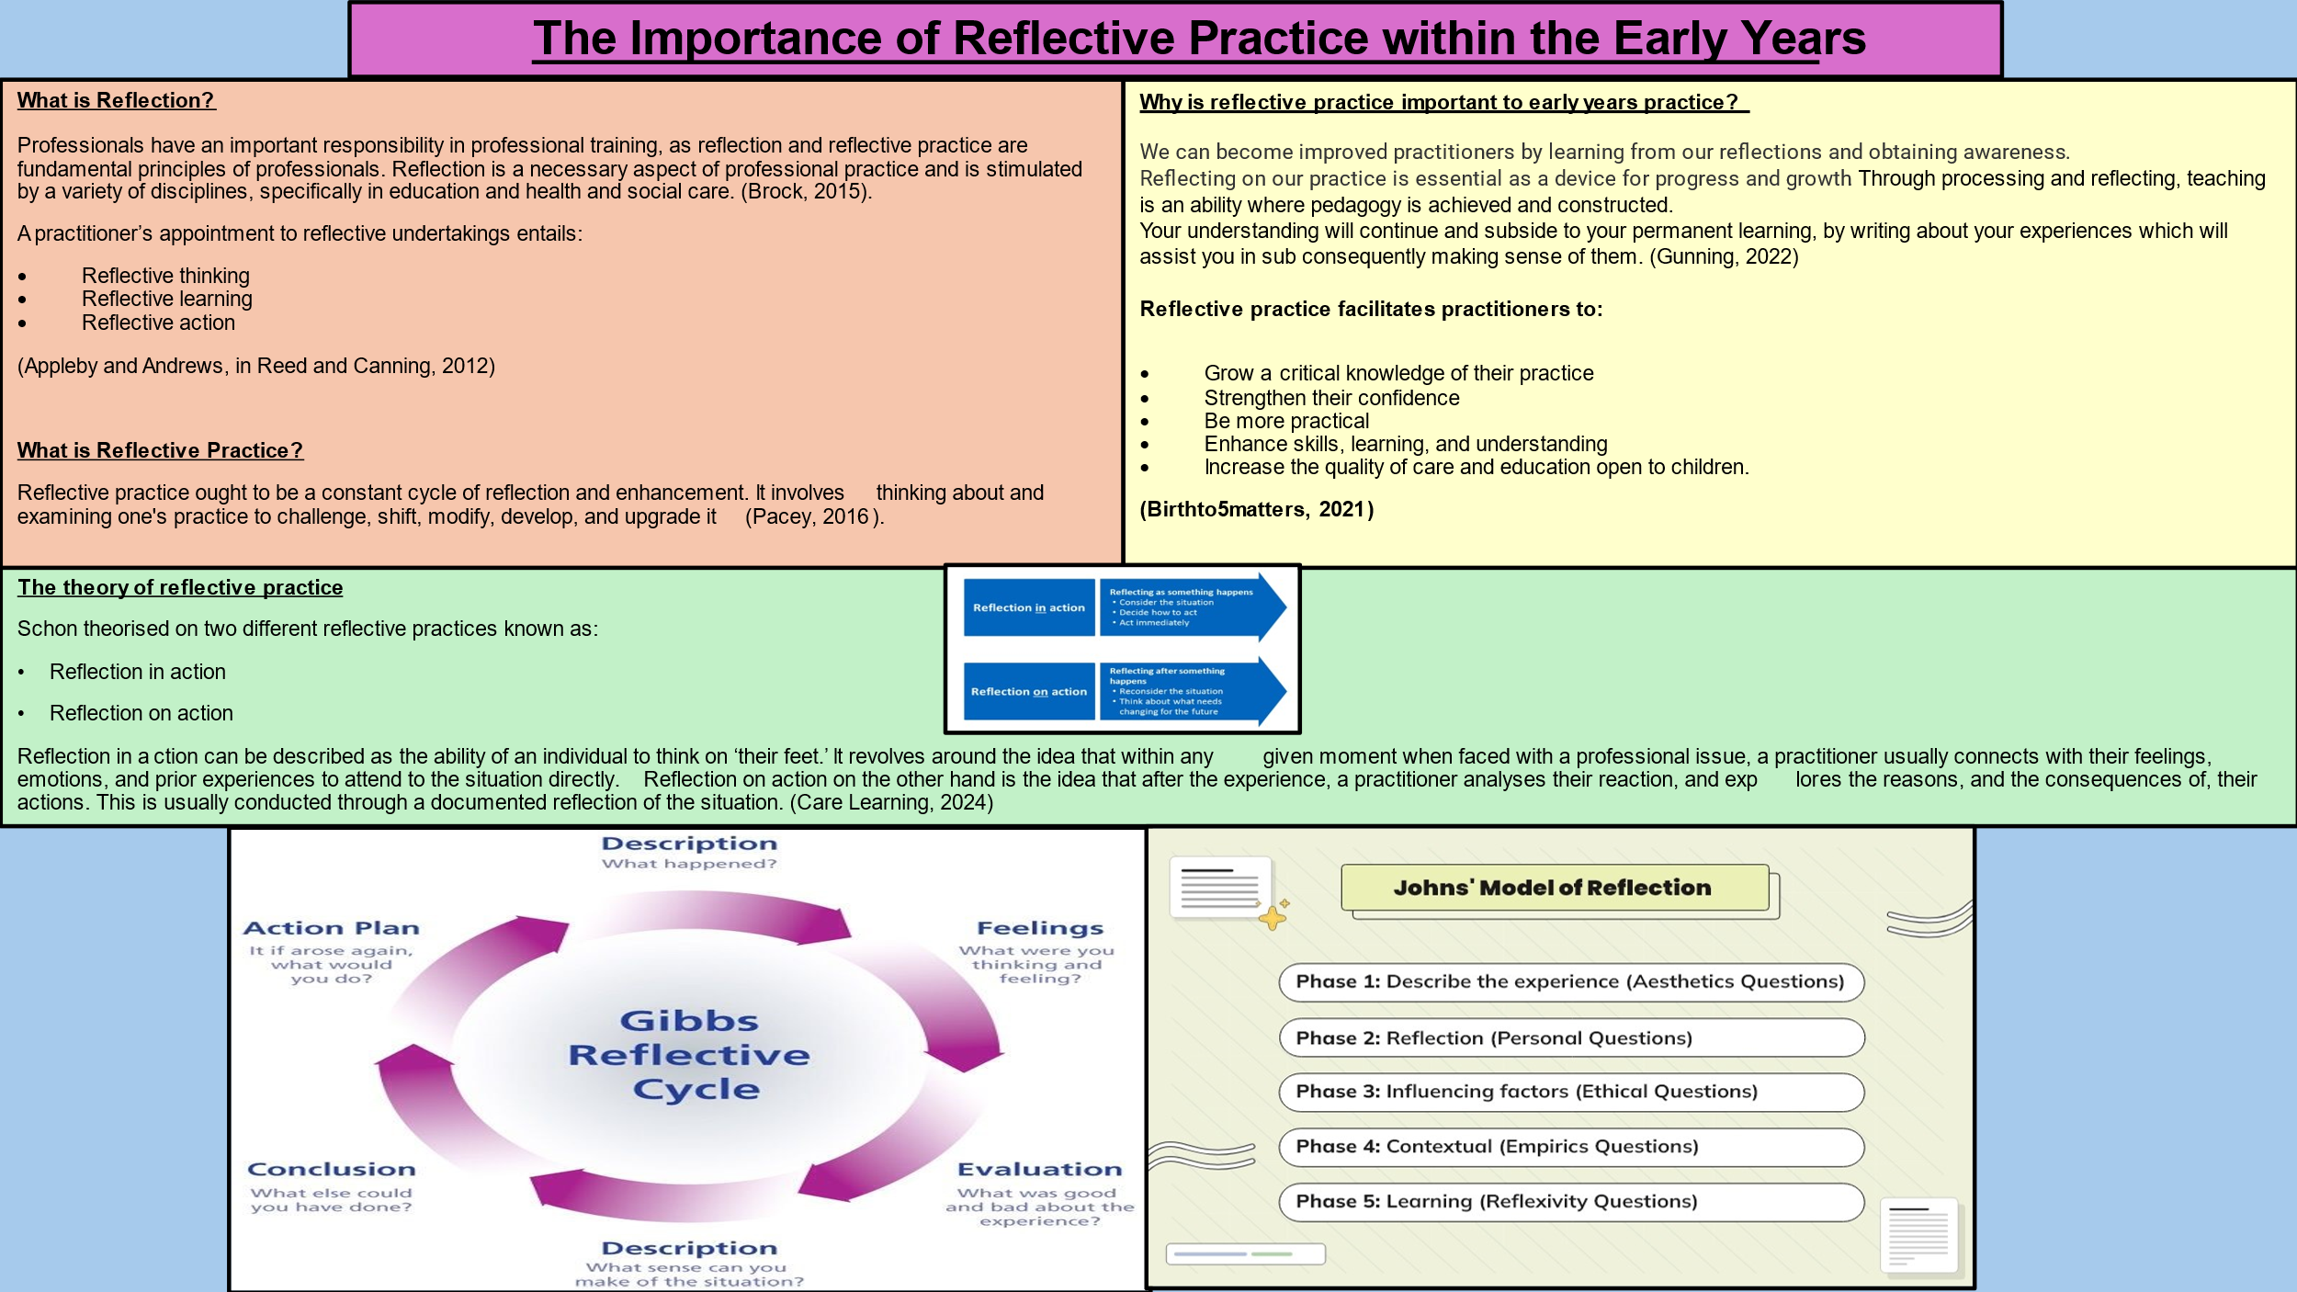

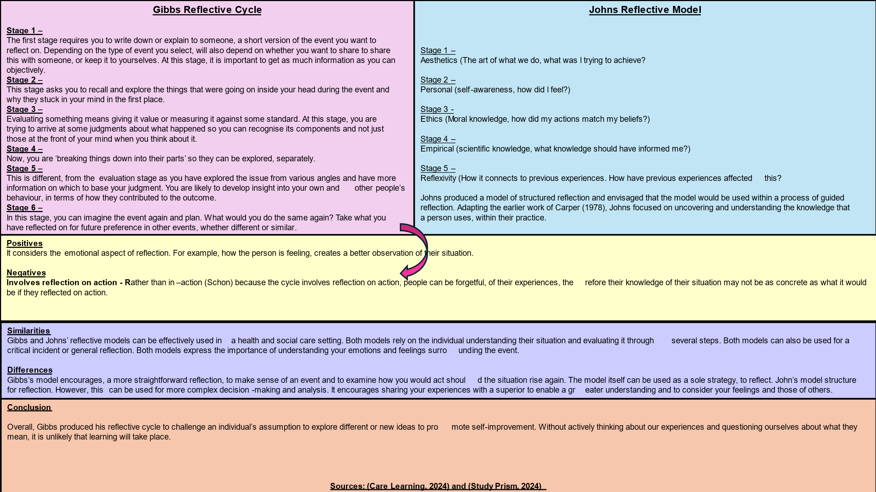

The early years are foundational for a child’s future success. Quality early education significantly impacts academic performance, emotional well-being, and social skills highlighting the need for accessible and effective early childhood programs. Early childhood educators play a pivotal role in shaping a child’s future by providing essential skills and knowledge. Their influence in early development affects social, emotional, and cognitive growth, making their professionalism vital for long-term success. Professionalism is essential in shaping the experiences and outcomes of young children. Professionals play a critical role in fostering a positive learning environment, demonstrating the values and ethics necessary for early childhood education. Being professional in early childhood education embraces a devotion to quality care and education, adherence to ethical standards, and ongoing professional development. Professional educators exhibit critical characteristics such as effective communication, empathy, patience, and adaptability. They are skilled in building relationships with children and families, fostering trust, and demonstrating a deep understanding of child development principles. Ethical responsibilities of early childhood educators include promoting the well-being of children, maintaining confidentiality, and treating all children and families with respect and dignity. Professionals must also advocate for the rights of children and guarantee equitable admission to excellent learning. Young child professionals play critical roles in the development of young children, aiding as facilitators, caregivers, and advocates. These multifaceted roles are essential in nurturing children’s growth and creating supportive learning environments. The role of the facilitator is that early year’s professionals guide learning experiences that empower children to explore and discover. They create engaging environments, implement developmentally appropriate practices, and encourage critical thinking, allowing children to take ownership of their learning process. Educators as caregivers provide emotional support and foster secure attachments with children. They create trustful relationships that are, foundational for a child’s societal and sensitive growth, ensuring a nurturing atmosphere that promotes well-being. Young children’s experts provide as, advocates for children’s rights and needs, collaborating with families to support child development. They promote awareness of educational policies, early intervention, and inclusion practices, ensuring equitable access to resources for all children. Effective communication, keen observation, and thoughtful curriculum planning are vital skills for early childhood professionals. Mastering these competencies enhances teaching strategies and supports holistic and child development. Effective communication skills are essential for early childhood educators to engage children, families, and colleagues. This involves active listening, clear verbal expression, and non-verbal cues to support the learning environment. Observation and assessment are critical for understanding children’s development and learning styles. Educators must utilise systematic observation techniques to gather data, which informs instructional strategies and supports personalised learning. Effective curriculum planning considers children’s interests, developmental stages, and learning styles. Educators design engaging age-appropriate activities that propose cognitive, social, and emotional growth within a structured framework. Effective relationships with children, families, and colleagues are fundamental components of successful early childhood education. Establishing these connections fosters trust, collaboration, and a supportive learning environment. Building strong relationships with children enhances their learning capacity. Using age-appropriate communication and active listening helps educators understand children’s needs, interests, and emotions leading to tailored educational experiences that promote growth. Including children’s families in the learning procedure boosts the home and school relationship. Regular communication, family events, and collaborative projects foster a sense of community and ensure their children’s development. Collaborating with colleagues enhances professional practice and child outcomes. Sharing insights and strategies fosters a supportive network environment and improves teaching methods and challenges collectively benefiting the children we serve. Lifelong learning is crucial for educators, ensuring they remain current with practices in early childhood education. Embracing professional development strengthens skills that directly benefit children’s learning and development. Lifelong learning fosters continuous growth and adaptability among educators. By engaging in ongoing education, professionals can refine their teaching methods to meet evolving educational standards and children’s needs. Various professional development opportunities exist, including workshops, seminars, online courses, and conferences. Engaging in these activities can enhance an educator’s expertise in young children’s learning. Reflective practice involves significantly evaluating a person’s teaching techniques and practices. By reflecting, educators can identify strengths and areas for improvement, leading to enhanced teaching effectiveness and child outcomes. The role of early childhood educators extends beyond basic instruction; it profoundly influences children’s social, emotional, cognitive, and creative growth. Understanding these impacts is essential to fostering well-rounded development in the early years. Young children’s teachers play a crucial function by nurturing societal and emotional skills. Creating a supportive environment, helps children develop self-regulation, empathy, and resilience, which are essential for healthy relationships and overall well-being. Educators contribute significantly to cognitive development by stimulating activities that enhance critical thinking and problem-solving skills. Engaging children in play-based learning and exploration fosters curiosity and lays the groundwork for lifelong learning. Creative expression is vital for holistic development. Via arts and imaginative play, educators encourage children to express themselves, fostering innovation and emotional processing. This creative outlet is crucial for self-discovery and personal growth. The landscape of early childhood education is evolving, requiring professionals to adapt continually. This section examines the critical importance of educators, the challenges they face, and a forward-looking vision for the industry. Early childhood professionals confront challenges, including low wages, high turnover rates, and insufficient resources. These factors can lead to burnout and impact the quality of education provided to children. The future of early childhood education involves embracing diversity, technology, and innovative teaching methods. A collaborative effort among stakeholders is crucial to creating an equitable and high-quality education system for all children.

