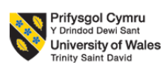

BMIH6004
Hotel Placement – Managing Hotel Administration

Student Name: Romeo Marinel Popescu
Student ID: 1922487

Contents
Introduction 1
Experiences and Personal Development 2
Critical Analysis of Work Based Skills and Technical Knowledge 2
Reflection on Organisational Issue 3
Future Action Plan 5
Conclusion 6
References 7

Introduction
The DoubleTree by Hilton in Bristol North is a very experienced hotel that is recognized within the UK market for its dedication to the highest standards of service to customers. The administrative department of the hotel is in charge of various important functions like front desk manager, reservation unit, guest services and administrative support for a smooth operation (Nam et al., 2021). In this reflective report, I will demonstrate my working experiences as an intern in the hotel’s administration department and highlight the skills I have gained and wish to gain in future along with an action plan. I will be using Kolb’s reflective model in this report also to describe my experiences of working in the administrative department at The DoubleTree by Hilton hotel.

Experiences and Personal Development
The DoubleTree by Hilton Bristol North placement has given me the privilege to took part in shading a supervisory position within the administration department and this given me an outstanding understanding of dealing with guest services effectively. There was no better way of understanding the details of what overseeing front office responsibility is and handling the guest inquiries and complaints as I worked in the industry. This experience gave me a understanding of the extent of the importance of technical knowledge and good work-base skills in hospitality. Such skills are those like the ability to work with property management systems in hospitality indsustry, the ability to learn the guest’s preferences, and the ability to communicate efficiently.
The starting towards realization of the knowledge of personal and vocational development for meeting guest expectations has been done via the working experience of mine in the hotel. Applying the lessons learned from my academic and relevant experiences, I expanded the level of my comprehension of communication strategies, teamwork foundations, and problem-solving skills valuable in offering outstanding guest services. Through hands-on training during the placements, I developed my skills to manage the complicated guest queries and proactively identify their needs during the operations. Moreover, university studies and practice supplied me with the theoretical background in hospitality that was a natural continuation of my practical experience. This combination of theoretical knowledge and practical practice supported the formation of the comprehensive view on the guests service requirements and the administration role in meeting these requirements.

Critical Analysis of Work Based Skills and Technical Knowledge
Property Management System: For successful hotel management, the knowledge of Property Management System (PMS) is a useful tool. Having knowledge what PMS can do is not only helps to conduct administrative tasks and but also helps with more personal interactions through the customer's past booking details (Denysenko & Yurynets, 2021). I was acquainted with the PMS while working as a way of smoothing the processes of visitor check-ins, reservations, and room assignments.

Communication Skills: Visitors will talk to the front desk officers with their expectations which can be managed effectively by mastering communication skills (Bardi, 2010). Guests’ smooth journey necessitates the clarity of interactions with visitors, fellow workers, and other departments. I had to talk to the housekeeping team immediately to make sure the next guest is happy even if the room turnaround time is short.
Attention to Detail: Hotel management must incessantly double-check the accuracy of guest records, billing, and room assignments, while also being perfectly precise (Vallen & Vallen, 2014). I found out how to check guests info and payments accurately and precisely while I made my training under supervision and trials. Such measures will help to get rid of errors and increase level of customer satisfaction.
Problem Solving: Hotel administration is based on problem-solving abilities that involve the finding of solutions to guests' dissatisfaction and to operational issues (Casado, 2012). I always had to be prepare to solve the problems of the guest and I found it to be the most difficult as different problems needs different solutions immediately.

Reflection on Organisational Issue
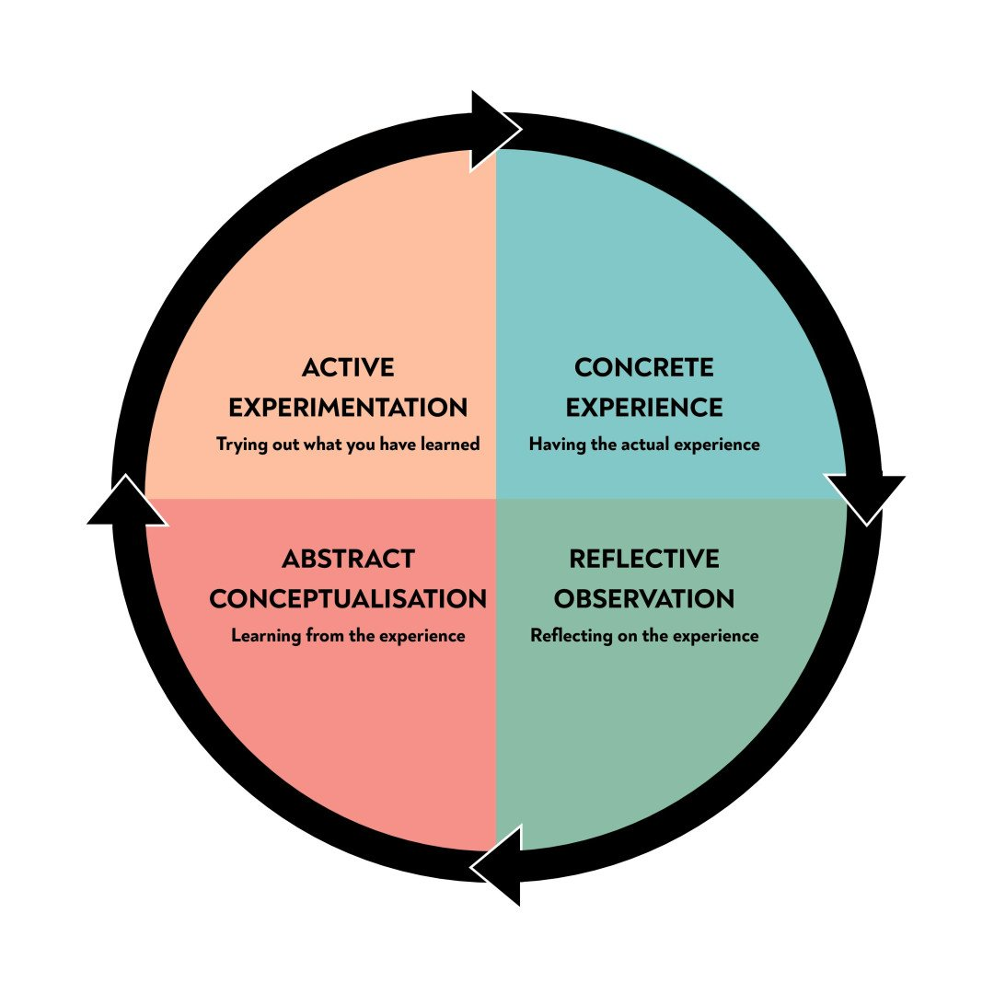
Figure 1: Kolb's Reflective Model
Source: (Ushakov et al., 2020)
Concrete Experience
I had a reservation at DoubleTree hotel during my internship which was a major hassle for me. Among the issues that have ever been in my mind, the most important one is managing the rooms properly. The delay in the occupancy of the guest was caused by last-minute changes to the room availability, the delayed cleaning service, and also without any communication between departments. It was busy afternoons at one Friday and we were working at the front desk and making sure the everything is running smoothly. We found it difficult to have the rooms ready even where guests had booked for them. The housekeepers trying to change the rooms exactly according to schedule and the front desk just being able to find the right reasons to calm the customers who spent more time than they were expected to waiting for their rooms was running the it all.
Reflective Observation
The issue under consideration was a significant factor that had a significant bearing on both the departmental performance, guest service, and the operations. Firstly, it caused the guests to wait for longer which provoked anger and poor appreciation. I could not help but notice as a few of the guests complained loudly and even proclaimed that they would leave the hotel and find another. Secondly, the situation hampered the operational efficiency too. What made the situation more overwhelming was that we had to reassign rooms on the run to provide regular check-in services. The third concern was the poor communication and coordination between the front office and housekeeping departments as this had a negative impact on the guests experience.
Abstract Conceptualization
To handle this problem adequately, practical solutions needs to be implemented. Enforcing regular meetings or briefs to talk about rooms availability and status could allow to improve coordination of the smooth check-in procedure and prevent last minute changes affecting check-in procedure (Jawabreh, 2020). Updating room status in real-time could be the exact avenues for housekeeping to pass on the information to the front desk, thus, managing the expectations. If front desk attendant is taught the basics of room changing, maybe they can start doing the room attendants' work, so that more rooms will be ready.
Active Experimentation
Through participation in the discussions and team work with individuals from the hotel I plan to take actions needed for managing the administration during peak-arrival hours. For illustration, I will offer to assist in setting up procedures manifesting both status communications and training of the employees. I will constantly track the results of the measures and use their feedback to keep the improvement ongoing. I will aim at the measurement of guest wait times and satisfaction level at the initial stage and then after any proposed changes in order to evaluate the effect of such alterations.

Future Action Plan
Enhancing Work-Based Skills and Technical Knowledge: Identifying the specific areas for improvement in property management system competence and guest service methods and procedures can be very effective (Hu et al., 2022). I also plan to attend extra training programs or workshops tailored to property management system functions, as well as guest service techniques for more technical expertise.
Improving Communication and Teamwork: I will try to develop techniques to improve communication within the department, for example, regular team meetings, open communication channels. Emphasizing the team environment through team-building activities and cross-training found to be effective to strengthen the team working (Mingotto et al., 2021).
Strengthening Task Management: Task management tools or software are very effective to achieve administrative efficiency (Wood, 2012). I will build up a systematic approach to task prioritization and time management so that all your duties will be completed on time.
Developing Personal Skills: I will identify areas for personal growth in the skills, such as problem-solving and conflict resolution. Also, I will participate in self-improvement activities including reading relevant literature or attending ability-building workshops to increase personal effectiveness.

Conclusion
The learning log entails the sum of my progressive and professional development through the placement at DoubleTree by Hilton, Bristol North. From that experience, two main lessons were learned such as important role of work-based skills, technical knowledge and understanding of the guest service standards in hotel administration. Practical experience assisted in the assimilation of theoretical knowledge, which, in turn, helped me to improve communication, teamwork, and task management skills. The need for ongoing personal and professional development to achieve future career objectives in the hospitality industry was emphasized from the experience.

References
Bardi, J. (2010) Hotel Front Office Management. London: Wiley.
Casado, M. (2012) Housekeeping Management. London: Wiley.
Denysenko, M. and Yurynets, Z., 2021. Modern hotel management principles and methods for providing a quality product. Економіка та держава, (3), pp.28-33.
Hu, F., Trivedi, R. and Teichert, T., 2022. Using hotel reviews to assess hotel frontline employees’ roles and performances. International Journal of Contemporary Hospitality Management, 34(5), pp.1796-1822.
Jawabreh, O., 2020. Innovation management in hotels industry in aqaba special economic zone authority; hotel classification and administration as a moderator. Geo Journal of Tourism and Geosites, 32(4), pp.1362-1369.
Mingotto, E., Montaguti, F. and Tamma, M., 2021. Challenges in re-designing operations and jobs to embody AI and robotics in services. Findings from a case in the hospitality industry. Electronic Markets, 31, pp.493-510.
Nam, K., Dutt, C.S., Chathoth, P., Daghfous, A. and Khan, M.S., 2021. The adoption of artificial intelligence and robotics in the hotel industry: prospects and challenges. Electronic Markets, 31, pp.553-574.
Ushakov, R.N., Kryukova, E.M., Khetagurova, V.S., Mukhomorova, I.V. and Zelenov, V.V., 2020. Efficiency of hotel management. Training of specialists in hotel industry field. Journal of Environmental Management & Tourism, 11(2 (42)), pp.388-395.
Vallen, G.K. & Vallen, J.J. (2014) Check-in Check-out: Managing Hotel Operations. 9th ed. Pearson New International.
Wood, R., 2012. Key Concepts in Hospitality Management. London: Sage.

