
Staff shortages in the health and care sector
Problem Solving and Decision Making

August 6, 2022
Nahar sultana sumi- 2122279
Module: 4004-Problem solving and decision making
Tutor: Charles Nimoh

Content
Summary……………………………………………....................................2
Introduction……………………………………………………………………2
Effects & Impacts……………………………………………………………..2
PESTEL analysis factors of staff shortages……………………………….3
Fishbone Diagram……………………………………………………………5
Research informed solutions………………………………………………..6
Evaluation of alternative solutions………………………………………….6
Chosen solution………………………………………………………………7
Effectiveness………………………………………………………………….8
Conclusion…………………………………………………………………….8
Reference List………………………………………………………………..9

Summary
This is a research informed report for the strategic problem of “staff shortages” in the care sector of the UK. It contains the nature and impacts of the problem, the PESTEL analysis of the factors contributing to the core subject and the fishbone diagram to present the causes and factors contributing to the problem. It has suggestions for short term and long term solutions. At the end it helps us to choose an appropriate solution among other alternative to solve the problem. This report is a secondary research report for which facts and information have been collected from various resources, such as books, online articles, government website and NHS website, etc.
Introduction
The NHS (National Healthcare Service) a immense workforce in England. The hospital and community services has around 1.1 million staff who is delivering full time (NHS Digital 2018) high quality care service. Throughout the COVID -19 pandemic we have witnessed their remarkable commitment and dedication.

According to research care sector has a ‘Strategic problem’ of staff shortages since 2007, as the whole organisation is facing various issues throughout the departments with significant consequences. There has been a shortage of staffs to meet the demand and the number of unfilled posts are still rising. According to the official figure the vacant posts are rising up to 110,192 across the service and many more in primary care service ( bmj 2022;377) .This is equivalent to 1 in 9 (11%) has left active service in the year Sept 2021. Vacancies creates a cycle: shortages leads to chronic stresspressurise existing staffhigher turnover and absence.

Effects & impacts

These huge numbers of shortage severely effecting some key groups such as the

- Nursing departments,
- Adult social care,
- Health visitor,
- Medicine department,
- Some specialties, Ailed health professionals, etc.

Fewer staff available to do the same amount of work makes the work take longer, affect the quality of that work, risks the safety for both the staff and service user.

Inappropriate staffing leads to

- Errors,

- High morbidity rates.

- Failure-to-rescue situations,

- Work related stress. According to the online article on bmj.com staff shortages throughout the services, causing burnout and sustained pressure on hard working and overstretched professional.

- Longer waiting time effecting the care service of patients in planned care, people with mental health issue and even in accidents and emergency department. 62 days standard waiting time for cancer patients has not been match since 2013. More than 6 million people waiting for routine hospital treatment.

- Work force under pressure of extra workloads effects the quality of services. Surveyed by BMA shows that doctors have been anxiety, stress, depression and burnout because of extra workload.

- Organisations struggling to deliver a quality service.

- Employers having to re–evaluate workforce requirements more frequently.

- Risks safety regulations of the organisation. NHS staff has been subject to abuse and harassment. A BMA survey in July 2021 stated that more than 1 in 3 doctors have experienced verbal abuse and one in six have been threatened in the last month.

- Putting vulnerable people’s health and wellbeing at risk.

PESTEL analysis factors of staff shortage
- Political---
Government Foreign Policy- One of the policies is leaving the EU. A large number of health care professional comes from those countries. Brexit has effected the NHS. As mentioned in the article “Closing the Gap”, there are more outflow of nurses than inflow after the policy has changed. In one year(2017-2018), 1,584 more EU nurses and health visitors left their roles in the NHS.
Removing bursary for students- The decision of removing the students’ bursaries has effected the number of people to join the course. As based on research, the number of English students accepted on to undergraduate nursing courses has fallen by 4% and post graduate training route has also stalled.(UCAS 2018, 2017). As www.health.org.uk points out “failure to invest in training” as a route cause of shortage.
- Economical---

Budget cut- Councils are struggling to fill vacancies due to budgetary cuts. The NHS is facing more than decades of cumulative financial difficulties. Not enough funding for training and not enough pay for necessary skills. According to Thomas Bush “a serious lack of qualified staff” is the result of this.

Disposable income- People in care sectors have worrying reports of minimum wage non-compliance and a zero-hour contracts. As research shows almost a third of staff in social care leave their job each year (Skills for Care 2018)
Inflation rate- The increasing cost of living is effecting staff and trainees. According to Umar Farooq, lack of resources and various economic regulations makes the NHS expensive, pressure to reduce the salaries of its staff so, a huge portion of the NHS staff resigned. Research by HEE found that finances are ‘by far the most significant concern for students in all years of study’ (2018, p 48)
- Social-----
Increased number of vulnerable adult - The life acceptancy of people of the UK is growing steadily, which has vast chances of health issues. In result extra workload for care sector, where they struggle to provide sufficient quality service.
Change of lifestyle attitude- Recent research has identifies maintaining sedentary lifestyles and the overconsumption of processed foods promote short term and long-term illnesses. As mentioned in Wikipedia, treatment lifestyle diseases are costly and time consuming for workforce and health care
- Technological---
Not enough awareness of technology- At present the health care sector is struggling to meet the demand of rapidly changing patients’ needs due to the lack of awareness to medical and technological advances. These technological improvements are beneficial for everyone. Patients will be able to receive high standard care service and the care sector will be able to save time and resources. Without it, the pressure is overloading both, the new and experienced staff.
Failure to deliver advance technology- Technology can then be used be in opening doors to better healthcare. Without getting enough required level of support less experienced staff finds it hard to engage with their work and it effects their mental wellbeing, which in turn makes them more likely to leave. (Closing the Gap)

- Environmental----

Climate change contributes on more illness- Global warming leads to heat related morbidity and mortality. Antimicrobials resistant microbes are becoming more common in the environment due to contamination, meaning more infectious illness become harder to treat.

Go green policy effects-wider cross-government initiatives, such as the Clean Air Strategy and the 25 Year Environment Plan, is implemented to bring further change to the NHS. Welcomed by every individuals but not easy to do, As Oung C stated “ But changes in behaviour are not easy for many people – for example, alternative transport may not be at hand – and they will require support.”

- Legal-------

Insufficient migration pathways for the care sector- The adult care sector is considered as highly “unattractive” which leads Brits to pursue other careers. Until now, migrant workers have been more than happy to take their places. However with immigration restrictions limiting the number of foreigners allowed into the UK, positions aren’t getting filled. According to research in the next 20 years, the crisis could escalate to a shortage of more than one million. (www.uniqueiq.co.uk)
Lack of action on inequality and discrimination-Inequality in progression opportunities for women and minority ethnic groups has been a cause of persistent inequity leading to pay gaps. The research done by NHS in 2018 shows that 1 in six staff perceive these inequalities.

Cause and effect analysis of the problem, using the fishbone diagram
To find out the cause and the factors of the problem of staff shortages, The Fishbone diagram has been used,(below)

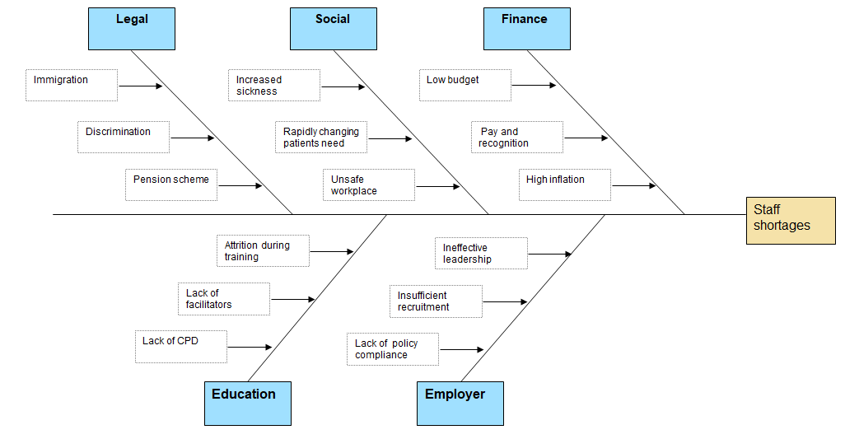

Research informed solutions for Staff shortage

- Train the team to do more.

- Supply new staff

- Pay and recognition

- International Recruitment

- A good employer

- Work force re-design

Evaluation of alternative solutions

Training the existing team
Work place training can be an effective solution to improve and expand the service of the organisation and their employee’s Continuing Professional Development (CPD), particularly during the preceptorship and transitions time. This long term plan requires time and funding to reduce attrition, solve the financial problems of trainees and collaboration between the NHS, higher education institute and local workforce action board. For example, training a hospital consultant requires more than £500,000 investment and 14 years (Curtis and Burns 2018).so we wouldn’t see immediate result.

Supply new staff

Refined Recruitment policy to allow new staff to fulfil the huge number of vacancies will ease the shortage. New improved pay deal, redesigned workforce services, apprenticeship and wider campaign of recruitment policy needs to be implanted. Funding for students and placement-provider funding will also needs to be reinstate. Apprenticeships can be significant route to widening participation, which can help key workforce shortage.

Pay and Recognition

A reconstructed pay and recognition policy will pay a vital role for employees
Job satisfaction (NHS 2019).To decrease shortage of certain group and specialities, pay can be one of the influences to recruitment and retention. While pay ensures employees a fair trade of their skills and efforts, recognition increases productivity and loyalty.
Local government financial incentivises have to focus on targeted areas of pay and non-pay policies, ensuring guaranteed pay, training, equality and portability. The Department of Health and Social Care has to work on a more targeted way to overcome barriers.

International recruitment

Recruiting international skilled worker can be one of the speedy solution to demand and supply. If migration restrictions are lifted, foreign workers will be attracted by stable employment which will offer the industry several key benefits. They are generally younger than their British counterparts and according to the report from Independent Age and the International Longevity Centre-UK revealed they are “significantly more likely to be high-skilled (have a qualification equivalent to level 4 or above).”
More government funding has to be used to full advantages of international staff and their family. The CoP (Code of Practice) clearly sets out responsibilities for recruiters, employers and the government to reduce the chances of unethical recruitment on an ongoing basis and will ensure countries with the weakest health systems are protected.

A Good Employer

Stronger leadership impacts the progress of workforce implementation plan. Finding the root causes of problems, evaluating the solutions and implementing effective concerted action fairly and equitably will lead the organisation to a high performing health system. The recommendation on series of published national reports is towards changing, compassionate leadership.

Work force redesign

The whole health care sector is in clear need of redesign.
Effective team with updated, adaptive skill and technological support will lead to reshape the work force.
Central and regional government have to change the way to implement policy, structural financial support to design the workforce, from the core,the primary care sector to the leadership of NHS. Collaboration between NHS and care sector on workforce planning will reduce professional and public confusion about advanced practice and new roles. Dedicated support to ensure collaborative and effective multi-professional teams working across the care system is essential.

Chosen solution

As the problem has various cause and factors contributing to the whole sector, one particular solution for it can be a better employer with a stronger leadership. All the solutions evaluated earlier can only be implemented by a compassionate leader, a good employer. The culture of modern organisation is based on powerful and malleable leadership. The table below helps to evaluate the decision;

PMI- Weighing the pros and cons of a solution

Plus | Minus | Implication
Inclusive leadership enables teams to deliver better care.  +5 | Need better understanding of the reasons to improve management.  -2 | Can create more opportunities for flexible working, which leads to potential to retain experience staff.  +3
Ensures better value for money.+5 | Revised set of actions to implement within 12 months.  -3
Create a strong leadership culture.

+5
Can change the rigid structure of NHS employment and rostering.  +5 | Prioritise undertaking the recommendation of nationwide reports have been published.  -1 | Can support newly qualified staff by including sufficient funding for Continuous Professional Development(CPD)  +2
Can offer a career open to diverse people of society by ensuring flexibility to parent, carer and people having to source multiple income.  +5 |  | Need to provide clarity to staffs about their rights and greater accountability when discrimination take places.  +5
+25 | -6 | +10

The score table is 35-6=29.

Effectiveness

These overview and focusing on key areas that need action now, shows immediate opportunities exist to make the NHS a place where more people want to build a career. Wide range of measures has to be taken to make the health care sector a better employer for future. Workforce implementation group should prioritise the recommendation of researchers to support the organisation to understand the key issues. NHS,HEE, National Bodies, National workforce implementation group, local government, central government need to have a proper collaboration to implement their improved policy. To be a good employer it should attempts to provide equal access for equal need. Additional investment for training, pay rise, advanced technology, improved pension scheme etc has to be done with proper policy and managerial focus which should be consistent and co-ordinated by a strong employer.

Conclusion,

Better co-ordination between higher education institutions, commissioners of training and the NHS work together will improve decisions on funding, the number of training places to commission; forecasts on the future demand, recruitment; and co-ordinated planning to address factors outside the control of the NHS as well as unexpected events within the NHS. According to NHS long term plans intent for local workforce action boards – responsible for supporting regional workforce plans – to ‘become more accountable’ to health and social care employers (NHS England 2019c, p 78).To get the best result of the whole workforce the employer has to be a better place to build a sustainable career.
Evidence and experience from high-performing health systems demonstrate that compassionate, inclusive leadership enables teams to deliver better patient care and value for money while also delivering continuous improvements to population health (National Improvement and Leadership Development Board 2016).

Reference list
www.gov.uk
www.nhs.uk

Cite this as: BMJ 2022; 377:o945
https://www.rcn.org.uk/-/media/royal-college-of-nursing/documents/publications/2017/september/pdf-006415.pdf
THOMAS,B. PESTLE Analysis of the NHS(OCT 29, 2019 )
https://www.bma.org.uk/advice-and-support/nhs-delivery-and-workforce/workforce/nhs-medical-staffing-data-analysis
Oung C (2019) “The environment needs to be higher up the NHS agenda”, Nuffield Trust comment. https://www.nuffieldtrust.org.uk/news-item/the-environment-needs-to-be-higher-up-the-nhs-agenda
Umar Farooq,https://www.marketingtutor.net/pestle-analysis-of-the-nhs/ https://www.health.org.uk/news-and-comment/blogs/staff-shortages-left-the-nhs-vulnerable-to-the-covid-19-storm
https://www.uniqueiq.co.uk/the-care-sector-in-urgent-need-of-migrant-workers/

