Easy Jet Plc

Programme: BA (Hons) Leadership and Management Skills for the Workplace
Module name: Workplace culture and its impact on Organisational Efficiency
Module code: BMSW5105
Student Names: Mihai Arhire (2030027)
Lecturer Name: Nadeem Mirza

Table of Contents
Introduction 3
Company Overview (Easy Jet Plc) 3
Business Environmental Scanning of the company 4
SWAT Analysis of Easy Jet Plc……………………………………………………………4
PESTEL Analysis of Easy Jet Plc 5
Porter’s Five Forces Analysis of Easy Jet Plc 7
Key drivers for the changes for the company 9
Organizational Culture of Easy Jet Plc and changes due to external forces 10
Ethical Approaches at Easy Jet Plc 11
Recommendations to Easy Jet based on the environmental and ethical challenges 11
Conclusion 12
References 13

Introduction
Easy Jet Plc employs around 13000 individuals around the globe in 2023. Adding to it, it operating over 927 routes across 34 countries by using 330 Airbus aircrafts in 153 airports. Thus, the report makes business environmental scanning of the organization in which it discusses internal factors of Easy Jet Plc. Such as the coming out of the health-conscious consumer in the urbanized world indicates that the company can confiscate the opportunity to market to this sector along with its prevailing and yet-to-be-launched service assortment that is particularly tailored toward the modern consumers. Apart from that, the report also analyzes some external factors that impact the business performance of Easy Jet Plc as of its competitors in the marketplace. Like, employment is serving as the greatest economic factor for the organization if there is a great range of unemployed individuals, and then it can assist Easy Jet Plc in lessening the costs of final product and offering its products at lower costs to the consumers. Easy Jet Plc is unbeatable company that selling very affordable flights and holiday packages.

Company Overview (Easy Jet)


EasyJet Plc is a British low-cost airline with its main office in London Luton Airport. EasyJet company was founded in 1995 and offers flights to domestic destinations as well as international destinations to various cities in Europe and Africa. The portfolio of Easy Jet Plc consists in innovation, pleasant low cost flights, great selection of food, comfort and excellent service on board under Orange Spirit and more. It employs more than 13000 individuals around the globe according to 2023 statistics. 4000 pilots, 7000 cabin crew staff and the rest are customer’s service staff and touristic operations service and sales agents. It comprises over 34 countries that are fling to over 1000 cities (Easy Jet, 2023). Easy Jet Plc operates domestic flights and international flights via Easy Jet UK, Easy Jet Europe, Easy Jet Switzerland. Also from 2019 Easy Jet Plc are selling holiday packages which are affordable and much demanded. Holidays are including flights, accommodation, 23 kg luggage/ person and transfers. The main object of activity of Easy Jet Plc is the performance of domestic and international air transport of passengers and luggage, through regular flights, the purpose of which is to establish the traffic policy, tariffs and endowment, concludes and executes agreements and contracts with domestic and foreign partners.

Business Environmental Scanning of the company

SWOT Analysis of Easy Jet Plc

Strength- Among many strengths of Easy Jet Plc, some of the vital strengths is that the company is very popular among other competitors; it’s very profitable for the customers by comparing price and quality Easy jet Plc offers; strong brand; diversified range of countries where Easy Jet Plc are flying; saving time by choosing to fly instead of driving; distinctive spirited advantage, merging global point of view with local execution, and many more (Bowen, 2022). Easy Jet Plc put lots of accent on safety and they operating modern aircrafts Airbus and own 59% of them. Easy Jet Plc wins the heart of customers as it gives preference to global alterations and in the same time making high profit.

The weakness-The chief weakness of Easy Jet Plc is that it operates in a cut-throat market where its opponents such as Lufstansa, Wizz Air, Vueling Airlines, Ryanair, Pegasus, etc are confronting at every turn (Tien, 2019). At this critical moment of time cancellation can be another weakness. People are struggling financially and even if airline put cancelation measures in place they are still cancelling flights and holidays. There is no business class on Easy Jet Plc flights which can make more demanding customers to fly with different companies. Another weakness is that booking system is only online, which not helping elderly people whom not having knowledge how to use internet. Easy Jet Plc still doesn’t reach many important airports. One of them is Heathrow.

Opportunity- Easy jet Plc has opportunity to extend and fly to more countries. Even to fly to Asia or over the ocean to United States and Canada. The furthest flight for Easy Jet Plc is to Hurghada. At this point, it's not a good idea for aircraft to depend 100% on battery power. But ten years ago people thought the same thing about electric cars, and now the situation has changed quite a bit compared to the last five years. This mean there is an opportunity in the future Easy Jet Plc to use electric aircrafts for transporting people.
Threat- Easy Jet Plc operates in a market segment that already contains the similar services and it faces a threat from smaller and comparatively more agile companies that can offer more value for slighter money (Bowen, 2022). Easy Jet Plc can be impacted by a new virus, like it was for 2 years because of Covid-19. All airlines was dramatically affected and their activity was completely stopped, which brought lots of losses. Weather conditions can be a threat because of storms, strong winds, tornadoes, snowstorms etc. Easy Jet Plc has to pay to the customers for the cancellation or delay of the flights to avoid dissatisfaction.

PESTEL Analysis of Easy Jet Plc

Political Factors- In the present times I have detected next political factors as political instability and precariousness caused by Brexit, disequilibrium of supply and demand, airlines restriction created by diseases (Covid-19, Ebola, etc), airlines very rigid regulations and restrictions because they are linked to risks which can bring to accidents or death. Terrorist attacks and war are other political factors that can influence massively Easy Jet Plc performance.

Economic Factors- variation of economic factors like foreign exchange rates, taxes, interest rate, inflation rates, currency rate and expand of combustible costs are some of the relevant economic factors that can affect EasyJet's financial performance. When fuel prices went up Easy Jet Plc was struggling to make profit for a while. Employment also serves as the greatest economic factor for the organization as if there is a great range of unemployed enthusiastic individuals, then it can assist Easy Jet Plc in lessening the costs of the service and offering its services at lower costs to the consumers.

Social Factors- Easy Jet Plc has to be open for changes and employ pilots not only male, but female also. Easy Jet Plc are required to embrace changes if wants to be part of modern world. Modern Online platforms can help people to facetime each other, have conferences and meetings and avoid travelling. In addition, Easy Jet Plc is also required to be conscious of buying behavior and preferences of the consumers in the marketplace. Like, advertisements and announcements on board have to be done in the language of the destination country (Turkish, Italian, French, German, etc).
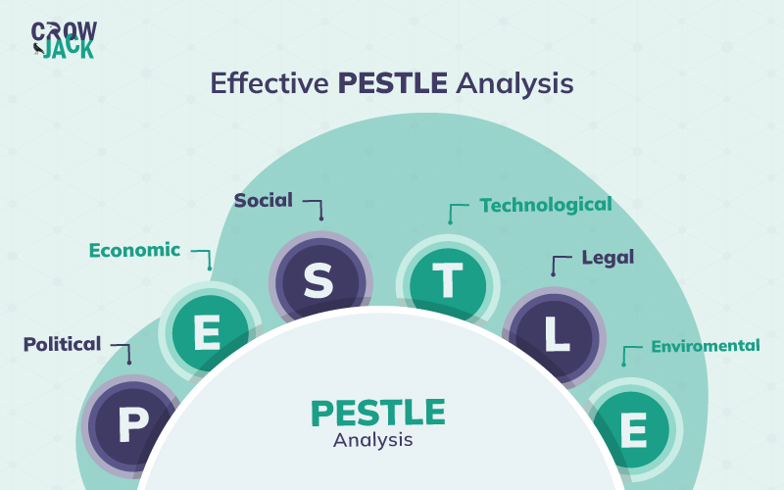
(Source: Tiamboonprasert and Charoensukmongkol, 2022)

Technological Factors- The manager of Easy Jet Plc must be needed to keep its business actions innovative with the technology in the marketplace to keep competitive as its rivals over the globe. Thus, constant improvements in the performing procedures by the organization allow it to enhance its efficiency as well as lessen the costs of services. Therefore, it gives a greater edge to Easy Jet Plc to offer quality products and services at the lowest costs to consumers across the Europe. Well, a range of resources should be put by the leaders in further line of services and should be effectively launched by Easy Jet Plc in the marketplace which further allows it to progress its earnings as of rivals. It also assists the company to catch a greater market space (Philip and Gavrilova, 2022). Furthermore, it also helps Easy Jet Plc to save time and enables the customers with products and services at a specific period. Also, nowadays customers prefer to buy tickets and check in online, leave the luggage at the self-service point and do not bother to stay at long queues and waist time and energy.

Ecological Factors- Easy Jet Plc has needed to effectively comply with environmental actions to catch a note-worthy growth and development in the marketplace. Thus, the organization usually puts its concentration towards environmental actions with the main aim to keep its image highly competitive in the market as of its rivals. About this, Easy Jet Plc develops its focus on European sustainability objectives (environmental friendly and fuel efficient Airbuses) which will further assist the company to establish its well-known brand image in the marketplace. Besides, the company is required to devise its approaches and strategies, as well as technologies to lessen the amount of plastic used by the company for the packaging and replace them with biodegradable cups and packaging The reason is that it gives greater assistance to Easy Jet Plc in reducing its carbon footprint from the community and establishing its positive brand image among consumers across the world.

Legal Factors- Easy Jet Plc has providing their service in 34 countries and always puts in the middle of their activity, its customers. There is so many rules about flying activities regarding safety, the quality of the service in the aircrafts and the way cabin crew treat the customers. Well-built legal department in aviation, made Easy Jet Plc to follow some rigid rules and regulations. This helps the company to develop trust and belief in the mind of the consumers and hence Easy Jet Plc can catch a greater loyalty of its customers in the marketplace.

Porter’s Five Forces Analysis of Easy Jet

The threat of New Entrants- Easy Jet Plc is considered one of the well-known multination organization based in London, England, United Kingdom. The creator of Easy Jet is Sir Stelios Haji-Ioannou. He created the brand of Easy jet in a bar in London on a napkin. The company started its business actions in the year 1995. Having a well legacy of popular brand in the marketplace is extremely comprises as tricky. One of the core reasons behind it is referred to as the requirement for huge capital as well as resources.
The airline industry is nearly impossible to enter. To start airline business requites very high cost. Buying airplanes requires a large amount of capital and equipment from with the airline industry are not affordable also. This is the main reasons why new entrants are cramped to enter the airplane market. A threat can come from existing airlines which want to enter the low cost market. This competitors already have required knowledge, equipment and they know the regulations and restrictions.

The threat of Substitutes – The threat of substitute is low, because there is no many substitutes for airbuses. Trains can be considerate the main substitute. Trains journeys are cheaper than planes but only for short journeys. For long distances Easy Jet Plc have affordable prices that sometimes are cheaper than train prices. As a substitute worth mentioning vehicles, cars or buses, it is usually convenient when more people travel together but the travel time is much longer for long journeys and parking is expensive.

Bargaining power of buyers- The bargaining power of buyers is high because in the same time the competition is intense as Easy Jet Plc is not the only low-cost company, and it is easy for customers to choose another company for two main reasons: firstly, customers can choose any company and the most suitable for them, and secondly, changing companies does not implement any cost of agent intervention.

Bargaining power of suppliers- On the market there is two main retailers that manufacture nearly all of the production cost of air transport. Two airplane suppliers are available in the world: Boeing and Airbus, so the bargaining power of Easy Jet Plc is low. Indeed, it is difficult for them to change prices as they are not in a position of dictating. Airplane suppliers got lots of customers. On the other hand petrol suppliers have a high power and influence. Till electric planes will be invented, current planes need fuel to fly. Petrol suppliers are in complete control. They can dictate petrol prices. The last supplier is the airport which brings with it airport charges. Each plane is charged for landing and parking when arrives on any airport. The landing, taking off and parking are very expensive on important airports like Heathrow. Easy Jet Plc save the money because never use Heathrow airport.
Competitive rivalry- Some of the core rivals of easy Jet in the existing marketplace and across the world are referred to Ryanair, Wizz Air, Flybe and so on. Easy Jet Plc faces immense rivalry from direct and indirect competitors. Direct competitors are other low cost companies and indirect competitors for example BritishAirways because they target different market segments (Shantz and Dempsey, 2021). In the context of this, towards keeping competitive and remaining in this rival marketplace, Easy Jet Plc concentrates on customers who are travelling for leisure and business, when Ryanair is focusing on client who travelling for leisure. Easy Jet Plc are landing on important airports like Charles de Gaulle in Paris or Madrid airport, when Ryanair is landing only on minor airports.

Key drivers for the changes for the company
Trade and Uncertainty- The development of a global trading system and its influence on the multinational economy comprises as uncertain (Hamid and Younus, 2021). In the context of this, this key driver for the changes is considered one of the greatest difficulties for Easy Jet Plc to successfully comply in this challenging environment and predict its long-term development in the marketplace.
The impact of digital advancements- The development of digital infrastructure as well as the innovation of digital advancement is rapidly and crucially altering the way people perform and live (Edmondson and Besieux, 2021). Thus, this possesses the greatest influence on the performance of Easy Jet to the greater extent in the marketplace and serves as one of the core drivers for the change for the organization.
Changing expectations and behavior of the consumers- Buying behavior of the consumers hardly affected the growth and profitability of Easy Jet Plc in the marketplace as of its contenders (Hamid and Younus, 2021). Expectation and buying behavior of consumers severely changes due to the greatest expectation of higher levels of collaboration as well as transparency.
The urgency for sustainability- The global deal with major threats to the surrounding, if the company is not able to successfully address imminent threats brings due to suitability (Edmondson and Besieux, 2021). Easy Jet Plc want to lead decarburization of aviation. Easy Jet joined the UN-backed Race to Zero campaign, and by 2050 wants to reach zero net carbon emissions.

Organizational Culture of Easy Jet and changes due to external forces
The organizational culture of Easy Jet Plc usually emphasizes the importance of the workforce's efficiency as well as output. This corporate culture of the company significantly highlights the significance of criteria, processes, and measures used by the leaders of the organization to analyze the output and its adequacy as per requirement (Ljajić and Pirsl, 2021). In the context of this, the organizational culture of Easy Jet Plc has some specific characteristics or features refer as it generally concentrates on both the individual’s performance and organizational performance, focuses on quality, concentrates on efficiency, and so on. Thus, this culture of the company is observable in the extended history of Easy Jet Plc.The business actions of the company have tremendously grown from a tiny company to a most efficient, loved and popular low cost airline.
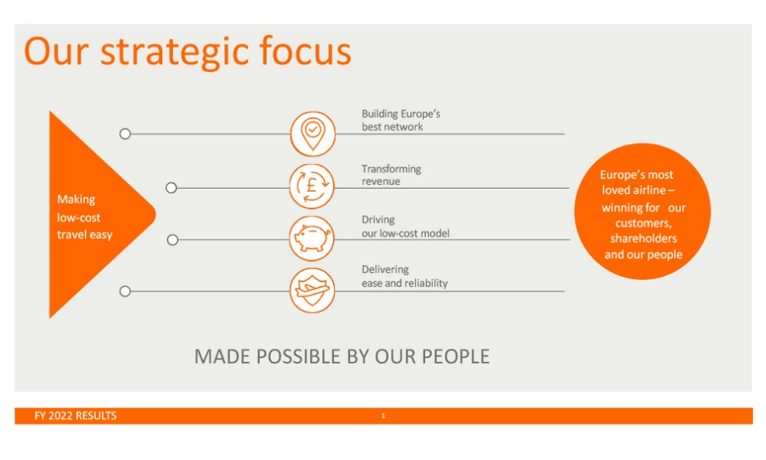
(Source: Easy Jet, 2022)
Such accomplishments of Easy Jet Plc are prudently relying on the efficiency and capability of its corporate culture. This mainly concentrates on the derived greater performance of workforces through enabling them greater inducements. As it also helps the company to maximize its business output and accomplish note-worthy growth and development in the marketplace (Ljajić and Pirsl, 2021). It also helps Easy Jet Plc to establish its note-worthy position and brand image in the market as the greatest quality of products allows it to successfully fulfills the needs and preferences of the consumers and keep its position itself as competitive both in the home market and global market.

Ethical approaches used by Easy Jet
Ethical Issues in Aviation focuses on current concerns and trends, to reflect the changes that have occurred in the last decade. The most common ethical dilemma in the workplace of Easy Jet Plc constitutes accepting tips on board, zero tolerance to modern slavery and discrimination, unethical leadership, environmental damage, employment conditions, and so on (Ljajić and Pirsl, 2021). Having an issue with the leader of the company on a personal level can cause issues in the working environment and also with the person that is conducting them unethically within the company. Easy Jet Plc connect, collaborate, create, and celebrate success together which highly induced its workforce and create a happier working surrounding for them under slogan “Living the orange spirit”. This gives a greater edge to the employees of the company to collaborate and maximize both their efforts and efficiency. They are promising to the customers to be warm and welcoming, to challenge always the cost, to make a positive difference comparing to others and to have safety in our hearts. This leads to note-worthy growth and development of Easy Jet Plc in the existing marketplace and in the world.

Recommendations to Easy Jet based on environmental and ethical challenges
In order to defeat the competition, Easy Jet Plc have to make improvements in its activity. For a better strategic development can be made some ethical recommendations. Easy Jet Plc could try to develop a new loyal policy, instead of the Easy Jet Plus, which only enables customers to jump the queue. For example fidelity cards system, which allows building up points in order to have several vouchers, discounts, etc. Offer the staff with reward cards for each birthday and give them opportunity to buy goods that they are selling on flights at reduced prices. At Christmas time should be organized a ball in the selected hotel, with live music, dress code, tombola and nice time for all Easy Jet Plc staff. Easy Jet Plc it call itself a green airline, to attract more people and expand the customer's target. For example they could include a green leaf in their logo. Also, Easy Jet Plc should place itself more in the middle sector. In this fashion, Easy Jet Plc will attract people who hunt cheap tickets for holidays and the others demanding for more business services, even if it does mean paying for extra fees.
Know the Principles- In ethical decision-making procedures, there are usually three kinds of basic principles refer as the principle of intuition, the principle of moral idealism, and utilitarianism concerns. These principles allow Easy Jet Plc to successfully deal with ethical dilemmas developed concerning its business actions (Grant and Hartley, 2013). Thus, this refers to one of the core suggestions to the company for resolving the identified ethical challenges in the marketplace.
Debate moral choices- Before implementing the decision-making process, Easy Jet Plc is required to though about moral and ethical decisions (Algahtani, 2014). A company doesn't need to accept any decision just blindly as it impacts its brand image to a greater extent in the existing marketplace and over the globe.
Balance Sheet Approach- This is another greatest or useful approach recommended to Easy Jet Plc to successfully comply with the identified ethical dilemmas. Under this, the manager of the company is required to analyze both the advantage and disadvantages of the decision (Ljajić and Pirsl, 2021). This assists the company to develop a clear picture of all the related things as well as organizing them in a well-efficient manner.
Engage people up and down with the hierarchy- One good practice suggested to Easy Jet Plc is to announce one stand on several ethical issues clearly like enabling all the individuals in the workplace with a clear message and to every people who are at the larger threat of diminishing prey to unethical actions (Grant and Hartley, 2013). Staff is not allowed to accept any tips. This fact is very strict controlled.

Conclusion
Easy Jet Plc is the one of the leaders of the European low-cost flights market. Easy Jet’s biggest competitor is company Ryanair, which is very popular too. Recently, Easy Jet Plc has proved that wants to expand and grow more. Easy Jet Plc got good reputation and is known as a safe company to fly with. Has low rate of accidents and low rate of missing luggage between flights. Customers a delighted to fly with “Orange spirit “in nice holidays or in the business trips. However, Easy Jet Plc has to face a strong competition. It has to deal with both direct and indirect competitors. That is why Easy Jet Plc focuses on the cost leadership strategy and the differentiation strategy. Many customers use it because Easy Jet's flights are considered as the cheapest in the airline market and also offer very advantageous holiday packages.

References
Algahtani, A., 2014. Are leadership and management different? A review. Journal of management policies and practices, 2(3), pp.71-82.
Bowen, P.W., 2022. "Words can hurt": The role of leadership in the passionate work of the twenty first century. A discussion about individual sensitivity and pathocratic influence in the academic (university) environment. LEADERSHIP, 6(2), pp.26-45.
Easy Jet Plc, 2023. [Online] Available at: https://corporate.easyjet.com/about/what-we-do [Accessed at 12/04/2023]
Hamid, A. and Younus, M., 2021. An Analysis of Library Professionals’ Communication Skills: Status and Effectiveness on Workplace Productivity. Library Philosophy and Practice (e-journal), 4736.
Ljajić, S. and Pirsl, D., 2021. The role of internal communication and workplace language in positioning of organizations. Društvene i humanističke studije, 6(1 (14)), pp.441-452.
Philip, J. and Gavrilova Aguilar, M., 2022. Student perceptions of leadership skills necessary for digital transformation. Journal of Education for Business, 97(2), pp.86-98.
Tiamboonprasert, W. and Charoensukmongkol, P., 2022. Effects of Ethical Leadership and Organizational Politics on Workplace Cyberbullying and Job Consequences of Employees in a Thai Educational Institution: Moderating Role of Political Skill of Employees (Doctoral dissertation, National Institute of Development Administration).
Tien, N.H. and Nhi, D.T.Y., 2019. Comparative Analysis of Knowledge Management, 6(10), pp.22-27.
Tien, N.H., 2019. Comparative analysis of multi domestic strategy. International journal of foreign trade and international business, 1(1), pp.5-8.

