The module title: Marketing Essentials BMIH4005

A comparison of the marketing methods of two multinational hotel brands.
Six Senses and Holiday Inn

Name: Dimitar Evtimov Karamanov

Student ID number: 2235640
Lecturer’s name: Huw Thomas
Word Count: 1650

1. Introduction
1.1 Outlining the key points.
In this contemporary world, marketing and its essentials are highly preferred as these would provide the company with defining to promote the product or the services of the company. The company is also determined to be able to follow up on maintaining the marketing concepts and techniques that are lasting impressions within the hospitality industry as well as within the mind-sets of the target customers (Ryan, 2012). This study, therefore, highlights the external analysis, marketing mix as well as STP comparing both companies.
1.2 Reason for Essay
The main reason for conducting this essay is that there is a need to examine marketing methods as well as strategies for multinational hotel brands such as Six Senses & Holiday Inn. This task is also further determined to focus on exploring the varied generational as well as strategic approaches within the marketing concepts of both companies.
1.3 Thesis statement
As there has been increasing competitiveness within the marketing concepts and environment, therefore, this study is considered to focus on drawing a comparison between the marketing methods of two multinational hospitality companies (Holiday Inn and Six Senses). This study would therefore signify upgrading and signifying the enhancement of potential marketing activities for maintaining future growth within contemporary conditions.

2. Main Discussion

2.1 Situational Internal or External Analysis
2.1.1 SWOT analysis
Holiday Inn
Strengths
1. High brand recall and viability
2. Entering new markets across the continents
Weaknesses
1. Huge competitive atmosphere
Opportunities
1. Travellers looking for new destinations
2. Country-specific seasonal offers
Threats
1. Growth in costs for operations indirectly
Six Senses
Strengths
1. High profitable margins
2. Well-trained management
Weaknesses
1. High-cost structure
2. Single brand strategy
Opportunities
1. Developed cross-selling strategies
2. Developed personalised services
Threats
1. High turnover
2. Strong competition
2.1.2 PESTLE analysis
Political
Political factor is the most important part of business development as it ensures business policies successfully (Dalirazar and Sabzi, 2023, p.181). As Brexit has caused issues within Holiday Inn, as the company had to set off the course of labour and for this reason, the company is needed to increase wages for attracting new staff. On the contrary, Six Senses being the prime selling products to their customers had faced issues with covid-19 also. The company was with the economy fell by 2% in 2020.
Economic
As depicted by Nandonde, (2019, p.59) economic factor is one of the major elements in the case of business decision making process. The inflation rate impacted Holiday Inn the maximum, as the company provides their customers with competitive pricing strategy products and due to the inflation rate, the company had to increase their prices and for this reason, they were losing customer contacts (Smith and Zook, 2020). On the other hand, due to the fluctuations in the GDP rate of the UK, Six Senses is stated to suffer with the fall in demand for services or products.
Social
Based on the view of Capobianco et al., (2021, p.6266), social factors are important in the case of business development as it focuses on the forces within the society. According to Ghauri (2014), it can be stated that cross-cultural differences are high in the UK, and for this reason, both the hotel multinational companies would be facing issues in proving certain topics (Afandi et al., 2023, p. 4). However, due to the demographic conditions of the UK, that is there are maximum males with 97.75 males per 100 females. This at certain times creates issues within the industry to maintain equality considerations.
Technological
With the UK being the most widely used technological space, therefore, Holiday Inn is stated to be able to focus on using AI tools that are evitable for the company to touch the heights within the hotel industry. However, in comparison to this, Six Senses is seen to use AI, Virtual & augmented reality as well as IoT facilities with Block chain Technology. Therefore, the technological factor is stated to highlight the facilities that the hotel industry considered to be used.
Legal
As asserted by Tumaku and Ren, (2020) legal factors are the most important to abide by laws and regulations within a country. Holiday Inn is determined to use income tax 2007 (c 3) that is determined to process the act of parliament of the UK. On the other hand, Six Senses is determined to use the Transport Act 2000 that is determined to help the company in making free plans to execute the transportation procedure with the use of strategy and action plan.

Environmental
The UK has varied environmental factors that are required to be considered by the hotel industries for better sustainability procedures Such as Environment Safety Acts, Health Acts, and Carbon Emission Acts (Acheampong and Kemp, 2022, p.105634). However, Holiday Inn is stated to be following the Waste Management Act 2006 which is determined to provide the company with the ability to focus on the prevention and reduction of waste materials that are harmful for the environment to sustain (Kotler et al., 2020). Subsequently, the Six Senses are stated to focus on the use of the Climate Change Act 2008, which is determined to help the company in maintaining its carbon emission levels.

3. Marketing Mix
As stated by Bowie et al., (2027), 7Ps of marketing is important to evaluate key issues of marketing of a business entity.
7Ps
Product- Holiday Inn is determined to serve its customers with food services, lodging, convention, meetings as well as timeshares. On the other hand, the Six Senses are providing exotic resorts and spas to private clubs and luxurious residences.
Price- Holiday Inn is determined to be using a competitive pricing strategy that would be helping the organisation to be able to follow the effectiveness of understanding the competitive level of the UK market. This pricing strategy is managing a set of prices that are based on competitors' pricing. This strategy is also able to consider the online and offline markets that can maintain the attractiveness for more customers and in increasing the market share (Chaffey and Ellis- Chadwick, 2019). Whereas Six Senses is using a premium pricing strategy and is determined to be able to involve in setting up the price of the product that is higher than similar products. These are also certain strategies that are certainly sometimes considered skim pricing strategies that would attempt to skim the cream off the top of the market.
Promotion- Both the hotel companies are determined to be using social media promotional strategies that would help the company in maintaining the conditions of the company. Social media marketing is determined to help both companies with the use of social media applications as a marketing tool (Similar web 2023). Social media platforms are also stated to enable the brands for connecting with the audiences to build up the brand and in increasing sales for driving through the traffic of the website (Zhao, 2023).
Place- The place that is selected by holiday inn is Blackpool UK and on the other hand, Six Senses is being placed in London UK.
Physical evidence- The physical evidence for Holiday Inn is stated to be existing within all the potential features of the customers who are seen engaging with the business. On the other hand, Six Senses is determined to use tangible proof that can establish credibility. These are also stated to include the look as well as be able to feel the effectiveness of business branding.
People- People across the world are the customers of both companies. However, majorly Blackpool UK as well as London, UK customers are stated to be the most essential individuals who are useful for business management (Dwivedi et al., 2023, p. 770). Both companies are also able to be managing the cues of quality by considering the experiences the company is offering.
Process- Holiday Inn is determined to be able to use strategic marketing analysis would help the company in focusing on improving the considerations of the marketing concepts. On the other hand, Six Senses are determined to be using effective marketing controls for being able to improve the concepts of developing the marketing research plan. The company is also determined to be able effectively to collect all the relevant data and information for bringing an improved and focused ability for the marketing conditions.

4. Segmentation, Targeting & Positioning
Brand customer segments
Holiday Inn is widely focused on the usage of market segmentation methods that are stated to be based on various variables those are age, gender, income and many more. This segmentation is determined to help the company to understand consumer behaviour to focus on maintaining an accurate performance. Holiday Inn could focus on maintaining age, gender as well as religion (Stephens, 2023). And educational qualification of their target audiences. These are the factors that are considered by the company for maintaining a long-term concern. On the contrary, Six Senses are determined to be using both demographic as well as psychological segmentation. Both would help the company in getting enough information about their target customers and the behavioural changes and mind-sets of the staff members.
Compare the brand’s targeting strategies.

Targeting factors

Six Senses
Age => 30-60 travellers both males and females
Income => Premium Income Group
Location => London,Uk

Holiday Inn
Age => 35 to 54 business travellers both males and females
Income => Medium Income Group
Location => Blackpool, UK

5. Conclusion
The above study is determined to be able to focus on the considerations that are required to be based on mentioning the advantages and disadvantages of both companies. This study also stated to be focusing on the understanding of understanding the marketing essentials and also in maintaining the conditions of the company. This study is also considered to understand the external analysis of the company based on the SWOT & PESTLE analysis. This study is also considered to understand the marketing mix and segmentation of both companies.

References
Books
Bowie,D. Buttle,F. Brookes,M and Mariussen,A 2017, Hospitality Marketing. 3 rd ed, Routledge, London
Chaffey, D and Ellis- Chadwick, F. 2019. Digital Marketing. 7 thed, Pearsons, London.
Ghauri, P N 2014. International Marketing, 4 th Ed, McGraw Hill, London
Kotler, P., Armstrong, G., Harris, L. and He, H., 2020. Principles of marketing. 8 th European ed, London: Pearson Education Limited.
Ryan, D. 2012. Understanding Digital marketing: Marketing Strategies for Engaging The Digital Generation. Kogan Page, London. http://117.240.231.117:8081/jspui/bitstream/123456789/457/1/Understanding%20Digital%20Marketing_%20Marketing%20Strategies%20for%20Engaging%20the%20Digital%20Generation.pdf
Stephens, D.L., 2023. Essentials of Consumer Behavior: An Applied Approach. Taylor & Francis. https://books.google.com/books?hl=en&lr=&id=RAymEAAAQBAJ&oi=fnd&pg=PT9&dq=+Marketing+Essentials&ots=Agcnqk8Uog&sig=IY2CxCbh1YTdO6J5QxaTpi5MpAM
Journals/PDFs
Acheampong, T. and Kemp, A.G., 2022. Health, safety and environmental (HSE) regulation and outcomes in the offshore oil and gas industry: Performance review of trends in the United Kingdom Continental Shelf. Safety Science, 148, p.105634. https://www.sciencedirect.com/science/article/abs/pii/S0925753521004744
Afandi, A., Eltivia, N. and Sakdiyah, S.H., 2023. Marketing Dashboard as an Early Warning on PR. GagakHitam. INTERNATIONAL JOURNAL OF ECONOMICS, MANAGEMENT, BUSINESS, AND SOCIAL SCIENCE (IJEMBIS), 3(1), pp.1-10. https://cvodis.com/ijembis/index.php/ijembis/article/download/105/100
Capobianco, N., Basile, V., Loia, F. and Vona, R., 2021. Toward a sustainable decommissioning of offshore platforms in the oil and gas industry: a PESTLE analysis. Sustainability, 13(11), p.6266. https://www.mdpi.com/2071-1050/13/11/6266
Dalirazar, S. and Sabzi, Z., 2023. Strategic analysis of barriers and solutions to development of sustainable buildings using PESTLE technique. International Journal of Construction Management, 23(1), pp.167-181. https://www.tandfonline.com/doi/full/10.1080/15623599.2020.1854931?casa_token=4IHSiRoJLXYAAAAA%3ABT-aXWoM9abQgAqq0h7G0g142lFxdA9pHFLOR8DwgBsVsoh7MCjVpPRA9KPkIQANkgW4iCbIObWLCump
Dwivedi, Y.K., Hughes, L., Wang, Y., Alalwan, A.A., Ahn, S.J., Balakrishnan, J., Barta, S., Belk, R., Buhalis, D., Dutot, V. and Felix, R., 2023. Metaverse marketing: How the metaverse will shape the future of consumer research and practice. Psychology & Marketing, 40(4), pp.750-776. https://onlinelibrary.wiley.com/doi/pdf/10.1002/mar.21767
Nandonde, F.A., 2019. A PESTLE analysis of international retailing in the East African Community. Global Business and Organizational Excellence, 38(4), pp.54-61. https://onlinelibrary.wiley.com/doi/abs/10.1002/joe.21935
Smith PR and Zook ZE, 2020. Marketing Communications. 7 thed, Kogan Page, London
Tumaku, J. and Ren, J., 2020. Ghanaian Perspective of Franchise Contract in Africa, a Pestle Analysis. ECON-Journal of Economics, Management & Business, 8(3). https://pdfs.semanticscholar.org/a98e/39201f80f9b1ac024eec00ccd5a2d9acbff8.pdf
Wang, J., Hu, Y., Jiang, T.X., Tan, J. and Li, Q., 2023. Essential tensor learning for multimodal information-driven stock movement prediction. Knowledge-Based Systems, p.110262. https://taixiangjiang.github.io/paper/2023/KBS-2023-STOCK-RPCA.pdf
Zhao, Y., 2023. The Influence Factors of Short Video Marketing on Consumer Purchasing Behavior and the Effective Suggestions. In SHS Web of Conferences (Vol. 155, p. 02002). EDP Sciences. https://www.shs-conferences.org/articles/shsconf/pdf/2023/04/shsconf_sdmc2022_02002.pdf

Appendices
Figure 1: Positioning Map
(Source: Developed by the Author)

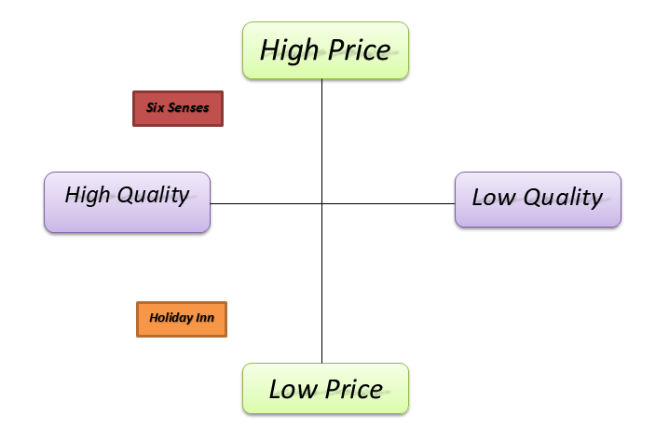

Social media traffic analyses for Six senses
(Similarweb.com)
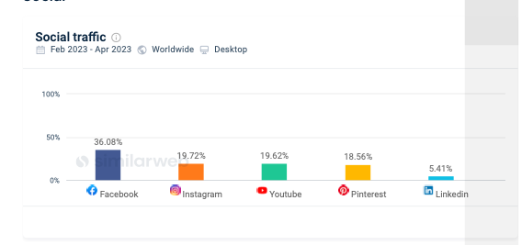

Social media traffic analyses for Holliday Inn
(Similarweb.com)


