University of Wales Trinity Saint David

Module Code: BMSK4003
Assignment Title: Digital Skills and Research Methods

Name: Md Kawsar Mazid
Student Number: 1708619
Module Lecturer’s Name: ZZ: Ze Zook

Table of Contents
Introduction 3
Part One 3
Task 1.1: Evaluating the effectiveness of the use of modern technologies within the workplace 3
Task 1.2: Exploring social media for marketing, information collecting and building communication within the workplace 5
Task 1.3: Creation of own social and professional accounts in several social media 10
Conclusion 11
References 12

Introduction
Technological progress is rising at increasing rate in the last couple of decades and the importance of digital technologies in the workplace environment is beyond question nowadays. These digital technology tools and appliances have changed the job nature and work environment drastically. It has become one of the topmost crucial duties of magnets and relevant personnel to keep an eye on the upcoming technological change in respective discipline. So social media also captured enough space in this segment, these social media are using for gathering information and making good communication with others. Here in this report how the effectiveness can be assessed and improved will be delineated with pertinent examples.

Part One

Task 1.1: Evaluating the effectiveness of the use of modern technologies within the workplace
There are several items of modern technologies and social media serving us at this present era. This number has grown over the time and necessity of these media is beyond any question nowadays. Apart from a business perspective, people’s life is significantly coherent with these tools and appliances; young generation is just obsessed with these tools and almost everybody is becoming dependent on these modern technologies. Our point is to assess the usefulness and effectiveness of these modern technologies and several social media (Hess, 2014).For example, mobile, smartphone, laptop, tab and computer are the best example of modern technologies.

Figure 1: Modern Technologies
Source:(Sibson, 2012)
Some qualification is required to run these technological appliances smoothly which is named by digital skill. Digital skill defines basic technical knowledge and practical aptitude how to operate a laptop, computer and smartphone. Organisation arranges several trainings session to spread the technical knowledge among the employees in a workplace environment. The government also take initiatives and provides incentives when one country launches any new tool in certain country or region.
The evaluation of effectiveness of modern technologies in the workplace environment
Modern technologies and social media are being used both by the employers and employees in the workplace environment and effectiveness are going to be focused on this ground lately. There are a lot of assessment criteria about how we can measure the effectiveness of these appliances. Let’s move on and see the evaluation process in the below.
Communication and efficiency
The fast and foremost purpose of using these social media is to build better communication among colleagues, senior, juniors and with bosses. In the workplace environment, better communication can be maintained through the mobile, laptop, smartphones and tabs. Communication has its various formats in this present innovative age for example; email communication is randomly used in workplace area (Schaab, 2015). On the other hand, email communication is heavy to transfer and to provide official files, relevant images and crucial videos and important links. These technologies and social media have paved the way for better communication. Organisations can use these tools for supply chain management, logistics department to pass their dispatch related data within a short period and meagre cost. For example, BP, Reckitt Benckiser and Unilever initiated sophisticated dashboard system for their manufacturing department in the UK market. It lessens expenses tremendously and can be transferred information within a single second. When they can save both time and money in the working zone which means efficiency is bound to be attained.
Improvement for employability
Employment opportunity is leaping forward to a higher range of productivity for the sake of these digital technology tools and instruments. Human resources managers can easily perform their jobs by using these instruments very quickly and efficiently. For example, HR managers can train their successive employees by video conferencing and over the audio call. They have the opportunity to examine candidates and recruit from them by the best use of these technological tools. Whatsapp, IMO, skype and messenger are frequently used to take GMAT, GRE and IELTS viva test nowadays and these just made our life easier and smoother(Rocha, 2013).
Workplace productivity
As the employees can complete their job within short time and less cost to both productivity and profitability is bound to be emphasised for that certain organisation. For example, automated teller machine frequently said ATM which technology has just brought disastrous change in people lifestyle. After installation of ATM booths in several corners of the cities, all people can do their jobs faster than previous. Another example can be chosen here that technologies used by companies like Google, Microsoft and Intel provide 24/7 service to their respective customers. A Harvard study said that after launching Google street view services its profit was increased by 28% of the total profit from the previous year(Park, 2013).So, workplace profitability and productivity are bound to enhance by these digital technologies.

Task 1.2: Exploring social media for marketing, information collecting and building communication within the workplace
In the last couple of decades, many social media platforms have been developed in this entire globe. Now the internet connection and bandwidth are too available among the people so everyone can grasp this opportunity from the internet and digital technologies. The number of software developers is rising and rising and they always try to innovate something new which will make our job easier and flexible. In this present world, more than 2.5 billion people use technological innovation and take services from social media. There are several social media and some highlighted and most used are Facebook, Twitter, Instagram, LinkedIn, Pinterest, YouTube and Google plus.
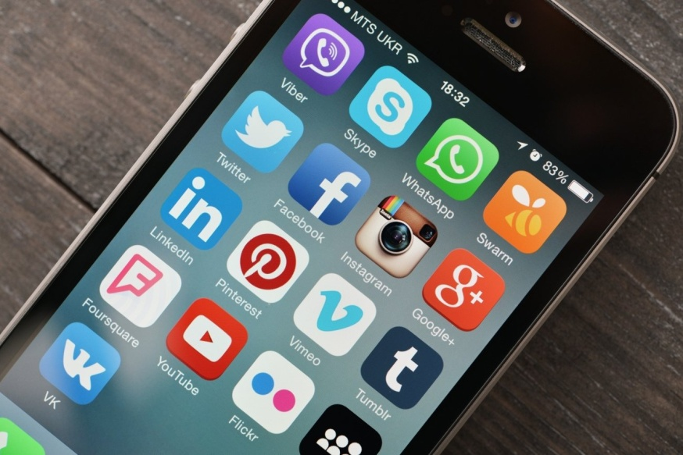
Figure 2: Social Media
Source:(Bowen, 2016)
These types of social media which are mentioned above are being used in a different aspect of the business. Hence its best use is to promote brand name, products features and to attract target customers through these social media; this is known as social media marketing. Social media marketing requires trivial expenses and it is capable of spreading the news more swiftly than any other augmented source. Social media marketing captured and exploited the previous ways and methods of marketing when festoon, placards and poster were used rigorously (Simakova, 2013). These tools have become obsolete and Facebook, Twitter, Meetme, LinkedIn, VK and YouTube are dominating for advertising in the marketing sector. Educated employees are becoming more interdependent on these social media and these media can influence greatly and can change the buying pattern of consumers. For example, Restaurant business, apparel industry and automobile industries are totally operated by their online accounts severely.
Online presence matters a lot for these mentioned industries and apart from industry perspective almost all of the industries are getting attention from customers by these platforms. The telecast and spread their new features and attribute on these social networks. If they launch any new product or go for market expansion they upload instantly pertinent images with a precise caption on various social media. For example, Unilever Company has their verified Facebook page, Twitter, Instagram, Google plus and YouTube account. They update their information continuously. These can be named by YouTube.com/Unilever, Facebook.com/Unilever and Twitter.com/Unilever etc.
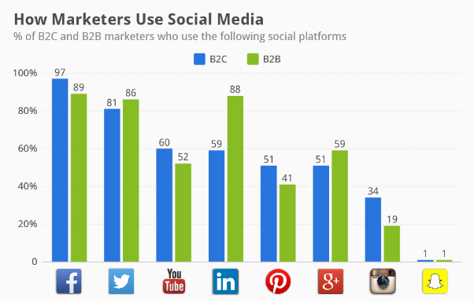
Figure 3: Usages of social media as marketing
Source: (Rocha, 2013)
The marketing managers can easily assess the contribution of social media on periodic business revenue by using several metrics. For example, they can get help from such factors such as conversion rate, time spent on sites, brand mention, number of comments and feedback from customers. The Facebook page becomes very useful for promoting business brand value because target customers visit and leave their comments on this site and some well-wishers send their opinion in the inbox so developers should improve their services considering customer choice (Salpeter and Morgan, 2014).
Social media for information collecting
At this present moment, social media are inundated with huge contents and topics are enlarging gradually. Expert employees and experienced business personnel share their view, thoughts and even research paper on these social media. Whoever needs the information can easily attain several sources of gathering information from social media platforms. For example, the Facebook group is atoo helpful source of information gathering and achieving experience. There are huge numbers of Facebook groups according to their disciplines and job demands. For example, marketing people can find marketing related informative and effective group; there is some magnificent photography group in facebook where handy and world-class photographers share their amazing photos and provide tutorials about insights of photography (Wahlgren, 2017). Same things can be followed by the finance department, HRM and engineers.
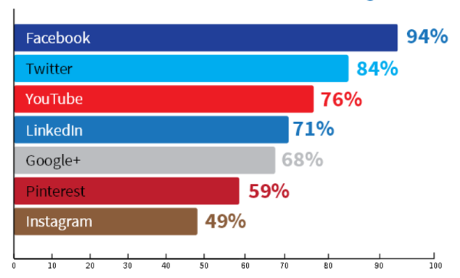
Figure 4: Usage of social media for gathering information
Source:(Wahlgren, 2017)
On a different note, multination organisation can use inbox group chat for sharing and providing relevant information within similar personalities and necessity. Employees who work in the same platform can ask their colleagues and seniors about critical issues of jobs and they can discuss informally so that they can learn new things which boosts their performance and organisation’s profitability in a healthy manner. The Facebook post can be an essential elements of information collecting source (Gravells, 2010).
One of the critically important sources of information collection is YouTube video and Facebook video also. YouTube has just broken all the previous records, it surpassed many primitive ways of collecting information and learning process. There are many tutorials on YouTube about different disciplines and it is entailing more and more. People are now interested to watch 5 minutes video rather than to read 5 pages contents because gesture, posture can make them understand easily and they can articulate properly on that topic. LinkedIn is too popular as professional social networking site and here people sign in for getting help from professional people. Apprentice lawyers, medical intern students and start-up entrepreneur can grasp the best output from LinkedIn; employers from several industries can recruit their distinguished employees from this site because they can sort out within best possible shortest time and lowest cost (Information marketing business, 2012). Professional business magnets and content providers publish their research materials and the innovative idea here so these can be a great source of information collection.
There are some drawbacks to using social media. Majority of users take this information lightly and most of the information is not authentic.
Social media for communication
Renowned social media websites and platforms were mainly established for the unique purposes and building better communication was the utmost priority. Apart from other activity communicating with other people is the distinct motto of these social networks. Here the study purpose is to justify and analyse the professional communication within the workplace by these websites and social media(Evers, 2011). For example, Facebook brought a new service for professional people named by channel for communication. Employees can use following option of facebook so that they seldom miss any chance to communicate with germane personalities.
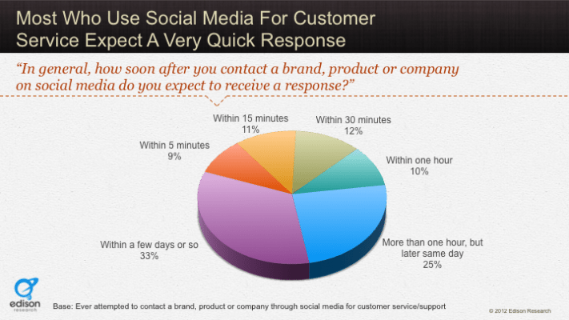
Figure 5: Social media used in the workplace to get customer response
Source: (Salpeter and Morgan, 2014)
Both multinational companies and domestic companies grasp this opportunity of building communication within relevant persons so that they can advantage when necessary. Employees and managers can arrange video conference meeting which doesn’t require physical existence and they can reach their information within real time. This process will energize employee engagement and productivity. For example, communicating and sending similar texts to thousands of people through the Messenger and WhatsApp reduces significant cost and it does not extra charge for crossing country barrier(Sibson, 2012).
There are some limitations of communicating via social media and website; those are in the following, people do not provide enough importance on these texts, messages and most of the times they engage in informal discussion when it comes to social media. Professionalism does not rule on them on these sites.

Task 1.3: Creation of own social and professional accounts in several social media
The importance and necessity of several social media have been elaborated previously in this ground of topic so everyone is now concerned about maintaining an online presenceon these floors. For getting updated information and maintaining the same pace with my co-workers I have opened my different social media accounts. Here I would like to present my Facebook and Twitter accounts. The links and screenshots of my Facebook and Twitter accounts have been attached to the below.
Facebook account link:https://www.facebook.com/noorprodhan

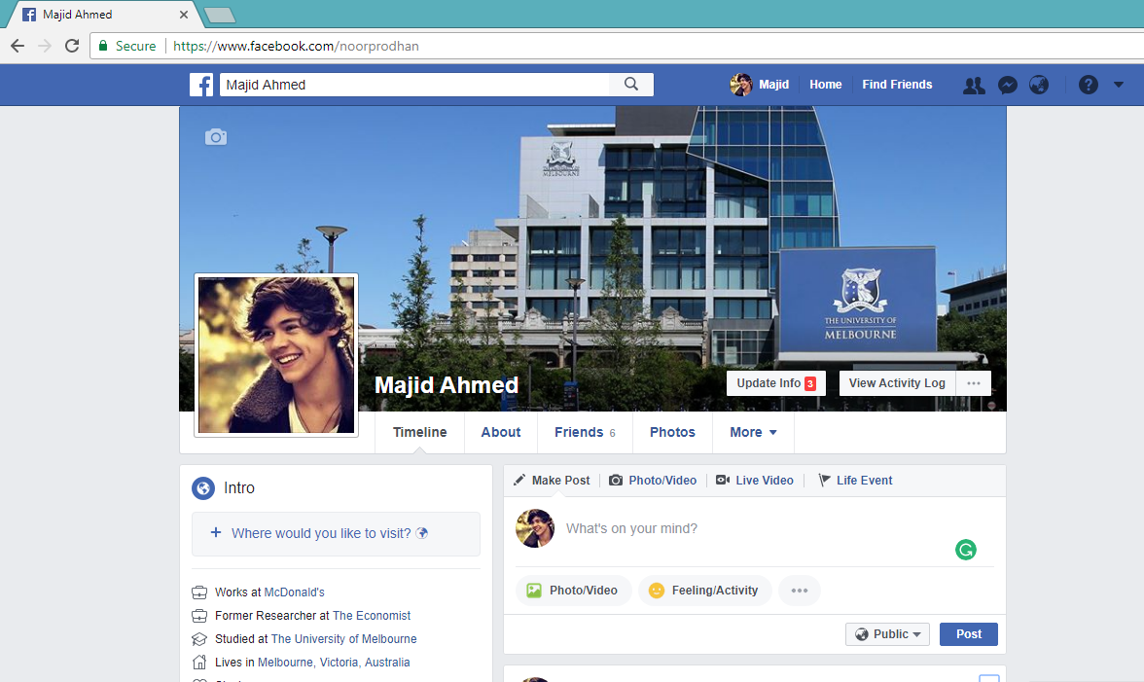
Screenshot of My Facebook account

Twitter account link:https://twitter.com/Majid1789
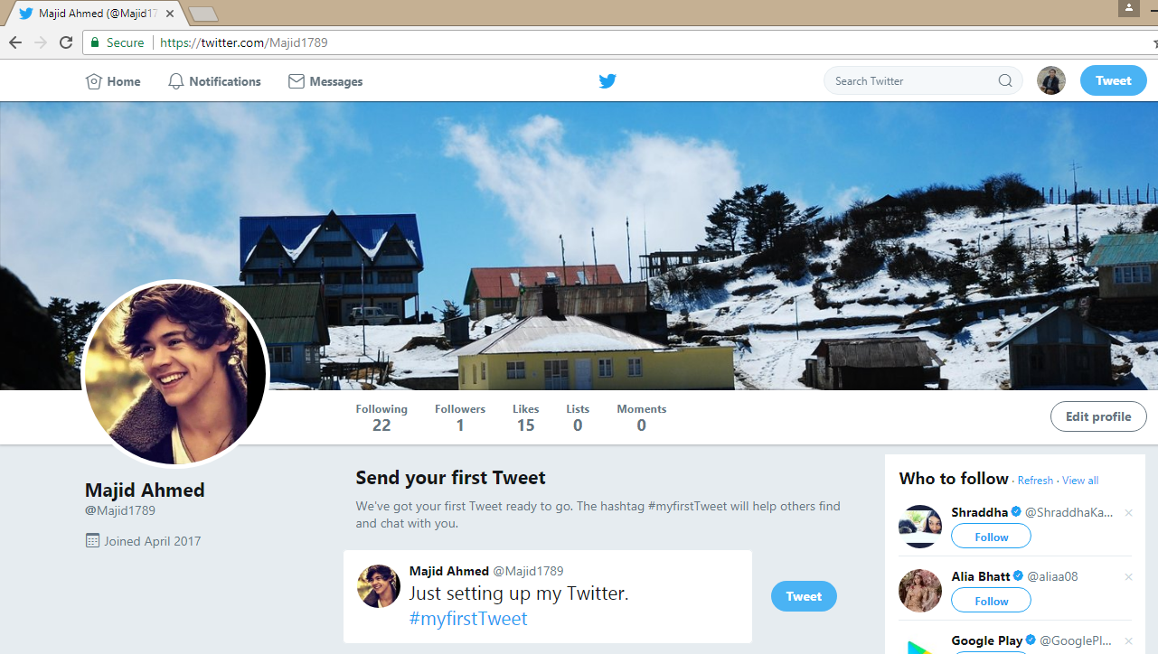
Screenshot of Twitter account
And things to be noted that these are the excerpt from social media account. There islarge number of social medium platform exists at this right moments. And this number is growing significantly. Important thing is to maintain these accounts professionally to achieve the goal and objectives.

Conclusion
How these several social media and technological forces change our job nature and work structure has been demonstrated rigorously in this report. On the other hand, we have come to that these media are avery useful platform to reduce the information collection cost and optimized efficiency can be achieved through the use of these social media. Here top managers and business personnel are suggested to handle these technical tools wisely and technically because most of the times they can kill time which leads to inefficiency for both individual and organization. The pertinent online manager should focus on customer satisfaction, employee engagement and profitability enhancement ultimately when they go for facilitating these social media into the workplace environment.

References
Bowen, G. (2016). Competitive social media marketing strategies. Hershey, PA: Business Science Reference.
Evers, F. (2011). The bases of competence. San Francisco, Calif.: Jossey-Bass.
Gravells, A. (2010). Delivering Employability Skills in the Lifelong Learning Sector. Exeter: Learning Matters Ltd.
Hess, K. (2014). Training adaptability in digital skills. Alexandria, Va.: U.S. Army Research Institute for the Behavioral and Social Sciences, Advanced Training Methods Research Unit.
Information marketing business. (2012). New York: Entrepreneur Press.
Park, J. (2013). New directions in information organization. Bingley, U.K.: Emerald.
Rocha, A. (2013). Advances in information systems and technologies. Berlin: Springer.
Salpeter, M. and Morgan, H. (2014). Social networking for business success. New York: LearningExpress, LLC.
Schaab, B. (2015). Digital skills training for net-centric operations. Alexandria, VA: U.S. Army Research Institute for the Behavioral and Social Sciences.
Sibson, R. (2012). Maximizing employee productivity. New York: American Management Association.
Simakova, E. (2013). Marketing technologies. London: Routledge.
Wahlgren, P. (2017). Information & communication technology. Stockholm: Stockholm Institute for Scandinavian Law.

