GROUP PRESENTATION ON TEAM WORKING
SPEAKER NOTES

Student name: MARIANA-ADELA SUGAR
Student id:2244011

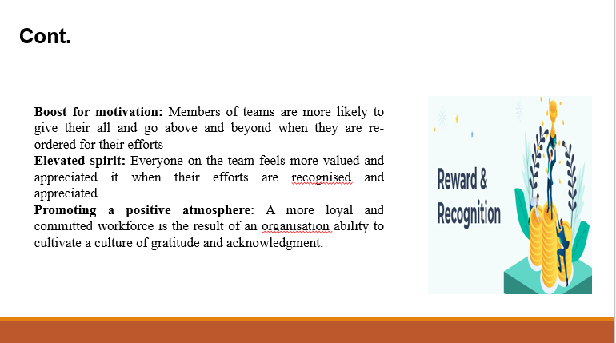
Boost for motivation: Members of teams are more likely to give their all and go above and beyond when they are re-ordered for their efforts
Elevated spirit: Everyone on the team feels more valued and appreciated it when their efforts are recognized and appreciated. This promotes morale which in turn increases engagement and work satisfaction
Promoting a positive atmosphere: A more loyal and committed workforce is the result of an organization ability to cultivate a culture of gratitude and acknowledgment.
Loyalty and retention: By decreasing turnover rates and protecting knowledge of the organization recognition programs help keep employees by fostering a feeling of connection and devotion to the company.

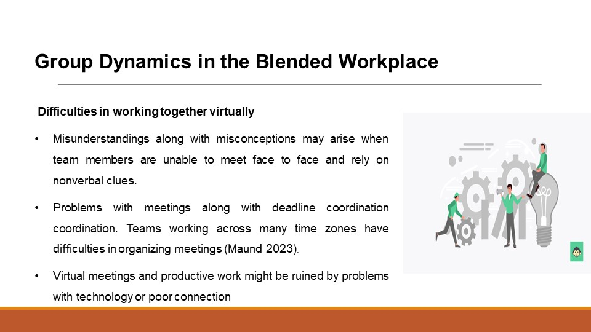
There are new possibilities and obstacles to consider while managing group dynamics in a hybrid workplace.
Difficulties in working together virtually
Misunderstandings along with misconceptions may arise when team members are unable to meet face to face and rely on nonverbal clues. Problems with meetings along with deadline coordination. Teams working across many time zones have difficulties in organising meetings along with deadlines which may affect corporation and productivity. Virtual meetings and productive work might be ruined by problems with technology or poor connection.

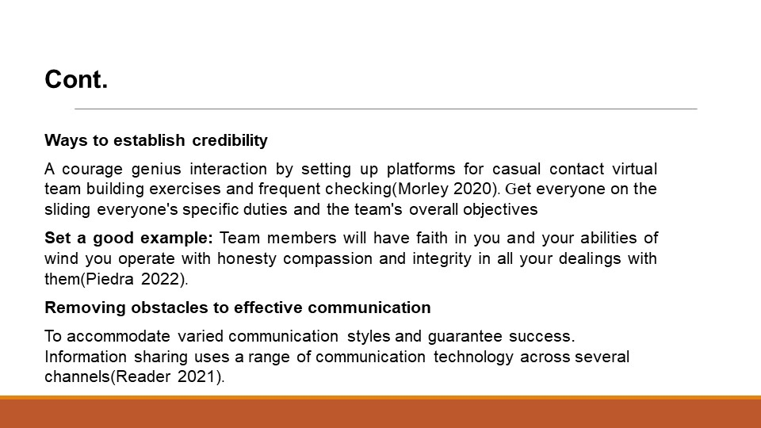
Ways to establish credibility
A courage genius interaction by setting up platforms for casual contact virtual team building exercises and frequent checking. This will help to improve connections and establish trust. Get everyone on the sliding everyone's specific duties and the team's overall objectives
Set a good example: Team members will have faith in you and your abilities of wind you operate with honesty compassion and integrity in all your dealings with them.
Removing obstacles to effective communication
To accommodate varied communication styles and guarantee successful Information sharing use a range of communication technology across several channels. Provide technical help for any issues linked to technology along with training sessions on the latest techniques for virtual communication.

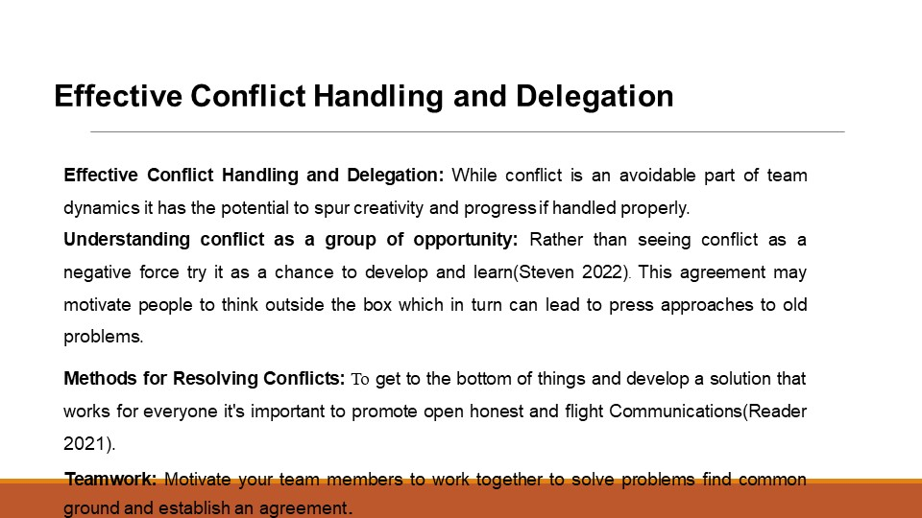
While conflict is an avoidable part of team dynamics it has the potential to spur creativity and progress if handled properly.
Understanding conflict as a group of opportunity
Perspective change: rather than seeing conflict as a negative force try it as a chance to develop and learn Innovation stimulus. This agreement may motivate people to think outside the box which in turn can lead to press approaches to old problems.
Methods for Resolving Conflicts
To get to the bottom of things and develop solutions that work for everyone it's important to promote open honest and flight Communications. One way to help people understand and empathize with one another is to listen carefully to each side of the argument
Teamwork: Motivate your team members to work together to solve problems find common ground and establish an agreement.
Importance of Delegation
Distributing duties and power among teammates enables them to own up to their work and make their own choices. This is known as delegation. By distributing tasks to team members, managers may help them hone their craft and gain experience in new areas.

REFERENCES:
Berkley, S 2021, How to Improve Productivity and Success: The Ultimate Tips,
Planning, &amp; Habits Guide, 76th ed, Abbott Properties LLC.
Piedra, D 2022, Innovations in the design and application of alternative digital
credentials, 7th ed, Information Science Reference, an imprint of IGI Global, Hershey,
PA.
Steven, C 2022, Integrating key skills in higher education: employability, transferable
skills, and learning for life, 87th edn, Kogan Page; Sterling, Va, London.
Reader, S 2021, Integrating Key Skills in Higher Education, 87th ed, Routledge.
Maund, A 2023, Certificate in higher education: skills for the workplace student
yearbook, 87th ed, Sage Publications, London

