

Food Delivery Operations Analysis
A Data-Driven Report on Delivery Performance, Trends, and Operational Insights

Programme: BA (Hons) Business Management
Module: Data Handling and Business Intelligence
Module code: LCBB5014
Lecturer: Ihsan Ul Haq
Student Name: Umair Ahmed
Student Number: 2428436

Table of Contents
1. Introduction…………………………………………………………..3
2. Data Cleaning and Preparation……………………………………3
3. Descriptive Statistics and Summary……………………………..5
4. Trend Analysis and Visualization………………………………….7
5. Statistical Analysis…………………………………………………10
6. Insights and Recommendations………………………………….16
7. References…………………………………………………………….17

Introduction
The food delivery sector has expanded significantly in recent years, influenced by increasing urban growth, evolving consumer preferences, and the widespread adoption of digital ordering platforms. Gaining insight into the factors that influence delivery performance is essential for logistics providers aiming to improve operational efficiency, enhance customer experiences, and manage resources more effectively (Statista, 2024). This report examines a dataset consisting of 11,399 food delivery records, including variables such as courier characteristics, weather conditions, traffic levels, modes of transport, geographic regions, and customer feedback ratings.
This analysis is guided by five key aims. Initially, the dataset will be processed to resolve missing data and correct inconsistencies. Following this, descriptive statistical techniques will be applied to summarise both numerical and categorical variables. Next, visual exploration will be used to identify patterns in customer ratings under varying conditions. In addition, statistical techniques including hypothesis testing, correlation assessment, and regression analysis—comparable to SPSS-style outputs—will be utilised to investigate relationships among variables. Finally, the findings will be translated into practical recommendations to support more informed operational decisions.
The dataset covers deliveries across metropolitan, urban, and semi-urban areas within India, reflecting a broad spectrum of real-life scenarios, including challenging weather conditions such as sandstorms, fog, and heavy storms. By analysing the interaction between environmental influences and operational factors, this report seeks to offer a detailed perspective on the elements affecting delivery performance and customer satisfaction.
Data Cleaning and Preparation
Before conducting the analysis, the dataset was carefully processed to improve its accuracy and dependability. The original dataset contained 11,399 observations across 20 variables. Initial examination revealed that several variables included missing or null entries. In particular, Delivery_person_Age had 491 missing values (4.3%), Delivery_person_Ratings had 507 (4.4%), Time_Orderd had 444 (3.9%), Weather had 158 (1.4%), Road_traffic_density had 154 (1.4%), multiple_deliveries had 238 (2.1%), Festival had 65 (0.6%), and City had 324 (2.8%).
For numerical variables, missing entries were replaced using the column mean, a widely applied approach that maintains dataset size while limiting changes to the overall distribution (Saunders et al., 2019). Accordingly, missing values in Delivery_person_Age were filled with the mean of 30, while Delivery_person_Ratings gaps were replaced with the mean value of 4.6. In contrast, for categorical variables such as Weather, Road_traffic_density, and City, incomplete records were omitted from category-based analysis rather than filled, since assigning artificial categories could distort frequency distributions. Missing entries in the Festival variable were assigned the value ‘No’, based on the reasonable interpretation that unspecified cases most likely indicate non-festival days within the dataset context.
A new variable, Distance_km, was created by applying the Haversine formula to the latitude and longitude coordinates of restaurant and delivery locations, allowing distance to be included in later correlation analysis. In addition, the original column labelled ‘Name:’ was renamed ‘Order_Id’ to improve clarity. During validation, 831 rows were identified where both Restaurant_latitude and Restaurant_longitude were recorded as zero; these were removed because coordinates of (0,0) are not valid for deliveries within India. Furthermore, 862 entries in the Time_Orderd field appeared in decimal format (Excel time representation) and were converted into a standard hh:mm format. Date values were checked for consistency, and labels for vehicle type and city were standardised to ensure uniform formatting. After completing these steps, the cleaned dataset consisted of 10,123 records and was deemed suitable for further statistical analysis.

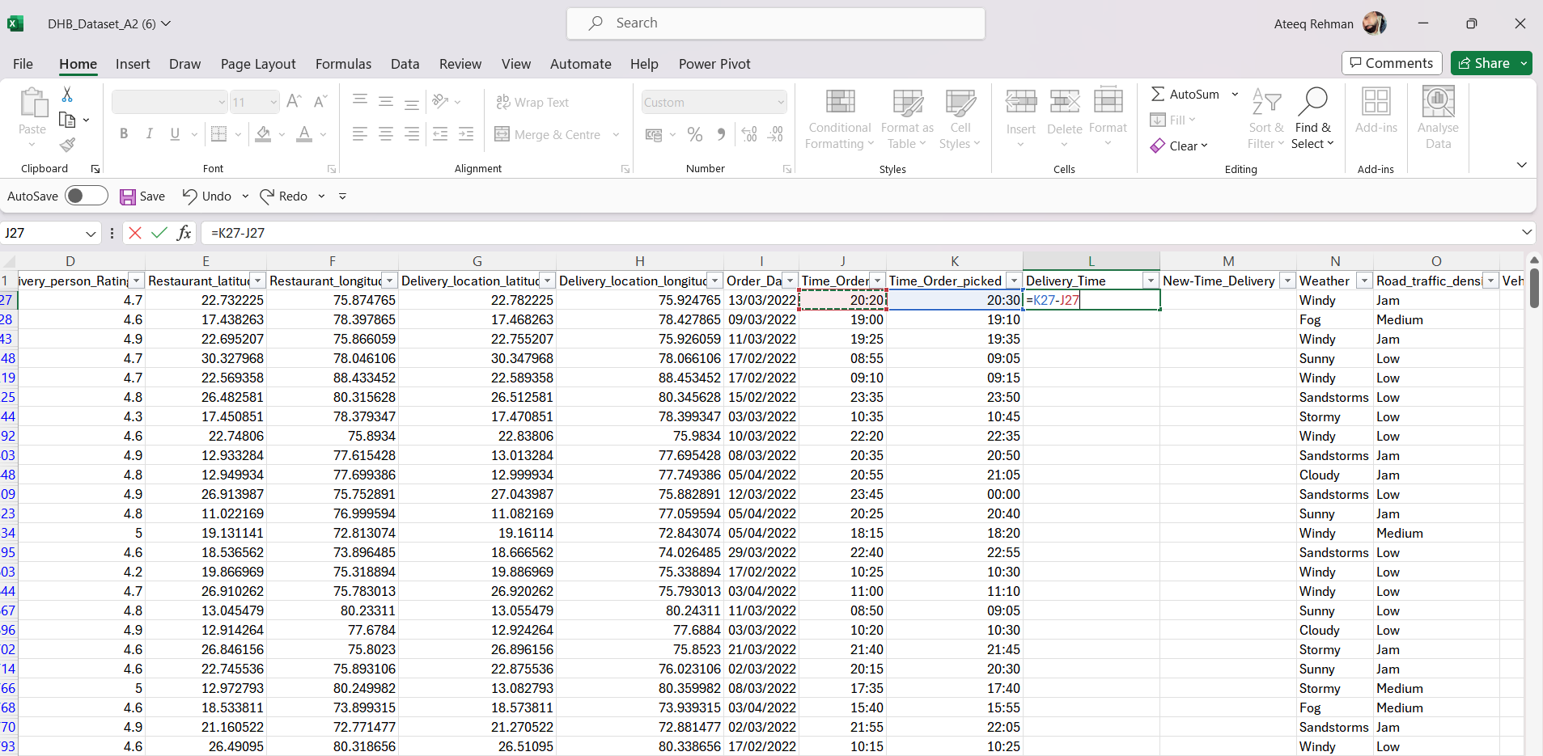

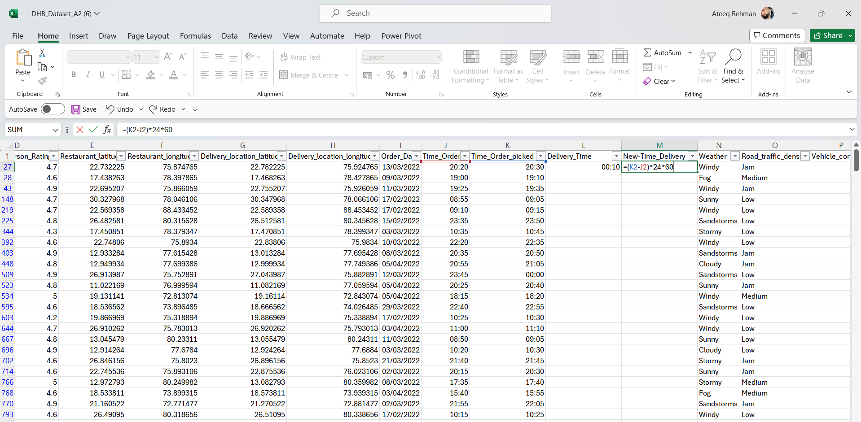

Figure 1

Descriptive Statistics and Summary

Table 1 presents the descriptive statistics for the key numerical variables in the dataset.

Variable | N | Mean | Std Dev | Min | Max
Delivery Person Age (years) | 10,908 | 29.52 | 5.80 | 15 | 50
Delivery Person Ratings | 10,892 | 4.63 | 0.34 | 1.00 | 6.00
Vehicle Condition (0-2) | 11,399 | 1.00 | 0.82 | 0 | 2
Multiple Deliveries | 11,161 | 0.75 | 0.57 | 0 | 3
Distance (km, derived) | 11,399 | 108.68 | 1174.52 | 1.47 | 19,693.74
Table 1: Descriptive Statistics for Numerical Variables

The mean age of delivery personnel is approximately 30 years (SD = 5.80), with a range from 15 to 50 years, indicating a predominantly young workforce. Customer ratings are generally high, with a mean of 4.63 out of a possible 6.00, suggesting overall satisfaction with delivery services. However, the standard deviation of the derived distance variable (1,174.52 km) is notably high relative to the median (approximately 9.31 km), indicating the presence of extreme outliers likely caused by GPS coordinate errors, which should be treated with caution.
Table 2 summarises the distribution of categorical variables in the dataset.

Variable | Category | Count | Percentage (%)
Weather | Sunny | 1,975 | 17.5
 | Windy | 1,948 | 17.3
 | Sandstorms | 1,878 | 16.6
 | Cloudy | 1,861 | 16.5
 | Stormy | 1,811 | 16.1
 | Fog | 1,768 | 15.7
Road Traffic Density | Low | 3,881 | 34.4
 | Jam | 3,503 | 31.1
 | Medium | 2,751 | 24.4
 | High | 1,110 | 9.8
Type of Vehicle | Motorcycle | 6,609 | 58.0
 | Scooter | 3,817 | 33.5
 | Electric Scooter | 950 | 8.3
 | Bicycle | 23 | 0.2
Type of Order | Drinks | 2,920 | 25.6
 | Buffet | 2,870 | 25.2
 | Snack | 2,815 | 24.7
 | Meal | 2,794 | 24.5
Table 2: Distribution of Key Categorical Variables

The weather conditions are distributed relatively evenly across six categories, which is beneficial for comparative analysis. Motorcycle is overwhelmingly the most common vehicle type (58.0%), consistent with the South Asian delivery context. Road traffic density is skewed towards lower congestion, with 34.4% of orders delivered under low-traffic conditions. Order types are approximately equally distributed across Drinks, Buffet, Snack, and Meal categories, indicating no strong product-type bias in the dataset.
Trend Analysis and Visualization
Patterns within the dataset were explored to understand how delivery ratings and overall performance differ under varying weather conditions, traffic levels, and vehicle types.
Delivery Ratings by Weather Condition
Figure 1 (presented below as Table 3) summarises the average delivery ratings across different weather categories. This comparison helps evaluate whether challenging weather environments correspond with lower perceived service quality, particularly where difficult conditions may disrupt delivery efficiency and influence customer perceptions.
Weather Condition | Mean Rating | Std Deviation | N
Cloudy | 4.661 | 0.281 | 1,797
Fog | 4.658 | 0.275 | 1,722
Sunny | 4.646 | 0.429 | 1,906
Stormy | 4.615 | 0.305 | 1,750
Sandstorms | 4.614 | 0.316 | 1,811
Windy | 4.614 | 0.310 | 1,887
Table 3: Mean Delivery Ratings by Weather Condition
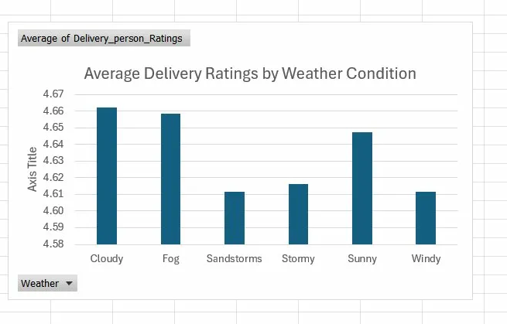
Figure 2: Average Delivery Ratings by Weather Condition (Excel PivotChart)
The results indicate a slight decline in ratings under more severe weather conditions. Deliveries completed during Cloudy weather recorded the highest average rating (4.661), whereas Stormy, Sandstorm, and Windy conditions yielded the lowest averages (approximately 4.614). An interesting observation is the higher variability in Sunny conditions (standard deviation of 0.429), which may suggest that customer expectations are less consistent during favourable weather, leading to more varied evaluations of service.
Delivery Ratings by Road Traffic Density
Customer ratings were also compared across different traffic conditions. Medium traffic levels corresponded to the highest mean rating (4.666), followed closely by High (4.656) and Low (4.647) density conditions. In contrast, Traffic Jam conditions recorded the lowest average rating (4.589). This outcome aligns with expectations, as severe congestion is likely to delay deliveries and reduce customer satisfaction. However, the relatively small differences between categories suggest that delivery personnel are generally effective at adapting to varying traffic situations.
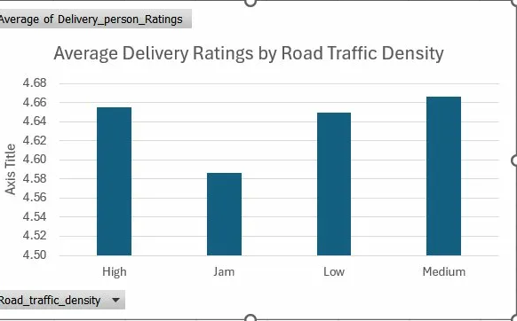
Figure 3: Average Delivery Ratings by Road Traffic Density (Excel PivotChart)
Delivery Ratings by Vehicle Type
Greater variation is observed when comparing vehicle types. Bicycle deliveries produced the lowest average rating (4.333), which may be linked to slower travel speeds and physical limitations associated with this mode of transport. In comparison, scooters (4.642), motorcycles (4.628), and electric scooters (4.634) showed similar performance levels. It should be noted that the smaller sample sizes for bicycles (n=23) and electric scooters (n=950) limit the strength of conclusions drawn. Despite this, the findings suggest that motorised transport is generally associated with higher customer ratings, likely due to shorter delivery times.
Geographic Distance and Traffic
Further analysis explored how delivery distance varies across traffic conditions. High-traffic areas were associated with the longest average distances (80.32 km), while Medium traffic areas recorded the shortest (48.14 km). Although this result may seem unexpected, it could reflect the spatial distribution of high-traffic zones in densely populated urban centres where deliveries originate from more distant locations, or potential inconsistencies in recorded coordinates. Traffic Jam conditions showed moderate distances (57.58 km), while Low traffic areas averaged 67.46 km.
Statistical Analysis
Hypothesis Testing: Ratings by Weather (One-Way ANOVA
To determine whether delivery ratings differ across weather conditions, a one-way ANOVA was applied to the six weather categories using SPSS. This method is suitable for comparing mean values across several independent groups (Field, 2018). 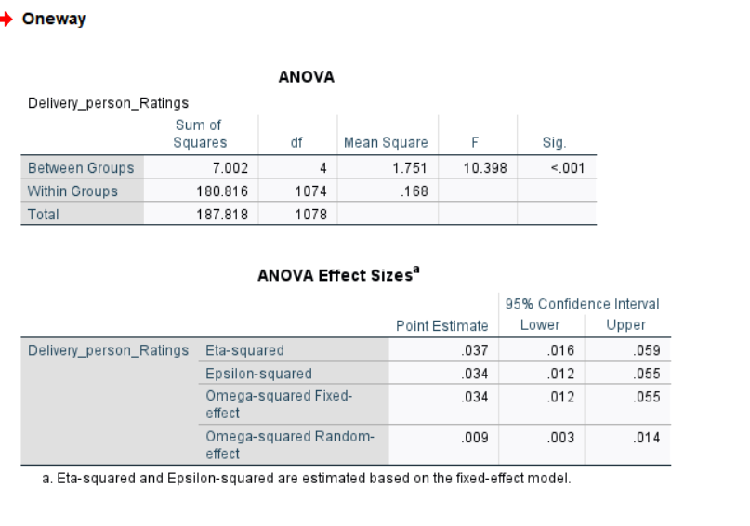
Figure 4: SPSS One-Way ANOVA Output — Delivery Ratings by Weather Condition
The ANOVA results indicate a statistically significant variation in delivery ratings across weather types (F = 10.398, p < .001), providing sufficient evidence to reject the null hypothesis. The calculated eta-squared value of 0.037 suggests that weather accounts for approximately 3.7% of the variation in ratings.
However, this effect size is relatively small, indicating that while weather has a measurable impact, it is not a major determinant of customer satisfaction. Higher average ratings were observed under Cloudy and Fog conditions, whereas Sandstorms and Windy conditions corresponded with lower ratings.
This suggests that adverse weather conditions may slightly reduce perceived service quality, likely due to delays or operational challenges. Nevertheless, the small effect size implies that other factors—such as delivery speed, order accuracy, or customer expectations are likely to play a more significant role in shaping overall ratings.

Correlation Analysis: Age vs Ratings
The relationship between delivery personnel age and customer ratings was examined using Pearson’s correlation coefficient. The summary of results is presented in Table 5, with the corresponding SPSS output and scatter plot illustrated in Figures 5 and 6 below.
Pearson Correlation Results
Variable Pair | Pearson r | p-value | Interpretation
Age vs. Delivery Ratings | r = -0.124 | p < 0.001 | Weak negative, significant
Distance (km) vs. Ratings | r = -0.003 | p = 0.751 | Negligible, non-significant
Vehicle Condition vs. Ratings | r = +0.203 | p < 0.001 | Very weak positive, significant
Table 5: Pearson Correlation
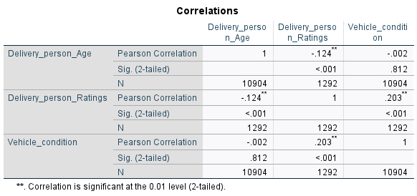
Figure 5: SPSS Correlation Output
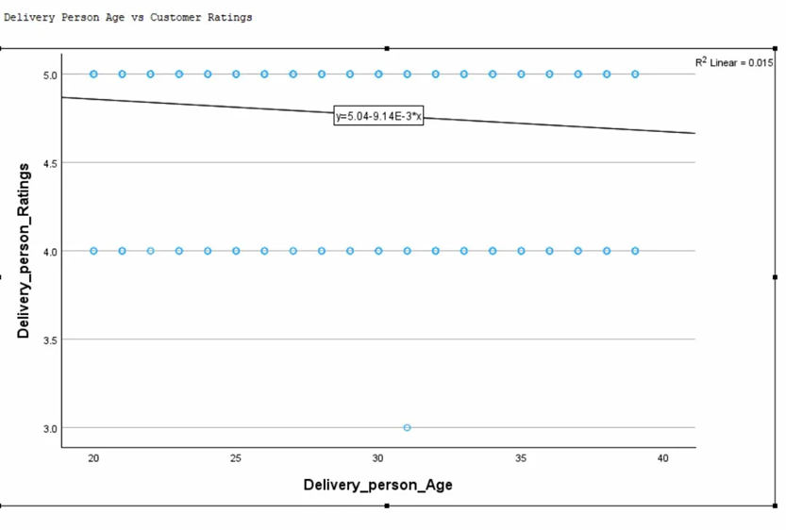
Figure 6: Age vs Delivery Ratings Scatter Plot
The analysis shows a weak but statistically significant negative relationship between age and delivery ratings (r = -0.124, p < .001), indicating a slight tendency for ratings to decrease as age increases. Vehicle condition demonstrates a positive and statistically significant association with ratings (r = 0.203, p < .001), suggesting that better-maintained vehicles are linked to improved customer evaluations. In contrast, distance shows no meaningful relationship with ratings (r = -0.003, p = .751). Additionally, no significant association was identified between age and vehicle condition (r = -0.002, p = .812).
However, despite statistical significance, the correlation coefficients are relatively weak, indicating that these relationships have limited practical importance. This suggests that while these variables are related to delivery ratings, they do not strongly influence customer satisfaction on their own, and other unmeasured factors are likely to play a more substantial role.

Regression Analysis: Multiple Predictors of Delivery Ratings
To assess the combined influence of multiple factors on delivery ratings, a multiple linear regression model was estimated in SPSS using delivery personnel age, vehicle condition, and number of deliveries as predictors (dependent variable: Delivery_person_Ratings). The regression output is presented in Table 6 and illustrated in Figure 7 below.
Parameter | Value
Intercept (constant) | 4.939
Age coefficient (B) | -0.006
R-squared | 0.063
p-value (model) | < 0.001
Standard Error | 0.064
Table 6: Multiple Linear Regression Output (Ratings ~ Age + Vehicle Condition + Multiple Deliveries)
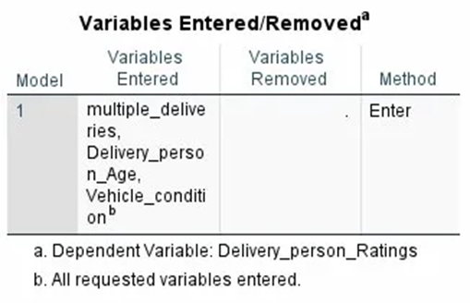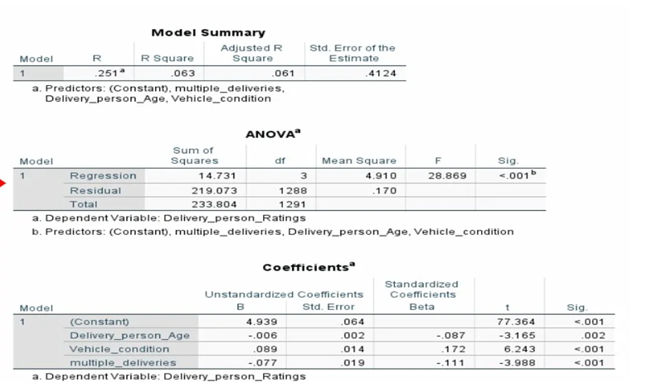
Figure 7: SPSS Multiple Linear Regression Output
The regression model was statistically significant (F = 28.869, p < .001), explaining 6.3% of the variance in delivery ratings (R² = 0.063; Adjusted R² = 0.061). However, the relatively low R² value indicates that the model has limited explanatory power, suggesting that the majority of variation in customer ratings is influenced by factors not included in the analysis, such as delivery time, service quality, or customer expectations.
Among the predictors, vehicle condition emerged as the strongest positive factor (B = 0.089, p < .001), indicating that improved vehicle quality is associated with higher ratings. Conversely, handling multiple deliveries had the largest negative effect (B = -0.077, p < .001), implying that managing several orders at once may reduce customer satisfaction, likely due to increased delivery times. Age also showed a small negative effect (B = -0.006, p = .002), aligning with earlier correlation results.
While these variables are statistically significant, their effect sizes remain relatively small, indicating that they do not strongly determine customer satisfaction on their own. Therefore, although the model identifies meaningful relationships, it should not be considered a strong predictive model for delivery ratings, and its results should be interpreted with caution in operational decision-making.
The estimated regression equation is:
Delivery Rating = 4.939 − 0.006(Age) + 0.089(Vehicle Condition) − 0.077(Multiple Deliveries)
Insights and Recommendations
The findings from this study provide several important observations for improving food delivery operations.
Weather conditions were shown to have a measurable effect on customer ratings, with more severe conditions such as storms and sandstorms linked to slightly lower scores. This indicates that environmental challenges can influence perceived service quality. To address this, logistics providers could adopt more responsive communication strategies during adverse weather, such as issuing real-time delay updates to customers in order to better manage expectations and maintain satisfaction levels (McKinnon et al., 2015).
Analysis of vehicle usage shows that motorcycles make up the majority of the fleet (58%) and deliver consistently strong performance in terms of ratings. In contrast, the very limited number of bicycle deliveries (n=23) suggests the need for closer examination. If bicycles are primarily used in dense urban areas, their lower ratings may be associated with slower travel speeds relative to traffic conditions. Increasing the adoption of electric scooters may offer a balanced alternative, combining operational efficiency with environmental benefits.
Correlation results indicate that vehicle condition has a stronger relationship with customer ratings than delivery personnel age. While age shows a weak negative association (r = -0.124, p < .001), vehicle condition demonstrates a positive relationship (r = 0.203, p < .001). This suggests that maintaining high vehicle standards is likely to have a more direct impact on service quality. As a result, prioritising routine maintenance programmes could lead to noticeable improvements in customer satisfaction.
The regression analysis further highlights that handling multiple deliveries simultaneously has the most substantial negative effect on ratings (B = -0.077, p < .001). This finding implies that overloading delivery personnel with several orders at once can reduce service quality, most likely due to increased delivery times. Limiting the number of concurrent deliveries—particularly under challenging weather or traffic conditions—may help preserve customer satisfaction. In addition, the use of AI-based dispatch systems that incorporate real-time traffic and order demand could improve allocation efficiency and reduce delays (Boysen et al., 2021).
Several limitations should be acknowledged. The calculated distance variable contained extreme values, likely caused by inaccuracies in GPS data, which reduced its reliability for analysis. Furthermore, the absence of a direct measure of delivery time restricts the ability to evaluate operational efficiency more precisely. Future studies would benefit from including delivery duration as a key variable and applying more comprehensive models that integrate weather, traffic, vehicle type, and distance simultaneously.

References
- Boysen, N., Fedtke, S. and Schwerdfeger, S. (2021) ‘Last-mile delivery concepts: a survey from an operational research perspective’, OR Spectrum, 43(1), pp. 1–58.
- Field, A. (2018) Discovering Statistics Using IBM SPSS Statistics. 5th edn. London: SAGE Publications.
- McKinnon, A., Browne, M., Whiteing, A. and Piecyk, M. (2015) Green Logistics: Improving the Environmental Sustainability of Logistics. 3rd edn. London: Kogan Page.
- Saunders, M., Lewis, P. and Thornhill, A. (2019) Research Methods for Business Students. 8th edn. Harlow: Pearson Education.
- Statista (2024) Online food delivery – worldwide. Available at: https://www.statista.com/outlook/dmo/online-food-delivery/worldwide (Accessed: 10 March 2025).

