Foreign Languages & Cultural Awareness (BMIH5003)
Student Name: Dobir Miah
Student ID: 2019720
Student email: 2019720@students.uwtsd.ac.uk
Lecturer Name: Rodrigo Aguilera

Señal de precaución – Caution sign
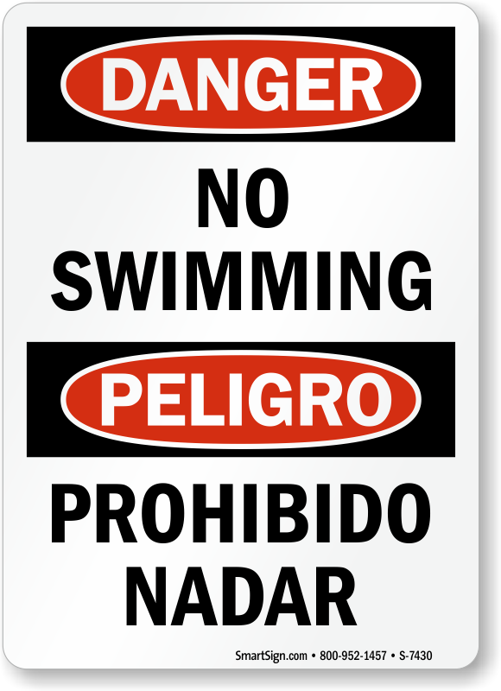


PELIGRO
Prohibido Nadar

No Swimming
DANGER

