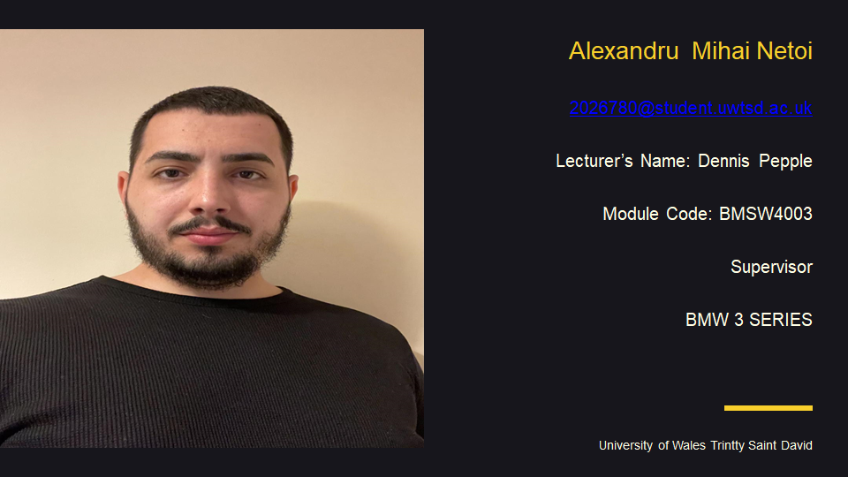
Hi! First thing I would like to say is thank You because You gave me the opportunity to introduce myself .
- My name is Alexandru Mihai Netoi, I’m from Romania and I’m 28 years old.
- I live in Wellingboroug Northamptonshire and I’ve been here in Uk for 4 years now .
- I went to high school and I studied till 12 class diploma. I study at University OF Wales Trinity Saint David. My favorite module is Digital Skills and Research Methods . Now I work in Uk for a logistics company and my current role there is Team LEADER .
I like playing computer games, surfing the internet. In my free time I also like to listen music . I like to travel and my favorite place is Italy . I like this country because Italy’s history goes back thousands of years and the legacy of that long and often tempestuous history can be found throughout the country. I’m a big fan of history and art so it’s not difficult to imagine why Italy always fascinated me.

In the introduction my report is about to evaluate Angela Duckwort researches meet the CRAAP test and I will going to show how to conduct researches in DIKW and then I will talk about Angela’s reseaches order.In her research she will give a definition of self-control is like to have the ability to do something that benefits your long-term goals. Basically, self-control is the ability to do something that benefits your long-term goals and not just what might make you feel good at the moment. However, for many of us, short-term gratifications are irresistible - we sacrifice our future selves if we don't exercise self-control. Why is self-control so difficult for some, and how can you find your own restraint? Duckworth advises, finally, that you should lay a foundation of self-control that you can build on in the future. It's happened to all of us at some point--not enough sleep the night before, or a poor breakfast--that created unproductive workdays. Living a healthy lifestyle away from the workplace can give you the strength and stamina you need to control your worst impulses when it counts.I will add for you the link with my video where I talk about Angela’s Duckworth video.
Link of the video .. https://web.microsoftstream.com/video/5827cdea-ad6e-4ca8-9331-539b94388391

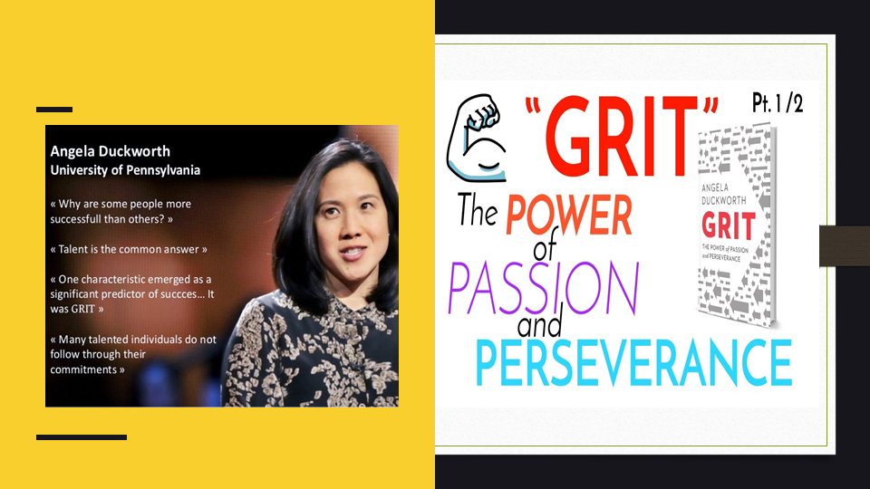

As a high school and middle school teacher, Angela Duckworth taught math before becoming a psychology professor. A seemingly obvious point took her a long time to think about: Students who worked hard did the best, and those who didn't work hard did not do as well. During Duckworth's interview, he asked a question: How is effort related to success? Her research focuses on a personality trait called "grit," which she calls a personal trait. Grit is defined as the ability to persevere over the long-term until you master the subject. The gritty individual approaches success like a marathon; the advantage they possess is stamina.


200 words – explain your data collection


200 words-the students are on lvl 2 from the class

300 words- how the information we got in class compare with the schoole
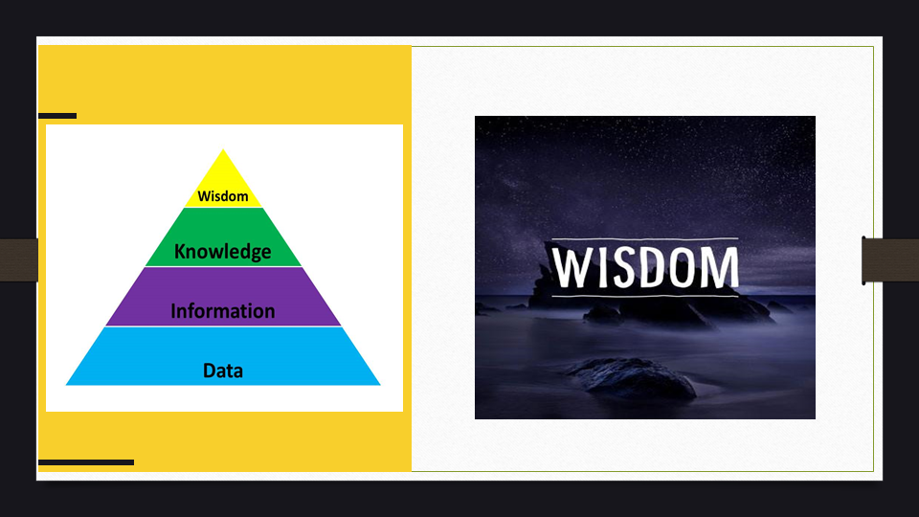
According to the information provided by the primary research study conducted by Angela Duckworth, there is no direct relationship between self-control and grit score, but it is concluded that people who have high grit tend to have a low level of self-control. In the wisdom-creation process, it is important to integrate and interpret information that might assist with good decision-making. Angela Duckworth's information and the entire primary study were created by integrating the grit and the self-awareness process..

Also, a more successful strategy can be a result of research that is innovative, consistent, and resilient. Finally, a summary of academic brilliance and grit can lead to the conclusion that such ideas are not mutually exclusive. This study demonstrates that the DIKW can be viewed as a pyramid, each layer contributing quality and assisting in the support and analysis of skills and research. Having grit is having the courage and conscientiousness to achieve long-term goals. Additionally, it is important to mention that according to Angela Duckworth's research, having a bachelor degree is not a guarantee of someone's success; however, wisdom is necessary to become successful in achieving the knowledge acquired.


