Samina Ibrahim 2021656

Samina Ibrahim 2021656

Assessment 2 market research & website
BMSW4003 Digital Skills & Research Methods

Website login details
Email address: 2021656si@gmail.com
Password: Cardiff1983

Introduction

This report is about the business idea is of opening a Dessert Parlor in the Cardiff area.
A questionnaire has been created for a business idea and data was collected relatively quickly.
The questionnaire was to collect both quantitative and qualitative customer reviews, getting into the customer's head and discovering what the intended audience truly thinks.
Things to consider were choosing to concentrate the business on indulgence, trying to outperform competition in the market in satisfying the need for celebration and extravagance. Certain studies are carried out to undertake to identify this need. During each stage of the dessert place process, there is a target market to keep in mind as well as beginning to develop a solid business plan that describes anticipated costs, menu, business model and staffing requirements.

It is very important to gain knowledge and understanding from the requested questionnaire to understand the targeted audience in order to create the website. The learning gained from the questionnaire is used to develop and attract its users.

Questionnaire design & analysis

Primary market research is the only way of getting direct feedback from clearly defined target groups.( https://blog.gclb2b.com/blog/info/5-reasons-why-primary-market-research-is-essential)
This research method is performed mainly discretely or from an unbiased perspective. This can also be transformed into highly useful content in the form of white papers, assisting you in developing new sales and service analysing strategies.
The data about intended customers and existing customers, you can use it to set attainable and performance targets for continuous efficiency and improved growth.
Market research data will assist in making more smart judgments. Pricing, distribution channels, marketing mediums, or identifying opportunities to introduce a new product or service are just a few examples. These findings will also assist in making more educated choices about current decisions and processes.

Evaluating the results of the following question, we can evidently see that the vast participants will buy a dessert 1-2 times a week.
While using this data, we can propose on how the majority often likes to buy a dessert. This has also made aware of the problem solving skills and time management to assure all orders go out at the same time. If customers enjoy going out for a dessert this needs to be taken into account.

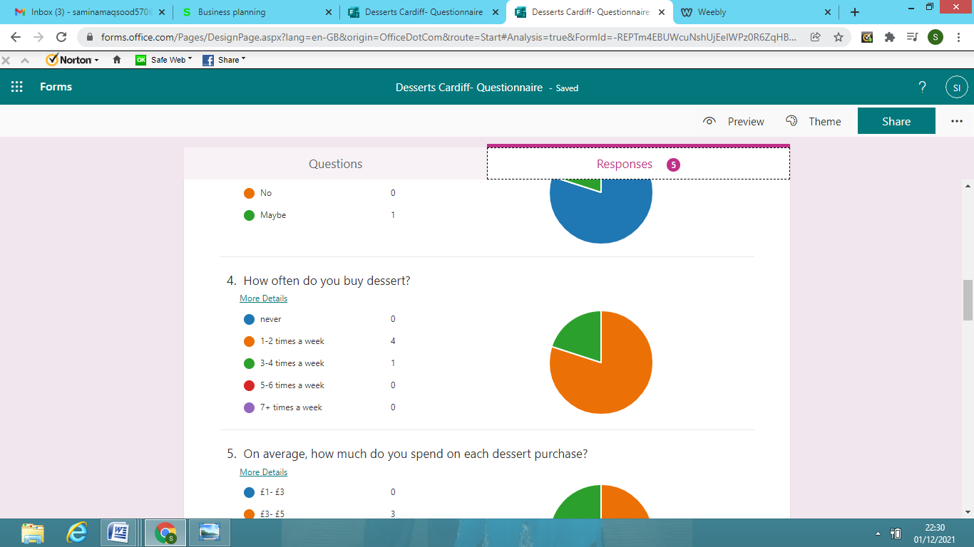

We can clearly also see that the majority of individuals will purchase a dessert between £5-7
Its greatest common source of conflict is the commonly held view that the only road to prosperity is via expansion. Many business owners believe that increasing sales is the panacea for all troubles. It almost never is. Expansion does not imply capitalist system success. In fact, reducing the variety of products or market segments is usually the most direct path to increased profit and return on asset. With this in mind, concentrating on serving only desserts made from ingredients grown right on the farm. This business idea may appear to be lost in the fast lanes of the Internet, but if you're constantly linking your Facebook fans and friends to what's new this season, you can really drum up some excitement. (Theresa Navarra Pg 20 2018)

Offering customers an incentive to keep coming back, having a weekly offer will help this, alongside social media interaction. The key is picking a high enough threshold for a freebie or a discount to make it worthwhile.

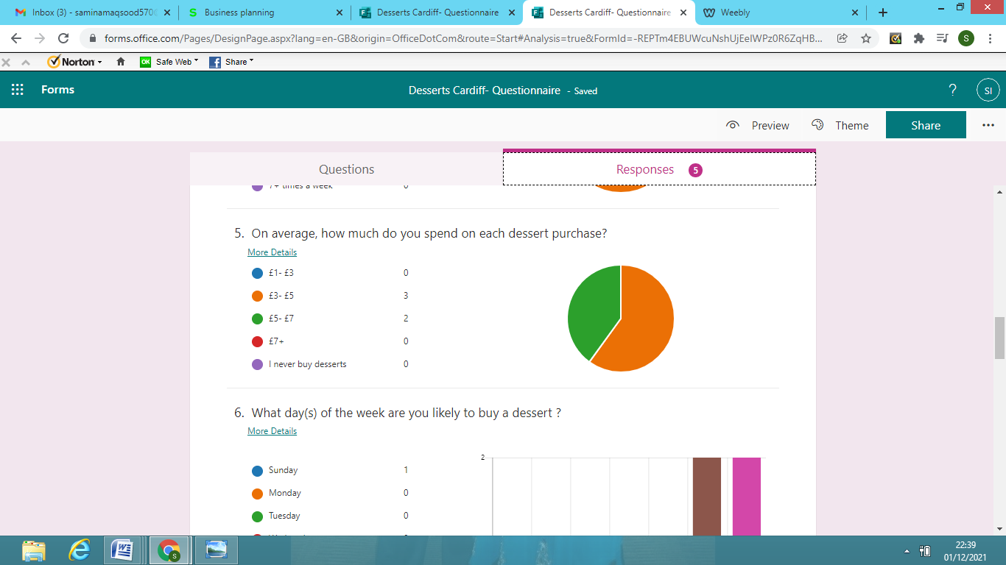

From the results below we can see as obvious it may be the weekend is the most common time people would be going out for desserts.
Their existence on the menu makes us feel full after eating and makes up for low blood sugar levels. The effort to better your mood by consuming sugar can also play a role. Sweet snacks induce the production of the so-called happiness hormone. Human behaviors play a significant role as well.

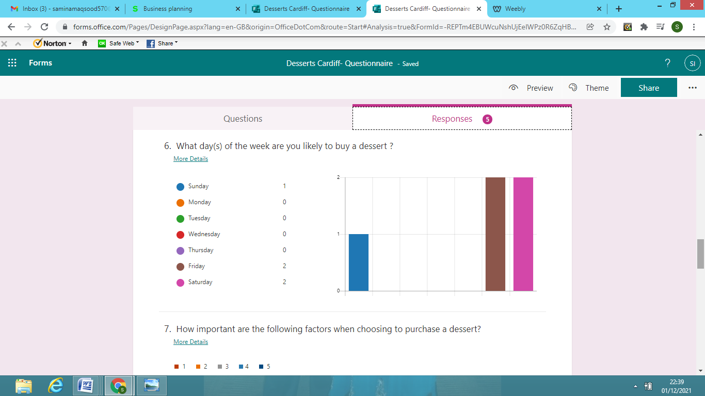

Website design

The website reflects the company, its products, services, and, inevitably, its brand. As a result, it is critical to be eye catching, slick, and knowledgeable. Allowing for white space, unadorned setups, and high-quality photographs and visuals to allow your statement sparkle.
All pages are considered quick and operational at all times, because it could be a prospective customer's first or foremost impression. The popularity of mobile and tablet devices is increasing, so you never know what your next visitor will be using. Maximizing for mobile will improve both visitors' experience and SEO rankings.
Also looking at Blogs and social media updates will be a great ways to add fresh content, which keeps people returning and helps SEO strategy.
Another quality for the website was to ensure the phone number, email address, physical address, business hours, was on contact page in the main navigation. If internet users want to call you, place an order, or request more information, its best that they are able to find up-to-date contact information. Also ensuring the website had a good use of headings, lists, and visuals, to catch the visitors eye.

Having social-sharing buttons is also essential, as social media marketing and advertising could indeed assist in increasing financial return because the cost of advertising on these social media forums is frequently less than the return, resulting in more profits. Digital marketing can help reach hundreds of thousands of people by merely determining, lowering advertising costs. Facebook and Instagram assist you in attracting potential buyers while also attempting to keep potential customers engaged on their respective social media networks so that you and they both advantage. This greater consumer time on social media networks rises the likelihood of users seeing your ad or profile, visiting your profile, and ultimately are customers.

Below are some of the screenshots taken from the website. Here it is clearly stated of how certain fonts are used and colour branding is simply using colours to help build an image for a company or influence how people perceive a company. (https://studywebdevelopment.com/understanding-color-web-design.html)
Colours can be used to bring awareness, convey intent, create excitement, boost customer, and even earn a company image. Good colours choices necessitate careful consideration and, when done correctly, can influence how the audience perceives what they see just as much as the design and content writing. The use of legible fonts is critical in presentations. The fonts enhance the readability of your text. It aids readers in comprehending meaning from the text. Color, font, and text size are all important factors in attracting your core demographic.
You can market your business online if you have a website and an online presence strategy. A website is also essential because it aids in the establishment of a company's credibility. A website not only positive quality, but it also contributes to the perception that your company is larger and more beneficial.

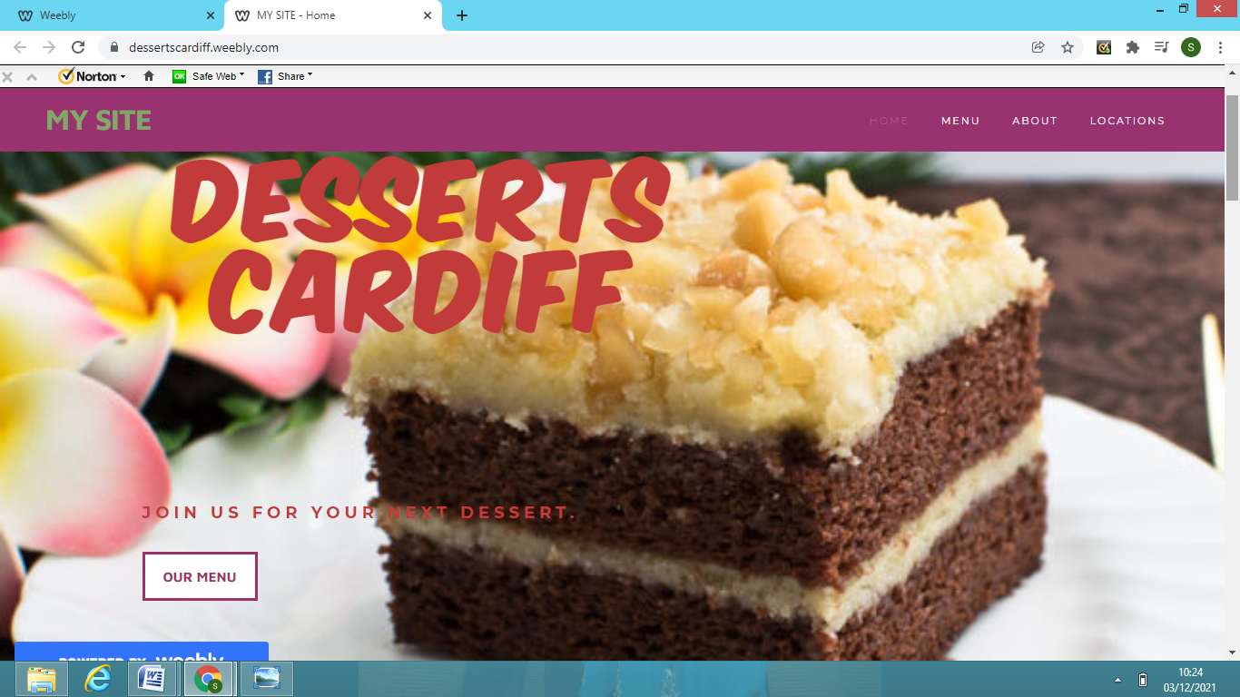

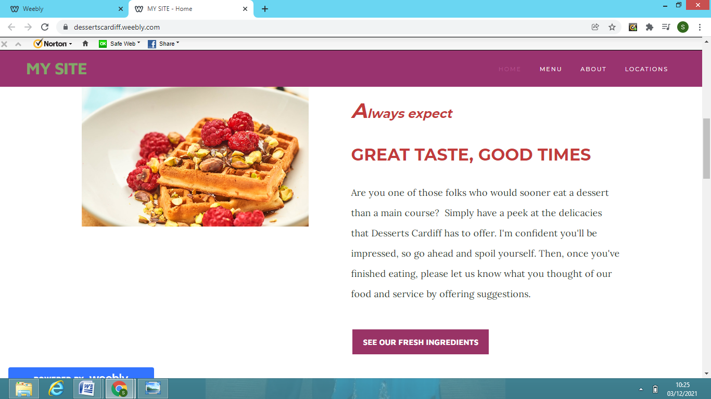

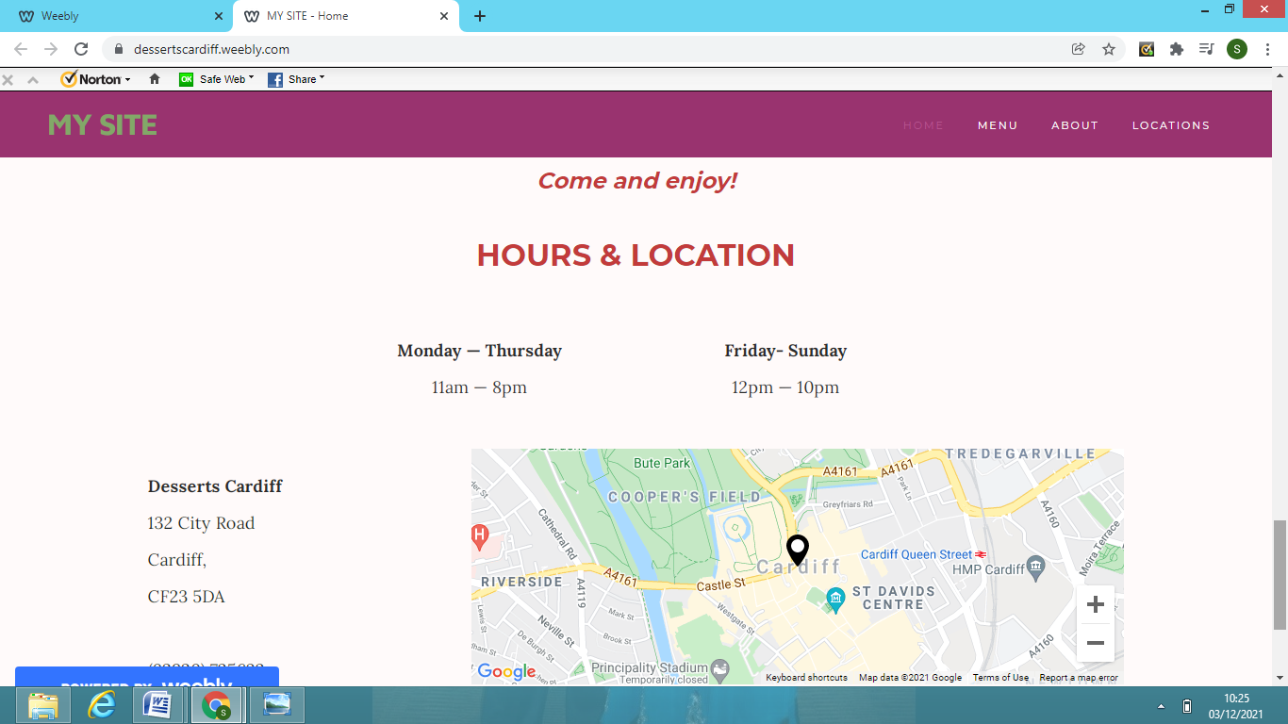

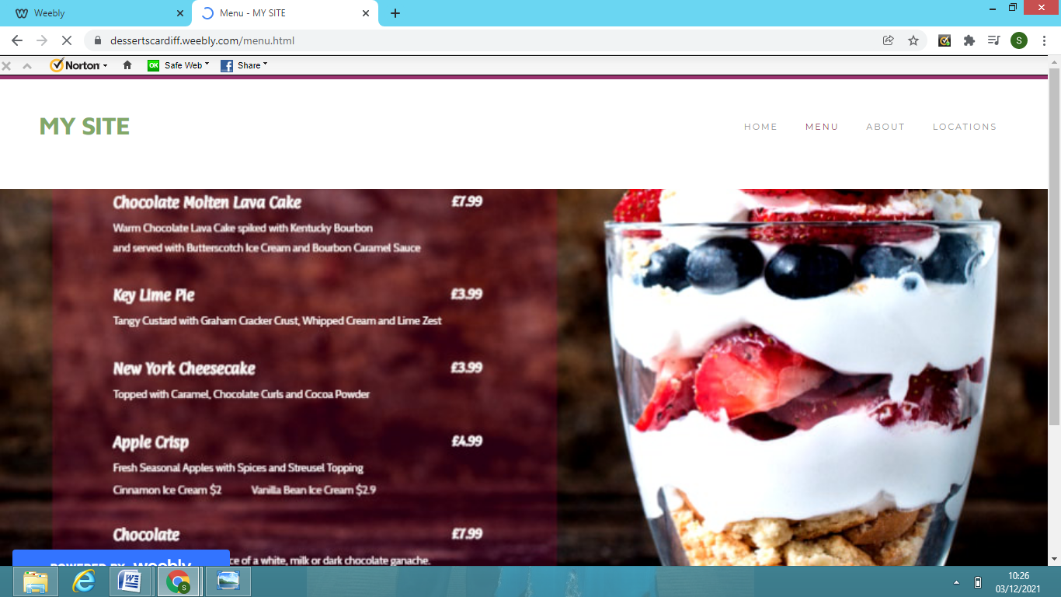

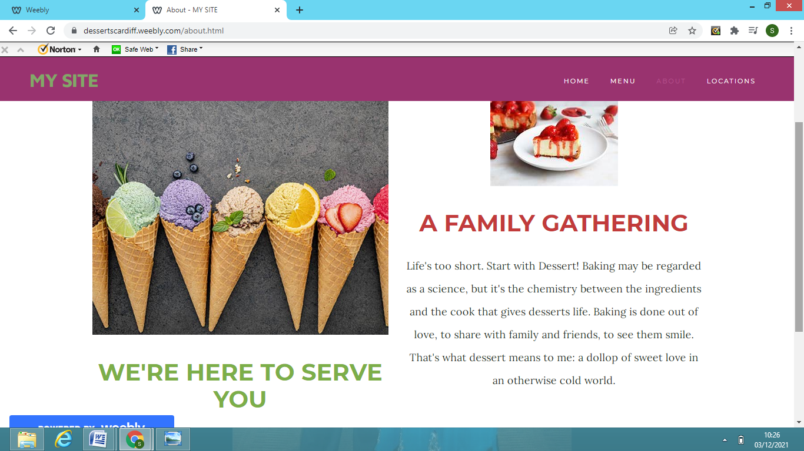

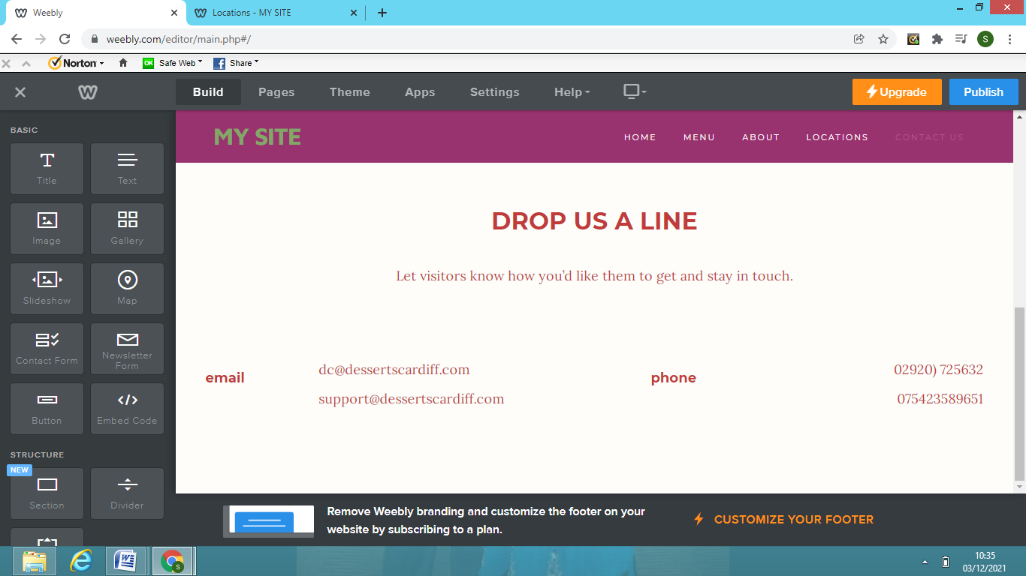

Conclusion
In conclusion, the value of market research must never be overlooked, especially when starting up a new business. Market research provides businesses with a competitive advantage, enabling them to prosper in different surroundings by doing everything from getting to understand customer needs and wants to investigate potential competitors. The sort of communication you'll collect is given by the product or customer care you would really like to offer as well as your ultimate research objectives. You can use your information to find a market opportunity, assess the competition, or test the utility and placement of your item or brand.
Market research should be the simplest way for entrepreneurs to keep up with market trends and maintain a competitive edge by sizing up your business opportunity (https://www.bl.uk/business-and-ip-centre/articles/why-is-market-research-important-for-new-business-ideas)

Overall market research can reveal how customers and potential customers perceive your company, as well as any gaps in customer perspective. This is useful information to have when putting together your marketing strategy. When making critical business decisions, having proper market intelligence can help to reduce risks.
“A big business starts small.”-Richard Branson

References

British Library (2021 )https://www.bl.uk/business-and-ip-centre/articles/why-is-market-research-important-for-new-business-ideas)
Accessed on 01st December 2021

Danannavar, M 2021 (Pg 142) Let's Startup: Starting Up Business & Entrepreneurship

GCL 16 November 2020 https://blog.gclb2b.com/blog/info/5-reasons-why-primary-market-research-is-essential
Accessed on 01st December 2021

Navarra, T (2018) https://upserve.com/restaurant-insider/3-sweet-ways-market-dessert/
Accessed 30th November 2021

