

Innovation in Crisis –
Why Is It More Critical Than Ever?

Module name : Developing Innovation and Creativity for Business Advantage
Lecturer : Davina Evans
Assignment deadline : 23rd April 2021
---------------------------------------------

Student name : Veronika Topolcanyova Student number : 1806303

EXECUTIVE SUMMARY

Business organisations had to adapt to a ‘new normality’ of providing services and products to their customers and adhere to social distancing and safety measures implemented in their businesses, regulated by the government. According to global financial institution Goldman Sachs Group. Inc. (2020) approximately more than 45% of small corporations have turned or changed their strategy and the way they do business and 74% stated that these changes might become permanent as part of them created new products, innovated the old products or services and invested into new technologies.
The purpose of this report is to describe the importance of innovation and creativity and how businesses should be changing their products or processes continuously to be able to survive in a competitive marketplace. Once business is established and making profit there is no guarantee that is going to last forever, therefore the research and development department is responsible for the innovation process in the company. There’s many business innovation models companies can use to innovate. Closed innovation happens within a company, and open innovation is involvement with other stakeholders.
Innovation processes must be followed in detail, and all steps of process discussed beforehand. Business must establish what they are going to innovate , is it going to be product or service, process, their position or paradigm and once this is agreed, if this will benefit the company, they can trial the innovation . At this stage organisation should discover all barriers and risks and try to remove them and all attributes of the change are positively established the change can become permanent. As an example of innovation a small family business from Cornwall was used to show their beginnings and years of innovation progress and how they coped with the coronavirus outbreak. Company is well established and making good profit during lockdown, only one recommendation was suggested was keep being motivated, creative and bring many new ideas into business even after the world reopen again and don’t let customers lose interest and engagement. Keep up with social trends and media and follow businesses strategy and vision with passion and hard work !

‘’Starting and growing a business is as much about the innovation, drive and determination of the people who do it as it is about the product they sell.’’
-Elon Musk-

TABLE OF CONTENTS

1.0 Introduction……………………………………………………………………………………..1
2.0 Main Findings ……………………………………………………………………………….. 2
2.1 SWOT……………………………………………………………………………………. 3
2.2 Type of Innovation - Matrix………………………………………………..4
2.3 Models of Innovation…………………………………………………………. 7
2.3.1 Open and Closed Innovation…………………………………………….7
2.3.2 The Innovation Process……………………………………………………..8
2.3.3 4 p’s to Innovation……………………………………………………….…10
2.4 Assessment of the Effectiveness…………………………………….……13
2.4.1 Barriers and Risks…………………………………………………………...13
3.0 Conclusion……………………………………………………………………………………..14
4.0 Recommendations………………………………………………………….…………….15
5.0 References…………………………………………………………………………………….16

1.0 INTRODUCTION
This report is requested by University of Wales Trinity Saint David and it's been compiled by their student Veronika Topolcanyova in order to analyse why creativity and innovation has never been more important than now, when businesses around the world are fighting to survive the impact of the coronavirus outbreak.Company chosen for this report is called Moon and Stars Sleepovers and Events Cornwall. It was established in 2017 by a married couple Matt and Emma , who lives in a little village in Cornwall called Polgooth. They have two dogs, two children and lots of great ideas which they implemented into their successful business. At the beginning , they only provided themed sleepover party packages for children 5 year and above but they slowly expanded into bigger business and widened their range of services. Hit by the pandemic in 2019, they had to react quickly and adapt to safety measures to protect themselves, customers and public. As they both self employed, having regular income for the family was at risk. They took action in their own hands and found a way to change threats of pandemic into business opportunity and benefit from it. One year after the coronavirus outbreak their business is blooming, having many satisfied customers and looking forward to what the future brings. (Thomas and Thomas, 2017)
There is no doubt that this company is surviving through pandemic thanks to the founders' creativity and level of innovation they put into their business to strive and survive. But what innovation really is, and does it differ from creativity?
Dr McKeown (2014) described innovation as creating ideas which are useful, explaining that an old idea can solve new problems and vice versa by applying different methods and paying attention to the innovation to be a success. Edward de Bono cited in Small Business Trends (2020) that creativity is most definitely one of the most important human skills and business can’t progress without promoting creativity, otherwise they would be going around circles following the same pattern.

Creativity is thinking up new things. Innovation is doing new things.
Theodore Lewitt.

2.0 MAIN FINDINGS

Henderson (2017) states in Forbes that it is important to have the right team in order to distribute new ideas. Different people have different minds thus individual ideas and those might not be the same as originally proposed . However by obtaining a different view of the innovation process everyone has the opportunity to contribute and come to the agreement for the final innovation idea and that will motivate the team and to help this project to succeed. The De Bono model of six thinking hats is a great model to use for problem solving and for innovative thinking. Model contains 6 colours and each hat represents a different character or symbol of thinking. It's a great model when collecting ideas and could tell a lot about feelings or assumptions. White hat represents only needed facts, yellow is positive stating the benefits and positives, unless like black examines con’s or problems, red is for instinct or second thought, green is the alternatives and blue is to manage and control that all hats were considered in the process. (Six Thinking Hats, 2021)

2.1 SWOT ANALYSIS
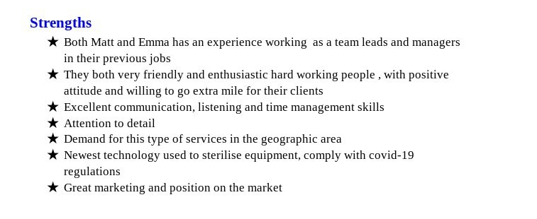

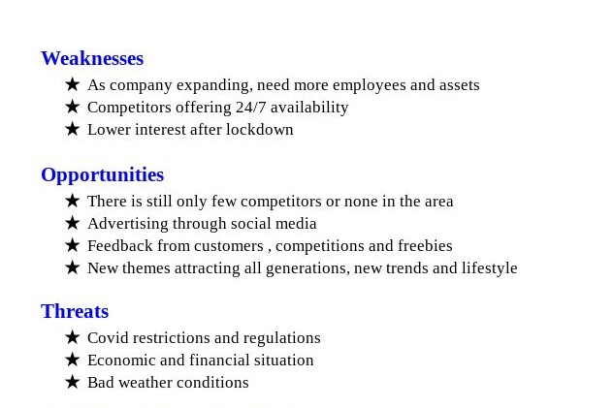

2.2 TYPE OF INNOVATION - MATRIX
Ros and Jeyakodi (2019) explain that Innovation matrix is a simple composition of management needed for innovation.
Companies can use available tools as a ‘Nano tool ‘to create matrices , for instance Lego company compiled one by following 4 easy steps . At first they have to identify the type of innovation and input that correctly into matrix , also brainstorming can make innovation more succesfull , setting up the right team responsible to deliver the innovation and finally think about available resources , budget, finance HR needed for completion of innovation. (How to Use Innovation Matrix, 2014)
Moon and stars went through existing service development and that is mostly incremental innovation. They pointed out what could improve business, and in what areas must be put more effort. This area is falling under product suite, and represents a collection of services that delivers complete solutions. New offering category is an existing survival with new value proposition. Being hit by lockdown brought new ideas for improvement and so it was time for a business innovation model. As sleepovers were out of picture for who knows for how long, Emma and her husband Matt held a brainstorming session and brought sleepovers outside of the house. They invested into two four meters long bell tents which can accommodate the whole family and that way make it easier for children and their parents to make lockdown enjoyable and family celebrations more exciting and fun. Emma’s creative mind is amazing and shows how design can be changed to accommodate different group ages and fit every venue. At the moment the company is offering more than 12 fun themes and can adjust to special customer requests. Planning a proposal , movie night or just a birthday party? It seems to be no problem for this creative company to fulfill customer wishes. It is all about little details and perfectionism put into every venue with guaranteed satisfaction. Emma’s ideas come from all areas, she listens what customers like, what kids dream of and what is currently ‘in’ on social media and the world of entertainment. It was partly a radical innovation as when the lockdown was announced these ideas were a ‘game changers’ for the company and its existence.

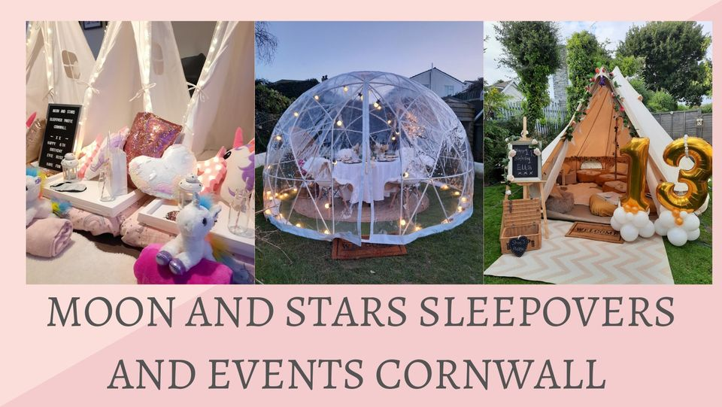

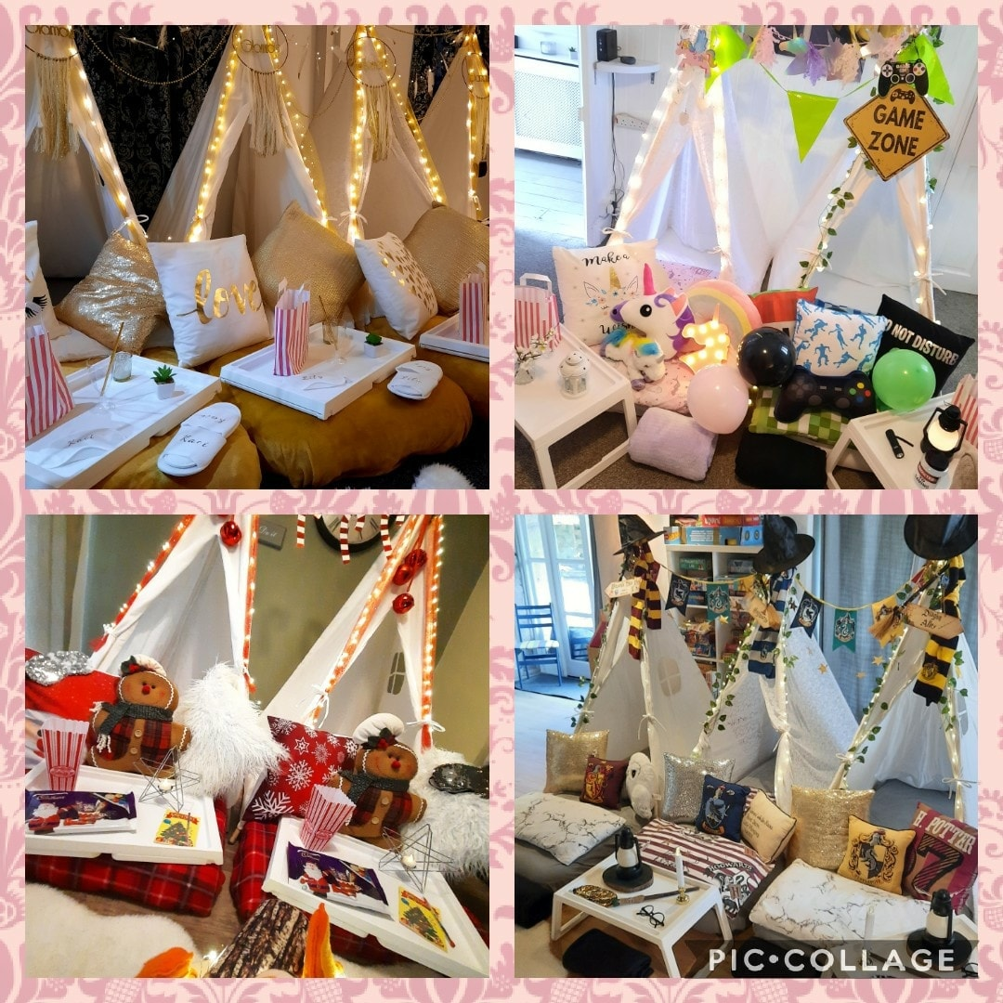 | 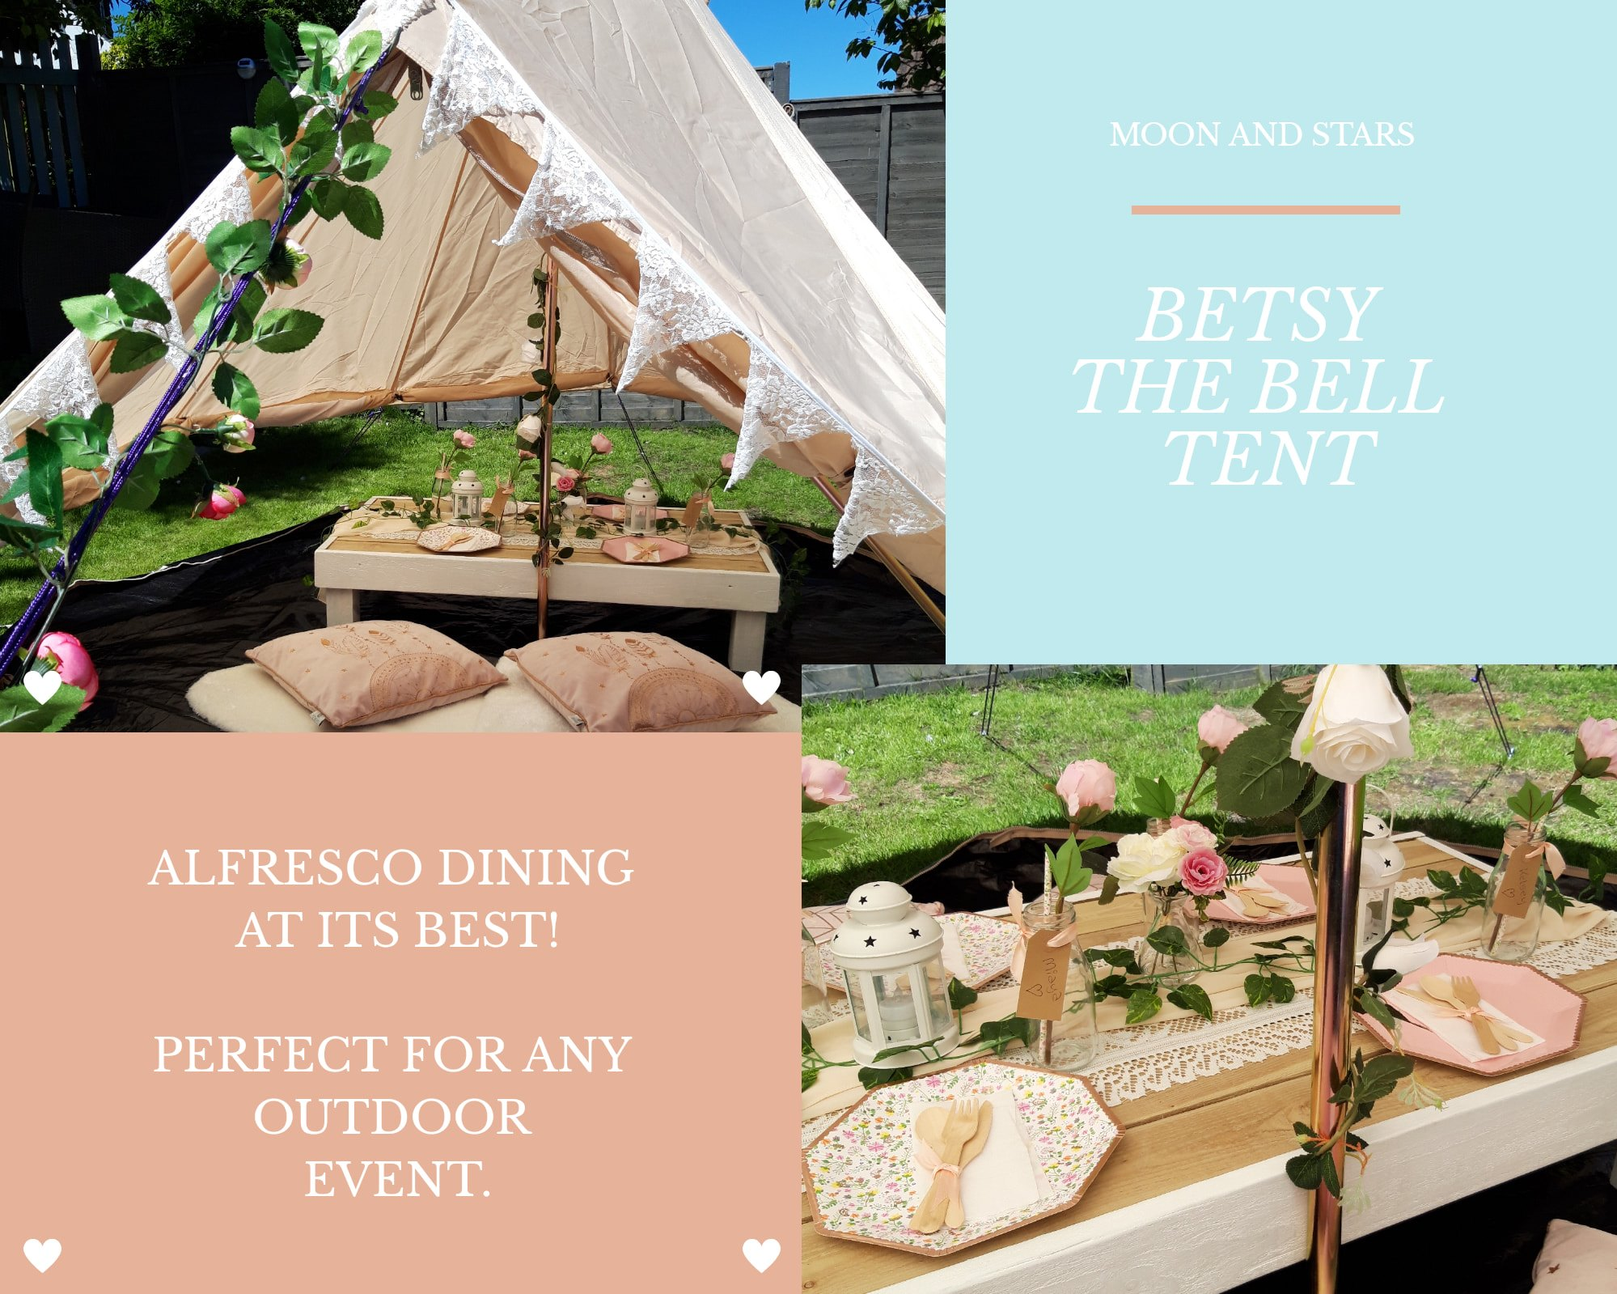
https://www.facebook.com/moonandstarssleepoversandeventscornwall/photos/26608775441934

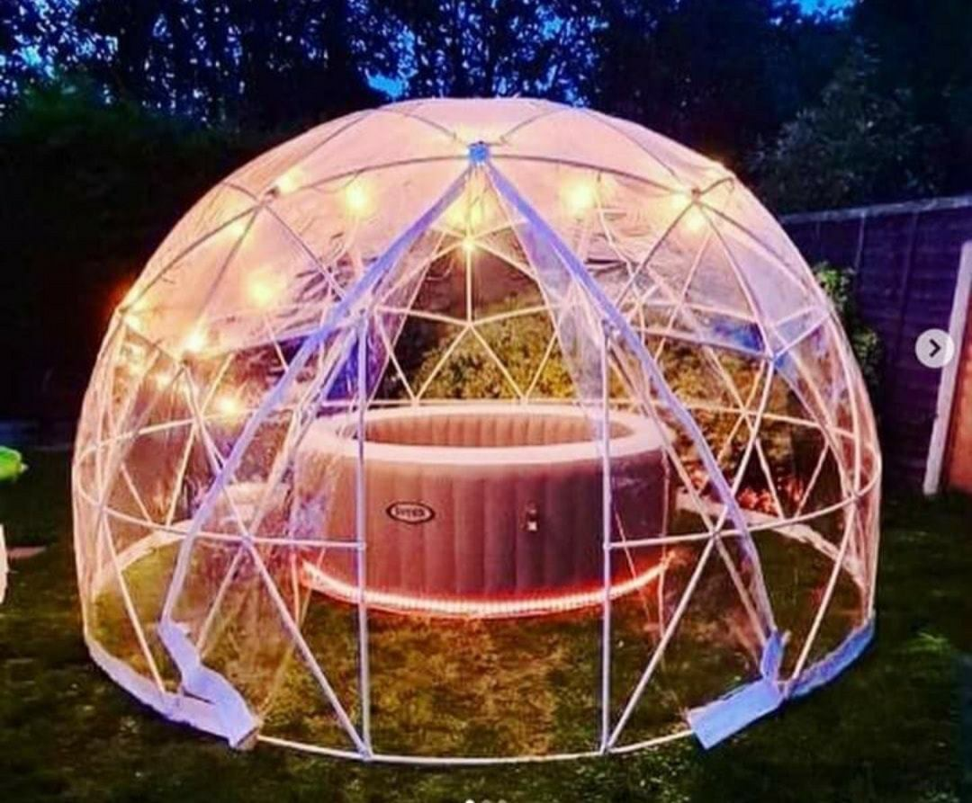 | 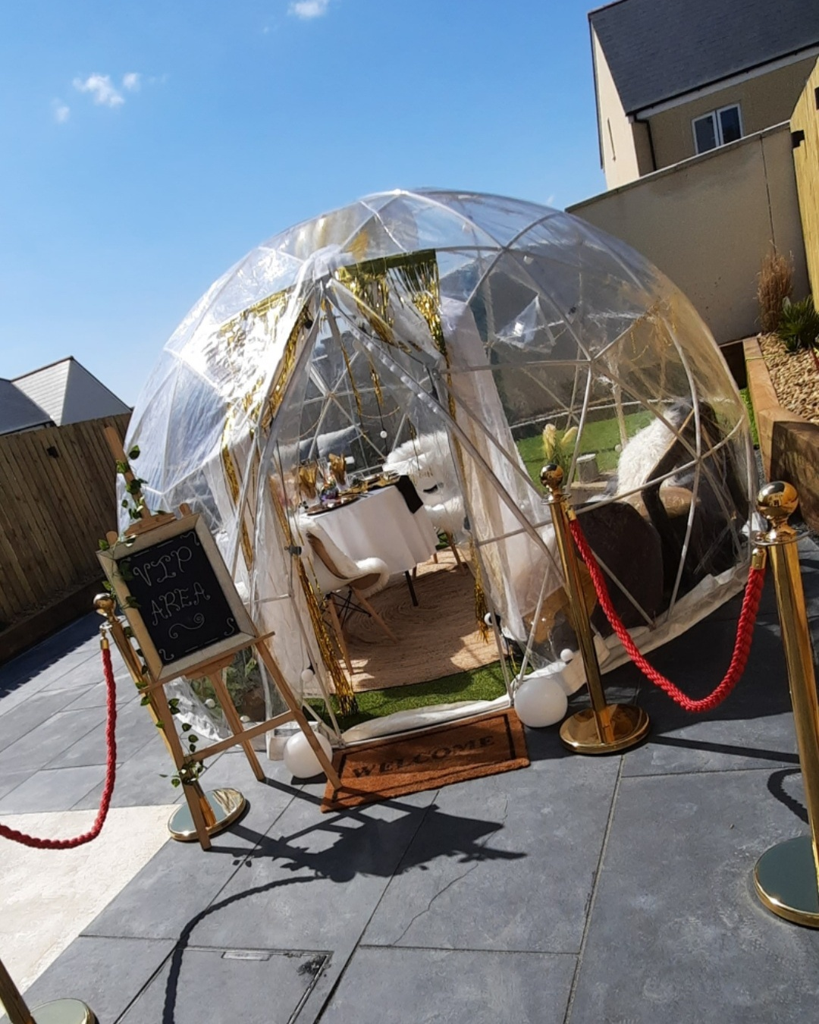
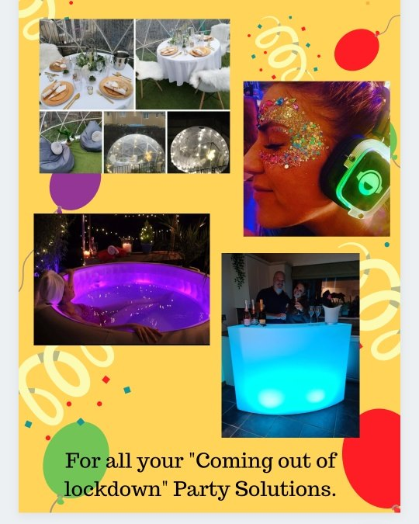 | 
https://www.facebook.com/moonandstarssleepoversandeventscornwall/photos/2774932216121266/

Offering outdoor experience could be tricky as different people have different expectations therefore to accommodate customers in this hard time of lockdowns associated with business and venues closures it was important to continue innovation and bring something new all the time. Sustaining innovation involves all these small steps which company has taken to get where they are now. Providing what customers need and making it better is similar to incremental innovation but with greater focus on customers. Therefore, based on customer feedback and people's needs, the company introduced a brand new igloo experience, which could replace dining under the stars, outdoor cinema or family celebration. Being this an open innovation, they collaborate with hot tub providers and bought numerous hot tubs for a spa experience, silent disco and karaoke equipment and at last but most important to keep all their equipment clean and sterilised, laundry services and professional cleaning equipment and products as steamers, fogging machine and upholstery and carpet specialists.

2.3 INNOVATIONS MODELS
Innovation plays a major part in an organisation's strategy and using the right model is important for its successful execution.(Innovation Models, 2020). An innovation is partly art and partly science, which both has to be examined and studied separately but knowledge will create structured procedure on the road to innovation. It is beneficial for the company to study all business innovation models to be able to recognize which one will suit the company best. (Kylliäinen, 2018)
2.3.1 OPEN AND CLOSED INNOVATIONS
Close innovation is defined as an internal process. Company is responsible for development of ideas and marketing itself and the whole innovation project and its realization is happening within the corporation . It might be costly as company finance R&D, and all resources needed for innovation and therefore it puts pressure on people working for the company. (Zapfl, 2018)
Although Open innovation is still an internal activity, companies are struggling to do everything by itself and reaching for external resources to help with the process of innovation in order to satisfy customer needs. It is a perfect mixture of external knowledge and internal R&D and it requires strong collaboration to bring new /better products or services to the marketplace and generate profit. (Chesbrough, 2006).
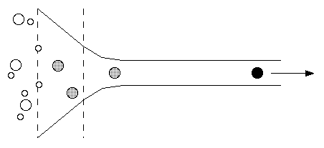

For small family business the Innovation funnel has a top down model approach thus all effort and focus is on single product/service and improving of something the company does but tries to improve it , make it even better . (Innovation Funnel, 2021).There might be internal barriers following open innovation such as finances, organisational culture, employees values and beliefs or operational systems. Between external barriers belongs political situation, legal requirements, technology and market demands. (Rahman and Ramos, 2017)
As an example of an open innovation at Moon and Stars would be the company's cooperation with other local businesses which they use for their party experience such as cake maker Victorias sponge, Medlin design, Taylor made balloons and others.

2.3.2 THE INNOVATION PROCESS

Innovation process is a plan of actions followed by the team until innovation is successfully completed. Each step of this process needs to be followed as it can impact the outcome in a positive or negative way. Adhering to this strategy, it will benefit the company as it might build urgency for innovation, also efficiency and effectiveness become greater alongside with overall performance and build the company culture when effort is rewarded and lessons from failures learned. (Luenendonk, 2019).
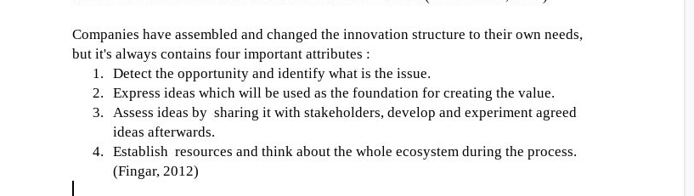
Applying these steps to Moon and Stars looking at innovation after covid - 19 impact, at first it was an opportunity to bring something customers are not allowed to have at that very moment , impacted by lockdown. As everybody likes to enjoy life and as they say ‘life goes on no matter what’ it was definitely an open space for ideas of how to replace what was lost. How to enjoy life when locked in the house for months? Not being able to meet friends and family was just part of the issue but entertaining kids was a huge task. Kids don’t fully understand the importance of social distancing and not being able to socialise. The issue was here and a solution needed to be found.
Emma and Matt had definitely hundreds of ideas of how to innovate their business in order to survive and support their existing customers. Collecting data and demand for services they decided what is going to benefit business the most, what is going to interest customers most and what is going to generate the biggest profit. Baring in mind their available finance and human resources they set the budget which can afford to invest and introduced this idea to their customers via social media. By reaction from people to their incoming events they could work out if that investment is going to be a successful invention for the company and its future.
 | 

2.3.3 4 P’S TO INNOVATION

There's 4 types of innovation company can go through and as described in innovation mix model, created by Tidd & Bessant (2014) these are:
a) Product or service offered by the organisation.
b) Process of making and distributing.
c) Position in the market ; marketing and advertising.
d) Paradigm changing the entire mental model of what business does, its rules or technology.
Applying 4P’s model to Moon and Stars should look like this:
- First service offered by the organisation were small tents and large teepee , later improved by transparent igloo with additional hot tub and silent disco , movie projector for more experience
- Company started providing their services just with two family cars and no employees, currently owning a van and trailer , due to expansion of business and high customer demand , they recruit a full time employee. They went as far as moving their family to a bigger house with extra storage and a bigger drive to park company van.
- Starting just with their simple website, they created many accounts on social media to promote business and to obtain customer feedback such as Twitter, Facebook, Instagram, Pinterest. Also invested in professional advertising companies managing their website, leaflets, car sign , uniforms etc.
- Being huge fans of sleepover parties, they began with parties for children 5 years and over , but adding more features business can accommodate all age groups and fit every purpose, for instance ‘adults only parties’ such as hen do’s and stag nights.

2.4 ASSESSMENT OF THE EFFECTIVENESS
Before businesses decide to go ahead with new innovation, they have to analyse if the innovation will be a success or failure, therefore they should use business models to evaluate, inspect and select all possible advantages and disadvantages it might bring to the business. Every product or service was once someone’s idea. Businesses are pushed to bring new ideas continuously and if they fail to do so, customers might lose interest and choose to go to competitors. (Smartstorming, 2021). Social psychologist Kurt Lewin designed a model called ‘Force Field Analysis which is a plain yet effective technique for companies to identify and make a list of forces which drive and resist proposed innovation. For the change to be implemented, the forces cannot be equal and pro’s or forces for change have to be greater than forces resisting the change.
Sometimes companies have the ability to reduce or remove some restraining forces and therefore can proceed with innovation. (Force Field Analysis, 2021)

Change proposal - Igloo tent accommodating larger venues


Is it a good idea?
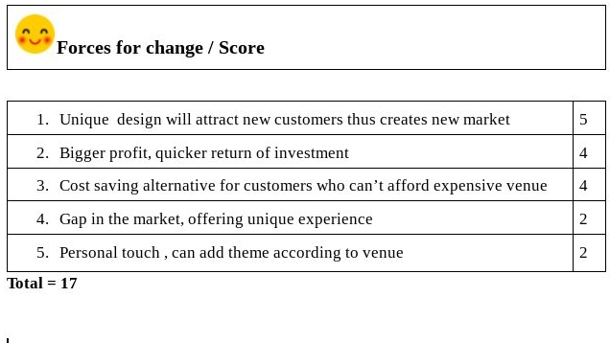
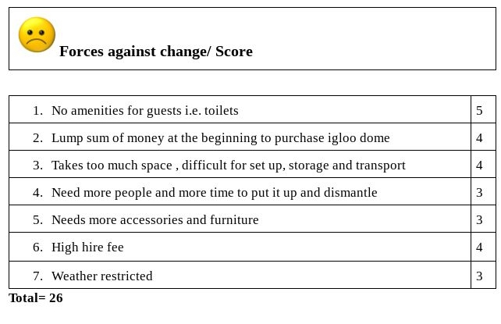

2.4.1 BARRIERS AND RISKS
According to Gower (2015), research found that 10 barriers of successful innovation are fear of failure, missing leadership skills, short-time thinking, deficit of resources and teamwork, lack of focus and urgency and at least missing action to fishing projects, running out of time and money.
Innovation brings benefits to the business but also the risks! As benefits could be adding value, improving process and quality , reducing cost or lift morale and motivating employees, there is risk that competitors might copy the innovation as it's hard to protect innovated products and processes, profit might be lower than expected and limited budget will become an issue . (tutor2u, 2021)

3.0 CONCLUSION
Every company should continuously innovate. If they stop improving their services or products they will risk stagnation of the business or possibly fighting for survival. To be able to survive in this hectic and constantly upgrading fast pace environment they need to know what are the company's strengths and weaknesses and through opportunities minimize threats. It is easy to do that using business models and theories. Through the innovation process they can select the best innovation idea and turn it into a successful project. It is important to conduct force-field analysis in order to establish all pro’s and con’s of innovation and decide if to proceed with realisation or decline in case it might not be beneficial for the company. Now is a more crucial time for companies to be innovative as the world is facing a pandemic crisis and is harder than ever to keep business running. In all respect, many companies adapted rather quick measures and restrictions , changed the way of doing business (mostly going on-line) and were able to make profit and even benefit from the pandemic. Thanks to excellent collaboration and communication with their stakeholders, small and big businesses managed to entertain the whole nation and deliver outstanding products and services into our homes and communities.

4.0 RECOMMENDATIONS
It is hard for small businesses to operate during world pandemic and financial advice can come handy. Advice for small businesses and self employers is to reach out for available funds, grants and furlough schemes offered by the government. It might be worth a try or even safe business from closing down. Promote business and all innovations which were implemented and assure customers about safety of services provided. Customers want to feel protected therefore making sure that organisation comply with health and safety regulations and all measures were put in place in order to protect the public. Make sure that the physical and mental health of all employees is most important and provide appropriate resources for employees who struggle to cope with the impact of coronavirus outbreak. At last, spread the word and collaborate with other small businesses to lift each other and support the community.

5.0 REFERENCES
ALCOR FUND. 2020. Innovation Models | Innovation Process Models | Examples. [online] Available at: <https://alcorfund.com/insight/innovation-models-innovation-process-models-examples/#:~:text=An%20Innovation%20model%20provides%20a,to%20create%20the%20needed%20value.> [Accessed 18 April 2021].

Bplans Blog. 2021. Innovate! 7 Quotes About the Value and Risk of Innovation. [online] Available at: <https://articles.bplans.com/innovate-7-quotes-about-the-value-and-risk-of-innovation/> [Accessed 19 April 2021].

Chesbrough, H.W., 2006. The era of open innovation. Managing innovation and change, 127(3), pp.34-41.

Goldman Sachs. 2020. Small Business Britain: The Impact of COVID-19 To-Date. [online] Available at: <https://www.goldmansachs.com/citizenship/10000-small-businesses/UK/infographics/small-business-britain/> [Accessed 8 April 2021].

Google, 2021. Image of a light bulb made out of paper. [image] Available at: <http://www.blr.com/html_email/Images/SMDAimages/SMDA_101416.jpg> [Accessed 31 March 2021].

Gower, L., 2015. The ten barriers to innovation > Lucidity. [online] Lucidity. Available at: <https://www.lucidity.org.uk/the-ten-barriers-to-innovation/> [Accessed 15 April 2021].

Henderson, T., 2021. Council Post: Why Innovation Is Crucial To Your Organization's Long-Term Success. [online] Forbes. Available at: <https://www.forbes.com/sites/forbescoachescouncil/2017/05/08/why-innovation-is-crucial-to-your-organizations-long-term-success/?sh=52d0b6683098> [Accessed 18 April 2021].

Ifm.eng.cam.ac.uk. 2021. Innovation Funnel. [online] Available at: <https://www.ifm.eng.cam.ac.uk/research/dstools/innovation-funnel/> [Accessed 13 April 2021].

Kylliäinen, J., 2018. Key Innovation Management Models and Theories. [online] Viima.com. Available at: <https://www.viima.com/blog/innovation-management-models> [Accessed 18 April 2021].

Luenendonk, M., 2019. The Innovation Process: Definition, Models, Tips. [online] Cleverism. Available at: <https://www.cleverism.com/innovation-process-definition-models-tips/> [Accessed 12 April 2021].

Mckeown, M. (2014). The Innovation Book: How to Manage Ideas and Execution for Outstanding Results. United Kingdom: Pearson Education.
Moon and Stars Sleepovers and Events Cornwall, 2021. picture of Sleepover party tents. [image] Available at: <https://www.facebook.com/moonandstarssleepoversandeventscornwall> [Accessed 10 April 2021].
Moon and stars, 2021. Announcements. [image] Available at: <https://www.facebook.com/moonandstarssleepoversandeventscornwall> [Accessed 18 April 2021].

Rahman, H. and Ramos, I., 2017. Open Innovation in SMEs: From Closed Boundaries to Networked Paradigm. [pdf] Braga. Available at: <http://file:///media/fuse/drivefs-6ea4a1ad5aa5a41f6178cf04c24ddbee/root/Open_Innovation_in_SMEs_From_Closed_Boundaries_to_.pdf> [Accessed 15 April 2021].

Ros, M., Jeyakodi, D. (2019). Innovation Matrix. Netherlands: BIS Publishers.

Smartstorming.com. 2021. Smartstorming. [online] Available at: <https://www.smartstorming.com/and-may-the-best-idea-win-5-proven-tips-for-evaluating-and-selecting-your-best-ideas/> [Accessed 15 April 2021].

Skymark.com. 2021. Force Field Analysis or Force Field Diagrams: Anticipate Problems before they bite you.. [online] Available at: <https://www.skymark.com/resources/tools/force_field_diagram.asp> [Accessed 15 April 2021].

The De Bono Group. 2021. Six Thinking Hats. [online] Available at: <https://www.debonogroup.com/services/core-programs/six-thinking-hats/> [Accessed 18 April 2021].

Thomas, E. and Thomas, M., 2017. About Us. [online] Moon and Stars Sleepovers Cornwall. Available at: <http://www.moonandstarssleepoverpartiescornwall.co.uk/> [Accessed 1 April 2021].

Tidd, J., Bessant, J. (2014). Managing Innovation: Integrating Technological, Market and Organizational Change. United Kingdom: Wiley.
Tutor2u. 2021. Innovation - Benefits and Risks | tutor2u. [online] Available at: <https://www.tutor2u.net/business/reference/innovation-benefits-risks> [Accessed 15 April 2021].

Wharton Executive Education. 2014. How to Use Innovation Matrix for Product Development – Nano Tools for Leaders. [online] Available at: <https://executiveeducation.wharton.upenn.edu/thought-leadership/wharton-at-work/2014/02/the-innovation-matrix/> [Accessed 10 April 2021].

Zapfl, D., 2018. Open Innovation vs. Closed Innovation. [online] Lead-innovation.com. Available at: <https://www.lead-innovation.com/english-blog/open-innovation-vs.-closed-innovation> [Accessed 11 April 2021].

