Effective Team Working and Communication

Component 1: Effective Teamworking for team success

Executive Summary
In the report, the key concepts of teamwork focused on the characteristics and importance by citing the literature. The integrated approach to developing an effective ‘team’ using Tuckerman’s Team Development model has been analysed in the current report. The multiple phases of the team formation by examining the key challenges and team leader’s intervention have been assessed in the present report. The importance of assigning the team roles to avoid role conflicts using the Belbin Team Role model has been outlined in the report.

Table of Contents
Executive Summary 3
Introduction 3
Team working: Overview and Analysis 3
Models of Team Development 4
Team Roles 6
Discussion: Effective and ineffective team working 7
Conclusion 8
References 9

Introduction
The report will demonstrate the key concepts of teamwork by focusing on the characteristics and importance. The integrated approach to forming a ‘team’ using Tuckerman’s Team Development model will be analysed in the current report. The multiple phases of the team formation by examining the key challenges and the team leader’s intervention will be highlighted in the present report. The importance of assigning the team roles to avoid role conflicts using the Belbin Team Role model will be analysed in the report. Furthermore, the report will conclude by establishing the differences of the effective and ineffective team working in consideration with the organisational examples.

Team working: Overview and Analysis
A ‘Team’ reflects the group of people working together to achieve a common goal (Baker, 2016). Adair (2019), defined a team is a group of individuals that are independent in consideration to the information, skills, competencies, knowledge and accordingly combine their efforts in achieving the common goal. In the team, the complementary skills for generating synergy through coordinated effort can be spotted. It has been observed that team members have to learn the ways to extend their help with other team members and create a positive environment where everyone will share discretionary effort for achieving the goal (Anderson, 2016). The concept of ‘team working’ was introduced in the workplace in the late 20th century. The members in a team used to work towards interchangeable achievements and shared common attainments. Fraher (2019), claimed that team communication is important to create positive relationships. Therefore, the strong sense of mutual commitments in attaining synergy can be reflected in the team.
The significant attributes of the team working are mutual commitment, coordinated effort, specific roles and integrated team communication (Baker, 2016). Positive teamwork reflects the commitment of the members, sense of cooperation and quality driven effort. In teamwork, the members have to remain accountable for the decisions and outcomes. There are major influences towards effective team working that are unstructured communication, rigid organisation structure and ineffective leadership. Moreover, the lack of skills and competencies of the members to work in a team can influence positive teamwork. In the dynamic business environment, cross-cultural teams are effective in understanding the market requirements. Therefore, the retailer like Tesco Plc is emphasising the team working to enhance the store efficiency and customer satisfaction. The development programme undertaken by Tesco plc consists of ‘teamworking’ to assist the customers efficiently.
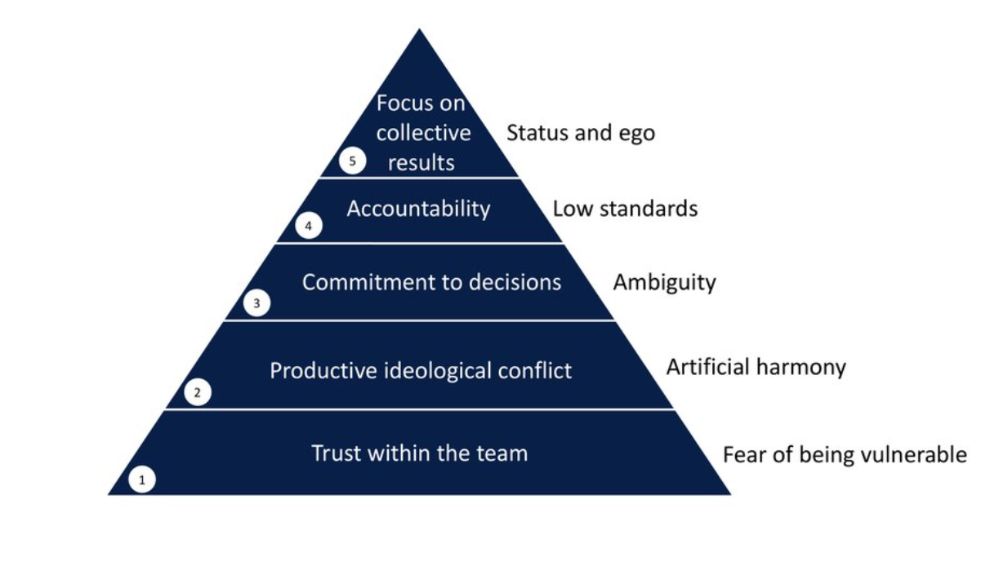
Effective Teamwork, Source: https://www.stormbal.com/
As per Collins (2018), Effective Teamwork stands to be important in driving business success. From a study, it has been observed that employees working in a team can deliver much better results and accordingly trigger success for the organisation. An effective team must have the skills like openness, trust and respect (Baesu, 2017). The team members must be willing to know each other due to their diverse backgrounds and different interests. Moreover, trusting each other can help to generate creative ideas in a team. Adair (2019), opined that team member has to remain accountable for the activities that go wrong without blaming each other. Constructive feedback and learning from the previous mistake can help to achieve better results.

Models of Team Development
Team Development reflects the learning process of working together for achieving a common purpose (Anderson, 2016). An educational psychologist Bruce Tuckman has developed a five-stage team development process that constitutes storming, storming, norming, performing, and adjourning. The purpose of the team development model is to ensure the smooth running of the team by implementing team leadership and a constructive learning process. With the correct team development, the team members will have adequate opportunities to build a rapport and foundation of acceptance. It has been spotted that member trusting one another in the team can likely share ideas and collaborate effectively in undertaking the right decisions. Therefore, team development establishes a captivating atmosphere by encouraging cooperation, teamwork and interdependence.
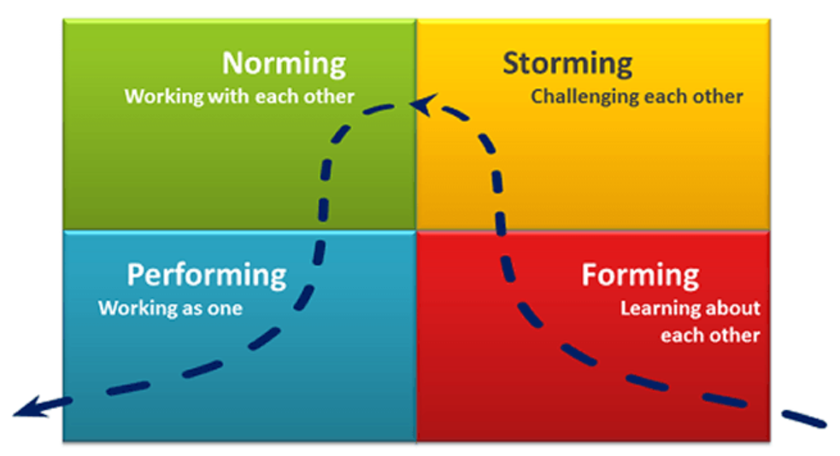
Tuckman’s team development model, Source: https://miro.medium.com/
The five phases that are observed within Tuckman’s team development model are as follows:
- Forming stage: In the forming stage, the team members are not accustomed to the goals and direction of the group project (Larson, 2017). Therefore, effective leadership is needed to ensure a clear direction and roles of the team members.
- Storming stage: The storming stage insist the members share creative ideas and feedback for forming a work approach. In this stage, the members may be disagreeing with each other due to their diverse backgrounds. However, effective leadership can resolve conflicts and ensure the smooth functioning of the team.
- Norming stage: In the norming stage, the differences created among the members will gradually reduce due to effective leadership and openness in the team. The team members will share consensus towards a specific work style and remain focused to achieve the desired target.
- Performing stage: In the fourth stage, the coordination, mutual commitment, and respect between the team members will produce positive outcomes. The cooperation among the team members will accomplish the team objectives.
- Adjourning stage: The Adjourning stage is the final stage of the team development model where the team members share a positive relationship. The team members form an informal relationship with each other due to the existence of group maturity level.
In the year 1993, the Katzenbach and Smith Team Effectiveness model has enabled team functioning by representing the team’s goals and objectives. The collective effort, positive performance results and personal growth has focused in the model (Salas, 2018). The three points of the triangle under the Katzenbach and Smith Team Effectiveness model are commitment, accountability and skills. From the model, it can be observed that a lack of commitment can influence the group dynamics. Therefore, it is recommended that the team members must adapt teamwork and problem-solving skills to accomplish the goals. Furthermore, the team members have to be steadfast in their commitment related to the individual task and team goals.
As per the case study, the members from diverse backgrounds will encounter conflicts and issues due to the different perceptions and views. In this situation, Tuckman’s team development model is effective to follow as it considered the challenges and ways to minimise the issues with a holistic approach. The getting mature of the team over a specific period of time can be reflected under Tuckman’s team development model. The model is justified for minimising the differences among the members of University of Wales Trinity Saint David irrespective of gender, background, age, and experience with the aspects like mutual respect, aligned goals, patience and open communication. Brainstorming has been identified as an effective approach under Tuckman’s team development model that helps to exchange constructive ideas and opinions.

Team Roles
A Belbin Team Role model manifest the nine clusters of behavioural attributes that help to facilitate the progress of the team (Anderson, 2016). The team roles reflect the range of behaviours that makes an effective contribution towards positive team performance. However, Belbin Team Role Model has identified the nine clusters of roles under three broad categories that are action-oriented roles, people-oriented roles, and thought-oriented roles. Firstly, the ‘resource investigator’ helps to bring new ideas to the team by sharing possible data and information. Secondly, a ‘team worker’ shares a positive contribution to the team for achieving the target. Thirdly, a ‘coordinator’ is used to delegate the responsibilities and focus on the team objective. The team member playing the role of a ‘plant’ used to solve the problem using creative and innovative ideas. It is the ‘monitor evaluator that is used to examine the judgements using the logical and impartial objective. The ‘specialist’ in the team has in-depth knowledge and supports the team to achieve the desired target. A ‘shaper’ in the team motivates another member to maintain the momentum of the team. The role of the ‘implementer’ is to establish an action plan by introducing a workable strategy. Lastly, a ‘complete finisher’ work on the errors to maintain a high standard (Dickinson, 2019). From the Belbin Team Role, it can be spotted that each team member in a team has to share certain expertise to achieve the desired target. The behavioural tendencies of the members will be different due to the diverse background but positive contribution is important to achieve the group dynamics. Baesu (2017), mentioned that ‘team cohesion’ occurs when the team members are aware of their roles and ensure flexibility and accountability of their work. Therefore, interconnectedness and trustworthiness among the members are necessary to achieve team cohesion.
In recruiting new staff, team roles are necessary to remain focused and committed. Moreover, a balanced team is important to achieve a cohesive team. The team roles show the behavioural tendencies of the members. Each member under the diverse team roles shares discretionary effort in the team to achieve the goal. The members of the team with dedicated roles can overcome the hurdles with a coordinated effort. Therefore, assigning the team roles based on expertise, specialisation and skills are important.

Discussion: Effective and ineffective team working
An Effective Team is a foundation for every successful business firm. In an effective team, the members used to bring potential talents and skills that contribute efficiently towards the group success (Jones, 2016). Dickinson (2019), opined that for an effective team, the members are united and remain motivated to achieve the desired target. Furthermore, an effective team is clear about the objectives, deliverables, and other requirements. Ineffective team working, the complementary skills for generating the synergy through the coordinated effort of the members can be spotted. Effective teamwork reflects the commitment of the members, sense of cooperation and quality driven effort (Baesu, 2017). Moreover, the members used to remain accountable for the decisions and outcomes without blaming others. Salas (2018), briefed that effective teamwork establishes a captivating atmosphere by encouraging cooperation, teamwork and interdependence. Effective teamwork has the skills like openness, trust and respect. Ineffective team working, the team members must be willing to know each other due to their diverse backgrounds and different interests.
The key advantages of effective team working are as follows:
- Effective teamwork ensures idea generation and creativity as it involves the participation of all members of the team (Tambe, 2017). The openness in the effective team will encourage the members to share valuable feedback and ensure cooperation from each other.
- Effective teamwork drives productivity and supports the organisation in achieving better results (Dickinson, 2019). The discretionary effort of the team will facilitate the organisation in achieving the desired results.
- Ineffective teamwork, employee morale and motivation are high. The commitment of the members to achieving the targeted results will be high (Salas, 2018).
On the contrary, the distrust, conflict-driven and negative relationship of the team members can disrupt the team functioning and group dynamics. The lack of flexibility and cooperation among the team members reflects ineffective team working (Larson, 2017). Moreover, in social loafing, there are certain members in the team that delivers unequal contribution and eventually increase the work pressure on other members.
As per the organisational context, Tesco Plc has emphasised the team working to enhance the store efficiency and customer satisfaction. The development programme undertaken by Tesco plc consists of ‘teamworking’ to assist the customers efficiently. From the point of evidence, the group sales of Tesco have evidenced a rise of 3% around £27.33bn. Moreover, in the UK, the sales of Tesco have reported an increase of 1.2% despite the outbreak of the COVID-19 pandemic (Insight, 2021). Therefore, effective teamwork has supported the organisation to achieve the desired goal.

Conclusion
To conclude, the report has evaluated the key concepts of teamwork by focusing on the characteristics and importance by citing the literature. The integrated approach to developing an effective ‘team’ using Tuckerman’s Team Development model has been analysed in the current report. The multiple phases of the team formation by examining the key challenges and team leader’s intervention have been assessed in the present report. The importance of assigning the team roles to avoid role conflicts using the Belbin Team Role model has been outlined in the report.

References
Anderson, N. a. S. S., 2016. An evaluation of gender differences on the Belbin team role self‐perception inventory. Journal of Occupational and Organizational Psychology, 77(6), pp. 429-437.
Baesu, C. a. B. R., 2017. Leadership approaches regarding organisational change. The USV Annals of economics and public administration, 13(4), pp. 146-152.
Baker, D. a. S. E., 2016. Principles for measuring teamwork skills. Human factors, 34(2), pp. 469-475.
Dickinson, T. a. M. R., 2019. A conceptual framework for teamwork measurement. In Team performance assessment and measurement. London : Psychology Press.
Insight, R., 2021. Tesco raises full-year profit outlook after strong H1 results. [Online]
Available at: https://www.retail-insight-network.com/news/tesco-h1-2021-results/
[Accessed 25 10 2021].
Jones, G. a. G. J., 2016. The experience and evolution of trust: Implications for cooperation and teamwork. Academy of management review, 23(4), pp. 531-546.
Larson, C. L. C. a. L. F., 2017. Teamwork: What must go right/what can go wrong. London : Sage.
Salas, E. B. C. a. C. J., 2018. Teamwork: emerging principles. International Journal of Management Reviews, 2(1), pp. 339-356.
Tambe, M., 2017. Towards flexible teamwork. Journal of artificial intelligence research, 7(2), pp. 83-124.

