CYBERSECURITY AND DATA GOVERNANCE POLICY
SteelForm Manufacturing Ltd (SFM)

Cybersecurity Report

Student Name NASEER SARDAR
STUDENT ID 2512875

Table of Contents
1. Introduction 3
2. Threat Identification and Risk Assessment 4
2.1 External threats 4
2.2 Internal threats 4
Table 1. SFM Cybersecurity Risk Priorities 5
3. Security Policies 5
3.1 Access control and authentication policy 5
3.2 Network, firewall and VPN policy 5
3.3 Data governance and classification policy 6
3.4 Patch, vulnerability and asset-management policy 6
3.5 Backup and recovery policy 6
Figure 1. Proposed Network Security Architecture 7
4. Mitigation Measures and Implementation 7
Table 2. Mitigation Measures and Implementation 8
5. Monitoring and Incident Response 9
Figure 2. SFM Incident-Response Flow 10
6. Training and Security Awareness 11
Table 3. SFM Security Awareness Program 11
7. Governance and Performance Measurement 11
8. Conclusion 12
References 13

1. Introduction
Industry 4.0 is driving the revolution in manufacturing based on connecting machines, sensors, enterprise systems and cloud services. This connectivity facilitates automated production and remote monitoring for SFM, but it also expands the attack surface. Networked manufacturing systems can be breached through credential theft, phishing, use of a malware, an exposed system asset, and an insecure secure-connected route. Network security is needed to ensure that the physical production systems, including those such as office computers, are protected. As described by Stewart and Kinsey [1] network protection relies on several complementary controls, such as secure access, firewalls, and VPNs. Likewise, Stallings & Manna [2] highlight the importance of secure communications and reliable network design.
SFM's security requirements could be assessed using the CIA Triad over a simple basis. Confidentiality is important, as engineering drawings, customer specification and information about suppliers could be of commercial value. Integrity is important because production information or machine settings could be set to produce the wrong product or cause an operational issue if there were unauthorized changes. Availability is essential in case ransomware attacks, or a network failure halts manufacturing. The flexible framework in NIST CSF 2.0 to respond to these risks includes the functions of Govern, Identify, Protect, Detect, Respond, and Recover [3].

2. Threat Identification and Risk Assessment
SFM has external and internal threats. The risks are related; a phishing email could lead to a user's password being hijacked and then lead to the corporate network and to production systems.

2.1 External threats
Phishing and social engineering are immediate threats because of the contact procurement staff have with suppliers and the fact that they could process invoices and payment requests. Attacks can include the infiltration of suppliers or managers to obtain credentials and control financial activities. Ransomware is also a significant hazard in that it can make business and manufacturing data unavailable. However, Steinberg [5] points to the continued value of human behavior, secure credentials and awareness in minimizing common cyber risks.
Industrial espionage, particularly in the automotive and aerospace industry, is important given the need for customers to have access to commercial secrets, design spec and manufacturing information. An attacker does not need to stop production to cause serious harm; stealing intellectual property may create long-term commercial damage. Supply-chain compromise is also relevant because of different technologies from suppliers, and maintenance and cloud services are used for SFM. A good supplier account can be a pathway to SFM.
The online threat is a new type of threat—one involving OT and IoT. In comparison to traditional office systems, an industrial system can directly interact with the physical process. NIST SP 800-82 Rev. 3 clearly highlights the need to account for performance, reliability and safety requirements when considering OT security [4]. If SFM, without first assessing operational impacts, does not, then it is not.

2.2 Internal threats
Internal risks are accidental disclosure, weak passwords, users using unsafe USB drives, misconfiguration of systems, employees clicking malicious links. Also, through legitimate access, malicious employees or contractors can wreak havoc. Excessive privileges increase the potential impact of a compromised account because an attacker can access more systems than the user needs.

Table 1. SFM Cybersecurity Risk Priorities
Threat | Main asset affected | Business impact | Priority
Ransomware | Production and business data | Downtime, recovery cost, lost orders | Very High
Phishing / social engineering | User accounts and email | Credential theft, fraud, malware | Very High
OT / IoT compromise | Machines, PLCs and sensors | Production and safety disruption | Very High
Industrial espionage | Engineering IP and customer data | Competitive and contractual loss | Very High
Supply-chain attack | Trusted connections and software | Indirect compromise of systems | High
Insider misuse | Confidential information | Data theft or system damage | High
Unpatched systems | IT/OT devices | Exploitation and malware | High
Weak access controls | Accounts and cloud services | Unauthorised access | High

3. Security Policies

3.1 Access control and authentication policy
The principle of least privilege applies in the case of the SFM. Employees should only be given access to the items they require in their work role, and access to those items should be reviewed at least once every three months. MFA should be mandatory for email, cloud services, VPNs, privileged accounts and remote access. Separate administrator accounts should be used for privileged work. The actions performed are consistent with network-security basics since some basic network-access control requirements make network resources secure for the messages to be transmitted or received securely [1, 6].

3.2 Network, firewall and VPN policy
A multi-layered structure within the network for SFM. The corporate IT network, guest network, IoT devices and production OT should be separated. Firewalls need to control traffic across zones and remote maintenance should be performed through a approved VPN instead of direct Internet usage with MFA. Network segmentation lessens the chances of an attacker navigating their way from infected office equipment to production. Stewart and Kinsey [1] mention that firewalls and VPNs are part of the network-security chain; and Stallings [6] declares that network security is not a device but an area of applications and standards.

3.3 Data governance and classification policy
SFM should categorise information as either Public, Internal, Confidential or Highly Confidential. Construction drawings or customer specifications, production authorization data and strategic information will generally be considered as Highly Confidential. Sensitive data should be encrypted when stored and in transit, and access logs kept for critical repositories. Information must be reviewed based on a retention schedule and securely deleted. Data governance should also identify the owner of each important dataset and define who may access, change, share and delete it.

3.4 Patch, vulnerability and asset-management policy
SFM should have precise server, laptop, network equipment, IoT equipment, PLC and other critical OT equipment tracking. Vulnerabilities should be established taking into consideration business risks and production risks. IT systems need to be patched as soon as possible; OT patching needs to be thought through with the owners of production and equipment. If a patch cannot be applied safely, then use compensating controls, such as restricted access, network isolation and additional monitoring [4].

3.5 Backup and recovery policy
Critical production and business data should be backed up regularly using encrypted copies, including at least one backup that is isolated from the normal network. Backup should be tested to ensure it is known that backup that's not tested will not be a trusted recovery control. SFM should establish critical system recovery goals, and conduct practical system recovery, at least twice a year.
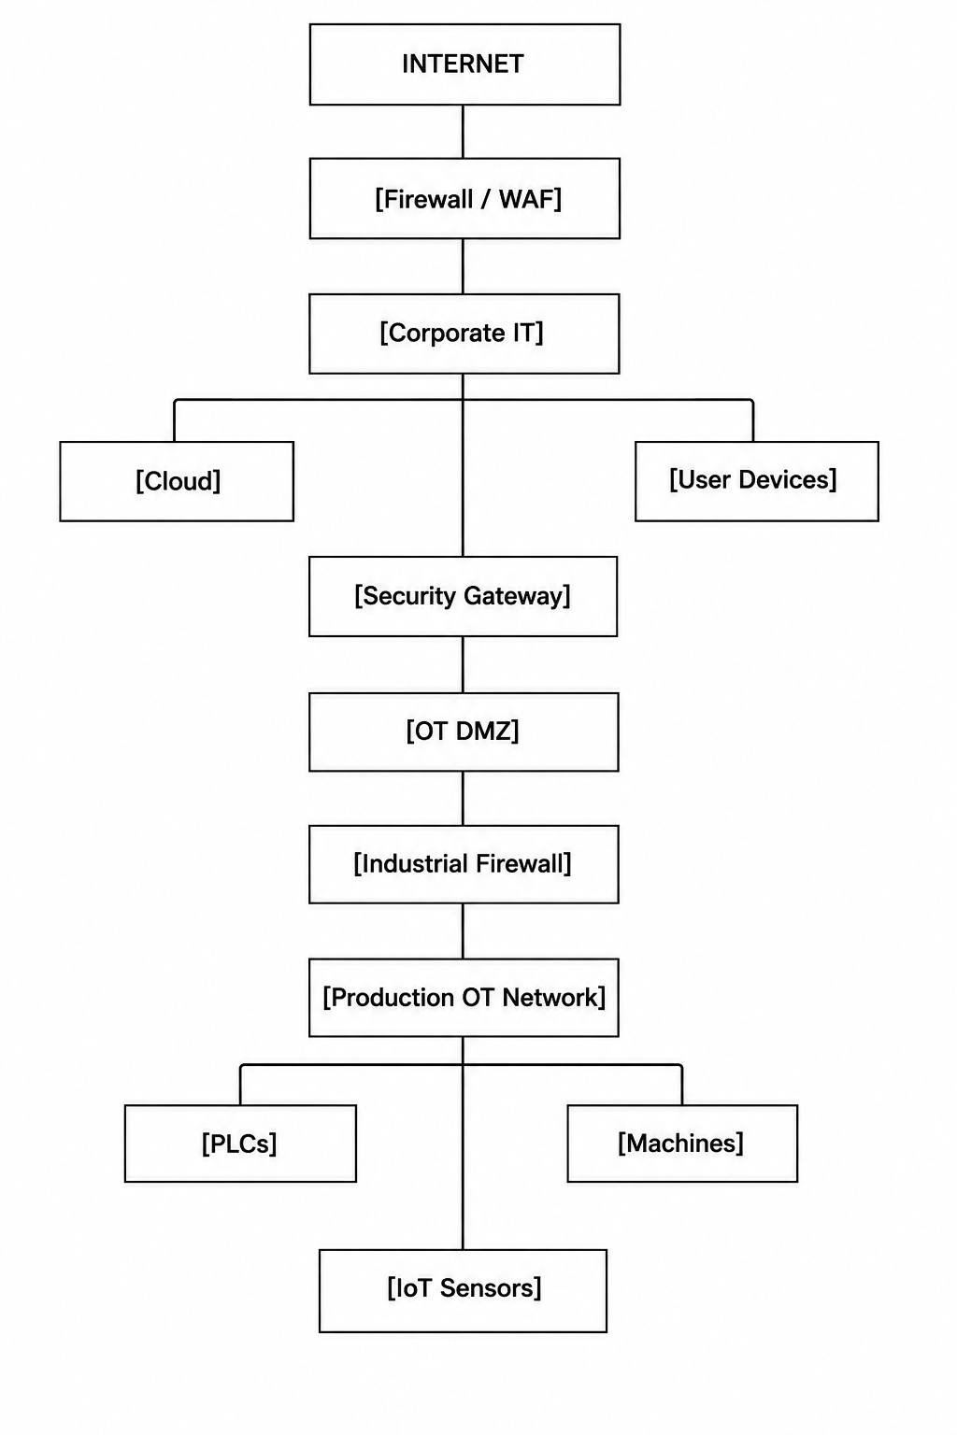

Figure 1. Proposed Network Security Architecture

4. Mitigation Measures and Implementation
The controls have to be put in place effectively over the course of time, so as not to strains a medium-sized organisation over-rapidly.
Phase 1: 0–3 months
SFM to undertake asset inventory and risk assessment; capability to support MFA, removal of non-essential administrator accounts, securing critical backup and improving email filtering. Risks in the form of weaknesses should be fixed first. Immediate phishing and Payment Fraud awareness training of procurement staff.
Phase 2: 3–6 months
SFM should implement network segmentation and firewall rules between IT, IoT, DMZ and OT zones. Block unsecured remote connections with Secure VPN access. Endpoint detection and response should be enabled on supported computers, and centralised logging should record key information from firewalls, servers, cloud systems, and authentication sources. These controls take place in layers, rather than one security device. [1], [2]
Phase 3: 6–12 months
SFM should create an information-security management program following ISO/IEC 27001 and go through the NIST CSF 2.0 to discuss progress [3, 7]. A review of security controls, incident reporting and access management should be conducted for critical suppliers. SFM is required to undertake penetration testing on the appropriate IT systems every year and undertake regular vulnerability assessments. OT testing should be managed and planned with production teams, as intrusive testing could impact equipment availability or safety [4].

Table 2. Mitigation Measures and Implementation
Risk | Control | Implementation | Success measure
Phishing | MFA + email filtering + simulations | Enable MFA; filter malicious links; test users quarterly | Lower phishing failure rate
Ransomware | EDR + offline backups | Deploy EDR; isolate one backup copy; test recovery | Successful recovery tests
OT compromise | Segmentation + industrial firewall | Separate OT; restrict protocols and remote access | No unauthorized IT-to-OT paths
Industrial espionage | Data classification + encryption | Classify IP; restrict access; encrypt sensitive files | Access reviews completed
Supplier attack | Supplier security assessment | Risk-rate critical suppliers; require incident reporting | 100% critical suppliers reviewed
Insider misuse | Least privilege + logging | Role-based access; quarterly reviews; monitor privileged use | Reduced excessive privileges
Unpatched systems | Asset inventory + vulnerability management | Record assets; prioritise critical vulnerabilities | Patch compliance target met

5. Monitoring and Incident Response
Prevention does not ensure that it is enough. SFM must be continuously vigilant of such factors as authentication, unusual network traffic, new information about the malware, changes in privileges, cloud activity of engineering materials, or significant changes to engineering materials. A managed security services startup may be the option for a small security operations function in case 24-hour monitoring is not cost-effective.
Incident Response should be part of an ongoing Cybersecurity Risk Management program. NIST SP 800-61 Rev. 3 suggests linkages between preparation, detection, response and recovery, and cyber security risk management in a broader sense [8]. SFM starts with event detection and triage, then proceeds to containment, investigation, eradication, recovery and lessons learned.
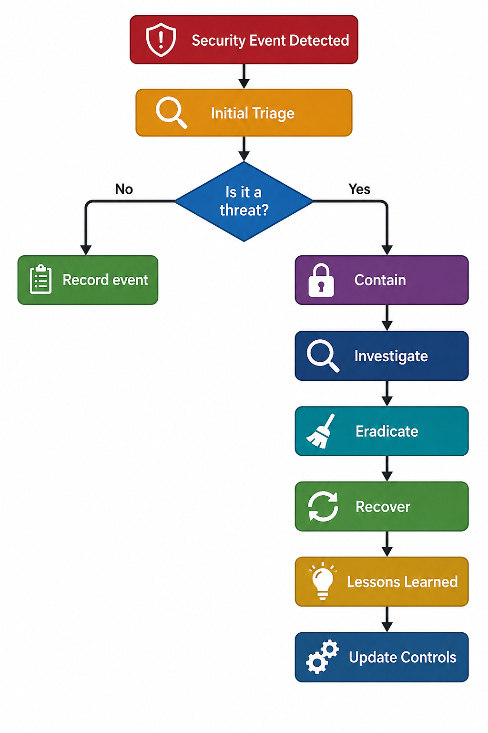

Figure 2. SFM Incident-Response Flow
If ransomware is suspected, the infected device needs to be isolated as soon as possible. The IT Security Manager should seek to communicate with the production manager before acting, which may cause problems with safety and operation if the production equipment is concerned. The evidence should be retained, compromised accounts should be locked, and the scope of attack established before recovery. Use verified clean backups to make your recovery. The incident should then be reported and an analysis carried out to assist with the improvement of controls.

6. Training and Security Awareness
There are many attacks that are dependent on human input and staff is a major element in security at SFM. Steinberg [5] shows how important it is to be aware of what is practical when confronted with common cyber threats. Training should hence be continuous, job-focused and measurable, rather than occurring annually.

Table 3. SFM Security Awareness Program
Training activity | Audience | Frequency
Cybersecurity induction | All new employees | At joining
Core security awareness | All employees | Annually
Phishing simulation | All employees | Every 3 months
Data classification and handling | All employees | Annually
Secure procurement and payment fraud | Procurement staff | Every 6 months
OT security and safe remote access | Engineers / production staff | Every 6 months
Privileged access security | IT administrators | Every 6 months
Incident reporting exercise | All employees | Annually

Key metrics to assess training effectiveness are the number of phishing tests that fail, the number of suspicious emails reported, and the time needed to report emails, and the number of emails completed. If an employee fails the simulation, don't automatically punish them; provide them with further information. The objective is to create a culture in which reporting a suspicious event is encouraged.

7. Governance and Performance Measurement
The board should also oversee the project strategically in a timely fashion and get a quarterly cybersecurity report. It is normally recommended that IT, production, HR and procurement have defined responsibilities, with the IT Security Manager as the de facto owner of the security program. Business risks registers to include cybersecurity risks as potential impacts to production, customers' commitments, intellectual property and reputation exist.
Some useful KPIs are the percentage of accounts protected by MFA, percentage of critical vulnerabilities that have been patched within the target timeframe, employee training completion, phishing simulation failure rate, percentage of failed backup recovery tests, percentage of critical suppliers assessed, and mean time for detection and containment.

8. Conclusion
SFM brings tangible operational benefits from the adoption of smart manufacturing technologies, while also posing cybersecurity challenges. The most serious risks are phishing, ransomware, industrial espionage, OT/ IoT compromise, supply-chain attacks, and insider misuse and unpatched systems. Security measures might include good identity controls, firewalls, VPNs, network segmentation, secure data handling, vulnerability management, backup systems, monitoring and, crucially, ongoing training of staff: defence in depth.
The critical controls will be implemented first and will be phased in a realistic way for a medium-sized manufacturer. Immediate threat remediation is possible with MFA, secure backups, access control and email protection, followed by segmentation, monitoring and supplier governance. Most importantly, cybersecurity must be a business continuity and production matter, rather than an IT problem. By combining established network-security principles from Stewart and Kinsey [1] and Stallings [2], [6] with current NIST guidance [3], [4], [8] and practical awareness guidance [5], SFM can build a stronger and more resilient security posture.

References
[1] J. M. Stewart and D. Kinsey, Network Security, Firewalls, and VPNs, 3rd ed. Burlington: Learning, 2021.
[2] W. Stallings and M. M. Manna, Data and Computer Communications, 10th ed. Boston: Pearson, 2021.
[3] C. Pascoe, S. Quinn and K. Scarfone, The NIST Cybersecurity Framework (CSF) 2.0, NIST Cybersecurity White Paper 29, National Institute of Standards and Technology, 2024.
[4] K. Stouffer et al., Guide to Operational Technology (OT) Security, NIST Special Publication 800-82 Rev. 3, National Institute of Standards and Technology, 2023.
[5] J. Steinberg, Cybersecurity for Dummies, 3rd ed. Hoboken: For Dummies, 2025.
[6] W. Stallings, Network Security Essentials: Applications and Standards, 6th global ed. Harlow: Pearson, 2017.
[7] International Organization for Standardization, ISO/IEC 27001:2022, Information Security, Cybersecurity and Privacy Protection—Information Security Management Systems—Requirements, ISO, 2022.
[8] A. Nelson, S. Rekhi, M. Souppaya and K. Scarfone, Incident Response Recommendations and Considerations for Cybersecurity Risk Management: NIST SP 800-61 Rev. 3, National Institute of Standards and Technology, 2025.



