Professional Career Development

Student ID: 1811816
Student Name: Paul Petrache
Module: BMSK4005_LON
Table of Contents
Introduction 3
Self- evaluation review, Self-motivation, learning styles 4
Different approaches to self-assessment and learning 5
Personal Development Planning using SWOT analysis, SMART Objectives and Johari window model 10
Reviewing the understanding and expectations of the world of employment 13
Career ambitions and aspirations 15
A personal development plan that will enable me to achieve my ambitions 16
Conclusion 17
References 18

Introduction
Finding the right job is not an easier task in the current competitive business market. Companies whether the small, medium or multinational focus on multiple skills in the employees to recruit and ensure competitive advantage in the market. My name is Paul and I am living in the UK for almost 5 years which means since 2015. During my stay in the UK, I realised a job cannot be easily found without appropriate education and different sets of skills though I work at the ASDA warehouse as an order picker. My current age is 30 but I am still continuing my study at the University of Wales to ensure a better career in order to get recruited or promoted for a better position. My duty at the ASDA warehouse is to pick the order from the customers and inform them of the higher position. As an employee, I understand that I need to possess good skills and abilities to perform the job roles to ensure customer satisfaction and for this purpose appropriative education and qualification are needed. My course at the university assessed me to acknowledge more skills and knowledge than I know before. Undertaking the course professional career development assesses me to acknowledge the ways to develop my career in the most effective and suitable manner. The following report will provide a portfolio that will assess in increasing my knowledge and learning about the professional career development. In this report, I will use self-evaluation methods like learning styles and self-motivation. I will also use SWOT analysis, SMART objectives and Johari window for the purpose of personal development planning. After that, I will review the understanding and expectations of the employment world to evaluate my own career ambitions and aspirations. At last, I will develop a personal development plan that will enable me to achieve my ambitions and will also assess me to increase my experience and knowledge in the workplace.

Self- evaluation review, Self-motivation, learning styles
Self-evaluation review is the way to review the performance of an individual by his own perspective and in this way an individual can gather more knowledge about him such as his actions and choices and can highlight these to the manager for better job scope and opportunity. Self-motivation is the way to motivate oneself without the influence of others to complete a task (Miller, 2017). Learning styles are the way an individual learns from the environment surrounding him as a person can learn in a different way such as by speaking with others, by listening and by reading and so on. Below the concept of self-evaluation, self-motivation and learning styles are described briefly-
Concept of self-evaluation review
Self-evaluation review is used to judge own skills and knowledge according to the job role. The purpose of self-evaluation is to highlight one's strengths, weaknesses, evaluate correct performance and to develop the unused abilities and skills. Different types of techniques such as quiz method, question method assesses in self-evaluation review (Turner and Record, 2018). Self-evaluation review makes a person aware of his own skills and the area needs to be improved from time to time. So it enables an employee to get updated with new skills and knowledge. As I work in the British supermarket ASDA as an order picker I always monitor my skills and abilities to satiate the customers and to meet with the standards and as a result, it assesses in my career development.
Concept of Self-Motivation
In the workplace, employees have to face different barriers and have to dill with different critical situation and it can also occur in personal life. Self-motivation is the tool that assists to tackle or face these barriers and critical situations with their own awareness and knowledge. Self-motivation is an effective tool to ensure self-review because it eliminates any kinds of issues without the influence of others. To become a professional in my career it is required to ensure effective self-motivation as it will help me to develop my career. In order to self-motivation, an individual must have to set a clear goal and also has to check his progress from time to time to perform the task (Gröpel and Kehr, 2017). Besides, self-awareness techniques such as self-reflection, personal values, and strength assessment can be used as effective tools for both self-awareness and self-motivation in professional life. As I work at ASDA, self-motivation can help me to upgrade my skills and knowledge from time to time.
Concept of learning styles
As an order picker at ASDA, it is necessary for me to continuously learn about different skills and abilities as it will assess in my professional career development. Different persons learn differently as per their mental and physical appearance. So, there are different learning styles that are used for the learning of personal. Different learning models such as the VARK model, Honey, and Mumford model assesses in effective learning that also helps a lot in professional career development (Turturean, 2018).

Different approaches to self-assessment and learning
There are different approaches used for self-assessment and for learning. As an employee, it is important for me to practice different self-assessment and use them as learning styles. Below some learning processes are described for self-assessment and learning-
- Assess readiness to learn
- Set learning goals
- Engage with the learning process
- Evaluate learning
Assess readiness to learn
Before trying to learn anything new it is effective to judge if I have the eagerness to learn and will it be effective for my career to learn these new things. So, if people have more interest in learning, they can ensure better professional and personal development. In my point of view, I am very much attentive to learn about different and new things that will accelerate my career with new skills and abilities (Octavianti and Usman, 2019). I always try to learn from my workplace and from my institute. The reason behind I have joined university is to develop my professional career through developing my educational background and to learn about new skills and abilities and to apply these in the job sector to ensure appropriate professional career development. So, I can say I am very spirited and do not miss any opportunities to learn.
Set learning goals
If a person has the willingness to learn then he has to set a goal to ensure appropriate learning in order to meet with an appropriate outcome. So, I also have to set a goal for my learning to find or ensure an appropriate outcome. The goal of my learning is to develop my abilities and skills to perform my job role in an appropriate manner. This goal will also help me in my workplace a lot because with comprehensive skill and ability I can ensure a competitive advantage on behalf of my company. So, this goal will assess me to learn appropriately in an effective manner.
Engage with the learning process
The most important task in the learning process and self-assessment is to engage with the learning process (Motley, 2018). Without an institute, it is not easy to engage with the learning processes. So, I am also engaged with an institute that is the University of Wales and here I am learning from the undergraduate program that is assessing me to develop both my employee knowledge and academic skills. Besides, I also learn from my workplace that it is an ASDA warehouse.
Evaluate learning
The final stage of the learning process is an evaluation of the skills and abilities I learned from my workplace, university and also my own learning. As a learner, it is not probable for me to learn every single thing at a time but I can learn slowly with times. So, evaluation provides me the realisation the number of skills and knowledge I learned in my learning process as it is most effective. In my learning process, I have found I have learned most of the skills such as communication skills, problem-solving skills but I have missed some skills in my learning process as all things cannot be acquired at a time. So, I can evaluate my learning in this manner that will assess my skills and abilities.
Honey and Mumford learning style
The Honey and Mumford learning styles demonstrates four different effective learning styles to learn appropriately to develop skill and abilities. They are described below-
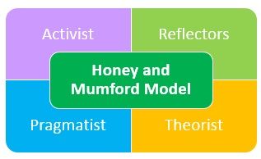
Figure 1: Honey and Mumford Learning styles
In the activist learning process, the learner has to provide direct effort in order to learn. For this purpose, the learner has to solve problems using own skills and knowledge, brainstorm to generate new ideas and adapting the challenges are some learning approaches used in this leaning method (Mumford, 2017). So, I prefer this learning style as it provides me the opportunity to learn to do the task by myself.
In the theorist learning style, the learner always focuses on model and article based theory to learn. As I am studying at the University of Wales I also learn using the theory that is established before by scholars. This type of learning style is very effective as it assesses to understand the reason behind the learning action. So, I prefer this style and also remember the theories that are taught by the teacher and also apply these in my daily work.
In the pragmatist learning style, the learner learns in the practical way that means the learner learn from the real world by seeing different application and action. Such kinds of learners are the interns that learn from the senior's work. I also work in an organisation that is the ASDA warehouse so I also learn by seeing my seniors work.
In the reflector learning style, the learner learns by previous experience and by observing the previous outcomes of the application (Mumford and Honey, 2018). When a learner learns by own mistakes learns effectively as he understands what to correct and what skills and ability are needed for the task. So, I also prefer this learning style as I also learn from real-life work experience and also learn from my university.
Kolb’s learning styles
Kolb’s learning style also consists of four different styles of learning. Kolb’s learning style is a cycle for effective learning and it is used widely so that all types of learners can learn easily. They are demonstrated below-

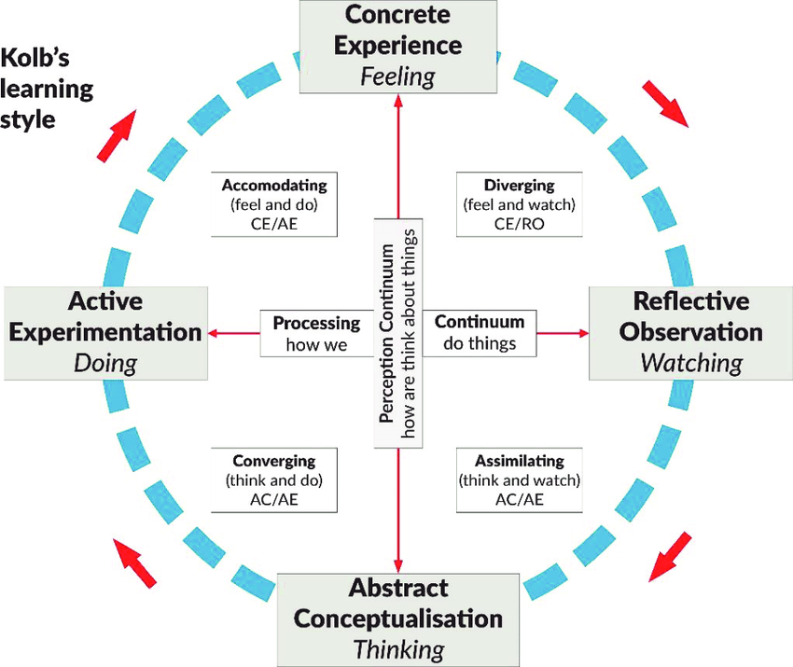
Figure 2: Kolb’s learning style
(Kaushik, 2017)
The first stage of the cycle is concrete experience and it provides learning opportunities by experiencing new things. The learner feels new experience and learns by focusing on the tasks and mistakes. So, I also try to feel the new experiences and try to learn from these experiences.
The second stage of the learning cycle is reflective observation and in this step, the learner learns based on the feeling of the new experience. The learner performs tasks in this step and observes these to understand the actual action. I also observe my tasks to learn from new experiences according to my own understand.
The third stage of the learning cycle is abstract conceptualization and in this step, the learner learns from the reflection of new experience and by creating own idea (Garner, 2017). The learner thinks critically in this learning style and generates new ideas to solve the problems that arise. I also think and my practical skills and abilities develop the learning perception in this step.
The last stage of the learning cycle is active experimentation. The learner applies the learning in this step from their developed perception. I also applied my academic learning in my workplace and by doing so I am able to understand whether my learning works or not. In this step, accommodation assesses in feeling and doing so I can focus on another personal learning easily.
Identifying personal learning preferences
Among the different learning styles, I prefer the VARK model that is most effective for me to learn any new concept or application. VARK model consists of four different learning styles such as visual, Auditory, Reading or Writing, and Kinesthetic (Moayyeri, 2015). These learning styles are described below-
Visual
In the visual learning style, the learner learns by seeing videos, graphs, charts and so on (Miller, 2017). I learn effectively from the internet, social media and books and so on. My personality fits with this learning style and the visual diagram assesses last long in my memory thus I prefer this style more than other learning styles.
Auditory
I also prefer this learning style as it assesses in learning by listening to audio. I always focus on my teacher's lecture and also record these as a method for auditory learning. I use this type of learning in my academic life and to solve critical problems.
Reading or Writing
Some people learn better when they read or write. I also read books and write many times and it assesses me to memories the lessons for longer and I also use this easily in my workplace.
Kinaesthetic
There is also a learner that learns effectively from practical working and real life. I am the kind of person that learns from real-life experiences. So, this learning is very effective for me and I also use it in my workplace.
By going through these learning approaches, styles of self-review and methods I have found I am capable of undertaking any kind of job role and my skills and abilities are also suitable for employment. I am also positive about my abilities and skills so I think I have a better job scope as I use effective learning styles and I also have high self-motivation strengths.

Personal Development Planning using SWOT analysis, SMART Objectives and Johari window model
When an individual intended to prepare a personal development plan he/she needs to go through different stages that determine whether the person is able to develop oneself. The SWOT analysis will assess in finding the potential skills and abilities. After that, a SMART objective needs to be set based on the SWOT analysis that ensures the personal development plan effectively. The Johari window model will assess to evaluate the effectivity of the personal development plan. So, I will use these steps for my personal development plan.
SWOT analysis
Strengths | Weakness
- I possess multiple skills that assess me to perform any job role.  - I have good problem-solving skills.  - I have good communication skill that assesses me to keep good communication with the customers.  - I can work under pressure and can perform the task.  - I am very passionate about my job role and details oriented.  - I have good technical skills to manage computers and social media. | - I am not able to communicate in multiple languages.  - I am not good at teamwork.  - I am not able to collaborate easily with other employees in the workplace.  - I have a lack of motivating skills.  - I do not understand the company’s policy appropriately.
Opportunities | Threats
- I have opportunities to learn new skills by working in a team.  - As a student, I have the opportunity to develop my academic skills.  - I have the opportunity to engage with different cultural employees to learn their language in order to improve multiple communication skills. | - I am bad at managing times to develop new skills for my professional career development.  - I am bad at selecting to select appropriate learning styles from different choices.

Based on the SWOT analysis, I found that I have good command over different abilities and skills but there are many skills I need to work on for effective employee roles such as leader and manager. I have opportunities to learn many new skills but I have to maintain my time appropriately and I also have to work on my decision-making skills to improve my overall skills and abilities.
SMART objectives for personal development
As I mentioned, I will set SMART objectives based on the SWOT analysis so from the analysis I have found I have to improve my weakness and eliminate the threats for an effective employment opportunity. SMART objectives are the objectives that are specific, measurable, achievable, and realistic and demonstrate a time plan to achieve the objectives. Below a SMART objective is provided for me-
SMART Objectives | Specific | Measurable | Achievable | Realistic | Timing
Improve the team-working skill | I can work with other employees in my workplace and can respect their opinions to improve my team-working skills. | This skill can be measured if my team can succeed in any task in my involvement. | By engaging with other members will assess in achieving the team working skills. | This skill can be achievable if I engage with other employees regularly. | It can take 1 year for me to develop this skill.
Improve communication skills | I can maintain appropriate communication with other cultural people to learn multiple languages. | It is possible to improve this skill by engaging with different types of people so it is measurable. | The skill is achievable through maintain communication with others. | This skill is realistic as it takes real-life communication to improve communication skills. | I can improve this skill within 1 year.
Develop the motivation skill | I can learn public speaking to motivate others in the workplace. | I can measure the skill if peoples get influenced by my appearance and speaking. | I can achieve this skill by watching motivational videos. | Motivation is realistic as people get the spirit to work effectively after getting motivated. | I can improve this skill within 8 months.
Improve collaborating skill | To improve this skill I can engage with more people in the workplace. | This skill can be measured if other employees like to work with me. | I can achieve the skill by ensuring appropriate communication with others. | As I have a workplace so this objective is realistic. | I can improve this skill within 7 months.

Johari Window Model
Johari window model focuses on four features to ensure the effectivity of my personal development plan. These are described at large below-
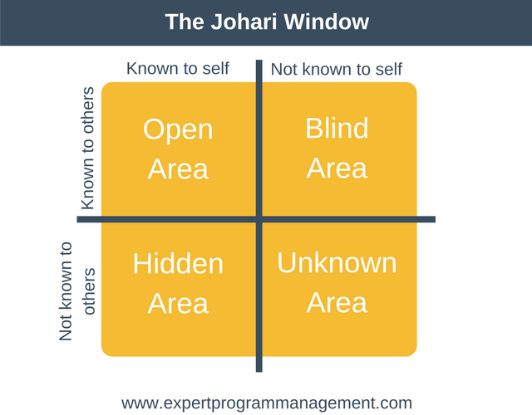
Figure 3: Johari Window Model
Open Area
The open area describes the skills and abilities of an individual that is known by others or oneself. I have good communication skills, managing skills, a technological skill so all of these skills are in the open area. I can easily improve my skills as I am already good at these skills.
Blind Area
In the blind area, the skills and abilities are not known to oneself rather it is known by others. In my workplace, my senior says I can think critically but I do not have acknowledgment about this skill.
Hidden Area
The hidden area demonstrates the skills that are not known to others rather than self (Verklan, 2018). I have some hidden skills such as problem-solving skills, interpersonal skill but as I do not work on these skills they are hidden. I will try to develop these skills to make these my open area skills.
Unknown Area
The unknown area describes the skills that are not known to anyone and also to self. I will spend more time with me to identify my unknown skills.

Reviewing the understanding and expectations of the world of employment
The world of employment is completely different from my understanding so the expectation is also different from the real-life experience. Below a review is provided to demonstrate the understanding and expectations of the world of employment-
Self-exploring
As I am already working in a company so I have the opportunity to explore the world of employment. I have found that the company focuses on professionals as they have better competence and can contribute to upgrading knowledge in the organisation. I also get different ideas to succeed in the world of employment by evaluating my own work and other's work. I also found that good skills and knowledge are required for a better employment opportunity.
Observing own job role and employment
I observed my job role and found that I have the scope to get promoted if I can able to improve my motivating skill, managerial skill, technological skill, and communication skills. As an order picker at ASDA, I can get the opportunity to become the manager with the right skill set.
Exploring career and academic options
I have found that the world of employment requires a good educational background as the academic skills are effective in both personal and professional career. The educational background determines how far a person can shine in his life (Moayyeri, 2015). So, as an undergraduate, I try to gather enough academic knowledge for an effective employment opportunity.
Strategies for career advancement
Staff recruitment
An organisation can recruit employees in two ways such as internal and external recruitment. If an organisation recruits employees by recommendation or by existing employee’s referrals it is internal recruitment. In contra, if employees are recruited through advertisement and job post then it is external recruitment. If an organisation ensure effective employee’s recruitment it assesses in attaining organizational goal so, in my opinion, external recruitment is best to recruit qualified employees.
Person specification
When an employer selects a person specifically by seeing his competence it is defined as person specification. In this technique, the employer selects a suitable person for the job role.
Interviewing
In the interview process, the employer judges the employees according to the skill needed for the job role. Interviewing undertakes direct communication among the employer and candidate. A candidate's overall appearance and skills are judged in the interview process.
Mentoring
Mentoring is an effective technique as after getting recruited employees to need to learn about the basic policies of the organisation. Effective mentoring assess the employer to monitor whether the employee is really suitable for the job role.

Career ambitions and aspirations
As an employee, I have my own career ambitions and aspirations that I like to fulfil. My career ambitions and aspirations are provided below-

Figure 4: My career ambitions and aspirations
Learning new skills
My career goal is a professional career development and for this purpose, I need to learn new skills. I am learning new skills not in my university but I am also trying to learn from my mentors and seniors in my workplace.
To become an effective professional
I am working on different skills to update my knowledge as it is my aspiration and my desire is to get promoted and it will assess me to become an effective professional in my job field.
Effective management and leadership skills
As an employee, I understand the value of a manager and a leader. Management and leadership skills assess in managing the employees. So, I have the desire to develop management and leadership skills and manage employees.
Communication more on professional levels
My ambition is to communicate with the professional as it will provide me the scope to learn about the appearance and skills of professionals. Regular communication on a professional level will allow me to learn good management and leadership skill.

A personal development plan that will enable me to achieve my ambitions
In this report, I have done many tasks such as self-evaluation review, learning styles, SWOT analysis and also provided a SMART objective to improve my skills. From these activities, I have found the need for a personal development plan that will enable me to achieve my ambitions as described above. The personal development plan is provided below-
Objectives | What to do for achieving the objective? | Required timeframe for achieving the objective | Achievement progress | Further development strategies
Learn new skills | I need to engage with other employees and seniors. | 2 years | Progressing | Professional Courses involvement and learning.
Become an effective professional | I need to have command over vital skills such as communication skills, problem-solving skill and critical thinking skills. | 2 Years | Progressing | Working and learning from work.
Improve management and leadership skill | Outside of the workplace, I can manage a small group of people to improve management and leadership skills. | 1 year | progressing | Need to Involve more in team working in a different role.
Improve communication skill | I need to learn different languages for this purpose I can engage with the professional course. | 6 Months | progressing | Practicing the languages so that can communicate more precisely.

Conclusion
All the people engage with professional career development in time because it is required to ensure an effective job role and to find a secure job. The report is based on the portfolio of professional career development and it is successfully done by me. Throughout the report, I have performed different activities that helped me to understand my skills and abilities and I also acknowledge my strengths and weaknesses. The Johari window model also helped me a lot to understand the skills that I do not know about. Different learning styles showed me the path of how to learn effectively by undertaking different model and techniques. The SMART objectives helped me to set a unique objective to improve my career. So, as a result, I have developed my own personal development plan based on these learnings and models that will assess me to learn new skills such as team working skills, problem-solving skills and so on. By developing these skills I can ensure effective professional career development.

References
Garner, I. (2017). Problems and Inconsistencies with Kolb's Learning Styles. Educational Psychology, 20(3), pp.341-348.
Gröpel, P. and Kehr, H. (2017). Motivation and Self-Control: Implicit Motives Moderate the Exertion of Self-Control in Motive-Related Tasks. Journal of Personality, 82(4), pp.317-328.
Kaushik, P. (2017). Redefining Learning: Kolb's Theory of Learning Styles with Gardner's Multiple Intelligences. International Journal of Learning and Teaching, 9(1), pp.330-339.
Miller, W. (2017). A Comprehensive and Coordinated Program of Professional Career Personnel Development. Journal of Career Development, 1(1), pp.3-10.
Moayyeri, H. (2015). The Impact of Undergraduate Students’ Learning Preferences (VARK Model) on Their Language Achievement. Journal of Language Teaching and Research, 6(1), p.132.
Motley, P. (2018). Learning-to and from-the Visual Critique Process. New Directions for Teaching and Learning, 2015(141), pp.77-86.
Mumford, A. (2017). Learning Style and Learning Skills. Journal of Management Development, 1(2), pp.55-65.
Mumford, A. and Honey, P. (2018). QUESTIONS AND ANSWERS ON LEARNING STYLES QUESTIONNAIRE. Industrial and Commercial Training, 24(7).
Octavianti, S. and Usman, O. (2019). Effect of Environmental School, Study Habits, Interests Learn, Learn the Readiness of Students. SSRN Electronic Journal.
Turner, C. and Record, A. (2018). Self-Concept Clarity: Evaluation of Self, Peer, and Professional Ratings. Measurement and Evaluation in Guidance, 14(1), pp.38-45.
Turturean, M. (2018). Teaching Styles Associated with Students' Learning Styles. SSRN Electronic Journal.
Verklan, M. (2018). Johari Window Model. The Journal of professional career development, 21(2), pp.173-174.

