30/03/2026

Programme: CertHE Computing Skills for Workplace
Module Name: Computer Architecture and Operating Systems
Module Code: ACCA4022
Lecturer: Rajeev Nath, Kwame Assa Agyei
Word count (or equivalent): 2000 words, (2500-word equivalent)
Student name: Sunny Anibaba
Student ID number: 2210976
UNIVERSITY OF WALES TRINITY SAINT DAVID
LONDON CAMPUS

ASSIGNMENT
  - Component 2-Coursework System
Table of Contents
Introduction 2
1. Key functions of general Operating Systems 3
1.2 Managing hardware / Device Management 3
1.3 Process Management 3
1.4 Handling files 4
1.5 Managing memory 5
1.6 Security and access control 5
1.7 Providing a user interface 5
2 Use of Windows OS CLI commands 5
2.1 Process Management: 5
2.2 Files & Directories: 6
2.3 Networking: 6
2.4 User Management 7
2.5. Task Scheduling 8
3 Use of Linux OS CLI commands 9
3.1 Managing Processes 9
3.2 File & Directory Management 9
3.3 Network Monitoring 10
3.4 User Management 10
3.5 Automation with Cron 10
4. Automating Windows with Batch Scripts 11
4 Use of Windows OS scripts 11
5. Automation in Linux (Bash Scripting) 12
Task 5. Use of Linux OS scripts 12
Conclusion 12
References 13

Introduction

Computer architecture and operating systems sit at the heart of everything a computer can do and understanding them feels a bit like lifting the hood on a machine you’ve used your whole life. Computer architecture is the blueprint, the way processors, memory, and hardware components are designed and connected so they can carry out instructions efficiently. The operating system, such as Windows, Linux or MacOS etc.. is the software layer that sits on top, bringing all the hardware to life, managing files, running programs, juggling resources, and making sure everything works smoothly without the user needing to think about it. Together, they form the foundation that allows modern technology to feel seamless, whether you’re streaming a film, writing code, or just browsing the web.

1. Key functions of general Operating Systems
Whether you’re using Windows, macOS, or a Linux distro like Ubuntu, the operating system (OS) is the essential middleman. It sits between you and the hardware, making sure everything stays stable, secure, and easy to use.

Here are the key functions of a general operating system:

1.2 Managing hardware / Device Management
For your keyboard, printer, mouse, or webcam to work with the computer, the OS uses drivers. These are essentially "instruction manuals" that tell the computer how to talk to its hardware. Without good device management, your peripherals simply wouldn't respond.
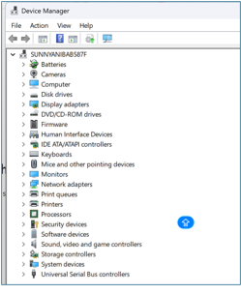
Figure 1: Shows devices connected to my computer
Source: Author’s own screenshot

.

1.3 Process Management
Process management within the computer architecture is responsible for starting, scheduling, and closing programs while making sure the CPU isn't overwhelmed, while the task manager enables the user to gain control of the running and disabling tasks. This is what allows us to multitask, like browsing the web while listening to music. It loads applications, keeps them running, and switches between them smoothly so you can multitask without thinking about it.
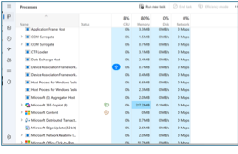
Figure 2 : Task Manager showing active processes and CPU usage Source: Author’s own screenshot

1.4 Handling files
Everything you save, open, move, or delete goes through the OS. It keeps your files organised and makes sure they’re stored safely. Beyond just moving files around, it also handles permissions deciding who can see or edit specific folders.
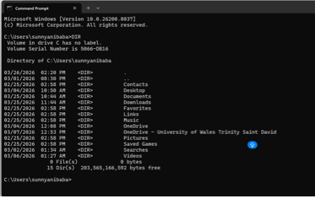
Figure 3: Command Prompt showing created directory (TestFolder) Source: Author’s own screenshot

1.5 Managing memory
The OS decides how much memory each program gets and frees it up when it’s no longer needed, preventing slowdowns and crashes.

1.6 Security and access control
It protects your system by controlling who can access what, blocking harmful actions, and keeping your data safe.

1.7 Providing a user interface
Whether it’s a desktop, command line, or touch interface, the OS gives you a way to interact with the computer that feels natural.

2 Use of Windows OS CLI commands

Using the Windows Command Line
While most people stick to the desktop, the Windows Command Prompt and PowerShell are incredibly powerful for system admin work.

2.1 Process Management:

You can use tasklist to see everything running. If a program freezes and won't close normally, taskkill lets you shut it down instantly by its ID or name.
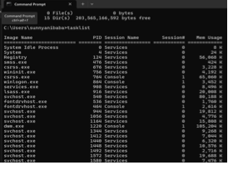
Fig 4
- Source: Author’s own screenshot

Description example:
"Lists all currently running processes along with their process IDs and memory

2.2 Files & Directories:

Instead of clicking through folders, you can use dir /s to find files deep in subdirectories or ‘mkdir’ to instantly create new folders.
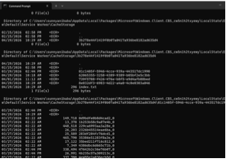
Fig 5
Source: Author’s own screenshot

2.3 Networking:

If your internet is acting up, ping google.com is the quickest way to see if you're connected. You can also use netstat -an to see every active connection your PC has open.
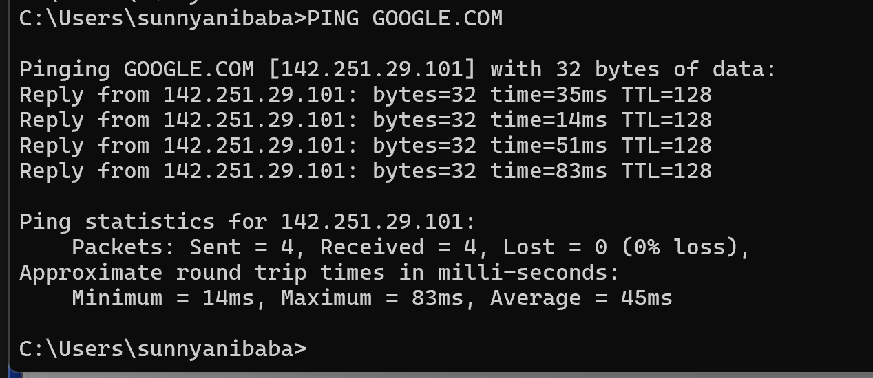
Figure : Ping Google.com to verify Network is connected
Source: Author’s own screenshot

2.4 User Management

User Accounts: Admins can manage users without opening the Settings app. net user shows everyone on the system, while adding /add or /delete lets you manage accounts quickly. ‘net user’ lists all NETWORK user accounts on the system
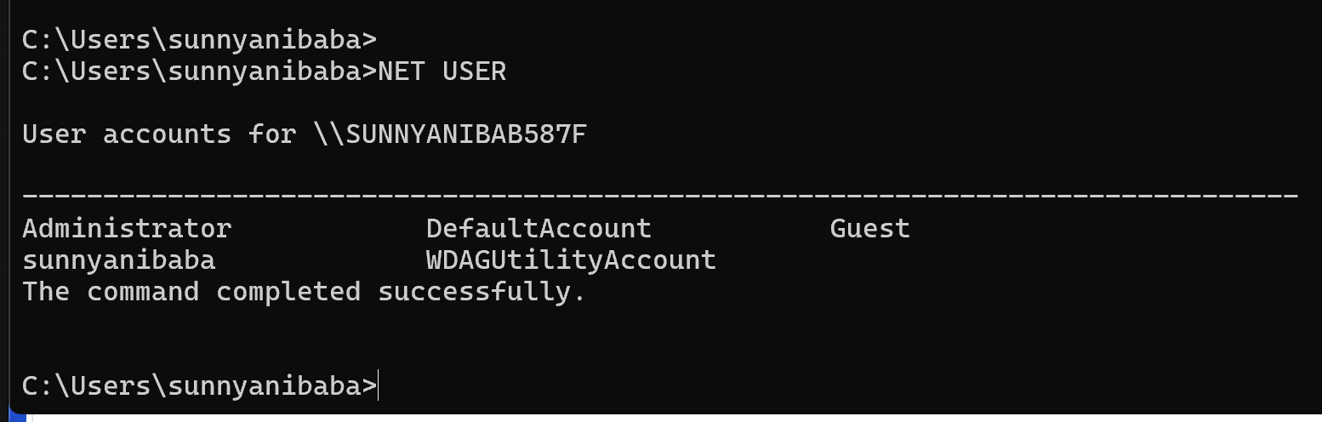
Source: Author’s own screenshot

Automation: The schtasks command is a lifesaver for repetitive work. You can set it to run a backup script or a maintenance tool at the same time every day so you don't have to remember to do it manually.

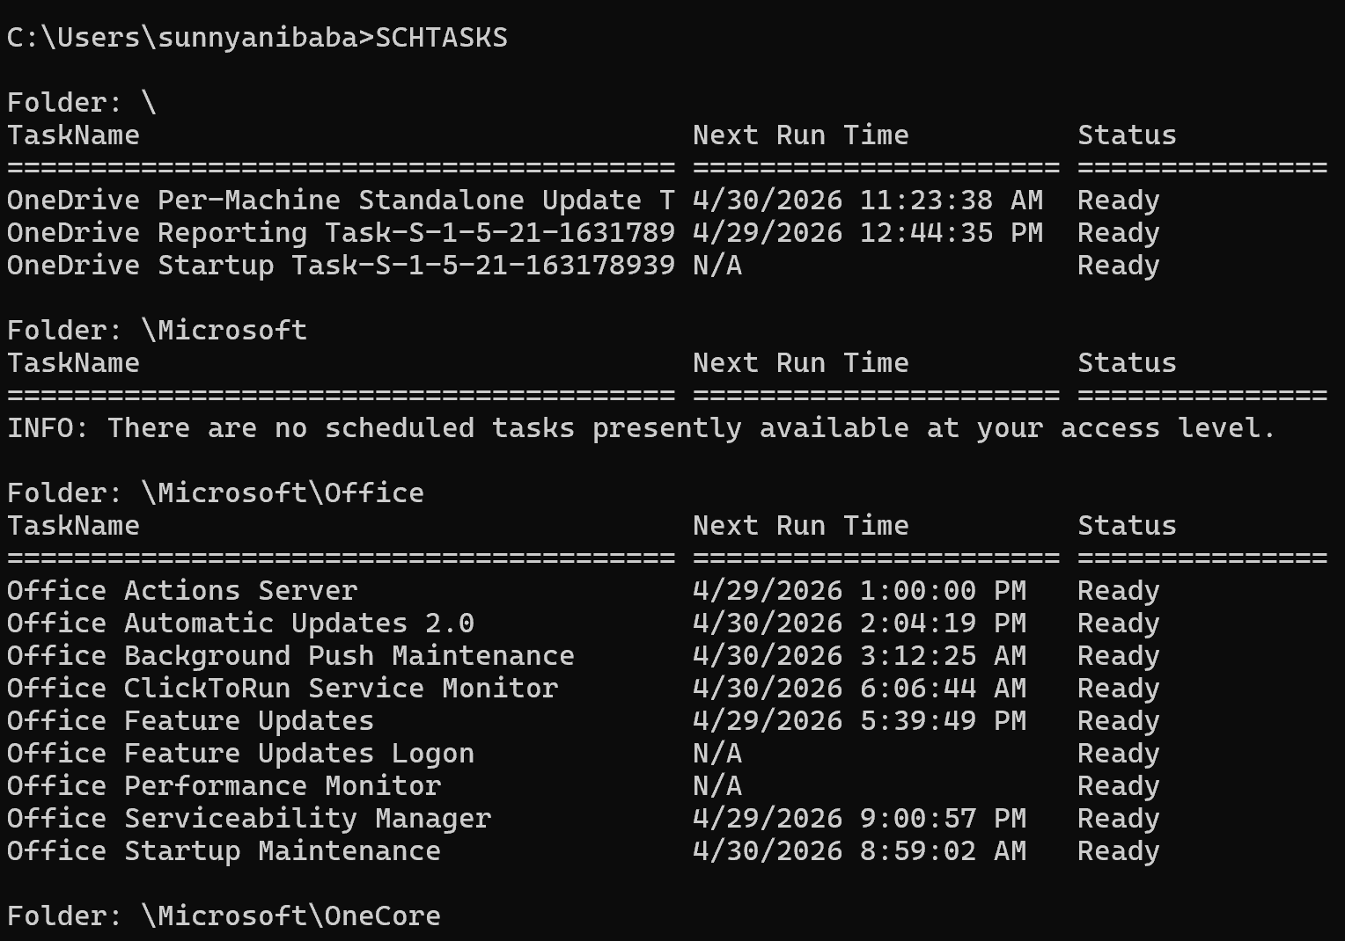

Source: Author’s own screenshot

2.5. Task Scheduling

Windows makes it easy to automate repetitive jobs using the Command Prompt or PowerShell. This is a huge timesaver because you can set scripts or programs to run on their own without having to remember to start them manually.

Figure 10 here: Showing the "SUCCESS" message after creating the task

How it works: The schtasks command is basically the command-line version of the Task Scheduler. You use /tn to give your task a name, /tr to point to the file you want to run, and /sc and /st to set the frequency and time. It’s a straightforward way to handle things like daily backups or system maintenance without much fuss.

3 Use of Linux OS CLI commands

Mastering the Linux Command Line
Linux is built around its terminal (the Bash shell). It’s the go-to for developers and sysadmins because it’s often much faster to type a quick command than to click through several menus.

3.1 Managing Processes
- ps aux: Think of this as a detailed snapshot. It shows every single thing running on the system, including who started the process and how much RAM it’s hogging.
- top: If you want to see what’s happening right now, top is the interactive version. It updates in real-time, which is perfect for catching an app that is suddenly freezing the system.
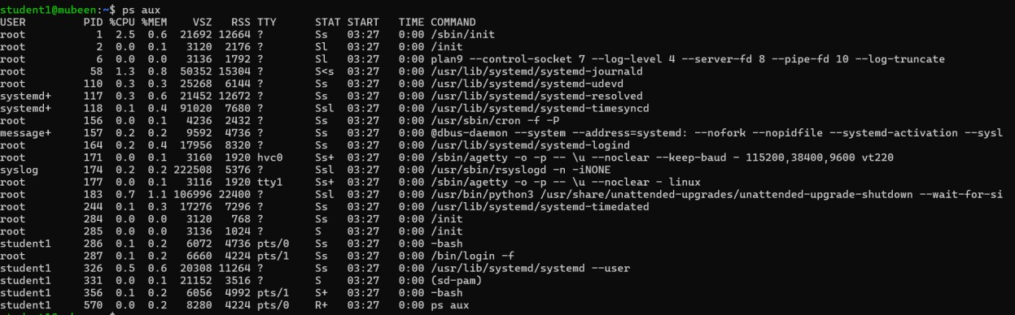

Figure

3.2 File & Directory Management

Organising files is a lot quicker in the terminal once you know the basics:
- ls -R: This doesn't just show you what's in your current folder; it lists everything in the subfolders too.
- mkdir Projects: A simple way to instantly spin up a new folder.

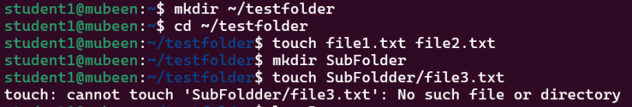
Figure ps aux showing running processes
Source: Ubuntu Documentation , Linux Manual Pages

Figure 2. interactive view showing CPU and memory usage
Source: Ubuntu Documentation
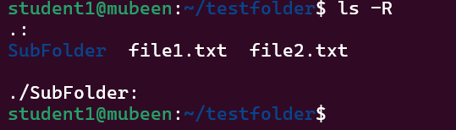

3.3 Network Monitoring
Whether you’re troubleshooting a dead connection or just checking your IP, these tools are essential:
- ping google.com -c 4: This sends four "pings" to Google to see if your internet is actually reaching the outside world.

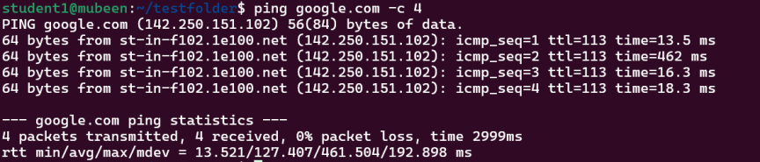

Figure Caption: Figure 9 – ping checking connectivity to Google
Source: Ubuntu Documentation

- ifconfig (or ip addr): This displays your network hardware details, like your IP and MAC addresses.
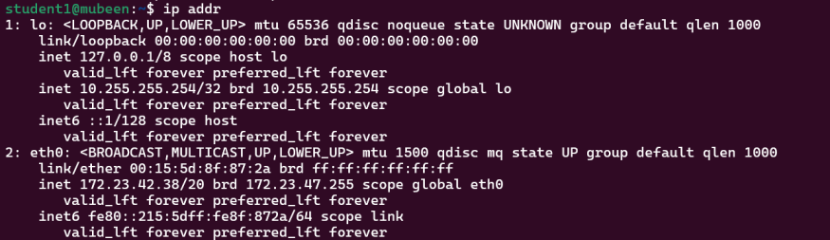

Figure Caption: Figure 10 – ip addr displaying network interfaces
Source: Ubuntu Documentation

- netstat -tuln: This shows which "doors" (ports) are open on your computer and which services are listening to them.
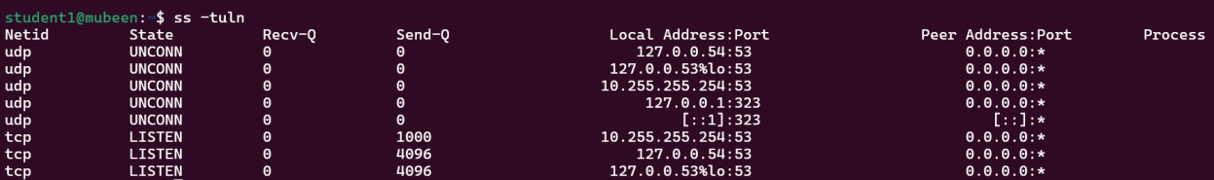

3.4 User Management
Linux is built for multiple users, so keeping track of who can do what is a big part of the job:
- whoami: A quick check to see which account you’re currently using.
Figure Caption: Figure – ss -tuln showing active TCP/UDP ports
Source: Ubuntu Documentation

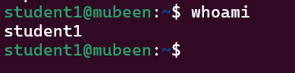
- id and groups: These tell you exactly what permissions you have and which groups you belong to.

3.5 Automation with Cron
For tasks you don’t want to do manually, Linux uses cron jobs:
- crontab -l: Lists all your currently scheduled tasks.

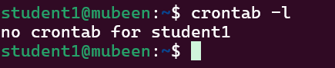

- crontab -e: Opens the editor so you can sch

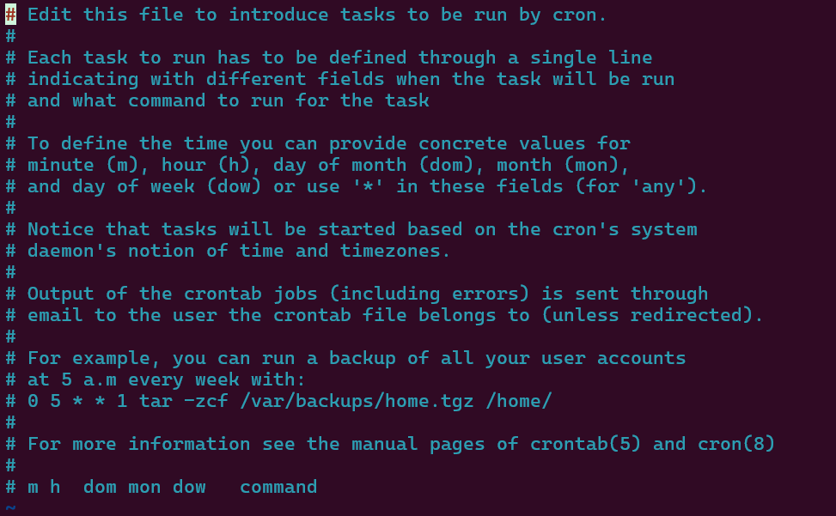
- Schedule a new task to run at a specific time (like a backup every Sunday at midnight).

Figure crontab -l showing no scheduled tasks for the user
Source: Ubuntu Documentation

4. Automating Windows with Batch Scripts
Batch scripts are basically just a list of commands saved in a file so Windows can run them all at once. They are great for turning a complex job into a one-click process.
Script 1: The Disk Space Checker
This script is a handy tool for system admins. It asks the user for a drive letter (like C:), looks at the available space, and warns them if there’s less than 1GB left.
Why it’s useful: It saves you from having to manually check properties on every drive, making it a great "early warning" system for full disks.

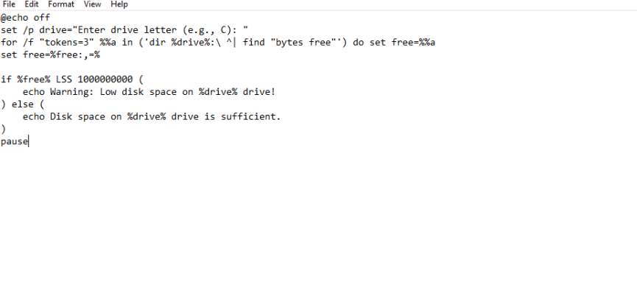
Figure

Script 2: A Simple Guessing Game
While this is just a game, it’s a perfect example of how scripts "think." It uses random numbers, loops, and "if/else" logic to react to what the user types.
The point: The same logic used to check a guess in a game is used in the "real world" to check if a backup was successful or if a server is down.

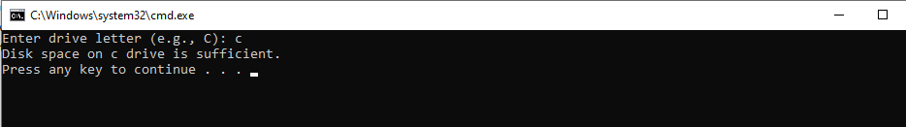

4 Use of Windows OS scripts

1. Use of Windows OS Scripts (Enhanced Version)

Windows Batch scripting provides a way to automate routine system tasks, combining user input, variables, loops, conditional statements, and basic arithmetic operations. Batch scripts allow
administrators or users to execute repetitive tasks efficiently without relying on graphical interfaces .
Script 1 – Disk Space Checker

This script prompts the user to enter a drive letter (e.g., C:) and checks the available free space. If the drive has less than 1 GB of free space, it alerts the user; otherwise, it confirms that the space is sufficient.

Key features:

• set /p for user input

• for /f loop to retrieve disk space information

• if ... else conditional statements to display appropriate messages

• echo to provide feedback in the command line

Practical use: This script can be used by system administrators to monitor storage usage and prevent low disk space issues before they affect system performance.

5. Automation in Linux (Bash Scripting)
Bash scripts are the Linux equivalent of Batch files, but they tend to be even more powerful.
Script 1: The Backup Script
This script is designed to take a specific folder and copy its contents to a backup location automatically. It uses variables and loops to make sure the data is moved safely without the user having to drag and drop files every day.
(Figure 22)

Task 5. Use of Linux OS scripts

Conclusion
Working through these tasks showed just how much more efficient it is to manage a system via the command line rather than just relying on a desktop interface. From managing users to setting up automated backups with Batch and Bash scripts, these exercises highlighted the core functions that keep an OS running smoothly. Ultimately, the ability to use these tools directly allows for much better administrative control and productivity in any computing environment.

References
[1] J. L. Hennessy and D. A. Patterson, Computer Architecture: A Quantitative Approach, 6th ed. Cambridge, MA, USA: Morgan Kaufmann, 2017. [Online]. Available: Amazon.
[2] A. Silberschatz, P. B. Galvin, and G. Gagne, Operating System Concepts, 10th ed. Hoboken, NJ, USA: Wiley, 2018. [Online]. Available: Wiley.
[3] I. Englander, The Architecture of Computer Hardware and Systems Software: An Information Technology Approach, 2nd ed. New York, NY, USA: John Wiley & Sons, 2000. [Online]. Available: Biblio.Appendix

