

Module Name: Problem Solving and Innovation
Module Code: (BMSW4014)
Assignment Name: Greenwashing in the
Automobile Industry

Student Name: Adnan Alsoul
Student Number: 2437246
Lecturer: Arpu Kumar
Module Lead Jaliya de Silva
Deadline: Friday 14th November 23.59

AI Acknowledgement

I confirm that I have not presented any AI generated materials as my own work

Contents
AI Acknowledgement 2
I confirm that I have not presented any AI generated materials as my own work 2
Introduction 4
Main Body 4
1. Realize the Problem 4
2. Gather Data 4
3. Determine Possible Causal Factors 5
4. Identify the Root Cause 5
5. Recommend and Implement Solutions 5
Conclusion 6
REFERENCES 7
APPENDIX 8
Root Cause Analysis 8

Root Cause Analysis of Volkswagen’s 2015 Diesel Scandal

Introduction

One of the largest car manufacturers in the world, Volkswagen, was involved in a major scandal in 2015 called the Dieselgate. It was found out that the company had installed special software in diesel cars to pass the emissions tests. The vehicles appeared to be green in the tests but when on the road, they produced a lot of harmful gases. This episode demonstrated the gross inefficiencies in the ethics and management culture of Volkswagen (Florio and Sproviero, 2021). In this essay, the reasons behind the scandal and the attempts that the company has undertaken to regain its image through the Root Cause Analysis (RCA) process and the Fishbone (Ishikawa) model (Model attached in APPENDIX) will be analysed.

Main Body

1. Realize the Problem
The issue that Volkswagen faced was not just a technical failure but an ethical and governance problem. The company had lied deliberately to regulators and customers to market the diesel cars as clean when they were not. The global outrage, legal penalties, and loss of public trust were caused by the fact that approximately 11 million cars around the world were impacted (Guidara, 2025). This demonstrated that the management of the company placed more emphasis on performance and profit rather than honesty.

2. Gather Data
The U.S. Environmental Protection Agency and European regulators conducted investigations and discovered that Volkswagen employed defeat devices to manipulate the results of the emissions. Internal records and emails showed that executives and engineers knew about this fraud. The statistics also indicated that workers were too scared to report misconduct because of the rigid top-down management (Zhang, Atwal and Kaiser, 2021). The company lost money, lawsuits, and reputation that was damaged in the long run.

3. Determine Possible Causal Factors
The Fishbone diagram finds a number of causes. Poor ethical leadership and profit pressure were major issues under management. There was poor compliance and auditing and weak processes. In technology, engineers abused the use of software to control test results. The human aspect involved the lack of ethics training and the fear of whistleblowing. Strict emissions regulations and intense competition in the market were aspects of the environment, and materials problems included diesel engines that could not meet clean-air requirements (Turna, 2022). All these combined formed a system that enabled misconduct to thrive uncontrollably.

4. Identify the Root Cause
The cause of the problem was a corporate governance and ethics failure. The leaders of Volkswagen were concentrated on dominance in the market and disregarded internal warnings. The company did not have ethical behaviour as a part of its culture, and compliance systems were merely symbolic (Kano, Simoes and Verbeke, 2023). This led to the introduction of dishonesty in day-to-day activities.

5. Recommend and Implement Solutions
Volkswagen reacted by restructuring the top management, enhancing compliance and transparency. Electric and hybrid vehicle projects were also introduced by the company to show a real desire to be environmentally responsible (Florio and Sproviero, 2021). Also, Volkswagen introduced ethics training and a culture in which employees were able to express their concerns freely, without the fear of being punished (Turna, 2022)

Conclusion
The case of Volkswagen Dieselgate demonstrates that absence of ethics can destroy trust in the company. This was primarily caused by a bad culture and leadership. Through honesty, responsibility and innovation, Volkswagen will be able to restore its image and move on to a brighter future.

REFERENCES
Florio, C. and Sproviero, A.F., 2021. Repairing legitimacy through discourses: insights from the Volkswagen’s 2015 diesel scandal. Meditari Accountancy Research, 29(3), pp.524-542.
Guidara, A., 2025. LESSONS FROM THE VOLKSWAGEN EMISSIONS SCANDAL: A LITERATURE. Business Review, 1(1), pp.17-22.
Kano, L., Simoes, S. and Verbeke, A., 2023. Governance failure and firm-level crises: The case of the Volkswagen emissions scandal. In Research Handbook on International Corporate Social Responsibility (pp. 168-186). Edward Elgar Publishing.
Turna, G.B., 2022. How “dieselgate” changed Volkswagen: Rushing to erase the traces of greenwashing. In Socially responsible consumption and marketing in practice: Collection of case studies (pp. 255-273). Singapore: Springer Nature Singapore.
Zhang, M., Atwal, G. and Kaiser, M., 2021. Corporate social irresponsibility and stakeholder ecosystems: The case of Volkswagen Dieselgate scandal. Strategic Change, 30(1), pp.79-85.

APPENDIX

Root Cause Analysis
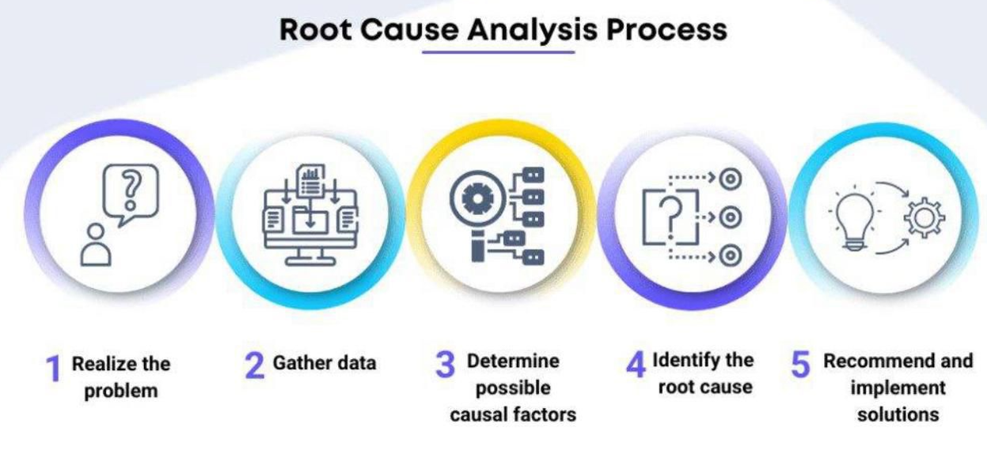

Fish Bone Diagram


