TESLA Inc.
Assessment of the current environmental forces and their impact.


Module: Global Business Challenges
Module code: BMMB7006D
Student Name: Arcangelo Ferrigno
Student Number: 1917529
Date Submitted: 07/01/2022

Executive summary

This essay aims to analyze Tesla Inc, a company that disrupted the industry of the Electric Vehicles (EV), shaping its business model in order to overcome the obstacles which have historically held back the large-scale spread of this industrial segment
After an introduction of the company, its marketplace, business model, and competitors, it will be done an analysis of its environmental forces and their impact on it.
Will be presented also the marketing strategy, the target consumers, strengths, and weaknesses.

Table of Contents

1. Introduction – The Company 4
2 The Company Business Model 5
2.1 Mission and strategy 5
2.2 Vertical Integration 6
2.3 Direct Sales 7
3 The Marketplace 9
3.1 The EV Market: Trends and Developments 9
3.2 The EV Market: Tesla and Competitors 12
4 STP- Segmentation, Targeting and Positioning 16
5 Tesla PESTLE Analysis 17
6 Tesla SWOT Analysis 18
7 Conclusion 21
References 23

Introduction – The Company

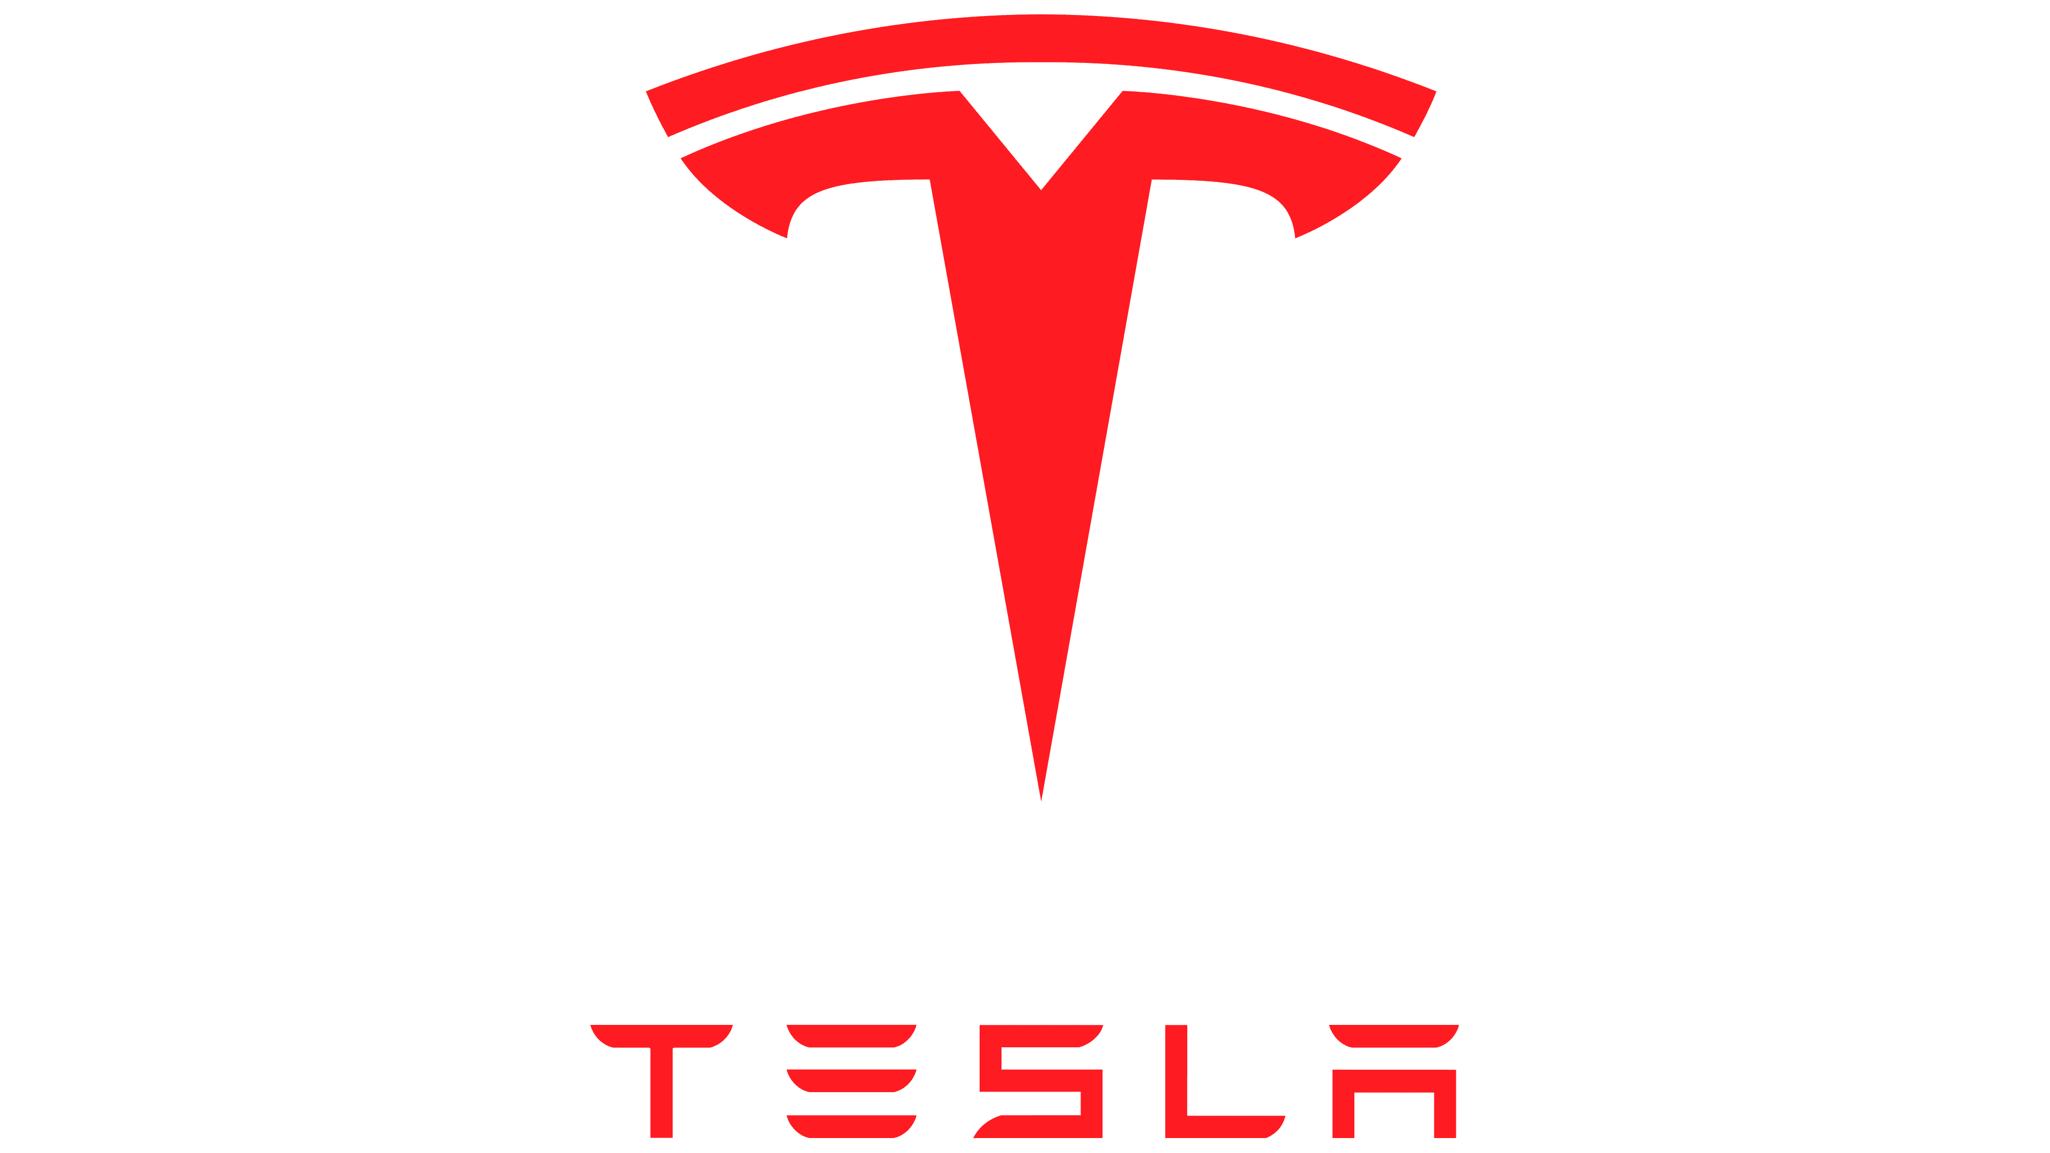
Tesla Inc is an American manufacturer of high-performance electric vehicles and electric vehicle powertrain components. The company whose name is a tribute to the inventor Nikola Tesla was founded in the 2003 in Palo Alto by Elon Reeve Musk, Jeffrey B. Straubel, Martin Eberhard, and Marc Tarpenning (Bloomberg, 2021).
The mission is to create full electric vehicles, therefore without thermal engines, which in addition to being ecological also offer high performance for the mass market.
The NASDAQ listed company is in fact the ambitious bet of a group of young people from Silicon Valley on the mobility of the future. The first investments of more than $30 million came from PayPal co-founder Elon Musk, who became CEO of Tesla Inc since 2004 (Britannica, 2021), leading the company's first challenges and involving VantagePoint Venture Partners which owned 6.6% of Tesla after the IPO (The WS Journal, 2010).
This is followed by additional funding from Google founders Sergey Brin and Larry Page and former eBay President Jeff Skoll.
Tesla's global vehicle sales were 499,000 units in 2020, a 35.8% increase over the previous year and at the 3rd quarter of 2021 they already reached 627,350 units (Statista, 2022).
In October 2021, Tesla's market capitalization reached US$1 trillion, the sixth company to do so in U.S. history (CNBC.com, 2021).
The overall number of employees at the end of 2020 was 70,757 (Satatista.com, 2022).

The Company Business Model

2.1 Mission and strategy

“A business model is a company's core strategy for profitably doing business” (Investopedia, 2021).
Tesla founder and CEO Elon Musk launched the company with the mission, “to accelerate the advent of sustainable transport by bringing compelling mass-market electric cars to market as soon as possible” (Tesla.com, 2021).
This mission is at the very core of Tesla's business model. In fact, rather than trying to build a relatively affordable car that could be mass produced and marketed, the focus was on creating a compelling car that would create demand for electric vehicles (Investopedia, 2021).
Tesla's business strategy is not only to create highly innovative and performing electric vehicles, but at the same time seeks to reduce the obstacles that have historically prevented their spread such as the reduction of the cost of batteries, the implementation and dissemination of charging stations and energy storage systems for homes and businesses.
In light of this and according to Forbes, the company operates through the following segments:
- The Automotive segment includes the design, development, manufacture, and sale of electric vehicles.
- The Energy Generation and Storage segment includes the design, manufacture, installation, sale, and lease of stationary energy storage products and solar energy systems, and sale of electricity generated by its solar energy systems to customers.
(Forbes, 2021)

Tesla vehicles are manufactured at the Fremont plant in California, Gigafactory 1 in Nevada, and Gigafactory 2 in Shanghai. Today more than 10,000 people work at the Fremont plant, one of the most advanced automotive plants in the world with 5.3 million square feet of manufacturing and office space on 370 acres. Before Tesla, this facility was owned by General Motors from 1962 to 1982. (Tesla.com, 2021).
The Tesla Gigafactory was born out of the need to supply enough batteries to meet Tesla's projected vehicle demand. That's because to reach the goal of increasing production to more than 500,000 cars a year, Tesla alone would need today's entire world supply of lithium-ion batteries.
In mid-2018, battery production at Gigafactory 1 reached an annual rate of around 20 GWh, making it the world's highest-volume battery plant. Tesla currently produces more batteries in kWh than all other automakers combined (Tesla.com, 2021).
As production at Gigafactory increases, Tesla's battery cell costs will drop significantly, making the products accessible to more customers.

2.2 Vertical Integration

“Vertical integration is the combination, under a single ownership, of two or more stages of production or distribution (or both) that are usually separate” (Robert D. Buzzell, 1983).
Tesla has adopted a vertical integration model on a much larger scale than any other automaker. It in-house produced 95% of its stamps and the software for the car control. In addition, more than 185 robots were installed at its Fremont, California plant to automate more manufacturing operations, which is more than any other auto factory in the United States (Perkins and Murmann,2018 p.475).
That’s because Elon Musk believes that in-house manufacturing of strategic products is the key to success in pushing innovation as high as possible and thus creating a competitive advantage (Behzad Benam, 2020).
For example, in the case of battery production, it is possible to optimize the electric motor, the battery and all the elements around it without any dependence on the supplier.
The vertical integration approach helped Tesla to learn quickly and maintain control of all the key details of the project. According to Behzad Benam the main benefits have been:

- More control over the production process and product quality.
- Higher level of optimization.
- Reduction of dependence on suppliers and optimization of delivery time.
- Avoid complex supplier validation processes.

Additionally, Tesla went one step further by vertically integrating its retail channel and building its own network of charging stations (Behzad Benam, 2020).
Vertical integration is a complex and highly expensive process, especially at the beginning. However, new technologies such as automated mobility solutions based on artificial intelligence (AI) are pushing car manufacturers towards greater vertical integration.
Today there is so much technology in the automotive industry that Elon Musk himself stated: “Tesla is arguably the world’s biggest robotics company because our cars are like semi-sentient robots on wheels” (Newscientist.com, 2021).

2.3 Direct Sales

Unlike all other car manufacturers, since its inception Tesla has had the characteristic of not turning to traditional sales channels (franchised dealerships), but of preferring direct sales of its cars. Therefore, it has created an international network of company-owned showrooms and galleries, mostly in urban centers, with the dual purpose of avoiding potential conflicts of interest between the various showrooms as customers only deal with Tesla employees and to create a better customer experience when purchasing their car. The company has also made use of Internet sales with consumers being able to customize and purchase a car online.
From the direct experiences of the customers emerges the satisfaction of the latter in being able to configure and buy the cars directly from the online site and in having them delivered to their home just as if they were buying a simple appliance on Amazon. Furthermore, this gives to the customers the feeling of having paid the right price, and above all the exact same price that any other Tesla customer paid for a car with the same level of equipment. Usually this does not happen during the traditional shopping experience in dealers of other brands in which real negotiations often take place regarding discounts, accessory packages and optional that lead the purchase price to differ greatly from the price list.
Initially this strategy was supported also by the low volume of production and sales that characterized the niche of the automotive market to which the company was aimed, and according to the same company, by the fact that initially the dealers would have been discouraged in proposing this kind of product due to the low volume of sales.
It should also be noted that the target customers to which Tesla aims are on average younger, and so more willing to embrace innovations and technology than the traditional customers of the main thermal engine manufacturers. This has certainly facilitated the use of the online sales channel.
However, in addition to the positive aspects seen so far, some critical issues also emerged.
The first problem was the difficulty encountered by customers in interfacing with someone who could answer their doubts and curiosities about the product. In fact, with dealers it is very easy to express your doubts and obtain clarifications.
A further problem was that there was no leasing scheme, and the trade-in system was not at the level of that of competitors. All aspects that are usually managed in an optimal way by the dealers.
Last but not least, some legislative problems also needed to be addressed. For example, in some states such as Texas, Virginia and Arizona, the law does not allow the sale of vehicles without the intermediation of dealers (CleanTechnica, 2021). Therefore, with the growth of the brand, the introduction of new models and the increase in demand and sales volumes, it was necessary for Tesla to think about introducing a physical place where potential customers could get in touch with the product. From this need, the idea of the "Tesla Showroom" was born, not a reseller, but a place to train and retain customers, bringing them closer to the brand philosophy and offering superior quality service on the Apple Stores model.
Tesla showrooms are usually minimal and bright environments with cars in the center. They enable direct contact with older customers, less accustomed to using the internet and test drives can be booked online for free.
Including the showrooms, Service Plus centers (a combination of retail and service center), and service facilities, Tesla has 438 locations around the world at the end of 2021 (Investopedia, 2021).

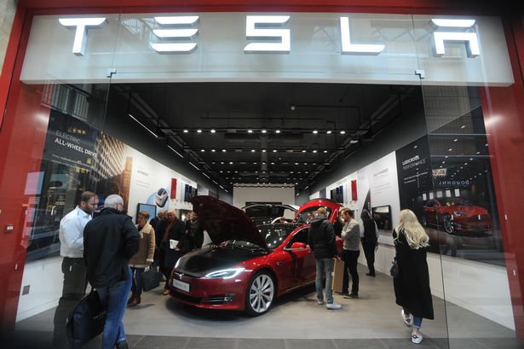
Figure 1 - The new Tesla store in the Grand Arcade, Cambridge – Source: www.cambridge-news.co.uk

The Marketplace

3.1 The EV Market: Trends and Developments

The Electric Vehicle market is still a young market, however comparing the sales figures of the last few years it is clear that market trends are increasingly pushing towards alternative solutions to the internal combustion engine.
According to the International Energy Agency (IEA), at the end of 2020, after a decade of rapid growth, there were 10 million electric cars on the world's roads. Despite the pandemic-induced decline in global auto sales, in which global auto sales fell by 16 percent, electric vehicle registrations increased by 41 percent in 2020 [Figure 2].
With over 3 million electric cars sold in 2020, the electric car market share in the global automotive market reached 4.6% (IEA, 2021).
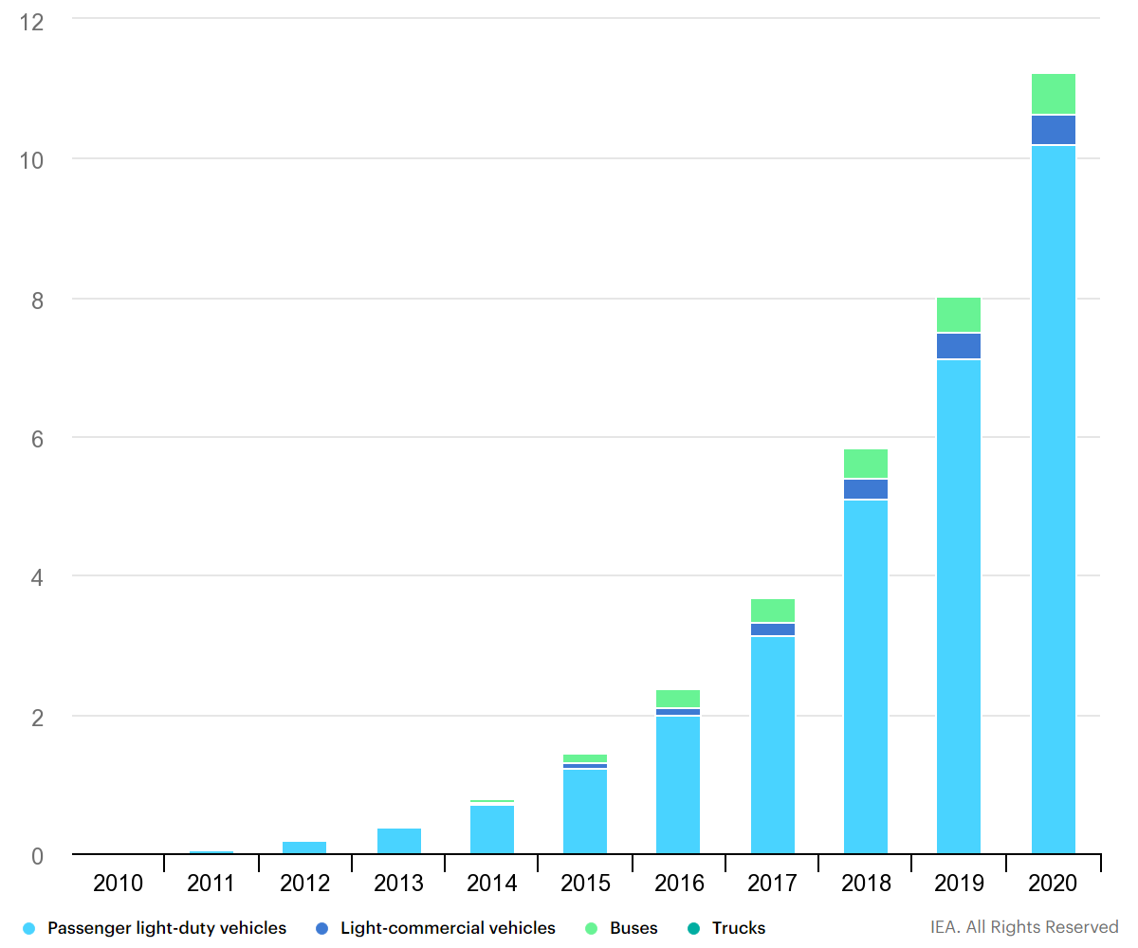
Figure 2 – Global electric vehicle stock by transport mode, 2010-2020 – Source: www.iea.org 2021

Figures 3-4-5 show that Europe is the second market in terms of number of sales, preceded only by China. However, the largest share of the European market is covered by Norway (in which almost one in two cars is electric), Germany, France, and Great Britain which together account for 70% of European electric vehicle sales.
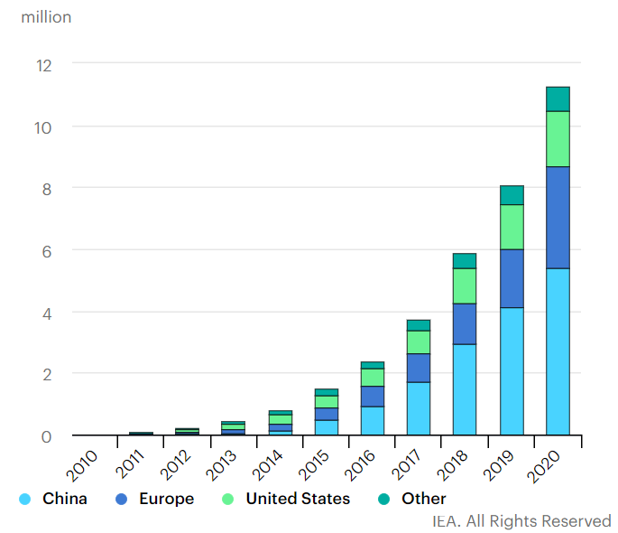
Figure 3 – Global electric vehicle stock by region, 2010-2020 – Source: www.iea.org 2021

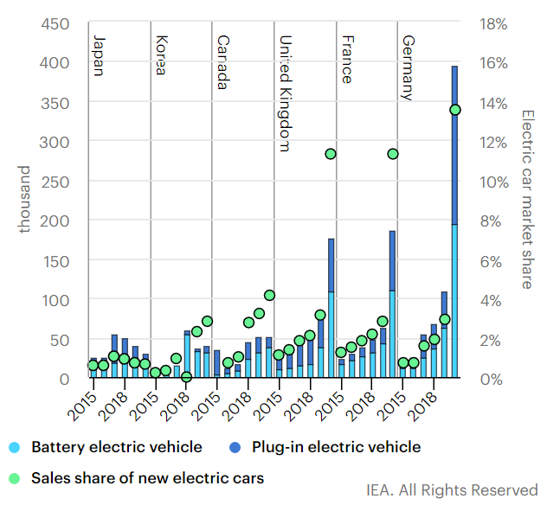
Figure 4 – Electric car registrations and market share in selected countries, 2015-2020 – Source: www.iea.org 2021

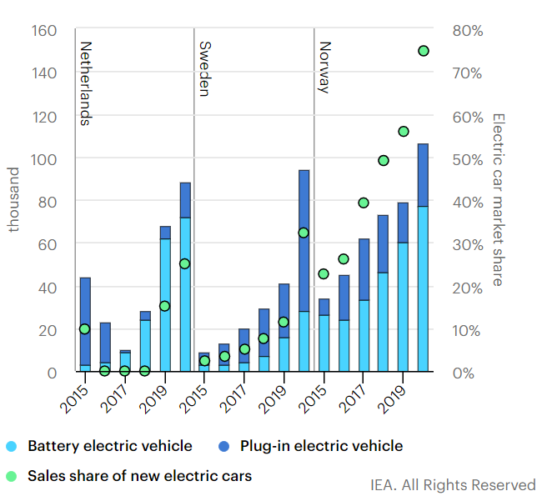
Figure 5 – Electric car registrations and market share in north-western European region, 2015-2020– Source: www.iea.org 2021

According to the IEA (2021), the main reasons why, despite the COVID-19 pandemic, the electric vehicle market has outperformed are:
- Supportive regulatory framework: even before the pandemic, many countries had strengthened important guidelines such as CO2 emission standards and requirements for emission-free vehicles.
- Incentives to boost EV sales: some European countries have increased their purchase incentives and China has delayed exiting its subsidy program.
- Increase in the number of EV models available on the market and progressive reduction in the cost of batteries.
- The vast majority of the vehicle manufacturers have stated plans to increase their portfolio of electric models.

In this perspective and to give further impetus to the electric vehicle market, the UK has recently introduced new laws starting from January 2022. In fact, now new buildings in the UK must have built-in EV chargers. This includes all new residential and non-residential buildings such as supermarkets and offices and also radically renovated buildings with more than 10 parking spaces (Euronews.com, 2021)
The government hopes that it will help to increase the number of EV chargers available to the public, in view of the 2030 ban on the sale of new diesel and petrol cars (Euronews.com, 2021).

3.2 The EV Market: Tesla and Competitors

Tesla has seen a steady increase in sales over the past few years. The Figure 6 shows the sales trend from 2016 until the 3rd quarter of 2021. Tesla's global vehicle sales were 499,000 units in 2020, a 35.8% increase over the previous year and at the 3rd quarter of 2021 they already reached 627,350 units (Statista.com, 2022).
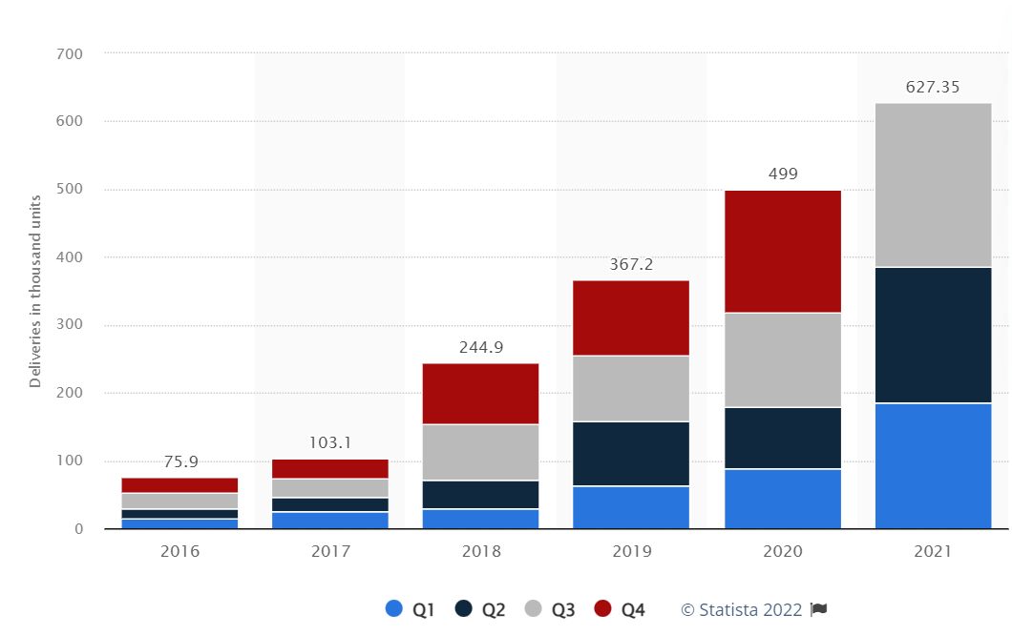
Figure 6 – Number of Tesla vehicles delivered worldwide from 1st quarter 2016 to 3rd quarter 2021 – Source: Statista.com

The company has revolutionized the electric vehicle market by concentrating all investments on this niche, preceding the historic car brands ("incumbents" of the traditional global market), and providing an innovative product based on greater battery efficiency without sacrificing the performances of the car. This has enabled the creation of a new market making this segment more attractive and gave Tesla a competitive advantage.
At the same way the revenues have followed the trend of the sales, as shown in Figure 7.

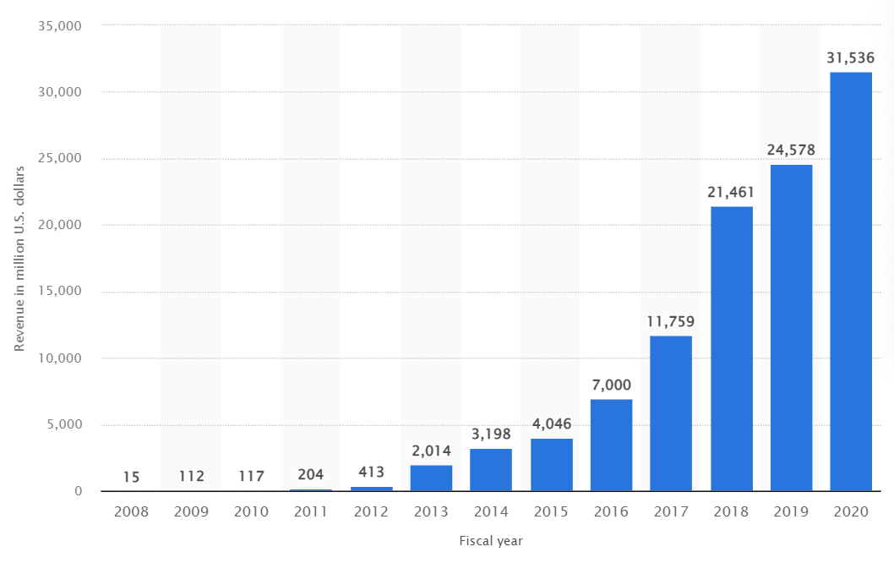
Figure 7 – Tesla's revenue from FY 2008 to FY 2020 (in million U.S. dollars) – Source: Statista.com

In terms of global market share, Tesla is the leader of the electric vehicle market with a market share of 14.55%, followed by the giant Volkswagen Group (which include the brands VW, Audi, and Porsche), with a share of 12.52%. [Figure 8].

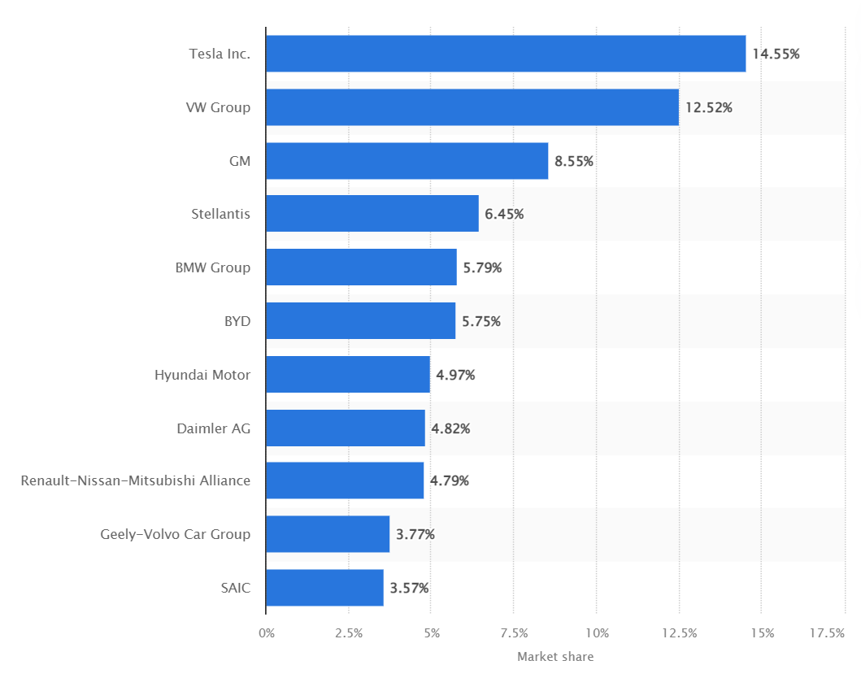
Figure 8 – Global electric vehicle market share in the first half of 2021, by main producer – Source: Statista.com
However, according to Experian, even if Tesla surpassed the number of 627,350 units at the 3rd quarter of 2021, the global market percentage is shrinking due to the increase of the number of competitors as auto industry titans are betting on a future dominated by battery-powered cars.
The Figure 9 shows the U.S. market share trend by brand since 2017. As we can see the Tesla's market share dropped to 66.3% in 2021 from 79.5% in 2020. Instead, Chevrolet reached 9.6%, Ford 5.2%, Nissan 3.9%, and Audi 3.3% (Experian, 2021).
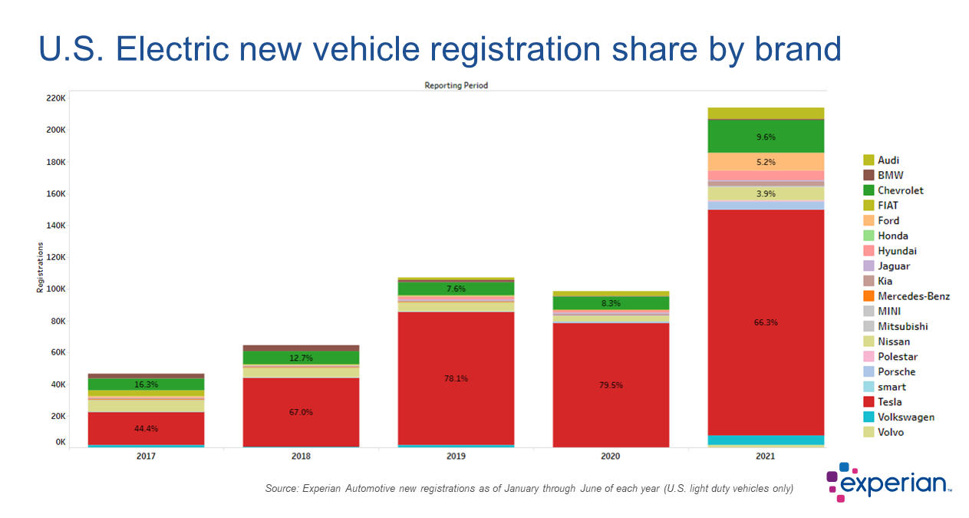
Figure 9 – U.S. Electric new vehicle registration share by brand – Source: Experian.com 2021

For the completion of the analysis, the Figure 10 shows the UK market share of the electric vehicles at the end of 2021.
As we can see, the Volkswagen Group has a decent advantage, thanks to the good performance of the VW and Audi brands, and the Tesla and Hyundai groups are in close competition for second place (CleanTechnica, 2021).
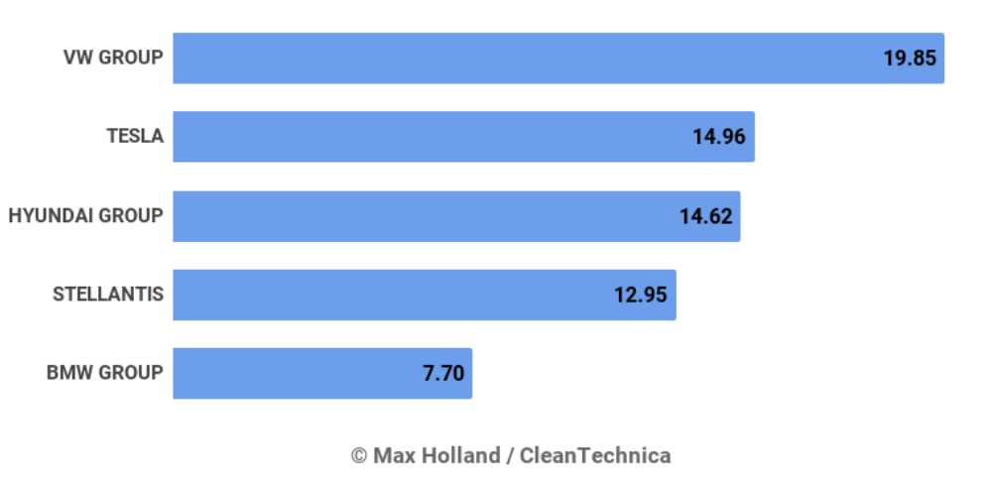
Figure 10 – 2021 UK Electric Vehicles market share by Group – Max Holland / CleanTechnica 2021

STP- Segmentation, Targeting and Positioning

- Segmentation: Tesla only serves one target market. The one they have created, which is the premium all-electric sports car market (Taylor Wells, 2021).
- Targeting: segments of customers between 20 and 40 years of age that are aware of sustainability, ecological and safe driving experience. There is a growing awareness about global warming and climate change. As a result people feel compelled to help the environment.
According to Edmunds.com the profile of current Tesla Model S owners is:
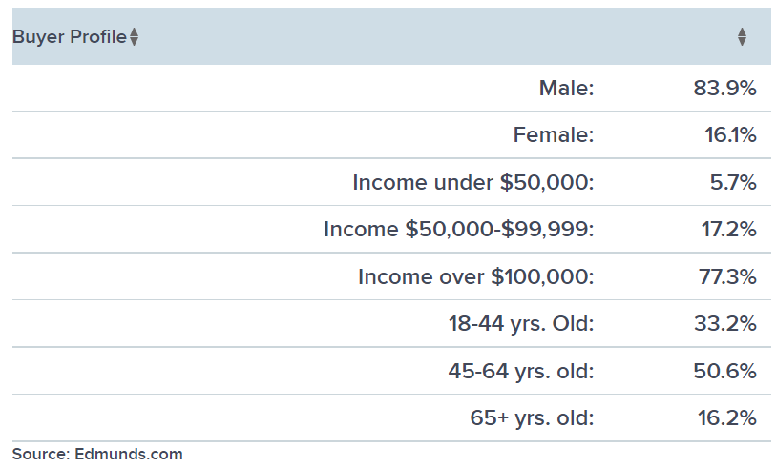
Figure 11 – Tesla model S buyer profile research – Source: Edmunds.com for CNBC

- Positioning: Tesla is the car brand to turn to for electric cars and at the same time it is the car brand that cares for the Earth.

Tesla PESTLE Analysis

According to CIPD a “PESTLE analysis is a framework to analyse the key factors influencing an organisation from the outside. It offers insight of external factors impacting the organisation and helps managers on making strategic decisions” (CIPD, 2021).

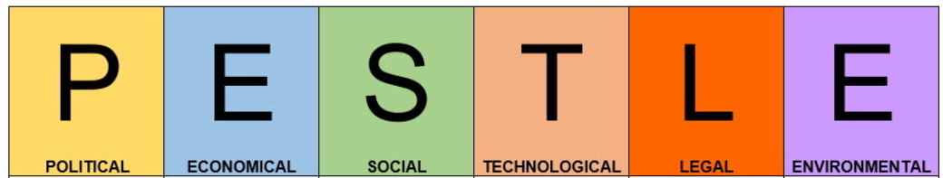

Political:
- Tesla enjoyed initiatives taken by national and state governments to encourage manufacturing and sale of electric vehicles (opportunity).
- Operating around the world, it is subjected to various political patterns and legal factors (mostly threat).
- Political tensions among countries (threat).
However, despite the political tensions between China and US, Tesla set up in China one of its Gigafactory to boost the production.

Economical:
- Improving the production of the electric batteries, Tesla enabled their cost reduction, and this made electric cars more affordable than the past (opportunity).
- The increase in fuel price has been an opportunity for the EV industry (IEA, 2021).
- Tesla has revitalized the whole EV market (opportunity).

Social:
- The social aspects are favorable to Tesla and the company has a good brand reputation as its car is seen as an environmental and sustainable choice to reduce its carbon footprint (opportunity).

Technological:
- As already mentioned in this report, technology is the electric vehicle industry's biggest strength. Indeed, we are seeing an increasing use of embedded technologies in the automotive industry (opportunity & threat).
- Advancement of technology to improve battery efficiency in term of range (opportunity).

Legal:
- Increase of regulations related to automobile standards like safety and emissions by various governments (mostly opportunity).
- Dealership sales regulation in the United States (opportunity & threat).

Environmental:
- Tesla is considered an environmentally friendly brand as it meets most of the environmental related regulations (Tesla.com, 2020) (opportunity).

Tesla SWOT Analysis

SWOT stands for Strengths, Weaknesses, Opportunities, and Threats.
According to CIPD, “It is a framework for matching an organization’s goals, programs and capacities to the environment in which it operates” (CIPD, 2021).
After identifying the objective to be achieved, the company must focus on identifying the Strengths, Weaknesses, Opportunities, and Threats.
Strengths and weaknesses are internal factors on which the company can have some control over and can change. Opportunities and threats are external factors on which the company can take advantage of opportunities and protect against threats.

Strengths:

- Strong control over production processes thanks to the adoption of vertical integration.
- Strong brand reputation thanks to the strong marketing policies and improving customer base.
- Integrated battery manufacturing at Gigafactory.

Tesla is known for its high innovation rate, in particular for the introduction of the first fully electric sports car in the world. A strong brand allows the company to attract and retain new customers.
The fact of having control over production processes is based on vertical integration which allows this factor to minimize the problems related to third-party involvement and improves the ability to integrate and optimize the components.

Weaknesses:

- High product prices.
- Increased assets and debt liabilities due to the adopted strategy of vertical integration and for the huge R&D investments.
- Limited market presence, especially when compared to car market incumbents.
- Limited productive capacity although constantly growing.

Tesla suffers from a limited market presence. In fact, the company generates most of its revenues in the United States and has a small presence in Europe, China and developing countries. This represents an obvious weakness that could affect business growth.
Furthermore, Tesla products are relatively more expensive than the cars of competitors, particularly with respect to the cars of the same segment but with thermal engine. This limits the ability to quickly increase its market share.

Opportunities:

- Increased attention toward reducing fossil fuel consumption.
- Sales expansion in untapped Market, mostly in ASIA, to expand its global market and doing so improving its financial stability.
- Diversification.

In relation to its weaknesses, Tesla must consider the opportunity to expand global sales. This is taking advantage of the economic growth of many countries where the company currently has a negligible market presence. For example, the company can increase its revenues through expansion into the Asian auto markets.
Furthermore, the company can improve its performance through diversification. Diversification involves the creation or acquisition of new businesses to reduce exposure to the risks of the automotive market (Investopedia.com, 2021).

Threats:

- Huge competition in automobile market.
- Fluctuations in the prices of materials.
- Changes in dealership sales regulation.
- Foreign currency exchange rates.

Car makers compete aggressively against each other. This external factor can be a threat to Tesla, especially considering the current investments and efforts of other companies in the production of electric vehicles.
Fluctuations in the prices of materials are another threat to the company, for example lithium, a fundamental material for the production of batteries, has a fluctuating and generally increasing cost (The Telegraph, 2021).
Furthermore, as we have already seen, the company also faces the threat of dealer regulations where in some states the direct sale of the company's products is prohibited.

The table below summarize the SWOT analysis just performed (Table 1).

STRENGTHS | WEAKNESSES
• Strong control over production processes. | • High product prices.
• Strong brand reputation. | • Limited market presence.
• Integrated battery manufacturing. | • Limited productive capacity.
• Vertical Integration. | • Financial exposure.
OPPORTUNITIES | THREATS
• Diversification. | • Huge competition in automobile market.
• Sales expansion in untapped Market. | • Fluctuations in the prices of materials.
• Increased attention toward reducing fossil fuel consumption. | • Changes in dealership sales regulation.
 | • Foreign currency exchange rates.
Table 1 – SWOT analysis of Tesla Inc.

Conclusion

Tesla was able to revolutionize the automobile industry that was previously focused on internal combustion engine vehicles and in doing so it created a new market based on full electrical vehicles (EV). The fact that Tesla entered this market as the first player has generated a competitive advantage for the company which has allowed it to become the global market leader in electric vehicles segment. However, this was not so easy!
The company's focus was on creating a compelling car that would create demand for electric vehicles, a highly innovative and performing electric able to overcome the historical "bottlenecks" which have discouraged the major car manufacturers from investing in this type of solution. In fact, the electrical car had the limit of the battery efficiency in term of range and speed performances. Moreover, the total absence of a network of charging station and innovative home charging systems made the spread of this solution almost impossible.
The Tesla's strategy in order to overcome these bottlenecks was to adopt the vertical integration as business model. In this way the company was not limited only to the production of cars but also to the manufacturing of batteries and energy generation and storage systems.
This choice has allowed a progressive reduction in the production costs of the batteries and a better optimization of the components that make up the final product.
The first model launched on the market was the "Tesla Roadster" which was a high-performance sports car. This was a marketing strategy to show the whole world that the electric car was a possible solution and that even its performances were comparable to a car of the same segment with a thermal engine. Since then, Tesla has built its company reputation as innovative company and sustainable choice to reduce its carbon footprint.
However, even if Tesla sold more 627,350 cars at the 3rd quarter of 2021, the global market percentage is shrinking due to the increase of the number of competitors as auto industry titans are betting on a future dominated by battery-powered cars.
On my opinion the 2 pillars on which tesla built its competitive advantage were: “Timing” and “Innovation”.
Timing: because Tesla entered the market in a time when there is more awareness of environmental issues and global warming. Governments acknowledge these problems as social problems and try to tackle them through ad-hoc regulations and incentives. Therefore, and according to what Richard Porter said in 2013, Tesla proposed itself as a solution to a social problem creating a new market and making a profit.
Furthermore, when the company decided to enter the electric car market, it found an adequate level of technology that did not exist a decade earlier.
Innovation: on my opinion this is the key to disrupt the market and create a competitive advantage.

Recommendations:

- As a popular electric vehicle manufacturer, the company benefits from global expansion. For this reason, in order to foster the business growth, Tesla must increase its presence on the international market and mostly in developing countries.
- Furthermore, the company must continue to invest in research and development to produce increasingly technologically advanced and competitive products.
- Perceive the business diversification through the creation or acquisition of new businesses to reduce exposure to the risks of the automotive market.

References

Behzad Benam, Why Vertical Integration Made Tesla More Powerful. Medium.com, (2020). Available at: https://medium.com/@bhbenam/why-vertical-integration-made-tesla-more-powerful-8b33b6aee77 (Accessed: 2nd January 2022).

Bessant, J. and Tidd, J. (2015,) Innovation and Entrepreneurship, 3rd edition, Chichester: John Wiley & Sons.

Bloomberg, (2021), Tesla Inc. Available at: https://www.bloomberg.com/profile/company/TSLA:US (Accessed: 27th December 2021).

Britannica, (2021), Tesla, Inc. Available at: https://www.britannica.com/topic/Tesla-Motors (Accessed: 27th December 2021).

Businessinsider.com, (2021), Electric cars are more popular than ever, but Tesla is losing market share to new competitors. Available at: https://www.businessinsider.com/tesla-market-share-drops-ford-gm-audi-2021-10?r=US&IR=T (Accessed: 1st January 2022).

Chen, Y. and Perez, Y., 2018. Business model design: lessons learned from Tesla Motors. In Towards a Sustainable Economy (pp. 53-69). Springer, Cham.

CIPD, (2021), PESTLE analysis. Available at: https://www.cipd.co.uk/knowledge/strategy/organisational-development/pestle-analysis-factsheet#gref (Accessed: 5th January 2022).

CIPD, (2021), SWOT analysis. Available at: https://www.cipd.co.uk/knowledge/strategy/organisational-development/swot-analysis-factsheet#gref (Accessed: 5th January 2022).

Cleantechnica.com, (2021), Car Dealership Sues Tesla And A Town Because They Don’t Want Tesla To Sell To Its Customers. Available at: https://cleantechnica.com/2021/06/02/car-dealership-sues-tesla-and-a-town-because-they-dont-want-tesla-to-sell-to-its-customers/ (Accessed: 1st January 2022).

Cleantechnica.com, (2021), CARSUK Plugin EV Market Share Hits Record 28.1% In November – Diesel At Just 5%. Available at: https://cleantechnica.com/2021/12/06/uk-plugin-ev-share-hits-record-28-1-in-november-diesel-at-just-5/ (Accessed: 1st January 2022).

CNBC, (2013), The young and rich snapping up Tesla's Model S. Available at: https://www.cnbc.com/id/100970641 (Accessed: 3rd January 2022).

CNBC.com, (2021), As Tesla joins the elite $1 trillion stock club, two traders see another potential milestone ahead. Available at: https://www.cnbc.com/2021/10/25/tesla-stock-passes-1-trillion-market-cap-traders-bet-on-more-gains.html (Accessed: 29th December 2021).

Euronews.com, (2021), UK to make electric car chargers compulsory in new buildings from 2022. Available at: https://www.euronews.com/green/2021/11/24/uk-to-make-electric-car-chargers-compulsory-in-new-buildings-from-2022 (Accessed: 1st January 2022).

Experian, (2021), While EV Registrations Grow Through the First Half Of 2021, Non-Electric Remains Dominant. Available at: http://www.experian.com/blogs/insights/2021/10/ev-registrations-grow-first-half-2021-non-electric-remains-dominant/?sid=bi%7C61719189d861f955f72277ae%7C164124410207141j44s24 (Accessed: 1st January 2022).

Forbes, (2021), Tesla company profile. Available at: https://www.forbes.com/companies/tesla/?sh=740edfe348d4 (Accessed: 27th December 2021).

International Energy Agency IEA, Global electric vehicle stock by transport mode, 2010-2020, IEA, Paris https://www.iea.org/data-and-statistics/charts/global-electric-vehicle-stock-by-transport-mode-2010-2020 (Accessed: 29th December 2021).

International Energy Agency IEA, (2021), Global EV Outlook 2021. Available at: https://www.iea.org/reports/global-ev-outlook-2021?mode=overview (Accessed: 29th December 2021).

Investopedia, (2021), Business Models. Available at: https://www.investopedia.com/terms/b/businessmodel.asp (Accessed: 2nd January 2022).

Investopedia, (2021), Diversification. Available at: https://www.investopedia.com/terms/d/diversification.asp (Accessed: 6th January 2022).

Johnson, G., Whittington, R., Regner, P., Scholes, K and Angwin, D. (2020) Exploring Strategy: Text & Cases, 12th edition, Pearson.

Michael Porter, (2013), The case for letting business solve social problems. [video]. Available at: https://www.ted.com/talks/michael_porter_the_case_for_letting_business_solve_social_problems (Accessed: 27th December 2021).

Morrison, J. (2020) The Global Business Environment Towards Sustainability, Red Globe Press.

Newscientist.com, (2021), Tesla is building an AI humanoid robot called Optimus, says Elon Musk. Available at: https://www.newscientist.com/article/2287792-tesla-is-building-an-ai-humanoid-robot-called-optimus-says-elon-musk/#ixzz7HCl2g838 (Accessed: 2nd January 2022).
Palmer, A. (2004). Introduction to Marketing - Theory and Practice, UK: Oxford University Press.

Perkins, G. and Murmann, J.P., 2018. What does the success of Tesla mean for the future dynamics in the global automobile sector?. Management and Organization Review, 14(3), pp.471-480.

Robert D. Buzzell. Is Vertical Integration Profitable?. Harvard Business Review. Jan1983. Available at: https://hbr.org/1983/01/is-vertical-integration-profitable (Accessed: 2nd January 2022).

Sloman, Hinde & Garratt, (2019). Economics for Business, Pearson.

Statista.com, (2022), Global plug-in electric vehicle market share in the first half of 2021, by main producer. Available at: https://www.statista.com/statistics/541390/global-sales-of-plug-in-electric-vehicle-manufacturers/ (Accessed: 1st January 2022).

Statista.com, (2022), Number of Tesla employees from July 2010 to December 2020. Available at: https://www.statista.com/statistics/314768/number-of-tesla-employees/ (Accessed: 1st January 2022).

Statista.com, (2022), Number of Tesla vehicles delivered worldwide from 1st quarter 2016 to 3rd quarter 2021. Available at: https://www.statista.com/statistics/502208/tesla-quarterly-vehicle-deliveries/ (Accessed: 1st January 2022).

Statista.com, (2022), Tesla's revenue from FY 2008 to FY 2020. Available at: https://www.statista.com/statistics/272120/revenue-of-tesla/ (Accessed: 1st January 2022).

Taylor Wells, (2021), What is marketing segmentation and targeting. Available at: https://taylorwells.com.au/what-is-marketing-segmentation-and-targeting/ (Accessed: 3rd January 2022).

Tesla.com, (2020), Impact Report. Available at: https://www.tesla.com/ns_videos/tesla-impact-report-2019.pdf (Accessed: 4th January 2022).

Tesla.com, (2021), About Tesla. Available at: https://www.tesla.com/about (Accessed: 27th December 2021).

Tesla.com, (2021), Tesla Factory. Available at: https://www.tesla.com/factory (Accessed: 28th December 2021).

Tesla.com, (2021), Tesla Gigafactory. Available at: https://www.tesla.com/igafactory (Accessed: 28th December 2021).

Tesla.com, (2021), The Mission of Tesla. Available at: https://www.tesla.com/blog/mission-tesla. (Accessed: 2nd January 2022).

The Telegraph, (2021), Rising lithium prices risk pushing electric car dreams off the road. Available at: https://www.telegraph.co.uk/business/2021/12/02/rising-lithium-prices-risk-pushing-electric-car-dreams-road/ (Accessed: 6th January 2022).

The U.S. Department of Justice, (2021), ECONOMIC EFFECTS OF STATE BANS ON DIRECT MANUFACTURER SALES TO CAR BUYERS. Available at: https://www.justice.gov/atr/economic-effects-state-bans-direct-manufacturer-sales-car-buyers (Accessed: 2nd January 2022).

The Wall Street Journal, (2010), Wasting No Time, DFJ Drives Off With $60M In Tesla Stock. Available at: https://www.wsj.com/articles/BL-VCDB-9665 (Accessed: 28th December 2021).

