1901767

C++ Coding Assignment
By Dylan Yeates

Table of Contents
Contents
Table of Contents 1
Introduction 2
Problem Solving 2
Exercise 1 2
Book Title 2
Length 2
Shopping Cart 2
Exercise 2 3
Entering Radius 3
Squaring Radius 3
Pi R Squared = Area 3
Exercise 3 4
Numbers 1-7 4
Pounds Total 4
Euros Total 5
Exercise 4 5

Introduction
This document will cover several programmes, each becoming progressively more difficult.

Problem Solving

Exercise 1
The first exercise consisted of three different major tasks. It had us enter a book title, a length and number of items in a shopping cart.
To solve this problem I had to setup a system that lets a user input information and the input is converted to a variable so it can be printed at a later time. To do this I will have a blank string called input. I will also have a string stream. These will be used to allow the user to enter their information in any format and the string stream will convert these into the specific variable for each one. After all the information was imputed I will use cout to print all of these variables on different lines. Once I have created one of these, I just follow the but turn the data type. The book title will be a string as it will need to be letters. Length will be a double as it can then be a decimal number. The number of items in the cart will be an int as you cannot have half an item in your cart.
The hardest part will be the spacing out whilst the easiest is converting the streams.

Book Title
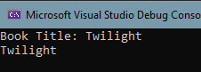
This screen shot shows I have made it so that the book title is read back straight away. I have only done this for testing purposes. It will be done at the end as a set of three when all the tasks are compete.

Length
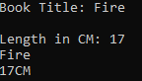
Here I have put them at the bottom again and made it display CM after the length.

Shopping Cart
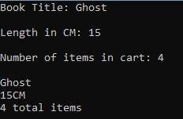
Here it asks all 3 questions then displays all three answers adding CM to the endo f length and total items to the end of the shopping cart. Here is an example that they all work with any variable
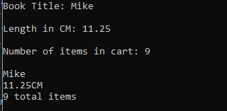

Exercise 2
Exercise 2 will have a user enter a radius, the code will then calculate and print the area based on this radius. To calculate area I will be using the formula of Pi * RSquared = Area. For Pi I will be using 3.142. The hardest part of this is calculating the area. The middle part is squaring the radius and the easiest part is having the user enter a radius.
The first stage of developing the code is to have the user enter a radius. This code is basically the same as task one. I have the user enter a number for the radius of the circle in the double format.

Entering Radius
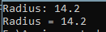
Here I have got the user entering a radius and ensuring it is saved by printing this. The radius will only be printed in this version as proof its saved.

Squaring Radius
Next, I must get the code to workout what radius squared is. To workout radius squared I have multiplied radius with itself.
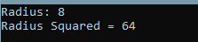
Here I have it displaying the radius squared. I purposefully picked a number I know what it is squared so I can see straight away that my code is working correctly.

Pi R Squared = Area
In the final part of this task I have multiplied radius squared by 3.142.
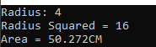
Here is a calculator confirming that the code is multiplying the numbers correctly. 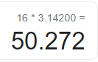

Exercise 3
Exercise 3 has three parts. The easiest task is having a user enter a set of prices and display them back. The second easiest is to convert it to euros as you just have it times a set rate. The hardest part will be adding all the prices and displaying.
For the sake of longevity, I have set it so that the user must enter 7 different numbers. I felt like this number, whilst it might be a bit much, is a nice length to start a list. Ideally, I would have it so that the user can set how many numbers they must enter, However, I could not implement this feature.

Numbers 1-7
I used the same premise of code from the first task to store numbers from 1-7 but this time I used an array to make life a little easier instead of 7 different variables. I used 1 variables with 7 different forms. It’s the same code for every step but with a different number in the variable square brackets.
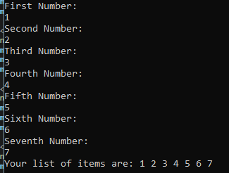

Pounds Total
To get the pounds total I must have it add all the numbers then print the total. I also added comas to the list to make it clear what each line does. I also set the number to show up on the same line as the colons.
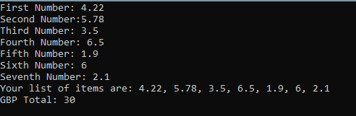
I purposefully picked sets of numbers that added up to 10 at a time so that I could track the pricing and ensure the number is accurate quickly.

Euros Total
Here I have converted my total to euros using the current conversion rate of 1 pound is 1.14 euros. To make this possible I simply multiplied the british total by 1.14. 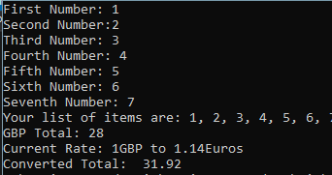
Here is the codes answer. The following is a calculator result confirming the code has successfully multiplied.
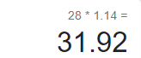

Exercise 4
I had issues implement exercise 4 and couldn’t quite figure out how to do it. However, I did solve the first part as it’s the same as the previous set of code. It would simply be an array asking the user to fill in X[0] Y[0] to X[2] Y[2]. This is all that I could implement successfully. This would be the easiest task. The second easiest task would be implementing the grid system. The third would be having the grid update when a user makes a guess and update to an X or an M dependant on if they miss.

Appendances
Please refer to the code files uploaded to Moodle. They are in a Zip file as are the following
DY_E1 = Exercise 1
DY_E2 = Exercise 2
DY_E3 = Exercise 3

