Module Name: Marketing Fundamentals

Module code: LCBB4004

Assessment 1 Blogging to communicate

Module Cordinator : Afzal Munna

Student Name: Angel Angelov

Student Number:2120247

Table of Contents
Overview of PRIMARK 3
Segmentation Targeting and Positioning 4
Market Segmentation 4
Targeting 5
Positioning 5
Marketing Mix 7
Product Strategy 7
Price & Place Strategy 7
Promotion & Process Strategy 8
People & Physical Evidence Strategy 8
References 10

Overview of PRIMARK

Fig 1: Primark store in London
(Source: Primark, 2022)
Primark is the leading fashion retailer in the UK providing its customers with a wide variety of products. Its products are highly affordable and trendy. The organisation is headquartered in Dublin, Ireland and also has registered offices in England and Wales. Primark is a subsidiary of a British food processing company, Associated British Foods (ABF) (Statista, 2022). It offers a diverse product variety ranging from kid’s clothing, men's and women's clothing, and homeware items, to beauty products, accessories, footwear, and confectioneries. Affordability has been the main aim for Primark. The primary vision of the organisation is to make sustainable and trendy fashion sustainable for every individual. Fuelled by its passion for creativity and innovation, Primark offers something for everyone at an extremely wallet-friendly price range. Currently, the UK is the largest market for Primark with over 190 stores operating across s number of different locations (Primark, 2022). Globally, the organisation operates close to 400 stores in 14 countries, including but not limited to, the U.S., Italy, Spain, Austria, Germany, Belgium, Poland and France (Statista, 2022). Primark also allows its customers to browse its latest collections and order through its online website and mobile application. The organisation also offers a click-and-collect trial for customers to try products that they see online at the nearest store.

Segmentation Targeting and Positioning

Market Segmentation
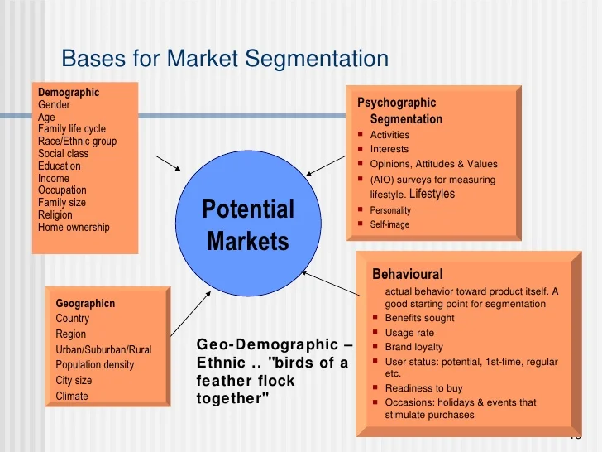
Fig 2: Bases for market segmentation
(Source: Fahy and Jobber, 2019)
Market segmentation refers to the marketing strategy that involves the segregation of customers based on a number of factors such as demographics, behaviours, psychology, or geography. Since the market size of Primark is diverse, therefore reaching customers get quite tricky and confusing for the organisation. The implementation of the market segmentation process enables the company to understand the customer preferences and expectations that are often influenced by a number of different factors. Primark considers a number of variables in order to produce different customer segments. Demographic segmentation considers customer characteristics such as age, gender, family size, income, employment, education level, ethnicity, and religion (Fahy and Jobber, 2019). Behavioural segmentation divides customers based on their preferences, buying habits, user loyalty and usage rate. Geographic segmentation considers the customer’s geographic location to make more location-specific offerings. Psychographic segmentation involves characteristics that are more emotional and mentally such as needs, preferences, values, attitudes and lifestyle. The primary focus of Primark is on psychographic and demographic segmentation. The company invests time in creating customer personas to gain a deeper sense of the buyer’s psychological state and customise the offerings accordingly (Yu et al., 2018). It has partitioned its potential customers based on customers’ previous practices and socioeconomic factors.

Targeting
The segmentation process is followed by targeting. It involves selecting a specific segment of customers after the market has been segmented. This process mainly focuses on the analysis and evaluation of the customer segments and selecting the most appropriate one or more segments for the business (Xydia, 2019). Once the attractiveness of the segment is analysed, appropriate marketing approaches are directed toward the targeted customer segment. Based on the psychological and demographic segmentation performed by Primark, the primary customer is female customers between the age group of 16-35 years. In 2021 alone, the company had 11.1 million consumers for women’s wear while for men’s and kid’s wear the numbers were 10.3 and 6.1 million, respectively (Statista, 2022). Hence, the majority of its products are trendy fashion apparel at extremely affordable prices. The company has been successful in figuring out the necessary actions to undertake in order to become the favourite brand for customers looking for trendy and affordable fashion. Its strategy to refresh its products consistently has enabled the fashion retailer to multiply its growth without saturating the existing market size. The secondary customer base includes the potential customers who seem relevant to the offerings of the company. The brand offers limited edition stocks to breed customer engagement and a sense of exclusivity among buyers.

Positioning
Primark has been able to position itself as one of the most successful and loved fashion brands by selling affordable fashion. The company has been extremely successful in aligning its offerings to the value proposition and desires of the customers. It is majorly focused on excellent in-store experience and customer service. The supply chain of the company has proven to be an asset for the company owing to its ability of sourcing cheap yet reliable and authentic fashion for customers (Zanjirani Farahani et al., 2022). Primark’s supply is highly efficient which ensures the creation of products from their initial design to being displayed on the shelves within six weeks. Primark labelling itself as a value retailer has been successful in reflecting the purpose of the company, of making quality fashion affordable at unbeaten prices. The well-designed and attractive interiors of its stores also help the company in standing out from its competitors such as ZARA, H&M and NEXT plc. The company’s slogan “look good pay less” has made its way subconsciously into the minds of customers. Primark manufactures ongoing trends in relevant sizes to maximise the economy of scale of production to keep prices lower for customers (Kreutzer, 2019). The lower pricing strategy of Primark has been beneficial for the company in influencing and attracting a large segment of customers.
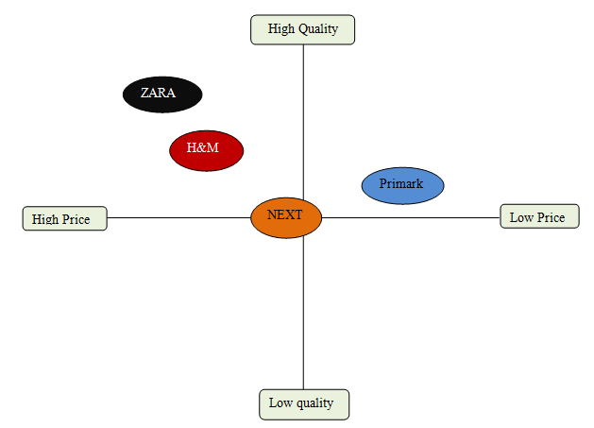
Fig 3: Perceptual mapping
(Source: created by the learner)

Marketing Mix

Product Strategy
Primark utilises marketing mix elements to plan appropriate strategies for gaining consistent brand promotion and recognition. Market mix strategy allows the company to cover seven elements of marketing including product, place, promotion, price, people, process and physical evidence (Kreutzer, 2019). Its effective marketing strategy has enabled the company to position itself competitively in the highly competitive fashion industry. The company has built up a strong brand image and worldwide recognition owing to its top-notch strategies. The product element of Primark includes the wide product variety offered by the company. The fashion retail offers menswear, womenswear, kidswear, footwear, lingerie, beauty products, accessories, home products and confectionaries. Besides, each product line offers different versions and quality thus making the product much more extensive. Additionally, the brands also offer products from different brands in its stores. Its wide range of offerings makes the brand appeal to different sections of customers. Since the primary customer base of the company is women, its major focus is on keeping up with the latest trends and lifestyles in women’s fashion (Agnihotri and Bhattacharya, 2020). Primark always keeps a new arrival section in its stores to build up curiosity among customers and gain rand engagement.

Price & Place Strategy
The pricing strategy of Primark is competitive pricing. The company offers its products to customers at comparably lower prices as compared to other fashion retailers like Zara and NEXT. Primark manufactures popular sizes and utilises economics of scale to lower the cost of production which enables the company to offer its products at lower prices to its customers. Further, the company has its manufacturing in China, Bangladesh and Pakistan which helps the company in sourcing cheap labour and raw materials (Xydia, 2019). The company targets value-seeking customers who wish to keep up with the fashion trends at minimum expense. This lower pricing strategy has enabled Primark to attract frequent buyers and maintain its revenue stream. The place strategy of Primark is pretty strong with string distribution channels and supply chains. It has hundreds of stores located across different nations including the US, the UK, Germany, France, Spain, and so on. The brand operates its stores in prime locations such as Oxford Street, New Castle, Cardiff, and Belfast which allows an abundance of customer flow in its stores. Additionally, its online website and mobile application have added to its increasing brand recognition and business growth (Nagaraj, 2020). It has a well-established supply chain that enables a constant supply of products to different outlets across the world.

Promotion & Process Strategy
The promotional strategy of Primark is heavily dependent on the word-of-mouth of its customers. The retail brand does not show any interest in investing huge amounts in intense advertisements for its products. It is heavily dependent on its low pricing strategy to attract as many customers as possible (Ruiz and Lluesma, 2018). Verbal advertising through loyal customers has been quite effective for Primark in promoting its business. However, the brand utilises social media platforms such as Facebook, Twitter, Pinterest, Instagram, and so on to communicate with its customers and develop a stronger online community. Primark also focuses on consistent social work through Primark Cares to build up a positive brand image. The operational processes within the organisation are extremely efficient and effective to ensure the smooth progress of the production process and delivery of the final products to the customers quickly. It has a well-developed distribution network to ensure timely delivery of the manufactured goods to its stores (Helsen, 2018). However, there have been several allegations against the company regarding its workplace conditions and the safety of workers in producing clothes that are so cheap and affordable. Like its competitors, Primark has been extremely vocal about its commitment to making fashion more responsible and sustainable.

Fig 4: Primark Instagram Page
(Source: Instagram)

People & Physical Evidence Strategy
The hardworking and loyal employees of the company have been relentlessly contributing to its growth and success. The brand currently employs more than 70,000 people for carrying out different activities within the organisation (Varley et al., 2018). The employees are provided with adequate training and development lessons to enhance their abilities and skills. It offers its customers several employee benefits such as retirement benefits, vacation policy, insurance benefits, employee discounts, and so on, to create job satisfaction and employee engagement. Customers are equally essential for Primark in driving its business. Over the years, the brand has been successful in securing an influential portion of customers for its business. The most influential physical evidence element of Primark is its distinguished stores. Primark stores are massive with proper layout and ease of access thus making it favourble among customers. The stores avail a large number of customers under different categories hence providing a high level of convenience for shoppers (Quix and van der Kind, 2019). The stores provide a comfortable ambience to motivate shoppers to shop more. It also provides an efficient parking facility at no extra cost. Its customer-friendly website and mobile application are also playing an active in brand recognition. Customers can get easy access to the new arrival and can check which products are available at the nearest store for try-on. Also, its attractive packaging and quick delivery service are effective physical evidence of Primark.

Fig 5: Primark shopping bag (physical evidence)
(Source: YOU Magazine, 2022)

References
Agnihotri, A. and Bhattacharya, S., 2020. Primark Stores Limited: Low-cost Strategy and Sustainability Initiatives. Ivey Publishing.
Fahy, J. and Jobber, D., 2019. EBOOK: Foundations of Marketing, 6e. McGraw Hill.
Helsen, K., 2018. Sustainable Marketing Strategies: Overview.
Kreutzer, R.T., 2019. Concepts for the Development of Strategies. In Toolbox for Marketing and Management (pp. 49-87). Springer, Cham.
Kreutzer, R.T., 2019. Toolbox for Marketing and Management: Creative Concepts, Forecasting Methods, and Analytical Instruments. Springer.
Nagaraj, S., 2020. Customer Engagement by Fashion Brands: An Effective Marketing Strategy. In Circular Economy and Re-Commerce in the Fashion Industry (pp. 161-175). IGI Global.
Primark.com, 2022. About Us | Primark. [online] Primark.com. Available at: <https://www.primark.com/en-gb/about-us> [Accessed 25 August 2022].
Quix, F.W.J. and van der Kind, R.P., 2019. Competitor analysis. In Retail Marketing (pp. 245-284). Routledge.
Ruiz, P.G. and Lluesma, C.R., 2018. Virtues and the common good in marketing. In Business Ethics (pp. 99-123). Routledge.
Statista, 2022. Topic: Primark. [online] Statista. Available at: <https://www.statista.com/topics/4684/primark/#topicHeader__wrapper> [Accessed 25 August 2022].
Varley, R., Roncha, A., Radclyffe-Thomas, N. and Gee, L., 2018. Fashion management: A strategic approach. Bloomsbury Publishing.
Xydia, N., 2019. Sustainably-conscious consumers’ perceptions, attitudes and behaviours towards the fast fashion industry: A Case of Primark.
YOU Magazine, 2022. Primark's clever new paper bags can be reused as wrapping paper. [online] YOU Magazine. Available at: <https://www.you.co.uk/primark-wrapping-paper-bags/> [Accessed 25 August 2022].
Yu, M., Cao, D. and Tan, J.Y., 2018. CSR-consumption paradox: examination of UK apparel companies. Journal of Fashion Marketing and Management: An International Journal.
Zanjirani Farahani, R., Asgari, N. and Van Wassenhove, L.N., 2022. Fast Fashion, Charities, and the Circular Economy: Challenges for Operations Management. Production and Operations Management, 31(3), pp.1089-1114.

