University Of Wales Trinity Saint David
Wales institute of science and arts



Experimental Validation of Finite Element Model Simulation for Structural Behaviour of Cantilever Beams

Independent Project (ACMA6013)

Jacob Christian Jones

2005053

April 2025
Declaration of Authenticity
This thesis is the result of the author’s original research. It has been composed by the author and has not been previously submitted for examination, which has led to the award of a degree.
Signed: J.C. Jones Date: 25/04/25
Abstract
This project investigates the validity of Finite Element Analysis in modelling the structural response parameters of cantilever beams under quasistatic loading. Through the interrogation of classic beam theories, structured experimental testing, and numerical modelling, the project identifies deflection, stress, and strain of four distinct beams. Theoretical calculations provided a baseline of estimations for comparison of experimental and simulation results. Response values were obtained through precise experimental equipment and post testing analysis to ensure clarity. Numerical models, created in SolidWorks were assessed in ANSYS, where iterative mesh density studies ensured validity against analytical and experimental test data. Discrepancies arose, particularly in the aluminium and stainless steel beams, identifying the impact of non-linearities in real-world scenarios. Overall, this project confirms the effectiveness FEA provides in estimating reliable data of structural loading analysis.

Table of Contents
Acknowledgements i
Table of Figures ii
Table of Tables iv
Table of Equations v
Nomenclature vii
1 Introduction 1
1.1 Background 1
1.2 Aims and Objectives 3
1.2.1 Aim 3
1.2.2 Objectives 3
1.3 Timing Plan 3
1.4 Report Structure 4
2 Literature Review 5
2.1 Introduction 5
2.2 Mechanics of Materials 5
2.2.1 Euler-Bernoulli Theory 5
2.2.2 Timoshenko Beam theory 7
2.3 Experimental Investigation 8
2.3.1 Deflection 8
2.3.2 Strain 9
2.3.2.1 Strain Gage Placement 11
2.3.3 Stress 12
2.4 Computational Modelling Analysis 13
2.4.1 Mesh Density 13
2.4.2 Element Type 14
3 Methodology 15
3.1 Analytical Modelling 15
3.2 Experimental Setup 16
3.2.1 Compression Testing 16
3.2.2 Strain and Stress Data Collection 18
3.3 Simulation Setup 20
3.4 Data Analysis and Correlation 21
4 Results and Analysis 22
4.1 Quantitative Analysis 22
4.1.1 Analytical Maximum Deflection 22
4.1.2 Analytical Maximum Strain 23
4.1.3 Analytical Equivalent Stress 24
4.2 Experimental Findings 25
4.2.1 Experimental Deflection 25
4.2.2 Experimental Strain 29
4.2.3 Experimental Stress 35
4.3 Finite Element Modelling 36
4.3.1 Mesh Density Studies 36
4.3.2 FEA Results 39
4.4 Correlation 41
4.5 Error Analysis 46
5 Conclusions 48
5.1 Further Work 49
Appendices 54
Appendix A 54
Appendix B 56
Appendix C 58

Acknowledgements
Firstly, I would like to thank my dissertation supervisor Kelvin Lake for his continued support through the completion of this project. I would also like to take the time to thank Jordan Jenkins for his additional support in experimental testing and overall advice. Alongside this, I would also like to thank Mark Fall for his aid in physical testing and component manufacture. Additionally, I thank all other lecturers at UWTSD who have aided me in the completion of my studies.
My second thanks goes to my family and friends for their immense support, prior and during my studies at UWTSD. Their assistance has guided me through my academic and personal life, continuously supporting me along the way.
Lastly, I would like to thank Student Finance Wales for their financial support, which allowed me to peruse the opportunity.

Table of Figures
Figure 1-1-1 Plane Sections Assumption (Dirige, 2024) 2
Figure 2-2-1 Stress and Strain Curve (University of Cambridge, 2025) 6
Figure 2-2-2 Plane Sections Remain Plane Assumption (Erochko, 2020) 6
Figure 2-2-3 Deformation modes of bending beams: a.) Shear-Rigid; b.) Shear-Flexible (Ochsner, 2021) 7
Figure 2-2-4 Compression and Tension of Cantilever Beam (Tacuna Systems, 2024). 10
Figure 2-2-5 Wheatstone Bridge Circuit (National Instruments, 2023) 10
Figure 2-6 Types of Mesh: hexahedral - left, tetrahedral - right (Sosnowski, et al., 2017) 14
Figure 3-1 Deformed Aluminium Beam in Bolted Clamp System 17
Figure 3-2 Demonstration of Vernier Height Gage Measuring Deflection of Dummy Run Aluminium 17
Figure 3-3a.) NI-compactDAQ with NI-9235 b.) Strain Gage Secured at Support Base Location on Brass Test Piece 19
Figure 3-4Complete Experimental Setup 19
Figure 3-5 Boundary Conditions Applied in ANSYS Mechanical 20
Figure 4-1Aluminium Load Displacement Graph Plotted by Rubicon Control Interface Software 26
Figure 4-2 MATLAB Generated Load Displacement Graph for Aluminium Test Piece 26
Figure 4-3MATLAB Generated Load Displacement Graph for Brass Test Piece 27
Figure 4-4MATLAB Generated Load Displacement Graph for Mild Steel Test Piece 27
Figure 4-5MATLAB Generated Load Displacement Graph for Stainless Steel Test Piece 28
Figure 4-6Time Dependant Aluminium Strain Response Under Tension, Compression, and Free-End Behaviour 29
Figure 4-7Time Dependant Brass Strain Response Under Tension, Compression, and Free-End Behaviour 30
Figure 4-8Time Dependant Mild Steel Strain Response Under Tension, Compression, and Free-End Behaviour 31
Figure 4-9Time Dependant Stainless Steel Strain Response Under Tension, Compression, and Free-End Behaviour 31
Figure 4-10 Visualization of Aluminium Signal Stability in Strain Data 32
Figure 4-11Visualization of Brass Signal Stability in Strain Data 33
Figure 4-12Visualization of Mild Steel Signal Stability in Strain Data 33
Figure 4-13Visualization of Stainless-Steel Signal Stability in Strain Data 34
Figure 4-14Mesh Density Study for Aluminium Beam 37
Figure 4-15Mesh Density Study for Brass Beam 37
Figure 4-16Mesh Density Study for Mild Steel Beam 38
Figure 4-17Mesh Density Study for Stainless Steel Beam 38
Figure 4-18FEA Deflection Models at Most Accurate Mesh Densities 40
Figure 4-19FEA Strain Models at Most Accurate Mesh Densities 40
Figure 4-20FEA Stress Models at Most Accurate Mesh Densities 41
Figure 4-21Mesh Density Correlation for Aluminium Test Piece 42
Figure 4-22Mesh Density Correlation for Brass Test Piece 42
Figure 4-23Mesh Density Correlation for Mild Steel Test Piece 43
Figure 4-24Mesh Density Correlation for Stainless Steel Test Piece 43

Table of Tables
Table 1-1Timing Plan GANTT Chart 4
Table 3-1Material Properties and Geometries of Materials Used a.) Aluminium b.) Brass c.) Low Carbon Steel d.) Stainless Steel 16
Table 4-1Analytical Response Parameter Results 25
Table 4-2Experimental vs Analytical Deflection with % Difference 28
Table 4-3Experimental vs Analytical Strain with % Difference 34
Table 4-4Experimental vs Analytical Stress with % Difference 36
Table 4-5Mesh Densities Showing Greatest Accuracy Correlation to Analytical Values 39
Table 4-6Response Parameter Accuracy at 0.9mm Mesh 44
Table 4-7Correlation Analysis of Experimental and Simulated Response Parameters for Varying Material Beam 45
Table 4-8Percentage Deviation of FEA results from Analytical and Experimental Values 46

Table of Equations
Equation 2-2-1 Hooke's Law 5
Equation 2-2-2 Max deflection 8
Equation 2-2-3 Strain/Resistance Relationship 11
Equation 2-2-4 Flexure Formula 12
Equation 2-2-5 Stress-Strain Relationship 12
Equation 2-6 Normal Stress 13
Equation 3-1 Maximum Beam Deflection 15
Equation 3-2 Maximum Strain with Regards to its Bending Moment 15
Equation 3-3 Bending Moment of a Cantilever Beam 15
Equation 3-4 Maximum Strain 16
Equation 3-5 Maximum Bending Stress 16
Equation 4-1Maximum Deflection Equation for Aluminium 22
Equation 4-2Aluminium Deflection Result 22
Equation 4-3Maximum Deflection Equation for Brass 22
Equation 4-4Brass Deflection Result 22
Equation 4-5 Maximum Deflection Equation for Mild Steel 22
Equation 4-6 Mild Steel Deflection Result 22
Equation 4-7 Maximum Deflection Equation for Stainless Steel 23
Equation 4-8 Stainless Steel Deflection Result 23
Equation 4-9Maximum Strain Equation for Aluminium 23
Equation 4-10Aluminium Strain Result 23
Equation 4-11Maximum Strain Equation for Brass 23
Equation 4-12Brass Strain Result 23
Equation 4-13Maximum Strain Equation for Mild Steel 23
Equation 4-14Mild Steel Strain Result 23
Equation 4-15Maximum Strain Equation for Stainless Steel 24
Equation 4-16Stainless Steel Result 24
Equation 4-17Bending Stress Equation for Aluminium 24
Equation 4-18Aluminium Result 24
Equation 4-19Bending Stress Equation for Brass 24
Equation 4-20Brass Result 24
Equation 4-21Bending Stress Equation for Mild Steel 24
Equation 4-22Mild Steel Result 24
Equation 4-23Bending Stress Equation for Stainless Steel 24
Equation 4-24Stainless Steel Result 24
Equation 4-25 Aluminium Experimental Stress Equation 35
Equation 4-26 Aluminium Experimental Stress Result 35
Equation 4-27Brass Experimental Stress Equation 35
Equation 4-28Brass Experimental Stress Result 35
Equation 4-29Mild Steel Experimental Stress Equation 35
Equation 4-30Mild Steel Experimental Stress Result 35
Equation 4-31Stainless Steel Experimental Stress Equation 35
Equation 4-32Stainless Steel Experimental Stress Result 35

Nomenclature
Abbreviation | Name | Units
FEA | Finite Element Analysis | N/A
FEAM | Finite Element Analysis Model | N/A
FE | Finite Element | N/A
FEM | Finite Element Models | N/A
Ε | Youngs Modulus | GPa
σ | Stress | MPa
ε | Strain | N/A
EBBT | Euler-Bernoulli Beam Theory | N/A
EBB | Euler-Bernoulli Beam | N/A
TB | Timoshenko Beam | N/A
TBT | Timoshenko Beam Theory | N/A
γ | Gamma | °
UDL | Uniformly Distributed Load | N/A
P | Applied load | N
L | Length of Beam | M
I | Second Moment of Area | $$m^{4}$$
LVDT | Linear-Variable-Differential Transformer | N/A
LDV | Laser Doppler Vibrometers | N/A
$$Q$$ | Resistivity | $$Ωm$$
R | Electrical Resistance | $$Ω$$
$$ν$$ | Poissons Ratio | N/A
FBG | Fiber Bragg Grating | N/A
UTM | Universal Testing Machine | N/A
F | Force | N
A | Area | $$m^{2}$$
y | Distance from Neutral Axis | m
$$δ$$ | Deflection | mm

Introduction
In structural engineering, understanding the responsive behaviour of structural supports under load bearing conditions holds great importance during design specifications and following safety regulations. Structural analysis of supports through Finite Element Analysis (FEA) is a very common procedure due to the simplicity of the producible models, with a cantilever beam being the subject of this report. An essential component in various mechanical and civil structures, the cantilever beam offers a fundamental example for validating Finite Element Models (FEM).
FEA has become an essential tool used in the simulation and prediction of physical systems under load conditions. FEA provides a numerical approach to completing complex problems where a closed-form analytical solution may not be easily accessible. With respect to cantilever beams, FEA serves as a powerful tool in the evaluation of the structural integrity of the beam alongside identifying potential failures in its structure. Although results gained through FEA should be trusted and effectively applied in real-world design, they must be validated against industry standard data or established theoretical models. Validation of the FEM is crucial in ensuring that the simulations performed accurately represent the physical systems and predict scenarios correctly.
This report aims to embark on the exploration of cantilever beam testing through varying mediums, where the focus lays on the results of deflection, stress, and strain. By testing the cantilevers structural response parameters, the validation process aids the identification of limitations within the simulation and assesses its capability to accurately model loading scenarios. This study adopts a comprehensive strategy for validation, involving experimental procedures, theoretical analysis, numerical solutions, and case study research into similar studies.

Background
A common structural element, the cantilever beam is frequently found in buildings, bridges, and mechanical systems. Such supports are consistently subjected to forces and bending moments that cause varying stress and strain distributions, and deformation along the length. Due to the simplicity of the beams design, its behaviour has been extensively studied, and it plays a vital role in both theoretical and practical applications. Analysing the physical behaviour of cantilever beams can be performed through the bending beam theory. Originally it was thought that Galileo Galilei developed the initial attempts at beam theory in roughly 1638 but was later found that Leonardo Da Vinci published work of the same methods over 100 years prior (Bailey, et al., 2013). Now, we can accredit the analysis of beam theory to the Euler-Bernoulli Beam theory (EBBT), published by Daniel Bernoulli and Leonard Euler in 1750. The principle provides a mathematical description for deflection and stresses encountered in beams under load. An assumption made by the theory states that any section of the beam, if cut at any point along its length, will remain a flat plane post deformation, as depicted in Figure 1-1-1. This assumption can be deemed correct unless the beam encounters shear or torsional stresses that are commonly found in beams with a large height-to-length ratio (Erochko, 2020). Although the equations stated in the theory provide a reliable means of estimation, real-world conditions are often complex and include nonlinearities. Computational methods such as FEA provide an advancement in the understanding of said issues.
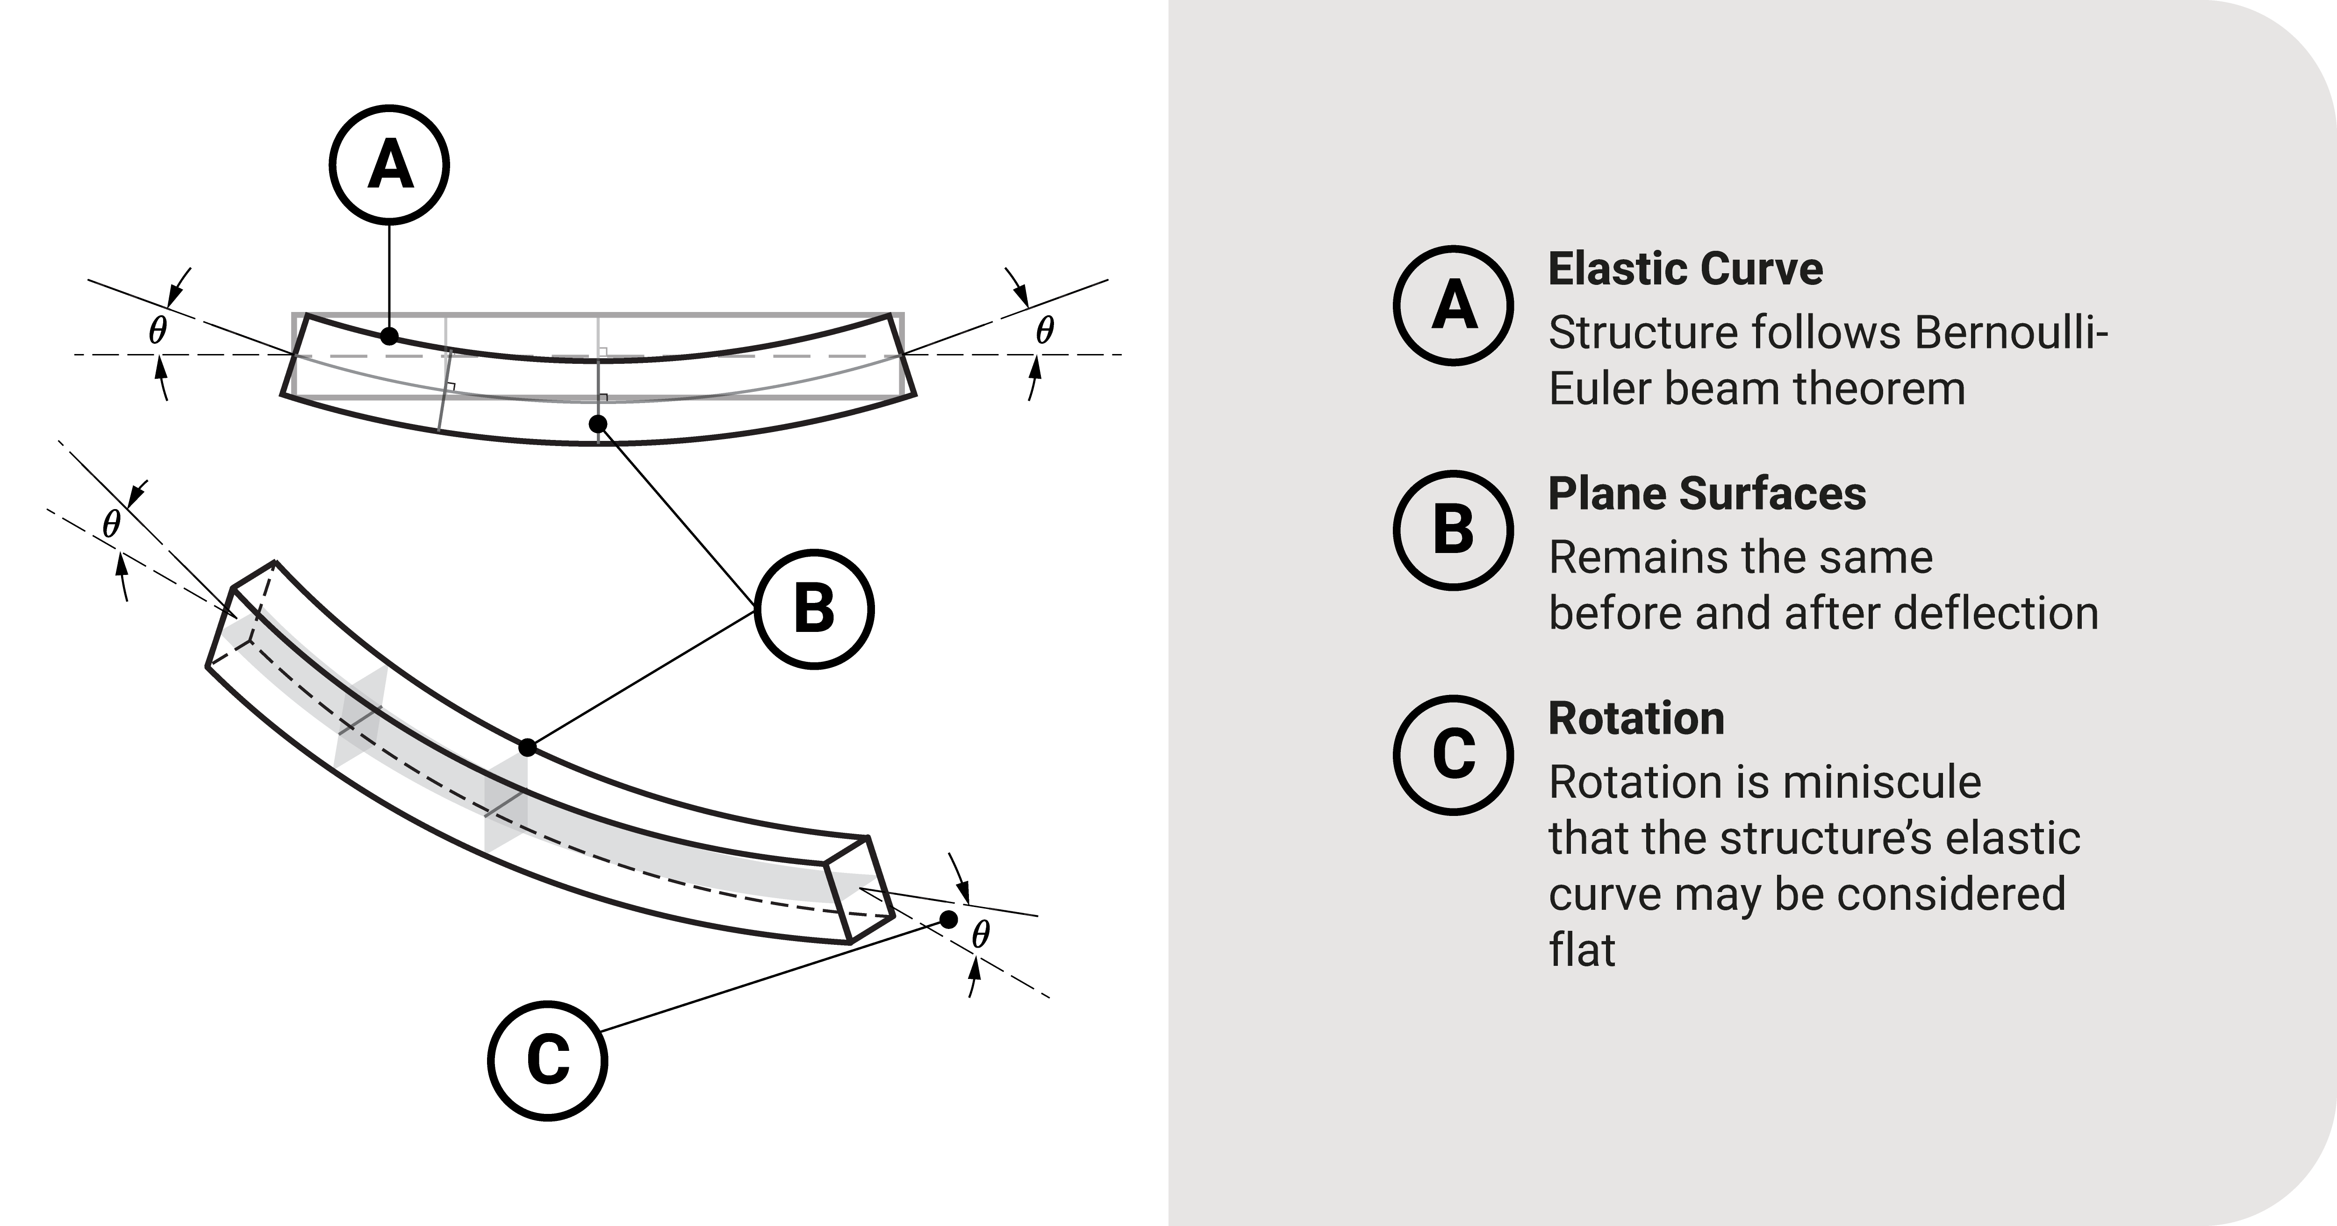
Figure 1-1-1 Plane Sections Assumption (Dirige, 2024)

FEA is highly contributory for beam design and analysis, providing engineers with an insight into the structural integrity of the load-bearing beam, allowing for simulations under varying circumstances. It allows for, in this study, the analysis of deformation, stress, and strain, enabling the user to optimize the beams material, load-bearing abilities, and safety factors. Once more, FEA is capable of solving complex loading conditions and geometries, where beam theory would struggle due to its idealized assumptions.

Aims and Objectives

Aim
The primary aim of this study is to validate FEA simulations through the experimental testing of the quasistatic behaviour of a cantilever beam. The correlation process involves assessing the accuracy of the Finite Element Analysis Model (FEAM) through the comparison between its predictions with real-world and proven analytical data. To accomplish the aim of this study, the following objectives will act as a guide for success:

Objectives
- Perform Analytical Calculations
  - Apply beam theories and mechanics of materials in hand calculations
  - Cross-reference theoretical models with analytical approach
- Conduct Experimental Testing
  - Execute experimental procedures in the quasistatic loading of a cantilever beam
  - Ensure testing environments are controlled to minimise error
- Evaluate Structural Response Parameters
  - Quantify key structural response parameters predicted by the FEAM
- Correlate and Compare Results
  - Establish a systematic approach for comparison between FEA, experimental, and analytical results
  - Identify key trends, discrepancies, and deviations
- Investigate Error analysis
  - Conduct error analysis to account for any uncertainties in results
  - Propose methods to improve quality of findings

Timing Plan
A timing plan was created through the medium of a Gantt Chart. This ensured that deadlines and milestones were met, delays were minimized, improvement in workflow, and a successful project was completed in the given timeframe. Table 1-1 displays the projects timing plan

Table 1-1Timing Plan GANTT Chart
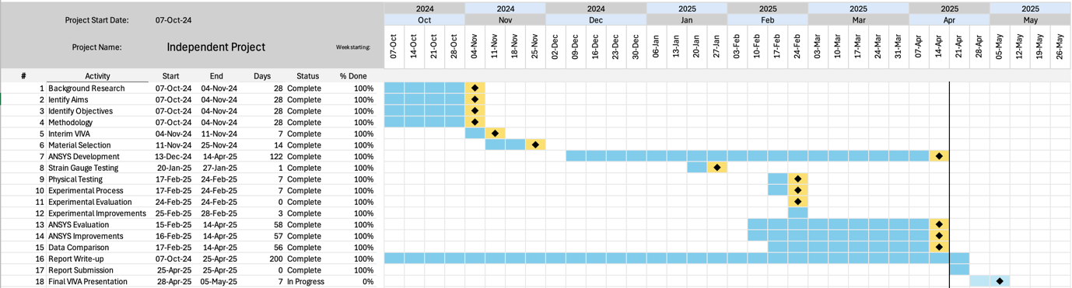

1.4 Report Structure
This independent project is structured in the following format:
Chapter 2 conducts an in-depth review into the analysis of theoretical, experimental, and simulation based modelling of mechanical response parameters. It starts by discussing the classic beam theories applied in the mechanics of materials. Analysis of formulas and their origins aim to improve understanding of material behaviours. Discussion of experimental processes used in gaining deflection, stress, and strain follows, providing further understanding for experimental methodology. Computational modelling analysis completes the chapter, where studies on mesh density and element type are presented, aiming to influence later decisions.
Chapter 3 presents the methodology used to perform successful data collection. This chapter explains the methodology used in analytical modelling, experimental testing, and FEA. This provides a stepping stone in the understanding of how each dataset is acquired, taking influence from studies analysed in the literature review.
Chapter 4 uses the methodology of the previous chapter to gain data used in its analysis. It starts by applying material properties to classic beam theories, gaining baseline results used in later correlation. Experimental data analysis follows, where adequate figures aid in visualisation. Final data analysis ends with FEA result scrutinization. Next, analysis of all data collected from the three methods aims to correlate and validate the application of FEA in structural analysis. Error analysis brings the chapter to close, where suggestions for deviations in accuracy are presented.
Chapter 5 contains the conclusions, and the further work suggested as a result of the findings of this project.

Literature Review

Introduction
This section of the report details brief analysis of previous theoretical, experimental, and simulation-based studies related to FEA and structural analysis. An investigation into error analysis will also contribute to the success of this report, aiding in the accuracy of obtainable results. Exploration of the theory will require deep study into a wide range of literature to apply the method correctly. Moreover, this research aims to address the effectiveness of utilizing FEA when performing structural analysis.

Mechanics of Materials
It is acknowledged that analysing the structural response parameters of a beam under load can be accomplished by applying beam theories. The theories can be classified into two categories, in the case of small deflections. The first method ignores shear deformation whereas the second takes these into consideration (M. Ahmed & M.Rifai, 2021).

Euler-Bernoulli Theory
The basic principle of the initial method, Euler-Bernoulli, applies various assumptions when analysing homogenous isotropic beams. The first assumption being made is that the behaviour of the material coincides with the constitutive law that it is isotropic elastic during loading. It is known that an elastic material will return to its original state upon de-loading (Yang, 2017). When determining whether a material abides this law, a second rule can be utilized by the application of Hooke’s Law. The law dictates that elastic deformation can only occur within the materials elastic limit, illustrated in Figure 2-2-1. Above the yield strength, a material cannot restore to its original shape upon stress removal, therefore for the majority of materials considered to be crystalline, there is a constant ratio between stress and strain (University of Cambridge, 2025). This relationship can be defined as the Youngs Modulus, displayed in Equation 2-2-1, where Ε denotes Youngs modulus, σ represents the stress, and ε signifies strain.

$$Ε=\frac{σ}{ε}$$
Equation 2-2-1 Hooke's Law

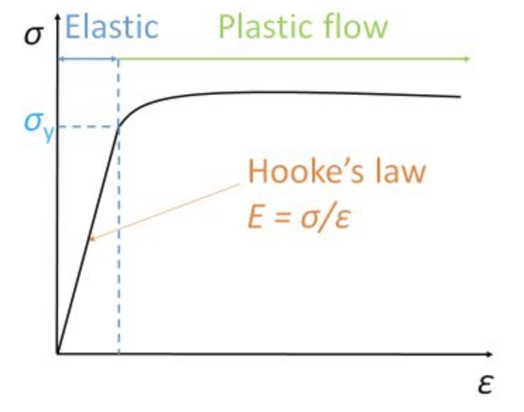
Figure 2-2-1 Stress and Strain Curve (University of Cambridge, 2025)
The second assumption hypothesised by the theory is that during deformation, the cross-section planes remain perpendicular to the deformed beam. (Sideris & Tsakmakis, 2022). This suggests that there is no distortion or warping of the beams cross-sections during deformation. It also states that the axis which passes through the centroid, the neutral axis, does not vary in length following deformation (Chen & Liu, 2015). The previous statement is displayed by Figure 2-2-2, although the beam shown is simply supported, the principle continues to apply to cantilever beams.
When a beam experiences bending, the Euler-Bernoulli theory states that no transverse shear deformation occurs. For homogenous beams with a length 10-20 times greater than any cross-sectional value, the shear fractions are considered negligible and disregarded (Ochsner, 2021). This statement by Ochsner applies to the beams used in this report, however a secondary theory can be used to inspect the transverse loads applied to a beam.
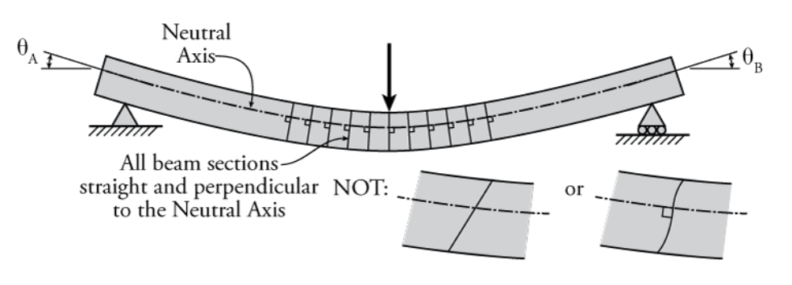
Figure 2-2-2 Plane Sections Remain Plane Assumption (Erochko, 2020)

Timoshenko Beam theory
Along a beam’s member, the vertical shear forces produced on the rectangular cross section plane cause an average shear stress considered to be constant throughout. The actual shear stress follows the parabolic law, and the maximum values occur on the beam’s neutral axis. Such members that account for shearing effect are known as the Timoshenko Beam (TB) and are governed by the Timoshenko Beam theory (TBT) (M. Ahmed & M.Rifai, 2021) .
In the book ‘strength of materials – part1’ Timoshenko states that the shear stresses in beams cause once plane cross sectional areas to become warped. Although these forces cause the layers of the material to slide over another during bending, it remains orthogonal to both upper and lower surfaces. It was also outlined in Timoshenko’s work that if the shearing forces applied to a member remain constant, the warpage also remains constant (Timoshenko, 1930).
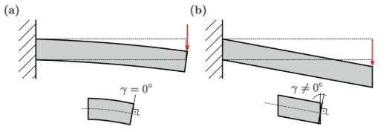
Figure 2-2-3 Deformation modes of bending beams: a.) Shear-Rigid; b.) Shear-Flexible (Ochsner, 2021)
Previously mentioned in the EBBT, it is assumed that the cross-sectional area of a member remains perpendicular during bending and remains unwarped, as displayed in Figure 2-2-3 (a). In the case of shear-flexible beams and the TBT, the shear deformation can be considered and included alongside bending deformation, and the cross-section planes are rotated by an angle (γ) correlated to the perpendicular line, see Figure 2-3 (b) (Ochsner, 2021).
Specific to this study and thus due to the nature of the beams under investigation, the TBT will prove invalid. Although described as an improved version of the Euler-Bernoulli theory, the measurements of shear bending etc will be ineffective. Ultimately, the decision was made to continue forward with the EBBT due to its applicability to this study.

Experimental Investigation
To accurately measure the response parameters mentioned in the Mechanics of Materials section (stress, strain, deflection etc) in real-time, the experimental methods require evaluation. This section will exhibit the analysis of industry-approved methods of response parameter investigation.

Deflection
The term deflection refers to the displacement of a point on the beam’s neutral axis from its original unloaded position, caused by the application of an external load. In terms of cantilever beams, the external load is compressive force along its top-face in either a Uniformly Distributed load (UDL) or point load. Mathematically, the deflection $y(x)$ at any position $(x)$ along the members length experiencing a point load can be determined by applying the EBBT. The already-mentioned theory provides an equation which relates the external force (load), beam geometry, and material properties to the maximum deflection, see Equation 2-2-2. The applied load is denoted by $P$, $L$ represents the length of the beam, $E$ is the stiffness of the specific material, and $I$ characterises the second moment of area.

$$y_{max}=\frac{PL^{3}}{3EI}$$
Equation 2-2-2 Max deflection

Absolutely critical to structural assessment, beam deflection measurements are commonly obtained through the use of contact instrument measurements. Dial gauges and linear-variable-differential transformers (LVDT) are the subject of a report by (Whiteman, et al., 2002). They state that an LVDT in short, “yields an induced voltage signal proportional to the displacement experienced by its iron core that resides within a set of coils”. It was found that however very precise, the sensors only had the capability to provide one-dimensional results that are best found in laboratories. Once outside a stable environment, it was discovered that electromagnetic fields affected results. A study conducted by (Doebelin, 1990) provides a more in-depth valuation of LVDT operation and applications. It should be noted that contact instruments such as dial gages and LVDT’s are primarily used for baseline results of deflection and act as validation references for new techniques. Despite their reliability for static or slowly varying loads due to the requirement of manual reading, high-speed or long-duration loading proves to be an issue.
An alternative approach to measuring deflection involves using the non-contact optical methods, commonly known as Laser Displacement Sensors. These methods include Laser Triangulation Sensors and Laser Doppler Vibrometers (LDV). The former measures distance by the reflections of lasers off the beam whereas the latter measures velocity and displacement by the application of a laser interface. (Nassif, et al., 2005) conducted a study on the comparison of deflection results gained from a bridge girder using non-contact LDV system and a contact displacement transducer LVDT. Findings from the study showed that there was correlation in results between the two measuring systems. In an additional study published by (Szewczyk & Kudyba, 2022), several measurement techniques were applied to a steel beam to measure deflection. It was found that laser-based equipment showed similar results to contact sensors, within a 0.1mm tolerance, validating the results found by Nassif, et al. The authors also highlighted that laser sensors are susceptible to noise (vibration) negatively affecting results.
Another widely used technique for measuring deflection can be achieved through the use of strain gages. While strain gages cannot measure deflection directly, the EBBT can be applied, linking the beams curvature to its deflection, being proportional. An investigation by (Kliewer & Glisic, 2019) included several methods for calculating deflection using strain gages. They measured the deflection simultaneously during static and dynamic loadings. Results showed the data derived from the strain gages were comparable with that from actual deflection measuring devices. (Szewczyk & Kudyba, 2022) also found that displacement-converted strain gage data showed similar results to direct displacement results.

Strain
Strain is a measurement of deformation in a material when subjected to an external force and is defined as the ratio of change in length to the original length. In the application of cantilever beams, strain can be classified by three primary types: Tensile, Compressive, and Shear. The two initial types mentioned exhibit opposite effects, see Figure 2-2-4. Tensile strain occurs when the material of the beam is stretched thus increasing its length, primarily found on the top-surface of a beam. Materials that undergo compressive strain decrease in length due to compression under bending. This specific variant of strain can be found parallel to the face at which the load is applied. Shear strain however occurs when transverse shear forces (loads) are applied to a beam, causing angular deformation. As previously mentioned in this report, shear stresses, strains, and forces etc will be ignored due to the inapplicability of the TBT.

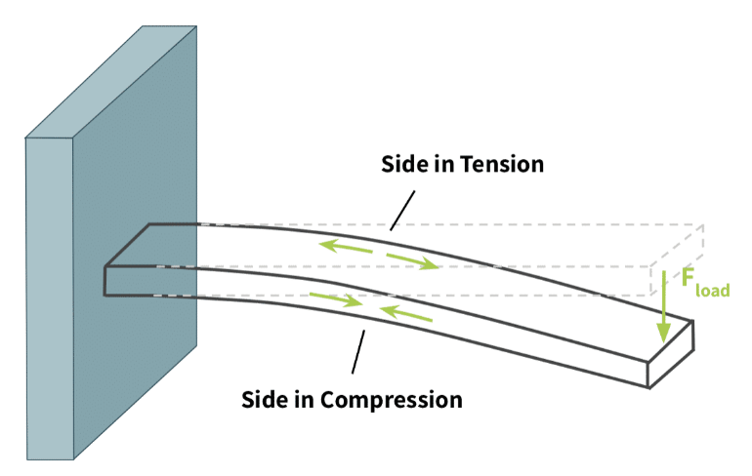
Figure 2-2-4 Compression and Tension of Cantilever Beam (Tacuna Systems, 2024).
Various techniques can be utilised to accurately measure strain within cantilever beams, with each offering unique advantages and setbacks. Traditionally, strain gage sensors are used due to their overall accuracy and reliability. Research by (Abuye, et al., 2024) analysed the flexural behaviour of cantilever beams under varying loads using analytical, experimental, and computational techniques. The investigation employed strain gage sensors configured in a Wheatstone bridge configuration, see Figure 2-2-5. The study concluded that the experimental data showed close correlation to that found using FEA and analytical methods, highlighting the effectiveness of using strain gages.

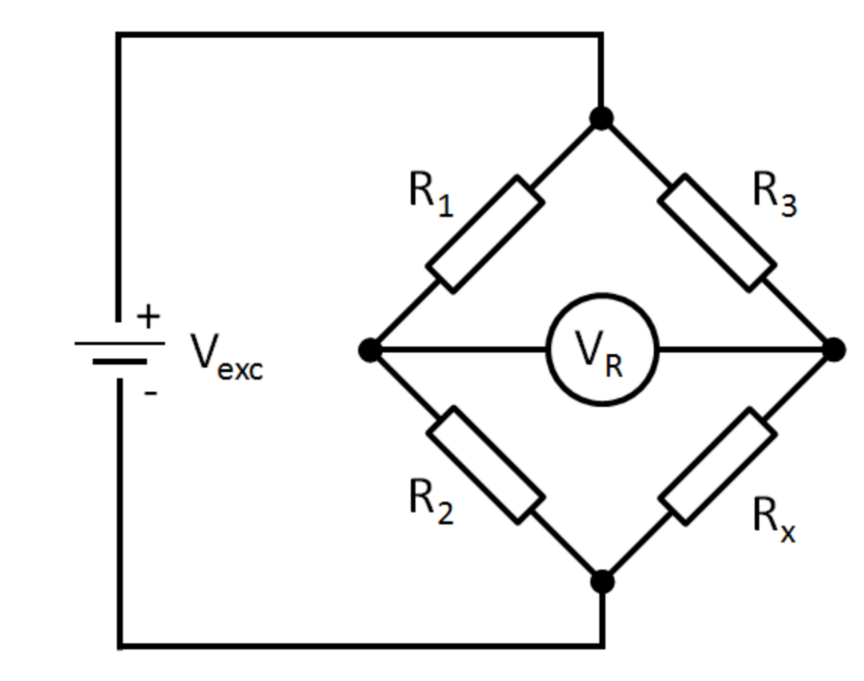
Figure 2-2-5 Wheatstone Bridge Circuit (National Instruments, 2023)

Additionally, in the book ‘An Introduction to Measurements using Strain Gages’ by Karl Hoffman, it is described that the workings of metal strain gages are based on the strain/resistance relationship, discovered by Wheatstone and Thompson. It is said that changes in the electrical conductor’s resistance can be accredited to the mechanical stresses caused by compressive/tensile forces. The resistance change is also due to the change in resistivity ($Q$) in the material as a result of microstructural movements. The process is described by the following relationship, where $R$ is the electrical resistance, strain is $ϵ$, and poisons ratio is shown as $ν$:
$$\frac{dR}{R_{o}}=ϵ\left(1+2ν\right)+\frac{dQ}{Q}$$
Equation 2-2-3 Strain/Resistance Relationship
Alternatively, advancements in strain measurement techniques have seen the introduction of Fiber Bragg Grating (FBG) sensors, which have gained prominence due to their sensitivity and electromagnetic interference immunity. A study by (Nandi, et al., 2023) presented a measurement model containing FBG sensors for beam structures. It was found that the effectiveness of FBG sensors reinforced applicability in structural integrity monitoring by providing accurate strain values and variations.

Strain Gage Placement
Strain gage placement for cantilever beams is a limiting factor in the accuracy of output results due to non-uniformed distributions. Studies have been conducted to identify optimal position for strain gages to ensure accurate strain measurements, with (Kumar, et al., 2012) being one. FEA modelling was implemented to simulate a beam subjected to loading conditions, where strain values were analysed along its length. Key findings show that placing gages near the support display the highest resulting strain. Due to the characteristics of a cantilever beam, the bending moment in this area is at maximum as it must counteract the applied load at its free end (Gregory & Gladwell, 1982). A similar study by (Zubin, 2008) evaluated strain measurement accuracy in bending beams. Comparable to the initial reviewed study, maximum strain values were found near the fixed end of the beam. However, this study also reviewed uncertainties in the methodology. Primary errors included misalignment, variations in adhesive application, and surface finish irregularities.

Stress
In terms of cantilever beams, stress refers to the internal forces that develop within the material when subjected to external loads, a point load in this case. Two primary types of stress occur in cantilever beams, being bending and shear stress. However, as previously mentioned, shear stresses will be excluded from this report. When beams are subjected to a point load at the free end, bending moments occur that induce normal stresses, spanning across the cross-section plane. Because of the external load, beams experience compression and tension on opposite surfaces relative to the neutral axis, which remains unstressed, previously shown in Figure 2-2-4. The Maximum bending stress (σ) at any given point is calculated using Equation 2-2-4, where M is the bending moment, $y$ shows the distance from the neutral axis, and $I$ signifies the moment of inertia of the beams cross-sectional area (Young & Budynas, 2002).
$$σ=\frac{M.y}{I}$$
Equation 2-2-4 Flexure Formula

Mathematically, analysing the stress encountered by a beam during loading can be performed by the application of Hooke’s Law, or more so its transposition. Originally, the relationship between stress and strain is directly proportional and can be given as a materials Youngs Modulus, see equation 2-2-1. This relationship implies that for materials behaving elastically, the stress-strain ratio remains a constant. However, through transposition, stress is given as:
$$σ=E.ε$$
Equation 2-2-5 Stress-Strain Relationship
Experimentally, stress-analysis differs to deflection and strain data collection in terms of accessibility. Where strain and deflection measurements are conducted using specialist equipment (LVDT’s and Strain gauges etc.), stress is primarily measured analytically. Through the application of the aforementioned measuring techniques, data is manipulated using equations such as the stress-strain relationship above, to derive stress values. Studies that apply this methodology are (Hunt, et al., 2015) and (Pabari & Mavani, 2016). The initial study mentioned aimed to analyse the bending stress of cantilever beams that were displaced at the free end and held for a specified duration. It should be noted that the specimens used as cantilever beams were wood composites, although materials differ drastically in structure, the methodology of stress-analysis applies. The results recorded for strain and deflection were examined and manipulated to gain accurate stress values. The latter study employed strain gages at varying positions to a cantilever beam experiencing a point load. The primary aim of the study was developing stress measurement accuracy by optimizing strain gage placement. It was found that this methodology provided accurate stress data that coincided with theoretical analysis, validating its application.

Computational Modelling Analysis
Among the various parameters that influence the accuracy of computational simulations, mesh types and densities are crucially important to overall performance. This body of the report will investigate how mesh characteristics affect simulation accuracy and computational efficiency.

Mesh Density
In a study conducted by (Dutt, 2015), the relationship between mesh size and computational accuracy was emphasized through the analysis of a cantilever beam under load. It was demonstrated that finer mesh densities significantly improve the accuracy of equivalent strain and deflection results. Coarser meshes, although computationally efficient, essentially led to greater deviations from analytical solutions. Similarly, a study published in the European Journal of Engineering and Technology Research presented a finite-element based model to investigate deflection in two cantilever beams of varying material. Comparison of results from a course 4-element mesh and a finer 10-element mesh displayed that finer meshing produced results of similar alignment to theoretical solutions (Oladejo, et al., 2018).
Despite findings by (Dutt, 2015) and (Oladejo, et al., 2018) showing improvements in accuracy with finer meshes, over refinement can lead to inaccuracies. Research conducted by (Gukop, et al., 2021) found that a decrease in element size caused an increase in peak stress values. This outcome is likely attributed to the relationship between stress, force, and area, demonstrated in equation 2-6. Assuming the force remains constant, as the area it is applied decreases (mesh size reduction), a resulting increase in stress will be observed. Physically, this implies that the intensity of the force over the material increases, commonly known as a stress singularity.
$$σ=\frac{F}{A}$$
Equation 2-6 Normal Stress

Element Type
In the analysis of structures, the two most commonly employed element types are hexahedral (brick) and tetrahedral (Tet) meshes, Figure 2-6. Numerous studies have aimed to analyse the performance of mesh types in terms of their computational efficiency, accuracy, and applicability to various loadings and boundary conditions. One study by (Osuji & Adegbemileke, 2015) compared linear hexahedral elements with triangular elements in the modelling of a cantilever beam. It was discovered that hexahedral elements achieved faster convergence in fewer elements to determine accurate stress predictions. Whereas the triangular mesh required a finer density to produce similar accuracy. Correspondingly, a study by (Słota & Wosatko, 2025) compared both element types in their accuracy in terms of bending benchmarks. The research conducted that in particularly course mesh, the brick elements produced displacement results of greater accuracy compared to triangular mesh types. Additionally, in a study comparing tetrahedral and hexahedral elements for FEA, the authors concluded that for analysis of bending problems, hexahedral mesh consistently achieved convergence compared to tetrahedral mesh types. For simulations with structured domains, brick elements demonstrated the ability to align with component geometry and loading conditions due to their simplified shape. Moreover, analysis revealed that tetrahedral elements were less efficient in terms of computational cost due to the increase in degrees of freedom (Shneider, et al., 2022).

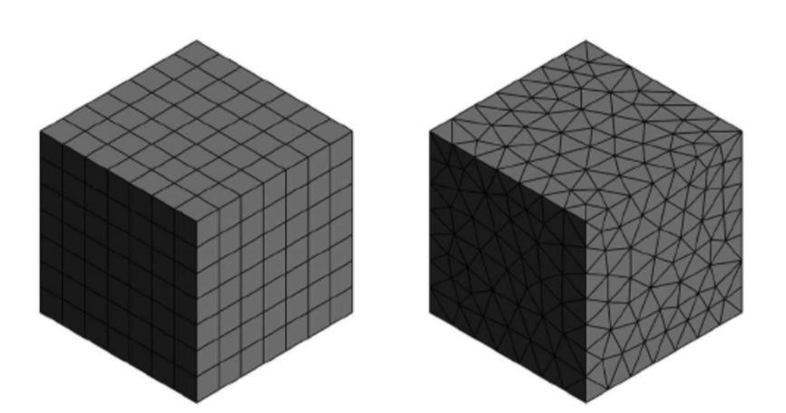
Figure 2-6 Types of Mesh: hexahedral - left, tetrahedral - right (Sosnowski, et al., 2017)

Methodology
This report employed the integration of numerical solutions, experimental procedures, and the analysis of the FEAM to validate the simulations accuracy. The methodology of this study focusses on comprehensive evaluation of the structural response parameters (deflection, stress, and strain) of a cantilever beam. The procedures executed, being analytical modelling, experimental testing and simulation, are followed by extensive comparison and error analysis.

Analytical Modelling
Theoretical analysis served as a stepping stone in predicting the beams behaviour under quasistatic loading. Application of the EBBT aided in calculating expected values for the response parameters under investigation. Idealised assumptions of the beam were made, being a homogenous and isotropic structure, rigidly supported at one end, subjected to a point load at the other. To establish a baseline for expected values, equations for deflection, stress, and strain are presented below. With regards to maximum deflection, it was originally stated in the report that equation 2-2-2 would be applied. However, the previously mentioned equation can only be utilized if a point load is applied to its maximum distance from the support. Due to the loading conditions of the experiment being applied at a defined distance, an alternative equation is required to accurately model maximum deflection, see equation 3-1.
$$δmax=\frac{P{.a}^{2}.(3L-a)}{6E.I}$$
Equation 3-1 Maximum Beam Deflection
In terms of strain, assuming pure bending and linear elastic behaviour, maximum values occur at the members outmost fibers and is related to its bending moment and geometry. For cantilever beams with a point load, its bending moment can be sourced using equation 3-3. Ultimately, the maximum strain within a cantilever beam is displayed in equation 3-4.
$$ε_{max}=\frac{M.y}{E.I}$$
Equation 3-2 Maximum Strain with Regards to its Bending Moment

$$M=P.L$$
Equation 3-3 Bending Moment of a Cantilever Beam
$$ε_{max}=\frac{P.L.y}{E.I}$$
Equation 3-4 Maximum Strain
Given the relationship between stress, strain, and a materials young’s modulus, the following equation is utilized to calculate maximum bending stress:
$$σ=E.ε$$
Equation 3-5 Maximum Bending Stress

Experimental Setup
To obtain real-world data for correlation, controlled quasistatic load testing was performed on 4 beams of varying material, with known geometries and material properties shown in Table 3-1. Material properties were gained through the university’s metal supplier aalco, (aalco metals Ltd, 2025).
Table 3-1Material Properties and Geometries of Materials Used a.) Aluminium b.) Brass c.) Low Carbon Steel d.) Stainless Steel
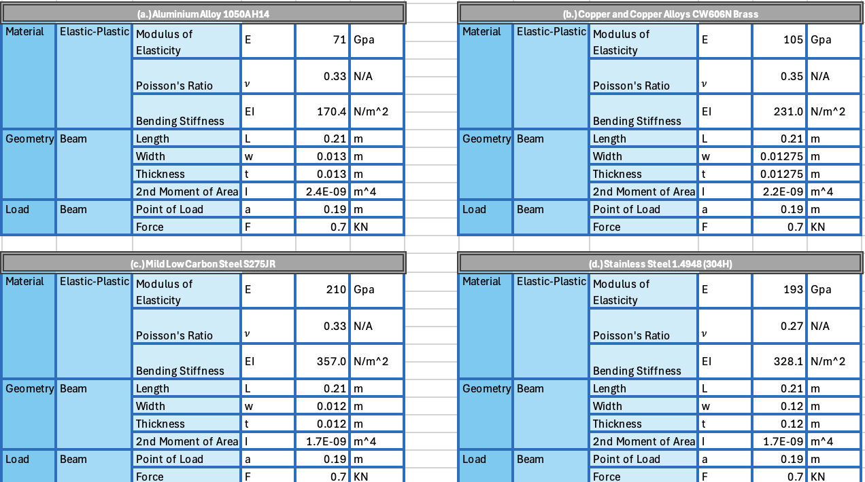

Compression Testing
To mimic a real-world example, each beam was secured in a rigid support fixture using a bolted clamp system, Figure 3-1. A Gradual increasing point load was applied using a Denison Mayes Group Universal Testing Machine (UTM) with an integrated load cell for precise force output (Denison Mayes Group, 2025). The load was applied in 0.15kN increments, ranging from 0-0.6kN, the minimum increment achievable with the UTM, with a machine speed of 0.002KN/s and 0.5mm/min tighten speed remaining constant. A final increment of 0.1kN was applied to reach maximum point load of 0.7kN. A maximum load value was set to remain withing the material’s elastic limit and avoid surpassing its yield strength.
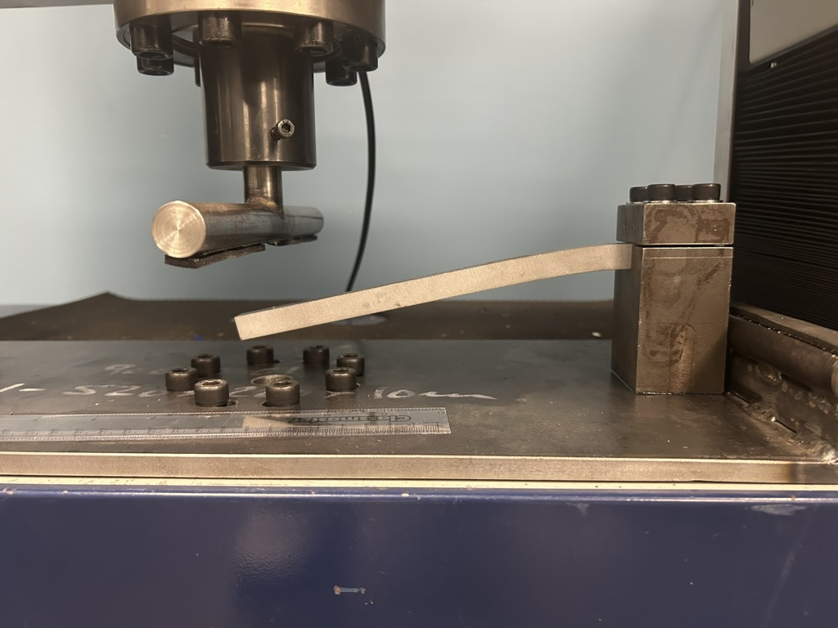
Figure 3-1 Deformed Aluminium Beam in Bolted Clamp System
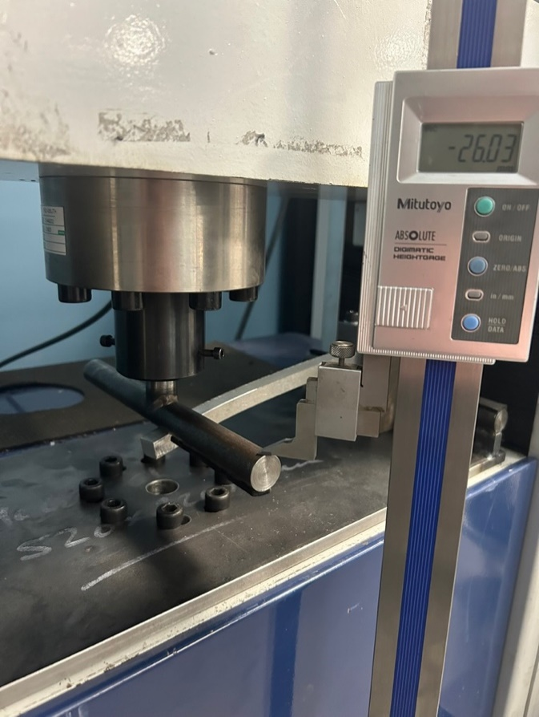
Figure 3-2 Demonstration of Vernier Height Gage Measuring Deflection of Dummy Run Aluminium
The decision to select the described equipment was based on its accuracy and availability to the university. Additionally, UTM’s include Rubicon Control Interface software, which aid the user in analysing data in real time alongside graph plotting and raw data extraction. In addition to data collected by the UTM, the use of a vernier height gage was also applied to verify the accuracy of the machines data collection, see Figure 3-2. All loading controls can also be managed using the equipment’s interface. Other available methods were investigated such as the Deflection of Beams Kit ES4, provided by TecQuipment (TecQuipment, 2025). However, it was concluded that the ES4 would not be suitable due to the simplicity of the experiment and scarcity of data producible in the time frame.

Strain and Stress Data Collection
To capture strain within the beam, strain gages were mounted to its surface using general adhesive. The predetermined locations of the strain gages were influenced by strategies found in the Strain Gage Placement section of this report. They were located at the base of the support in both compression and tension (Figure 3-3 b.), with an additional gage mounted at the free end of the beam: 45mm, 45mm, and 105mm from the base respectively. To further secure the strain gages to each test beam, masking tape was applied. All gages were integrated to the NI cDAq-9178 (NI compactDAQ) chassis, supplied by National Instruments, with Flexlogger being the software of choice for strain data collection. The chassis contained the NI-9235 input module which measures strain on multiple channels simultaneously (National Instruments, 2025), see Figure 3-3 a.). A standout characteristic of the NI-9235 module is the built-in circuit which negates the necessity for a dummy gage. Additional methods of strain data recording were considered, such as the built-in measuring software of the UTM. However, it was decided that using multiple measuring techniques ensured accuracy and decreased error likelihood.
Data collection for stress varied compared to the other measured parameters, with no physical measurement technique available. Analytical methods were alternately used in conjunction with acquired strain data, with equation 2-2-5 from Stress chapter being utilised. The equation required knowledge of the materials Young’s Modulus and corresponding strain value at specific locations. Figure 3-4 presents the complete experimental setup, detailing measuring instrument attachment and UTM load application.

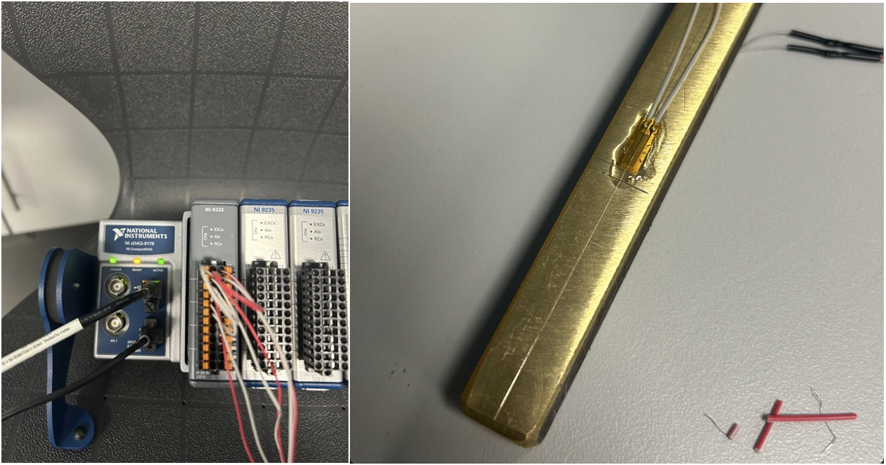
Figure 3-3a.) NI-compactDAQ with NI-9235 b.) Strain Gage Secured at Support Base Location on Brass Test Piece
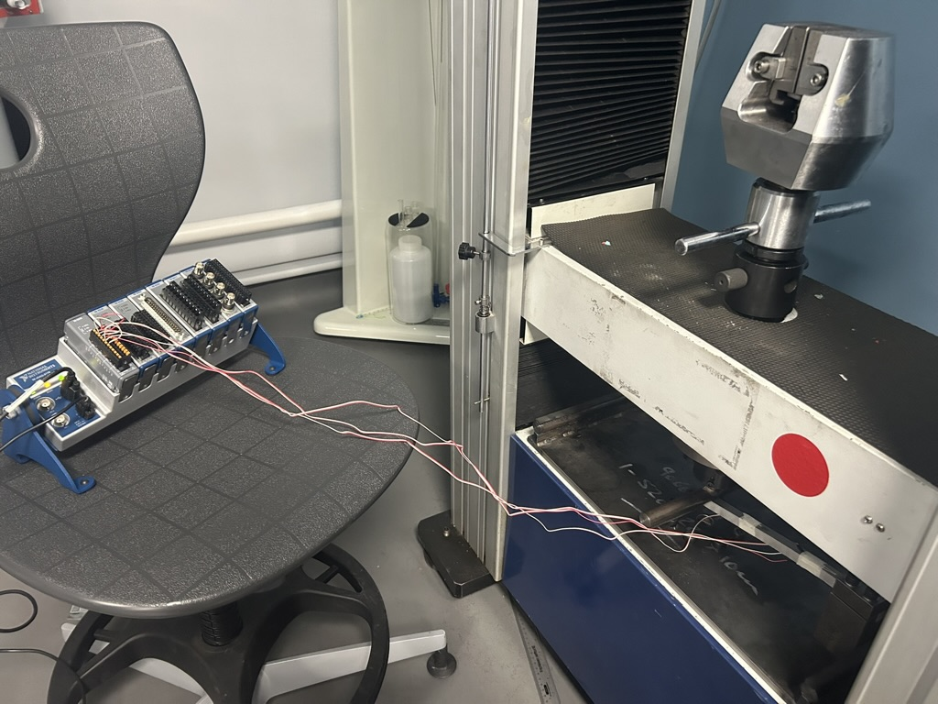
Figure 3-4Complete Experimental Setup

Simulation Setup
In advance of conducting FEA, four distinct beam models were developed in SolidWorks to accommodate the varying cross-sectional geometries, shown in Appendix A. Prior to result correlation, a mesh study was conducted to determine optimal mesh density that balances computational efficiency with accuracy. Taking influence from studies in the literature review, hexahedral elements were chosen as the most fitting element type due to their alignment with geometry and computational efficiency. The aforementioned experiments were modelled in ANSYS Workbench 2023 R2 using 3D solid Elements (SOLID186). Boundary conditions were set to mimic the experimental procedure: 40mm long fixed support on all sides to replicate the bolted clamp system, and a 0.7kN load applied 20mm from its free end resembling the load applied by the UTM (both displayed in Figure 3-4 Boundary Conditions Applied in ANSYS Mechanical). Solver type determination found that static structural analysis under linear elastic conditions best resembled the experimental process. Utilizing the static structural solver allowed for post-processing and the extraction of maximum deflection, stress distribution and strain development across the beam’s member.

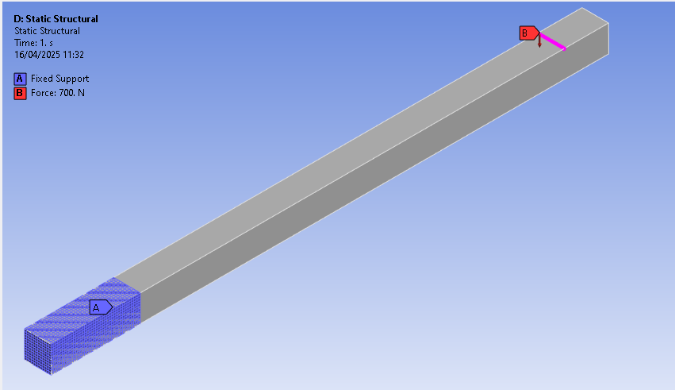
Figure 3-5 Boundary Conditions Applied in ANSYS Mechanical

Data Analysis and Correlation
To accurately establish correlation, a comparative analysis of the three approaches was conducted. Statistical analysis included calculating error percentages and standard deviation of experimental and FEA data against theoretical results. Graphical plots were used in aiding the visualisation of trends and discrepancies in the reports results.
Where discrepancies were identified, an investigation into potential sources of error was conducted. The following contributing factors were analysed, in terms of theoretical, experimental and numerical domains. Theoretically, classic beam theories such as the EBBT assume idealised conditions, where shear deformation is neglected. However, in practical applications, such assumptions can lead to underestimation of response parameter measurement. Additionally, imperfections in experimental setup lead to potential sources of error. Such errors include measurement noise caused by the UTM, strain gage sensitivity, and variability in adhesion bonding quality. Physical testing discrepancies can also be attributed to slippage of load point, fixture movement, and sensor misalignment. Maximum care was taken to idealise the experimental procedure; however, errors and discrepancies were anticipated.

Results and Analysis

Quantitative Analysis
Serving as a benchmark for comparison of experimental and simulation results, initial idealised results of response parameters must be acquired. Utilizing the analytical modelling methodology of this report, the following calculations will aid in the attempt for correlation.

Analytical Maximum Deflection
The employment of Equation 3-1 Maximum Beam Deflection, and material properties gained through aalco allow for the deflection calculation of each respective beam (aalco metals Ltd, 2025).
For Aluminium:
$$δ_{max}=\frac{700×{0.190}^{2}×(3×0.210-0.190)}{6×(71×{10}^{9}×2.4×{10}^{-9})}$$
Equation 4-1Maximum Deflection Equation for Aluminium
$$δmax=10.87mm$$
Equation 4-2Aluminium Deflection Result
For Brass:
$$δ_{max}=\frac{700×{0.190}^{2}×(3×0.210-0.190)}{6×(105×{10}^{9}×2.2×{10}^{-9})}$$
Equation 4-3Maximum Deflection Equation for Brass
$$δmax=8.022mm$$
Equation 4-4Brass Deflection Result
For Mild Steel:
$$δ_{max}=\frac{700×{0.190}^{2}×(3×0.210-0.190)}{6×(210×{10}^{9}×1.7×{10}^{-9})}$$
Equation 4-5 Maximum Deflection Equation for Mild Steel
$$δmax=5.1908mm$$
Equation 4-6 Mild Steel Deflection Result
For Stainless Steel:
$$δ_{max}=\frac{700×{0.190}^{2}×(3×0.210-0.190)}{6×(193×{10}^{9}×1.7×{10}^{-9})}$$
Equation 4-7 Maximum Deflection Equation for Stainless Steel
$$δmax=6.58mm$$
Equation 4-8 Stainless Steel Deflection Result

Analytical Maximum Strain
The application of Equation 3-4 Maximum Strain and aforementioned material properties allow for the determination of the maximum strain experienced by each beam.
For Aluminium:
$$ε_{max}=\frac{700×0.210×0.0075}{71×{10}^{9}×2.4×{10}^{-9}}$$
Equation 4-9Maximum Strain Equation for Aluminium
$$ε_{max}=0.006470$$
Equation 4-10Aluminium Strain Result
For Brass:
$$ε_{max}=\frac{700×0.210×0.006375}{105×{10}^{9}×2.2×{10}^{-9}}$$
Equation 4-11Maximum Strain Equation for Brass
$$ε_{max}=0.004056$$
Equation 4-12Brass Strain Result
For Mild Steel:
$$ε_{max}=\frac{700×0.210×0.006}{210×{10}^{9}×1.7×{10}^{-9}}$$
Equation 4-13Maximum Strain Equation for Mild Steel
$$ε_{max}=0.002470$$
Equation 4-14Mild Steel Strain Result
For Stainless Steel:
$$ε_{max}=\frac{700×0.210×0.006}{193×{10}^{9}×1.7×{10}^{-9}}$$
Equation 4-15Maximum Strain Equation for Stainless Steel
$$ε_{max}=0.002680$$
Equation 4-16Stainless Steel Result

Analytical Equivalent Stress
Through the application of Equation 3-5 Maximum Bending Stress, the utilization of strain values for each beam in conjunction with their respective stiffness allow for the following stress calculations.
For Aluminium:
$$σ=71×{10}^{9}×0.006470$$
Equation 4-17Bending Stress Equation for Aluminium
$$σ=459.37MPa$$
Equation 4-18Aluminium Result
For Brass:
$$σ=105×{10}^{9}×0.004056$$
Equation 4-19Bending Stress Equation for Brass
$$σ=425.88MPa$$
Equation 4-20Brass Result
For Mild Steel:
$$σ=210×{10}^{9}×0.00247$$
Equation 4-21Bending Stress Equation for Mild Steel
$$σ=518.7MPa$$
Equation 4-22Mild Steel Result
For Stainless Steel:
$$σ=193×{10}^{9}×0.00268$$
Equation 4-23Bending Stress Equation for Stainless Steel
$$σ=517.24MPa$$
Equation 4-24Stainless Steel Result
To enhance clarity, Table 4-1 was created, where analytical values for deflection, strain, and stress for each beam under investigation are displayed. Interpretation of the table shows that Aluminium is the most ductile and encompasses the highest flexibility, primarily due to its low stiffness property. Brass displays a mid-range performance between the aluminium and steels, being stiffer than the former but more flexible than the latter. Mild and stainless-steel show similar values in terms of stress and strain due to identical geometries and comparable stiffness values.
Table 4-1Analytical Response Parameter Results
 | Response Parameters
 | Deflection | Strain | Stress
Material: | mm | N/A | MPa
Aluminium Alloy 1050A H14 | 10.87 | 0.006470 | 459.37
Copper and Copper Alloys CW606N Brass | 8.022 | 0.004056 | 425.88
Mild Low Carbon Steel S275JR | 5.1908 | 0.002470 | 518.70
Stainless Steel 1.4948 (304H) | 6.58 | 0.002680 | 517.24

Experimental Findings
This section of the report presents the results obtained from the experimental testing of the cantilever beam’s deflection, strain, and corresponding stress. The recorded data provides means of comparison for later finite element exploration.

Experimental Deflection
As mentioned previously, measurements of deflection were recorded using the UTM’s built in Rubicon Control Interface software. The digital package allows for the continuous measurement of deflection at its corresponding load. Moreover, plotting of load displacement graphs was done automatically. Figure 4-1 displays an example of a load displacement graph for an aluminium test piece plotted by the software. It is evident from the figure that the y axis has been set to a constant maximum load value producible by the UTM, rather than an axis fitting to its specific test load. To counter this issue, separate load displacement graphs were created in MATLAB utilizing raw data extracted from the machine’s software. Respective load displacement graphs plotted by the software can be found in Appendix B.
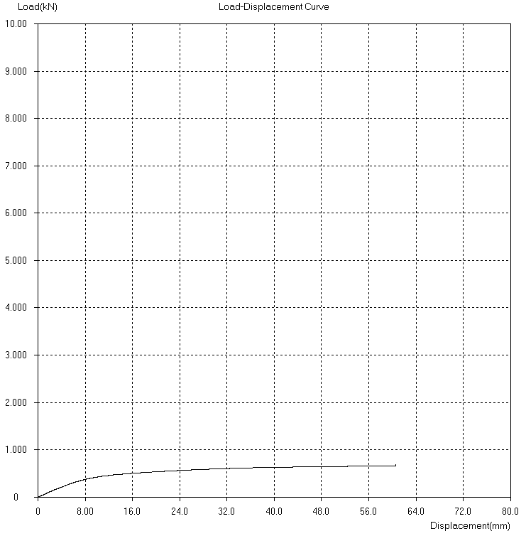
Figure 4-1Aluminium Load Displacement Graph Plotted by Rubicon Control Interface Software
As a comparison to the load displacement graph presented in Figure 4-1, the MATLAB generated graph for aluminium test piece is illustrated in Figure 4-2. Initial analysis of the figure suggests elastic behaviour within the 0-20mm displacement slope, where deformation is behaving proportionally to the applied load. In the 20mm-50mm region the curve reduces in steepness, indicating plastic deformation. The curve continues to rise beyond 50mm and approaching maximum load, where a sharp spike in load suggest that the material has yielded and approached its mechanical limit. The maximum deflection result is especially significant as theoretically the aluminium test piece should show a deflection result in the region of 10.87mm. Whereas, experimentally the beam has experienced a deflection result 457% larger than its expected value. Further analysis of this case study will follow in latter sections of the report
Figure 4-2 MATLAB Generated Load Displacement Graph for Aluminium Test Piece
Unlike aluminium, the brass test beam displays a near linear curve, indicating a proportional relationship between load applied and displacement. Consistent stepping nature of the curve portrays the load application of 0.15kN and a final 0.1kn increment clearly. The linearity of the graph supports the conclusion that the brass beam remained elastic throughout testing with no plastic deformation occurring. Analytically, the test piece should show a maximum deflection in the region of 8.022mm. However, according to figure 4-3’s legend, the maximum displacement was recorded at 10.59mm, a 13% increase. Many variables could cause this deviation, with likelihood of component slippage in the clamp and measurement errors due to the resolution of the measuring equipment having an effect on accuracy.
Figure 4-3MATLAB Generated Load Displacement Graph for Brass Test Piece
Figure 4-4MATLAB Generated Load Displacement Graph for Mild Steel Test Piece
Comparable to brass, the mild steel specimen produced a load displacement graph demonstrating a linear mechanical response. The absence of non-linearities and sudden shifting in Figure 4-4 indicates that during loading, the mild steel specimen remained within its elastic limit. At a final load of 0.7kN, mild steel achieved a maximum deflection of 6.46mm, a 24% increase from its maximum theoretical value. In contrast, the stainless steel beam displays a distinct load displacement curve in Figure 4-5. An initial steepness in the graphs curve indicates a stiffer response in the initial phase of loading, suggesting material softening or viscoelastic behaviour. Comparison of stainless steel’s experimental deflection to previous analytical calculations show a 63% increase, implying a slight yield in the material.
Figure 4-5MATLAB Generated Load Displacement Graph for Stainless Steel Test Piece
Following a similar methodology to Table 4-1, an updated table containing experimental data and corresponding response parameter accuracy to analytical results is presented in Table 4-2. A comparison of deflection values shows mixed variation of accuracy, with aluminium exhibiting especially substantial deviation, followed by brass. Both steel beams display the closest alignment, however there is a lack of consistency in accuracy.
Table 4-2Experimental vs Analytical Deflection with % Difference
Material: | Experimental Deflection | Analytical deflection | % Difference to analytical result
Aluminium Alloy 1050A H14 | 60.59 | 10.87 | 457.41
Copper and Copper Alloys CW606N Brass | 10.59 | 9.35 | 13.26
Mild Low Carbon Steel S275JR | 6.46 | 5.1908 | 24.45
Stainless Steel 1.4948 (304H) | 9.22 | 5.648 | 63.24

Experimental Strain
Utilization of strain gages, NI compactDAQ, NI-9235 input, and Flexlogger software allowed for the simultaneous measurement of strain on the beam’s member during loading. Placement of the gages provided strain recordings at areas of maximum compression and tension, with an additional located at the free end as a control point. Post loading, extraction of raw data was performed and sorted into adequate spreadsheets. An issue that arose with the extraction was the time variable, being in a dd/mm/yy 00:00:00 format. To rectify this issue, a relative time step of 0.01s was applied. This allowed for a common time step for all testing results and the generation of time dependant strain graphs.
An example of a time dependant strain graph lays in Figure 4-6, where the aluminium beams tension, compression, and free end strain behaviour are captured. Initially, all strain profiles demonstrate a stable response up to 400s, with negligible recorded fluctuations. Sudden increases in strain followed by plateaus were expected, where load application and intermission are displayed clearly prior to 600s. Post peak values, data recorded for both tension and compression regions start to decay, stabilizing toward initial steady-state values, suggesting material relaxation. Such observations support findings in Experimental Deflection, where material yielding is evident. Notably, minor fluctuations continue through the duration of the test, indicating microstructural movement within the material. With regards to results, the aluminium beam experienced maximum strain of 0.01003813, 55% greater than anticipated analytical analysis. However as previously mentioned regarding deflection results, the aluminium beam shows an overall inaccuracy in experimental results with a strong likelihood of error propagation.
Figure 4-6Time Dependant Aluminium Strain Response Under Tension, Compression, and Free-End Behaviour
Figure 4-7Time Dependant Brass Strain Response Under Tension, Compression, and Free-End Behaviour

Originally, the brass beam was subjected to a maximum load of 1kN, rather than the standard 0.7kN applied to other test pieces, with the aim of experiencing material yield as observed in aluminium. Conversely, the outcome was not evident in the brass beam due to its superior yield strength of 125MPa, according to Granta EduPack 2022 R2 (Granta EduPack, 2022). The decision was made to exclude strain results post 0.7kN load to maintain a fair comparison across all materials. This decision led to the absence of observable stabilization in results in Figure 4-7, however maximum strain values were obtainable through data analysis. To aid in comparison, the original graph plotting strain values at a maximum load of 1kN has been included in Appendix C. Similar to the strain curve of aluminium prior to material yield, brass displays clear loading and intermission plateaus. Notably, the compression curve identically mirrors the tension curve, indicating balanced strain distribution throughout loading. Theoretically, it is expected that maximum strain for the aluminium experiment should be anticipated in the region of 0.004056. Comparably, experimental findings demonstrate a 10% overachievement of 0.004481. These findings suggest that the strain measurement equipment displayed a 15% improvement in measuring strain in brass compared to aluminium.
Figure 4-8Time Dependant Mild Steel Strain Response Under Tension, Compression, and Free-End Behaviour
Much like the behaviour observed in brass, the illustrated strain response of mild steel in Figure 4-8 exhibits alignment in curve profiles. Corresponding behaviour was also observed in the respective load displacement graphs, indicating both materials remained elastic throughout testing. Notably, a distinct stabilization is apparent post 80s, indicating maximum load value completion and constant. Among the materials tested thus far, mild steel exhibited the most accurate strain measurements, 5% difference to analytical results respectively.
Figure 4-9Time Dependant Stainless Steel Strain Response Under Tension, Compression, and Free-End Behaviour

Stainless steel presents varying curve profiles to previous strain plots analysed in this report. The exemption of spikes and plateaus in Figure 4-9’s strain curve suggests that the material experienced constant strain throughout loading. Additionally, a study presented in the Journal of Materials Science and Technology supports these findings. Where work hardened metals such as stainless steel exhibit gradual and continuous strain responses, contributing to its smooth strain curve (Llewellyn, 1997). Maximum experimental strain values in the case of stainless steel occur in compression, aligning with the findings of (Song, et al., 2017). The journal article indicates that under load, stainless steel encounters varying strain responses in tension and compression. Due to its microstructural properties, the material can withstand higher strains in compression before ultimately yielding. Evident to the findings, the experimental compressive strain value for stainless steel peaked at 0.00591644, a 120% increase to the analytical estimations. Error analysis of these results will prove essential in the understanding of such deviation.
To aid in the identification of steady-state behaviour within material testing, standard deviation plots were created aimed at visualizing and identifying regions of low variability within the tension strain signals. The rationale for the presentation of such figures is the assistance of time interval detection withing stable strain responses, indicating system equilibrium and steady-state material behaviour. Upper subplots in Figures 4-10 through 4-13 display raw strain data aquired from the tension strain gage against relevant elapsed time. Shaded regions indiate segments where local standard deviation falls below a predefined threshold of 0.4, for a minimum of 75 data samples. Minimal fluctuation occurs in these regions, where time intervals of signal stability are represented. Additionally, illustrated in the respective figures’s subplots, a 7-sample sliding window filter has been applied, serving as a basis of validation to the sability conditions defined in the upper subplots.
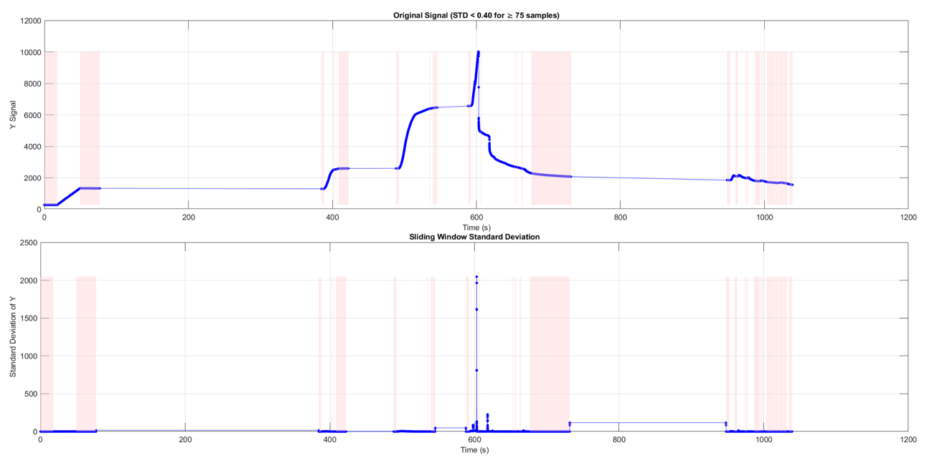
Figure 4-10 Visualization of Aluminium Signal Stability in Strain Data
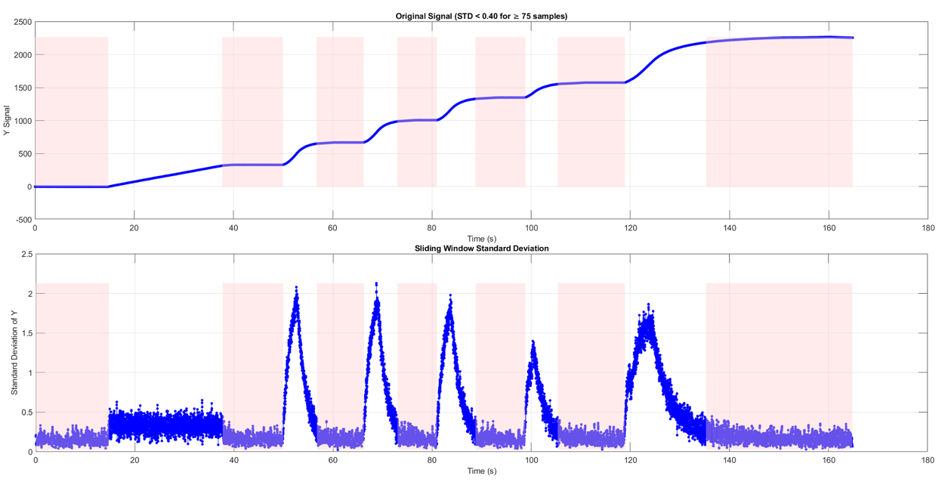
Figure 4-11Visualization of Brass Signal Stability in Strain Data

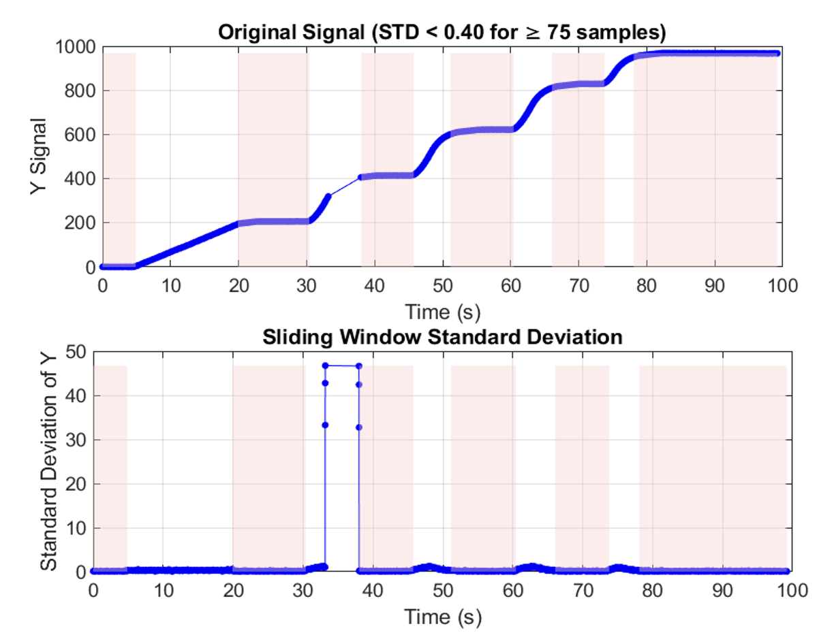
Figure 4-12Visualization of Mild Steel Signal Stability in Strain Data
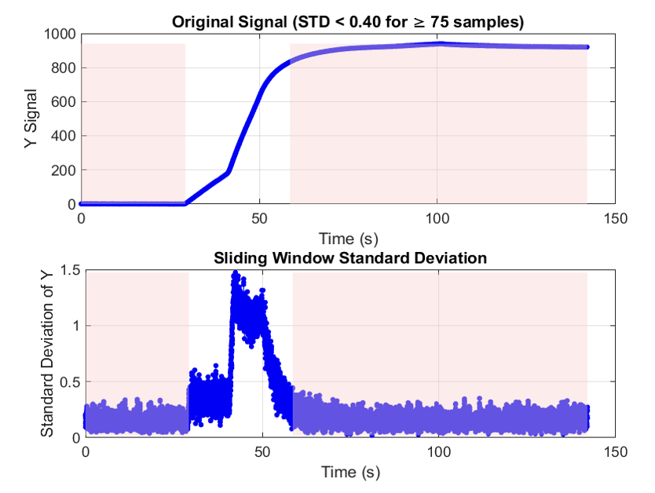
Figure 4-13Visualization of Stainless-Steel Signal Stability in Strain Data
Maximum recorded strain gage data for each respective material beam was analysed and correlated against analytical values. Analysis of Table 4-3 demonstrates that mild steel displayed the most accurate experimental strain value in conjunction with analytical estimations. Demonstrating a deviation from standards set in deflection measuring, aluminium exhibits a much smaller accuracy to analytical accuracy compared to prior response parameter values. Underperforming relative to projections, stainless steel exhibited the worst percentage accuracy to analytical values, 120% respectively.
Table 4-3Experimental vs Analytical Strain with % Difference
Material: | Maximum Experimental Strain | Analytical Strain | % Difference to analytical result
Aluminium Alloy 1050A H14 | 0.010003813 | 0.00647 | 55.15
Copper and Copper Alloys CW606N Brass | 0.004481 | 0.004056 | 10.48
Mild Low Carbon Steel S275JR | 0.0026051 | 0.00247 | 5.47
Stainless Steel 1.4948 (304H) | 0.00591644 | 0.00268 | 120.76

Experimental Stress
To determine the maximum stress experienced by each beam during loading, the application of Equation 3-5 Maximum Bending Stress was utilized. Maximum strain values from Table 4-3 and material stiffness values gained through aalco allowed for the following calculations (aalco metals Ltd, 2025).
For Aluminium:
$$σ_{max}=0.01003831×71×{10}^{9}$$
Equation 4-25 Aluminium Experimental Stress Equation
$$σ_{max}=712.707MPa$$
Equation 4-26 Aluminium Experimental Stress Result
For Brass:
$$σ_{max}=0.004481×105×{10}^{9}$$
Equation 4-27Brass Experimental Stress Equation
$$σ_{max}=470.505MPa$$
Equation 4-28Brass Experimental Stress Result
For Mild Steel:
$$σ_{max}=0.0026051×210×{10}^{9}$$
Equation 4-29Mild Steel Experimental Stress Equation
$$σ_{max}=547.071MPa$$
Equation 4-30Mild Steel Experimental Stress Result
For Stainless Steel:
$$σ_{max}=0.00591644×193×{10}^{9}$$
Equation 4-31Stainless Steel Experimental Stress Equation
$$σ_{max}=1141.873MPa$$
Equation 4-32Stainless Steel Experimental Stress Result

To aid in the comparison of experimental and theoretical strain values, Table 4-4 displays the corresponding response parameter accuracy of each beam. Due to the relationship of stress and strain in Equation 3-5 Maximum Bending Stress, the percentage difference between analytical and experimental will mirror values of Table 4-3.
Table 4-4Experimental vs Analytical Stress with % Difference
Material: | Maximum Experimental Stress (Mpa) | Analytical Stress (Mpa) | % Difference to analytical result
Aluminium Alloy 1050A H14 | 712.707 | 459.37 | 55.15
Copper and Copper Alloys CW606N Brass | 470.505 | 425.88 | 10.48
Mild Low Carbon Steel S275JR | 547.071 | 518.70 | 5.47
Stainless Steel 1.4948 (304H) | 1141.873 | 517.24 | 120.76

Finite Element Modelling
To replicate the structural response parameters of the cantilever beams, a series of FEA simulations were performed. Utilizing boundary conditions set in the Analytical Modelling chapter of this report, and hexahedral element types suggested in the Element Type review, independent mesh studies were carried out. Mesh densities ranging from 10mm to 1mm, in 1mm increments, were evaluated and compared to analytical results in terms of their percentage accuracy. Due to three parameters being investigated, it was decided that a mesh density best resembling an overall accuracy for each beam would be applied.

Mesh Density Studies
The following study aims to identify the optimal mesh size for each of the 4 beams in terms of their response parameters. As mentioned, an initial size of 10mm was applied and further reduced following each iteration. However, it should be noted that a mesh density of 1mm displayed significant stress and strain values for all beams, verifying the findings of Mesh Density review. These findings led to the exclusion of said mesh density.
Through the application of percentage difference to analytical results, comparative graphs were produced. The aim of Figures 4-14, 4-15, 4-16, and 4-17 set to display at which mesh density saw the greatest correlation between deflection, stress, and strain accuracy.

Figure 4-14Mesh Density Study for Aluminium Beam

Figure 4-15Mesh Density Study for Brass Beam

Figure 4-16Mesh Density Study for Mild Steel Beam

Figure 4-17Mesh Density Study for Stainless Steel Beam
Analysis of Figure 4-14 suggests that at lower mesh densities, the aluminium model exhibits improved correlation, with the response parameters showing grouping at 2mm. However, the model suggests overestimation compared to the analytical results. Initial coarse meshes introduce over prediction of stress and strain with no visible stabilization. Dissimilarly, the brass model exhibits a grouping of accuracy at a much coarser mesh, 9mm respectively. At low mesh densities, deviations from the analytical result are significant, with an increase of 42% strain being the most prominent. Poor convergence from brass suggests that possible non-linear effects have been captured by the model. Mild steel displays a similar deviation at finer meshes to the previous models, however deviations narrow close to 0% at a mesh size of 3mm. With the majority of response parameter deviations being negative, it is implied that there is slight underestimation within the model. Comparably, stainless steel displays similar oscillation to its mild steel counterpart, with both demonstrating improved accuracy at a finer mesh of 3mm. Both steel models achieved the most consistent agreement with the analytical results. To aid in the identification of at which mesh density each material displays highest correlation, Table 4-5 provides results gained from analysis.

Table 4-5Mesh Densities Showing Greatest Accuracy Correlation to Analytical Values
Material: | Mesh Density
Aluminium Alloy 1050A H14 | 2mm
Copper and Copper Alloys CW606N Brass | 9mm
Mild Low Carbon Steel S275JR | 3mm
Stainless Steel 1.4948 (304H) | 3mm

FEA Results
From the completed mesh density study, the corresponding ANSYS simulation models can be seen in Figures 4-18, 4-19, 4-20, and 4-21, at their most accurate mesh sizes in terms of overall accuracy. To enhance visibility, deflection, stress, and strain ANSYS models for each material have been displayed in corresponding groups. The objective of these visualizations is to aid in comparing areas of interest during loading. To maintain clarity, the figures are organized using the following format: Top-left – Aluminium (2mm mesh size), Top-right – Brass (9mm mesh size), Bottom-left – Mild Steel (4mm mesh size), Bottom-right – Stainless Steel (4mm mesh size). Appropriate legends are visable, where maximum values are disaplyed at the top (red) and minimum (blue), with varying values in between represented by corrosponding legend colour contours.

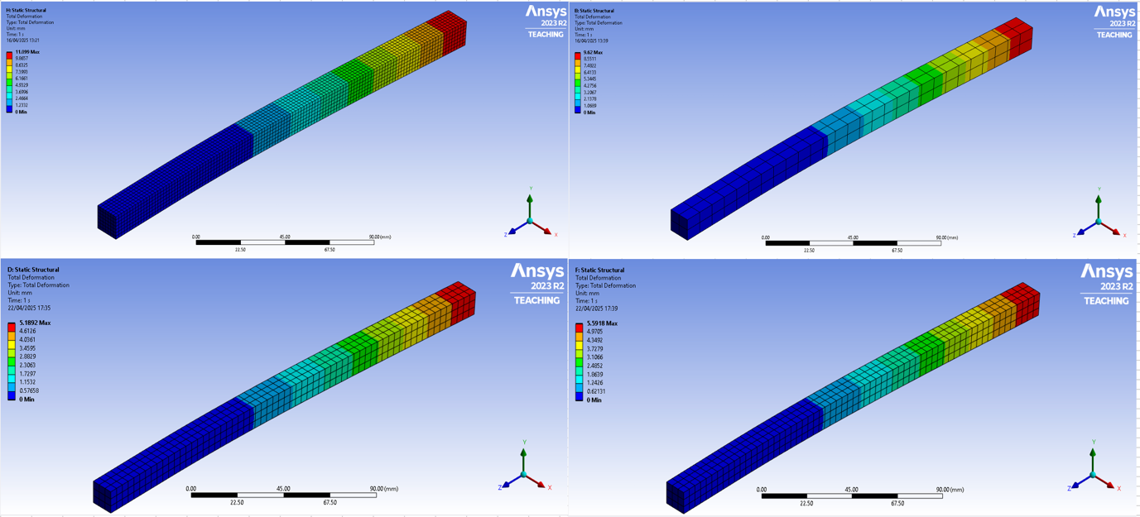
Figure 4-18FEA Deflection Models at Most Accurate Mesh Densities
Analysis of deflection models depicted in Figure 4-18 show all beams experienced identical deformation behaviours. Maximum deflection values occur at the free end, due to the loading conditions, aligning with experimental observations. Mesh density does not seem to affect the visualization of deformation; however, the opposite is evident in Figure 4-19. It is apparent that a reduction in mesh size localizes maximum strain, giving the impression of a smaller more intense strain location. Moreover, a reduction of mesh size provides an additional area of strain located at the point of load, not visible at coarse meshes. Despite the presence of a further strain location, through utilization of the figures legends, it is apparent that the recorded strain values in this area are negligible and do not affect overall results.
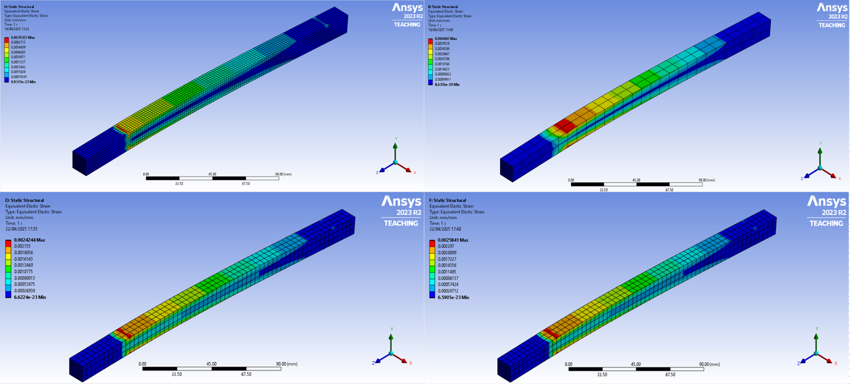
Figure 4-19FEA Strain Models at Most Accurate Mesh Densities

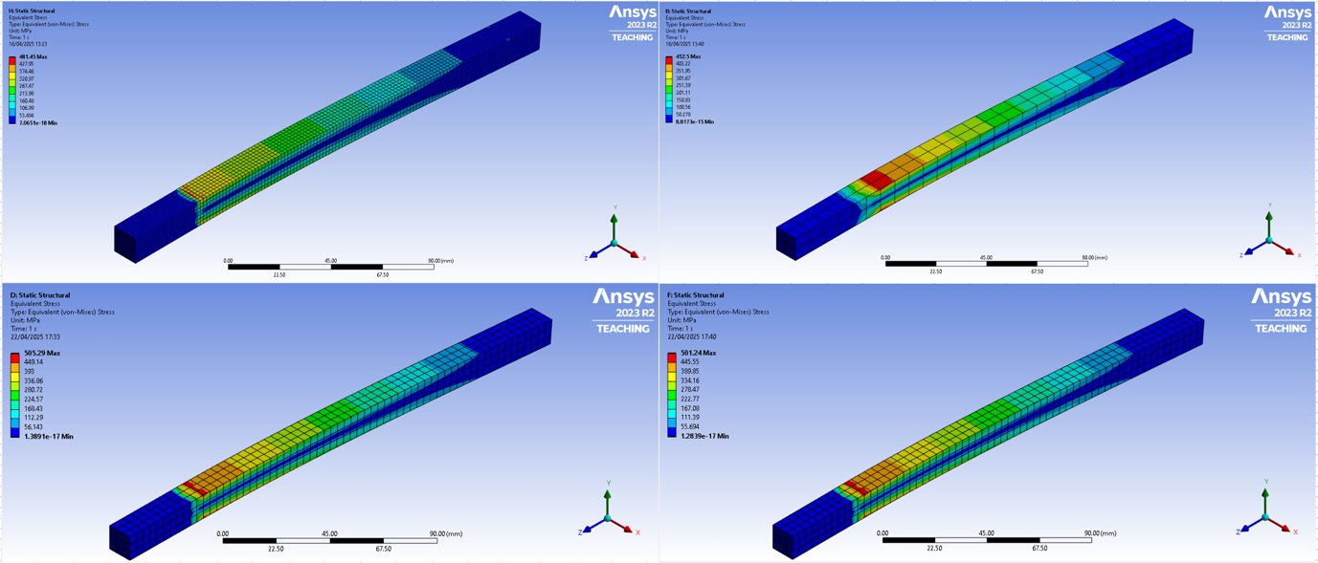
Figure 4-20FEA Stress Models at Most Accurate Mesh Densities
Similar to the strain models of Figure 4-19, stress is simulated in almost identical areas. Higher stress gradients located at the supports base indicate a more concentrated load, prominent in both steel models and aluminium especially. These observations support the findings of (Gukop, et al., 2021), where peak stress values are observed as intense stress concentrated areas, rather than a smooth strain gradient seen in Brass. As mentioned in Mesh Density chapter of this report, these findings are witnessed due to the proportional relationship between stress, force and area: Equation 2-6 Normal Stress.

Correlation
Following the methodology of analysing the accuracy of experimental data against analytical values, similar mesh density graphs were generated with the aim of displaying at which mesh size displays the closest correlation between experimental and FEA results. A notable difference between the two studies is the inclusion of 1mm mesh size. The rationale for this decision was due to the model’s ability to simulate non-linearity behaviours at lower mesh densities, often apparent in real-world scenarios. This is the case in Figure 4-21, where it can be seen that at a mesh size of 1mm, the model accurately produces results comparable to stress and strain values gained in experimental testing. Oscillation at this mesh density suggests that the simulations modelled overestimation accurately, not witnessed in idealised analytical calculations. Aluminium deflection however does not follow this trend. With experimental values succeeding FEA results by 440%-505%, it is apparent that deflection testing experienced massive deviations. Overall, a 1mm mesh density provides the most accurate correlation between FEA and experimental results, validating the findings of (Dutt, 2015) (Oladejo, et al., 2018).

Figure 4-21Mesh Density Correlation for Aluminium Test Piece
Correlation curves for brass show an opposite behaviour to that of aluminium. It is apparent that a more uniform convergence of all response parameters is met at maximum coarse mesh (10mm), with percentage differences of deflection, stress, and strain being -4%, -0.06, and -0.8% respectively. Supporting the findings of (Gukop, et al., 2021), stress and strain values were recorded at over 70% deviation at a 1mm mesh. Reasoning for this resides in the overrefinement of area at which the load is applied, causing a spike in values. The accuracy of this case study supports the use of FEA in modelling cantilever beam analysis, showing accurate correlation between experimental and simulation results.

Figure 4-22Mesh Density Correlation for Brass Test Piece

Figure 4-23Mesh Density Correlation for Mild Steel Test Piece
Analysis of Figure 4-23 shows consistent deviation in deflection modelling of the mild steel beam, oscillating at roughly 30% accuracy error. Despite these findings, comparison in Mesh Density Studies between analytical and FEA results presented a minimum of -0.03% deviation. This suggests that the model has been unsuccessful in accounting for non-linear behaviours in deflection that occurred during loading. Stress and strain values show improvement in correlation at 3mm mesh size, with both achieving accuracy of 5% and 4% respectively. It is evident that for mild steel, the model has portrayed a more idealised situation in comparison to experimental findings.

Figure 4-24Mesh Density Correlation for Stainless Steel Test Piece
With regards to correlation between experimental and FEA results, stainless steel demonstrates the greatest overall deviation. All response parameters display an overestimation of 20% and above at the most accurate mesh size (1mm). These findings imply that, similarly to mild steel, the model was unsuccessful in representing the exact behaviour experienced in experimental testing. Investigation of the stress and strain correlation curves suggest that reductions in mesh density improve accuracy, coinciding with studies examined in this report. From this conclusion, an additional mesh refinement was performed aiming to verify the previous statement. Mesh sizing was reduced to 0.9mm with identical boundary conditions in place. Table 4-6 displays the values from this additional case, where overall improvements were seen in stress similarity. Despite the improvement, deflection results saw a negligible 0.95% increase in deviation to the original 1mm mesh. The most notable discovery was the increase in strain values, showing a 20% increase in deviation at 0.9mm compared to -25.65% seen in 1mm mesh. These findings did not improve the accuracy to a standard where justification for increases in computational cost and time were deemed reasonable. This led to the termination of further mesh refinement.
Table 4-6Response Parameter Accuracy at 0.9mm Mesh
Response Parameters | Stainless Steel 1.4948 (304H) | % Difference to Experimental result | % Deviation to 1mm mesh
Deflection (mm) | 5.5582 | -65.88 | 0.95
Strain | 0.0073957 | 20 | 45.65
Stress (Mpa) | 1298.9 | 12.08 | 43.32

Taking the most accurate mesh in terms of experimental value resemblance, Table 4-7 was generated with the aim of displaying the model’s ability to accurately simulate real-world loading scenarios. From the table, we can see that the model was most accurate in simulating stress and strain behaviours for all beams. Bar stainless steel, the simulation value accuracy did not deviate greater than 4.51% for strain and 5.51% for stress. The same cannot be said for deflection however, with values ranging from 0.8% for brass to 450.82% for aluminium. It seems that compression loading in ANSYS simulation testing largely deviates from occurrences witnessed in experimental testing.

Table 4-7Correlation Analysis of Experimental and Simulated Response Parameters for Varying Material Beam
Aluminium Alloy 10500A H14 @ 1mm Mesh
Experimental Deflection (mm) | ANSYS Deflection (mm) | Correlation %
60.59 | 11.00 | 450.82
Experimental Strain | ANSYS Strain | Correlation %
0.01003831 | 0.010116 | 0.7
Experimental Stress (MPa) | ANSYS Stress (MPa) | Correlation %
712.707 | 692.46 | 2.92
Copper and Copper Alloys CW606N Brass @ 10mm Mesh
Experimental Deflection (mm) | ANSYS Deflection (mm) | Correlation %
10.59 | 10.675 | 0.8
Experimental Strain | ANSYS Strain | Correlation %
0.004481 | 0.0046904 | 4.46
Experimental Stress (MPa) | ANSYS Stress (MPa) | Correlation %
470.505 | 470.8 | 0.06
Mild Low Carbon Steel S275JR @ 3mm Mesh
Experimental Deflection (mm) | ANSYS Deflection (mm) | Correlation %
6.46 | 5.005 | 29.07
Experimental Strain | ANSYS Strain | Correlation %
0.0026051 | 0.0024925 | 4.51
Experimental Stress (MPa) | ANSYS Stress (MPa) | Correlation %
547.071 | 518.48 | 5.51
Stainless Steel 1.4948(304H) @ 1mm Mesh
Experimental Deflection (mm) | ANSYS Deflection (mm) | Correlation %
9.22 | 5.5901 | 65.88
Experimental Strain | ANSYS Strain | Correlation %
0.00591644 | 0.0047087 | 25.65
Experimental Stress (MPa) | ANSYS Stress (MPa) | Correlation %
1141.879 | 870.06 | 31.24

To show comparison of the model’s accuracy to simulate real-world loadings and theoretical values, findings from both correlation studies are presented in Table 4-8, with regards to their percentage accuracy. Evaluating each material in vertical order of the table, we can see that with the exception of deflection, simulation of the aluminium test more accurately represents the experimental data than analytical values. This suggest that material behaviours not evident in idealised equations have been captured by the FEA model. Similarly, brass simulation values encompass a great accuracy to observations made in experimental testing. With no deviations surpassing 5%, it can be concluded that the model provides accurate estimations in the compression loading of a brass beam. Despite this, mild steel appears to more closely resemble the findings of the theoretical values. Possible errors in experimental setup and material specifications provide reasoning for the inaccuracies. The same can be said for stainless steel, showing large deviations from experimental data, but closely resembling analytical calculations.
Table 4-8Percentage Deviation of FEA results from Analytical and Experimental Values
Deviation % | Deflection | Strain | Stress
Aluminium Alloy 10500A H14
Analytical | 2.11% | 4.81% | 8.7%
Experimental | 450.82% | 0.7% | 2.92%
Copper and Copper Alloys CW606N Brass
Analytical | 9.62% | 9.64% | 6.25%
Experimental | 0.8% | 4.46% | 0.06%
Mild Low Carbon Steel S275JR
Analytical | 3.58% | 0.91% | 0.04%
Experimental | 29.07% | 4.51% | 5.51%
Stainless Steel 1.4948(304H)
Analytical | 4.51% | 0.76% | 0.41%
Experimental | 65.88% | 25.65% | 31.24%

Error Analysis
This section presents a comprehensive review of response parameter values gained through theoretical predictions, experimental testing, and FEA simulations. The aim is to assess the areas of identified errors and to reflect on the reliability of the methodology applied in this report. Analytical calculations utilized in this report were derived from classic beam theories and mechanics of materials, EBBT and hook’s law etc. Such equations assume linear elasticity during loading, uniform loading, and idealised boundary conditions. While these equations provide estimations for material behaviour, experimental values saw notable deviations, with deflection raising the highest concern. Aluminium demonstrated the highest deviation regarding deflection, with values 457.41% greater than anticipated in the calculations. To further verify the discrepancies observed in experimental testing, the FEA model predicted a lesser deflection value of 450.82%. These findings support that the material yielded under the 0.7kN load, ultimately entering its plastic region. This behaviour is not captured in linear elastic models due to their idealised assumptions. Other sources for experimental deflection error reside in the beams fixed support, with slippage within the bolted clamp system being possible due to varying factors. Such factors include insufficient clamp force allowing components to slip under load or vibration, improper surface contact reducing friction between beam and clamp, exclusion of knurling or other anti-slip features.
Overall, strain measurement techniques performed reliably, producing experimental results of acceptable similarity to analytical and numerical solutions. Brass and mild steel displayed the most promising results comparable to analytical values, with 10.48% and 5.47% deviation respectively. Aluminium recorded a maximum strain value 55.15% greater than anticipated, suggesting error in data recording. However, the greatest deviation analytically was observed in stainless steel, where strain values were measured 120.76% greater. Improvements in data accuracy was seen when comparing the experimental and simulation strain values. Despite this, error analysis was performed with the aim of establishing a rationale for observed discrepancies. Research into three studies show that strain gage discrepancies are commonly experienced due to misalignments with principal strain axis. It is stated that strain gages orientated at angles approaching 45$°$ to principal axis cause significant errors in measurement accuracy (James, 1988). Other factors include transverse sensitivity in strain measurement equipment, where gages respond to strain recordings perpendicular to strain directions. Such inaccuracies lead to states of complex strain, diminishing equipment accuracy (Measurements Group, Inc., 1983). Comparably, an additional article in the ‘Experimental Techniques’ journal suggest that human error impacts the accuracy of producible results (Pople, 1984). Such errors that have a likelihood of affecting results seen in this report include adhesion application. Evidence of this lies in the results of stainless steel. Due to the sleek surface finish of the material, likelihood of poor adhesion is high, where it is expected that the adhesive used caused a layer to dry between the surfaces of the material and strain gage. To negate poor surface adhesion, it is suggested that the substrate is correctly prepared for strain gage application.
Moreover, material specification errors present a critical source of deviation in the analysis of response parameters. When assumed mechanical properties of beams used in analytical and numerical modelling differ from correct properties of the investigated material, accuracy can drastically decrease. Misidentification of properties such as young’s modulus cause large inaccuracies in estimated response parameter values, significantly deviating from true values. Additional errors in specified yield strength and poisons ratio can propagate through FEA models, resulting in inaccurate stress distributions.

Conclusions
The primary aim of this independent project was the validation of the effectiveness of FEAM’s ability to accurately predict the structural behaviour of cantilever beams, through the application of analytical and experimental comparison. The classic beam theories applied in the analytical component served as a benchmark for comparison, where assessment against experimental and numerical results was performed. While the predictions aided in further data expectations, their idealised assumptions were unsuccessful in accommodating non linearities observed during physical testing.
Mesh density studies performed on each individual beam revealed that overly fine mesh sizes began to introduce areas of intense stress concentration. Despite these findings, the stainless steel model exhibited a higher stress-strain accuracy at finer mesh sizes. Aiming to improve correlation, further refinement was applied. Conversely, values of stress drastically rose, verifying conclusions made in the respective mesh densities.
Findings demonstrate that the numerical models provide appropriate approximations in the response values of stress and strain, with majority of analysed materials displaying reasonable deviation. It was found that the brass model simulations presented the most accurate estimations in regard to response parameters. Achieving a correlation of 0.8%, 4.46%, and 0.06% to experimental deflection, stress, and strain values respectively. Comparably, mild steel demonstrated agreement in experimental and simulated stress and strain results, showing deviations of 5.51% and 4.51% respectively. These findings provide a justification for utilizing tools such as FEA in the analysis of structures. However, substantial deviations were observed in deflection values, predominantly in the aluminium beam. Discrepancies were measured exceeding 450%, suggesting such factors as yielding of material, bolted clamp slippage, and human errors in strain gage adhesion were to blame. These variations do not attribute to the accuracy of the model, but rather the accuracy of experimental testing.
In summary, the findings of this project demonstrate that FEA is an extremely effective tool in modelling structural behaviour of materials. The integration of theoretical and experimental methods provided valuable awareness of the model’s strengths and limitations. Despite its clear accuracy, it should be understood that its efficiency is dependent on the quality of input and set boundary conditions. Model assumptions of nonlinearities should be anticipated, giving the user a clear understanding of observable deviations.

Further Work
Although this report may be considered successful, the following further work is suggested to further validate the performance of FEA models:
- Whilst this study utilized linear elastic models in simulation testing, it would be advised that future FEA simulations incorporate non-linear plastic models. This would be beneficial for materials such as aluminium and stainless steel, which exhibit post yield behaviour.
- This study applied material properties from data specification sheets supplied by aalco metals. Although data sheets should be trusted, it is suggested that tensile testing of materials be carried out prior to experimental data collection, to verify properties provided by the supplier.
- Whilst careful care was taken when bonding strain gages to test beams, additional methods of adhesion should be investigated. Material preparation should also be revised to further understanding of substrate adhesion.
- The bolted clamp system applied in experimental testing performed well, however methods of improvement are suggested. Such suggestions include introducing textured interfaces like knurling, hoping to improve material friction. Additional constraints may also be introduced to enhance fixture security.
- The application of load in this study was applied in short increments leading to a final load value, causing the beams to be held under force during the next load setup. It would be a matter of interest to see if applying one large load simultaneously would affect observable results. Additionally, results may vary by using a different load point. The load interface used in experimental testing was cylindrical and spanned the width of the beam. A possible suggestion would be to apply varying load interfaces on each material and compare findings.

Bibliography
aalco metals Ltd, 2025. aalco - The UK's largest independent multi-metals stockholder. [Online]
Available at: https://www.aalco.co.uk
[Accessed 11 April 2025].
Abuye, A., Kibrete, F., Ayay, G. & Gebrekidan, E., 2024. Comparative Flexural Analysis of Cantilever Beam at Various Loads Using Analytical, Computational and Experimental Techniques.. Engineering Headway, Volume 4, pp. 35-44.
Bailey, C., Bull, T. & Lawrence, A., 2013. The Bending of Beams and the Second Moment of Area. The Plymouth Student Scientist, 6(2), pp. 328-339.
Chen, X. & Liu, Y., 2015. Finite Element Modeling and Simulation with ANSYS Workbench. 1 ed. s.l.:Taylor & Francis Group.
Denison Mayes Group, 2025. Denison Meyes Group - Universal. [Online]
Available at: https://www.denisonmayesgroup.com/Universal-default.htm
[Accessed 11 April 2025].
Dirige, E., 2024. What is the Bernoulli-Euler Beam Theory?. [Online]
Available at: https://www.wethestudy.com/tree-posts/what-is-the-bernoulli-euler-beam-theory
[Accessed 5 February 2025].
Doebelin, E. O., 1990. Measurement Systems: Application and Design. 4th ed. Singapore: McGraw-Hill.
Dutt, A., 2015. Effect of Mesh Size on Finite Element Analysis of Beam. SSRG International Journal of Mechanical Engineering, pp. 8-10.
Erochko, J., 2020. An Introduction to Structural Analysis. Ottawa: Erochko, J.
Granta EduPack, 2022. Granta EduPack. s.l.:s.n.
Gregory, R. & Gladwell, I., 1982. The cantilever beam under tension, bending or felxure at infinity. Journal of Elasticity, Volume 12, pp. 317-343.
Gukop, N., Kamtu, P., Lengs, B. & Babawuya, A., 2021. Effect of Mesh Density on Finite Element Analysis Simulation of a Support Bracket. FUOYE Journal of Engineering and Technology, pp. 34-38.
Hunt, J., Zhang, H. & Huang, Y., 2015. Analysis of Cantilever-Beam Bending Stress Relaxation Properties of Thin Wood Composites. BioResources, pp. 3131-3145.
James, R., 1988. Strain-gage misalignment errors—A special case of interest. Experimental Techniques, Volume 12, pp. 28-29.
Kliewer, K. & Glisic, B., 2019. A Comparison of Strain-Based Methods for the Evaluation of the Relative Displacement of Beam-Like Structures. Frontiers in Built Environments - Bridge Engineering, Volume 5.
Kumar, A., Chaturvedi, S., Chaturvedi, V. & Yadaw, R., 2012. Design Studies and Optimization of Position of Strain Gage. International Journal of Scientific and Engineering Research, 3(10), pp. 1-4.
Llewellyn, D., 1997. Work hardening effects in austenitic stainless steels. Journal of Materials Science and Technology, 13(5).
M. Ahmed, A. & M.Rifai, A., 2021. Euler-Bernoulli and Timoshenko Beam Theories Analytical and Numerical Comprehensive Revision. European Journal of Engineering and Technology Research, 6(7), p. 20.
Measurements Group, Inc., 1983. Errors Due to Transverse Sensitivity in Strain Gages Published: 20 December 2017. Experimental Techniques, Volume 7, pp. 30-35.
Nandi, S., Chethana, K., Srinivas, T. & Sharan, P., 2023. Measurement model of integrated FBG sensor for beam structure. Journal of Optics, Volume 53, pp. 2355-2360.
Nassif, H. h., Gindy, M. & Davies, J., 2005. Comparison of laser Doppler vibrometer with contact sensors for monitoring bridge deflection and vibration. NDT & E International, 38(3), pp. 213-218.
National Instruments, 2023. NI 9235 and 9236 Resistance Ranges. [Online]
Available at: https://knowledge.ni.com/KnowledgeArticleDetails?id=kA00Z000001De1dSAC&l=en-GB
[Accessed 20 March 2025].
National Instruments, 2025. NI-9235. [Online]
Available at: https://www.ni.com/en-gb/shop/model/ni-9235.html
[Accessed 15 April 2025].
Ochsner, A., 2021. Classic Beam Theories of Structural Mechanics. 1 ed. s.l.:Springer Nature.
Oladejo, K., Abu, R. & Bamiro, O., 2018. Model for Deflection Analysis in Cantilever Beam. European Journal of Engineering and Technology Research, pp. 60-66.
Osuji, S. & Adegbemileke, S., 2015. Modelling Convergance of Finite Element Analysis of Cantilever Beam. Journal of the Nigerian Association of Mathematical Physics, Volume 30.
Pabari, U. & Mavani, A., 2016. Development of Stress Measurement. Imperial Journal of Interdisciplinary Research, pp. 1126-1136.
Pople, J., 1984. Errors in Strain Measurement—the Human Factor (or How Much Do I Contribute?). Experimental Techniques, Volume 8, pp. 34-38.
Słota, E. & Wosatko, A., 2025. Comparative Analysis of In-Plane and Out-of-Plane Bending Benchmarks Using Two Finite Element Packages. Applied Sciences, 15(6).
Shneider, T. et al., 2022. A Large-Scale Comparison of Tetrahedral and Hexahedral Elements for Solving Elliptic PDEs with the Finite Element Method. ACm Transactions on Graphics (TOG), 41(3), pp. 1-14.
Sideris, S.-A. & Tsakmakis, C., 2022. Consistent Euler-Bernoulli Beam Theories in Static for Classical and Explicit Gradient Elasticities. Composite Structures, Volume 282.
Song, B., Nishida, E., Sanborn, B. & Maguire, M., 2017. Compressive and Tensile Stress–Strain Responses of Additively Manufactured (AM) 304L Stainless Steel at High Strain Rates. Journal of Dynamic Behaviour of Materials, 3(3), pp. 412-425.
Sosnowski, M., Gnatowska, R., Sobczyk, J. & Wodziak, W., 2017. Computational domain discretization for CFD analysis of flow in a granular packed bed. Journal of Theoretical and Applied Mechanics, 57(4), pp. 833-842.
Szewczyk, P. & Kudyba, P., 2022. Effectiveness of Selected Strain and Displacement Measurement Techniques in Civil Engineering. Buildings, 12(2), p. 172.
Tacuna Systems, 2024. Choosing the Right Load Cell for Your Job. [Online]
Available at: https://tacunasystems.com/knowledge-base/choosing-the-right-load-cell-for-your-job/
[Accessed 7 March 2025].
TecQuipment, 2025. DEFLECTION OF BEAMS AND CANTILEVERS KIT. [Online]
Available at: https://www.tecquipment.com/deflection-of-beams-kit
[Accessed 11 April 2025].
Timoshenko, S., 1930. Elementary Theory and Problems. Lancaster, Pa: D.Van Nostrand Company, Inc..
University of Cambridge, 2025. Elastic deformation: Hooke's law and stiffness. [Online]
Available at: https://www.doitpoms.ac.uk/tlplib/mechanical_properties/elastic.php
[Accessed 14 February 2025].
Whiteman, T., Lichti, D. D. & Chandler, I., 2002. Measurements of Deflections in Concrete Beams By Close-Range Digital Photogrammetry, Perth, WA: Curtin University of Technology.
Yang, K., 2017. Basic Finite Element Method as applied to Injury Biomechanics. 1st Edition ed. s.l.:King-Hay Yang.
Young, W. & Budynas, R., 2002. Roark's Formulas for Stress and Strain: Seventh Edition. s.l.:McGraw-Hill.
Zubin, D., 2008. Error analysis and method of accuracy evaluation of strain gauge factor testing apparatus based on pure bending moment beams. Strain, Volume 35, pp. 87-96.

Appendices

Appendix A
Aluminium Beam Engineering Drawing
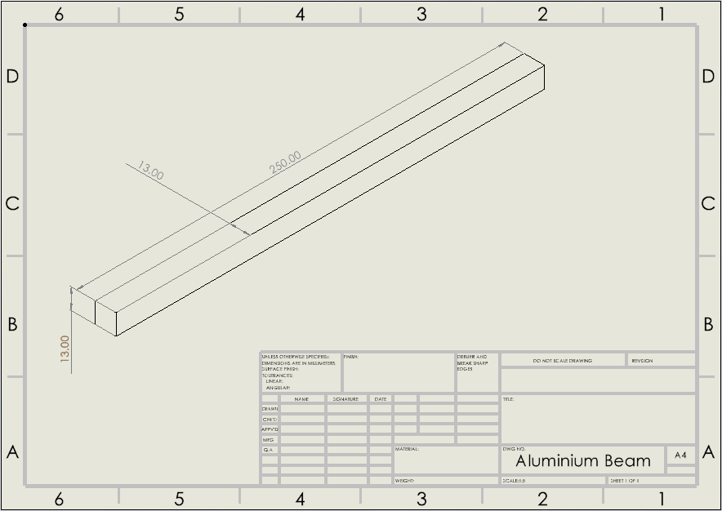
Brass Beam Engineering Drawing
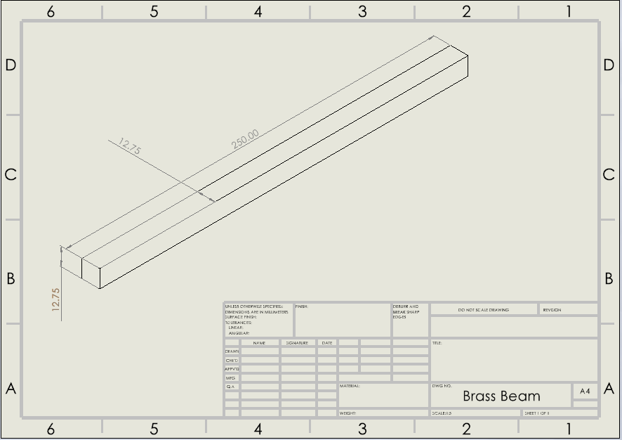
Mild Steel Beam Engineering Drawing
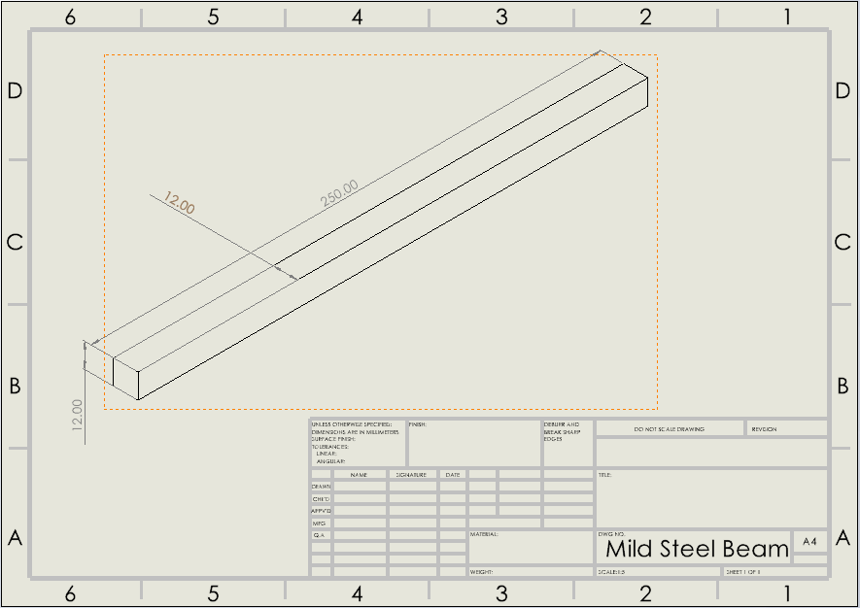
Stainless Steel Engineering Drawing
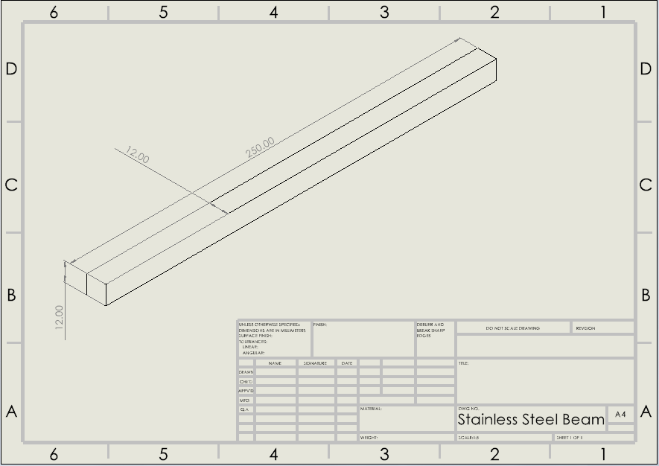

Appendix B
Aluminium load displacement graph plotted by UTM:
Brass load displacement graph plotted by the UTM:
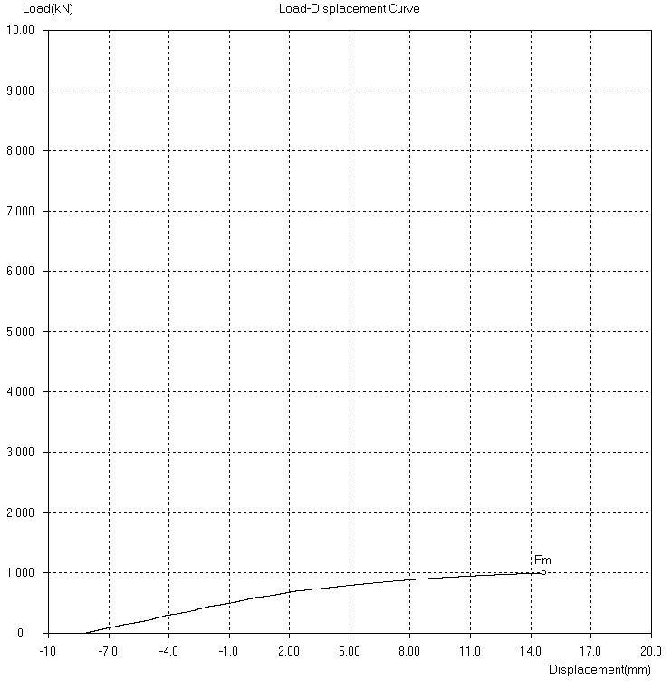
Mild steel load displacement graph plotted by UTM:
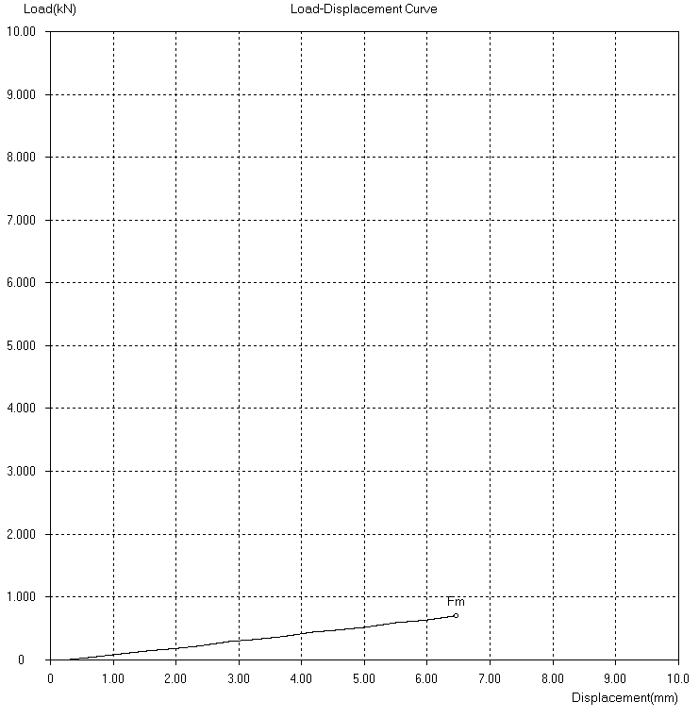
Stainless steel load displacement graph plotted by UTM:
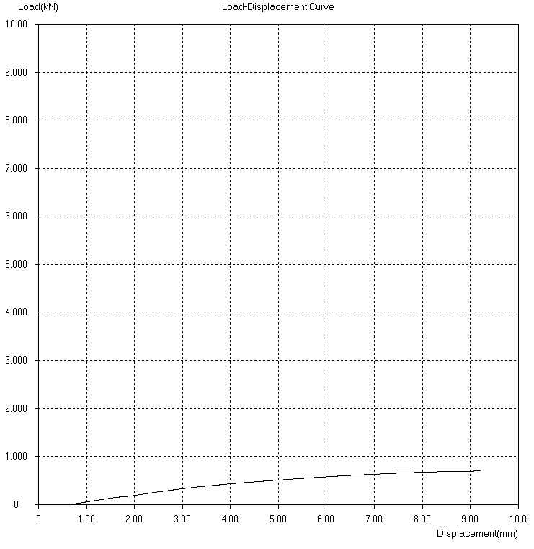

Appendix C
Time dependant strain graph plotting strain values to a maximum load of 1kN

