Synthesize A Solution to A Potential Real Life Scenario
Computer Forensics
ACCB5000
Imran Ali
1701017
Dr Carlene Campbell

Table of Contents

- Abstract
- Introduction
- Task 1 – Research
- Task 2 – Case Study
- Conclusion
- References

Abstract
This report will implement the use of computer forensics tools portraying an understanding of legal aspects related to forensics as well as displaying an understanding of the relationship between IT and forensics. This will be tested by responding to a case study incident with the use of the best practices, tools, legality and professionalism to overcome the problem given. The overall aim of this assignment is to identify if an incident handler or a forensics investigator is required by analysing the forensics methodology used to investigate the case.

Introduction
Computer forensics is associated with the security and penetration of computer devices in an ethical manner for the gathering of evidence dependent on the case by using science and technology to investigate and establish facts in the court of law [1]. The aim of a forensics analyst is to examine digital/computer devices in a way where data and information can be identified, preserved, recovered, analysed and then further presented as evidence in the court of law to a judge. Some of the items that are mostly looked into by a forensics analyst include multimedia files, computer/internet history and hard disks/drives as these can be looked into and tracked back to a further date to gather a vast amount of evidence. A forensics analyst’s tools can be categorised dependent on what they are looking into, they include: disk and data capture tools, file viewers, network forensics tools, internet analysis tools, mobile device analysis tools, email analysis tools and registry tools are the most used tools in the forensics field when there is a case. In the present day, there are many crimes now involving computers such as hacking, cracking, denial of service attacks, malware, viruses, blackmail and other cyber-attacks. The analysis process is as follows; investigating the case, seizing the evidence found at the crime scene, gathering of data found from evidence, providing an analysis of the data and then creating a report of the gathered evidence to present in the court of law.

Task 1 - Research

Commercial Vs. Open Source
Commercial tools are readily available to use for whoever needs them, at a given price or when a license is purchased to use the tools to full potential. Commercial tools are targeted for a certain use, but, the problem with commercial tools are that once they have been distributed, some may not be able to be updated, hence, the reason why new tools are created or re-written. Open source tools are free tools that are ready to use, that are developed for certain requirements and published for the general public. The positive about open source tools are that they provide prompt flexibility and problem addressing as anyone can fix and update any problems with the tools without the need of re-writing or creating new tools [2].

Computer Forensic Tools
The current computer forensics analysis tools, software’s and techniques being used and accredited by employers according to [3] include forensic analysis and cell site analysis tools and software’s, FTK (Forensic Toolkit), Data Recovery tools and software’s, Expert Witness techniques, Encase, XRY, Cellebrite and X-Ways.
The following are tools and software’s used worldwide by governments, organisations and analysts to gather evidence: Access Data Registry Viewer, Access Data FTK Imager, Autopsy, FileView, P2 Commander, R-Drive Image, EaseUS Data Recovery Wizard, Hash Calculator, MD5 Calculator, Disk Explorer, Advanced Archive Password Recovery, Advanced PDF Password Recovery, Passware Kit, DeepSound, Image Steganography, Open Steganography, StegSpy, Blade Professional, Forensic Explorer, Phone Image Carver, floAt’s Mobile Agent, iDEN Phonebook Manager, SEARCH Investigative Toolbar, TULP2G, Event Log Explorer, Helix, OS Forensics, Process Explorer and Paraben’s Email Examiner.

Categorisation
The tools stated above can be categorized into what actions they perform; file viewers, data recovery tools, hash value calculators, data acquisition, anti-forensics detectors, file carving, imaging, mobile forensics tools, operating system tools and email viewing tools.
The following tables will analyse a selected variety of tools from each category and provide an analysis of what they do and the effectiveness for a forensics analyst.

File Viewing/ Disk Imaging Tools | Description
FileView Pro  (Commercial – Subscription)  (Windows OS) | FileView allows the user to open various file types through one program, allowing you to open, edit or delete any non-viewable files [4].
P2 Commander  (Commercial)  (Windows OS) | P2 Commander is a court proven, computer forensics tool that provides affordable, reliable digital analysis. It processes large volumes of data in a fast, efficient manner. Users are confident the evidence gathered is preserved, defensible and presentable in reports [5].
R-Drive Image  (Commercial)  (Windows OS) | R-Drive Image creates an exact disk image file of files for backup or duplication. This software can completely and rapidly restore your system after heavy data loss caused by an operating system crash, virus attack or hardware failure [6].
FTK Imager  (Commercial – Free)  (Windows OS) | FTK Imager is a data previewing and imaging tool that acquires data by making copies of data without making changes to the original evidence [7]
Table 1 - File Viewing Tools

File viewing tool and disk imaging tools allow the user to open, edit, copy and recover files that are hidden or have been deleted on purpose or by failures without changing the original evidence. In relation to a court case, the advantage of using disk driving tools allow the user to present a detailed report with all the evidence that has been recovered and state all information related to the files.

Investigative Tools | Description
Autopsy  (Open Source)  (Windows, Linux & Mac OS) | Autopsy offers a way to recover and manage evidence of cyber and physical crimes from computers, mobile devices, and other digital media [8].
Hash Calc  (Open Source)  (Windows OS) | Hash Calc is a fast and easy-to-use calculator that allows to compute message digests, checksums and HMACs for files, as well as for text and hex strings
MD5 Calculator  (Open Source)  (Windows, Linux & Mac OS) | This tool provides a quick and easy way to encode an MD5 hash from a simple string of up to 256 characters in length. MD5 Calculator can compare a hash of the source file with a newly created hash of the destination file to check that it is intact and unmodified [9].
Forensic Toolkit (FTK)  (Commercial)  (Windows OS) | FTK scans the hard drive that is being investigated for information and data. It can locate deleted evidence such as email’s and is able to decrypt and crack passwords [10].
Disk Explorer for NTFS  (Commercial)  (Windows OS) | Disk Explorer investigates everything that is on a hard drive; boot records, partitions and directories. It is able read and write on a drive, view and recover files and create a virtual drive if the current boot is lost or corrupt [11]
Passware Kit Forensic  (Commercial)  (Windows OS) | Passware Kit Forensic is able to locate encrypted files, provide a full disk encryption, memory analysis, scan external registry files and recover passwords from websites and network connections [12]
Advanced PDF Password Recovery  (Commercial)  (Windows OS) | Advanced PDF Password Recovery can instantly unlock PDF restrictions to allow viewing, editing, copying and printing of locked PDF files [13]
Table 2 - Investigative Tools

Investigative tools check for strings and other encoded data and information into a viewable format by locating and decrypting files as well as cracking passwords to gain access to protected files. In relation to a court case, investigative tools allow recovery of passwords and usernames, however due to legal issues this needs to be done in an ethical way.

Steganography Detection Tools | Description
DeepSound  (Open Source)  (Windows OS) | DeepSound allows the user to extract “secret” files that are hidden in different file types and unmasks them into their true format. [19]
OpenStego  (Open Source)  (Windows OS) | OpenStego allows for data hiding/unmasking as well as enclosing hidden watermarking of pictures to reveal any messages that may be in the file [14].
StegSpy  (Open Source)  (Windows OS) | StegSpy is able to identify the location of hidden content in a vast number of programs and files [15].
Table 3 - Steganography Tools

Steganography tools extract and unmask hidden files that are placed into other files by identifying the location of hidden files and unmasking them and then enclosing them into a viewable format.

Data Carving Tools | Description
Blade  (Commercial)  (Windows OS) | Blade is able to able to provide raw recovery of data from a source without the original file from a physical/logical disk, mobile phone or binary dump [16]
Forensic Explorer  (Commercial)  (Windows OS) | Forensic Explorer is a tool that is able to analyse electronic data that has been hidden, deleted or unallocated. [17]
Phone Image Carver  (Commercial)  (Windows OS) | Phone Image Carver is able to analyse a mobile phone’s image file that are present or have been deleted. [18]
Table 4 - Data Carving Tools

Data carving tools extract raw data from an original file from a location on a device, providing an analysis of data and files that are present, hidden or have been deleted.

Mobile Forensics Tools | Description
floAt’s Mobile Agent  (Open Source)  (Windows OS) | floAt’s Mobile Agent allows for management of backups and restorations on a mobile phone, providing information and interactions on the mobile phone. [20]
iDEN Phonebook Manager  (Commercial)  (Windows OS) | iDEN Phonebook Manager gives the ability to create, edit and copy a phone’s phonebook list to a computer with the ability to modify and view call lists.
TULP2G  (Open Source)  (Windows OS) | TULP2G is a software framework that allows for the extraction and decoding of data stored on electronic devices. [21]
Table 5 - Mobile Forensics Tools

Mobile forensics tools provide the ability to manage and read data from backups and restorations and provide information and interactions that have taken place on a mobile device such as calls and location traces.

Email Examining Tools | Description
Paraben’s Email Examiner  (Commercial)  (Windows OS) | Paraben’s Email Examiner processes emails and is able to figure and restore corrupted and deleted data. [22]
Table 6 - Email Examining Tools

Email examining tools are able to trace sent and deleted emails and provide restorations of data that has been sent or deleted without fault.

Task 2 – Case Study

Forensics Methods and Other Processes John Would Have Taken/Used Before He Then Prepared A Chain-of-Custody Document And Stored The Original Hard Disk In A Secure Location

The preparation steps of any forensics related case with a Windows operating system will follow the steps:

- Locating and gathering volatile evidence on a Windows host [1]

Volatile evidence can be found on Windows hosts on files, slack space. Swap files, unallocated clusters, unused partitions and hidden partitions.

- Investigating Windows file slack for evidence [1]

Within the system slack, data from the system’s memory can be traced and located. The possibility of finding evidence such as user names, passwords and other sensitive information can be found.

- Interpreting the Windows registry and memory dump information [1]

The Windows registry contains the settings and operation information of the Windows OS. Interpreting registry data can show hardware/software configurations, OS configurations, installed and deleted software and user preferences, a whole log will display all of this information and timings. Memory dumps contain error logs and system crashes.

- Analysing Internet trace data and events [1]

Internet data and events contain cookies and browser history, here any activities undertaken on the internet can be found.

- Investigating the system state backups [1]

The system state backup contains the system registry, COM + Database, Certificate Services, Active Directories, SysVol, IIS Metabase.

Before creating a chain-of-custody form, the establishment of a forensics lab would’ve been created by John and he would’ve identified his physical, hardware, software and process requirements to tackle the case. When looking into physical requirements, John would’ve taken into consideration the security of his environment and data whilst ensuring ways of data loss were near impossible. Whilst looking into hardware requirements, John would’ve chosen the best devices with vast storage capabilities and fast processing to contain, clone, protect, copy and secure the seized evidence. Software requirements are a key factor for the case, John would’ve taken into consideration what computer forensics tools and software’s to use to gather evidence that offer authenticity and reliability of data and information from the physical evidence. John would’ve created a plan detailing each step of the case, from the gathering of the data to creating documentation all the way to presenting an end report all with detailed information and date and time stamps.

During the search and seizure [1] process, John would’ve identified the types of data and information and collected them, further labelling each piece of evidence for reference and preservation and protecting all digital evidence found at the crime scene by isolating all digital devices so that evidence is not lost. The creation of a log with detailed information of each seized device and its components and data will be maintained throughout the investigation, again for reference needs for the case. Photographs of the evidence will be taken with the exact state of the devices when they were discovered and then packed and transported to the lab environment safely.

John would have seized the data and carried out an inspection by making copies of the original data and information that was gathered as evidence so the original raw files would not get contaminated. A copy of volatile data would’ve been taken to track the last movements and processes made by the terrorists as the laptop was still in stand-by, showing that there is data present as the laptop was not switched off.

The gathering of photographs [1] of the original physical evidence and raw data and information would’ve been gathered to establish the chain-of-custody and further acquiring digital evidence and maintaining a log/information receipt with detailed descriptions, date and time stamps of when the evidence was created and used.

The evidence collection [1] process is the main and delicate process of the case due to the slight ability to damage, corrupt or lose data. John would ensure the integrity of the evidence is intact and maintained whilst recording all evidence gathered throughout the investigation period to ensure the evidence is presentable in the court of law. To ensure reliability of the evidence, John would’ve taken into consideration the practices required when handling: systems that are powered on or off, network systems, open & startup files, volatile and non-volatile data, ensuring proper shutting down of systems and the preservation of the electronic evidence gathered.

The data acquisition [1] process requires selecting the right tools for each factor within the case, ensuring duplicate copies of the evidence are being used to gather evidence. John would’ve acquired a separate drive to place the copy of the original drive to break down and gather evidence from, ensuring devices used are forensically cleaned and write blockers are used for the protection and safe keeping of the original raw evidence during the disk imaging process. For integrity purposes, to ensure the imaging process has completely duplicated the disk without any changes, John would use a hash calculator tool (HashCalc or MD5 Calculator), to verify both disk hash values match to prove no changes have taken place.
John would’ve investigated data that has been corrupted, lost or deleted from the original drive and established a data recovery process to detect for any data that has been interrupted intentionally by the terrorist or unintentionally by the system or during the investigation process. File recovery tools such as EaseUS Data Recovery Wizard would’ve been used by John to acquire such evidence.

Finally, the data analysis [1] process is crucial when dealing with a criminal case, here John would’ve identified and selected data and evidence that is relevant and reliable to the case to prove the perpetrators thoughts. FTK would be the tool of choice to gather all disk data, hidden and present due to the phases required when analysing data; examination of data, identifying the data, separation of data into a sort, the conversion and transforming of data and further modelling the data into a presentable format and viable information for the court of law.

All evidence located and extracted along with the original drive must be stored securely, preferably in a safe within the lab environment for security and contamination reasons.

How Would John Go About Retrieving Data & Information Files/Evidence?

This section of the case encloses the use of data acquisition and analysis techniques to provide presentable evidence.

The tool solution intended for use for the retrieving of data evidence is Forensic Toolkit (FTK) and FTK Imager [1] [1]. FTK is able to explore the disk drive providing an easy to use GUI and categorizing files into file types. FTK is also able to provide a single, central database for each separate case, this further helps with the end report writing, it also provides the ability to process a vast number of files quickly and efficiently, providing details of damaged, hidden or deleted files.

Firstly, an image of the original disk would’ve been created by the FTK Imager tool. Whilst the tool is in use, data is able to be previewed by creating duplicate copies of data without making changes to the original evidence.

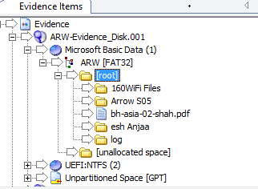
Figure 1 - Evidence Files

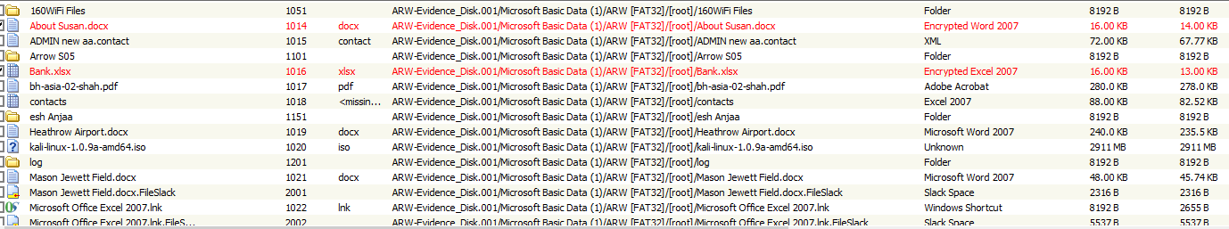
Figure 2 - Various Types of Files

As shown in Figure 1 and Figure 2, FTK has managed to locate files present and hidden on the terrorist’s drive, displaying the format, file type and information.

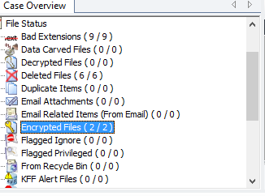
Figure 3 - Case Overview

FTK would’ve provided a full breakdown of all the files located, as shown in the case overview in Figure 3, no email messages were found.

Would John Have Made A Detailed List Of The Videos And Prepared A Document Explaining Each Of The Videos In Brief?

The videos that had been retrieved during the data acquisition period will require a detailed information document related to each of the videos found. The evidence can be seen to be related to terrorist attacks and terrorism related activities and practices. Each video will require a detailed explanation as there are different motives behind each of the videos, the terrorist may have had different plans and ideations that need to be highlighted.

When acquiring this kind of data, evidence must be admissible, authentic, complete, reliable and believable. Overall, the videos gathered can give an insight into terrorist activity, however John cannot say that there is terrorist motive as he is not law enforcement nor give a personal view but can however explain the possible motives of the terrorist with the videos that have been acquired and analysed.

Due to the seriousness of the investigation, the collection of this type of evidence must be documented to be presented in court. Upon documenting, the documentation will then be passed on to a person of higher liaise who will assess the possible effects from the videos and exhibit the findings for an expert to present in court.

Another reason for documentation is to protect any sensitive information that may have been found, which can then be processed and passed on to a higher governing body who will assess the seriousness impacts and prevent any mishaps.

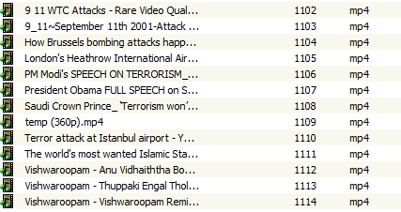
Figure 4 - Terrorist Videos

The videos found from the suspects drive in Figure 4 display terrorist attacks and terror related activities in mp4 format.

What Software John Used To Get The List Of Contacts In The Terrorist’s MS Outlook

To gain full access to the terrorist’s outlook contact list, Paraben’s E3 EMX [1] has been used to analyse the terrorist’s email depository.

The email files that were extracted from the original drive and image copied will be input into Paraben’s E3 EMX, where the tool will process and analyse the files and display them as the terrorist would view in his own inbox. E3 EMX will then allow you to view the emails along with any attachments and categorize the emails by sender/receiver and subject.

The advanced search gives the user the option to track the exact date and time the emails were sent and received as well identifying and locating any deleted or corrupted email files.

Upon tracing the emails, the subjects/names that were picked up are as follows:
- Merlin Malcom
- Ibrahim
- Susan

What Software John Used To Examine The Excel Sheets Containing Data And Information

A terrorist related activity that was found within one of the files found on the drive was a MS Excel sheet containing bank account details to two different people in two different countries and banks.

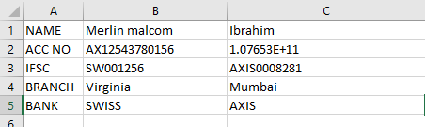
Figure 5 - Excel Sheet Containing Bank Details

To gather this piece of evidence, FTK was used to locate the hidden file and decrypt it into its original filing format. Upon extraction, the Excel sheet was found to be password protected, FTK’s password cracking tool was used to match the correct password to enable access to the file. The password that locked the file was “money”.

Report On John’s Forensics Analysis

The investigative techniques, practices and procedures taken out and followed by John throughout the case are related to first-hand evidence acquisition and handling.

John was able to follow the analytic concept in relation to computer forensics and gather the evidence in relation to the case by using commercial and open source acquisition and analysis tools by mirror imaging the terrorist’s disk drive.

John’s initial plan was constructed to be a non-contaminative evidence collection process by immediately photographing the state the laptop had been left in (stand-by) to ensure security and no tampering with the hard evidence. Upon gathering the raw evidence (laptop bag containing the laptop and documents), John was able to contract the volatile memory of the laptop and extract the drive gaining access to present and hidden files.

The file acquisition process used by John was able to gather the exact terror related files, personal and private documents that were on the terrorist’s drive. John was able to unmask files and videos related to terror incidents that can be used as motive evidence in further cases.
Images were found that were related to the possible terror attack locations as well as passport documents and terror organization related documents that could help in the confirmation of the intention and motives of the terrorist.

To assist the case, an FTK report created by John’s evidence acquisition and analysis will be provided with this report. (See separate submission file).

John’s services that were required in this case include:
- Securing Raw Evidence
- Create a Plan for the Investigation
- Identify Any Security Flaws of the Raw Evidence
- Perform Forensic Analysis and Acquisition of Evidence
- Documentation/Report Compiled for A Higher Liaise

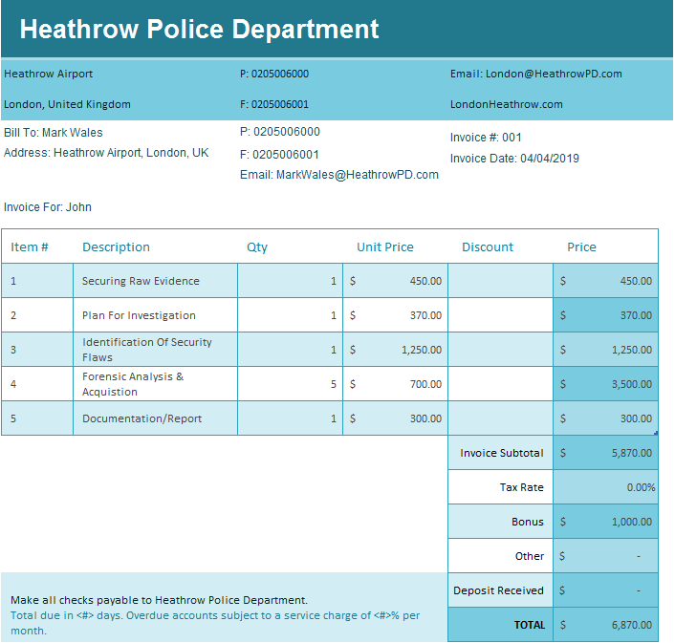
Figure 6 - Invoice For John's Services

Figure 6 displays the invoice for John’s professional services.

Conclusion

To conclude this report and investigation, the objective of this assignment was to consider if an incident handler or a forensics investigator was required to take on the task.

An incident handler is the first responder to the crime scene, where the handler will photograph the state of the crime scene as well as any evidence found to ensure the reliability of the case and the evidence. Further on, an incident handler will gather as much evidence possible, locate any hidden and protected files and unmask and crack them for further analysis and document their findings to pass on to a person with higher liaise for them to analyse and further pass on to a higher liaise.

A forensics investigator will analyse the first-hand data and evidence that has been found, measuring the authenticity and reliability of the evidence and further documenting findings into a report and identifying the seriousness and impacts of the evidence in relation to the case.

In relation to the given case study, John has handled the case as a forensics investigator as he has gained evidence from analytical and acquisition process that will need to be forwarded to Mark Wales, who will be the expert witness that will be in court and will present a complex technical report with all the findings from the raw evidence, providing legal judgement and giving a truthful, expert opinion without the influence from other factors and people.

References

[1] | U. Government, "Computer Forensics," 2008. [Online]. Available: https://www.us-cert.gov/sites/default/files/publications/forensics.pdf. [Accessed 3 March 2019].
[2] | K. Leetaru, "The Shift From Open Source To Commercial Data Analytics Is Placing Cost Over Accuracy," 9 March 2019. [Online]. Available: https://www.forbes.com/sites/kalevleetaru/2019/03/09/the-shift-from-open-source-to-commercial-data-analytics-is-placing-cost-over-accuracy/#4168707d6e0d. [Accessed 9 March 2019].
[3] | Prospects, "Forensic Computer Analyst," Prospects.ac.uk, 2019. [Online]. Available: https://www.prospects.ac.uk/job-profiles/forensic-computer-analyst. [Accessed 9 March 2019].
[4] | IBM, "FileViewPro," IBM, 18 April 2018. [Online]. Available: https://www-356.ibm.com/partnerworld/gsd/solutiondetails.do?&solution=46098. [Accessed 9 March 2019].
[5] | P. Corporation, "Reliable Digital Forensics," Paraben's Corporation, 2019. [Online]. Available: https://www.insectraforensics.com/Paraben-P2-Commander-v2/en. [Accessed 9 March 2019].
[6] | R.-T. Technology, "R-Drive Image," R-Tools Technology, 2019. [Online]. Available: https://www.drive-image.com. [Accessed 9 March 2019].
[7] | Autopsy, "Autopsy in Law Enforcement," Autopsy, 2019. [Online]. Available: https://www.autopsy.com/use-cases/law-enforcement/. [Accessed 9 March 2019].
[8] | M. Hash, "MD5 Hash Calculator," 2017. [Online]. Available: https://www.md5hashgenerator.com. [Accessed 9 March 2019].
[9] | AccessData, "Forensic Toolkit," AccessData, 2019. [Online]. Available: https://accessdata.com/products-services/forensic-toolkit-ftk. [Accessed 9 March 2019].
[10] | Passware, "Passware Kit Forensic," 2019. [Online]. Available: passware.com/kit-forensic.
[11] | S. Vaidya, "OpenStego," OpenStego, 2017. [Online]. Available: openstego.com. [Accessed 9 March 2019].
[12] | B. Englehardt, "SpyHunter," SpyHunter, 2002. [Online]. Available: spy-hunter.com. [Accessed 9 March 2019].
[13] | A. Data, "FTK Imager," AccessData, 2017. [Online]. Available: https://accessdata.com/product-download/ftk-imager-version-4.2.0. [Accessed 12 March 2019].
[14] | Runtime, "DiskExplorer," Runtime, 2019. [Online]. Available: https://www.runtime.org/diskexpl.htm. [Accessed 12 March 2019].
[15] | Passware, "Passware Kit," 1998. [Online]. Available: https://www.passware.com. [Accessed 12 March 2019].
[16] | Elcomsoft, "Advanced PDF Password Recovery," Elcomsoft, 2019. [Online]. Available: https://www.elcomsoft.co.uk/apdfpr.html. [Accessed 12 March 2019].
[17] | D. Detective, "Blade Professional V1," Digital Detective, 2019. [Online]. Available: https://www.digital-detective.net/product/blade-professional-v1/. [Accessed 12 March 2019].
[18] | F. Explorer, "Forensic Explorer," Forensic Explorer, 2017. [Online]. Available: http://www.forensicexplorer.com. [Accessed 15 March 2019].
[19] | G. Data, "Phone Image Carver," Get Data Software Company, 2002. [Online]. Available: http://www.phoneimagecarver.com/. [Accessed 15 March 2019].
[20] | Jpinsoft, "DeepSound," Jpinsoft, 2019. [Online]. Available: http://jpinsoft.net/deepsound/. [Accessed 15 March 2019].
[21] | fma, "floAt's Mobile Agent," 2003. [Online]. Available: http://fma.sourceforge.net/index2.htm. [Accessed 15 March 2019].
[22] | TULP2G, "TULP2G," sourceforge, 2007. [Online]. Available: http://tulp2g.sourceforge.net. [Accessed 15 March 2019].
[23] | P. Corporation, "Paraben's E3 EMX," Parabens Corporation, [Online]. Available: https://paraben.com/email-forensics-emx/. [Accessed 15 March 2019].
[24] | C. Easttom, System Forensics, Investigation and Response, Third Edition, 2019, p. 400.
[25] | M.-H. Mars, Computer Forensics, Cybercriminals, Laws and Evidence, Second Edition, 2015.

List Of Figures

Figure 1 - Evidence Files 9
Figure 2 - Various Types of Files 9
Figure 3 - Case Overview 9
Figure 4 - Terrorist Videos 9
Figure 5 - Excel Sheet Containing Bank Details 10
Figure 6 - Invoice For John's Services 11

